Rate Path 3: Symbolic Rate Laws
a formula found by fitting, read from a plain text file at run time
1. What this path is
A symbolic rate law is an ordinary algebraic expression, of the kind a modeller would write by hand, except that the form of the expression was found by fitting rather than chosen in advance. Ordinary fitting starts from a form you picked, a Monod law say, and finds the numbers in it. Symbolic regression searches over the form itself. What it returns is a formula, and the formula is what this path evaluates.
Nothing is trained at run time and nothing is solved. The file is read once at start-up and parsed into a tree of small nodes. Per voxel the tree is walked, the outputs are read straight off in file order, and the rates go to the transport step. There is no solver, no network, and no linear algebra of any kind.
The header does not do the fitting. Genetic programming is slow and its answer depends on the random seed, and neither of those belongs inside a simulation. Fit offline, write the file, run.
2. Where it sits in the time step
One time step of CompLaB3D runs flow, transport, reaction and update in that order. The rate path is the reaction step, and it is the only stage that differs between paths. Everything above and below it is the same code whichever path is selected, which is what makes the six paths interchangeable and comparable.
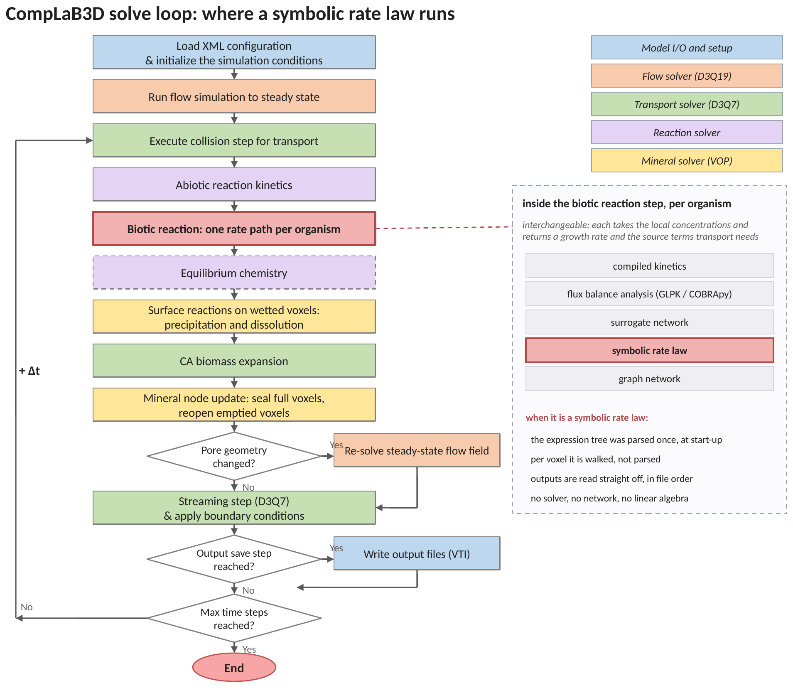
Figure 1. The solve loop, with the symbolic path marked. The biotic reaction step is one of six interchangeable rate paths, each of which takes the local concentrations and returns a growth rate together with the source terms the transport step needs. When the path is a symbolic law, the expression tree was parsed once at start-up, the tree is walked per voxel, and the outputs are read off in file order.
The whole run-time cost of this path is one tree walk per organism per voxel per reaction step, over an expression of a few dozen nodes. That is the reason the parsing is done once rather than per voxel: parsing per voxel would cost more than the linear program this path is standing in for.
3. Two phases, and the line between them
The method has an offline phase and a run-time phase, and the .sym file is the whole handover between them. Nothing on the offline row is inside CompLaB3D.
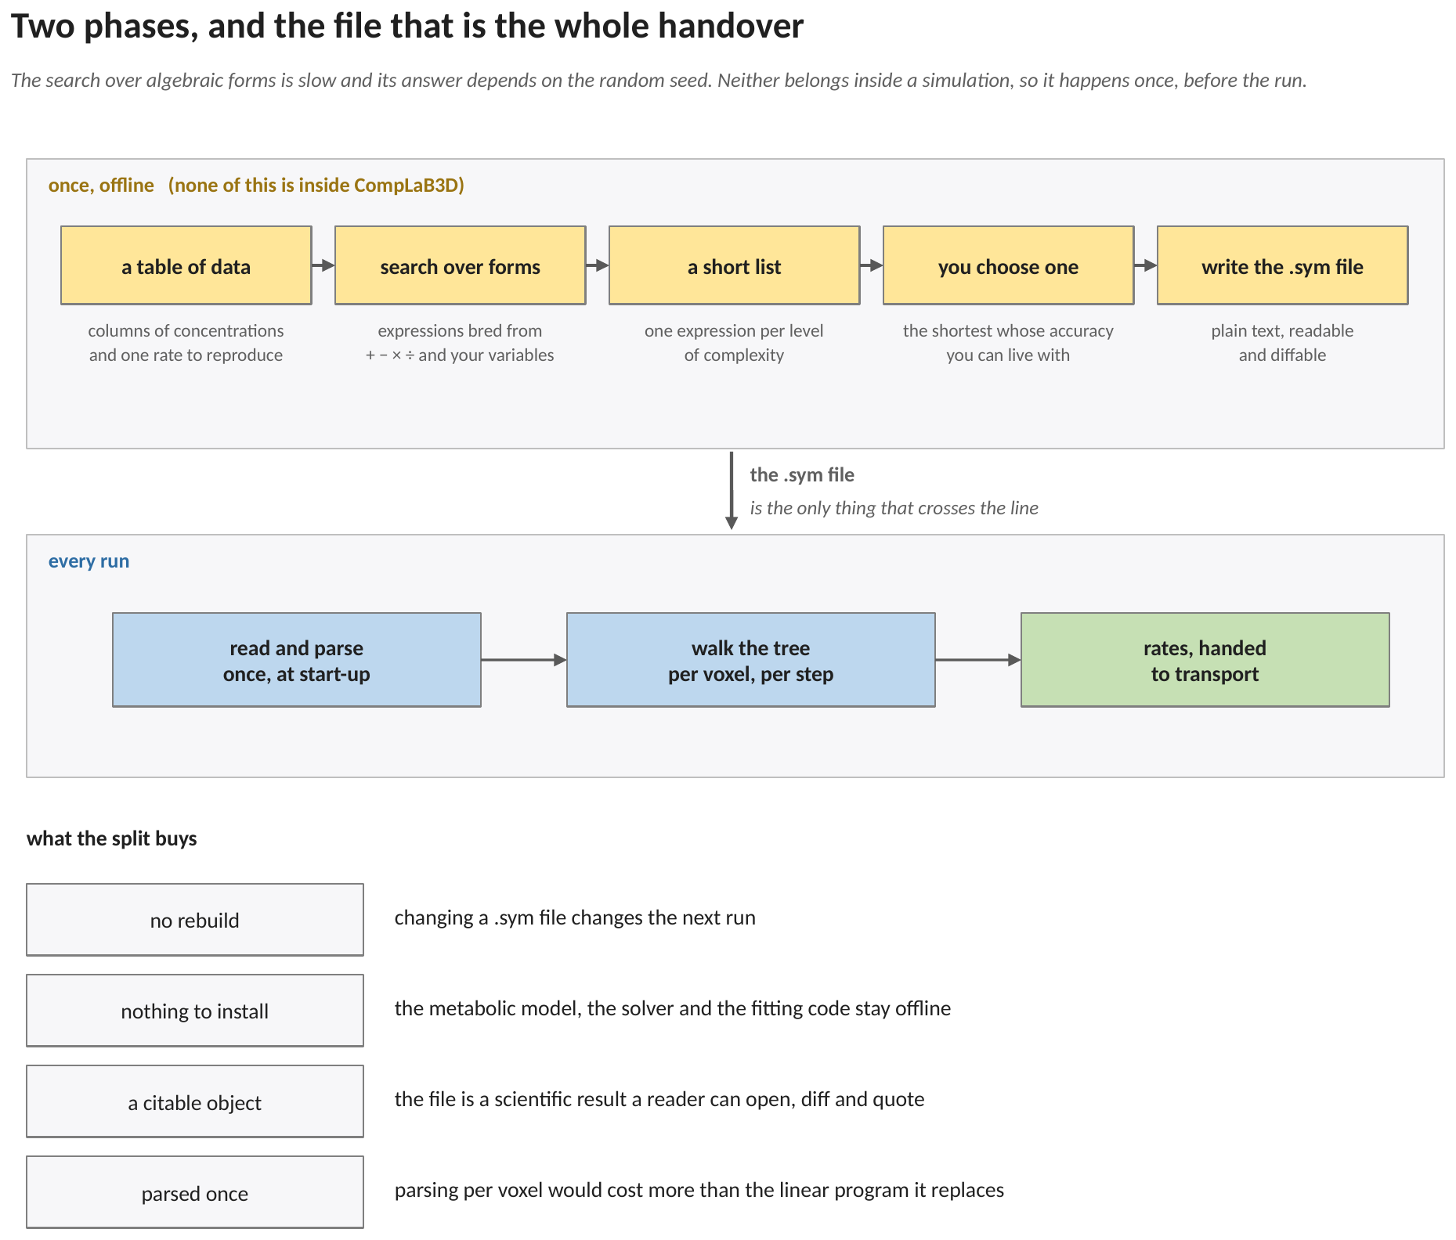
Figure 2. The two phases, and the four things the split buys. Above the line: a table of data, a search over algebraic forms, a short list of candidates, a choice among them, and a file written out. Below the line: the file is read and parsed once at start-up, the tree is walked once per voxel per step, and rates go to transport. The .sym file is the only object that crosses the line.
That last point is the same reasoning that put the surrogate weights of Rate Path 2 in a .srg file rather than in a compiled header. A fitted object is a scientific result, and it should be readable, diffable and citable on its own.
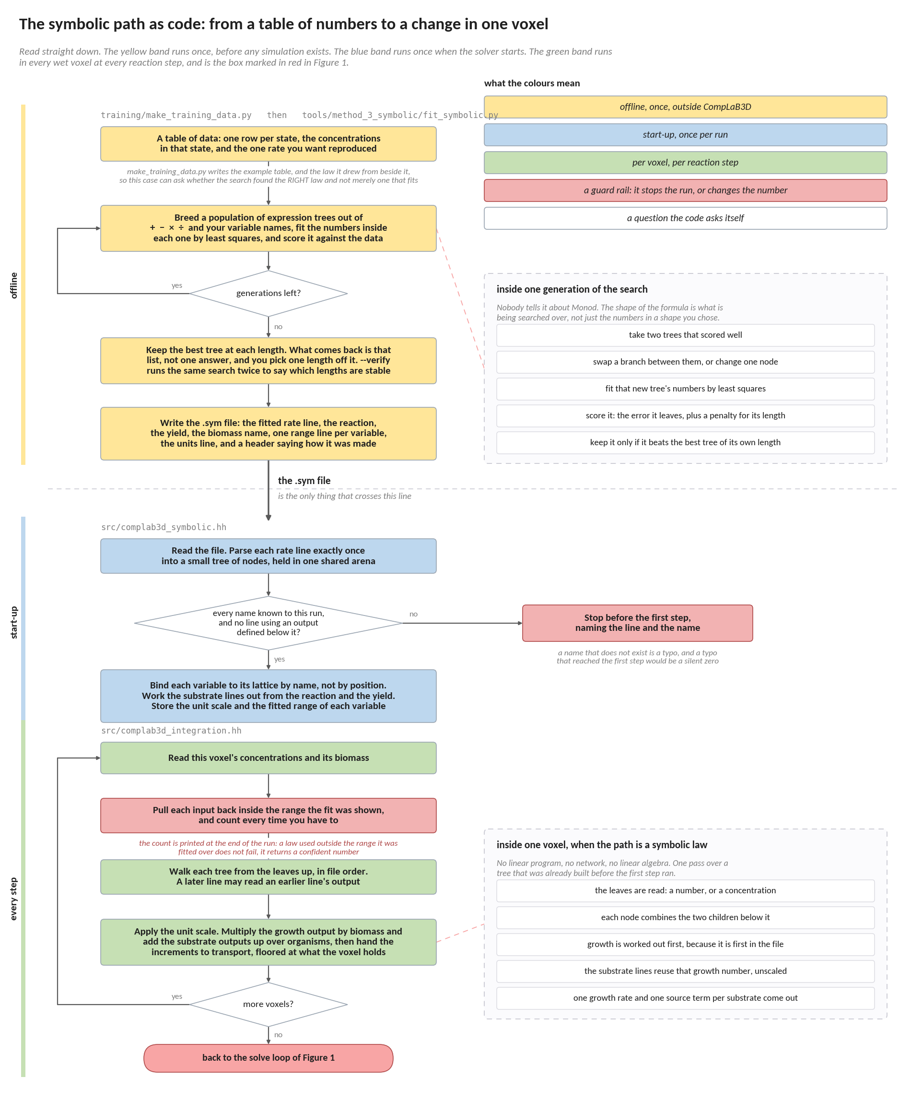
Figure 3. The symbolic path as code, from a table of numbers to a change in one voxel. The side panels open the two steps that are otherwise taken on trust: one generation of the search, and one walk of one expression tree in one voxel.
The three bands are the three time scales this method lives on. The yellow band happens once, on a workstation, and none of it is inside CompLaB3D. The blue band happens once when the solver starts. The green band happens in every wet voxel at every reaction step, and is the box drawn in red in Figure 1. Each band carries the name of the source file it lives in, so a box in the chart can be traced to the code that performs it. The dashed line across the page is the handover, and the .sym file is the only thing that crosses it. Two boxes are drawn in red because they are the two places where a mistake does not announce itself: a variable name the run does not recognise stops the run at start-up rather than becoming a silent zero, and a concentration arriving from outside the range the fit was shown is pulled back to the edge and counted.
4. What the search returns is a list, not an answer
A symbolic regression run does not return one expression. It returns one expression per level of complexity, together with the error each achieves, and the choice among them is left to the person. That is deliberate: the criterion is not numerical.
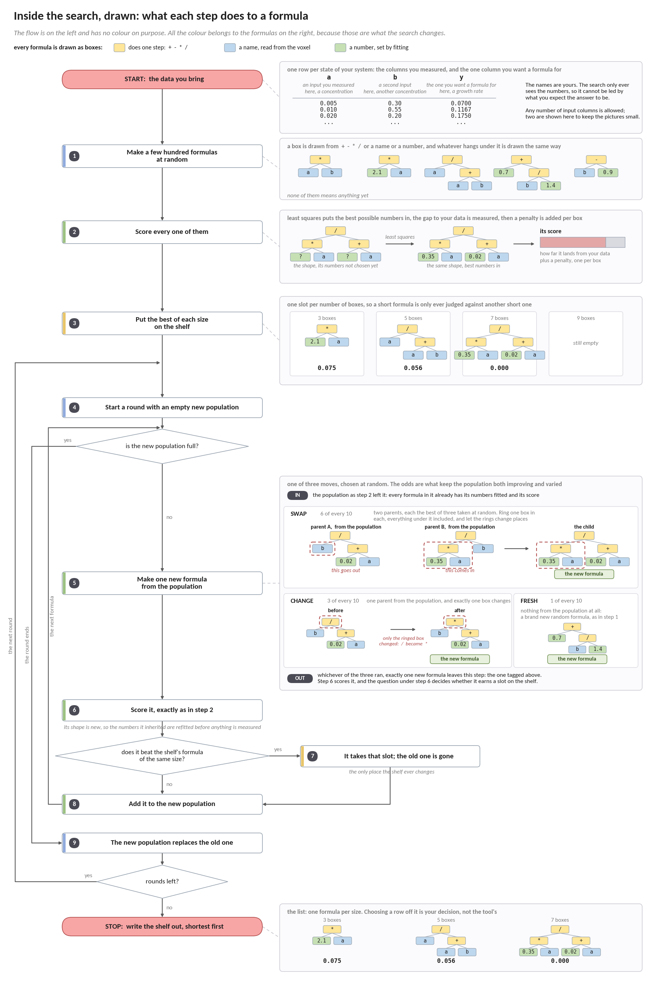
Figure 4. Inside the search: what each step does to a formula. Step 5 is drawn out in full because it is the step that carries the method, and the one whose description elsewhere has to be taken on trust.
The flow down the left is drawn without colour so that the only coloured objects in the figure are the formulas, which are what the search changes. A formula is held as a picture of boxes: a yellow box performs one arithmetic step, a blue box holds a variable name the run fills in per voxel, and a green box holds a number the fitting is free to move. The count of those boxes is what the list calls length. Steps 2 to 5 of the chart are one round, and the three lanes down the left edge are the three loops: one adds the next formula to the population, one closes the round, one begins the next. Step 5 states what enters it and what leaves it, because that is where the description usually goes vague: in, the population as step 2 left it, every member already fitted and scored; out, exactly one new formula, whichever of the three moves was drawn. The shelf keeps one slot per number of boxes, which is what stops a short formula from being discarded for being less accurate than a long one.
One thing the search does not know is the stoichiometry. It fits one output column at a time. The practice that follows is to fit the growth rate and to get the substrate lines from the reaction rather than from the data, which keeps them in exact stoichiometric ratio. Since v1.3.2 the file states the reaction, the yield and the organism, and the solver writes those lines itself before the first step, so the ratio is arithmetic rather than typing; writing them by hand still works and is what the file in section 8 does. A separate fit per species would hold no ratio at all, and the discrepancy would appear in the simulation as mass that the model quietly creates or destroys.
 | compiled kinetics | a symbolic law | the linear program
what you supply | a C++ expression | a text file of expressions | a genome-scale model
what is fixed | the form and the numbers | the form and the numbers | only the stoichiometry
what changes with conditions | the value of the law | the value of the law | which reactions carry flux at all
changing it costs | a rebuild | editing a file | editing a model file
cost per voxel per step | a few operations | one walk of a few dozen nodes | one simplex solve
valid where | wherever you say it is | inside the range lines, and nowhere else | everywhere

The last row is the whole trade. A compiled law is yours and its domain of validity is a claim you are making. A linear program has no fitted range at all, because nothing about it was fitted. A symbolic law sits between the two: it is as readable as the first and as range-limited as any other fitted object.
5. The expression, as the solver holds it
The picture of a formula that Figure 4 introduces is exactly what the solver holds: one node per box, built once at start-up and walked per voxel thereafter. This section is the language those boxes are written in, and the single rule that governs the order they are read in.
5.1 The language
The expression language is deliberately small. This is what the solver reads. The search of Section 4 builds its candidates from plus, minus, times and divide only, so a formula it writes never uses the rest of this list; the rest is there for laws written by hand.

numbers 1 1.5 1e-3 6.02E23
variables any name from the vars line, or an earlier rate output
operators + - * / ^ unary minus parentheses
functions exp log log10 sqrt abs min max pow tanh
constants pi e

Precedence is the usual one: the caret binds tighter than multiplication and division, which bind tighter than addition and subtraction. The caret is right associative, so 2^3^2 is 2^(3^2). Division by zero returns zero rather than an infinity, because a rate law that divides by a concentration the transport solver has driven to zero is a situation the run has to survive rather than a reason to stop.
5.2 Evaluation order, and why a forward reference stops the run
Expressions may refer to outputs defined earlier in the file. In the shipped example the growth rate is defined first and then used on the acetate and oxygen lines, which is how a stoichiometric ratio gets written as one line rather than as a repeated formula. Expressions are evaluated in file order, and a reference to a rate defined later is a hard error at start-up rather than a silent zero.
One detail matters for the units. A chained expression sees the unscaled value of the rate it refers to. The unit scale of Section 6.5 is applied only on the way out, so a line that reads as a pure stoichiometric ratio stays one whichever unit the file declares.
6. The equations
6.1 The offline equations: what the search minimises
The four subsections after this one are what the solver evaluates. This one is what produced the file it evaluates, and it belongs here because a number in a .sym file cannot be read honestly without knowing what was minimised to arrive at it. None of it runs during a simulation.
Every sample is weighted before anything is squared. A rate law is used across orders of magnitude, and plain least squares on the absolute error only cares about the large values, so the fit comes out excellent at the top of the range and can be wrong by several hundred per cent at the bottom, which is exactly where a substrate is running out and the interesting chemistry is:
r_{i} = ( E( x_{i} , c ) − y_{i} ) · w_{i} (S1)
where E the expression being tried; c its constants; x_{i} the inputs of sample i; y_{i} the rate that sample is to reproduce; w_{i} the weight, which is 1 under absolute loss and 1 / max( |y_{i}| , f ) under relative loss, the default. The floor f is one per cent of the root-mean-square rate, and without it a sample whose true rate is essentially zero would carry unbounded weight and drag the whole fit onto a corner of the domain that carries no information.
The numbers inside one shape are then fitted by Levenberg−Marquardt, on the residuals of (S1) with a small ridge attached:
S( c ) = Σ_{i} r_{i}² + ρ² Σ_{j} ( c_{j} / c̄ )² (S2)
where ρ ten to the minus seven times the span of the data, and c̄ the larger of that span and one. The second sum is a ridge and it exists for one purpose: when a shape carries more constants than the data can pin down, the best fit is not a point but a valley, and without the ridge two runs land in different places in it and the same law comes back spelled two different ways. It is dropped again before the fit is scored, so it is never counted as error.
What is scored is the first sum alone, as a mean over the samples:
M = ( 1 / N ) Σ_{i} r_{i}² (S3)
and what the search ranks on adds a price for every box the shape uses:
F = M / M₀ + p · n , M₀ = ( 1 / N ) Σ_{i} ( y_{i} w_{i} )² , p = 4×10−3 (S4)
where n the number of boxes in the shape and M₀ the error of predicting zero everywhere, which is what makes F a pure number. Without the second term the search buys accuracy with boxes until nothing on the list can be read, and the whole point of this path is that the answer is something a person can argue with.
The two percentages printed beside each row of the list are the typical and the worst error over the samples, judged the same way the fit was:
typical = 100 √( mean d² ) , worst = 100 max d , d_{i} = | E( x_{i} , c ) − y_{i} | · w_{i} (S5)
and the payoff column, which is the one to read down, is how much the error fell for each extra box:
g = ( ln M_{prev} − ln M ) / ( n − n_{prev} ) (S6)
The automatic pick is the largest g. It is a rule of thumb and not an answer, which is why the whole list is printed and why --pick exists: on the shipped training table the rule lands on the crude bilinear formula and skips the one that recovers both half-saturation constants. Choosing a row is a scientific act, not a numerical one.
6.2 What the solver works out for itself at start-up
If the file states a reaction, a yield and a biomass name, the substrate lines are not read from the file at all. They are derived once, before the first step, and printed in the log marked as derived:
coefficient( i ) = ( ν_{i} / | ν_{key} | ) / Y (D1)
where ν_{i} the stoichiometric coefficient of species i in the reaction line, negative for consumed and positive for produced; ν_{key} the coefficient of the species the yield is quoted against; Y the yield, in moles of biomass per mole of that species.
For the shipped example, acetate at −1 and oxygen at −2 with a yield of 0.4 give −2.5 and −5.0 exactly. The ratio between the two substrate lines is then arithmetic on the reaction rather than two numbers typed twice, and it cannot disagree with the chemistry. Mistype one digit in a hand-written pair and the run still finishes, the fields still look smooth, and the model quietly creates or destroys oxygen every step for the rest of the simulation. A species may have a rate line or a place in the reaction, never both; two sources of truth for one number is the thing this removes.
6.3 What is handed in, and the clamp
Each variable named on the vars line is bound at start-up to a lattice: a substrate concentration or a biomass density. Per voxel their current values are gathered, and any variable that carries a range line is clamped to it before the tree is walked:
x_{j} = min( max( C_{j} , lo_{j} ) , hi_{j} ) (1)
where C_{j} the current value of variable j in this voxel; lo_{j}, hi_{j} the low and high end of that variable's range line; x_{j} the value the expression actually sees.
A variable with no range line is not clamped. That is the right default for something like a biomass density, which has no meaningful upper bound and was not a fitted input in the first place.
6.4 The expressions, evaluated in file order
Each rate line is one output. Walking its tree gives
y_{r} = E_{r} ( x₁ ... x_{n} , y₁ ... y_{r−1} ) (2)
where E_{r} the parsed tree of rate line r; y_{r} its value, before the unit scale of equation (3) is applied. The second argument list is what makes a chained expression legal.
Two numerical guards sit on the result. A value that comes back as not-a-number is replaced by zero, and a value larger than 10³⁰⁰ in magnitude is clipped to that magnitude. Both exist so that one pathological voxel cannot poison a whole lattice.
6.5 Units
CompLaB3D works in mol per litre per second, and a growth rate per second, because that is what defineKinetics.hh uses. A formula fitted to flux balance output almost always comes out per hour, because that is the convention metabolic models use. The units line converts:
R_{r} = s_{u} · y_{r} , s_{u} = 1 for units per_second, 1 / 3600 for units per_hour (3)
Getting this wrong is a factor of 3600, which is large enough to look like a modelling result rather than a mistake, so the loaded setting is printed in the log either way.
6.6 Into the transport step
From here the chain is shared with every other rate path. Each output is either a substrate rate or the reserved word growth. The substrate outputs are accumulated over every organism present in the voxel and then applied against what the voxel actually holds; the growth output multiplies that organism's biomass:
ΔC_{k} = max ( Σ_{m} R_{k,m} F_{T,m} Δt , −C_{k} ) (4)
ΔB_{m} = R_{growth,m} F_{T,m} B_{m} Δt (5)
where m an index over the organisms sharing this voxel; B_{m} that organism's biomass density in this voxel; F_{T,m} the thermodynamic factor of the gate described in Method 5, which is exactly one when the gate is off; Δt the reaction time step.
The outer maximum in equation (4) is the substrate budget, and it is applied once for the voxel rather than once per organism, so a symbolic organism and a surrogate organism sharing a voxel obey the same rule. The biomass increment is floored at the biomass present, so a decay term cannot drive a density negative.
6.7 The order in which the code applies them
Read down. The three groups are three different time scales, and the gap between them is the cost argument for this whole path.

once, offline S1 weight every sample, so the small rates count
tools/method_3_symbolic/fit_symbolic.py S2 fit the numbers inside one shape
S3 score that shape against the data
S4 rank it, with a price for every box
S5 report typical and worst error for the list
S6 the payoff column, and the automatic pick

once, at start-up D1 derive one substrate coefficient per species
complab3d_symbolic.hh parse each rate line into a tree
bind every variable name to a lattice

per voxel, per reaction step 1 clamp each input to its range, and count it
complab3d_integration.hh 2 walk each tree, in file order
3 put the result in the solver's time unit
4 apply the substrate increments, floored
5 apply the biomass increment

Nothing in the first group runs during a simulation, and nothing in the second runs more than once. Only the third is inside the loop, and it is five lines of arithmetic over a tree of a few dozen boxes. That is the trade this path makes: the expensive equations are the ones that never run again.
7. A worked example: one voxel, step by step
Everything in Sections 5 and 6 on a single voxel, with every number written out.
7.1 Where every number in this example comes from
This comes before any arithmetic, because it is the part that is easiest to lose. Some of the numbers below are the modeller's choice and sit in the rate file; the rest are the state of the simulation at that instant, and those are the only ones that change from voxel to voxel.
the number | what it is | where it comes from
0.35 | the highest growth rate the organism reaches | the symbolic regression fit; it is written on the growth line of the .sym file
5.0e-4 | the acetate half-saturation constant, mol L⁻¹ | the same fit, the same line
1.0e-4 | the oxygen half-saturation constant, mol L⁻¹ | the same fit, the same line
−2.5 | moles of acetate used per mole of biomass made | the reaction. The organism makes 0.4 mol of biomass per mol of acetate, and 1 / 0.4 = 2.5, which the solver works out for itself from the reaction and yield lines
−5.0 | moles of oxygen used per mole of biomass made | the reaction again: two oxygen per acetate, so 2 × 2.5
1×10⁻⁶ to 5.0×10⁻³ | the acetate concentrations the fit was shown | the range line, written when the .sym file was made
1×10⁻⁶ to 2.0×10⁻³ | the oxygen concentrations the fit was shown | the other range line
per_hour | the time unit the formula was fitted in | the units line of the .sym file
1.2 mM | the acetate in this voxel right now | the transport solver, one step earlier
0.6 mM | the oxygen in this voxel right now | the transport solver, one step earlier
2.0×10⁻⁵ | the biomass in this voxel, mol L⁻¹ | the biomass lattice, where the biofilm automaton left it
0.5 s | how long this reaction step lasts | the run's configuration

The first three numbers are what the fitting procedure produced. The next two come from the reaction, either typed in as they are here or derived by the solver from a reaction line, which is the safer of the two. The two ranges say over what water the formula is entitled to be believed. Everything after that is the simulation, and changes from voxel to voxel and from step to step.
7.2 Step 1, equation (1): keep the inputs inside the fitted range
Before the formula is touched, each concentration is compared with the range the fit was shown. If it falls outside, it is pulled back to the nearest end. Here both sit comfortably inside, so nothing changes and nothing is counted:
acetate: 1×10⁻⁶ < 1.2×10⁻³ < 5.0×10⁻³ left as it is
oxygen: 1×10⁻⁶ < 6.0×10⁻⁴ < 2.0×10⁻³ left as it is
Biomass has no range line, so it is used as it stands. That is the right default: a biomass density has no upper bound the fit could have been shown.
7.3 Step 2, equation (2): work the formula out, innermost bracket first
The growth line is evaluated first, because it comes first in the file. It is a dual Monod expression, so it is worked exactly as one: two saturation terms, multiplied together, times the maximum rate.

the acetate saturation term
5.0e-4 is the acetate half-saturation constant, from the growth line of growth.sym
0.0012 is the acetate in this voxel, from the transport solver
bottom of the fraction 5.0e-4 + 0.0012 = 0.0017
the fraction 0.0012 / 0.0017 = 0.705882

the oxygen saturation term
1.0e-4 is the oxygen half-saturation constant, from the same line of growth.sym
0.0006 is the oxygen in this voxel, from the transport solver
bottom of the fraction 1.0e-4 + 0.0006 = 0.0007
the fraction 0.0006 / 0.0007 = 0.857143

the two, times the maximum rate
0.35 is that maximum rate, the leading coefficient of the growth line
0.35 x 0.705882 x 0.857143 = 0.211765 per hour

Both saturation terms are large, 0.71 and 0.86, because this voxel holds several times each half-saturation constant: 0.0012 against 5.0×10⁻⁴ of acetate, and 0.0006 against 1.0×10⁻⁴ of oxygen. The organism is running at about sixty per cent of its maximum, held back a little by acetate and hardly at all by oxygen. Read the two terms rather than the final number and you can always say which substrate is doing the limiting, which is the one thing a dual Monod law is for.
The two substrate lines are evaluated next, and both re-use the growth number just computed. That is why the growth line has to come first: an output can be used by a later line but not by an earlier one.
acetate: −2.5 × 2.1176×10⁻¹ × 2.0×10⁻⁵ = −1.0588×10⁻⁵ mol L⁻¹ h⁻¹
oxygen: −5.0 × 2.1176×10⁻¹ × 2.0×10⁻⁵ = −2.1176×10⁻⁵ mol L⁻¹ h⁻¹
The oxygen number is exactly twice the acetate number. It has to be, because the two coefficients were written from the reaction rather than fitted separately. That ratio holds in every voxel of the domain, whatever the growth line returns.
7.4 Step 3, equation (3): put the rates in the solver's time unit
The formula was fitted per hour, and CompLaB3D advances the transport step in seconds, so all three numbers are divided by 3600 on their way out:
growth: 2.1176×10⁻¹ / 3600 = 5.8824×10⁻⁵ s⁻¹
acetate: −1.0588×10⁻⁵ / 3600 = −2.9412×10⁻⁹ mol L⁻¹ s⁻¹
oxygen: −2.1176×10⁻⁵ / 3600 = −5.8824×10⁻⁹ mol L⁻¹ s⁻¹
This is the one line in the whole path where a mistake is invisible. Leave the units line out and all three numbers come out 3600 times larger; the run still finishes, the fields still look smooth, and the reaction is three orders of magnitude too fast.
7.5 Step 4, equations (4) and (5): the change in this voxel over this step
A rate becomes a concentration change by multiplying by the length of the step. One organism sits in this voxel and the thermodynamic gate of Method 5 is switched off, so the factor is one and there is nothing to sum over:
acetate drawn = −2.9412×10⁻⁹ × 1 × 0.5 s = −1.4706×10⁻⁹ mol L⁻¹
That draw is then checked against what the voxel actually holds. The voxel has 1.2 × 10⁻³ mol L⁻¹ of acetate and the reaction is asking for 1.5 × 10⁻⁹ of it, which is about one part in a million, so the request goes through unchanged:
ΔC = max ( −1.4706×10⁻⁹ , −1.2×10⁻³ ) = −1.4706×10⁻⁹
The second argument only wins in a voxel the reaction has nearly emptied, and it is what stops a concentration going negative however aggressive the fitted formula is.
The biomass grows by the growth rate times the biomass present times the step:
ΔB = 5.8824×10⁻⁵ × 1 × 2.0×10⁻⁵ × 0.5 s = 5.8824×10⁻¹⁰ mol L⁻¹
Those two numbers, one per substrate lattice and one per biomass lattice, are the whole output of the rate path for this voxel at this step. Transport takes them from here.
7.6 The same file in a voxel where the range does bite
Which end of the range matters is not obvious, and on this law it is not the end people expect. Take a voxel with the same oxygen but only 1.0×10⁻⁷ mol L⁻¹ of acetate, which is below the 1.0×10⁻⁶ lower end of the acetate range line. Step 1 now does something:
acetate: 1.2×10⁻³ replaced by 1.0×10⁻⁷ , which is below 1.0×10⁻⁶ , so 1.0×10⁻⁶ is used
and the growth line is worked at the edge of the range rather than at the true value:

using the clamped value 1.0e-6 / (5.0e-4 + 1.0e-6) = 1.996008e-3
growth = 0.35 x 1.996008e-3 x 0.857143 = 5.9880e-4 per hour

using the true value 1.0e-7 / (5.0e-4 + 1.0e-7) = 1.999600e-4
growth = 0.35 x 1.999600e-4 x 0.857143 = 5.9988e-5 per hour

The two answers differ by a factor of ten, and the clamped one is the larger. That direction matters. Above its half-saturation constant a Monod term has flattened out, so clamping a substrate down from the top of the range changes almost nothing: doing the same arithmetic with oxygen at 3.0 mM against the 2.0 mM ceiling moves the rate by under two per cent. Below the constant the term is still climbing steeply, and clamping a substrate up from the bottom of the range therefore overstates the rate, here by a factor of ten. The clamped value is still the one the solver uses, and that is still the right choice, because the fit was never shown a voxel this empty and 5.9988 × 10⁻⁵ is an extrapolation rather than a result. But a run with many clamped evaluations is not merely uncertain, it is biased in a known direction: it is reacting faster than the law it was given would. The evaluation is counted, and at the end of the run the log reports how many evaluations were clamped and what percentage that was, so a reader can judge how much of the domain sat outside the fit and, given the argument above, which way the answer leans.
8. References
Cranmer, M.: Interpretable machine learning for science with PySR and SymbolicRegression.jl. arXiv:2305.01582 (2023). https://doi.org/10.48550/arXiv.2305.01582
Brunton, S. L., Proctor, J. L., Kutz, J. N.: Discovering governing equations from data by sparse identification of nonlinear dynamical systems. Proceedings of the National Academy of Sciences 113, 3932-3937 (2016). https://doi.org/10.1073/pnas.1517384113
Jung, H., Song, H.-S., Meile, C.: CompLaB v1.0: a scalable pore-scale model for flow, biogeochemistry, microbial metabolism, and biofilm dynamics. Geoscientific Model Development 16, 1683-1696 (2023). https://doi.org/10.5194/gmd-16-1683-2023
Song, H.-S., Ahamed, F., Lee, J.-Y., Henry, C. S., Edirisinghe, J. N., Nelson, W. C., Chen, X., Moulton, J. D., Scheibe, T. D.: Coupling flux balance analysis with reactive transport modeling through machine learning for rapid and stable simulation of microbial metabolic switching. Scientific Reports 15, 6042 (2025). https://doi.org/10.1038/s41598-025-89997-9

