Name: Shahram Shahzad
Contact No: +92 336 2328081
Task 4: Network Intrusion Detection System

Table of Contents
1
SOC Simulation Project Report 3
Title 3
1. Introduction 3
2. Network Topology 3
2.1 Assigned IP Addresses 4
2.2 Routing 5
2.3 SPAN / Monitoring Configuration 5
3. Tools and Services 6
3.1 Kali Linux Tools 6
3.2 Ubuntu Server Services 6
4. Installation and Configuration of Suricata 7
4.1 Installation 7
4.2 Monitoring Interface 8
4.3 Configure HOME_NET 8
4.4 Enable Rule Set 8
4.5 Custom Suricata Rules 9
5. Wazuh Integration with Suricata 11
5.1 Installation of Wazuh 11
5.2 Custom Wazuh Rules 11
6. Attack Simulation and Results 11
6.1 DDoS Attack 11
6.2 Port Scanning 13
6.3 SSH Brute Force 15
6.4 IP Spoofing (Generic) 15
6.5 Malware Download Simulation 15
7. Conclusion 16

SOC Simulation Project Report

Title
Security Operations Center (SOC) Simulation using Suricata and Wazuh

1. Introduction
This project demonstrates a small-scale Security Operations Center (SOC) simulation. The objective is to detect and analyze common network attacks using Suricata (IDS) and Wazuh (SIEM). An attack machine (Kali Linux) generates malicious traffic, while an Ubuntu Server hosts services and monitoring tools. Suricata detects attacks at the network level, and Wazuh correlates and visualizes alerts through custom rules.

2. Network Topology
The simulated network consists of multiple machines connected through a switch and router.

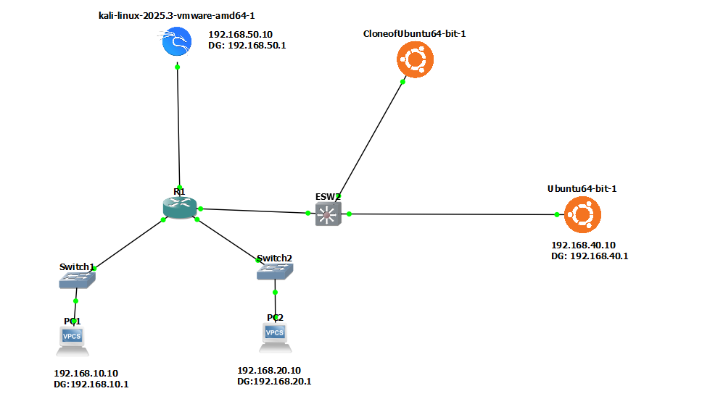

2.1 Assigned IP Addresses
- PC1:
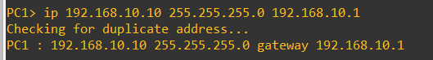
- PC2:
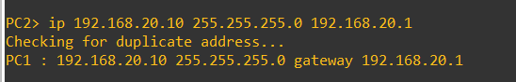
- Ubuntu Server: 192.168.40.10
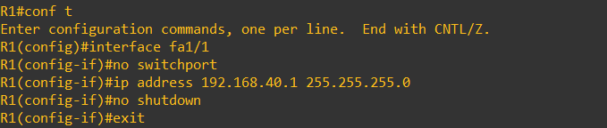
- Kali Linux: 192.168.40.X (attacker)
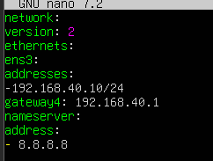
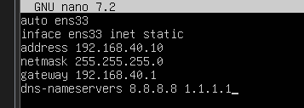

2.2 Routing
- PC1: Default gateway via Router R1
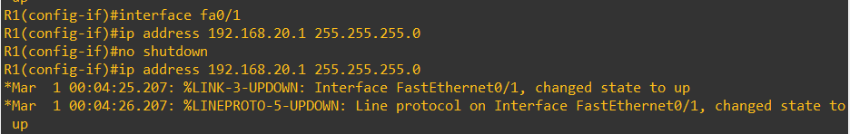
- PC2: Default gateway via Router R1
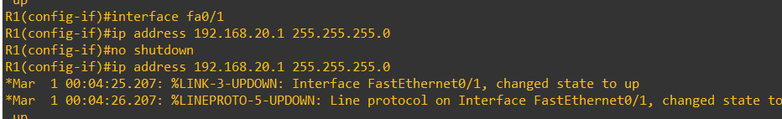
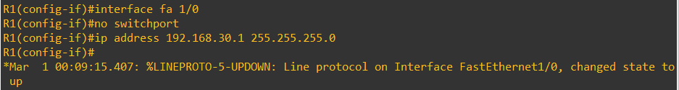
- Ubuntu Server: Default gateway via Router R1
- Kali Linux: Default gateway via Router R1


2.3 SPAN / Monitoring Configuration
- Fast Ethernet 1/3: Ubuntu Desktop
This port is connected to the Ubuntu Desktop system running Suricata IDS. It acts as the monitoring interface that receives mirrored traffic from the switch
- Fast Ethernet 1/1: Ubuntu Desktop
This port carries regular network traffic from end devices. Traffic passing through this interface is mirrored to the monitoring port using SPAN. This allows Suricata to observe real user traffic.
- Fast Ethernet 1/2: Switch to Router R1
This port connects the switch to Router R1 and handles inter-network traffic between different subnets. All traffic flowing between the internal networks and external segments passes through this interface.
SPAN (port mirroring) is used so that Suricata can monitor all traffic passing through the switch.

3. Tools and Services

3.1 Kali Linux Tools
- Nmap (Port scanning)
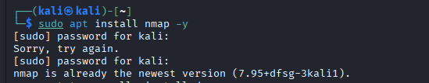
- hping3 (DDoS, spoofing, SYN attacks)
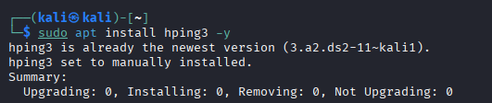
- Hydra (Brute force attacks)
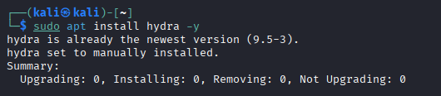

3.2 Ubuntu Server Services
- Apache (Web server)
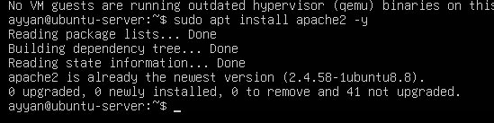
- Bind9 (DNS server)

- vsftpd (FTP server)
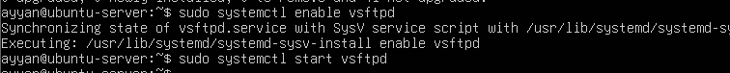

- Fail2Ban (Brute-force protection)


4. Installation and Configuration of Suricata

4.1 Installation
sudo apt update
sudo apt install suricata –y
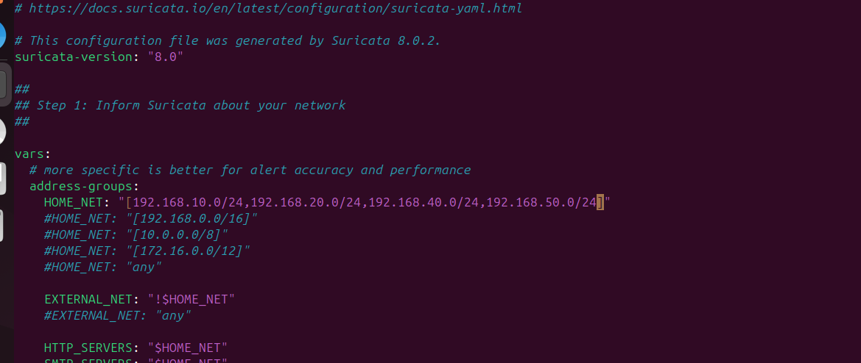

4.2 Monitoring Interface
Suricata is configured to listen on the monitoring interface connected to the SPAN port.
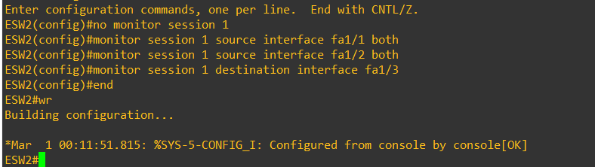

4.3 Configure HOME_NET
In /etc/suricata/suricata.yaml:

HOME_NET: "[192.168.40.0/24]"

4.4 Enable Rule Set
Local rules are stored in:
/var/lib/suricata/rules/local.rules


4.5 Custom Suricata Rules
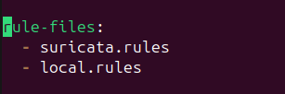
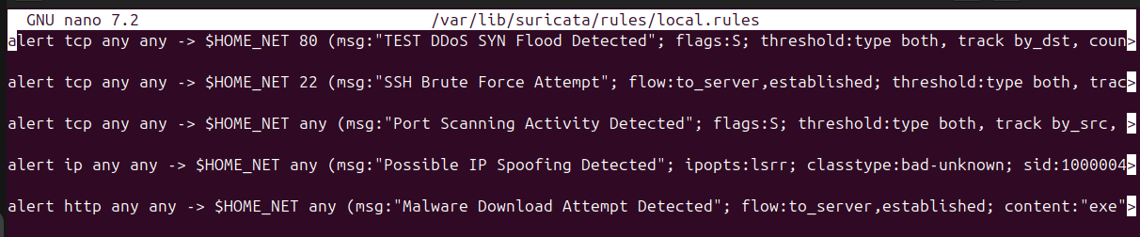
alert tcp any any -> $HOME_NET 80 (msg:"DDoS SYN Flood Detected"; flags:S; threshold:type both, track by_dst, count 20, seconds 1; classtype:attempted-dos; sid:1000002; rev:3;)
This rule detects a DDoS SYN flood attack by monitoring TCP packets sent to port 80 of the internal network. It checks for packets with the SYN flag and triggers an alert when 20 or more SYN packets are received by the same destination within one second, indicating abnormal connection requests.
alert tcp any any -> $HOME_NET 22 (msg:"SSH Brute Force Attempt"; flow:to_server; threshold:type both, track by_src, count 5, seconds 60; classtype:attempted-admin; sid:1000001; rev:3;)
This rule detects an SSH brute force attack by monitoring repeated login attempts to port 22 of the internal network. It triggers when multiple SSH connection attempts are observed from the same source within a short time period, indicating an attempt to guess user credentials through repeated authentication failures.
alert tcp any any -> $HOME_NET any (msg:"Port Scanning Activity Detected"; flags:S; threshold:type both, track by_src, count 20, seconds 10; classtype:network-scan; sid:1000003; rev:2;)
This rule detects port scanning activity by monitoring TCP SYN packets sent to multiple ports on systems within the internal network. When a source sends SYN packets to many different ports within a short time, the rule triggers, indicating reconnaissance activity used to discover open services.
alert ip any any -> $HOME_NET any (msg:"Possible IP Spoofing Detected (LSRR)"; ipopts:lsrr; classtype:bad-unknown; sid:1000004; rev:2;)
This rule detects port scanning activity by monitoring TCP SYN packets sent to multiple ports on systems within the internal network. When a source sends SYN packets to many different ports within a short time, the rule triggers, indicating reconnaissance activity used to discover open services.
alert tcp any any -> $HOME_NET any (msg:"Malware Download Attempt Detected"; flow:to_server,established; http.request_uri; content:".exe"; nocase; pcre:"/(malware|payload|trojan|virus).*\.exe/i"; classtype:trojan-activity; sid:1000005; rev:2;)
This rule detects possible IP spoofing by identifying packets that contain the LSRR (Loose Source and Record Route) IP option. The presence of this option is abnormal in modern networks and may indicate forged source addresses or attempts to manipulate packet routing paths.
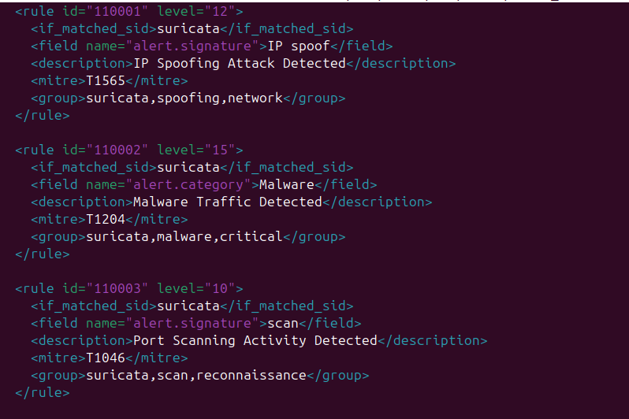
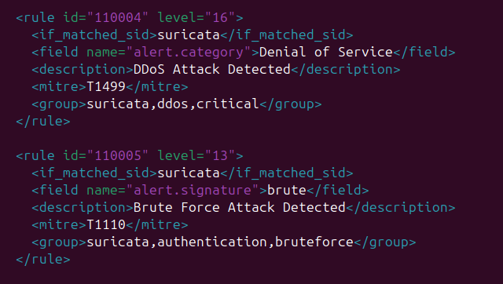

5. Wazuh Integration with Suricata

5.1 Installation of Wazuh
Wazuh Manager and Dashboard are installed on Ubuntu and integrated with Suricata logs (eve.json).

5.2 Custom Wazuh Rules
File location:
/var/ossec/etc/rules/local_rules.xml

6. Attack Simulation and Results

6.1 DDoS Attack
sudo hping3 -S -p 80 --flood 192.168.40.10
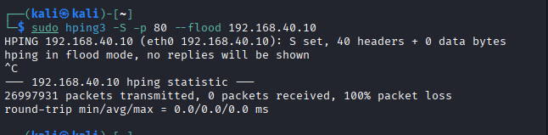
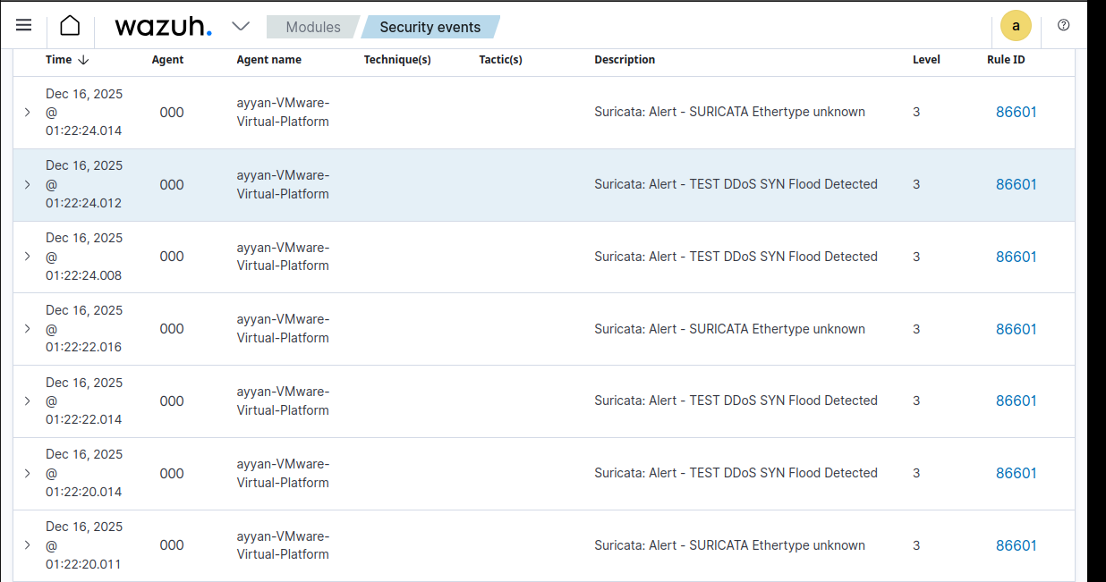


Detected by Suricata and escalated by Wazuh (Rule ID 110004).
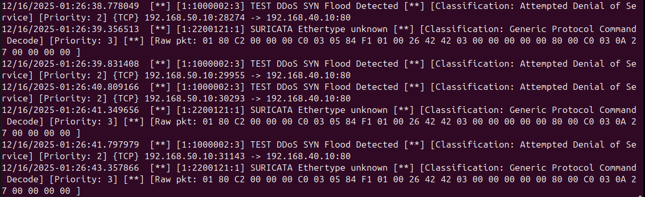

6.2 Port Scanning
nmap -sS -p 1-500 192.168.40.10
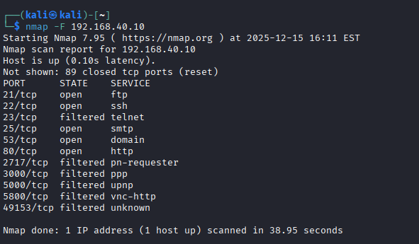
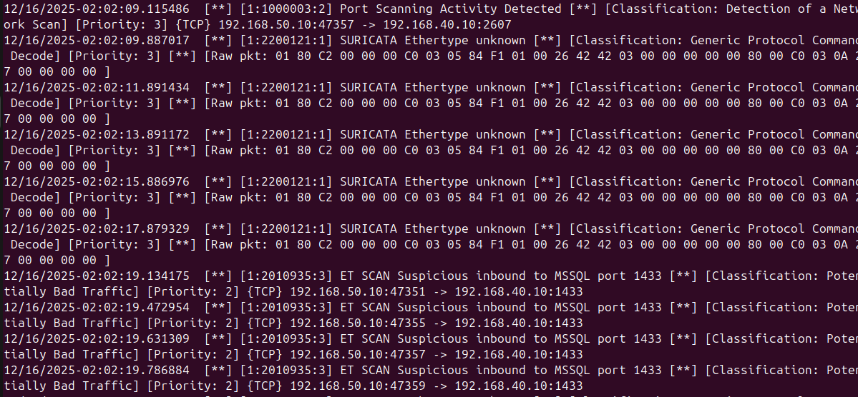
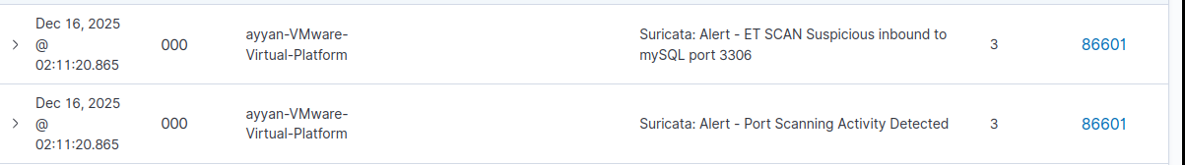
Detected as reconnaissance activity (Rule ID 110003).
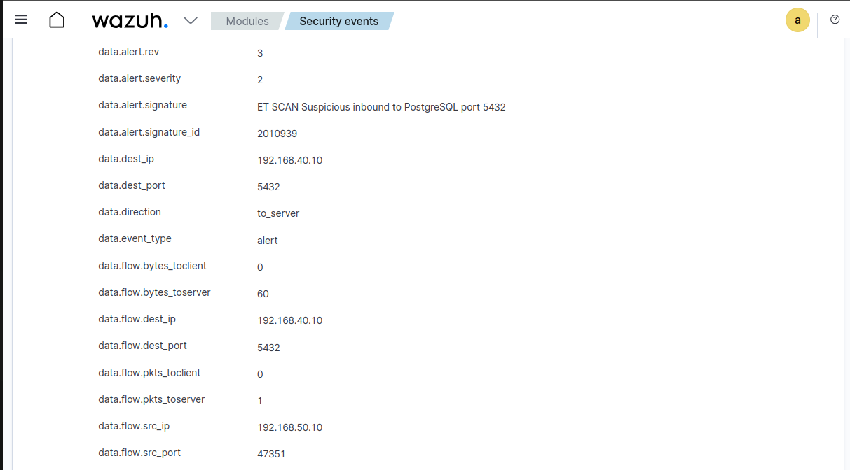
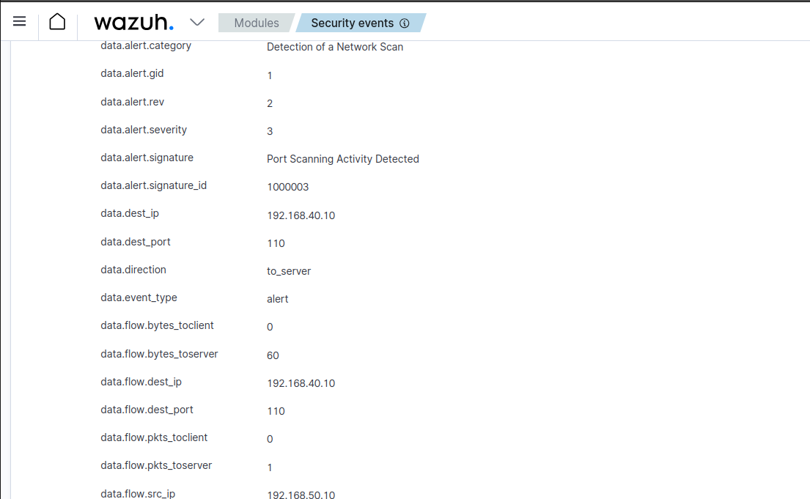

6.3 SSH Brute Force
hydra -l test -P /usr/share/wordlists/rockyou.txt -t 4 ssh://192.168.40.10

Detected as brute force (Rule ID 110005).

6.4 IP Spoofing (Generic)
sudo hping3 -a 127.0.0.1 -S -p 80 192.168.40.10
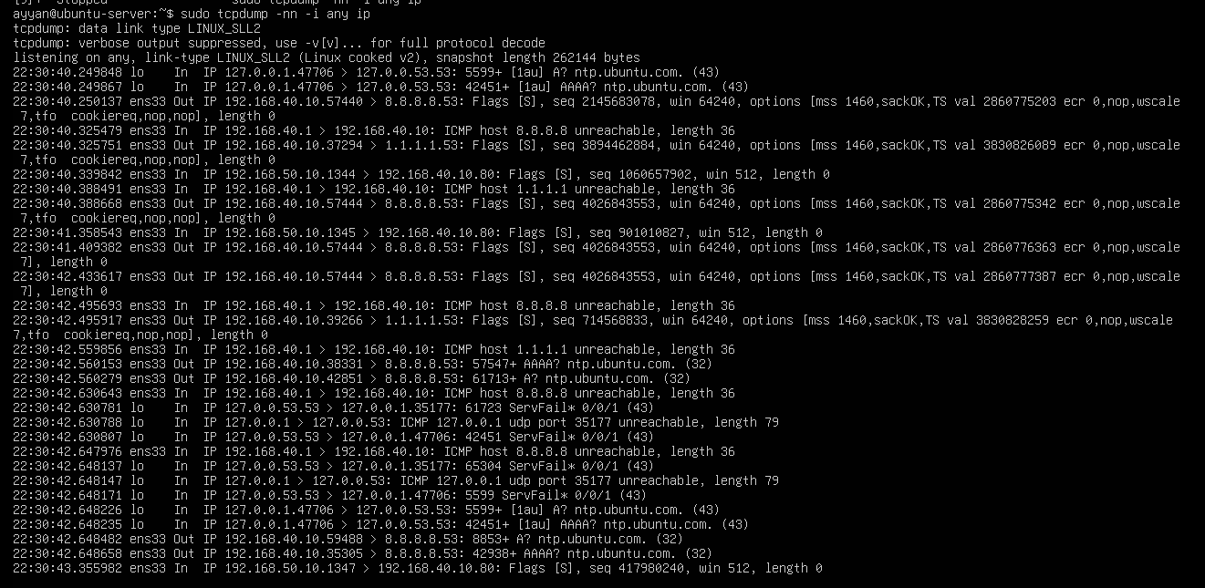
Detected via TCP anomalies (Rule ID 110001).

6.5 Malware Download Simulation
curl http://192.168.40.10/malware.exe
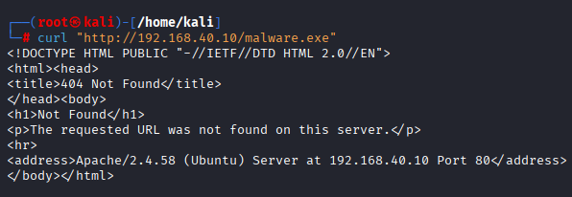
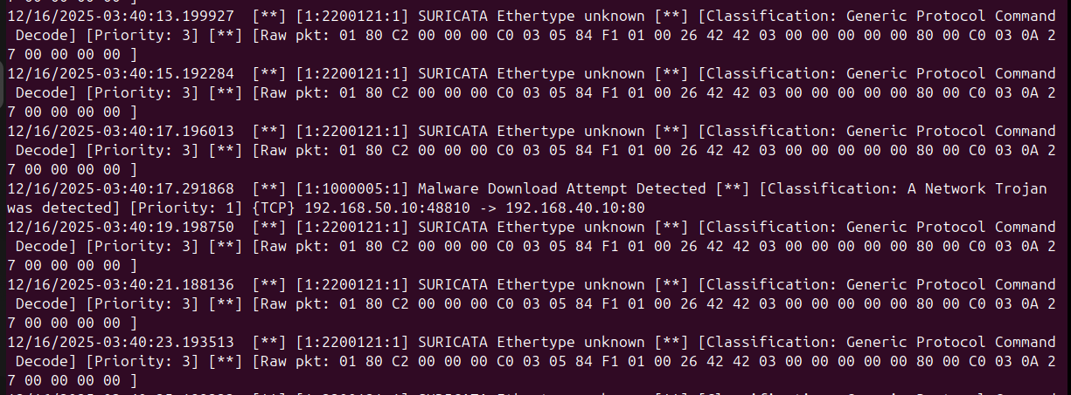
Detected as malware download attempt (Rule ID 110002).
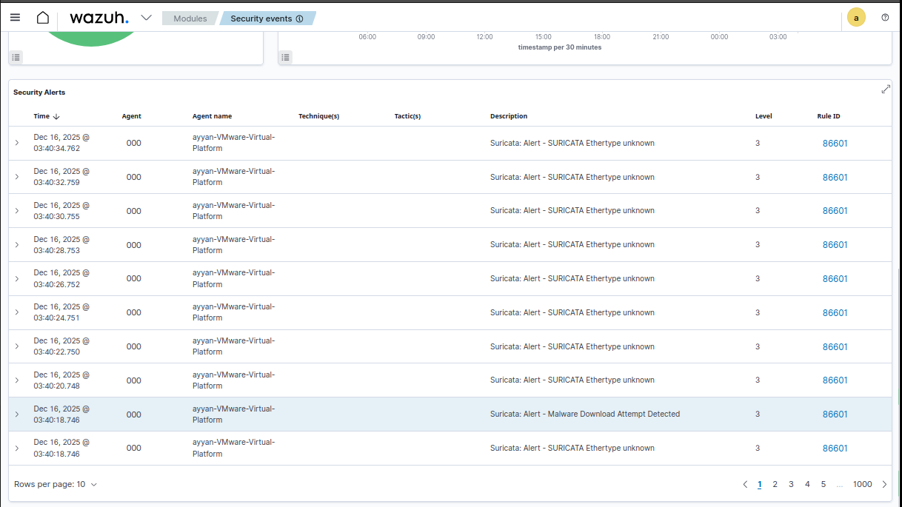

7. Conclusion
This task successfully demonstrates a functional Intrusion Detection simulation. Suricata effectively detects network-level threats, while Wazuh correlates and escalates alerts using custom rules. The integration provides visibility into attacks such as DDoS, port scanning, brute force, spoofing, and malware activity, closely resembling real-world SOC operations.

