INTERNATIONAL JOURNAL OF AGRICULTURE & BIOLOGY ISSN Print: 1560–8530; ISSN Online: 1814–9596

24–0220/2025/34:340111

[http://www.fspublishers.org](http://www.fspublishers.org/)

***Full Length Article***

A Comparison Between Smith-Hazel Index and Multi-trait Genotype- Ideotype Distance Index (MGIDI) in Winged Bean (*Psophocarpus tetragonolobus*) Breeding

## Sayyidah Afridatul Ishthifaiyyah1, Muhamad Syukur2*, Awang Maharijaya2, Trikoesoemaningtyas2 and Siti Marwiyah2

1*Program of Plant Breeding and Biotechnology, Graduate School, IPB University 16680, Indonesia*

2*Department of Agronomy and Horticulture, IPB University 16680, Indonesia*

*For correspondence: [muhsyukur@apps.ipb.ac.id](mailto:muhsyukur@apps.ipb.ac.id)

*Received 30 April 2024; Accepted 20 March 2025; Published online 01 May 2025*

**Editor:** Samiullah

# Abstract

The development of winged bean varieties in Indonesia has been hindered by late flowering and low productivity. To overcome this challenge, breeding programs must focus on obtaining superior varieties with early flowering time and high productivity, particularly for seed production purposes. This study aimed to compare the effectiveness of classic selection index and MGIDI in selecting from F2 winged bean population. The experiment was conducted at IPB University, Bogor, from April to November 2022. The genetic materials included purple-winged beans from Thailand (P1), green-winged beans from Indonesia (P2) and their offspring: F1, F1R, F2, BCP1 and BCP2. The populations were laid out in an augmented randomized complete block design with three replicates. The results showed that all observed characters were positively correlated with seed weight per plant, where the number of pods per plant exhibited the closest relationship (r = 0.82, *P* value = *0.00*), followed by seed weight per pod (r = 0.39, *P* value = *0.00*), number of seeds per pod (r = 0.30, *P* value = *0.00*) and pod weight (r = 0.30, *P* value = *0.00*). Thus, these characteristics can be used as selection criteria to obtain superior genotypes of winged beans. Sixteen plants were selected using SH-index and MGIDI. The plants F2-102, F2-110 and F2-259 were selected based on their performance for various traits that nearly match the ideotype. Selection response based on Smith-Hazel index and MGIDI demonstrated a decrease in flowering time and an increase in seed weight per plant in the following generation. Considering the simplicity, it is recommended to use MGIDI for multi-trait selection in other breeding programs, especially in early segregating generations.

**Keywords:** Correlation; Early-flowering; Genetic advance; Seed yield; Selection criteria; Winged bean

# Introduction

The winged bean (*Psophocarpus tetragonolobus* (L.) DC) is a diploid plant (2n = 2x =18) belonging to the Fabaceae family that has longitudinal winged pods and tuberous roots. This plant has determinate and indeterminate growth types to live as an annual or perennial plant. People generally perceive winged bean as a horticultural plant where young pods are harvested and consumed as a vegetable (Handayani 2013). Instead, there is another part of the plant that has great potential, which is the mature seeds. Winged bean seeds contain 33% protein, 19% fat and 39% carbohydrates (Amoo *et al.* 2006; Adegboyega *et al.* 2019). Compared to other indigenous legumes, the primary metabolite profile and characteristics of winged bean seeds are most similar to those of soybeans (Rif’atunidaudina 2018). Winged bean

seeds also produce oil with a higher thermal conductivity than soybean oil, which is suitable for cooking (Makeri *et al.* 2016). Blending winged bean seed oil into palm oil at a ratio of 75:25 can improve cloudiness resistance and increase unsaturated fatty acid content by up to 8% (Hishamuddin and Saw 2022). If this potential is optimized, then winged beans could become a promising commodity.

However, winged bean development has yet to be carried out optimally, so no national varieties are widely distributed among the community. Generally, people use local varieties and grow winged beans as gardens. The development of local winged beans is hampered by several factors, including late flowering time and low plant productivity (Eagleton 2019). Flowering time is a critical stage in plant life cycle since it ensures continuity of genetic transmission from one generation to the next generation

**To cite this paper:** Ishthifaiyyah SA, M Syukur, A Maharijaya, Trikoesoemaningtyas, S Marwiyah (2025). A comparison between smith-hazel index and Multi-Trait Genotype-Ideotype Distance Index (MGIDI) in winged bean (*Psophocarpus tetragonolobus*) breeding. *Intl J Agric Biol* 34:340111. https://doi.org/10.17957/IJAB/15.2346

© 2025 The Authors. International Journal of Agriculture and Biology published by Friends Science Publishers, Faisalabad, Pakistan

This is an open access article under the terms of the Creative Commons Attribution License, which permits non-commercial use, distribution and reproduction in any medium, provided the original work is properly cited

(Chakraborty *et al*. 2022). Early flowering would give advantages such as increases cropping index and prevents plants from stresses exposures that may happen during cultivation. In winged bean, flowering time was reported to be strongly associated with maturing time, which early flowering time led to early pod maturity (Tanzi *et al.* 2019). In addition, productivity is always the main target in crop improvement due to its economic value. Therefore, winged bean breeding programs need to be designed to obtain superior varieties with early flowering time and high productivity, particularly for seed production purposes.

In plant breeding programs, the selection process is an essential stage. Selection to obtain superior genotypes is challenging, especially if the breeder wants to collect several superior characters in one genotype. Index selection, proposed by Smith (1936) and Hazel (1943), is a strategy for selecting plant genotypes based on many characters. Nevertheless, assessing multiple traits simultaneously almost definitely results in the presence of associated traits, which might generate multicollinearity issues, leading to incorrect conclusions (Purnier *et al.* 2015; Olivoto and Nardino 2021). Furthermore, the lack of a technique for weighing economic importance makes it difficult to use this method (Lin 1978).

The Multi-trait Genotype-Ideotype Distance Index (MGIDI), which combines the genotype and ideotype distances, was created by Olivoto and Nardino (2021) as a solution to these problems. MGIDI has been widely used by breeders to select superior genotypes of oat, wheat, maize, sesame, rice and oil palm (Pour-Aboughadareh and Poczai 2021; Mamun *et al.* 2022; Klein *et al.* 2023; Ahsan *et al.* 2024; Pallavi *et al*. 2024; Sitepu *et al*. 2024). However, its application in winged bean breeding is still limited. This research aimed to study the effectiveness of classic index selection developed by Smith-Hazel and MGIDI in selecting winged bean genotypes in the F2 generation.

# Materials and Methods

## Study area and genetic materials

The study was conducted from April to November 2022 at the Leuwikopo Experimental Station (altitude of 250 m, latitude -6.563800°S and longitude 106.726083°E) and the Plant Breeding Laboratory of the Department of Agronomy and Horticulture, IPB University. The genetic materials were six basic generations of biparental winged bean cross, including P1, P2 and their offspring F1, F1R, F2, BCP1 and BCP2. The female parent was a purple-seeded genotype from Thailand with an early flowering time, long pods, large seed size and high protein content. In contrast, the male parent was a brown-seeded winged bean from Central Java, Indonesia. It has a late flowering time, a short pod with a small seed size and low protein content. The F1 plants were allowed to self-pollinate to produce an F2 population. BCP1 was generated by crossing F1 and P1, whereas BCP2 was generated by crossing F1 and P2.

# Experimental procedure

Sixty KU plants, 60 KH plants, 20 each of F1, F1R, BCP1 and BCP2 plants and 135 F2 plants were planted using an Augmented Design for a Randomized Complete Block Design with three replications. Single-row planting was carried out at a distance of 70 cm × 70 cm in 7 m2 beds covered with black and silver mulch. Bamboo stakes 2 m high were placed between the planting holes and then connected using wire to form a net. Soil ameliorant was given three weeks before planting using 20 tons of manure ha-1. Fertilizer was applied weekly using NPK 16:16:16 at a dose of 250 mL per plant and a concentration of 10 g L-1. Harvesting was performed when the pods were completely dry. Several quantitative variables, including morphological, developmental and yield-related traits, were assessed based on guidelines from PVTPP (2014) and Tanzi *et al*. (2019):

1) the number of branches (branches) was determined for the first 10 nodes of the main stem, with a minimum length requirement of 10 cm for branches with at least one fully developed leaf; 2) flowering time (days after planting/DAP) was observed from planting to the first flower opening; 3) the pod weight (g) was measured for each pod using the first 15 harvested pods; 4) dried pod length (cm) was measured from the top to the bottom of the pod using the first 15 harvested pods; 5) the number of seeds per pod (seeds) was calculated from the fully developed seeds in a pod using the first 15 harvested pods, 6) seed weight per pod (g) was measured from all developed seeds in a pod using the first 15 harvested pods; 7) 100-seeds weight (g) was measured for 100-seeds from each plant; 8) the number of pods per plant (pods) was calculated against all harvested pods from each plant; and 9) seed weight per plant (g) was measured against all seeds produced by each plant.

# Statistical analysis

Data were analyzed using Microsoft Excel, Minitab 16 and R Studio software. Microsoft Excel was used for adjusting the data and calculating the Smith-Hazel index. The data for each trait were adjusted to equalize the influence of environmental factors. Adjustments were made by calculating the 𝑎j (adjustment for block) value of the comparison genotype using the following formula:

𝑎j = 𝑥̅j − 𝑥̿,

Where, 𝑎j : adjustment value in j-th block; 𝑥̅j : j-th block mean; 𝑥̿: general mean of blocks. The calculation of the influence of blocks on the observed quantitative data is as follows:

𝑦(j = 𝑦𝑖j − 𝑎j,

Where, 𝑦(j: data resulting from the adjustment of the genotypes of the i-th rows and j-th block (block adjustment);

𝑦𝑖j: genotype data for row i and block j. Quantitative data

analysis included the following:

1. A t-test was run using Minitab 16 to study differences in the mean of quantitative characters between the parents (P1 and P2) and estimate maternal effects in the F1 and F1R populations.
2. The variance components included phenotypic variance (VP = VF2), environmental variance (VE), genotypic variance (VG = VP −VE), backcross variance (VBCP1 and VBCP2) and additive variance (VA).

V = (VF1+ VF1R + VP1+VP2)

1. The selection of genotypes with MGIDI was performed by analyzing all observed characters and considering the strengths and weaknesses of the chosen genotypes, as well as differential selection and genetic advance. This process was performed using the 'metan' package in R Studio.
2. The selection differential (S) and estimated genetic advance (ΔG) were calculated using the following formula:

S = ,Xs − X,0 ; ∆G = S . h2

E ) 4 +

2VF2 − (VBCP1+VBCP2)

ns

Where, X,s : the mean of selected genotypes, X,0 : the

ns

VA = )

VF2 +

mean of population before selection, h2 : narrow sense heritability.

1. The broad sense heritability (h2 ) was estimated based on the formula from Allard (1960), while the narrow sense

bs

heritability (h2 ) was estimated based on the formula from

# Results

ns

Warner (1952).

h2 =

VF2 − (VF1+ VF1R + VP1+VP2)/4

The following information provides a formal overview of the mean values and variances for various characteristics in

bs )

2

VF2 +

2VF2 − (VBCP1+VBCP2)

six generations of biparental winged bean cross. The data are

listed in Table 1-2. Significant differences (*P ≤ 0.05*) were

hns = )

2

h

bs : broad sense heritability

VF2 +

observed between the parents in nearly all characteristics,

except for 100-seed weight and seed weight per plant. P1 had

an earlier flowering time (53.20 ± 0.63 DAP) compared to P2 (80.80 ± 2.12 DAP). The hybridization of the parents

h2 : narrow sense heritability

ns

VF1 : variance of F1 VF2 : variance of F2 VP1 : variance of P1 VP2 : variance of P2

VBCP1 : variance of BCP1 VBCP2 : variance of BCP2.

1. Pearson’s correlation analysis between quantitative characters was used to determine characters related to flowering time and seed productivity.
2. The selection index was calculated using the following formula (Falconer 1961):

SI = b1P1+ b2P2+…+ bnPn SI : selection index

b1 : weighting factor for each character

P1 : standardized phenotypic value based on the following formula:

P = x – X̅,

σx

Where, x: the mean value of each genotype, X, : the mean value of certain characters from entire genotypes, dan σx: standard deviation.

In this study, the criteria utilized for selection were as follows: flowering time (-5), number of branches (-1), pod weight (2), dry pod length (2), number of seeds per pod (2), seed weight per pod (2), 100-seed weight (1), number of pods per plant (2) and seed weight per plant (5). The numbers in parentheses indicate the weight (b) assigned to each trait. Using a selection intensity of 20%, the genotypes with the highest SI were chosen, resulting in 27 genotypes being selected.

produced an F1 generation with a later flowering time (85.00

± 3.00 DAP). No significant difference in flowering time was found between the F1 and F1R populations. The mean flowering time for the backcross and F2 populations fell between parental values. P1 also exhibited fewer branches compared to P2, as evidenced by the mean of 2.6 ± 0.1 branches for P1 and 4.9 ± 0.1 branches for P2. Additionally, all offspring possessed a mean number of branches that was within the range between the two parents.

Based on its yield components, including pod weight, dried pod length, number of seeds per pod, seed weight per pod, number of pods per plant and seed weight per plant, P1 showed higher values for most of these components, with the exception of 100-seed weight. The greatest increase in seed weight per plant was observed in the F1 generation (F1: 193.70 ± 26.30 g, F1R: 138.70 ± 16.90 g), followed by the

backcross generation (BCP1: 122.20 ± 14.70 g, BCP2: 99.00

± 14.60 g). Significant differences were found between F1 and F1R for dry pod length, number of seeds per pod and seed weight per pod, as shown in Table 1-2. In terms of variance, P1, P2 and F1 exhibited lower variance than the others, indicating that they possessed the most uniform populations. Conversely, the backcross and F2 populations, which exhibited segregation, displayed higher variance.

Table 3 displays the heritability estimates for all observed characters. The study revealed that the broad sense heritability estimates ranged from 28.06 (number of pods per plant) to 87.54 (number of seeds per pod). On the other hand, the narrow sense heritability estimates ranged from

8.94 (seed weight per plant) to 86.16 (number of seeds per pod). Pearson's correlation analysis revealed that seed weight per plant was highly correlated with the number of

**Table 1:** Mean and variance of flowering time, number of branches, pod weight, dry pod length and number of seeds in six basic generations of winged bean

Population Traits

|  |  |  |  |  |  |  |
| --- | --- | --- | --- | --- | --- | --- |
|  | | FT (DAP) | NoB | PW (g) | DPL (cm) | NoS |
| P1 | X" ± SE | 53.20 ± 0.63 | 2.6 ± 0.1 | 9.92 ± 0.32 | 26.61 ± 0.50 | 17.1 ± 0.3 |
|  | σ! | 11.89 | 0.26 | 1.15 | 3.46 | 0.32 |
| P2 | X" ± SE | 80.80 ± 2.12 | 4.9 ± 0.1 | 7.82 ± 0.16 | 21.22 ± 0.31 | 12.5 ± 0.2 |
|  | σ! | 45.07 | 0.40 | 0.52 | 2.50 | 0.56 |
| F1 | X" ± SE | 85.00 ± 3.00 | 4.5 ± 0.5 | 7.91 ± 0.34 | 22.64 ± 0.43 | 12.9 ± 0.3 |
|  | σ! | 18.00 | 0.50 | 0.23 | 0.38 | 0.22 |
| F1R | X" ± SE | 85.00 ± 0.98 | 3.6 ± 0.1 | 8.95 ± 0.27 | 25.51 ± 0.76 | 16.2 ± 0.2 |
|  | σ! | 17.18 | 0.27 | 0.43 | 3.47 | 0.22 |
| BCP1 | X" ± SE | 58.71 ± 2.27 | 4.7 ± 0.4 | 9.92 ± 0.27 | 25.61 ± 0.62 | 13.9 ± 0.4 |
|  | σ! | 36.14 | 1.34 | 0.67 | 3.80 | 1.28 |
| BCP2 | X" ± SE | 51.57 ± 5.57 | 4.3 ± 0.5 | 8.05 ± 0.71 | 21.76 ± 0.79 | 12.0 ± 0.7 |
|  | σ! | 93.00 | 0.92 | 1.51 | 2.48 | 1.75 |
| F2 | X" ± SE | 61.52 ± 0.88 | 3.3 ± 0.1 | 7.86 ± 0.11 | 22.58 ± 0.16 | 13.1 ± 0.1 |
|  | σ! | 104.80 | 1.86 | 1.50 | 3.58 | 2.66 |
| t-value P1 *vs*. P2 |  | -12.46** | -12.41** | 5.82** | 9.20** | 13.56** |
| t-value F1 *vs*. F1R |  | 0.00ns | 1.76ns | -2.85ns | -3.28* | -9.21* |

X̅: mean, SE: standard error, σ2: variance, FT: flowering time, NoB: number of branches, PW: pod weight, DPL: dried pod length, NoS: number of seeds per pod, *: significant at 5% level of significance, **: significant at 1% level of significance, ns: not significant

**Table 2:** Mean and variance of seed weight per pod, 100-seed weight, number of pods per plant and seed weight per plant in six basic generations of winged bean

Population

SW (g) W100 (g) NPPP SWPP (g)

|  |  |  |  |  |  |  |
| --- | --- | --- | --- | --- | --- | --- |
| P1 | X" ± SE |  | 4.58 ± 0.17 | 29.70 ± 0.77 | 29.8 ± 1.5 | 105.27 ± 5.38 |
|  |  | σ! | 0.33 | 7.78 | 12.57 | 173.69 |
| P2 | X" ± SE |  | 4.11 ± 0.11 | 31.65 ± 0.60 | 25.8 ± 1.0 | 98.08 ± 8.80 |
|  |  | σ! | 0.25 | 9.29 | 11.96 | 852.28 |
| F1 | X" ± SE |  | 4.07 ± 0.2 | 32.47 ± 1.00 | 56.8 ± 11.5 | 193.70 ± 26.30 |
|  |  | σ! | 0.08 | 2.00 | 264.50 | 1,381.80 |
| F1R | X" ± SE |  | 5.02 ± 0.19 | 30.58 ± 0.45 | 35.5 ± 2.9 | 138.70 ± 16.90 |
|  |  | σ! | 0.22 | 1.24 | 34.25 | 1,146.70 |
| BCP1 | X" ± SE |  | 4.38 ± 0.18 | 32.01 ± 0.91 | 28.9 ± 3.8 | 122.20 ± 14.70 |
|  |  | σ! | 0.33 | 7.44 | 116.84 | 1,724.80 |
| BCP2 | X" ± SE |  | 3.61 ± 0.33 | 30.45 ± 2.55 | 33.0 ± 4.7 | 99.00 ± 14.60 |
|  |  | σ! | 0.44 | 26.06 | 89.58 | 848.30 |
| F2 | X" ± SE |  | 3.98 ± 0.06 | 30.05 ± 0.39 | 25.5 ± 0.9 | 89.84 ± 3.16 |
|  |  | σ! | 0.53 | 20.10 | 112.35 | 1,346.73 |
| t-value P1 *vs*. P2 |  |  | 2.37* | -2.00ns | 2.25* | 0.70ns |
| t-value F1 *vs*. F1R |  |  | -3.59* | 1.65ns | 2.44ns | 2.42ns |

X̅: mean, SE: standard error, σ2: variance, SW: seed weight per pod, W100: 100-seed weight, NPPP: number of pods per plant, SWPP: seed weight per plant, *: significant at 5% level of significance, **: significant at 1% level of significance, ns: not significant

**Table 3:** Variance and heritability estimates of quantitative traits in winged bean

|  |  |  |  |  |  |  |  |  |  |
| --- | --- | --- | --- | --- | --- | --- | --- | --- | --- |
| Variance | FT | NoB | PW | DPL | NoS | SW | W100 | NPPP | SWPP |
| Phenotype (VP) | 104.80 | 1.86 | 1.50 | 3.58 | 2.66 | 0.53 | 20.10 | 112.35 | 1,346.73 |
| Environment (VE) | 23.03 | 0.35 | 0.58 | 2.57 | 0.33 | 0.22 | 5.07 | 80.82 | 888.62 |
| Genetic (VG) | 81.77 | 1.50 | 0.92 | 1.01 | 2.33 | 0.31 | 15.02 | 31.53 | 458.11 |
| Additive (VA) | 80.46 | 1.46 | 0.83 | 0.88 | 2.29 | 0.28 | 6.70 | 18.28 | 120.36 |
| Non additive | 1.31 | 0.05 | 0.09 | 0.13 | 0.04 | 0.02 | 8.33 | 13.25 | 337.75 |
| h2 78.02 | | 80.95 | 61.41 | 28.17 | 87.54 | 58.18 | 74.75 | 28.06 | 34.02 |
| h2  ns 76.77 | | 78.31 | 55.10 | 24.60 | 86.16 | 53.57 | 33.33 | 16.27 | 8.94 |

bs

h2 : broad sense heritability, h2 : narrow sense heritability, FT: flowering time, NoB: number of branches, PW: pod weight, DPL: dried pod length, NoS: number of seeds per pod, SW: seed weight per pod, W100: 100-seed weight, NPPP: number of pods per plant, SWPP: seed weight per plant

bs ns

pods per plant (r = 0.82), followed by seed weight per pod (r = 0.39), number of seeds per pod (r = 0.30) and pod weight (r = 0.30) respectively.

Selection using the Smith-Hazel index generated 27 selected genotypes with selection index ranged from 9.99 to

25.04 (Table 4). The mean flowering time and seed weight per plant of selected genotypes were 57.71 DAP and 132.53 g, respectively. However, mean of flowering time and seed weight per plant for selected genotypes based on MGIDI were 57.09 DAP and 120.89 g (Table 5).

**Table 4:** Selected genotypes based on Smith-Hazel index selection

|  |  |  |  |  |  |  |  |  |  |  |  |
| --- | --- | --- | --- | --- | --- | --- | --- | --- | --- | --- | --- |
| No. | Genotype | FT (DAP) | NoB | PW (g) | DPL (cm) | NoS | SWPP (g) | W100 (g) | NPPP (pods) | SWPP (g) | SI |
| 1 | F2-124* | 53.57 | 3.0 | 9.48 | 24.70 | 15.9 | 5.24 | 30.17 | 32.3 | 166.97 | 25.04 |
| 2 | F2-110* | 48.57 | 2.0 | 10.52 | 24.83 | 14.8 | 5.78 | 37.82 | 18.3 | 118.72 | 22.48 |
| 3 | F2-259* | 51.57 | 4.0 | 9.21 | 24.24 | 15.7 | 5.07 | 29.11 | 39.3 | 150.32 | 22.32 |
| 4 | F2-31* | 58.57 | 4.0 | 8.83 | 23.94 | 13.9 | 4.41 | 35.37 | 42.3 | 189.64 | 22.02 |
| 5 | F2-43 | 63.57 | 3.0 | 9.72 | 24.04 | 13.9 | 5.05 | 37.06 | 38.3 | 165.94 | 20.50 |
| 6 | F2-560* | 66.57 | 3.0 | 8.40 | 26.36 | 13.1 | 4.39 | 33.33 | 44.3 | 192.49 | 20.46 |
| 7 | F2-619* | 60.22 | 2.6 | 8.04 | 22.55 | 15.5 | 4.41 | 24.64 | 48.8 | 186.41 | 20.06 |
| 8 | F2-725* | 62.21 | 3.4 | 9.49 | 26.09 | 14.1 | 4.60 | 30.80 | 40.9 | 142.92 | 17.29 |
| 9 | F2-711 | 59.21 | 2.4 | 11.29 | 25.11 | 13.9 | 5.86 | 41.50 | 19.9 | 87.99 | 15.72 |
| 10 | F2-615 | 65.22 | 2.6 | 10.36 | 24.86 | 13.3 | 5.33 | 38.61 | 25.8 | 129.09 | 15.30 |
| 11 | F2-680* | 71.22 | 5.6 | 10.29 | 26.37 | 16.5 | 5.20 | 30.31 | 30.8 | 136.24 | 15.14 |
| 12 | F2-10* | 55.57 | 2.0 | 9.47 | 24.20 | 15.9 | 5.13 | 31.50 | 22.3 | 108.36 | 14.85 |
| 13 | F2-692* | 61.21 | 1.4 | 9.05 | 24.99 | 15.4 | 4.91 | 32.10 | 28.9 | 115.52 | 14.33 |
| 14 | F2-569* | 34.57 | 3.0 | 8.22 | 25.60 | 13.6 | 4.47 | 32.27 | 26.3 | 72.72 | 13.76 |
| 15 | F2-252 | 69.57 | 4.0 | 10.54 | 27.14 | 16.1 | 5.44 | 34.98 | 19.3 | 108.50 | 13.56 |
| 16 | F2-687* | 55.21 | 3.4 | 8.44 | 25.35 | 14.2 | 4.60 | 31.47 | 31.9 | 120.14 | 13.47 |
| 17 | F2-211 | 47.57 | 4.0 | 8.75 | 23.59 | 13.2 | 4.30 | 33.44 | 34.3 | 112.46 | 12.89 |
| 18 | F2-696 | 70.21 | 5.4 | 9.26 | 25.43 | 14.1 | 4.61 | 30.28 | 41.9 | 150.65 | 12.80 |
| 19 | F2-599* | 64.22 | 4.6 | 9.04 | 25.82 | 16.2 | 4.72 | 32.01 | 30.8 | 118.93 | 12.78 |
| 20 | F2-115 | 44.57 | 2.0 | 8.97 | 23.30 | 14.5 | 4.79 | 34.42 | 18.3 | 89.25 | 12.58 |
| 21 | F2-339* | 50.57 | 2.0 | 9.23 | 22.86 | 14.9 | 4.63 | 29.78 | 28.3 | 99.19 | 12.35 |
| 22 | F2-82 | 54.57 | 6.0 | 8.28 | 21.24 | 13.0 | 4.74 | 33.59 | 35.3 | 145.50 | 11.39 |
| 23 | F2-102* | 48.57 | 3.0 | 7.55 | 23.96 | 16.3 | 4.04 | 26.41 | 27.3 | 111.56 | 11.39 |
| 24 | F2-589 | 63.22 | 3.6 | 9.78 | 22.66 | 14.9 | 5.29 | 31.45 | 25.8 | 119.92 | 11.30 |
| 25 | F2-595 | 68.22 | 5.6 | 7.21 | 20.96 | 13.4 | 4.06 | 26.29 | 57.8 | 187.57 | 10.87 |
| 26 | F2-618* | 57.22 | 3.6 | 8.64 | 22.87 | 13.8 | 4.54 | 28.54 | 32.8 | 127.70 | 10.42 |
| 27 | F2-138 | 52.57 | 4.0 | 8.89 | 21.57 | 12.5 | 4.50 | 40.59 | 22.3 | 123.56 | 9.99 |
|  | Mean | 57.71 | 3.5 | 9.15 | 24.25 | 14.5 | 4.82 | 32.51 | 32.0 | 132.53 |  |
|  | P1 | 53.20 | 2.6 | 9.92 | 26.61 | 17.1 | 4.58 | 29.70 | 29.8 | 105.27 |  |
|  | P2 | 80.80 | 4.9 | 7.82 | 21.22 | 12.5 | 4.11 | 31.65 | 25.8 | 98.08 |  |

*: Selected genotypes based on both indices (Smith-Hazel index and MGIDI), FT: flowering time, NoB: number of branches, PW: pod weight, DPL: dry pod length, NoS: number of seed per pod, SWPP: seed weight per pod, W100: 100-seeds weight, NPPP: number of pods per plant, SWPP: seed weight per plant, SWPP: seed weight per plant, SI: selection index, DAP: days after planting

**Table 5:** The comparisons between Smith-Hazel index and MGIDI

ns

ns

Parameter Smith-Hazel FT NoB PW DPL NoS SW W100 NPPP SWPP

Mean of selected genotypes ("Xs) 57.71 3.45 9.15 24.25 14.54 4.82 32.51 32.02 132.53

Mean F2 before selection (X"0) 61.52 3.34 7.86 22.58 13.15 3.98 30.05 25.52 89.84

Standard deviation F2 10.24 1.36 1.22 1.89 1.63 0.73 4.48 10.60 36.70

Selection response (S) -3.81 0.12 1.28 1.67 1.39 0.84 2.46 6.50 42.68

Narrow sense heritability (h2 ) 0.77 0.78 0.55 0.25 0.86 0.54 0.33 0.16 0.09

Genetic advance estimates (ΔG) -2.92 0.09 0.71 0.41 1.20 0.45 0.82 1.06 3.82

Predicted mean of F3 58.59 3.43 8.57 22.99 14.35 4.43 30.87 26.58 93.66

Parameter MGIDI

FT NoB PW DPL NoS SW W100 NPPP SWPP

Mean of selected genotypes ("Xs) 57.09 3.05 8.41 24.15 14.78 4.38 28.79 32.09 120.89

Mean F2 before selection (X"0) 61.52 3.34 7.86 22.58 13.15 3.98 30.05 25.52 89.84

Standard deviation F2 10.24 1.36 1.22 1.89 1.63 0.73 4.48 10.60 36.70

Selection response (S) -4.43 -0.28 0.54 1.58 1.63 0.40 -1.26 6.57 31.05

Narrow sense heritability (h2 ) 0.77 0.78 0.55 0.25 0.86 0.54 0.33 0.16 0.09

Genetic advance estimates (ΔG) -3.40 -0.22 0.30 0.39 1.41 0.22 -0.42 1.07 2.78

Predicted mean of F3 58.12 3.11 8.16 22.97 14.55 4.19 29.63 26.59 92.62

FT: flowering time, NoB: number of branches, PW: pod weight, DPL: dried pod length, NoS: number of seeds per pod, SW: seed weight per pod, W100: 100-seed weight, NPPP: number of pods per plant, SWPP: seed weight per plant

# Discussion

The selection process is an essential stage in plant breeding programs. The selection of superior genotypes is based on target traits, which are also referred to as selection criteria. A high level of genetic variability is the primary asset for breeders in conducting effective selection. In addition,

appropriate selection criteria must also be taken into account to enhance the effectiveness of the selection process. It is not solely the mean value that determines selection criteria; the heritability must also be considered. When the target trait has low heritability, it is necessary to identify secondary traits that are closely related and have a higher heritability than the target trait to be used as selection criteria (Acquaah 2007).

This study used two-winged bean genotypes with distinct quantitative and qualitative traits. P1 demonstrated superiority over P2 based on quantitative characteristics, as it had an earlier flowering time and a higher number of pods per plant. P1 also had larger pods and more seeds per pod, resulting in a greater seed weight per pod than P2. Hybridization between P1 and P2 and their reciprocal produced off-springs with significantly different mean values for dry pod length, number of seeds per pod and seed weight per pod, indicating a maternal effect or the role of genes outside the nucleus that control these three traits. Maternal effect on those traits were not found in soybean but it was found in faba bean for number seeds per pod (Ghareeb and Fares 2016; Kosev and Georgieva 2019; Badiaraja *et al.* 2021). However, no maternal effect was observed in other traits; therefore, the F1 and F1R populations could be combined for further analysis.

The variances of the parents and first offspring were generally less than those of the backcross and F2 populations. This could be attributed to the fact that P1 and P2 are homozygous pure lines, whereas F1 and F1R are heterozygous hybrids. Each population possesses the same genetic makeup as plants (homogeneous); hence, the variability observed is solely influenced by environmental factors. On the other hand, BCP1, BCP2 and F2 are segregating populations that exhibit variability as a result of genetic and environmental factors. Among these populations, F2 displayed the highest genetic variability, making it an appropriate population for estimating phenotypic variance (Falconer and Mackay 1996).

The selection process is typically based on a character's phenotypic value, which encompasses both genetic and environmental factors, as well as their interaction (Kang 2020). It is important to consider the proportion of genetic variation to phenotypic variation to increase the likelihood of selecting individuals that will produce offspring with phenotypic values higher than their parents. This comparison value is known as heritability, which is a measure that describes the extent to which the visible phenotype reflects the genotype. Narrow sense heritability has received considerable attention since the additive effect of each allele is passed on from parents to their offspring, resulting in a visible phenotype that is not influenced by allele interactions. The estimated heritability is generally categorized into three groups: high (> 50%), medium (20%–50%) and low (< 20%).

In this study, the value of broad sense heritability for the examined traits was classified as being moderate to high, while the narrow sense heritability was rated as low to high. The traits with high estimates of both broad and narrow sense heritability were flowering time, the number of branches, pod weight, the number of seeds per pod and seed weight per pod. A high broad sense heritability for the first flower appearance and number of branches were also found in cowpea, indicating high contribution of genetic factors that influence phenotypic performance (Owusu *et al.* 2020).

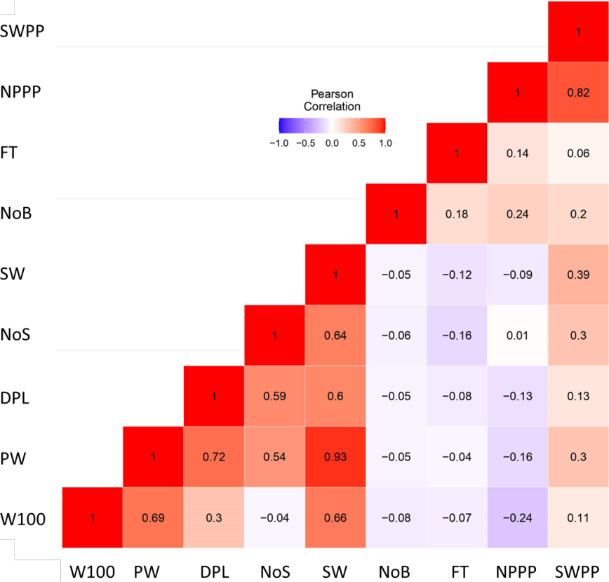

**Fig. 1:** Pearson correlation between quantitative traits in winged bean. W100: 100-seed weight, PW: pod weight, DPL: dried pod length, NoS: number of seeds per pod, SW: seed weight per pod, NoB: number of branches, FT: flowering time, NPPP: number of pods per plant, SWPP: seed weight per plant

On the other hand, dry pod length showed moderate heritability estimates, similar to the previous result conducted by Owusu *et al.* (2020) in cowpea. A high narrow sense heritability estimates indicate that the observed genetic variability in the traits was largely influenced by additive factors. The 100-seeds weight exhibited a high broad sense heritability and moderately narrow sense heritability. Conversely, the number of pods per plant and seed weight per plant showed moderate broad sense heritability and low narrow sense heritability, suggesting that non-additive factors played a role in determining the genetic variation of these traits.

Pearson correlation analysis showed a positive relationship between all agronomic characters and seed weight per plant, where the number of pods per plant had the closest relationship (r = 0.82), followed by seed weight per pod (r = 0.39), number of seeds per pod (r = 0.30) and pod weight (r = 0.30) (Fig. 1). These results confirmed previous research by Ishthifaiyyah *et al.* (2023) who reported that winged bean seed productivity was directly influenced by the number of pods per plant. In this study, NPPP, SW, NoS and SW also had higher narrow sense heritability than SWPP, so they could be used as selection criteria to obtain winged bean genotypes with high seed productivity.

Selection of superior winged bean genotypes with early flowering and high seed productivity can be accomplished through various methods, including index selection. In this study, classic index selection developed by Smith (1936) and Hazel (1943) were performed together with Multi-trait Genotype-Ideotype Distance Index (MGIDI) to choose

superior winged bean genotypes. The Smith-Hazel selection index was calculated by assigning a weight to each standardized selection criterion, while genotype selection in the MGIDI was based on the genotype and ideotype distances adjusted by the breeder (Olivoto and Nardino 2021).

In this case, winged bean improvement was subjected to obtain high yielding genotypes with early flowering time. The criteria used for selection were as follows: flowering time (- 5), number of branches (-1), pod weight (2), dry pod length (2), number of seeds per pod (2), seed weight per pod (2), 100-seed weight (1), number of pods per plant (2) and seed weight per plant (5). The numbers in parentheses indicate the weight assigned to each trait, with earlier flowering time and fewer branches being desired traits, as indicated by the use of negative signs in the model. Flowering time and seed weight per plant were the main targets of this selection, so they had the biggest weight among the others.

Selection was carried out using 20% selection intensity, generating 27 selected genotypes, with 16 genotypes selected based on both indices (Table 4; Fig. 2a). These genotypes included F2-10, F2-31, F2-102, F2-110, F2- 124, F2-259, F2-339, F2-560, F2-569, F2-599, F2-618, F2-619,

F2-680, F2-687, F2-692 and F2-725. The Smith-Hazel index successfully selected five genotypes that had better flowering time and seed weight per plant than the parents, three of which were also selected based on the MGIDI (F2- 102, F2-110 and F2-259). Based on the strength and weakness view, the three genotypes showed strengths in different characters (Fig. 2b). The F2-102 was superior in characters classified as FA3, namely flowering time, number of branches and number of seeds per pod. Meanwhile, the F2-110 genotype showed superiority in yield components classified in FA1, including dry pod weight, dry pod length, seed weight per pod and 100-seed weight. On the other hand, the strong points of F2-259 were the number of pods per plant and seed weight per plant.

The Smith-Hazel index was thought to increase the genetic advance of flowering time and seed weight per plant by -2.92 and 3.82, respectively (Table 5). This means that if the 27 selected F2 genotypes are planted, they would produce an F3 population with a mean flowering time of

2.92 days earlier and a seed weight per plant that is 3.82 g higher than the F2 population. Meanwhile, the predicted values for genetic advance in flowering time and seed weight per plant based on the MGIDI were -3.40 and 2.78, respectively. This means that selection with MGIDI is likely to reduce the mean flowering time of winged beans by 3.40 days and increase the mean seed weight per plant by 2.78 g. Thus, the estimated mean value of flowering time and seed weight per plant in the F3 population were 58.12 DAP and

92.62 g, respectively.

Using both indices, breeders need to conduct selection for at least 3 generations to obtain superior winged bean genotypes that had a combination of early flowering time and high seed yield, which is better than the parents. Simultaneous selection using a weighted index with the

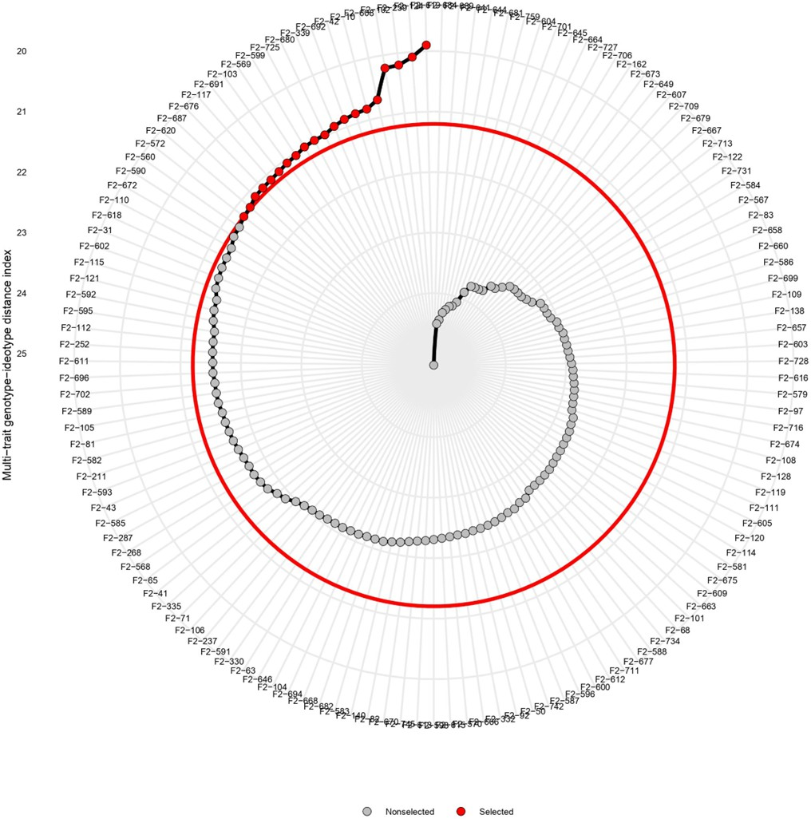

**Fig. 2a:** Selected genotypes based on MGIDI showed by the red dots

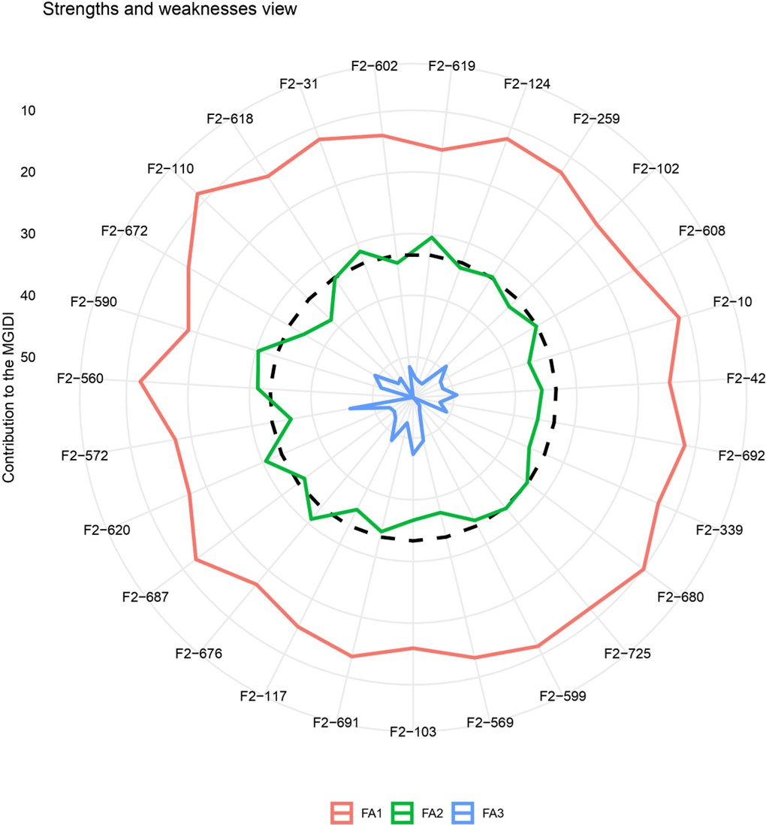

**Fig. 2b:** Strengths and weaknesses view of selected genotypes based on MGIDI. FA: factor analysis (FA1: pod weight, dry pod length, seed weight per pod, 100-seed weight; FA2: number of pods per plant, seed weight per plant; FA3: flowering time, number of branches, number of seeds per pod)

Smith-Hazel and MGIDI resulted in a comparable genetic advance. Considering the ease of use, selection using MGIDI was supposed to be more precise and efficient to select superior genotypes with early flowering times and high seed productivity.

# Conclusion

The number of pods per plant, seed weight per pod, number of seeds per pod and pod weight were chosen as secondary traits to select high-yielding winged bean genotypes. F2-102, F2-110 and F2-259 were potential genotypes that later need to be purified and used as variety candidates of winged bean for seed production purposes. Selection response based on Smith-Hazel index and MGIDI demonstrated a decrease in flowering time and an increase in seed weight per plant in the following generation. Thus, both indices are able to select superior genotypes in the early generation, considering multiple traits simultaneously, regardless of whether the criteria had different selection preferences. However, MGIDI was supposed to be more efficient than Smith-Hazel index so it can be recommended as a tool for multi-character selection in other plant breeding programs.

# Acknowledgements

The authors would like to acknowledge the Indonesia Directorate General of Higher Education (DIKTI) for providing financial support through PMDSU research grant financial year 2022 No. 001/E5/PG.02.00PT/2022.

# Author Contributions

SAI conducted the entire experiment, performed the statistical analysis and drafted the manuscript. MS designed the experiment, supplied the necessary resources, including parental genotype and funding and provided supervision. AM, Tr and SM contributed to the manuscript by providing guidance and oversight throughout the experiment.

# Conflict of Interest

The authors declare no conflicts of interest.

# Data Availability

Data presented in this study will be available on a fair request to the corresponding author.

# Ethics Approval

Not applicable to this paper.

# References

Acquaah G (2007). *Principles of Plant Genetics and Breeding*. Blackwell Publishing, Oxford, UK

Adegboyega TT, MT Abberton, AH AbdelGadir, M Dianda, B Maziya- Dixon, OA Oyatomi, S Ofodile, OO Babalola (2019). Nutrient and antinutrient composition of winged bean (*Psophocarpus tetragonolobus* (L.) DC.) seeds and tubers. *J Food Qual* 10:1–8

Ahsan AFMS, Z Alam, F Ahmed, S Akter, MAH Khan (2024). Selection of waterlogging tolerant sesame genotypes (*Sesamum indicum* L.) from

a dataset using the MGIDI index. *Data Brit* 53:110176

Allard RW (1960). *Principles of Plant Breeding*. John Wiley & Sons, New York, USA

Amoo IA, OT Adebayo, AO Oyeleye (2006). Chemical evaluation of winged beans (*Psophocarpus tetragonolobus*), pitanga cherries (*Eugenia uniflora*) and orchid fruit (orchid fruit Myristica). *Afr J Food Agric Nutr Dev* 6:1–12

Badiaraja PH, S Zubaidah, H Kuswantoro (2021). Maternal effect of agronomic and morphological characters on cluster structure of F3 soybean lines. *Biodiversitas* 22:969–982

Chakraborty A, R Chaudhury, S Dutta, M Basak, S Dey, AR Schaffner, M Das (2022). Role of metabolites in flower development and discovery of compounds controlling flowering time. *Plant Physiol Biochem* 190:109–118

Eagleton GE (2019). Prospects for developing an early maturing variety of winged bean (*Psophocarpus tetragonolobus*) in Bogor, Indonesia. *Biodiversitas* 20:3142–3152

Falconer DS (1961). I*ntroduction to Quantitative Genetics*. Oliver 7 Boyd, Edinburg, Scotland

Falconer DS, TFC Mackay (1996). *Introduction to Quantitative Genetics*, 4th edn. Longman Group Ltd., Essex, England

Ghareeb ZE, WM Fares (2016). Modified model for assessment of maternal effects in first generation of faba bean. *Ann Agric Sci* 61:77–85

Handayani T (2013). Kecipir (*Psophocarpus tetragonolobus* L.), Potensi Lokal yang Terpinggirkan. *J IPTEK Tanam Sayuran* 1:1–8 [Indonesian]

Hazel LN (1943). The genetic basis for constructing selection indexes.

*Genetics* 28:476‒490

Hishamuddin E, MH Saw (2022). Enhancement of physicochemical characteristics of palm olein and winged bean (*Psophocarpus tetragonolobus*) seed oil blends. OCL - Oilseeds fats. *Crop Lipid* 29:2–7

Ishthifaiyyah SA, M Syukur, Trikoesoemaningtyas, A Maharijaya, S Marwiyah (2023). Yield-related traits and proximate content of winged bean for seed production purpose. *Biodiversitas* 24:3609– 3615

Kang MS (2020). *Quantitative Genetics, Genomics and Plant Breeding*.

CAB International, Boston, USA

Klein LA, VS Marchioro, M Toebe, T Olivoto, D Meira, C Meier, G Benin, CA Busatto, DC Garafini, JV Alberti, JLB Finatto (2023). Selection of superior black oat lines using the MGIDI index. *Crop Breed Appl Biotechnol* 23:1–9

Kosev V, N Georgieva (2019). Inheritance of main quantitative traits in broad bean (*Vicia faba* L.). *J Biosci Biotechnol* 8:135–140

Lin CY (1978). Index selection for genetic improvement of quantitative characters. *Theor Appl Genet* 52:49–56

Makeri MU, R Karim, MS Abdulkarim, HM Ghazali, MS Miskandar, K Muhammad (2016). Comparative analysis of the physico-chemical, thermal and oxidative properties of winged bean and soybean oils. *Intl J Food Proper* 19:2769–2787

Mamun AA, MM Islam, SK Adhikary, MS Sultana (2022). Resolution of genetic variability and selection of novel genotypes in EMS induced rice mutants based on quantitative traits through MGIDI. *Intl J Agric Biol* 28:100–112

Olivoto T, M Nardino (2021). MGIDI: Toward an effective multivariate selection in biological experiments. *Bioinformatics* 37:1383–1389

Owusu EY, H Mohammed, KA Manigben, J Adjebeng-Danquah, F Kusi, B Karikari, EK Sie (2020). Diallel analysis and heritability of grain yield, yield components and maturity traits in cowpea (*Vigna unguiculata* (L.) Walp.). *Sci World J* 2020:1–9

Pallavi M, BPM Prasad, P Shanthi, VLN Reddy, ARN Kumar (2024). Multi trait genotype-ideotype distance index (MGIDI) for early seedling vigour and yield related traits to identify elite lines in rice *(Oryza sativa* L.). *Electr J Plant Breed* 15:120–131

Perlindungan Varietas Tanaman dan Perizinan Pertanian (PVTPP) (2014). *Guidelines for conduct of test for distinctness, uniformity and stability winged bean (Psophocarpus tetragonolobus L)*. Center for Plant Variety Protection and Agricultural Licensing, Ministry of Agriculture, Jakarta [Indonesian]

Pour-Aboughadareh A, P Poczai (2021). Dataset on the use of MGIDI index

in screening drought-tolerant wild wheat accessions at the early growth stage. *Data Brit* 36:107096

Purnier JG, M Colyn, X Legendre, KF Nimon, MC Flamand (2015). Multicollinearity in spatial genetics: separating the wheat from the chaff using commonality analyses. *Mol Ecol* 24:263–283

Rif’atunidaudina R (2018). Studies on morphological, primary metabolites content and molecular diversity among underutilized pulse genetic resources of Indonesia. *Thesis*, p:94. IPB University, Bogor, Indonesia

Sitepu AF, Y Yenni, Sujadi (2024). Multi-character selection for identifying superior oil palm cultivar using MGIDI. *In: IOP Conference Series: Earth and Environmental Science*, Vol. 1308, pp:1-8. IOP Publishing

Smith HF (1936). A discriminant function for plant selection. *Ann Eugen*

7:240‒250

Tanzi AS, WK Ho, F Massawe, S Mayes (2019). Development and interaction between plant architecture and yield-related traits in winged bean (*Psophocarpus tetragonolobus* (L.) DC.). *Euphytica* 215:1–14

Warner JN (1952). A Method of estimating heritability. *Agron J* 44:427–430