Real-time Spatio-Temporal Databases in Support of
Human Motor Skills

Shahram Ghandeharizadeh

USC Computer Science Department
Los Angeles, California 90089-0781

April 23,2001
Abstract

Advances in computer processing, communication, and storage have made multimedia information systems a reality. This paper explores haptic devices as an extension of these systems to capture the spatio-temporal data that pertains to human motor skill. We outline approaches to store and retrieve this data, along with data analysis techniques to facilitate query processing and data mining. Example applications that benefit from this research effort include patient rehabilitation, education, hand-sign recognition, and scientific applications.

- INTRODUCTION

The term multimedia has a different meaning to different communities. The computer industry uses this term to refer to a system that can display audio and video clips. Generally speaking, a multimedia system supports multiple modes of presentation to convey information. Humans have five senses: sight, hearing, touch, smell and taste. Thus, in theory, a system based on this generalized definition must be able to convey information in support of all senses. This would be a step towards virtual environments that facilitate total recall of an experience. The focus of this study is to explore touch and motor skill as an extension of multimedia information management system.

Driven by virtual reality applications, early 1990s witnessed a growing interest in haptic devices. By definition, a haptic interface is a force–reflecting device that enables a user to touch, feel and manipulate a virtual object. Its application domain ranges from entertainment to education and patient rehabilitation. With education, for example the dental curriculum of almost all major universities dedicates a portion of its program to train students on how to perform a procedure, e.g., root canal. Their focus is to educate students on the dexterity required to perform the procedure at a very fine (millimeter) granularity. These programs typically require students to observe the instructor followed with practice sessions. Haptic devices complement this curriculum by empowering students to experience the dexterity of the instructor. The idea is for the instructor to wear a haptic glove and perform the procedure. The haptic glove is equipped with sensors that monitor the movement of the instructor’s joints and the force exerted by each joint. Each sensor provides a stream of data that is stored in multimedia database management system. Next, a student would wear the glove. This time, the multimedia database management system controls the movement of student’s hand by streaming recorded data to the glove, enabling the student to experience the instructor’s dexterity. The glove can also be used to monitor the student’s learning progress to provide feedback (almost identical to an instructor watching and providing feedback ). Wearing the glove, the student would perform the procedure while the glove records his or her movement. Next, the underlying multimedia data base management system compares this recording with recording from the instructor in order to provide the student with detailed feedback, e.g., the student might not be moving his hand at the right velocity and accuracy at certain corners, the index finger of the student might not be at the right position relative to the other fingers, etc.

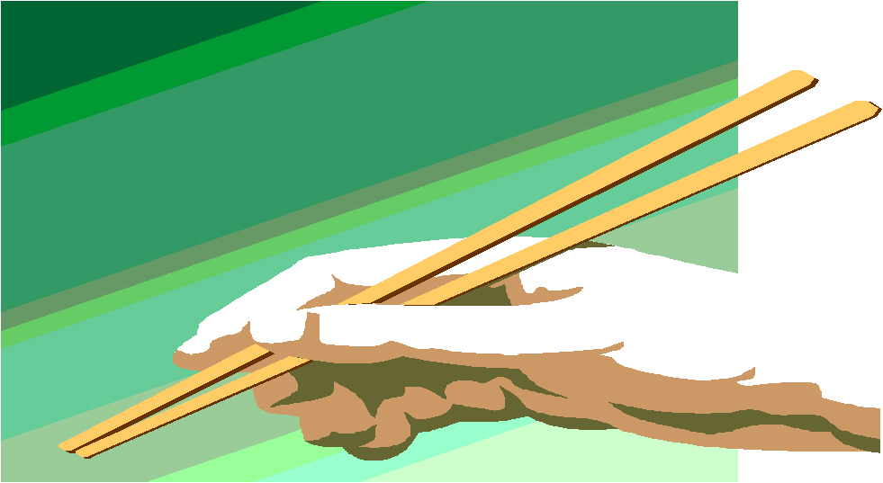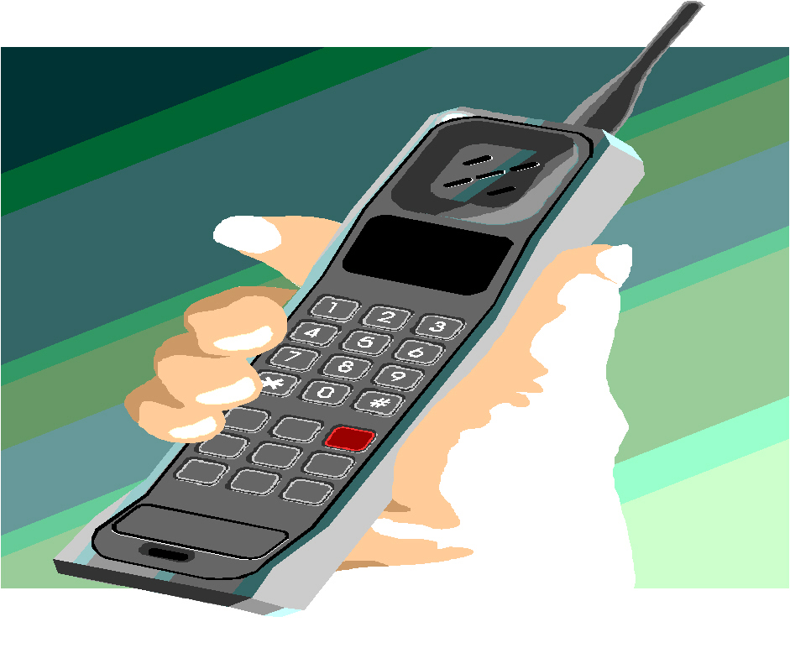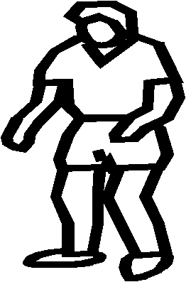

Multimedia Database
Haptic
Robotics
Learning
Training

Figure 1: Key components of a system

Haptic devices can also complement existing physical rehabilitation programs for patients with either a transplant or a prosthetic device that restores a motor skill. As an example, consider Mathew Scott who was featured in February 8, 1999 issue of Newsweek as the first person in United States to receive a hand transplant after a 15-hour surgery at the Jewish Hospital of Louisville, Kentucky. He had lost his hand to a 4th of July fireworks accident fifteen years earlier. His operation involved a 17-member surgical team to re-attach multiple tissues: skin, muscle, tendon, bone, nerves, and blood vessels. Haptic devices would be useful for rehabilitating patients similar to Mathew. Once again, the idea would be to collect recordings form a haptic glove while worn by a trainer who is performing complex activities such as dial a telephone, light a lighter, use chopsticks, etc. Next the patient would be provided with the glove in order to experience the transplant and its stimuli to the nerves, see Figure 1. The multimedia database may transform the raw data into knowledge by associating streams with the different limbs and muscle groups. This would empower patients such as Mathew to ask for those activities related to a specific finger (say index) in order to experience and exercise a single limb.

Both examples demonstrate that a haptic device extended with a multimedia Database Management System (MDBMS) is a valuable tool. (Such a coupling does not exist at the time of this writing.) While both highlight the use of a haptic glove, our research is envisioned to be general purpose and applicable to other haptic devices in support of motor skills. However, in order to simplify discussion, we use the human hand along with the haptic glove for the remainder of this study.

With both examples, the environment consists of three distinct modes of operation:
- Record: An instructor (or a physical trainer) performs a complex activity while wearing the glove. Each sensor attached to the glove generates a stream of data that is transmitted to continuous media server for storage.
- PLAY: A student (or patient) experiences the motor skill required in support of a specific activity by wearing the glove and playing back the recorded streams that constitute the activity. During this mode, the MDBMS retrieves the streams to activate the glove.
- TEACH: The system analyzes the movement of a student (or patient) in support of a complex activity to: (a) provide feedback as to what the student might be doing working, and (b) suggest informs the system that she (or he) wants to perform a specific procedure (say root canal on a manican). The glove records the information form the student has performed the activity correctly. When the system detects an error, it identifies which fingers where not in the right position and suggests possible exercises to help the student.

At the time of this writhing, one may find components of MDBMS, e.g., MITRA [24], and a haptic glove, e.g., Cyber Grasp, independent of one another. A marriage of these two raises several research directions. Here are a few :

- When the instructor and student’s hand have different dimensions, how can the database process the data to compensate for this difference in PLAY mode?
- An activity, e.g., dial a telephone, might be performed in a slightly different way every time that it is performed by the instructor/trainer during RECORD mode. How can the MDBMS process the data and extract the senesce of the motor-skill movement for the student/patient?
- When a student performs and activity in TEACH mode, how can the system process the data to evaluate what the student might be doing wrong?
- In TEACH mode with a given student, how can the system build a profile of the student to evaluate when learning is in progress and when learning is complete? Assuming that this is successful, how can the system propose other activities that would help the student to elevate to the next dexterity level?

1.1 What makes these research directions feasible?

Several key technological advances are making these research directions possible. First, computer components are becoming faster and more reliable every year. As predicted by Moore in 1965, computer CPUs becomes approximately twice faster every 12 to 18 months. While some predict an end to this trend with compound semiconductor, there exist alternatives such as superconducting metal, niobium, in support of 100 Gigahertz processors [4,5]. Second, cost of data storage is dropping by approximately a factor of two every 12 to 18 months with industry offering smaller devices. To illustrate, in 1980, IBM’s 3380 offered one Gigabyte of storage for $40,000. This refrigerator sized device weighed 550 Pounds (250Kg). Twenty years later, in 2000, IBM’s Micro drive offered the same storage capacity in a 1-inch device that weighed 1 Ounce (16 Grams) for $550. Another trend in the area of storage are high-density devices. At the time of this writing, 200 Gigabyte disk drives are commonplace. With rapid advances in disk head technology that can pack magnetic disks with a large amount of data per square centimeter [9], magnetic disks that offer terabytes of storage should be available in a few years from this writing. Third, rapid advances in both wire-based and wireless communication technology enables devices to exchange data rapidly. One may observe bandwidths in the order of tens of megabits per second from 802.11a/g cards. Fourth, the power consumption of these devices decreases every year, in turn reducing the amount of dissipated heat. These trends point toward powerful haptic devices with small footprints that can gather a large volume of data from a person’s joints and reason about this data in a fraction of a second.

One area that deserves greater scrutiny is the mechanical nature of haptic devices. First, they should be designed to minimize the likelihood of physical injury to their users. Second, they should become more reliable and user friendly in order to be accepted for general use.

The rest of this paper is organized as follows. Section 2 details technique in support of data retrieval. In Section 2.2, we describe the spatio-temporal characteristics of data. In Sections 3 and 4, we detail how this data is used for data mining and query processing. Brief conclusions are offered in section 5.

- CONTINOUS MEDIA AND HAPTIC DEVICES

The data generated by each sensor of a haptic glove is continuous media with a pre-specified bit rate requirement. If a system delivers a movement at a slower rate than its pre-specified rate without special precautions, the user might observe logical errors that result in undesirable behavior, e.g., with chopsticks, either one or both sticks might fall out of place. A second important characteristic of the haptic glove is the temporal constraints that exist between multiple streams. These temporal constraints are computed during RECORD mode. Moreover, during the PLAY mode, the system must ensure that the retrieval and rendering of data respect these temporal constrains. Otherwise, once again, the resulting motor skill might fail to satisfy the required task, e.g., causing one or both chopsticks to fall. Both types of logical errors are collectively termed hiccups [22]. In the following, we start by describing a scalable server to store the stream generated by a haptic glove and support hiccup free displays. Next, we focus on how to capture the temporal relationships between the different streams (i.e., sensors) and how to ensure that the retrieval of data respects these constraints. Finally, section 2.2 details how we intend to relate the different streams to the different joints and muscle groups in a hand in order to facilitate query processing.

2.1 MITRA: A SCALABLE CONTINUOUS MEDIA SERVER

From 1993 to 1999, we conducted pioneering research in support of a multimedia server that can store and retrieve continuous media. This research focused on multi-user systems that: (a) employs off-the-shelf hardware, (b) a software architecture that can scale as a function of the underlying hardware platform to support thousands of simultaneous streams, (c) utilize hierarchical storage structures to minimize cost, (d) use intelligent data placement techniques, disk scheduling algorithms, and buffering schemes to enhance either the cost effectiveness of a configuration (competitive cost per stream) or the experience by minimizing latency, i.e., the amount of delay incurred from when a user requests a stream to the start of a display. This research result is embodied in MITRA [24], an experimental prototype developed at USC. MITRA’s original hardware platform consisted of a cluster of workstation using Unix operating system. Currently, MITRA’s platform consists of a cluster of PCs using Microsoft Windows NT operating system. Attached to each PC is an Adaptec SCSI card with several magnetic disks, the system can show audio and video data encoded in different formats, e.g., MPEG.

Simultaneous to our implementation efforts, other investigators conducted pioneering research on fault-tolerant techniques in support of continuous media, e.g., [3, 4]. MITRA implements a simple mirroring technique to ensure the availability of data in the presence of disk failures. However, it can be extended to incorporate the more elaborate designs found in the literature.

In order to minimize the cost of storage with large data sets, MITRA is designed to support a hierarchical storage structure consisting of: either one or multiple tertiary storage devices, D disks, and M megabytes of memory [15, 26, 25, 45, 44]. The database resides permanently on the tertiary storage devices. Streams are materialized on the disk drives on demand (and deleted when the disk storage capacity is exhausted). A small fraction of a stream is staged in memory to support its display (see next paragraph for details). We have analyzed pipelining algorithms that stage portions of a stream intelligently from the tertiary storage on to magnetic storage in order to minimize the latency incurred when displaying a stream [16, 23].

At the file system level, each stream that constitutes a task is partitioned into a sequence of blocks. When the task is referenced, a block of each stream is staged from disk into memory for display (assuming that they are disk resident; otherwise, they must either be staged or pipelined from tertiary, see [16, 23]). Moreover, resources are scheduled intelligently in order to prevent data starvation. This ensures the availability of the right block at the right time for rendering [21, 13, 48, 49, 32, 39, 40, 42]. Moreover, this maximizes the number of simultaneous streams supported by a system configured with a fixed amount of resources. With D disks, the data blocks that constitute a stream are dispersed across all disks to distribute the load imposed by the retrieval of that stream evenly across the D disks (this is an important consideration when scalability is an objective). There are two ways to partition data blocks across disks [19, 34]: a) deterministic, e.g., round-robin [2] and b) un-deterministic, e.g., random [34]. In addition, there are a variety of ways to schedule resources and perform admission control [37]. In a nut shell, the tradeoff between these choices is one of: a) saving money versus saving time [21, 20], b) throughput versus latency [21, 7], and c) guaranteeing continuous display versus the possibility of a slight chance for data starvation and hiccups [46, 37]. A system designer must understand the requirements of the human motor skill in order to configure the system with the appropriate data placement, scheduling, and admission control strategy.

Assuming that the available bandwidth is scarce, one may assign a different priority to the different streams that constitute an activity (based on the different joints and fingers). Next, each stream is assigned a priority starting with the least important stream. In essence, a stream with a higher priority is more important. There are a host of scheduling techniques that strive to meet the deadline of as many low priority requests while meeting the deadline of almost all high priority requests [28].

2.2 SPATIO-TEMPRAL MULTIMEDIA OBJECTS AND EoL

We use Allen’s temporal constructs [1] to capture the temporal constraints that exist between multiple streams. Using these constructs, we can optimize both the placement of data and scheduling of resources in order to maximize system performance [8]. In the following, we describe each in turn. In passing, it is important to note that storage of streams is not currently supported by the Cyber Glove; the following is how we intend to capture this information.

During recording of a task, we use Allen’s starts and finishes constructs to mark the beginning and end of those streams that constitute the task. This is accomplished by identifying one stream as the master and the remaining 21 as slaves. Each of the slaves are synchronized with the master. Moreover, these temporal constructs can be periodically repeated in the recorded streams to prevent drifts during playback. There are alternative ways of capturing the above representation [14]. Currently, we plan to use an object-relational database and define a composite object that keeps track of the master and slave streams along with their temporal constraints (detailed below). Each stream is termed an atomic object.

In [8], we analyzed hiccup-free display of composite video and audio streams by scheduling resources intelligently. This study focused on applications that construct composite objects on the fly, e.g., CNN’s newsroom where an editor accesses an archive and constructs composite objects to narrate a documentary. It assumed that the placement of data cannot be modified to enhance the utilization of resources in order to minimize the delay incurred when a user requests the display of a composite object. Based on this assumption, it identified intra-object conflicts where retrievals of multiple streams that constitute the object compete for a single disk of D disk system, resulting in potential hiccups. It proposed a novel framework to identify these conflicts and resolve them by perfecting data. This framework is at the physical file system level using the individual blocks that constitute the streams of a composite object. It defines a composite object as a triplet (X, Y, j) indicating that the composite object consists of streams X and Y. The parameter j is the lag parameter: It indicates that the start time of stream Y (i.e., display of Y₁ ) is synchronized with the display of block X _{j.} For example, to designate a complex object where the display of X and Y must start at the same time, we use the notation (X, Y, 1). Similarly, the composite object specification (X, Y, 3) indicates that the display of Y is initiated with the display of the third block of X. This physical definition of a composite object supports the alternative temporal relationships described in [1]. Table 1 lists these temporal relationships and their representation using our notation of a composite object.

Allen’s Construct | Composite Object Representation
X before Y  X equal Y  X meets Y  X overlaps Y  X during Y  X starts Y  X finishes Y | (X, Y, j) where size (X) <j  (X, Y, j) where size (X) = size (Y) and j=1  (X, Y, j) where j = size (X) +1  (X, Y, j) where 1 < j <= size (X)  (X, Y, j) where (j < 1) and (size (X) <= size (Y)- j)  (X, Y, j) where (j = 1) and (size (X) < size (Y))  (X, Y, j) where  (j = size (Y)-size (X) +1) and (size (X) < size(Y))

As detailed in [8], our proposed techniques support all temporal constructs because they solve for: a) arbitrary j values, b) arbitrary sizes for both X and Y, and c) placement of X and Y starting with an arbitrary disk (assuming a round –robin placement of data).

The environment proposed here is different that that assumed by [8] in one fundamental way: composite objects are static and not authored on the fly. With a cyberglove, composite object may consist of 22 atomic objects (streams) and authored when the trainer/instructor performs a complex task. During the recording of a composite object, we can control the placement of its data blocks in order to prevent intra-object conflicts during its retrieval. With a round–robin data placement technique, this is accomplished by starting the storage of each stream with a different disk drive. If there are D <= 22 disks then the storage of each stream starts with a unique disk and its blocks are dispersed round-robin across all disks. There will be no intra-object conflicts because this assignment ensures that a unique disk supports the retrieval of each stream. When D < 22 disks, we can distribute the load of the composite object evenly across the available resources by assigning the streams to disks uniformly. Of course, the techniques detailed in [8] remain applicable whenever intra-object conflicts exhaust the available bandwidth.

In addition to being continuous, this data is both multi-level and spatio-temporal. It is spatio-temporal because each sensor is a spatial point that moves as a function of time. It is multi-level because the points can be combined to form a region that moves in time. For example, a limb, say an index finger, is a region that moves in time. This region consists of the sensors (points) that monitor the joints of this finger. This is applied recursively in support of higher representations, e.g., a hand is a region that moves in time. An activity performed by a trainer is one multi-level presentation. Moreover, a trainer performing an activity might do it slightly different each time. This slight variation is important and invariant of the activity should be captured as its essence. It provides for an opportunity to refine the system when operation in either the PLAY or TEACH mode. By capturing the variation, the system might be able to develop a set of boundaries, or “Envelope of Limits”, termed EoL, for the different fingers. An EoL is a continuous stream of data as a function of time. Now, in PLAY mode, the system can control the movement of the novice’s fingers based on the computed EoL. In essence, the EoL captures the statistically significant boundaries across multiple repetitions.

With a novice, the system can enlarge the EoL during playback in order to prevent stress and injury. In TEACH mode, the recorded stream is a measure of the student’s training progress. The same EoL is applied to see if the student has gained sufficient dexterity. Once the student satisfies the current EoL, the database can tighten the EoL in order to train the student of the next dexterity level. This process is repeated until the EoL is tightened to correspond to that of the instructor. The EoL is similar to a filter superimposed on the streams. Its logical representation and physical storage are challenging topics that that require further investigation.

The concept of EoL can also assist the users directly by making the TEACH mode more interactive. the idea is as follows. Consider a novice who is making a specific mistake consistently from time t₁ to t₂ relative to the start of the display of an activity; term this duration δ_{1.} The system can detect such errors and bring them to the attention of the user (or trainer). Next, it may switch from TEACH to PLAY mode during δ₁ when the error is encountered. This special mode is termed Active-TEACH. In this mode, if the user does not make an error during δ₁ then the system does not intervene and remains a passive observer. However, if the user starts to make the same mistake then the system becomes active by switching to the PLAY mode. In order to detect repetitive errors that are consistent in nature, the system must build an EoL for the student when operating in TEACH mode. Next, it can build a profile of errors as a function of time. For each error, it can analyze the student’s EoL to compute the invariant across several repetitions (say R repetition) if the invariant is below a certain threshold (and R is above a pre-specified threshold) then the error can be flagged as a consistent mistake. Next, the system can cross compare the student’s EoL with that of the instructors in order to compute the spatial difference during δ₁, This spatial difference can be minimized incrementally when the error is encountered during δ1.

This process builds a profile of a novice and his/her frequent errors. Based on this, the system can analyze its library of activities and their associated EoLs to identify those activities with movements that match the frequent mistake of the students. These can be brought to the students’ attention as potential practice activities to help them overcome the encountered learning curve.

The concept of EoL as a filter can also compensate for the difference between the trainer’s hand and the student’s hand. Given the dimensions of two different hands, the system can construct a filter, similar to an EoL, which would be applied to the streams in PLAY mode. The design of this filter is expected to be simple because it is spatial in nature. (The EoL is a spatio-temporal filter that can be viewed as a stream in its own right.)

- METADATA AND DATA MINING

Storage and retrieval of streams that constitute a composite object is a first step towards information retrieval. It is important to empower a patient/student to break an activity into its sub-activities in order to simplify the learning experience. For example, with chopsticks, a patient such a Mathew might request the system to display only the movement of this index finger (with no chopsticks of course). This metadata can also be used to enhance presentation. For example, not all five fingers of a hand are as mobile as one’s thumb: in particular, stretching the second finger entails the movement of adjacent fingers. To demonstrate, form a fist with your fight hand. Now, while keeping other fingers in the form of a fist, stretch your thumb out. Place your thumb back to form a complete fist again. Next, proceed to do this with your index finger. Repeat this with other fingers moving one finger to the fight each time. As one approaches towards the second rightmost finger, it becomes more difficult to maintain a fist with the other four fingers while stretching this finger outward. (It is easy to maintain a fist while stretching the thumb, index, or the rightmost finger.) Such knowledge is useful because it prevents the system form stretching the second finger while keeping the other fingers in an uncomfortable position. This minimizes stress and possible injury. We are investigating data mining techniques on how to discover and represent this knowledge. These tools analyze the streams and detect patterns of movements in the instructor’s hand to compute the dependency between different fingers. They can be made more application specific and powerful with triggers at the metadata level that provide a framework to direct the data mining tools towards the optimal solution.

An activity performed by a trainer is one multi-level representation. We are analyzing tools that can process data at different levels in order to detect correlations that represent constrains. To illustrate this concept, assume that for each activity, one level of representation corresponds to the movement of different fingers (regions). The MDBMS can scan all such data to build a profile of how the different fingers move relative to another. If two limbs always move with one another then it might be feasible to hypothesize that these two limbs are dependent of one another. The objective here is to realize a framework that can detect interesting spatio-temporal patterns based on the underlying data. These patterns can serve as a framework when activating the glove to move a single finger. They represent the system’s belief about the human hand. They might be patterns that communicate such simple concepts as “two fingers never occupy the same space” or “all fingers are mobile relative to a single plane”. A belief is almost identical to a hypothesis. In [17, 18], we described how deltas as first class citizens could facilitate hypothetical query processing. In addition, we introduced novel constructs such as merge, smash, and when to facilitate hypothetical query processing assuming the relational data model. We are now investigating automated techniques that compute deltas.

- QUERY PROCESSING

The system should be able to accept spatio-temporal input from the user to retrieve all those spatio-temporal data sets that match the input data. The input data constitutes a query against the database. One example use would be for a patient requesting to retrieve all those activities that contain the folding of the index finger. Another example use is an automated system that translates the hand signs performed by a hearing impaired individual into text to facilitate communications [35, 11, 43, 36, 30, 47]. With this example, the hand signs are represented as spatio-temporal data. Each is labeled as either a character or a word. Next, these characters are printed on a screen, conveying what the individual is trying to say.

We have investigated the role of clustering techniques in support of data retrieval for spatial data. Our objectives were to detect a hand sign from a continuous stream of haptic data generated by a glove. For experimental purposes, we used 10 subjects performing 10 different hand signs (nine corresponding to letters ‘A’ through ‘I’ plus letter ‘L’). We used an implementation of K_Means [31, 27, 38] and Adaptive [33, 6] provided by a package named numerical cruncher [12] for experimental purposes. Our study assumed a simplified environment consisting of two steps: training and data lookup. During training, a user issued a fixed number of hand signs and repeated them several times. The system detects the different clusters that represent each class with no prior knowledge of classes. The user then assigns a label to each cluster. During lookup, the user repeats a hand sign and the system compare it with the available clusters to identify the best match.

The K-Means algorithm requires the user to specify the number of classes K, where each class corresponds to sign. It forms the cluster by minimizing the sum of squared distances from all patters in a cluster to the center of the cluster. The patter samples are constructed using the 22 sensors that pertain to the position of different joins that constitute a hand. An assumption of K-Means is that clusters are hyper-ellipsoidal. Adaptive also determines the number of clusters based on training data. It is more general than K-Means because it does not require a prior knowledge of K. it chooses the first cluster center arbitrarily. It assigns an input training record to a cluster when the distance from the sample to the cluster is below θ ×τ where θ is t he distance threshold while τ is a fraction between 0 and 1. Adaptive does not create a new cluster when this distance is greater than τ. Moreover, it does not make a decision when the sample record falls in an intermediate region. Once the training ends, it assigns all patterns to the nearest class according to the minimum distance rule, i.e., Euclidean distance. It may leave some patterns as unclassified if their distances to all cluster centers are greater than τ. With adaptive, we used θ=0.8 and τ=4.1. These values were chosen to guide adaptive to construct 10 clusters. The obtained results demonstrate that the both clustering algorithm are dependent on the input training data set, its size and the order in which they are presented to the algorithm. Generally speaking, K-Means is most sensitive, providing an accuracy that ranges between 55% to 83% (depending of the input data and the order it is presented to the algorithm). Adaptive is less sensitive with its accuracy ranging between 66% to 77%. This is because adaptive delays the formation of clusters and does not assign a training set to one of them.

As a comparison, we used a classification algorithm, K Nearest Neighbor (termed KNN), to compare with both K-Means and Adaptive clustering. For each data point X, KNN constructs a hyper sphere centered on X that is just big enough to include K nearest neighbors (its similarity function is based on Euclidean distance.) With K= 5, the results demonstrate that KNN provides the best accuracy when compared with both K-Means and Adaptive, providing 81%to 88% accuracy. With large training sets, 2000 samples (20 samples per sign per subject), the accuracy of KNN increases to 95%. In this case, the accuracy of KNN decreases as the value of K is increased from 1 to 15.

We are investigating hybrid techniques that combine clustering, classification and neural net techniques to query data with a higher accuracy. In particular, we are studying a multi-level approach to data representation, with each abstract layer offering its own context in support of query processing. A preliminary design of this system is detailed in [10]. This system employs multiple neural nets to detect a vector of different hand postures that are present in a hand sign. This vector is compared with a pre-stored vectors of hand signs to detect a specific hand sign.

- CONCLUSION AND FUTURE RESEARCH DIRECTION

This paper detailed research issues, some solutions and challenges of real-time spatio-temporal databases in support of human motor skills. It focused on wearable haptic devices that produce spatio-temporal data for a motor skill and analyzed techniques to facilitate data storage and retrieval. These spatio-temporal data streams are almost always multidimensional, continuous, large in size, and noisy. We are investigating a multi-layer framework that represents this data at different levels of abstraction. The key characteristics of this framework are as follows. First, in addition to raw-data streaming bottom-up from sensors to higher abstraction layers, the framework streams context (whenever available) top-down from the higher layers down towards the sensors. The context is used to compensate for noise and improve accuracy. Second, intermediate representations produced by each layer are maintained in temporary buffers in support of delayed decision making. This enables a layer to delay detection of an uncertain pattern until further data is available either from sensors or context. Third, with those layers that can be incrementally trained, the buffers can be used to detect mistakes and retrain the layer. This realizes an adaptable framework that learns from its past mistakes and refines itself overtime. The metrics used to evaluate our framework are its accuracy in detecting spatio-temporal features, robustness to noise, time and space complexity, extensibility and adaptation to other devices. This in-progress research activity shapes our immediate research directions.

- ACKNOWLEDGMENTS

This research is supported in part by NSF grants IIS-0091843 and IIS-0307908.

7. REFERENCES

[1] James F. Allen. Maintaining knowledge about temporal intervals. Communications of the ACM, 26(11): 832-843, November 1983.

[2] S.Berson, S. Ghandeharizadeh, R. Muntz, and X. Ju. Staggered Striping in Multimedia Information Systems. In proceedings of the ACM SIGMOD International Conference on Management of Data, 1994. Available from
http://perspolis.usc.edu/User/shkim/dblab_papers.html.

[3] S. Berson, L. Golubchik, and R. R. Muntz. A Fault Tolerant Design of a Multimedia Server. In proceedings of the ACM SIGMOD International Conference on Management of Data, pages 364-375,1995.

[4] S. Brock, E. Track, and J. Powell. Superconductor ICs: The 100-GHz Second Generation. IEEE Spectrum, 37(12): 40-46, December 2000.

[5] P. Bunyk, K. Likharev, D. Zinoviev, and D. Brock. RFSQ Technology: Physics, Devices, Circuits, and Systems. International Journal of High Speed Electronics and Systems, January 2001.

[6] R. Carrasco, J. Galindo, J. M. Medina, and M. A. Vila. Clustering and classification in a financial data mining environment. In Third international ICSC SYMPOSIUM ON Soft Computing, pages 713-772, 1999.

[7] E. Chang and H. Garcia-Molina. Reducing initial latency in a multimedia storage system. In third International Workshop on multimedia Database Systems, August 1996.

[8] S.Chaudhuri, S. Ghandeharizadeh, and C. Shahabi.Avoiding Retrieval Contention for Composite Multimedia Objects. In Proceeding of the VLDB Conference, 1995. Available from http://perspolis.usc.edu/User/shkim/dblab_papers.html.

[9] R. Comerford. Magnetic Storage: The Medium That Would not Die. IEEE Spectrum, 37(12) 36-39, December 2000.

[10] J.Eisenstein, S. Ghandeharizadeh, L. Golubchik, C. Shahabi, D. Yan, and R. Zimmermann. Device Independence and Extensibility in Gesture Recognition. In IEEE Virtual Reality Conference (VR), LA, CA, March 2003.

[11] S. Fels and G. Hinton. Glove-talkii: An adaptive gesture-to-format interface. In Proceedings of CHI 95 Human Factors in Computing Systems, 1995.

[12] F. B. Galiano and J. C. C. Talavera. Data mining software. In Front DB Research, 1999.

[13] D. J. Gemmell, H. M. Vin, D. D. Kandlur, P. V. Rangan, and L. A. Rowe. Multimedia Storage Servers: A Tutorial. IEEE Computer, 28(5), May 1995.

[14] S. Ghandeharizadeh. Multimedia Servers. In F. Borko, editor, Handbook of Multimedia Computing. CRC Press, 1999.

[15] S. Ghandeharizadeh, A. Dashti, and C. Shahabi. A Pipelining mechanism to minimize the latency time in hierarchical multimedia storage managers. Technical report, University of Southern California, 1994.

[16] S. Ghandeharizadeh, A. Dashti, and C. Shahabi. A Pipelining mechanism to minimize the latency time in hierarchical multimedia storage managers. Computer Communications, 18(3), March 1995. Available from http://perspolis.usc.edu/User/shkim/dblab_papers.html

[17] S. Ghandeharizadeh, R. Hull, and D. Jacobs. Design, Implementation of Delayed Updates in Heraclitus. In Proceedings of the 1992 Extending Data Base Technology Conference, March 1992.

[18] S. Ghandeharizadeh, R. Hull, and D. Jacobs. Design, Implementation, and Application of Heraclitus[Alg,C]. ACM transactions on Database Systems, 21(3): 370-426, September 1996.

[19] S. Ghandeharizadeh, S. Kim, W. Shi, and R. Zimmermann. On Minimizing Startup Latency in Scalable Continuous Media Servers. In Multimedia Computing and Networking Conference, February 1997. Available from http://perspolis.usc.edu/User/shkim/dblab_papers.html

[20] S. Ghandeharizadeh, S. Kim, C. Shahabi, R. Zimmermann. Placement of Continuous Media in Multi-Zone Disks. In Soon M. Chung, editor, Multimedia Information Storage and Management, chapter 2.Kluwer Academic Publishers, Boston, August 1996.
ISBN: 0-79239764-9.

[21] S. Ghandeharizadeh and R. Muntz. Design and Implementation of Scalable Continuous Media Servers. Parallel and Distributed Systems, 1998. Available from: http://perspolis.usc.edu/User/shkim/dblab_papers.html

[22] S. Ghandeharizadeh and L. Ramos. Continues Retrieval of Multimedia Data Using Parallelism. IEEE Transactions on Knowledge and Data Engineering, 5(4):658-669, August 1993.

[23] S. Ghandeharizadeh and C. Shahabi. On Multimedia Repositories, Personal Computers, and Hierarchical Storage Systems. ACM Multimedia Conference, 1994.

[24] S. Ghandeharizadeh, R. Zimmermann, W. Shi, R. Rejaie, D.Ierardi, and T.W. Li. Mitra: A Scalable Continues Media Server. In Kluwer Multimedia Tools and Applications, July 1997. Available from: http://perspolis.usc.edu/User/shkim/dblab_papers.html

[25] B. Hillyer and A. Silberschatz. On the Modeling and Performance Characteristics of a Serpentine Tape Drive. ACM Sigmetrics, (170-179), May 1996.

[26] B. Hillyer and A. Silberschatz. Random I/O scheduling in Online Tertiary Storage Systems. ACM Sigmod, (195-204), May 1996.

[27] A. K. Jain and R. C. Dubes. Algorithm form Clustering Data. Prentice Hall, Reading, MA, 1988.

[28] I. Kamel, T. Niranjan, and S. Ghandeharizadeh. Novel Deadline Driven Disk Scheduling Algorithm for Multi-Priority Multimedia Objects. IEEE Data Engineering Conference, February 2000.

[29] M. Laubach, J. Wessber, and M. Nicolelis. Cortical Ensemble Activity Increasingly Predicts Behavior Outcomes During Learning of a Motor Task. Nature, 405(6786): 567-571, June 2000.

[30] C. Lee and X. Yangsheng. Online interactive learning of gestures for human /robot interfaces. In Proceedings of IEEE International Conference on Robotics and Automation, pages 2982-2987, 1996.

[31] J. B. MacQueen. Some methods for classification and analysis of multivariate observations. In Proceedings of the Fifth Berkeley Symposium on Mathematical Statistics and Probability, pages 281-297, 1967.

[32] C. Martin, P. S. Narayan, B. Ozden, R. Rastogi, and A. Silberschatz.The Fellini Multimedia Storage Server. In Soon M. Chung, Editor, Multimedia Information Storage and Management, chapter 5. Kluwer Academic Publishers, Boston, August 1996. ISBN: 0-7923-9764-9.

[33] M. J. Martin-Bautista and M. A. Vila. A survey of genetic selection in mining issues. In IEEE Conference on Evolutionary Computation, pages 1314-1321,1999.

[34] R. Muntz, J. Santos, and S. Berson. RIO: A Real-time Multimedia Object Server. ACM Sigmetrics Performance Evaluation Review, 25(2), Sep.1997.

[35] K. Murakami and H. Taguchi. Gesture recognition using recurrent neural networks. In Proceeding of CHI91 Human Factors in Computing Systems, 1991.

[36] Y. Nam and K. Wohn. Recognition of space-time hand-gestures using hidden Markov model. In Proceeding of ACM Symposium on Virtual Reality Software and Technology, pages 51-58,1996.

[37] G. Nerjes, P. Muth, and G. Weikum. Stochastic service guarantees for continuous data on multi-zone disks. In the 16th Symposium on Principles of Database Systems (PODS’97), May 1997.

[38] R. Ng and J. Yang. Maximizing Buffer and Disk Utilization for News On-Demand. In Proceedings of Very Large Databases,1994.

[39] B. Ozden, A. Biliris, R. Rastogi, and A. Silberschatz. A Disk-Based Storage Architecture for Movie On Demand Servers. Information Systems, 20(6): 465-482, September 1995.

[40] B. Ozden, R. Rastogi, P. Shenoy, and A. Silberschatz. A Low-Cast Storage Server for Movie on Demand Databases. Proc. Of the 20th Intl. Conf. on Very Large Data Bases, Sept. 1994.

[41] B.Ozden, R. Rastogi, P. Shenoy, and A. Silberschatz. Gault-tolerant Architectures fo Continuous Media Servers. ACM Sigmod, (79-90),May 1996.

[42] B.Ozden, R. Rastogi, and A. Silberschatz. Buffer Replacement Algorithms for Multimedia Databases. IEEE International Conference on Multimedia Computing and Systems, June 1996.

[43] A. Sandberg. Gesture recognition using neural networks, 1997.

[44] S. Sarawagi and M. Stonebraker. Reordering Query Execution in Tertiary Memory Databases. In Proceeding of the International Conference on Very Large Databases,1996,

[45] S. Sarawagi and M. Stonebraker. Reordering Query Execution in Tertiary Memory Databases. Proceedings of VLDB, pages 156-167,1996.

[46] H. M. Vin, P.Goyal, and A.Goyal. A Statistical Control Algorithm for Multimedia Severs. In Proceedings of the ACM Multimedia, pages 33-40, 1994.

[47] Y. Wu and T. Huang. Vision-based gesture recognition: A Review. In Proceedings of the International Gesture Recognition Workshop, pages 103-115, 1999.

[48] P. S. Yu, M. S. Chen and D.D. Kandlur. Design and Analysis of a Grouped Sweeping Scheme for Multimedia Storage Management. In Proceedings of the Third International Workshop on Networks and Operating System Support for Digital Audio and Video, November 1992.

[49] P.S. Yu, M-S. Chen, and D.D. Kandlur. Grouped sweeping scheduling for DASD-based multimedia storage management. Multimedia Systems, 1(1): 99-109, January 1993.

With multiple streams being rendered simultaneously, it is important for the software to re-synchronize them periodically. Otherwise, over the course of a long display, the streams might drift apart. This phenomenon was first observed with synchronized audio and video clips where over a period of time the lips of the speaker were no longer synchronized with their spoken works.
The letter ‘J’ was skipped because it is spatio-temporal. In [10], we focused on only spatial data.
This is based on trail and error by manipulating θ and τ multiple times. It took us four trails to realize ten clusters.

