%Authors: Wendy Mendoza & Shahrear Khan Faisal

%Due Date: October 18, 2021

%Mid-term Project PHYS 5387

addpath 'https://drive.matlab.com/files/'

%(i):Loading Data for LIGO S5 strain

load S5_878486500_878486600_DARM.mat

% data1 = load('dat1.mat');

data1 = dat1;

fs = 16384; %Sampling frequency

t = length(dat1)/fs; %Duration in seconds

len = t*fs; %total length of the data

timeVec = 0:1/fs:(len-1)/fs; %time vector

%(ii):Estimation of the power spectrum of dat1 using pwelch methods.

%Power spectrum density measure the signal power versus frequency(width).

%PDS shows the strong and weak frequencies variations(energy).

%They are known to become auto PSD Pxx(f)=Pxx(exp[ij2pif]) and cross PSD Pxy(f)=Pxy(exp[j2pif])

%Auto-PSD describes the frequency of the power of x[n] and real and

%nonnegative. Cross-PSD describes the frequency component in x[n] are

%associated with large or small amplitude same frequency y[n].

%For the PSD we use the terms of Welch method to approach a spectral density estimation.

% Using PWELCH methods to calculate the spectral density.

[pxx, f] = pwelch(data1,[],[],[],fs);

% (iii):Plotting the time series and the power of spectrum.

figure(1)

subplot(2,1,1);

plot(timeVec,dat1);

xlabel('Time(sec)');

ylabel('Amplitude');

title('Time Series');

subplot(2,1,2);

plot(f, 10*log10(pxx));

xlabel('Frequency(Hz)');

ylabel('PSD (dB/Hz)');

title('Power Spectral Density(PWELCH)')

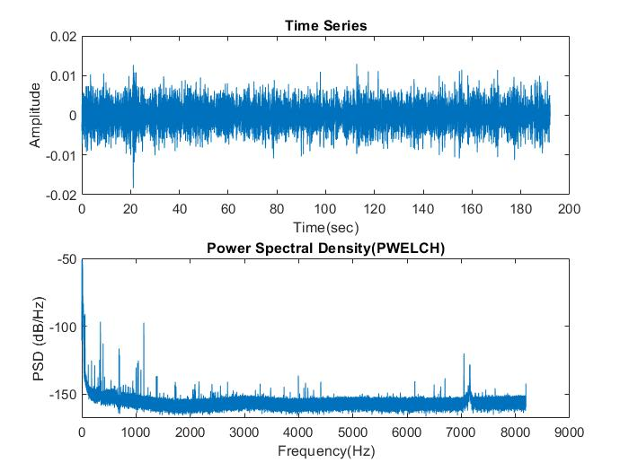

%(iv):Applying the lowpass fiter to data1

Wn = 2048/fs/2; %Cutoff frequency of 0.25

[b,a] = butter(6, Wn, 'low'); %Bandpass of 6th order Butterworth filter

% The transfer function

% H(z)=B(z)/A(z)=b0+b1z^-1_b2z^-2+..+bnz^-N/B(z)/A(z)=a0+a1z^-1_a2z^-2+..+bMz^-M

%Filtering the data

dat_low_pass = filter(b,a,data1);

[pxx_2, f2] = pwelch(dat_low_pass,[],[],[],fs);

figure(2)

subplot(2,1,1);

plot(timeVec,dat_low_pass);

xlabel('Time(seconds)');

ylabel('Amplitude');

title('Filtered Time Series');

subplot(2,1,2);

plot(f2, 10*log10(pxx_2))

xlabel('Frequency (Hz)');

ylabel('PSD (dB/Hz)');

title('Power Spectral Density(PWELCH) low pass filter');

%The low pass filter retains frequencies below a given cut-off which means

%it eliminate the higher frequencies to allow the lower frequencies to pass

%through.

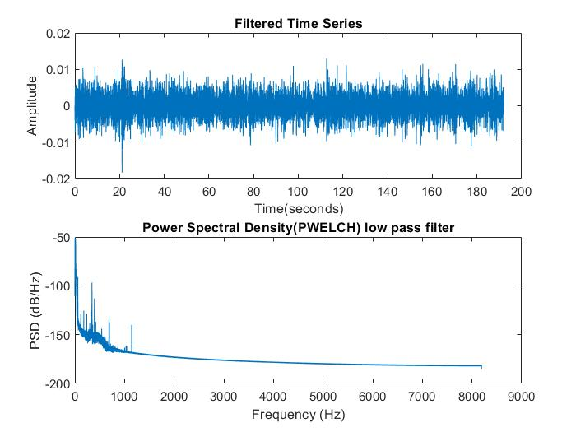

%(v):Resample the data to a lower sampling frequency

p = 1; %Resampling factors

q = 4; %Resampling factors

dat_low_pass2=resample(dat_low_pass,1,4); %change sampling rate

%New sample frequency will be 4096Hz

fs_new = fs * p/q;

t2 = length(dat_low_pass2)/fs_new; %duration in seconds

len2 = t2*fs_new; %lenght of the data

timeVec2 = 0:1/fs_new:(len2-1)/fs_new; %time vector

%(vi)pwelch the new sampling rate

[pxx_3, f3] = pwelch(dat_low_pass2,[],[],[],fs_new);

figure(3);

plot(f3, 10*log10(pxx_3));

xlabel('Frequency(Hz)');

ylabel('PSD (dB/Hz)');

title('Power Spectral Density with Resample Data');

% Comparing the power spectrum of the data before and after low pass

% filering, we can see that before the data had frequency components above

% 8 kHz, but after applying the filter the frequency components above 2048

% Hz have been discarded, which is expected, as out cut of frequency of the

% butterworth filter was 2048 Hz.

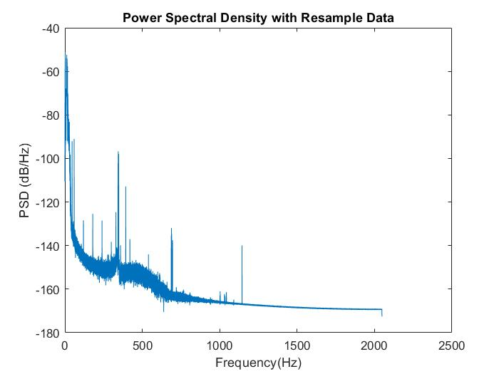

%(vii):Whiten the data

pxx_median_est = rngmed2(pxx,256);

%Median is the middle number of a Gaussian distribution in an order set of data values

%symmetrically around mean=median=mode.

%Inverse the median

freq=0:0.125/(fs*4):1;

%This function design filters with frequency inverse and the magnitude characterisitics of

%the white noise which is the containing vectors desires in the frequency.

N = 500;

bfilt=fir2(500,freq',1./sqrt(pxx_median_est)); %N is number of order, frequency, & magnitude

%fir2 is a digital filter order specified as an integer scalar.

%This return the 500 orders FIR filter with frequency magnitude charateristics.

%The filter coefficients are obtained by linearly interpolating the required

%frequency response onto a dense grid and then using the inverse Fourier transform and a Hamming window.

dat_whitened=fftfilt(bfilt,dat_low_pass2);

[pxx_4, f4] = pwelch(dat_whitened,[],[],[],fs_new);

figure(4);

subplot(2,1,1)

plot(timeVec2,dat_whitened);

xlabel('Time(sec)');

ylabel('Amplitude');

title('Time Series of Whitened Data');

subplot(2,1,2);

plot(f4, 10*log10(pxx_4));

xlabel('Frequency(Hz)');

ylabel('PSD (dB/Hz)');

title('Power of Spectral Density of Whiten Data')

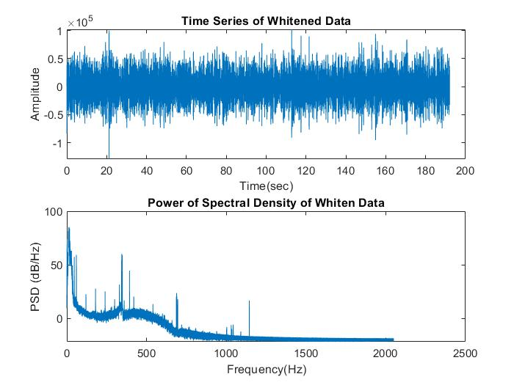

%(viii) Applying the Bandpass filter to the whitened data

[b,a]=butter(6,[100 1024]/2048);

dat_whitened2=filtfilt(b,a,dat_whitened);

[pxx_5, f5] = pwelch(dat_whitened2,[],[],[],fs_new);

figure(5);

subplot(2,1,1)

plot(timeVec2,dat_whitened2);

xlabel('Time(sec)');

ylabel('Amplitude');

title('Time Series of Bandpass Whiten Data');

subplot(2,1,2);

plot(f5, 10*log10(pxx_5));

xlabel('Frequency(Hz)');

ylabel('PSD (dB/Hz)');

title('Power of Spectral Density Bandpass Whiten Data');

%The bandpassfilter retains frequencies between a given lower cut-off and a

%higher cut-off. % Why we bandpassed the whitened data - Because LIGO is most sensitive

%between 100 Hz and 1000 Hz. Outside this frequency range signals other

%than our desired signals (noise) prevail, which makes it nearly

%impossible to detect gravitational wave in those frequency ranges.

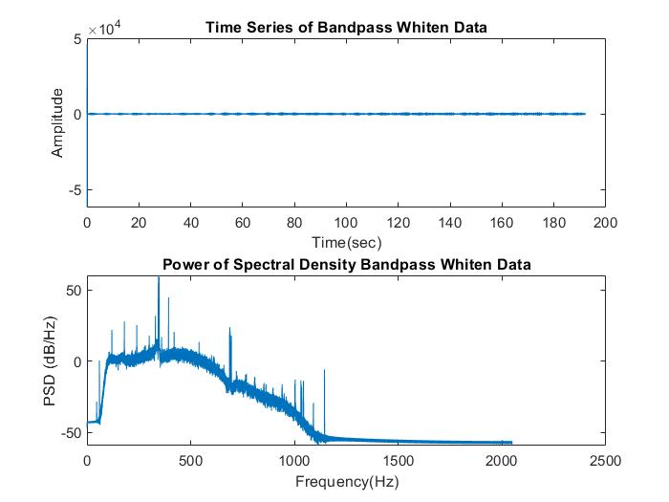

%(ix):Resample the whitened data to 2018 HZ

dat_low_pass2=resample(dat_low_pass,1,4);

nfft = 2018 * 4;

[pxx_6, f6] = pwelch(dat_low_pass2,[],[],nfft,fs_new);

figure(6);

plot(f6, 10*log10(pxx_6));

xlabel('Frequency(Hz)');

ylabel('PSD (dB/Hz)');

title('Power of Spectral Density Resample Data to 2018 Hz');

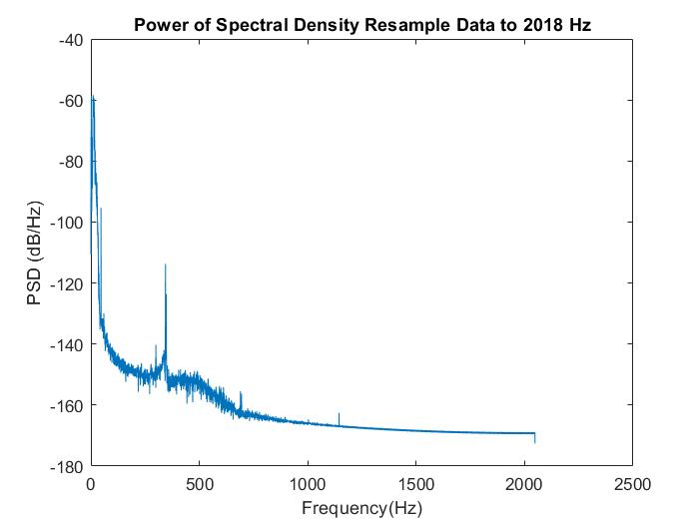

%(x): In the Power of Sepctral Density Resample Data of 2018 Hz we can see

%several narrowband noises. These narrowband noises could be produce by

%electrical and mechanical resonances. On our loop below we created the

%list of the highest peak frequencies that detect our narrowband frequency

%ranges and the half of the maximum amplitude. Running our loop it detected

%11 lines that could be the narrowband noises. We were able to identify

%some source between the ranges of 0Hz-1200Hz due to measured noise, expected noise

%& thermal noise.

% Finding peaks in the power spectral density plot.

[pks, locs, w, p] = findpeaks(10*log10(pxx_6));

pks = pks';

locs = locs';

w = w';

p = p';

p_sorted = sort(p, 'descend');

indx = zeros(1,11);

% Get the indices of the strongest narrowband lines.

for i = 1:11

for j = 1:length(pks)

if p_sorted(i) == p(j)

indx(i) = locs(j);

end

end

end

freq_list = f6(indx);

w1 = w(w_indx);

%Full Width Half Maximum.

w1 = w1'/2;

%2X2 matrix with narrowband frequencies and full width half maximum.

narrowband = [freq_list w1];