**Mini Project**

**Course Code: CSE103 (1, 2)**

**Course Title: Structured programming**

1. **Scientific Calculator**

Make a scientific calculator which can calculate any mathematical operations such as numeric conversion (decimal, binary, hexadecimal and octal), trigonometric function, factorial, Permutation, binomial equation, polynomial equation etc. Take input from user. After each calculation, ask user whether s/he want to continue calculation or not. If yes, show functions options. If no, show the result and exit option. Use file to store the result of each calculation. End of calculation, user can see their each calculation results at a glance (display all results from the file) using see results options. Scientific Calculator will able to load any formula given by the users and calculate the results. Calculator will also able to add and subtract different polynomial equations and calculate the results.

1. **Library Management system**

In this project, the system has keep records of category, books name, author name, quantity, borrower’s information such that name, contact number, book issue date, return date and amount of fine if the return date is over. User can search books by book name, author name or by category. The system will show the search result with available quantity. If there are spare books then it could be lent otherwise not. If any borrower doesn’t return within due date then there will be fine calculated 30 Tk. Per day. Please check EWU library for better understanding and incorporate all features.

1. **Hangman Game**

In this game, user has to guess the word by picking the letter. Scores will be added or subtracted depending on whether user has picked up a correct letter or not (The game ends when user finished 10 words.). For this game, you have to maintain a file which contains sample words. For each round, a word of the file will be selected randomly and has to guess it correctly. You can add hint(s) for playing the game. Please develop a game with unique and original features and do not copy available game from the internet.

1. **Flight Reservation System**

Flight Reservation System is based on a concept of booking and canceling flight reservations. Here, the system contains no login feature. The users can easily book flights, cancel flight reservation, and check tickets. It contains different payment options for the reservations. This mini project contains fewer features but the essential ones, like Domestic Flights, International Flights, Payment options, Cancel Flights, Check Tickets, etc.

Talking about the features of Flight Reservation System, for a flight reservation the user has to select whether he/she want domestic or international and date of journey. Then the system displays the city and the countries name and the user has to provide Source and Destination. After this, the system checks whether the flight is available or not, if it’s available then the system displays Airlines list with Departure and Arrival time, Price and Category. The system asks for the passenger’s information such as name, contact details, gender, email id. At last, for the payment process, the user has to select whether to pay from Debit, Credit or Net bankings.

1. **Digital Phonebook**

Create a digital phonebook where user can input person name, contact numbers (mobile number) and their email address and save into a file. User can also search information by using a person name or their contact number from the saved file. While taking input from user check that contact number can’t be more than 11 digits and for email address it should be a valid email domain such as @gmail.com, @yahoo.com, @outlook.com etc (it can’t be @xyz.com). Also ordering the phonebook according name and then save it into a file.

1. **Tic-Tac-Toe Game**

Tic-Tac-Toe Game played by 2 players, one player use ‘X’ and other player is use ‘O’ sign to play. The game board is 3 by 3 size grid. Between 2 players, who first match same sign 3 consecutive positions then that player will win. This game held 3 rounds and each round winner will get 3 points which stored in file. At the end of 3 rounds, total will be counted and show the winner. If the round is drawn then both player get 1 point and again play the round. You must design the game in a way so that a player can also play with the computer and computer gives a fair fight against its opponent.

## **Game of Life**

**Project Description**:

The Game of Life (or simply Life) is not a game in the conventional sense. There are no players, and no winning or losing. Once the "pieces" are placed in the starting position, the rules determine everything that happens later. Nevertheless, Life is full of surprises! In most cases, it is impossible to look at a starting position (or pattern) and see what will happen in the future. The only way to find out is to follow the rules of the game.

Initially, there is a grid with some cells which may be alive or dead. Our task to generate the next generation of cells based on the following rules:

1. Any live cell with fewer than two live neighbors dies, as if caused by under population.



1. Any live cell with two or three live neighbor’s lives on to the next generation.



1. Any live cell with more than three live neighbors dies, as if by overpopulation.



1. Any dead cell with exactly three live neighbors becomes a live cell, as if by reproduction.

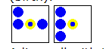

**Input**

N* M matrix as a grid where, N indicates the row and M indicates the column of the grid.Grid is initialized with 0’s representing the dead cells and 1’s representing alive cells.

**Output**

 Generate the next generation of cells based on the above rules

1. **Text Editor/ Personal Diary**

In this project you will develop a text editor in which the user can create several notes and can edit the text of a file later on. Also, you need to provide feature like search a file using its name and edit option of that file. You need to manage a file system and the user should create folders in which they can save their text files. It can also be used as a personal e-diary Add as many features as you can to make this project one of the best.

1. **Online shop management software**

In this project you will make a software for online shop. The software you will develop will have two types of user namely admin and customer. Admins can add products detail (product id, name, price, quantity etc.) by login to their account using their email and password. On the other hand the customers can buy those products. You should be able to generate payment receipt for every customer. Products’ quantity should be decreased if customers buy from the shop and quantity should be increased if admins add more quantity to that product using its product id. Add more features to make this project more usable and intuitive. Please check SHAWPNO, AGORA, MEENA BAZAR, etc. for better understanding and incorporate all features.

1. **Vocabulary Learning Application**

Develop a vocabulary learning application. Your app should have stored words with its meaning. It should have the capability to add new words given by the user. After that you need to show those words alphabetically to its user for learning (Let’s say 10 at a time or divide the word list into several parts). Your application must have quiz test to examine the progress of the user. See other vocabulary apps’ features available in the Google play store and enrich your application features to make this useful.

## **11. Pacman Game**

In this project, Pacman in the game will be driven where it moves along with the predefined path. While moving on the predefined blue path the path is eaten or erased by the Pacman. More you eat the path more your score is increased. You have to control the behavior and moving direction of the Pacman. Create (1) easy (2) moderate (3) difficult level of the game, which will give a realistic feel of playing the original game.

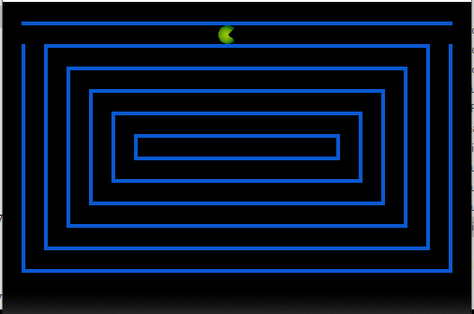

### **12. Puzzle Game**

Goal of the game is to fill in missing numbers in an 9x9 array.  Each number in the set [1-9] must be found in every row, every column, and every 3x3 block in the array. For example, here is an example game, including initial game state and final game state.  The user-provided solution is shown in red. Note that a board could have multiple solutions.  Thus, the solution provided with the initial puzzle may not be the only valid solution the user should provide. Create (1) easy (2) moderate (3) difficult level of the game, which will give a realistic feel of playing the original puzzle game.

| **Initial State:** | **Final State:** |
| --- | --- |
| Sudoku Initial State | Sudoku Final State  *(User input in red)* |

**13. Cybercafe Management System**

The whole project is divided into two programs, one for the client and one for the server. The server program is for managing settings and client requests. The client program gives clients access to the cyber services. Please see the following diagram for better understanding.

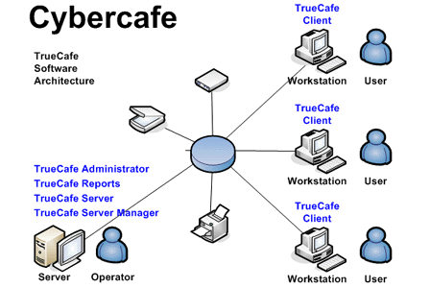

### **14.** [**Quiz Game**](https://www.codewithc.com/quiz-game-mini-project-in-c/)

In this project, a number of questions are asked, and the user is awarded cash prize for each correct answer given. In quiz game, questions are chosen in such a way that they cover all fields of a typical quiz contest. The user’s general knowledge is tested with quiz questions regarding science, technology, movies, sports, general health, geography and many more. Create (1) easy (2) moderate (3) difficult level of the game, which will give a realistic feel of playing the original quiz game.