:: ARCTIC FOX CLOTHING ::

MANUFACTURERS (BRANDS)

**To add, edit or remove a brand.**

Trough your backend,

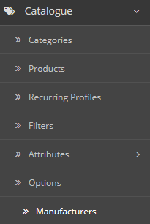

Click on “Manufacturers”.

You will see all of the brands

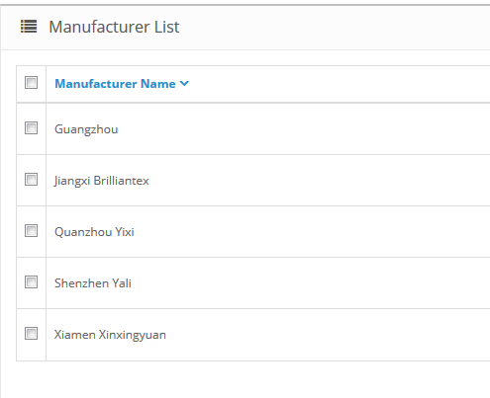

With the little icons you are able to edit, remove or add a brand.

If you add or edit a brand you will have a form like this :

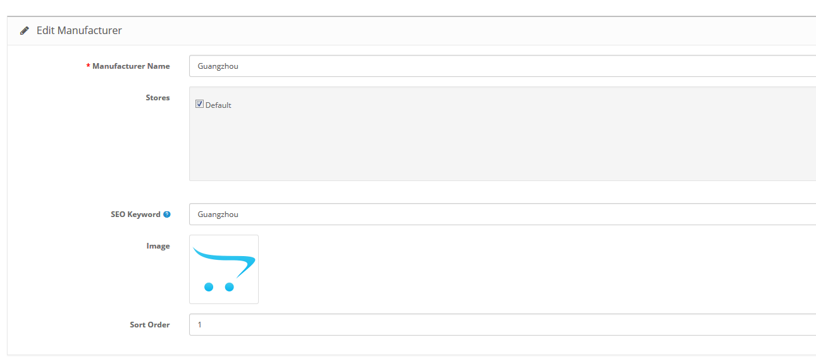

Could you please create some, and link an image to them then i will be able to run a slideshow.