Abhijatri
Data Flow Diagrams
How to draw them, which tools to use, and the complete Abhijatri data flow model

Item | Detail
Project | Abhijatri: a Bangla-first, offline-ready community travel platform for Bangladesh (Team ChoturMatra, CSE 3102)
Document | Data flow diagram (DFD) guide and model: context, level 0, level 1 and level 2
Version | 1.0, 30 October 2026
Basis | The implemented system: backend/app/models.py (tables), Docs/api/openapi-v1.json (92 routes), Docs/Architecture.md, Docs/Backend-Implemented.md 5.13 to 5.19
Notation | Gane-Sarson (rounded process boxes, open-ended data stores, square external entities)
Regenerate | python Docs/diagrams/make_diagrams.py, then python Docs/diagrams/build_dfd_doc.py

Contents
Contents appear here. If this line is still visible, right-click it and choose Update Field (or press F9).

1. Purpose and summary
A data flow diagram (DFD) shows how data moves through a system: where it comes from, which processes change it, where it is kept, and where it goes. It answers the question "what happens to the data?", not "in what order do things happen?" (that is a flowchart or sequence diagram).
This document does three things:
- Part A teaches how to draw a correct DFD by hand: the symbols, the rules, the levelling method and a step-by-step procedure.
- Part B lists the tools you can use (free and paid) and explains how to draw a DFD in each, so the team can redraw or edit the figures themselves.
- Part C is the complete DFD of Abhijatri as built: a context diagram, a level 0 diagram with seven processes, four level 1 diagrams and two level 2 diagrams. Part D is the data dictionary and the balancing proof.
Table 1. Diagrams in this document
Diagram | What it shows | Figure
Context (level C) | The whole platform as one process with ten external entities | Figure 1
Level 0 | Seven main processes, ten data stores, all external entities | Figure 2
Level 1: 4.0 Reviews | Create, edit, withdraw, view, media, appeal and report | Figure 3
Level 1: 6.0 Moderation | Task queue, decisions, appeals, reports, verification | Figure 4
Level 1: 5.0 Notifications | Outbox relay, inbox, email delivery, provider webhooks | Figure 5
Level 1: 3.0 Accounts | Registration, sign-in, password reset, TOTP, staff roles | Figure 6
Level 2: 4.3 Edit review | Owner check, state and version check, new revision | Figure 7
Level 2: 6.2 Decide review | Lease and version check, state change, ratings, media, audit | Figure 8

What was checked. Every diagram was drawn from one data file and passed an automatic check of the DFD rules in Part A (no process without an input and an output, no flow between two non-processes, no unnamed flow) and a balance check against its parent diagram. The result was 0 violations. The checks are listed in section 7.
Honest scope. Cost estimation, offline packs, saved trips and booking are prototypes in the repository (Docs/Implemented.md). They are drawn dashed. There is no service worker, manifest or IndexedDB yet, so the device store D10 is dashed too.

2. Part A: How to draw a data flow diagram

2.1 The four symbols (Gane-Sarson)
Table 2. DFD symbols
Symbol | Shape | Meaning | Naming rule | Abhijatri example
External entity | Square | A person or system outside the one you are modelling. It is a source or a sink of data. | Noun | Guest, Moderator, Supabase Auth
Process | Rounded rectangle with a number box | Something that changes data: it must turn inputs into outputs. | Verb + object, numbered 1.0, 4.3, 4.3.2 | 4.0 Submit and manage reviews
Data store | Open-ended rectangle with a D-number | Data at rest: a table, file or queue. | Noun (what is kept), D1, D2 ... | D3 Reviews
Data flow | Arrow with a label | Data moving between the symbols above. | Noun phrase (what data) | guest review, receipt, scope secret

Yourdon-DeMarco notation uses circles for processes and two parallel lines for data stores. The meaning is identical. Use one notation throughout a document; this one uses Gane-Sarson because it is the style most university courses and tools (Visio, Lucidchart) provide.

2.2 The rules every DFD must follow
Table 3. DFD rules
# | Rule | Why it matters | Common mistake
1 | Every process has at least one input and at least one output. | A process with no input is a miracle (it invents data); with no output it is a black hole. | A process that only receives data and never gives anything back
2 | Data never flows directly between two external entities, two data stores, or an entity and a store. A process is always in between. | Only processes can read, change and write data. | An arrow from a database straight to a user
3 | Name processes with a verb and an object, stores with a noun, flows with a noun phrase. | Names make the diagram readable without a legend. | "Process data", "Send" on an arrow, "Database" as a store name
4 | Number processes (1.0, 4.3, 4.3.2) and stores (D1, D2). | Numbers connect each level to its parent and to the data dictionary. | Renumbering a process on a lower level
5 | Balance the levels: the flows crossing the boundary of a child diagram equal the flows of the parent process it explains. | Otherwise the levels describe different systems. | Adding a new external flow while decomposing
6 | Show data, not control. No decisions, loops, start or end symbols, and no timing. | That belongs in a flowchart or sequence diagram. | Drawing "if approved" diamonds
7 | Keep 7 plus or minus 2 processes on one diagram. | More than nine becomes unreadable; decompose instead. | A single sheet with 20 processes
8 | Use the same name and number for a store or entity everywhere it appears. A store used by two distant processes may be drawn twice with a duplicate marker. | Prevents two copies being mistaken for two stores. | Calling the same table "Reviews" on one page and "Posts" on another
9 | Do not draw a store that nothing writes to or nothing reads from. | An unused store is a design error or a missing process. | A store with only outgoing arrows
10 | A store that only one process uses may first appear on that process's child diagram (a local store). | Keeps the parent diagram simple. | Showing every internal table on level 0
11 | Draw a request and its response as two arrows, and read-and-write of a store as one double-headed arrow. | Keeps each flow's content clear. | One arrow labelled "login" with no return

2.3 Levelling: from one box to the detail
- Context diagram (level C). The whole system is one process, numbered 0, surrounded by every external entity. No stores. It fixes the boundary of the system.
- Level 0. Open the box: 7 plus or minus 2 main processes, the data stores they share, and the same external entities with the same flows as the context diagram.
- Level 1. Take one level 0 process and open it into its own sub-processes (4.1, 4.2, ...). Its boundary flows must equal that process's flows at level 0.
- Level 2. Do the same again for a sub-process that is still too complex (4.3.1, 4.3.2, ...). Stop when a process can be described in a few sentences or one function.

2.4 Step-by-step procedure
1. Fix the boundary. Write one sentence saying what is inside the system and what is not. (Abhijatri: the PWA, API, staff app and ops app; not Supabase, Cloudflare or the email provider.)
2. List the external entities. Ask: who gives data to the system, and who receives data from it? Include other systems, not only people.
3. List the data stores. Take the data model (tables, files, queues) and group tables that are always used together into one store. Write the table names beside each store.
4. List the events or use cases. Each use case ("submit review", "decide appeal") suggests a process. Group closely related use cases into one level 0 process.
5. Draw the context diagram. One process, all entities, a pair of arrows per entity (in and out). Name each arrow by the data it carries.
6. Draw level 0. Place entities at the edge, processes in the middle, stores near the processes that use them. Put things that talk to each other next to each other to avoid crossing lines.
7. Label every flow with the data, not the action: "guest review, receipt" not "send review".
8. Check the rules in section 2.2 one by one, using the checklist in section 2.5.
9. Decompose the processes that are too big or too important to leave as one box. Repeat steps 6 to 8 for each; keep numbering.
10. Balance and describe. Compare each child's boundary flows with its parent's. Write the data dictionary: what each flow and store contains.
11. Walk through a scenario. Trace one real case (a guest submits a review, a moderator publishes it) through the diagrams and confirm each step has an arrow.

2.5 Quick self-check before you submit
Table 4. Self-check list
Check | Yes / No
Every process has an input and an output
No arrow joins two entities, two stores, or an entity and a store
All flows are named with nouns; all processes with verb + object
Processes and stores are numbered, and numbers match the data dictionary
The level 0 entity flows match the context diagram
Each child diagram's boundary flows match its parent process
No decisions, loops or timing appear
No more than nine processes on any diagram
Prototype or planned parts are marked, not drawn as working
A real scenario can be traced from start to finish
Text is readable at A4 size (at least 8 pt after scaling)

3. Part B: Tools for drawing DFDs by hand
You do not need special software. Pick one tool the whole team can open and keep the editable source file in the repository next to the exported image.
Table 5. Tools for drawing DFDs
Tool | Cost | Best for | Strengths | Limits
diagrams.net (draw.io) | Free; browser or desktop; saves .drawio to a file, Google Drive or GitHub | Recommended for the team | No account needed, exports PNG/SVG/PDF, rounded shapes, grid and snapping, runs offline in the desktop app | No built-in DFD checker; you apply the rules yourself
Lucidchart | Free tier with limits on objects and documents | Teams already using it (the use case diagram was drawn there) | Shape libraries including data flow shapes (enable them from the Shape Libraries panel), real-time collaboration | Free tier limits; export needs care
Microsoft Visio | Paid (Microsoft 365 plans), often available through a university | Formal documents | A data flow diagram template exists; precise alignment | Heavy; Windows or web
Visual Paradigm (Online or desktop) | Free community tier with limits; paid for more | Analysis diagrams with levelled decomposition | DFD support and tools for linking levels | Free edition limits and watermark on some exports
PowerPoint or Google Slides | Free or already installed | Quick diagrams, presentations | Everyone has it; Merge Shapes and alignment tools | No connectors that stick as reliably; easy to mis-align
Excalidraw or FigJam | Free | Sketching and brainstorming | Fast, hand-drawn look, shareable link | Not precise; fine for drafts, weaker for the final figure
Mermaid (text) in GitHub or mermaid.live | Free | Diagrams that live in Markdown and update with the code | Text source can be reviewed in a pull request; renders on GitHub | No Gane-Sarson shapes; layout is automatic and can be hard to control
PlantUML | Free (needs Java or an online server) | Developers who want text-defined diagrams | Text source, many diagram types | No native DFD symbols; approximate with rectangles and databases
Python with matplotlib (how the figures here were made) | Free | Regenerating many diagrams from one data file and checking the rules automatically | Rules checked by code; every figure rebuilt in one command | Needs programming; layout coordinates are set by hand
Pen and paper, then scan | Free | First draft on a whiteboard or in a meeting | Fastest way to agree the structure | Redraw digitally for submission

3.1 Recommended workflow for the team
1. Agree the processes, stores and entities on paper or a whiteboard first (45 minutes). Photograph it.
2. One person redraws it in diagrams.net using the steps in 3.2, and saves the .drawio source in Docs/diagrams/.
3. Export a PNG at 300 dpi (width at least 2400 px) and an SVG. Insert the PNG into Word or LaTeX at the full text width.
4. A second person checks the diagram against the self-check list (section 2.5) and the balancing table (section 6).
5. Commit the source and the image together so the next edit starts from the source, not from the picture.

3.2 Drawing a DFD in diagrams.net (draw.io), step by step
1. Open app.diagrams.net, choose Create New Diagram, a blank diagram, and save it first (the file is your source).
2. Turn on View > Grid and Snap to grid so boxes align.
3. Process: from the General shapes drag a *Rounded Rectangle*, about 4 cm by 2 cm. Type the number on the first line (4.0) and the name below. Draw a thin horizontal line under the number to make the number box.
4. External entity: drag a *Rectangle*; add an inner rectangle slightly smaller to give the double border used here. Fill a pale orange.
5. Data store: drag a *Rectangle*, then remove its right border (Edit Style: add strokeColor=none for the right edge by drawing the left, top and bottom lines only, or use the "Data Store" shape if your library has one). Put the D-number in a small box at the left.
6. Flows: hover over a shape and drag from the blue arrow to the target shape so the connector sticks. Double-click the line to type the label. Use *Waypoints > Curved* only when you must avoid another box.
7. For a request and response pair, draw two connectors and drag each slightly apart so they run parallel.
8. Use Format Panel > Arrange > Align and Distribute to line up columns of processes.
9. Export: File > Export as > PNG, set Zoom 200 percent or DPI 300, tick *Transparent background* off, *Border width 10*. Also export SVG.
10. Save, and keep the .drawio next to the image in the repository.

3.3 Drawing a DFD in PowerPoint or Google Slides
1. Use a blank slide, widescreen (16:9). Turn on gridlines and guides (View).
2. Insert Shapes > Rounded Rectangle for processes, Rectangle for entities, and a rectangle with only left, top and bottom outlines for stores (draw three lines, group them).
3. Draw flows with Insert > Shapes > Arrow or Elbow Connector. Connectors snap to shape handles, so move shapes, not lines.
4. Add labels as text boxes with a white fill so lines do not run through the words.
5. Select everything, Group, then File > Export (or Save as picture) as PNG at the highest quality.

3.4 Drawing a DFD in Lucidchart or Visio
- Create a new document, open Shape Libraries, search for "data flow" and enable the library. Choose the Gane-Sarson set so the shapes match this document.
- Drag process, entity and store shapes onto the page, then connect them with line tools; labels are attached to the lines so they move with them.
- Use Align and Distribute to keep columns tidy; use Layers if you want prototype parts on a separate, switchable layer.
- Export as PNG or PDF at print resolution.

3.5 Using Mermaid when you want the diagram to live in Markdown
Mermaid has no Gane-Sarson shapes, but a flowchart can approximate a DFD: round brackets for processes, square brackets for entities, and cylinder shapes for stores. Use it for quick diagrams in a README, not for the final submission figure.
flowchart LR
G[Guest] -->|guest review, receipt| P4(4.0 Submit and manage reviews)
P4 -->|review id, status| G
P4 <-->|reviews, revisions| D3[(D3 Reviews)]
P4 -->|moderation task| D5[(D5 Moderation records)]

3.6 Layout tips that make a DFD readable
- Put people on the left and outside systems on the right; processes in the middle; stores near the processes that use them.
- Draw a request and its response as two parallel arrows, not one arrow with two heads, unless it is reading and writing a store.
- Put each flow's label near the process end of the arrow when several arrows leave the same entity; the lines are far apart there.
- Keep crossings to a minimum: move boxes, not lines. If one flow must cross others, make it a gentle curve and keep it short.
- Use colour only as a helper (orange entities, blue processes, green stores). Shapes and text must still make sense in black and white.
- Mark prototype or planned items with a dashed outline and say so in a note.

4. Part C: The Abhijatri data flow diagrams
Reading guide: external entities are orange squares, processes blue rounded boxes, data stores green open-ended boxes. A double-headed arrow means a process reads and writes the store. A dashed outline means prototype. Store D4 is drawn twice on level 0 (duplicate marker, an extra bar at the right end) because process 1.0 reads it and process 6.0 writes it.

4.1 Context diagram
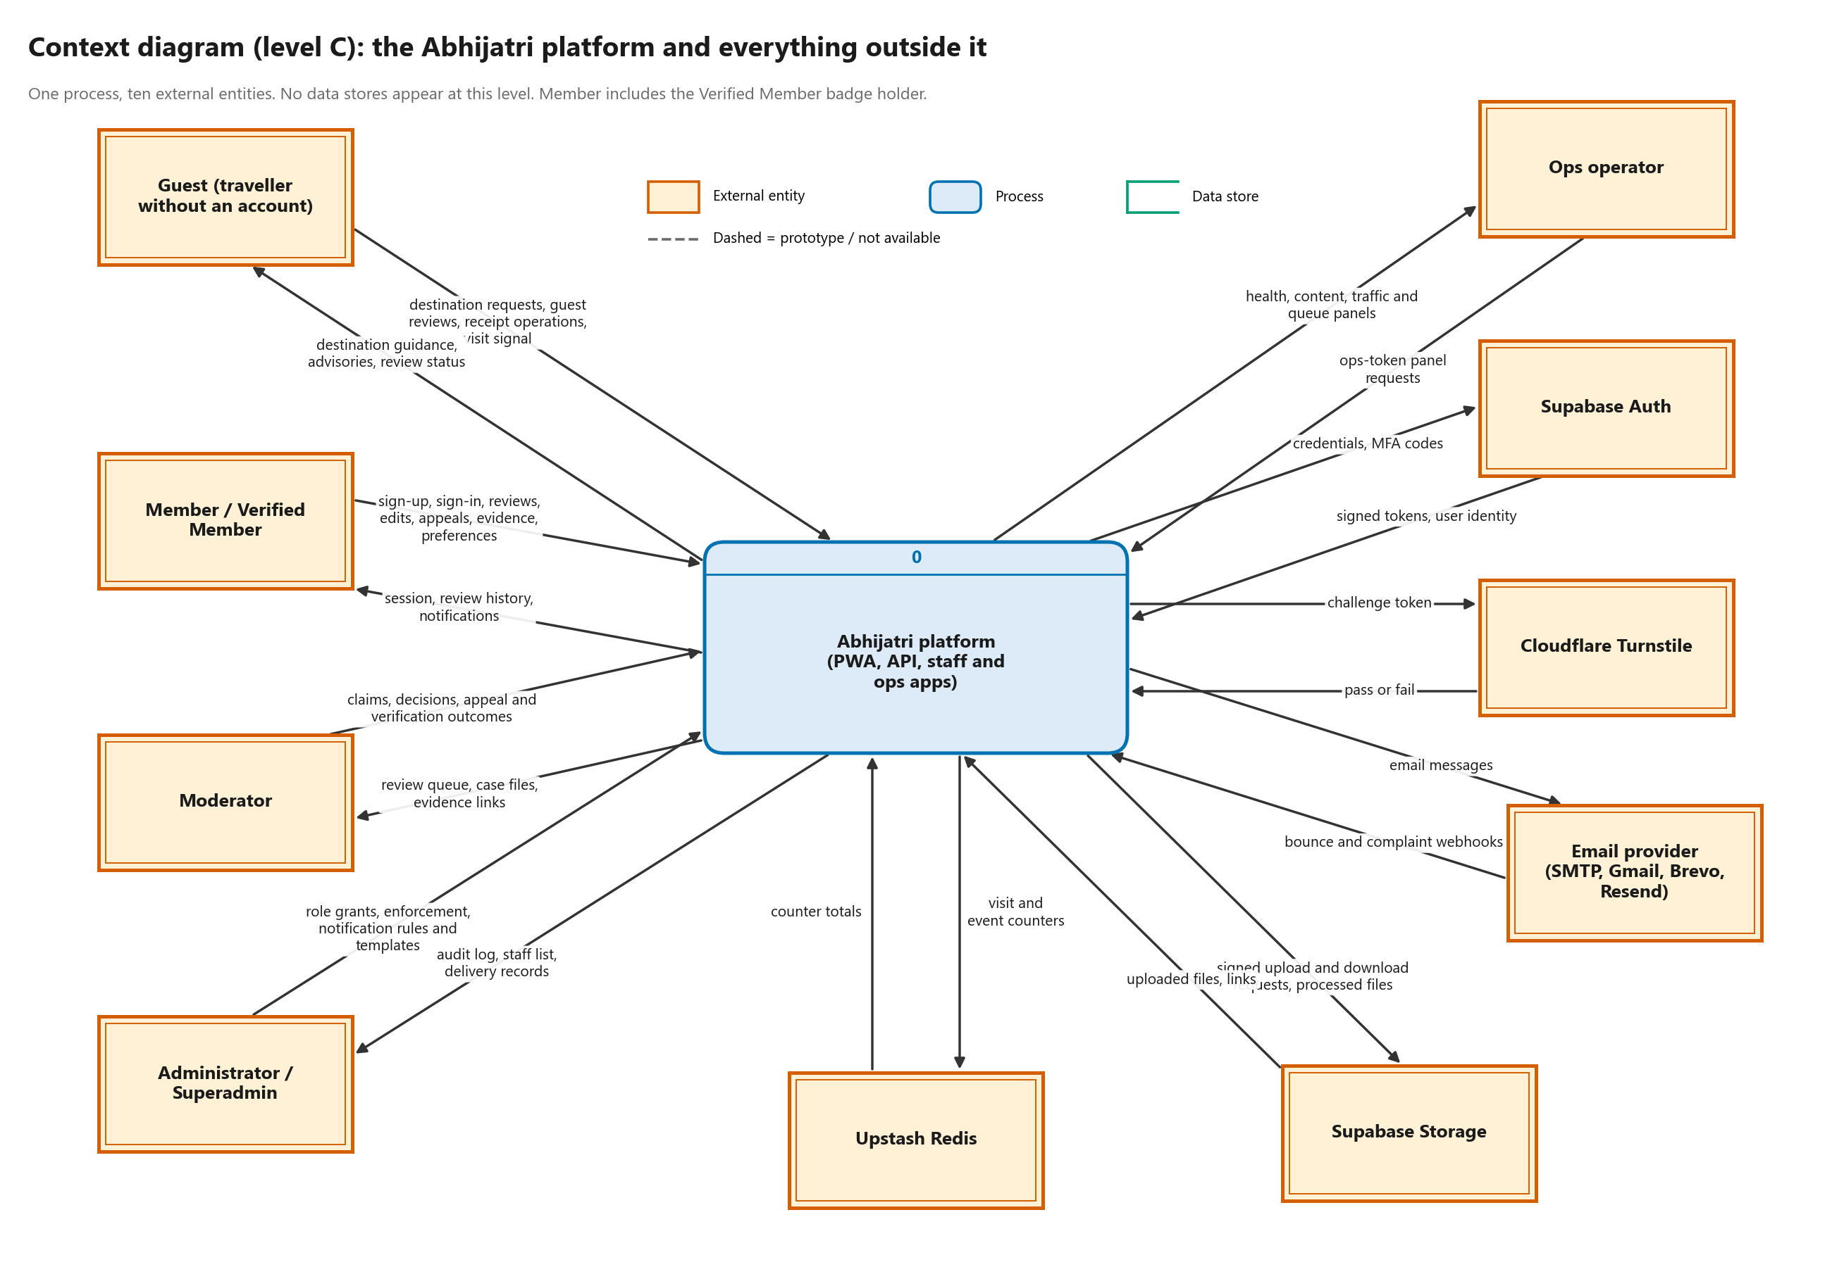
Figure 1. Context diagram: the Abhijatri platform and its ten external entities
The platform is treated as one process. Guests and Members use the public PWA; moderators and administrators use the staff app; the ops operator reads the monitoring panels with a token. Supabase Auth holds passwords and TOTP secrets, Cloudflare Turnstile checks that a guest is a person, the email provider delivers email, Supabase Storage keeps uploaded media and evidence, and Upstash Redis counts visits and events.

4.2 Level 0 diagram
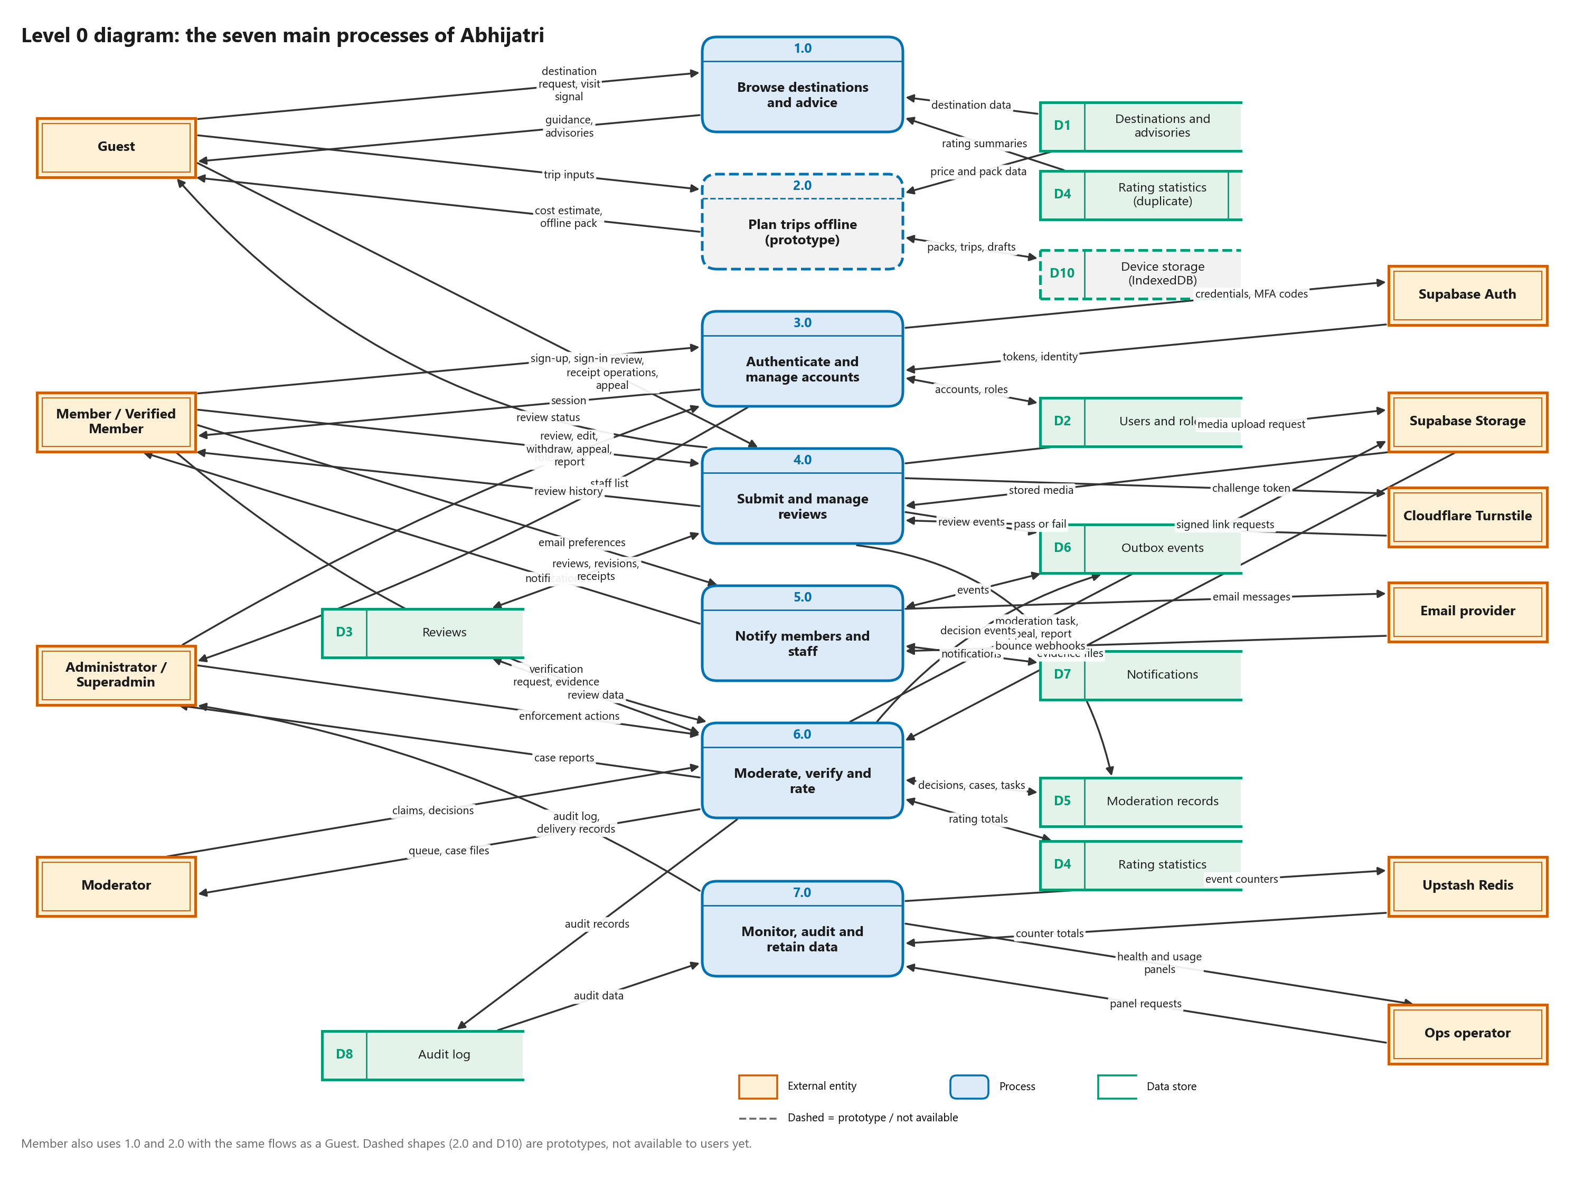
Figure 2. Level 0: seven main processes, ten data stores
Table 6. Level 0 processes
Process | What it does | Main code
1.0 Browse destinations and advice | Serves published destination profiles, advisories (current, stale or expired), contacts, ratings and the public review feed; counts the first visit. | destination_api.py, api.py (feed), visits.py
2.0 Plan trips offline (prototype) | Cost estimate, offline pack and saved trip screens. Prototype only; no estimator API or storage exists yet. | frontend PlannerPage, OfflinePacksPage, SavedTripsPage
3.0 Authenticate and manage accounts | Register, verify email, sign in, reset password, TOTP, sessions with CSRF, staff roles. | auth/routes.py, auth/sessions.py
4.0 Submit and manage reviews | Create (guest, member), edit while unpublished, withdraw, status and history, media, appeals and reports. | services.py, api.py, member_routes.py, media.py
5.0 Notify members and staff | Turns outbox events into notifications and email; inbox, preferences, webhooks, digests. | notify/worker.py, notify/messages.py, notify/delivery.py
6.0 Moderate, verify and rate | Task queue with leases, review decisions (and the rating change in the same transaction), appeals, reports, enforcement, verification cases. | admin/routes.py, admin/actions.py, admin/cases.py, services.moderate_review
7.0 Monitor, audit and retain data | Ops panels, audit log reading, visit roll-ups, retention jobs. | ops/, jobs/retention.py

4.3 Level 1 diagrams

Level 1: 4.0 Submit and manage reviews
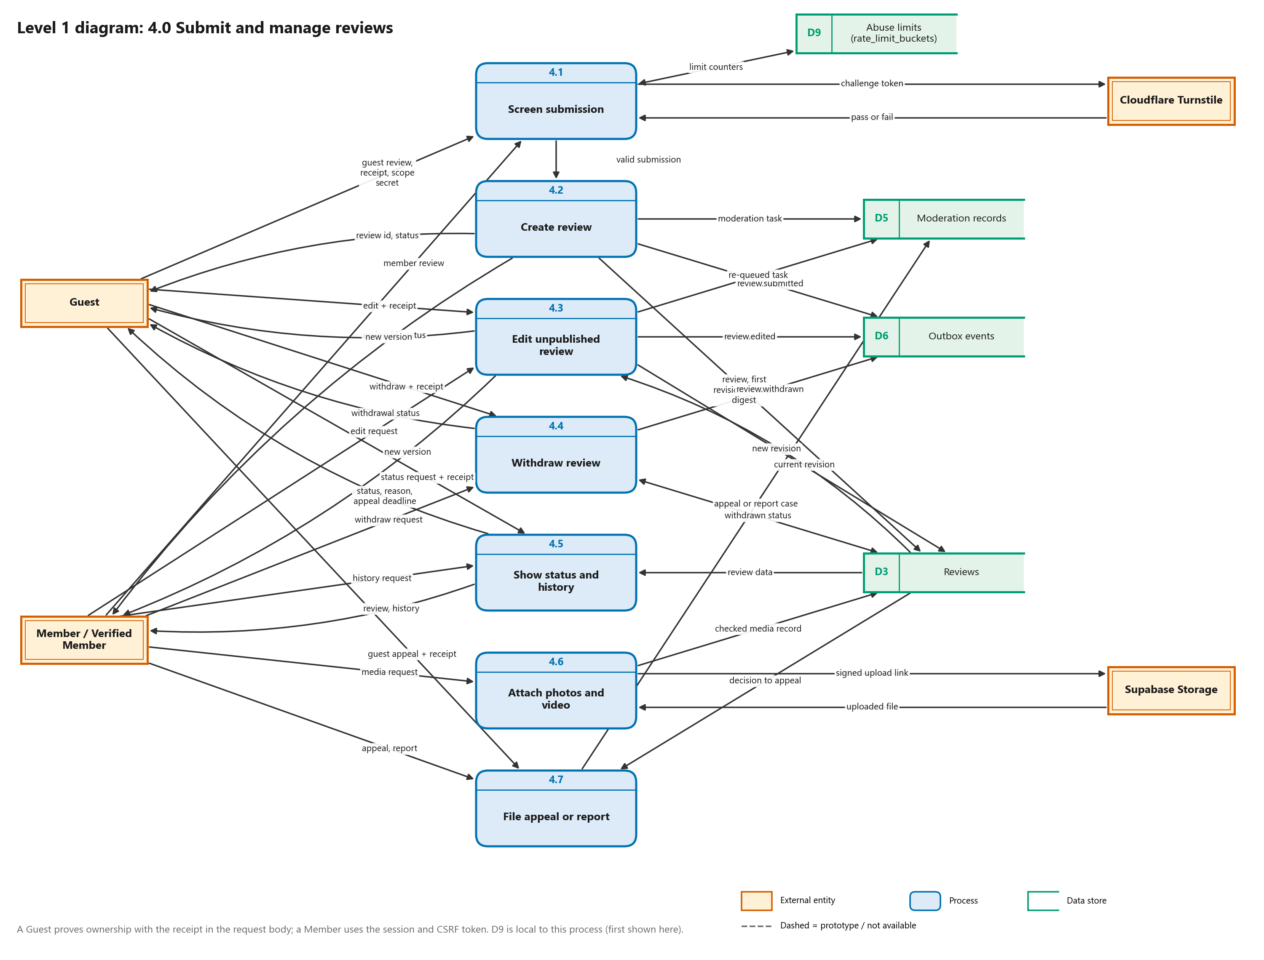
Figure 3. Level 1: process 4.0 decomposed into 4.1 to 4.7
4.1 screens every guest or member submission (schema, receipt format, Turnstile for guests, durable rate limits). 4.2 creates the review, its first revision, the receipt digest, a moderation task and an outbox event in one transaction. 4.3 to 4.5 are the R07 operations: edit, withdraw, and the owner's status and history views. 4.6 handles photos and video through signed upload links. 4.7 files appeals and reports.

Level 1: 6.0 Moderate, verify and rate
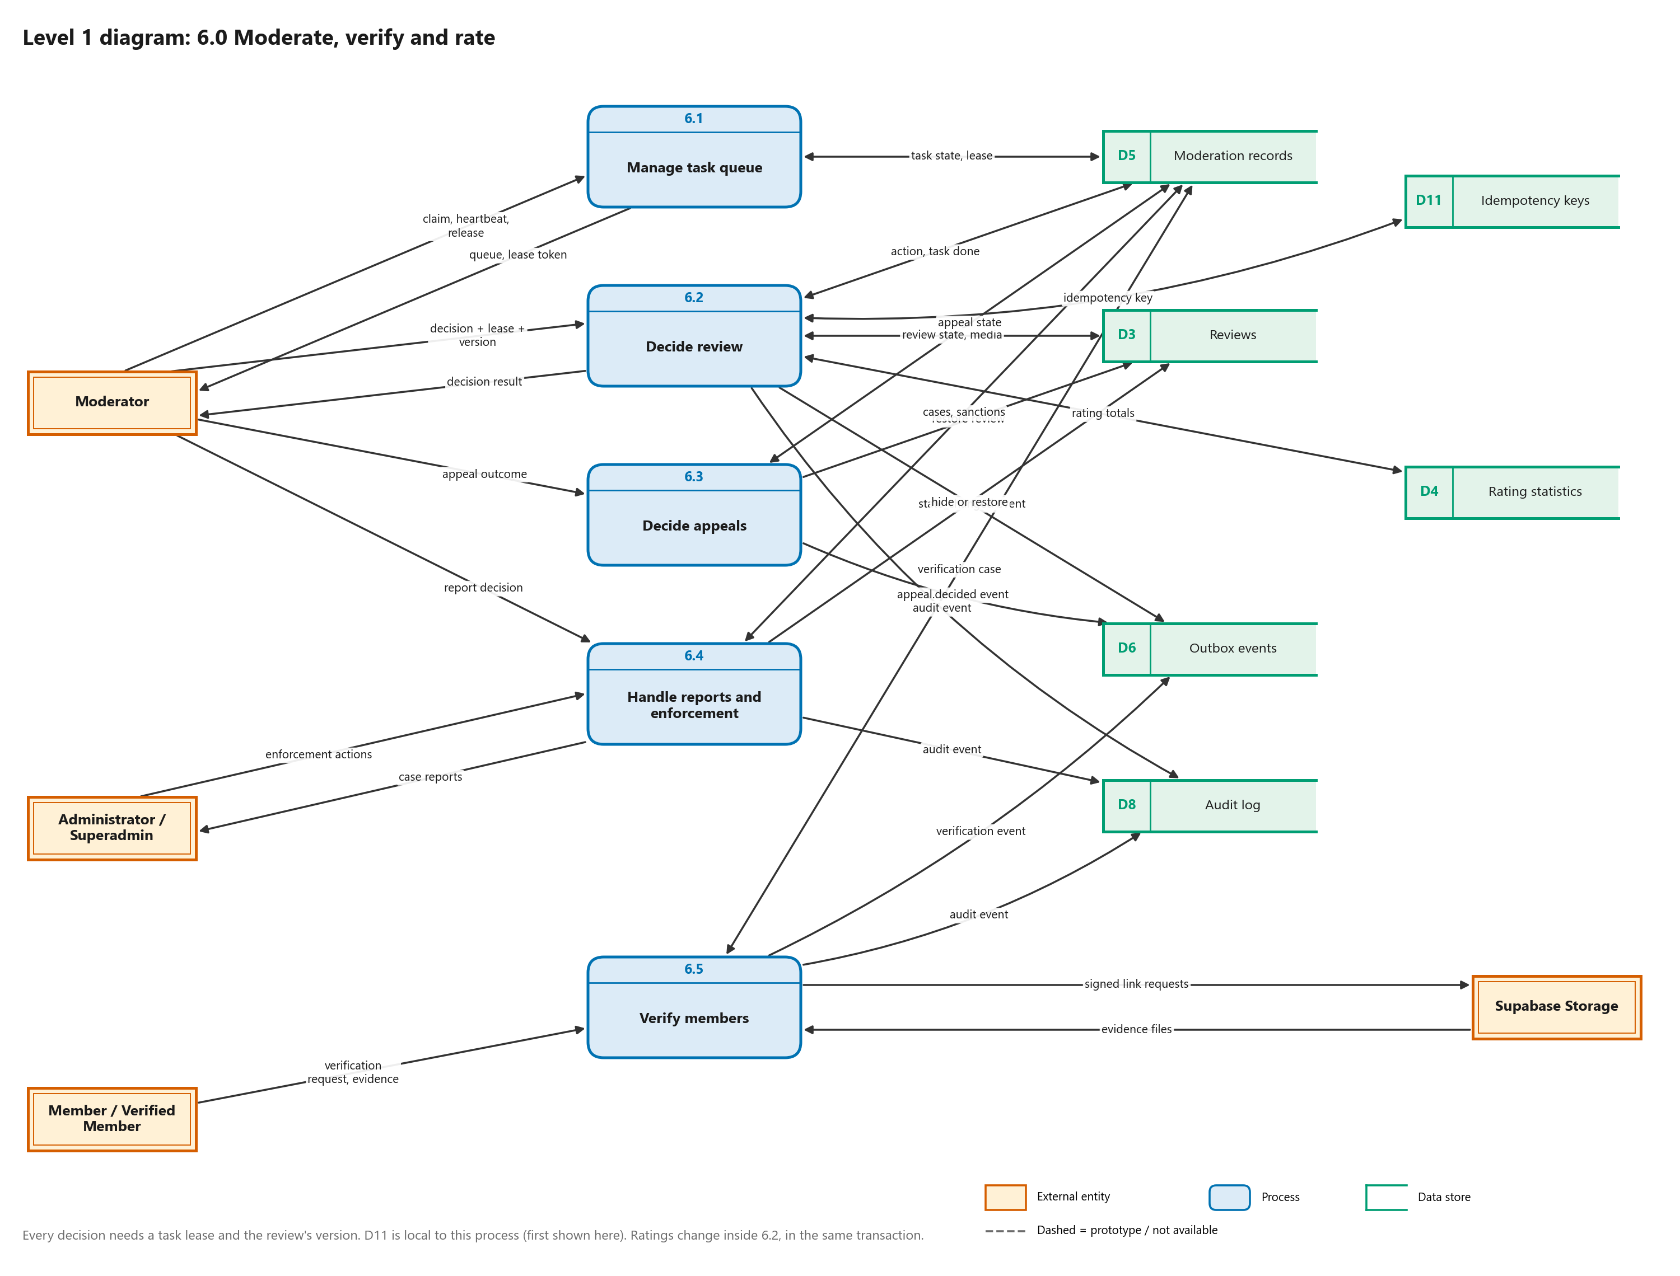
Figure 4. Level 1: process 6.0 decomposed into 6.1 to 6.5
Every decision needs the task's lease token and the review's expected version. Ratings are updated inside 6.2 in the same database transaction as the status change, so a published review is counted exactly once. D11 (idempotency keys) is local to this process and first appears here.

Level 1: 5.0 Notify members and staff
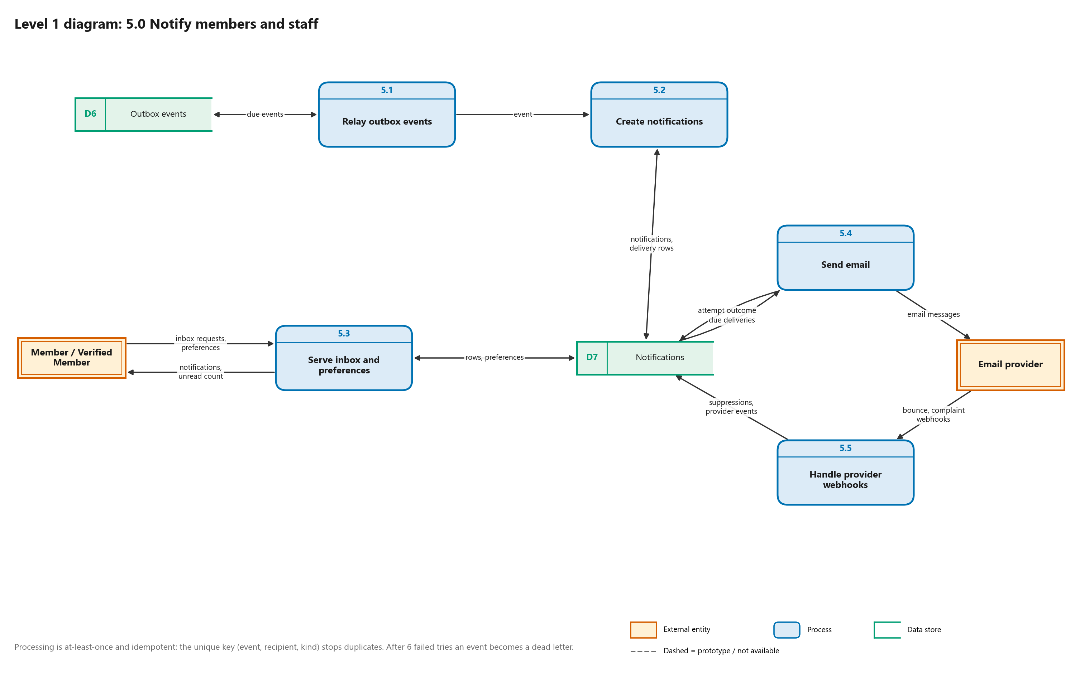
Figure 5. Level 1: process 5.0 decomposed into 5.1 to 5.5
Events are claimed with FOR UPDATE SKIP LOCKED, converted to notifications with a unique key on (event, recipient, kind) so replays never duplicate, and emailed with retries after 1 minute, 5 minutes, 30 minutes and 2 hours. After six failed relay attempts an event becomes a dead letter that superadmins and the ops dashboard can see.

Level 1: 3.0 Authenticate and manage accounts
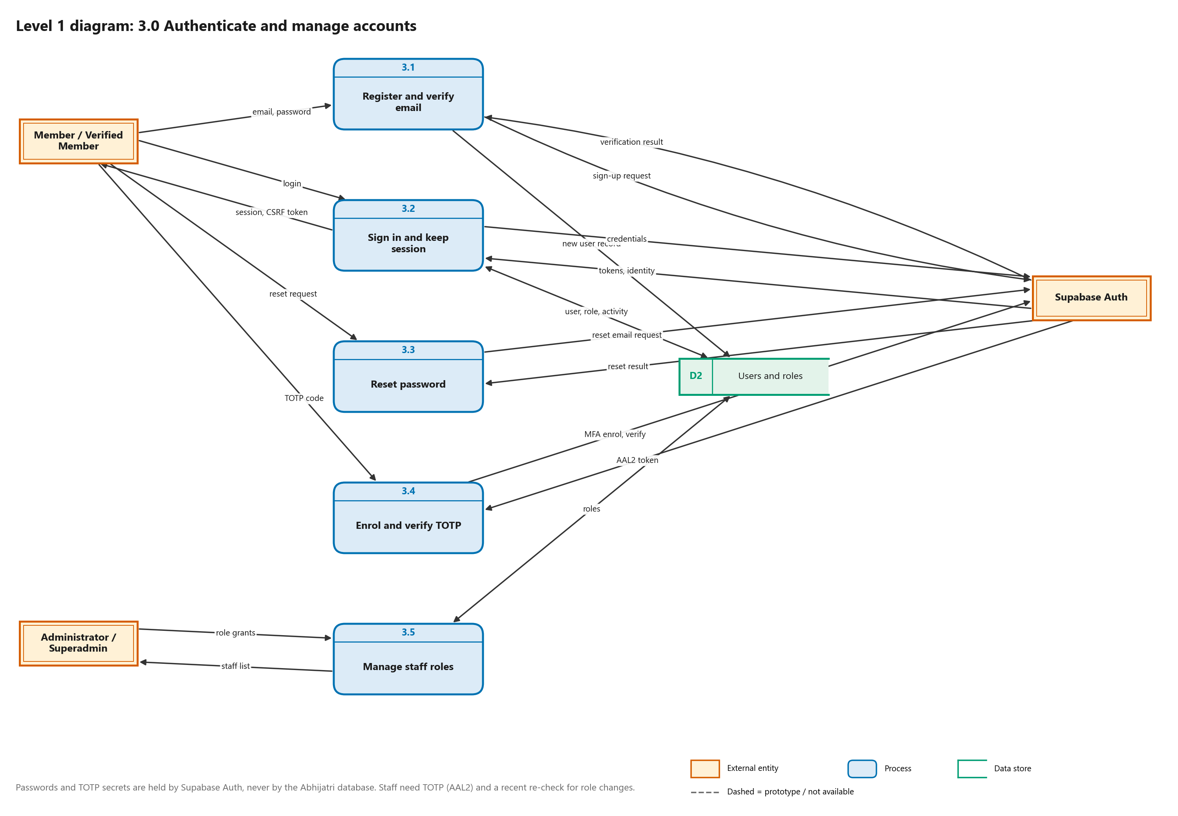
Figure 6. Level 1: process 3.0 decomposed into 3.1 to 3.5
Passwords and TOTP secrets never reach the Abhijatri database; Supabase Auth keeps them and returns signed tokens. The database stores the user, the staff role and session activity.

4.4 Level 2 diagrams

Level 2: 4.3 Edit unpublished review
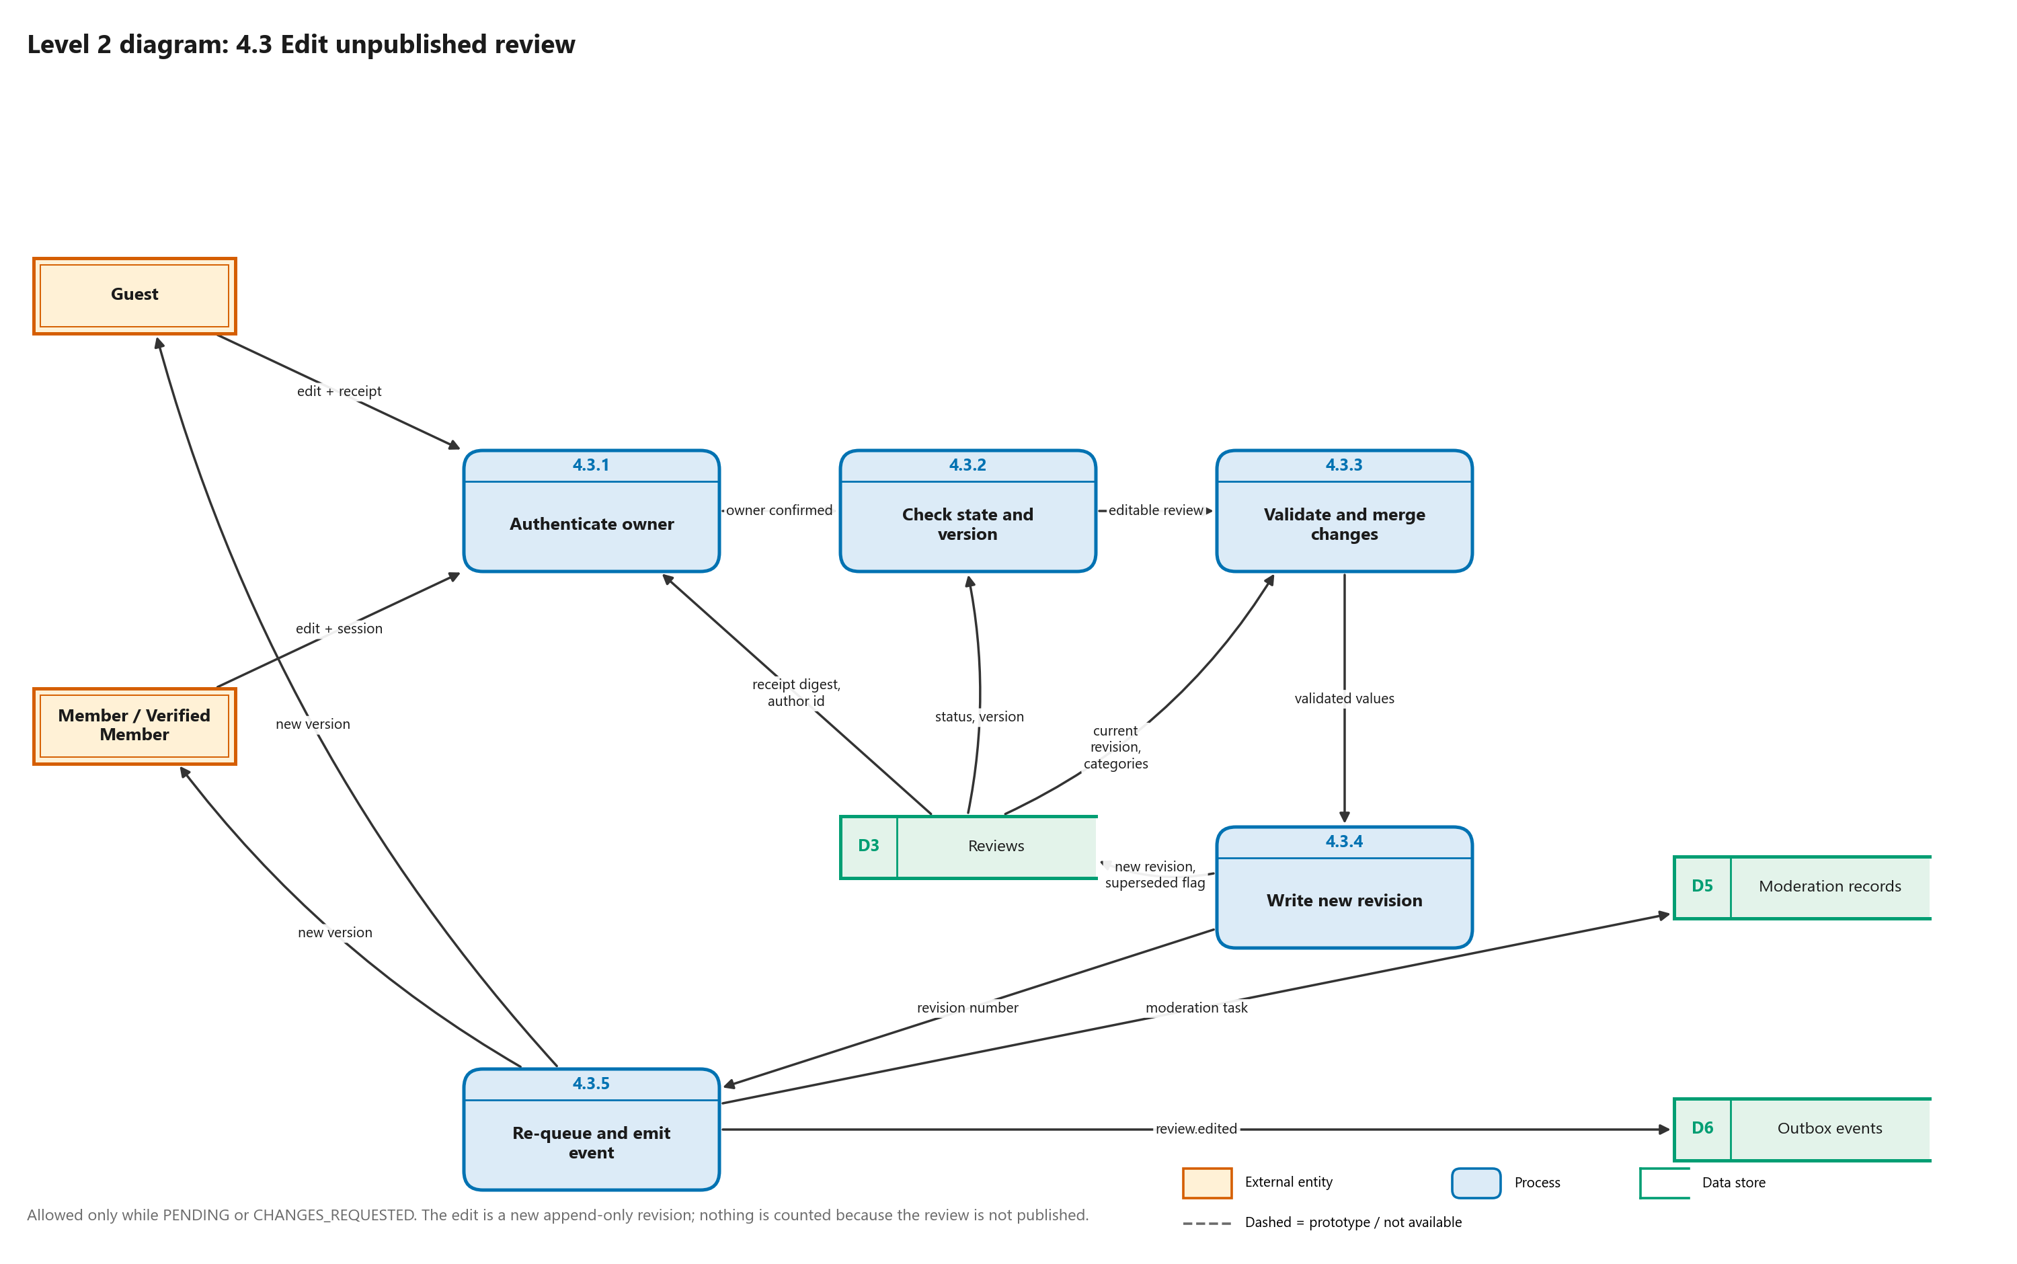
Figure 7. Level 2: process 4.3 decomposed into 4.3.1 to 4.3.5
The edit is allowed only while the review is PENDING or CHANGES_REQUESTED. The previous revision is marked SUPERSEDED, a new append-only revision is written, the review returns to PENDING and a moderation task is queued again. Nothing is counted because the review is not published.

Level 2: 6.2 Decide review
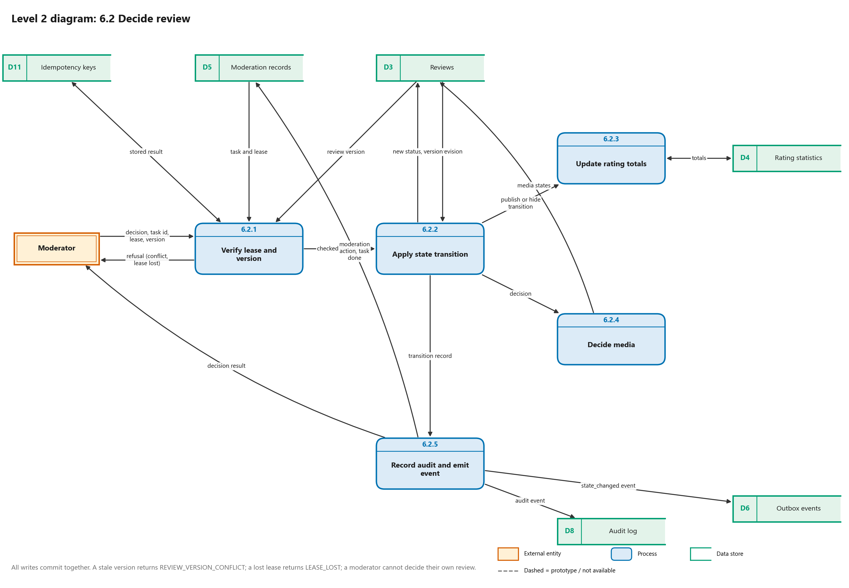
Figure 8. Level 2: process 6.2 decomposed into 6.2.1 to 6.2.5
A stale version gives REVIEW_VERSION_CONFLICT, a lost lease gives LEASE_LOST, and a moderator cannot decide their own review. All writes (status, rating totals, media states, action row, audit event, outbox event) commit together.

5. Part D: Data dictionary

5.1 External entities
Table 7. External entities
Entity | Who or what it is | What it gives the system | What it receives
Guest | A traveller without an account | Destination requests, guest reviews with a receipt, receipt operations, visit signal | Guidance, review status
Member / Verified Member | A signed-in user; Verified Member is a badge after staff approval | Sign-up, sign-in, reviews, appeals, reports, verification evidence, preferences | Session, review history, notifications
Moderator | Staff with the moderator role and TOTP | Claims, decisions, outcomes | Queue, case files, evidence links, staff notices
Administrator / Superadmin | Staff with the superadmin role | Role grants, enforcement actions, notification rules and templates | Staff list, case reports, audit log, delivery records
Ops operator | A person holding the ops token | Panel requests | Health, content, traffic and queue panels
Supabase Auth | Hosted identity service | Signed tokens, user identity | Credentials, MFA codes, reset requests
Cloudflare Turnstile | Bot check service | Pass or fail | Challenge token
Email provider | SMTP, Gmail, Brevo or Resend | Bounce and complaint webhooks | Email messages
Supabase Storage | Private object storage | Uploaded files and signed links | Signed link requests, processed files
Upstash Redis | Counter service | Counter totals | Visit and event counters

5.2 Data stores
Table 8. Data stores and the tables behind them
Store | Name | Tables or place | Where first shown
D1 | Destinations and advisories | destinations, destination_guide_items, destination_advisories, destination_contacts | Level 0
D2 | Users and roles | users, user_roles, auth_session_activity, role_admin_guard | Level 0
D3 | Reviews | reviews, review_revisions, review_category_ratings, review_receipts, review_media | Level 0
D4 | Rating statistics | destination_rating_stats, destination_category_stats | Level 0
D5 | Moderation records | moderation_tasks, moderation_actions, reports, appeals, enforcement_cases, sanctions, verification_cases, verification_evidence, verifications | Level 0
D6 | Outbox events | outbox_events | Level 0
D7 | Notifications | notifications, notification_deliveries, notification_delivery_attempts, notification_digests, notification_preferences, notification_suppressions, notification_templates, notification_rules, notification_provider_events | Level 0
D8 | Audit log | audit_events | Level 0
D9 | Abuse limits | rate_limit_buckets | Local to 4.0 (level 1)
D10 | Device storage (IndexedDB) | Browser storage, not a database table (prototype) | Level 0
D11 | Idempotency keys | idempotency_keys | Local to 6.0 (level 1)
(inside 7.0) | Visit statistics | visit_daily_stats (used only inside process 7.0, so not drawn) | Not drawn

The table names come from backend/app/models.py. The build script verifies each one exists in that file (section 7).

5.3 Level 0 data flows and what they carry
Table 9. Level 0 data flows
ID | From | To | Data flow | What it carries
F1 | Guest | 1.0 Browse destinations and advice | destination request, visit signal | destination id, language, first-visit flag
F2 | 1.0 Browse destinations and advice | Guest | guidance, advisories | bilingual destination profile, advisories with freshness state, contacts, rating summaries, one page of published reviews
F3 | D1 Destinations and advisories | 1.0 Browse destinations and advice | destination data | published destinations, guide items, advisories, contacts
F4 | D4 Rating statistics | 1.0 Browse destinations and advice | rating summaries | Guest Feedback and Community Rating totals
F5 | Guest | 2.0 Plan trips offline (prototype) | trip inputs | party, dates, comfort tier, transport and lodging choices (prototype)
F6 | 2.0 Plan trips offline (prototype) | Guest | cost estimate, offline pack | itemised BDT estimate, offline pack (prototype)
F7 | D1 Destinations and advisories | 2.0 Plan trips offline (prototype) | price and pack data | price and pack data (planned)
F8 | 2.0 Plan trips offline (prototype) | D10 Device storage (IndexedDB) | packs, trips, drafts (both ways) | saved trips, packs and drafts in the browser (prototype; IndexedDB is not built yet)
F9 | Guest | 4.0 Submit and manage reviews | guest review, receipt operations, appeal | guest review with receipt, scope secret, draft id and Turnstile token; receipt status, edit, withdraw and appeal requests
F10 | 4.0 Submit and manage reviews | Guest | review status | review id, status, rejection reason, appeal deadline
F11 | Member / Verified Member | 3.0 Authenticate and manage accounts | sign-up, sign-in | email, password, verification link, TOTP code, reset request
F12 | 3.0 Authenticate and manage accounts | Member / Verified Member | session | session cookies, CSRF token
F13 | Administrator / Superadmin | 3.0 Authenticate and manage accounts | role grants | staff role grants
F14 | 3.0 Authenticate and manage accounts | Administrator / Superadmin | staff list | staff list
F15 | Administrator / Superadmin | 6.0 Moderate, verify and rate | enforcement actions | enforcement actions
F16 | 6.0 Moderate, verify and rate | Administrator / Superadmin | case reports | case reports
F17 | Member / Verified Member | 6.0 Moderate, verify and rate | verification request, evidence | verification request, evidence files
F18 | 4.0 Submit and manage reviews | D5 Moderation records | moderation task, appeal, report | moderation task, appeal or report case
F19 | Member / Verified Member | 4.0 Submit and manage reviews | review, edit, withdraw, appeal, report | member review, edit, withdraw, appeal, report, media request
F20 | 4.0 Submit and manage reviews | Member / Verified Member | review history | review id, status, review history
F21 | 5.0 Notify members and staff | Member / Verified Member | notifications | inbox items, unread count
F22 | Member / Verified Member | 5.0 Notify members and staff | email preferences | email preferences, read and archive actions
F23 | 3.0 Authenticate and manage accounts | Supabase Auth | credentials, MFA codes | credentials, MFA codes, reset requests
F24 | Supabase Auth | 3.0 Authenticate and manage accounts | tokens, identity | signed tokens, user identity
F25 | 3.0 Authenticate and manage accounts | D2 Users and roles | accounts, roles (both ways) | accounts, roles, session activity (read and write)
F26 | 4.0 Submit and manage reviews | Cloudflare Turnstile | challenge token | challenge token
F27 | Cloudflare Turnstile | 4.0 Submit and manage reviews | pass or fail | pass or fail
F28 | 4.0 Submit and manage reviews | Supabase Storage | media upload request | signed upload link requests
F29 | Supabase Storage | 4.0 Submit and manage reviews | stored media | uploaded photo or video
F30 | 4.0 Submit and manage reviews | D3 Reviews | reviews, revisions, receipts (both ways) | reviews, revisions, category ratings, receipt digests, media records (read and write)
F31 | 4.0 Submit and manage reviews | D6 Outbox events | review events | review.submitted, review.edited, review.withdrawn events
F32 | Moderator | 6.0 Moderate, verify and rate | claims, decisions | task claims, decisions, appeal and report outcomes
F33 | 6.0 Moderate, verify and rate | Moderator | queue, case files | review queue, case files, evidence links
F34 | D3 Reviews | 6.0 Moderate, verify and rate | review data (both ways) | review data (read and write: new status, version, media state)
F35 | 6.0 Moderate, verify and rate | D5 Moderation records | decisions, cases, tasks (both ways) | tasks, decisions, cases, sanctions (read and write)
F36 | 6.0 Moderate, verify and rate | D4 Rating statistics | rating totals (both ways) | rating totals (read and write, in the decision's transaction)
F37 | 6.0 Moderate, verify and rate | D6 Outbox events | decision events | review.state_changed, appeal.decided events
F38 | 6.0 Moderate, verify and rate | Supabase Storage | signed link requests | signed link requests
F39 | Supabase Storage | 6.0 Moderate, verify and rate | evidence files | evidence files
F40 | 6.0 Moderate, verify and rate | D8 Audit log | audit records | audit events
F41 | D6 Outbox events | 5.0 Notify members and staff | events (both ways) | outbox events (read and write: processed, retry, dead letter)
F42 | 5.0 Notify members and staff | D7 Notifications | notifications (both ways) | notifications, deliveries, attempts (read and write)
F43 | 5.0 Notify members and staff | Email provider | email messages | email messages
F44 | Email provider | 5.0 Notify members and staff | bounce webhooks | bounce and complaint webhooks
F45 | Ops operator | 7.0 Monitor, audit and retain data | panel requests | ops-token panel requests
F46 | 7.0 Monitor, audit and retain data | Ops operator | health and usage panels | health, content, traffic and queue panels
F47 | 7.0 Monitor, audit and retain data | Upstash Redis | event counters | visit and event counters
F48 | Upstash Redis | 7.0 Monitor, audit and retain data | counter totals | counter totals
F49 | D8 Audit log | 7.0 Monitor, audit and retain data | audit data | audit data
F50 | 7.0 Monitor, audit and retain data | Administrator / Superadmin | audit log, delivery records | audit log, delivery records

5.4 Flows on the other diagrams

Context diagram (level C): the Abhijatri platform and everything outside it
ID | From | To | Data flow
F1 | Guest (traveller without an account) | 0 Abhijatri platform (PWA, API, staff and ops apps) | destination requests, guest reviews, receipt operations, visit signal
F2 | 0 Abhijatri platform (PWA, API, staff and ops apps) | Guest (traveller without an account) | destination guidance, advisories, review status
F3 | Member / Verified Member | 0 Abhijatri platform (PWA, API, staff and ops apps) | sign-up, sign-in, reviews, edits, appeals, evidence, preferences
F4 | 0 Abhijatri platform (PWA, API, staff and ops apps) | Member / Verified Member | session, review history, notifications
F5 | Moderator | 0 Abhijatri platform (PWA, API, staff and ops apps) | claims, decisions, appeal and verification outcomes
F6 | 0 Abhijatri platform (PWA, API, staff and ops apps) | Moderator | review queue, case files, evidence links
F7 | Administrator / Superadmin | 0 Abhijatri platform (PWA, API, staff and ops apps) | role grants, enforcement, notification rules and templates
F8 | 0 Abhijatri platform (PWA, API, staff and ops apps) | Administrator / Superadmin | audit log, staff list, delivery records
F9 | Ops operator | 0 Abhijatri platform (PWA, API, staff and ops apps) | ops-token panel requests
F10 | 0 Abhijatri platform (PWA, API, staff and ops apps) | Ops operator | health, content, traffic and queue panels
F11 | 0 Abhijatri platform (PWA, API, staff and ops apps) | Supabase Auth | credentials, MFA codes
F12 | Supabase Auth | 0 Abhijatri platform (PWA, API, staff and ops apps) | signed tokens, user identity
F13 | 0 Abhijatri platform (PWA, API, staff and ops apps) | Cloudflare Turnstile | challenge token
F14 | Cloudflare Turnstile | 0 Abhijatri platform (PWA, API, staff and ops apps) | pass or fail
F15 | 0 Abhijatri platform (PWA, API, staff and ops apps) | Email provider (SMTP, Gmail, Brevo, Resend) | email messages
F16 | Email provider (SMTP, Gmail, Brevo, Resend) | 0 Abhijatri platform (PWA, API, staff and ops apps) | bounce and complaint webhooks
F17 | 0 Abhijatri platform (PWA, API, staff and ops apps) | Supabase Storage | signed upload and download requests, processed files
F18 | Supabase Storage | 0 Abhijatri platform (PWA, API, staff and ops apps) | uploaded files, links
F19 | 0 Abhijatri platform (PWA, API, staff and ops apps) | Upstash Redis | visit and event counters
F20 | Upstash Redis | 0 Abhijatri platform (PWA, API, staff and ops apps) | counter totals

Level 1 diagram: 4.0 Submit and manage reviews
ID | From | To | Data flow
F1 | Guest | 4.1 Screen submission | guest review, receipt, scope secret
F2 | Member / Verified Member | 4.1 Screen submission | member review
F3 | 4.1 Screen submission | Cloudflare Turnstile | challenge token
F4 | Cloudflare Turnstile | 4.1 Screen submission | pass or fail
F5 | 4.1 Screen submission | D9 Abuse limits (rate_limit_buckets) | limit counters (both ways)
F6 | 4.1 Screen submission | 4.2 Create review | valid submission
F7 | 4.2 Create review | D3 Reviews | review, first revision, receipt digest
F8 | 4.2 Create review | D5 Moderation records | moderation task
F9 | 4.2 Create review | D6 Outbox events | review.submitted
F10 | 4.2 Create review | Guest | review id, status
F11 | 4.2 Create review | Member / Verified Member | review id, status
F12 | Guest | 4.3 Edit unpublished review | edit + receipt
F13 | Member / Verified Member | 4.3 Edit unpublished review | edit request
F14 | D3 Reviews | 4.3 Edit unpublished review | current revision
F15 | 4.3 Edit unpublished review | D3 Reviews | new revision
F16 | 4.3 Edit unpublished review | D5 Moderation records | re-queued task
F17 | 4.3 Edit unpublished review | D6 Outbox events | review.edited
F18 | 4.3 Edit unpublished review | Guest | new version
F19 | 4.3 Edit unpublished review | Member / Verified Member | new version
F20 | Guest | 4.4 Withdraw review | withdraw + receipt
F21 | Member / Verified Member | 4.4 Withdraw review | withdraw request
F22 | 4.4 Withdraw review | D3 Reviews | withdrawn status (both ways)
F23 | 4.4 Withdraw review | D6 Outbox events | review.withdrawn
F24 | 4.4 Withdraw review | Guest | withdrawal status
F25 | Guest | 4.5 Show status and history | status request + receipt
F26 | Member / Verified Member | 4.5 Show status and history | history request
F27 | D3 Reviews | 4.5 Show status and history | review data
F28 | 4.5 Show status and history | Guest | status, reason, appeal deadline
F29 | 4.5 Show status and history | Member / Verified Member | review, history
F30 | Member / Verified Member | 4.6 Attach photos and video | media request
F31 | 4.6 Attach photos and video | Supabase Storage | signed upload link
F32 | Supabase Storage | 4.6 Attach photos and video | uploaded file
F33 | 4.6 Attach photos and video | D3 Reviews | checked media record
F34 | Guest | 4.7 File appeal or report | guest appeal + receipt
F35 | Member / Verified Member | 4.7 File appeal or report | appeal, report
F36 | D3 Reviews | 4.7 File appeal or report | decision to appeal
F37 | 4.7 File appeal or report | D5 Moderation records | appeal or report case

Level 1 diagram: 6.0 Moderate, verify and rate
ID | From | To | Data flow
F1 | Moderator | 6.1 Manage task queue | claim, heartbeat, release
F2 | 6.1 Manage task queue | Moderator | queue, lease token
F3 | 6.1 Manage task queue | D5 Moderation records | task state, lease (both ways)
F4 | Moderator | 6.2 Decide review | decision + lease + version
F5 | 6.2 Decide review | Moderator | decision result
F6 | 6.2 Decide review | D5 Moderation records | action, task done (both ways)
F7 | 6.2 Decide review | D3 Reviews | review state, media (both ways)
F8 | 6.2 Decide review | D4 Rating statistics | rating totals (both ways)
F9 | 6.2 Decide review | D6 Outbox events | state_changed event
F10 | 6.2 Decide review | D8 Audit log | audit event
F11 | 6.2 Decide review | D11 Idempotency keys | idempotency key (both ways)
F12 | Moderator | 6.3 Decide appeals | appeal outcome
F13 | 6.3 Decide appeals | D5 Moderation records | appeal state (both ways)
F14 | 6.3 Decide appeals | D3 Reviews | restore review
F15 | 6.3 Decide appeals | D6 Outbox events | appeal.decided event
F16 | Moderator | 6.4 Handle reports and enforcement | report decision
F17 | Administrator / Superadmin | 6.4 Handle reports and enforcement | enforcement actions
F18 | 6.4 Handle reports and enforcement | Administrator / Superadmin | case reports
F19 | 6.4 Handle reports and enforcement | D5 Moderation records | cases, sanctions (both ways)
F20 | 6.4 Handle reports and enforcement | D3 Reviews | hide or restore
F21 | 6.4 Handle reports and enforcement | D8 Audit log | audit event
F22 | Member / Verified Member | 6.5 Verify members | verification request, evidence
F23 | 6.5 Verify members | Supabase Storage | signed link requests
F24 | Supabase Storage | 6.5 Verify members | evidence files
F25 | 6.5 Verify members | D5 Moderation records | verification case (both ways)
F26 | 6.5 Verify members | D6 Outbox events | verification event
F27 | 6.5 Verify members | D8 Audit log | audit event

Level 1 diagram: 5.0 Notify members and staff
ID | From | To | Data flow
F1 | D6 Outbox events | 5.1 Relay outbox events | due events (both ways)
F2 | 5.1 Relay outbox events | 5.2 Create notifications | event
F3 | 5.2 Create notifications | D7 Notifications | notifications, delivery rows (both ways)
F4 | Member / Verified Member | 5.3 Serve inbox and preferences | inbox requests, preferences
F5 | 5.3 Serve inbox and preferences | Member / Verified Member | notifications, unread count
F6 | 5.3 Serve inbox and preferences | D7 Notifications | rows, preferences (both ways)
F7 | D7 Notifications | 5.4 Send email | due deliveries
F8 | 5.4 Send email | D7 Notifications | attempt outcome
F9 | 5.4 Send email | Email provider | email messages
F10 | Email provider | 5.5 Handle provider webhooks | bounce, complaint webhooks
F11 | 5.5 Handle provider webhooks | D7 Notifications | suppressions, provider events

Level 1 diagram: 3.0 Authenticate and manage accounts
ID | From | To | Data flow
F1 | Member / Verified Member | 3.1 Register and verify email | email, password
F2 | 3.1 Register and verify email | Supabase Auth | sign-up request
F3 | Supabase Auth | 3.1 Register and verify email | verification result
F4 | 3.1 Register and verify email | D2 Users and roles | new user record
F5 | Member / Verified Member | 3.2 Sign in and keep session | login
F6 | 3.2 Sign in and keep session | Member / Verified Member | session, CSRF token
F7 | 3.2 Sign in and keep session | Supabase Auth | credentials
F8 | Supabase Auth | 3.2 Sign in and keep session | tokens, identity
F9 | 3.2 Sign in and keep session | D2 Users and roles | user, role, activity (both ways)
F10 | Member / Verified Member | 3.3 Reset password | reset request
F11 | 3.3 Reset password | Supabase Auth | reset email request
F12 | Supabase Auth | 3.3 Reset password | reset result
F13 | Member / Verified Member | 3.4 Enrol and verify TOTP | TOTP code
F14 | 3.4 Enrol and verify TOTP | Supabase Auth | MFA enrol, verify
F15 | Supabase Auth | 3.4 Enrol and verify TOTP | AAL2 token
F16 | Administrator / Superadmin | 3.5 Manage staff roles | role grants
F17 | 3.5 Manage staff roles | Administrator / Superadmin | staff list
F18 | 3.5 Manage staff roles | D2 Users and roles | roles (both ways)

Level 2 diagram: 4.3 Edit unpublished review
ID | From | To | Data flow
F1 | Guest | 4.3.1 Authenticate owner | edit + receipt
F2 | Member / Verified Member | 4.3.1 Authenticate owner | edit + session
F3 | D3 Reviews | 4.3.1 Authenticate owner | receipt digest, author id
F4 | 4.3.1 Authenticate owner | 4.3.2 Check state and version | owner confirmed
F5 | D3 Reviews | 4.3.2 Check state and version | status, version
F6 | 4.3.2 Check state and version | 4.3.3 Validate and merge changes | editable review
F7 | D3 Reviews | 4.3.3 Validate and merge changes | current revision, categories
F8 | 4.3.3 Validate and merge changes | 4.3.4 Write new revision | validated values
F9 | 4.3.4 Write new revision | D3 Reviews | new revision, superseded flag
F10 | 4.3.4 Write new revision | 4.3.5 Re-queue and emit event | revision number
F11 | 4.3.5 Re-queue and emit event | D5 Moderation records | moderation task
F12 | 4.3.5 Re-queue and emit event | D6 Outbox events | review.edited
F13 | 4.3.5 Re-queue and emit event | Member / Verified Member | new version
F14 | 4.3.5 Re-queue and emit event | Guest | new version

Level 2 diagram: 6.2 Decide review
ID | From | To | Data flow
F1 | Moderator | 6.2.1 Verify lease and version | decision, task id, lease, version
F2 | 6.2.1 Verify lease and version | Moderator | refusal (conflict, lease lost)
F3 | D5 Moderation records | 6.2.1 Verify lease and version | task and lease
F4 | D11 Idempotency keys | 6.2.1 Verify lease and version | stored result (both ways)
F5 | D3 Reviews | 6.2.1 Verify lease and version | review version
F6 | 6.2.1 Verify lease and version | 6.2.2 Apply state transition | checked decision
F7 | D3 Reviews | 6.2.2 Apply state transition | review, revision
F8 | 6.2.2 Apply state transition | D3 Reviews | new status, version
F9 | 6.2.2 Apply state transition | 6.2.3 Update rating totals | publish or hide transition
F10 | 6.2.3 Update rating totals | D4 Rating statistics | totals (both ways)
F11 | 6.2.2 Apply state transition | 6.2.4 Decide media | decision
F12 | 6.2.4 Decide media | D3 Reviews | media states
F13 | 6.2.2 Apply state transition | 6.2.5 Record audit and emit event | transition record
F14 | 6.2.5 Record audit and emit event | D5 Moderation records | moderation action, task done
F15 | 6.2.5 Record audit and emit event | D8 Audit log | audit event
F16 | 6.2.5 Record audit and emit event | D6 Outbox events | state_changed event
F17 | 6.2.5 Record audit and emit event | Moderator | decision result

6. Balancing: the levels agree
A child diagram is balanced with its parent when the flows crossing the child's boundary are exactly the flows of the parent process. The table lists, for each parent flow, the child flows that realise it. An empty child column would be a violation; there are none.
Table 10. Parent and child boundary flows
Child of | Boundary | Parent flow | Child flows that realise it
Level 0 diagram / 4.0 | from D3 Reviews | reviews, revisions, receipts | current revision; decision to appeal; review data; withdrawn status
Level 0 diagram / 4.0 | to D3 Reviews | reviews, revisions, receipts | checked media record; new revision; review, first revision, receipt digest; withdrawn status
Level 0 diagram / 4.0 | to D5 Moderation records | moderation task, appeal, report | appeal or report case; moderation task; re-queued task
Level 0 diagram / 4.0 | to D6 Outbox events | review events | review.edited; review.submitted; review.withdrawn
Level 0 diagram / 4.0 | from Guest | guest review, receipt operations, appeal | edit + receipt; guest appeal + receipt; guest review, receipt, scope secret; status request + receipt; withdraw + receipt
Level 0 diagram / 4.0 | to Guest | review status | new version; review id, status; status, reason, appeal deadline; withdrawal status
Level 0 diagram / 4.0 | from Member / Verified Member | review, edit, withdraw, appeal, report | appeal, report; edit request; history request; media request; member review; withdraw request
Level 0 diagram / 4.0 | to Member / Verified Member | review history | new version; review id, status; review, history
Level 0 diagram / 4.0 | from Supabase Storage | stored media | uploaded file
Level 0 diagram / 4.0 | to Supabase Storage | media upload request | signed upload link
Level 0 diagram / 4.0 | from Cloudflare Turnstile | pass or fail | pass or fail
Level 0 diagram / 4.0 | to Cloudflare Turnstile | challenge token | challenge token
Level 1 diagram / 4.0 | local store | (not on parent) | D9 Abuse limits (rate_limit_buckets)
Level 0 diagram / 6.0 | from Administrator / Superadmin | enforcement actions | enforcement actions
Level 0 diagram / 6.0 | to Administrator / Superadmin | case reports | case reports
Level 0 diagram / 6.0 | from D3 Reviews | review data | review state, media
Level 0 diagram / 6.0 | to D3 Reviews | review data | hide or restore; restore review; review state, media
Level 0 diagram / 6.0 | from D4 Rating statistics | rating totals | rating totals
Level 0 diagram / 6.0 | to D4 Rating statistics | rating totals | rating totals
Level 0 diagram / 6.0 | from D5 Moderation records | decisions, cases, tasks | action, task done; appeal state; cases, sanctions; task state, lease; verification case
Level 0 diagram / 6.0 | to D5 Moderation records | decisions, cases, tasks | action, task done; appeal state; cases, sanctions; task state, lease; verification case
Level 0 diagram / 6.0 | to D6 Outbox events | decision events | appeal.decided event; state_changed event; verification event
Level 0 diagram / 6.0 | to D8 Audit log | audit records | audit event
Level 0 diagram / 6.0 | from Member / Verified Member | verification request, evidence | verification request, evidence
Level 0 diagram / 6.0 | from Moderator | claims, decisions | appeal outcome; claim, heartbeat, release; decision + lease + version; report decision
Level 0 diagram / 6.0 | to Moderator | queue, case files | decision result; queue, lease token
Level 0 diagram / 6.0 | from Supabase Storage | evidence files | evidence files
Level 0 diagram / 6.0 | to Supabase Storage | signed link requests | signed link requests
Level 1 diagram / 6.0 | local store | (not on parent) | D11 Idempotency keys
Level 0 diagram / 5.0 | from D6 Outbox events | events | due events
Level 0 diagram / 5.0 | to D6 Outbox events | events | due events
Level 0 diagram / 5.0 | from D7 Notifications | notifications | due deliveries; notifications, delivery rows; rows, preferences
Level 0 diagram / 5.0 | to D7 Notifications | notifications | attempt outcome; notifications, delivery rows; rows, preferences; suppressions, provider events
Level 0 diagram / 5.0 | from Email provider | bounce webhooks | bounce, complaint webhooks
Level 0 diagram / 5.0 | to Email provider | email messages | email messages
Level 0 diagram / 5.0 | from Member / Verified Member | email preferences | inbox requests, preferences
Level 0 diagram / 5.0 | to Member / Verified Member | notifications | notifications, unread count
Level 0 diagram / 3.0 | from Administrator / Superadmin | role grants | role grants
Level 0 diagram / 3.0 | to Administrator / Superadmin | staff list | staff list
Level 0 diagram / 3.0 | from Supabase Auth | tokens, identity | AAL2 token; reset result; tokens, identity; verification result
Level 0 diagram / 3.0 | to Supabase Auth | credentials, MFA codes | MFA enrol, verify; credentials; reset email request; sign-up request
Level 0 diagram / 3.0 | from D2 Users and roles | accounts, roles | roles; user, role, activity
Level 0 diagram / 3.0 | to D2 Users and roles | accounts, roles | new user record; roles; user, role, activity
Level 0 diagram / 3.0 | from Member / Verified Member | sign-up, sign-in | TOTP code; email, password; login; reset request
Level 0 diagram / 3.0 | to Member / Verified Member | session | session, CSRF token
Level 1 diagram / 4.3 | from D3 Reviews | current revision | current revision, categories; receipt digest, author id; status, version
Level 1 diagram / 4.3 | to D3 Reviews | new revision | new revision, superseded flag
Level 1 diagram / 4.3 | to D5 Moderation records | re-queued task | moderation task
Level 1 diagram / 4.3 | to D6 Outbox events | review.edited | review.edited
Level 1 diagram / 4.3 | from Guest | edit + receipt | edit + receipt
Level 1 diagram / 4.3 | to Guest | new version | new version
Level 1 diagram / 4.3 | from Member / Verified Member | edit request | edit + session
Level 1 diagram / 4.3 | to Member / Verified Member | new version | new version
Level 1 diagram / 6.2 | from D11 Idempotency keys | idempotency key | stored result
Level 1 diagram / 6.2 | to D11 Idempotency keys | idempotency key | stored result
Level 1 diagram / 6.2 | from D3 Reviews | review state, media | review version; review, revision
Level 1 diagram / 6.2 | to D3 Reviews | review state, media | media states; new status, version
Level 1 diagram / 6.2 | from D4 Rating statistics | rating totals | totals
Level 1 diagram / 6.2 | to D4 Rating statistics | rating totals | totals
Level 1 diagram / 6.2 | from D5 Moderation records | action, task done | task and lease
Level 1 diagram / 6.2 | to D5 Moderation records | action, task done | moderation action, task done
Level 1 diagram / 6.2 | to D6 Outbox events | state_changed event | state_changed event
Level 1 diagram / 6.2 | to D8 Audit log | audit event | audit event
Level 1 diagram / 6.2 | from Moderator | decision + lease + version | decision, task id, lease, version
Level 1 diagram / 6.2 | to Moderator | decision result | decision result; refusal (conflict, lease lost)

Level 0 against the context diagram: every external entity on level 0 has the same directions of flow as on the context diagram (in, out, or both). The automatic check reports no difference.

7. What was checked, and what was not
Table 11. Verification
Check | How | Result
Every flow joins a process to an entity, a store or another process | Automatic, all diagrams | Pass (194 flows on 8 diagrams)
Every process has an input and an output | Automatic | Pass (40 process boxes)
No unnamed flow, no unconnected symbol | Automatic | Pass
Children balance with parents; level 0 matches the context diagram | Automatic (this document's section 6) | Pass
Table names in the store table exist in models.py | Script compares with backend/app/models.py | Pass
Routes and behaviours drawn match the code | Read against Backend-Implemented.md 5.13 to 5.19 and the R07 tests | Reviewed by the author; no automated link from picture to code
Readability when printed on A4 | Figures viewed at page size | Labels readable; a few labels sit close to crossing arrows on level 0 and level 1 (see limits)

Limits
- The diagrams show the system as built on 30 October 2026. When a route or table changes, update dfd_levels.py, rebuild, and re-read the balancing table.
- Level 1 diagrams were drawn for the four processes with the most behaviour (accounts, reviews, notifications, moderation). Processes 1.0 and 7.0 are simple enough to read from the level 0 description; decompose them if the course requires a level 1 for every process.
- Some label positions were set by hand; if a label touches a line in Word, move it in the source and rebuild.
- The Word table of contents is a field. Press F9 (or accept the prompt when opening) to fill in page numbers.

How to regenerate
cd Docs/diagrams
python make_diagrams.py # draws the DFDs and checks the rules and balancing
python make_other.py # state, sequence, ER and Venn figures
python build_dfd_doc.py # rebuilds Docs/Abhijatri-DFD.docx

