Abhijatri
SRS Completion and Proposal Coverage
What the project proposal already covers, what a complete SRS still needs, and the missing sections ready to paste

Item | Detail
Project | Abhijatri: a Bangla-first, offline-ready community travel platform for Bangladesh (Team ChoturMatra, CSE 3102)
Document | Proposal coverage check, SRS gap analysis, and the missing SRS sections
Version | 1.0, 30 October 2026
Checked against | Docs/Abhijatri_Project_Proposal.tex and its PDF (proposal date 12 October 2026) and the repository at 30 October 2026
Companion documents | Abhijatri-DFD.docx (data flow diagrams), Abhijatri-Venn-Diagram.docx, Abhijatri-Proposal-Judging-Checklist.docx
Standard followed | Section order follows the usual SRS structure of IEEE 29148 (introduction, overall description, specific requirements, appendices)

Contents
Contents appear here. If this line is still visible, right-click it and choose Update Field (or press F9).

1. Summary
The proposal already contains all nine points your instructor requires. Each is present and substantial. What it does not contain is the rest of a Software Requirements Specification (SRS): a glossary, constraints, assumptions, external interface requirements, data requirements, detailed use case descriptions, state and sequence diagrams, a data flow diagram, a traceability matrix, and revision history. It was also written on 12 October 2026, before the review, moderation, notification and account features were built, so some statements need an "as built" note.
Table 1. Summary of findings
Question | Answer
Are the nine required proposal points present? | Yes, all nine (section 2).
Is there a use case diagram? | Yes: the UML use case model with four actors and ten packages (proposal section "Primary Use Cases"). It is reproduced in section 4.4 of this document.
Is there a complete SRS? | Not yet. 14 standard SRS elements are missing or only partly covered (section 3). Sections 4 to 10 supply them.
Is there a data flow diagram? | No in the proposal. It is now in Abhijatri-DFD.docx (context, level 0, level 1 and level 2).
Does the proposal match what was built? | Mostly in intent, but with differences listed in section 11 (for example Supabase Auth instead of self-managed password hashing, and the offline features still being prototypes).

How to use this document. Sections 4 to 11 are written so they can be copied into the proposal or the SRS report as they are. Where something is a prototype or not built, the text says so plainly; do not remove those statements, because they are what the repository supports.

2. The nine required proposal points: coverage
Table 2. Coverage of the nine required points
# | Required point | Where in the proposal | Assessment and what to improve
1 | Executive Summary | Section 1, Executive Summary | Present. Covers the problem, the solution and the semester outcome (a tested PWA with five seeded destinations). Improve: add one sentence of as-built status and one headline measure.
2 | Problem Statement | Section 2, five subsections (fragmented information, unclear costs, weak connectivity, Bangla-first support, trust and freshness) | Present and well structured. Improve: add one or two cited sources or survey figures if available, because the section states the gap without evidence.
3 | Objectives and Goals | Section 3, objectives O1 to O8 with completion measures | Present and measurable (for example 10 of 10 airplane-mode tests, at least eight consenting participants). Improve: add the results as they become known; note that O4 depends on offline features that are not built yet.
4 | Functional Requirements | Section 4: core and future features, user roles, FR01 to FR17 catalogue, cost planner rules, use case model, user stories, MVP exclusions | Present and the strongest section. Improve: add use case specifications (section 4.6 here) and an as-built status per requirement (section 4.4).
5 | Non-functional Requirements | Section 5, table with performance, security, reliability, scalability, usability and accessibility, maintainability, portability, privacy | Present with acceptance measures. Improve: state uptime and load targets as numbers, name an accessibility standard, and record measured results.
6 | Stakeholders | Section 6, seven stakeholder groups with interest and engagement | Present. Improve: add influence and interest levels and who is the decision owner.
7 | Timeline / Milestones | Section 7: milestones M1 to M4 and gate G1, formal testing phase, Gantt chart with dependencies and effort | Present and detailed. Improve: add a "planned versus actual" column as of the submission date.
8 | Risk Assessment | Section 8, 13 risks with level, early warning, mitigation and owner | Present. Improve: add likelihood and impact scores, residual risk and a risk for dependence on third-party services (Supabase, Cloudflare, email provider).
9 | Feasibility Study | Section 9: technical, economic (BDT 6,000 ceiling), schedule, operational and ethical | Present, covers all three required kinds plus one more. Improve: update the cost table with the actual hosting and service costs, and say what happens if free tiers end.

3. What a complete SRS adds: gap analysis
Table 3. SRS elements: present, partly present, missing
SRS part | Element | Status in the proposal | What exists | Supplied by
Introduction | Purpose of the document | Partly | Executive Summary and Scope Decision | Section 4.1.1
Introduction | Scope of the product | Yes | Scope Decision, MVP exclusions | Reuse; section 4.1.2 restates it
Introduction | Definitions, acronyms, abbreviations (glossary) | Missing | none (0 mentions) | Section 4.1.3
Introduction | References | Missing | none | Section 4.1.4
Overall description | Product perspective and system context | Partly | Architecture is mentioned only in feasibility | Section 4.2.1 with the context DFD
Overall description | Product functions | Yes | Core and future features | Section 4.2.2 maps them to processes
Overall description | User classes and characteristics | Yes | User roles table | Section 4.2.3 adds Verified Member, moderator, superadmin, ops
Overall description | Operating environment | Partly | Portability row | Section 4.2.4
Overall description | Design and implementation constraints | Missing | none | Section 4.2.5
Overall description | Assumptions and dependencies | Partly | 3 scattered mentions | Section 4.2.6
Specific requirements | External interface requirements (user, software, hardware, communications) | Missing | none | Section 4.3
Specific requirements | Functional requirements | Yes | FR01 to FR17 | Reuse; section 4.4 adds status as built
Specific requirements | Non-functional requirements | Yes | Eight categories | Reuse; section 4.8 adds evidence
Specific requirements | Data requirements (data model, retention) | Missing | none | Section 4.5 with the ER diagram
Specific requirements | Use case specifications | Partly | Diagram and user stories only | Section 4.6
Specific requirements | Behaviour models (state, sequence) | Missing | none | Sections 4.7 (state) and 4.8 (sequence)
Appendices | Data flow diagram | Missing | none | Abhijatri-DFD.docx
Appendices | Requirements traceability matrix | Partly | User stories trace to FR | Section 4.9: FR to use case to API to test
Appendices | Verification plan | Yes | Formal testing table and phases | Reuse
Appendices | Revision history and approval | Missing | none | Section 4.11

Of 20 elements, 6 are present, 6 are partly present and 8 are missing. The 14 gaps (missing plus partly present) are all filled by the sections that follow.

4. Paste-ready SRS sections
Numbering below is the section numbering of the SRS you would assemble: 4.1 is SRS section 1 and so on. Rename them when you paste.

4.1 Introduction

4.1.1 Purpose
This Software Requirements Specification describes Abhijatri, a Bangla-first, offline-ready community travel platform for Bangladesh. It states what the system must do and the qualities it must have, so that the team, the instructor and the evaluators can judge the finished product against the same list. It is written for the four team members (frontend, backend, quality assurance and project leader), the course instructor and external evaluators.

4.1.2 Scope
Abhijatri lets travellers explore destinations in Bangla or English, read dated advisories, write and read moderated reviews, and (in the semester plan) estimate trip cost and use destination packs without a connection. Staff moderate content, decide appeals, verify members and monitor the system.
Table 4. Scope boundary
In scope (semester MVP) | Out of scope (future or excluded)
Five seeded destination profiles with sourced, dated guidance, contacts and advisories | Real payment, SMS gateways, NID verification, live inventory
Bangla and English interface | Native mobile applications
Guest and member reviews, structured ratings, moderation, appeals, reports, notifications | Live chat, arbitrary private groups, vendor responses, booking
Accounts, email verification, TOTP for staff, roles, audit log | Automated sentiment analysis and machine-learning moderation
Operations dashboard and retention jobs | Editing a published review (withdraw and resubmit instead)
Prototype screens for cost planning, offline packs and saved trips (not yet functional) | Agency and guide onboarding, commissions

4.1.3 Definitions, acronyms and abbreviations
Table 5. Glossary
Term | Meaning in this project
API | Application programming interface. Here, the FastAPI service under /api/v1.
Appeal | A request to reconsider a rejection or hiding decision, allowed until the end of the 30th day (Asia/Dhaka).
Audit event | An append-only record of a privileged action: who, what, when, and why.
BDT | Bangladeshi taka.
CSRF | Cross-site request forgery; prevented with a token that must accompany every signed-in write.
Draft id | A random UUID created on the device for one review; the server keeps only one review per draft id, so retries are safe.
Guest | A visitor without an account. Guest reviews never change the Community Rating.
Guest Feedback | The average of published Guest ratings, shown separately from the Community Rating.
Community Rating | A Bayesian score built only from eligible Verified Member reviews.
IndexedDB | The browser database planned for drafts and offline packs (not built yet).
Lease | A time-limited claim (300 seconds) a moderator holds on a task so two people do not decide the same item.
Member / Verified Member | A signed-in user / a member whose identity evidence staff approved.
MFA / TOTP | Multi-factor authentication / time-based one-time password from an authenticator app.
Moderator / Superadmin | Staff roles. Both need TOTP; only a superadmin can grant roles.
MVP | Minimum viable product: the semester deliverable.
Outbox | A database table of events written in the same transaction as the change they describe, processed later by a worker.
PWA | Progressive web application: a website that can be installed and work offline.
RLS | PostgreSQL row-level security, enabled on every public table.
Receipt | A secret the Guest's browser generates (abr1_ plus 43 characters). The server stores only a keyed digest and never reissues it.
Revision | One saved version of a review's content; revisions are append-only.
Supabase | Hosted PostgreSQL, identity and storage provider used by the project.
Turnstile | Cloudflare's bot-check widget used on guest submissions.
Verified Visit | A future, separate claim that a visit happened; not the same as Verified Member.
WP / R-number | Work package and Gantt task identifiers (for example R07 = structured review CRUD).

4.1.4 References
- Abhijatri Project Proposal, 12 October 2026 (Docs/Abhijatri_Project_Proposal.pdf).
- Docs/Architecture.md, Docs/Schema.md, Docs/Security.md, Docs/Decisions.md, Docs/Implemented.md.
- Docs/Backend-Implemented.md and Docs/Frontend-Implemented.md (what is built and the evidence).
- Docs/api/API.md and Docs/api/openapi-v1.json (the API contract).
- Features/Review.md, Features/Platform-Foundation.md, Features/Execution.md (feature specifications).
- Docs/Moderation-Dashboard-Specification.md, Docs/Notification-Documentation.md, Docs/System-Monitoring-Dashboard.md.
- IEEE Std 29148-2018, Systems and software engineering: Life cycle processes: Requirements engineering (structure of this SRS).
- Abhijatri-DFD.docx and Abhijatri-Venn-Diagram.docx (companion documents).

4.1.5 Overview of the rest
Section 4.2 describes the product in context. Section 4.3 lists its interfaces. Sections 4.4 to 4.8 give functional, data and behaviour requirements. Section 4.9 traces requirements to code and tests. Sections 4.10 and 4.11 compare the proposal with what was built and record revisions.

4.2 Overall description

4.2.1 Product perspective
Abhijatri is a new, self-contained system with four deployable parts and a small number of external services. The public web app (React, TypeScript) talks only to the API; it holds no database key. The FastAPI service enforces all authorisation, moderation, receipt checks and rating arithmetic. PostgreSQL (hosted by Supabase) is the source of truth. A separate staff web app and a private operations app use the same API.
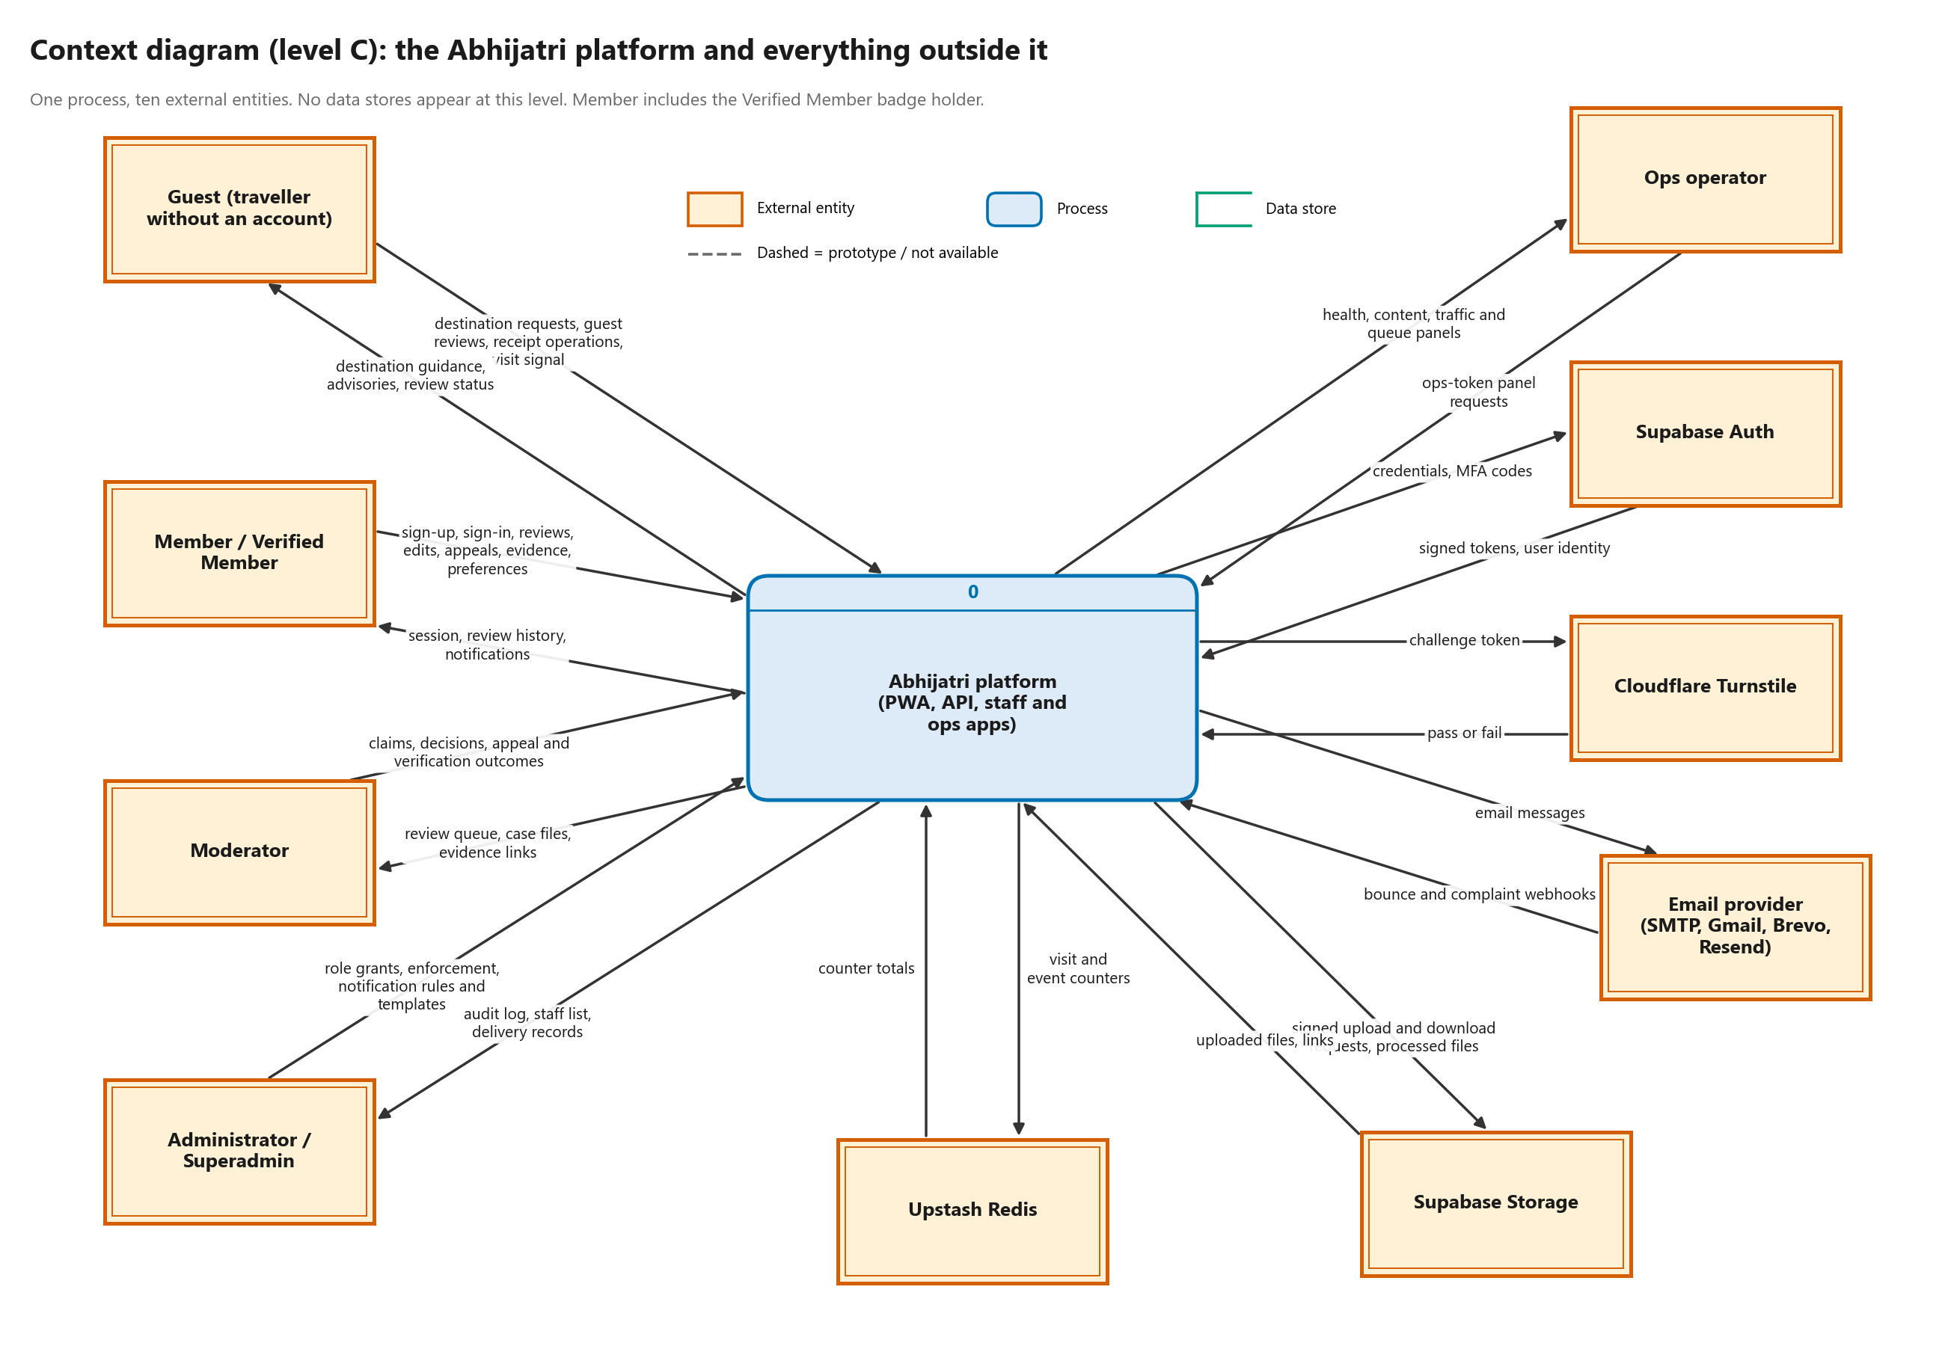
Figure 1. System context (the context data flow diagram)

4.2.2 Product functions
Table 6. Product functions and the data flow processes that realise them
Function group | What the system does | DFD process
Destination guidance | Shows bilingual destination profiles, advisories with a current, stale or expired state, contacts and rating summaries | 1.0
Trip planning (prototype) | Estimate cost, save trip briefs, download packs | 2.0
Accounts | Register, verify email, sign in, reset password, TOTP for staff, roles | 3.0
Reviews | Create, edit while unpublished, withdraw, view status and history, attach media, appeal, report | 4.0
Notifications | In-app inbox and email with preferences, retries and digests | 5.0
Moderation | Task queue, decisions, ratings, appeals, reports, enforcement, verification | 6.0
Operations | Panels, audit log, visit counters, retention | 7.0

4.2.3 User classes
Table 7. User classes
User class | Description | Technical skill | Can do
Guest | Traveller without an account; may use Bangla only and a low-end Android phone | Low | Browse, read reviews, submit one review with a receipt, check status, edit or withdraw it, appeal a rejection
Member | Signed-in user with a verified email | Low to medium | Everything a Guest can; also own review history, media upload, appeals, reports, notifications, verification request
Verified Member | Member whose evidence staff approved | Low to medium | Their reviews can count toward the Community Rating
Moderator | Staff with TOTP | Medium | Claim tasks, decide reviews, appeals and reports, review verification
Superadmin | Staff with TOTP and a recent password check for sensitive actions | High | Everything a moderator can; grant roles, see dead letters and delivery records
Ops operator | Holds the ops token | High | Read monitoring panels only

4.2.4 Operating environment
- Client: current Chromium-based Android browsers and modern desktop browsers; Safari limitations are documented where a device is available.
- Server: Python 3.12 container running FastAPI behind HTTPS; PostgreSQL 17 (Supabase); Redis over TLS for counters only.
- Build: Node 22 for the three front-end apps; CI on every pull request (lint, type check, tests, migration check, dependency audit, secret scan, image build).
- Time zone: the server stores UTC; dates shown to users and appeal deadlines use Asia/Dhaka.

4.2.5 Design and implementation constraints
Table 8. Constraints
ID | Constraint | Source
C1 | Bangla is the default language; Bangla text must render correctly including conjuncts, and names are limited by code point count, not bytes. | Proposal; Review.md 3.4
C2 | The browser never holds a database or service key; all authority is on the server. | Architecture.md section 1
C3 | No real payment, SMS gateway, NID or live inventory in the semester. | Proposal MVP exclusions
C4 | Total direct cost must stay within the planning ceiling of BDT 6,000. | Proposal feasibility
C5 | Final completion on 17 or 18 January 2027; formal testing 4 to 11 January 2027. | Proposal timeline
C6 | A published review is never edited; the author withdraws and writes a new one. | Review.md 5.2
C7 | A Guest review never changes the Community Rating; receipts are never reissued. | Review.md 3.2, 4.2
C8 | Personal data is minimised: no NID, no payment data; optional contacts stay on the device. | Proposal privacy; Security.md
C9 | Hosted free or low-cost tiers limit storage, email volume and request rates. | Decisions.md
C10 | Every schema change is a reversible migration; the API contract in openapi-v1.json is checked in CI. | backend/migrations, tests/test_openapi_contract.py

4.2.6 Assumptions and dependencies
Table 9. Assumptions and dependencies
ID | Assumption or dependency | If it fails
A1 | Supabase Auth, PostgreSQL and Storage are available. | Sign-in, reviews or media are unavailable; the API answers SERVICE_UNAVAILABLE and readiness reports 503.
A2 | Cloudflare Turnstile is reachable for guest submissions. | New guest reviews cannot be submitted; reading and receipt operations continue.
A3 | An email provider is configured and delivers. | Email retries (1 min, 5 min, 30 min, 2 h) then fails; the in-app notification still exists.
A4 | Users have a Chromium-based or modern browser. | Some features degrade; documented limits apply.
A5 | At least two trained moderators are available (a decision on appeal needs a second person). | Appeals wait in the queue.
A6 | Destination data is researched, sourced and dated by the team. | Advisories become stale or expired and are labelled so.
A7 | Redis is available for counters. | Visit and event counters lose data; reviews are not affected.
A8 | Users consent to the moderation and retention notice shown with a submission. | No submission is accepted without a consent version.

4.3 External interface requirements

4.3.1 User interfaces
Table 10. User interfaces
Application | Main screens | Notes
Public PWA (frontend/) | Landing, guest entry, register, verify email, sign in, forgot and reset password, overview, destinations and detail, reviews (form, receipt status, withdraw), account verification, appeals, notifications; prototype: planner, offline packs, saved trips | Bangla first; English selectable; keyboard and screen-reader support are required; prototype screens must be labelled
Staff app (staff/) | Sign-in with TOTP, task queue with lease, decision form, media, appeals, reports, enforcement, verification cases, staff, audit, inbox, notifications | Never part of the public build; staff routes answer 404 to non-staff
Ops app (ops/) | Health, content, traffic, members, notifications, queue and reviews panels | Read-only; token in a header; separate deployment

4.3.2 Software interface: the API
The contract is Docs/api/openapi-v1.json (checked against the code by a test) and Docs/api/API.md. All errors use one body, { error: { code, message, request_id, field_errors } }, with Bangla and English messages. Signed-in writes need a CSRF token; guest operations send the receipt in the JSON body only; lists use opaque cursors.
Table 11. API operations by group (from openapi-v1.json)
Group | Operations | Purpose
/admin | 37 | Staff API: task queue and leases, review decisions, appeals, reports, enforcement, verification cases, audit log, staff roles, notification administration, media decisions
/auth | 12 | Registration, email verification, sign-in and sign-out, password reset, TOTP enrolment, re-authentication, session and CSRF token
/reviews | 10 | Guest and member review creation, edit while unpublished, withdraw, owner view, member history, media upload, reports
/verifications | 6 | Verified Member requests and evidence
/notifications | 5 | Member inbox, unread count, mark read, live stream
/ops | 4 | Operator panels (token protected)
/appeals | 3 | Member appeals against rejection or hiding
/destinations | 3 | Published destination list, profile, and the public review feed
/staff | 3 | Original review moderation endpoints (kept for the vertical slice)
/health | 2 | Liveness and readiness
/notification-preferences | 2 | Email and notification preferences
/review-receipts | 2 | Receipt status and guest appeals (the receipt travels in the request body)
/guest-visits | 1 | First-visit signal counted in Redis
/review-parameters | 1 | Limits and labels the review form needs
/webhooks | 1 | Email provider callbacks
Total | 92 | operations in docs/api/openapi-v1.json

4.3.3 Third-party services
Table 12. Third-party services
Service | Purpose | Data exchanged | When unavailable
Supabase Auth | Identity, passwords, TOTP | Credentials, tokens, user id | Sign-in and registration fail with a clear error; existing sessions continue until expiry
Supabase PostgreSQL | System of record | All application tables | Readiness 503; the API does not accept writes
Supabase Storage | Private media and evidence | Signed links, processed files | Upload answers SERVICE_UNAVAILABLE with a Retry-After header
Cloudflare Turnstile | Bot check on guest submission | One-time token | Guest submissions refused; other features unaffected
Email provider (SMTP, Gmail, Brevo, Resend) | Notification email | Email address, message, delivery status webhooks | Retried, then marked failed; alert raised after a threshold
Upstash Redis | Visit and event counters | Counter increments and totals | Counters lost; core flows unaffected

4.3.4 Hardware and communications interfaces
- No special hardware. Target device: a low-end Android phone on a slow mobile network; the proposal's measure is usable core text within 5 seconds on a throttled Fast 3G profile.
- All traffic uses HTTPS; cookies are HttpOnly and Secure in production; CORS allows only the configured origins.

4.4 System features: use case model and requirement status
The use case model below is the proposal's own diagram (four actors; packages for supporting functions, cost estimator, offline, review, community, administration and verification; booking and payment are demonstration only).
Figure 2. Abhijatri use case model (from the proposal). Packages 4 and 6c are demonstration-only.

Status of each functional requirement as of 30 October 2026, from the repository (Docs/Implemented.md, Docs/Backend-Implemented.md, Docs/Frontend-Implemented.md and the tests):
Table 13. Functional requirement status
ID | Requirement | Status | Evidence or note
FR01 | Destination catalogue | Implemented | Five destinations with sourced, dated content; R01 content review pending
FR02 | Language selection | Implemented | Bangla default, English selectable; no test of the language switch was found
FR03 | Account lifecycle | Partly | Register, verify, sign in, reset, sign out built; account deletion request not found in the API
FR04 | Structured review | Implemented | Guest and member; seven category ratings; the local offline draft is not built (see FR12)
FR05 | Review moderation | Implemented | Publish, reject, hide, restore, request changes; audit and actor recorded; DELETED state defined but not used
FR06 | Review reporting | Implemented (member) | Member reports with duplicate control; anonymous public reports planned
FR07 | Destination rating | Implemented | Guest Feedback average; Bayesian Community Rating from eligible Verified Member reviews, hidden below the threshold
FR08 | Cost planner | Prototype | Screen only; no estimator logic or API
FR09 | Pricing units | Not implemented | Depends on the planner and a price catalogue
FR10 | Offline pack | Prototype | No service worker, manifest or IndexedDB yet
FR11 | Saved trip brief | Prototype | Screen only
FR12 | Offline review draft | Not implemented | Draft store (IndexedDB) planned for R15
FR13 | Retry-safe submission | Partly | Permanent draft id uniqueness and receipt recovery built and tested; Idempotency-Key replay is built for staff decisions, planned for other writes
FR14 | Pack update | Not implemented | Depends on FR10
FR15 | Advisory freshness | Implemented | Current, stale, expired and not-yet-effective, on the Dhaka date
FR16 | Administration | Partly | Staff roles, audit log, notification administration, media decisions built; staff editing of destination content not built
FR17 | Storage control | Not implemented | Depends on FR10

Summary: 7 implemented, 3 partly implemented, 3 prototypes and 4 not implemented, of 17. The offline group (FR10, FR11, FR12, FR14, FR17) and the estimator (FR08, FR09) are the main remaining work.

4.5 Data requirements

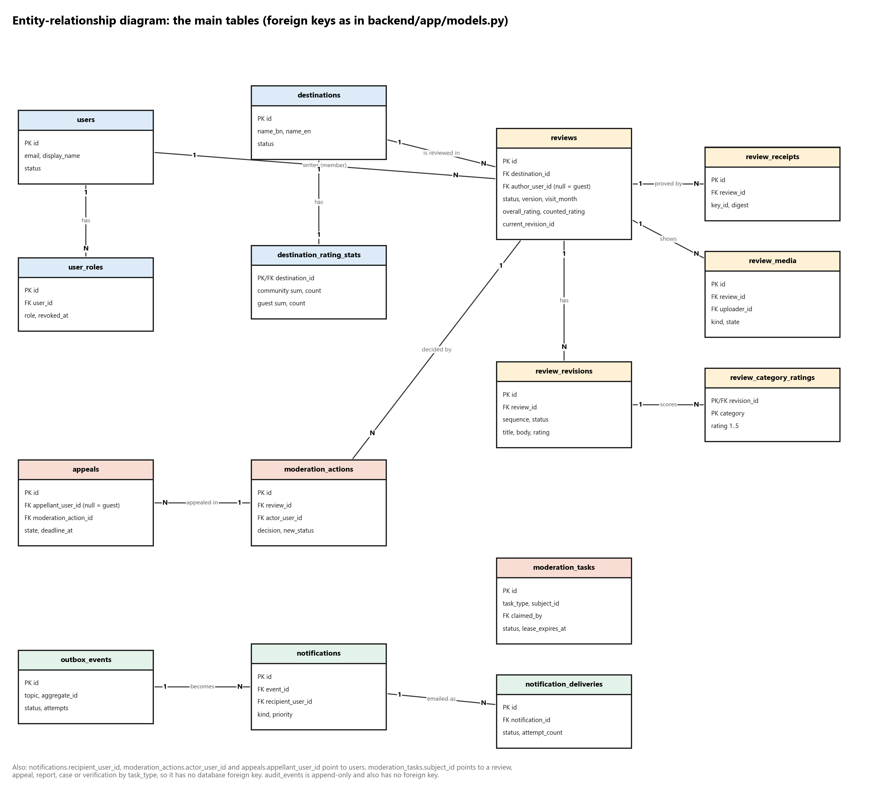
Figure 3. Entity-relationship diagram of the main tables

The database has more than 35 tables; the diagram shows the ones needed to understand reviews, moderation and notifications. Every public table has row-level security enabled, and the application connects as the owner role.
Table 14. Data kept and how it is protected
Data | Where kept | Retention or protection
Review text and ratings | reviews, review_revisions, review_category_ratings | Kept while published; revisions append-only; personal content may be tombstoned by the retention job
Guest receipt and scope secret | Browser only; server holds keyed digests (review_receipts, reviews.guest_scope_hash) | Raw values never stored or logged; receipts never reissued
Account identity | users, user_roles; passwords and TOTP in Supabase Auth | Passwords never in the application database
Verification evidence | Private storage; verification_cases, verification_evidence | Files erased within 24 hours of a decision; rejected cases kept 30 days
Photos and videos | review_media; private bucket | Uploads not completed within 24 hours are purged; re-encoded images have EXIF and GPS removed
Notifications | notifications and delivery tables | Standard items 90 days; critical items 24 months; open appeals preserved
Outbox events | outbox_events | Processed rows removed after 30 days
Rate-limit counters | rate_limit_buckets | Old windows purged automatically
Audit events | audit_events | Append-only; the application role cannot update or delete

4.6 Use case specifications
Six core use cases are specified in full. Each maps to a package in the use case model and to a flow in the data flow diagrams.
Table 15. UC-01 Submit a review
Field | Specification
Actors | Guest or Member (primary); Cloudflare Turnstile (secondary)
Trigger | The user finishes the structured review form and presses Submit.
Preconditions | A published destination exists. A Guest has a generated receipt, scope secret and draft id. A Member is signed in with a CSRF token.
Main flow | 1. The client sends the review (title, note, overall rating, optional category ratings, language, traveller type, comfort tier, visit month, consent version).  2. The server checks the schema and receipt format.  3. If the draft id already exists with the same receipt, it returns the existing review (no charge).  4. For a Guest it verifies the Turnstile token and durable rate limits and pending ceilings.  5. It creates the review (PENDING), first revision, category ratings, receipt digest, moderation task and outbox event in one transaction.  6. It answers 201 with review id and status.
Alternative flows | A member who already has an active review for the same destination and month gets MEMBER_REVIEW_EXISTS. A different receipt on an existing draft gets DRAFT_ALREADY_SUBMITTED.
Exceptions | Turnstile failure (CHALLENGE_FAILED), rate limit (RATE_LIMITED with Retry-After), guest writes paused (GUEST_WRITES_PAUSED), validation errors with field codes.
Postconditions | One PENDING review is queued for moderation; nothing is counted or public.
Requirements | FR04, FR13, FR05
API and tests | POST /reviews/guest, POST /reviews/member; tests/test_review_postgres.py, test_receipts.py, test_abuse.py, test_category_ratings.py

Table 16. UC-02 Edit an unpublished review
Field | Specification
Actors | Guest (with receipt) or Member (owner)
Trigger | The author changes a pending review or answers a moderator's request for changes.
Preconditions | The review is PENDING or CHANGES_REQUESTED and the author knows its current version.
Main flow | 1. The client sends PATCH /reviews/{id}/pending with expected_version and only the changed fields (a Guest adds the receipt; a Member uses the session and CSRF token).  2. The server proves ownership (receipt digest or author id).  3. It checks the state and the version.  4. It validates and merges the changes with the current revision.  5. It writes a new revision, marks the old one SUPERSEDED, sets the review to PENDING and re-queues the moderation task.  6. It answers 200 with the new version and revision number.
Alternative flows | Moving a member review onto a month already reviewed gives MEMBER_REVIEW_EXISTS.
Exceptions | Wrong receipt (RECEIPT_NOT_FOUND, counted toward a progressive block); another person's review (404); any other state (INVALID_TRANSITION); stale version (REVIEW_VERSION_CONFLICT).
Postconditions | A new revision exists; the review is hidden and uncounted until a moderator publishes it.
Requirements | FR04, FR05; Review.md 5.2
API and tests | PATCH /reviews/{id}/pending; tests/test_review_crud.py (member and guest edit, refused states, month collision, request-changes round trip)

Table 17. UC-03 Moderate a review
Field | Specification
Actors | Moderator or Superadmin
Trigger | A moderator opens the queue and takes a pending review.
Preconditions | Staff signed in with TOTP; a moderation task exists; the moderator is not the author.
Main flow | 1. Claim the task and receive a lease token (300 seconds; heartbeat extends it).  2. Read the content and any media.  3. Send the decision (PUBLISH, REJECT, REQUEST_CHANGES, HIDE, RESTORE) with the task id, lease token, the review's version and a reason code.  4. In one transaction the server changes the status, updates rating totals exactly once, decides media, writes the moderation action, an audit event and an outbox event, and completes the task.  5. The worker later notifies the author.
Alternative flows | A decision can be replayed with the same Idempotency-Key and returns the stored result.
Exceptions | Stale version (REVIEW_VERSION_CONFLICT); lost lease (LEASE_LOST); impossible move (TRANSITION_NOT_ALLOWED); own review (SELF_MODERATION_FORBIDDEN).
Postconditions | Status and aggregates are consistent; the decision is auditable; the author is notified.
Requirements | FR05, FR07, FR16
API and tests | POST /admin/tasks/{id}/claim, POST /admin/submissions/{id}/moderation-actions; tests/test_admin.py, test_review_postgres.py, test_review_crud.py

Table 18. UC-04 Appeal a rejection
Field | Specification
Actors | Member (session) or Guest (receipt); a second moderator
Trigger | The author sees a rejection with its reason and appeal deadline.
Preconditions | The review is REJECTED (or HIDDEN for a member) and the 30-day window (end of day 30, Asia/Dhaka) has not closed.
Main flow | 1. The author files the appeal (member: POST /appeals; guest: POST /review-receipts/appeals with the receipt and a 20 to 2000 character statement).  2. The server records one appeal per decision and queues an appeal task.  3. A moderator other than the original decider claims it and decides upheld or overturned.  4. If overturned, a rejected review returns to PENDING for a fresh review; a hidden review is restored.  5. The author is notified (a Guest sees the outcome in the receipt status).
Exceptions | Window closed (APPEAL_WINDOW_CLOSED); second appeal (DUPLICATE_APPEAL); the original decider tries to decide (APPEAL_REVIEWER_NOT_INDEPENDENT).
Postconditions | The appeal has a final state and an audit record.
Requirements | FR05; Review.md 4.2, 5.4
API and tests | POST /appeals, POST /review-receipts/appeals, POST /admin/appeals/{id}/decision; tests/test_cases.py, test_review_crud.py

Table 19. UC-05 Estimate trip cost (prototype)
Field | Specification
Actors | Guest or Member
Trigger | The traveller enters party size, dates, comfort tier and choices.
Intended flow | The estimator applies source-dated prices by pricing unit (person, room, vehicle, group, day, night, meal, entry) and returns an itemised BDT range with per-person cost and a confidence label.
Status | Prototype screen only. There is no estimator logic, price catalogue or API in the repository yet (FR08, FR09).
Requirements | FR08, FR09; proposal section 4 (cost planner rules and worked example)
Verification plan | Ten held-out trips evaluated after the price catalogue is frozen (objective O6).

Table 20. UC-06 Download an offline pack (prototype)
Field | Specification
Actors | Guest or Member
Trigger | The traveller chooses a destination pack to keep for airplane mode.
Intended flow | The app downloads a versioned pack (guidance, contacts, coordinates, advisories, costs) into IndexedDB, asks for persistent storage, and later replaces it atomically after validating a newer manifest.
Status | Prototype screen only. No service worker, manifest, IndexedDB or pack API exists yet (FR10, FR14, FR17).
Requirements | FR10, FR14, FR17
Verification plan | 10 of 10 packs open in airplane mode on real devices (objective O4).

4.7 Review lifecycle (state diagram)
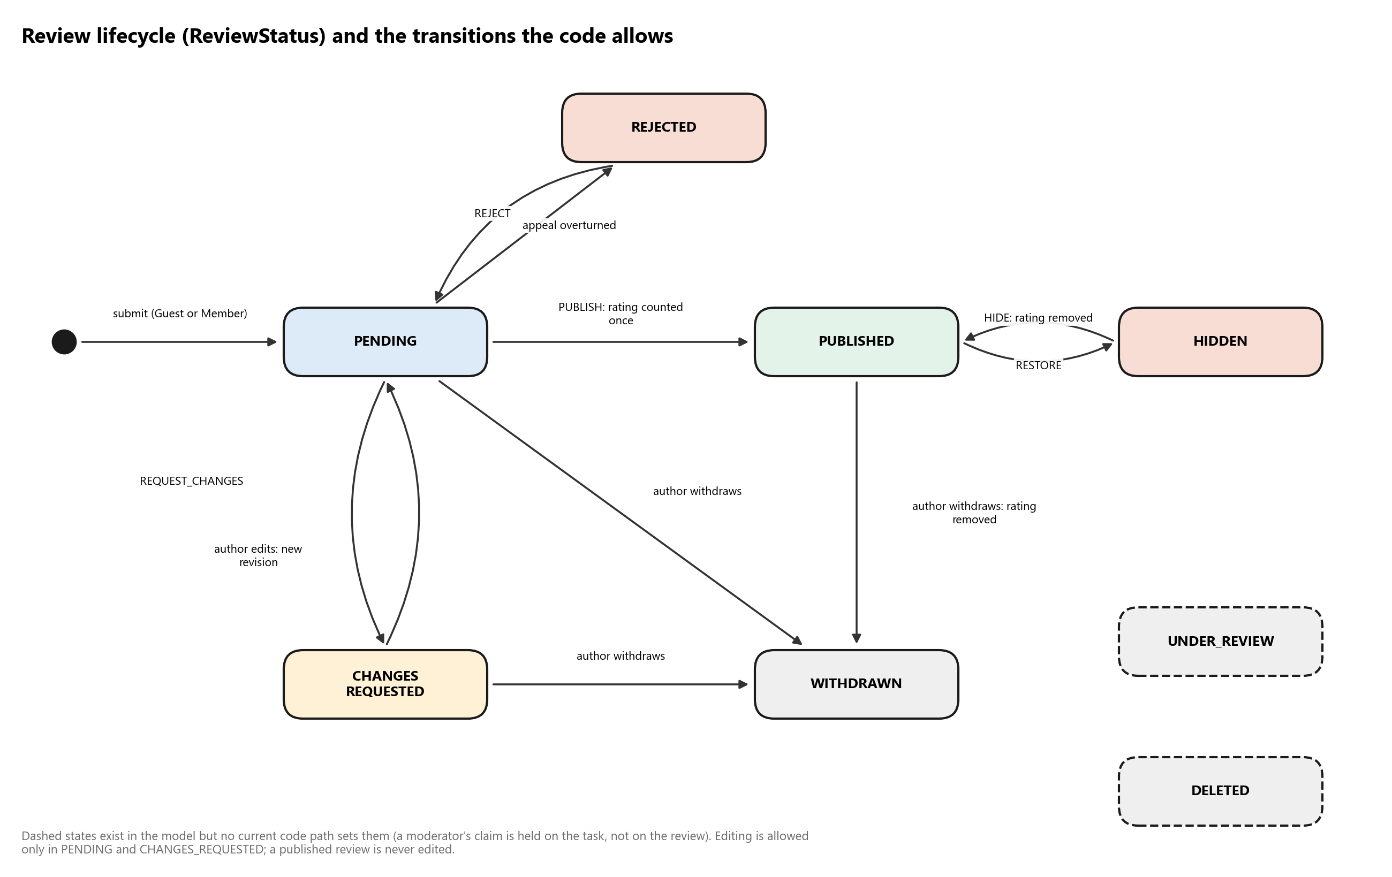
Figure 4. Review states and the transitions the code allows

Table 21. Transitions
Event | From | To | Who | Side effects
Submit | (new) | PENDING | Guest or Member | Revision 1, receipt digest, task, outbox event
PUBLISH | PENDING | PUBLISHED | Moderator | Rating counted once (Guest Feedback or Community Rating); category totals move; author notified
REJECT | PENDING | REJECTED | Moderator | Public-safe reason; 30-day appeal window starts
REQUEST_CHANGES | PENDING | CHANGES_REQUESTED | Moderator | Author notified with the reason; no rating change
Edit | PENDING or CHANGES_REQUESTED | PENDING | Author | New revision; old one SUPERSEDED; task re-queued
HIDE | PUBLISHED | HIDDEN | Moderator | Rating removed in the same transaction
RESTORE | HIDDEN | PUBLISHED | Moderator | Rating added back
Withdraw | PENDING, CHANGES_REQUESTED or PUBLISHED | WITHDRAWN | Author | Rating removed; task cancelled; idempotent
Appeal overturned | REJECTED | PENDING | A second moderator | Back to the queue for a fresh review

The states UNDER_REVIEW and DELETED exist in the data model and are accepted by some checks, but no current code path sets them; a moderator's claim is held on the task, not on the review.

4.8 Behaviour: sequence diagrams and non-functional evidence

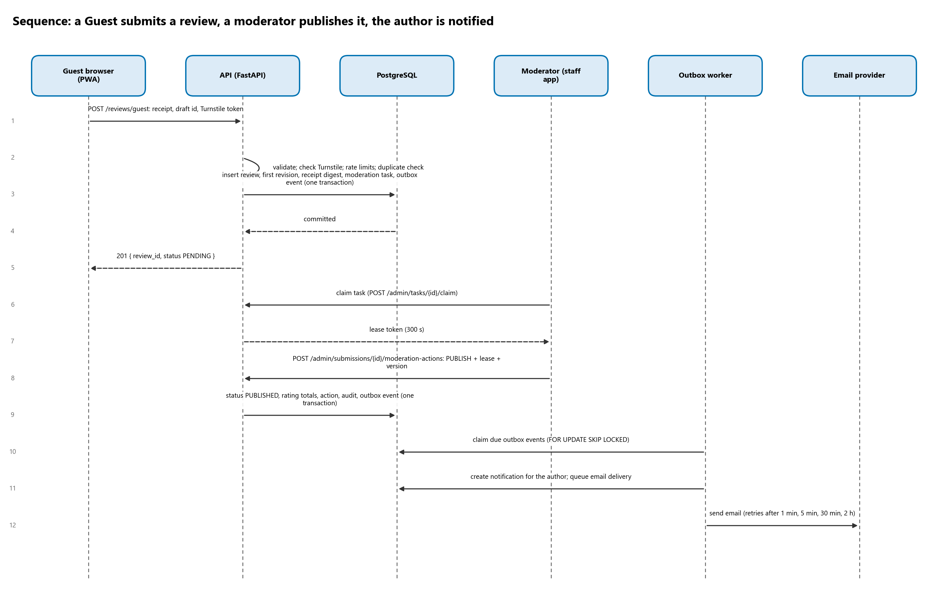
Figure 5. Submit, moderate, publish and notify
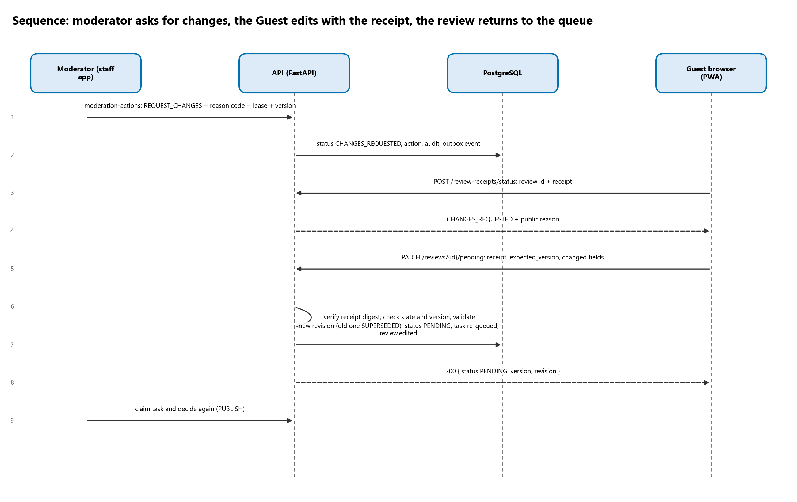
Figure 6. Request changes, edit with the receipt, return to the queue

Non-functional requirements and the evidence available for them at 30 October 2026:
Table 22. Non-functional requirements: evidence
Category | Requirement (proposal) | Evidence in the repository | Status
Performance | Core text usable within 5 s on throttled Fast 3G; pack opens within the stated time | Not measured. Public lists are paginated (default 20, maximum 50) and public responses are cached for 60 seconds; no timing test is in the repository. | Gap
Security and access control | Server-side authority, CSRF, TOTP for staff, role checks, audit, rate limits, Turnstile, RLS | Built and tested: tests/test_auth.py, test_admin.py, test_rls.py, test_abuse.py; dependency audit clean; committed-secret check in CI | Met
Reliability and availability | Identical retries create no duplicate; interrupted pack update keeps the last pack | Retry safety built and tested; outbox is at-least-once and idempotent; pack update not applicable yet; no uptime measurement | Partly
Scalability | Stateless API, indexes, pagination, bounded queries | Built; no load test | Partly
Usability and accessibility | Bangla default, labelled forms, keyboard access, Bengali conjunct rendering tested | Bilingual UI built; QA notes list remaining accessibility items; no screen-reader test record | Partly
Maintainability | Modular code, migrations, API docs, tests, code review | 502 backend tests, 64, 24 and 19 front-end tests, lint and strict typing in CI, 18 migrations, contract tests | Met
Portability | Chromium Android, modern desktop | Builds pass; no recorded real-device run | Partly
Privacy | Minimal data, consent, retention, deletion support | Retention jobs and consent version built; account deletion request not found | Partly

4.9 Requirements traceability matrix
Table 23. Traceability: requirement to use case to API to test
FR | Use case package (diagram) | API operations | Automated tests | Status
FR01 | 5.1 Explore Destination | GET /destinations, /destinations/{id} | test_destination_unit, test_destination_http, test_destination_postgres, test_seed_content | Implemented
FR02 | Supporting: Switch Language | Accept-Language on all routes | No test of the language switch found | Implemented
FR03 | Supporting; 6b Verification: Email and Account | POST /auth/register, verify-email, login, logout, password-reset/*; GET /auth/session | test_auth | Partly
FR04 | 3. Review: Fill Structured Review, Submit Review | POST /reviews/guest, /reviews/member; GET /review-parameters | test_review_postgres, test_review_unit, test_category_ratings, test_receipts, test_review_crud | Implemented
FR05 | 5. Community: Moderate Review | GET /admin/queue; POST /admin/tasks/{id}/claim, /admin/submissions/{id}/moderation-actions | test_admin, test_review_postgres, test_review_crud | Implemented
FR06 | 5. Community: Report Review | POST /reviews/{id}/reports; POST /admin/reports/{id}/transition | test_admin (report flow and rules) | Implemented (member)
FR07 | 5. Community: View Destination Rating | GET /destinations/{id}/reviews; rating logic in services.py | test_review_postgres, test_destination_postgres | Implemented
FR08, FR09 | 1. Cost Estimator | None yet | None yet | Prototype / not implemented
FR10, FR14, FR17 | 2. Offline | None yet | None yet | Prototype / not implemented
FR11 | 2. Offline: Save Local Trip Brief | None (local) | None yet | Prototype
FR12 | 3. Review: Save Offline Review Draft | None (local) | None yet | Not implemented
FR13 | 3. Review: Submit with Idempotency Key | POST /reviews/guest (draft id), POST /reviews/member; Idempotency-Key on staff decisions | test_review_postgres (retry deduplication), test_receipts, test_admin (idempotent decision) | Partly
FR15 | 6a Verification: Advisory and Offline Pack | GET /destinations/{id} (advisory state) | test_destination_unit (boundaries, Dhaka date) | Implemented
FR16 | Administration | GET /admin/staff, POST /admin/staff/{id}/role, GET /admin/audit-events, notification admin routes | test_admin, test_notifications | Partly
R07 (review CRUD) | 3. Review (edit, withdraw, history, appeal) | PATCH /reviews/{id}/pending, GET /reviews/{id}, GET /reviews/mine, POST /reviews/{id}/withdraw, POST /review-receipts/appeals | test_review_crud (16 tests) | Implemented
Notifications | Not in the proposal's diagram | GET /notifications, PATCH /notifications/{id}, /notification-preferences | test_notifications | Implemented

Two features are built but not drawn in the proposal's use case diagram: the notification system and the review edit and appeal flows. Add them to the diagram when the PDF is revised.

4.10 As built versus proposed
Table 24. Proposal and implementation compared
Topic | Proposal (12 October 2026) | As built (30 October 2026) | Action
Authentication | Argon2id hashing and opaque server-side sessions | Supabase Auth holds passwords and TOTP; the API verifies signed tokens and sets HttpOnly session cookies with a CSRF token | Update the security row and the technical feasibility text
Staff security | Role-based access | Staff need TOTP (AAL2); superadmin needs a recent password check for role changes; every action is audited | Add to NFR text
Guest identity | Guest reviews with a draft id | Client-generated receipt, keyed digests, durable rate limits, Turnstile, public pseudonymous guest tag | Describe in the review section
Review lifecycle | Published, hidden, rejected or deleted | Adds PENDING, CHANGES_REQUESTED, WITHDRAWN, SUPERSEDED revisions, appeals and edit-while-pending | Update FR05 and the state model
Photos and video | Image attachment for Verified Members | Any signed-in member may attach up to 5 photos and 1 video; no transcoding | Record as a scope decision (Decisions.md)
Notifications | Not in scope | Full outbox, inbox, email, digests and webhooks | Add as a feature
Observability | Not specified | Ops dashboard, audit log, alerts | Add to NFR
Hosting | Optional short-term hosting, BDT 2,500 | Supabase, Upstash and hosted API and front-ends | Update the cost table with actual costs
Offline and PWA | Core of the MVP | Prototype screens only; no service worker or IndexedDB | State the status; plan the remaining work
Cost estimator | Rule-based itemised estimate | Prototype screen only | State the status
Booking and payment | Demonstration only | Not built | Keep as demonstration or remove from the diagram

4.11 Revision history and approval
Table 25. Revision history
Version | Date | Author | Change
0.1 | 12 October 2026 | Team ChoturMatra | Project proposal
1.0 | 30 October 2026 | Prepared for the team | SRS completion sections, coverage check, traceability

Table 26. Approval
Role | Name | Signature | Date
Project leader | Shahriar Islam
Frontend and offline | Abdullah Bin Sorwar Choudhury
Backend and data | Syed Muhtasim Alam
Quality assurance | Md. Irfan Iqbal
Course instructor

