MME 346 - LAB REPORT



Exp - 02

**PROPERTIES OF MOULDING SAND AGGREGATE**

Date of Performance- 05.12.21

Date of Submission- 09.01.22

**SUBMITTED TO**

DR. KAZI MD. SHOROWORDI

Professor

MONIRUZZAMAN JAMAL

Lecturer

Department of Materials and Metallurgical Engineering

**SUBMITTED BY**

ABDULLAH SHAHRIAR

Student ID- **201711037**

Department of Materials and Metallurgical Engineering

# BANGLADESH UNIVERSITY OF ENGINEERING AND TECHNOLOGY

**OBJECTIVE**

The main objectives of this experiment are-

1. To be familiarize with the standard test procedures for moulding sand aggregates used in foundry establishment e.g., sieve analysis, clay content test and moisture content test, permeability, mould hardness, green compressive strength and dry compressive strength.
2. To calculate the AFS grain fineness number and learn about its significance.
3. To be able to differentiate between moulding sands for ferrous and non-ferrous castings, and for small and heavy castings.
4. To study the effects of moulding sand characteristics (clay and water contents and number of ramming) on the properties of greensand moulding mixture (permeability, mould hardness, green compressive strength and dry compressive strength).

**INTRODUCTION**

The need for systematic evaluation of the working qualities of moulding materials under foundry conditions has led to the development of a wide range of tests.

Sand testing falls into two categories:

1. Checking consistency of sand by determining its basic chemical and physical characteristics.
2. Measuring the bulk properties of an aggregate by evaluating physical and chemical properties of a sand mix.

The bulk properties of an aggregate are sensitive to small variations in mixing conditions and specimen preparation. Rigid standardization is needed at all stages. Even under these conditions results usually show considerable scatter.

Some of the most important tests routinely performed in foundry:

(a) **Consistency tests**:

1. AFS sieve analysis and GFN
2. Moisture content
3. AFS clay content and Methylene blue test
4. Compactibility

(b**) Bulk / mould property tests**

1. Mould hardness
2. Green and dry compression strengths
3. Permeability
4. Flowability
5. Collapsibility
6. Shatter index
7. Surface stability index

Some of the properties affiliated with this experiment are described below:

**Sieve analysis**: The size, size distribution, and shape of the sand grains are important in controlling the quality of the mould. Coarse grained sand provides metal penetration, poor surface finish and fine-grained sand provides better surface finish, low permeability, higher binder content. The grain size and shape contribute to the amount of sand surface area. The grain size and size distribution controls the permeability of the mould.

**Clay content:** Clay may contain active clay, dead clay, silt, sea coal, cellulose, cereal, ash, fines and all materials that float in water. Only the active clay gives active bonding capacity to the system. So dead clay and fines should be removed and active clay and new additives should be added periodically.

**Moisture content**: Moisture content affects every property of green sand (except GFN of base sand). Excess water produces an oxidizing atmosphere in the mould, excess gas evolution, lower permeability, high dry and hot strength, low mold hardness and poor flowability.

Two factors that affect the moisture requirement are:

1. The type and amount of clay, and
2. The type and amount of additives in the sand mix.

**Mould hardness:** Proper mold hardness will give castings a better finish, more accurate dimensions and reduced penetration, drops and swells. Excessive hardness can cause cracks, scabs, blows, pinholes and penetration.

**Permeability:** The grain size, shape and distribution of the foundry sand, the type and quantity of bonding materials, the density to which the sand is rammed and the percentage of moisture used for tempering the sand are important factors in regulating the degree of permeability. In case of used sand, fines and dead clay affects the permeability. An increase in permeability usually indicates a more open structure in the rammed sand, and if the increase continues, it will lead to penetration-type defects and rough castings. A decrease in permeability indicates tighter packing and could lead to blows and pinholes.

**Sand strength:** Sand strength test is the measure of holding power of various bonding materials in green and dry sand. It determines the cohesiveness or natural binding capacity of the sand grains. There are four types of tests for sand strength:

1. Compression
2. Shear
3. Tensile and
4. Overhang bar test

Of these tests, the compression test is by far most widely used and is very convenient for routine

testing of all types of normal bonded and synthetic moulding sand.

**EQUIPMENTS**

**Sieve analysis**

* 100g sand
* A set of standard testing sieve

**Clay Content**

* 50g dried sand
* Drying oven
* Balance and weight
* Sand washer

**Moisture Content**

* 50g tampered sand
* Balance and weight

**EXPERIMENTAL PROCEDURE**

**Sieve analysis**

* The test of determining the AFS grain fineness number was performed on a dried sand sample from which all clay substances had been removed.
* A set of standard testing sieve was used to screen the sand. These sieves were stacked in sequence with the coarsest sieve at the top and placed in a sieve shaker.
* About 100 g sand was placed at the top sieve and, after 15 minutes of vibration, the weight of the sand retained in each sieve was obtained.
* The AFS grain fineness number of the sand was determined by taking the percentage of sand retained on each screen, multiplying each by a multiplier (which is simply the next available sieve old mesh number greater than the one being weighed out), adding the total, and then dividing by the total percentage of sand retained on the sieves.

**Clay Content**

* 50 g of dried sand was placed in a wash bottle.
* To this sand, 475 c.c. of distilled water and 25 c.c. of 3.0 % caustic soda solution were added.
* The mixture was stirred for 5 min in a rapid sand washer.
* The liquid was then siphoned off after 10 min.
* The bottle was refilled twice more and siphoned the liquid off.
* The sand was placed in the oven for drying.
* The sand was weighed when it is completely dried and the percentage of clay was determined by the difference in the initial and final weights of the sample.

**Moisture Content**

* 50g of tempered sand was accurately weighed and placed in the pan.
* The timer for the blower of the moisture teller was set for the required time to dry the sand (approximately 15 min) and air at 110 C was blown over and through the sand.
* The sand was dried after this and weighed again.
* The difference in the initial and final readings were noted and the percentage of moisture in the sand was determined

**Sand Strength Test**

For green compression strength test, the AFS Standard sand specimen is prepared. The test is performed on the sand specimen by using Universal sand strength machine. This machine consists of a pusher arm and weight arm, both hanging from a pivot bearing at the top of the machine. The weight arm applies load on the specimen while pusher arm pushes the specimen against the weight. As the weight arm is pushed up higher, the load increases until the specimen breaks. Then the compression strength in ton/in2 may be read at the magnetic marker whose left side shows the maximum upward travel of the weight arm. For dry compression strength test, the AFS standard specimen is placed in the oven and dried it for about one hours at 110 C. The specimen is cooled and tested it on the same day they are made.

The specimen is placed in the upper position of the sand strength machine and broken the specimen

as in the case of green strength test. The dry strength values are read in psi off the dry strength

scale.

**CALCULATION**

**Sieve Analysis:**

Size of Sample: 50g

|  |  |  |  |  |
| --- | --- | --- | --- | --- |
| **USA Sieve Series No** | **Sand retained on each sieve, g** | **Percentage of sand retained (A)** | **Multiplier (B)** | **Product (A x B)** |
| 6 | 0 | 0 | 3 | 0 |
| 12 | 0 | 0 | 5 | 0 |
| 30 | 0.2 | 0.4 | 20 | 8 |
| 40 | 1.5 | 3 | 30 | 90 |
| 70 | 23.8 | 47.6 | 50 | 2380 |
| 140 | 19.3 | 38.6 | 100 | 3860 |
| 200 | 2.5 | 5 | 140 | 700 |
| 270 | 1.1 | 2.2 | 200 | 440 |
| Pan | 0.6 | 1.2 | 300 | 360 |
|  |  | = 98% |  | =7838 |

$$∴AFS=\frac{7838}{98}=79.97$$

**Moisture Content:**

$$Weight of sand before drying w_{1}=50g$$

$$Weight of sand after drying w_{2}=49.8g$$

$$∴Moisture Percentage= \frac{w_{2}-w_{1}}{w_{1}}×100= \frac{50-49.8}{50}×100=0.4\%$$

**Clay Content:**

$$Initial weight of sand w_{1}=50g$$

$$Final weight of sand w_{2}=48.7g$$

$$∴Clay Percentage= \frac{w_{2}-w_{1}}{w_{1}}×100= \frac{50-48.7}{50}×100=2.6\%$$

$$Final Clay Percentage=2.25\% [Excluding relative moisture content]$$

**Dry and Green Compressive Strengths:**

|  |  |  |  |  |  |  |  |  |
| --- | --- | --- | --- | --- | --- | --- | --- | --- |
| ***Sample Description*** | ***Clay Content*** | ***Moisture Content*** | ***Number of Ramming*** | ***Sample Number*** | ***GCS*** | | ***DCS*** | |
| ***g/cm2*** | ***average*** | ***g/cm2*** | ***average*** |
| Batch-2 | 20% | 4% | 3 | 1 | 560.84 | 567.64 | 731.88 | 731.52 |
| 2 | 560.84 | 653.02 |
| 3 | 581.24 | 806.23 |

**RESULTS AND DISCUSSION**

**DATA TABLE**

|  |  |  |  |  |  |  |  |  |  |
| --- | --- | --- | --- | --- | --- | --- | --- | --- | --- |
| Group no. | Moisture content | | Moisture % | Clay content | | Clay % | AFS number | GCS(avg) (g/cm2) | DCS(avg) (g/cm2) |
| Initial weight  (gm) | Final weight (gm) |  | Initial weight  (gm) | Final weight (gm) |  |
| A1 | 50 | 49.6 | 0.80% | 50 | 48.675 | 1.87% | 53.21 |  |  |
| A2 | 50 | 49.6 | 0.80% | 50 | 48.6 | 2% | 52.03 | 219.23 | 290.4 |
| A3 | 50 | 49.6 | 0.80% | 50 | 48.65 | 1.90% | 52.8 | 424.88 | 1022.4 |
| A4 | 50 | 49.6 | 0.80% | 50 | 48.8 | 1.61% | 53.35 | 193.7 | 208.38 |
| A5 | 50 | 49.6 | 0.80% | 50 | 48.9 | 1.41% | 52.66 | 203.94 | 216.59 |
|  |  |  |  |  |  |  |  |  |  |
| B1 | 50 | 49.7 | 0.6 | 50 | 48.7 | 2.01 | 82.13 |  |  |
| B2 | 50 | 49.8 | 0.4 | 50 | 48.8 | 2.008 | 74.81 | 355.759 | 880.17 |
| B3 | 50 | 49.8 | 0.4 | 50 | 48.7 | 2.25 | 79.97 | 567.64 | 731.52 |
| B4 | 50 | 49.7 | 0.6 | 50 | 48.4 | 2.61 | 75.95 | 272.14 | 632.59 |
| B5 | 50 | 49.7 | 0.6 | 50 | 48.4 | 2.6 | 78.93 | 285.52 | 755.4 |

Clay and moisture content for GCS and DCS experiment-

|  |  |  |
| --- | --- | --- |
| ***Group*** | ***Clay (%)*** | ***Moisture (%)*** |
| A2 & B2 | 14 | 4 |
| A3 & B3 | 20 | 4 |
| A4 & B4 | 10 | 2 |
| A5 & B5 | 10 | 4 |

|  |  |  |  |  |  |  |  |
| --- | --- | --- | --- | --- | --- | --- | --- |
| Section-A | | | | | | | |
| ***Sample Description*** | ***Clay Content*** | ***Moisture Content*** | ***Number of Ramming*** | ***Sample Number*** | ***Mould Hardness*** | | |
| Top | Bottom | Difference |
| Sand | 9% | 2.50% | 3 | 1 | 46 | 47 | 1 |
| 5 | 1 | 54 | 57 | 3 |
| 7 | 1 | 61 | 66 | 5 |
|  |  |  |  |  |  |  |  |
| Section-A | | | | | | | |
| ***Sample Description*** | ***Clay Content*** | ***Moisture Content*** | ***Number of Ramming*** | ***Sample Number*** | ***Time in Seconds*** | ***Permeability Reading*** |  |
| Sand | 9% | 2.50% | 3 | 1 | 10 | 300.72 |  |
| 5 | 1 | 17.83 | 172.04 |  |
| 7 | 1 | 18.3 | 164.33 |  |
|  |  |  |  |  |  |  |  |
| Section-B | | | | | | | |
| ***Sample Description*** | ***Clay Content*** | ***Moisture Content*** | ***Number of Ramming*** | ***Sample Number*** | ***Mould Hardness*** | | |
| Top | Bottom | Difference |
| Sand | 9% | 2.50% | 3 | 1 | 51 | 57 | 6 |
| 5 | 1 | 53 | 63 | 10 |
| 7 | 1 | 64 | 67 | 3 |
|  |  |  |  |  |  |  |  |
| Section-B | | | | | | | |
| ***Sample Description*** | ***Clay Content*** | ***Moisture Content*** | ***Number of Ramming*** | ***Sample Number*** | ***Time in Seconds*** | ***Permeability Reading*** |  |
| Sand | 9% | 2.50% | 3 | 1 | 30.5 | 98.59 |  |
| 5 | 1 | 29.94 | 100.44 |  |
| 7 | 1 | 27.62 | 108.877 |  |

1. **a)** The AFS grain fineness number of the batch-1 sand is 52.81 and batch-2 sand is 78.36. If the sand grains are consistent in size, then the AFS grain fineness number represents the number of apertures per inch that would just pass the sample. A higher AFS number suggests a finer sand particle, while a lower AFS value indicates a coarser grain size. So from the result it can be said that compared to B1 sand, B2 sand is finer.

AFS number doesn’t give foundrymen any information on size distribution of the sand specimen. Because same grain fineness number can result from various grain distributions and grain shape classifications.

**b)** The provided sand is 2-mesh type. Because a total of 86.2% of sand is retained in 2 sieves of +70 and +140. As majority of the retained sand is found in 2 sieves, the sand is 2-mesh type.

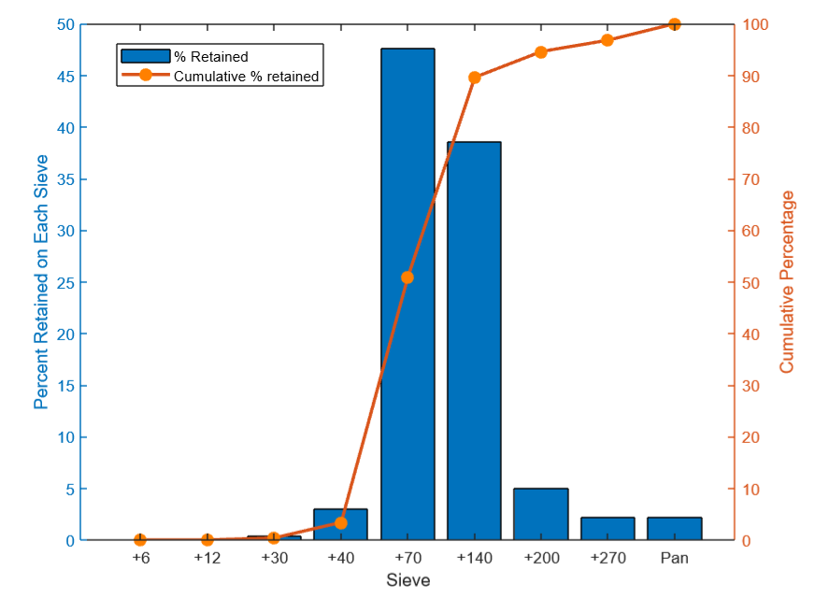**c)**

The graph plots both percent sand retained and cumulative percentage of sand retained on each sieve. The bar chart clearly indicates that maximum percentage of sand was retained on +70 and +140 sieve while othe sieves reteained very less amount and +6 and +12 have no sand retained. From this information it can be concluded that the provided sand is 2-mesh type.

**d)** Significant amount of gas is evolves in ferrous casting, compared to non-ferrous casting. If we don’t let this gas escape from the mould, casting defect like gas porosity, blow holes etc can occur. So, for ferrous casting we need sand with higher permeability. Coarse sand, in our case batch-1 sand can be used for ferrous casting. Because of it’s low AFS number, the sand is coarser than batch-2 sand. Coarse particles have less contact point among themselves and are less compact. So, the gases evolved during casting process can escape easily and result in a sound cast product.

Incase of non-ferrous casting, both coarse and fine sand can be used as the amount of gas evolved in this process is very low. But fine sand, in our case the batch-2 sand has some advantage over caorse sand. Because of compact nature, this sand has lower permeability and thus will result in a smooth surface finish of the cast product.

The mould hardness for heavy casting should be greater. So, batch-2 sand being the finer partciles exhibits more hardness than batch-1 sand can be used for heavy casting. Whereas strength is not of so importance in case of small casting, any of the provided sands can be used.

**RELATION OF DIFFERENCE IN HARDNESS AND PERMEABILITY WITH NUMBER OF RAMMING** 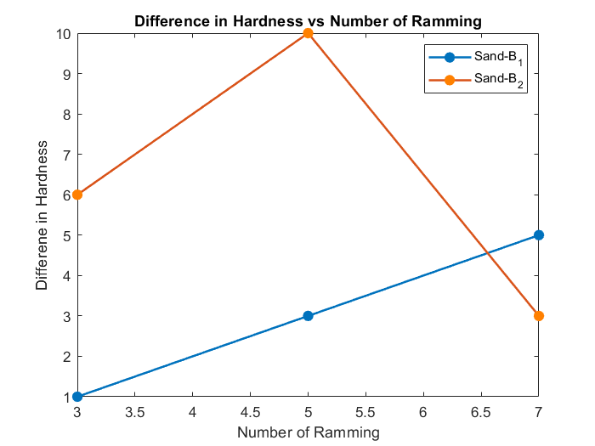

Figure 1

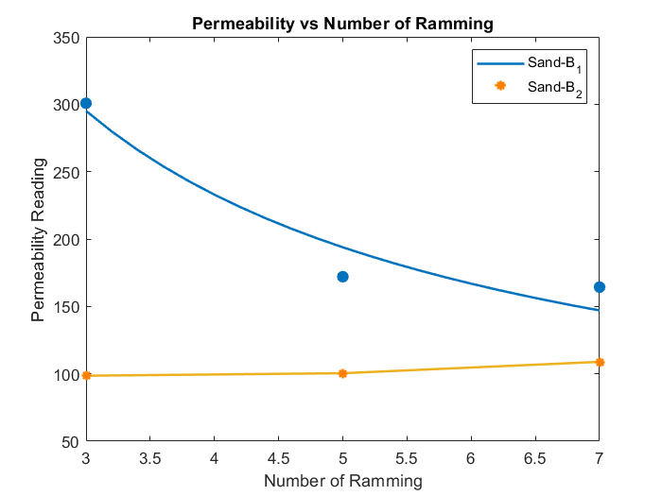The graph in Figure 1 shows relation between difference in hardness and number of ramming. For batch-1 sand the difference in hardness increased linearly. But for batch-2 sand, the graph shows decreasing of

Figure 2

permeability with increased number of ramming for batch-1 sand. This happens because when coarse sand is rammed, the structure becomes more compact. Contact point among the atoms increases. As a result, tighter packing occurs and permeability reading falls.

But for batch-2 sand, the behavior is counter-intuitive. The diagram in figure 2 shows permeability increasing with increase in number of ramming. The possible explanation to this behaviour could be that as the number of rams was increased the distance of air travel through the specimen was reduced, equally the ramming resulted in the reduction of cohesion between clay particles causing a rearrangement in the packing of the sand particles which allowed more gaps in the structure.

**EFFECT OF MOISTURE AND CLAY CONTENT ON GCS AND DCS VALUE**

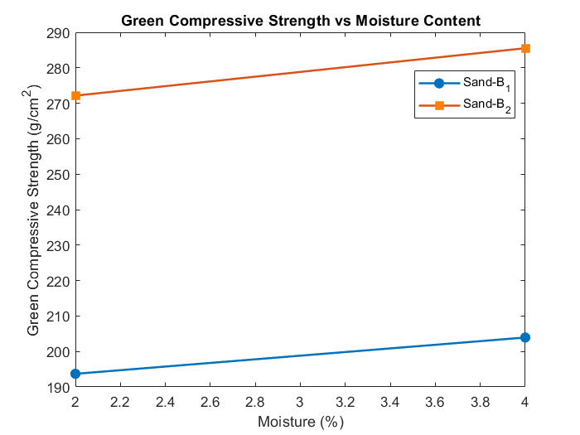

Figure 3

Batch-2 sand shows greater green compressive strength due to its fineness compared to that of batch-1. Fine sand inhibits better bonding and thus GCS increases. When moisture content is increased the GCS value increases to a certain value and becomes maximum. Strength is increased because the clay absorbs 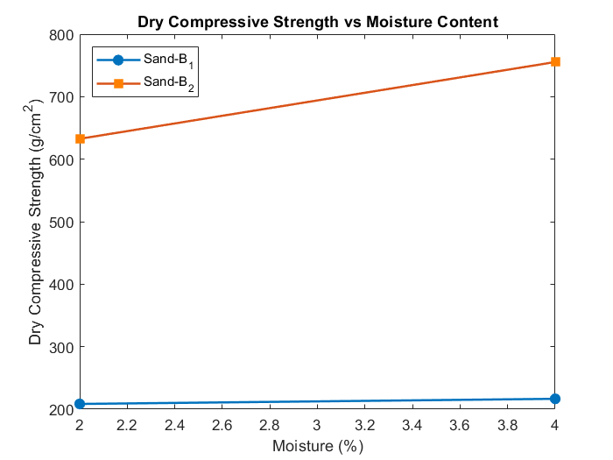the water and makes the bond stronger.

Figure 4

From the graph in figure 4 it can be seen that increasing moisture content has increased the DCS value largely for batch-2 sand. But the DCS value for batch-1 sand wasn’t increased much. This is because batch-2 sand was finer than batch-1. Finer sand inhibits better bonding when moisture is added up to a certain amount.

The graph in figure 5 shows increase in GCS value with increasing clay percentage. Batch-1 sand shows poor GCS value than that of batch-2 sand due to its coarser quality. The increment of strength is because as the clay content increased more fine clay particles occupying the available spaces between the sand grains. If further increment of clay content continues above a threshold limit, it will not increase the strength because the mixture becomes clay-saturated mixture.

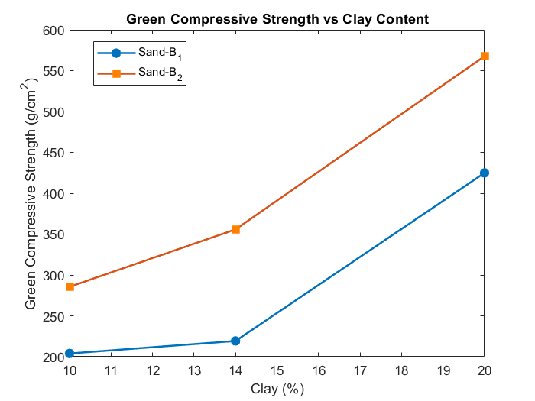

Figure 5

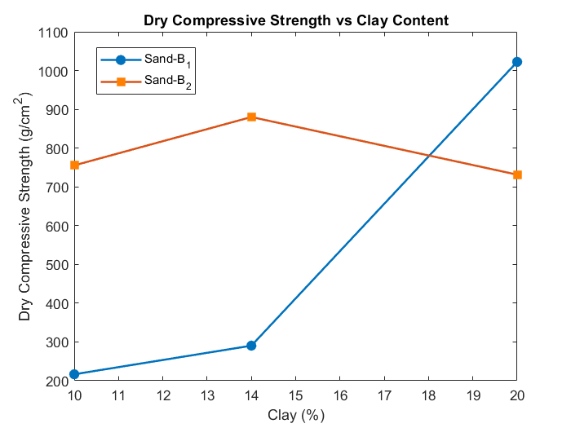The graph in figure 6 shows an anomalous behaviour. With increasing clay content, the DCS value usually

Figure 6

increases. But for batch-2 sand, DCS at 20% clay became less than DCS at 14% clay. The DSC value for batch-2 sand at 20% clay should have been higher than batch-1 sand with similar clay content. There might be some experimental error while performing this experiment which has caused this abnormal result.

**EFFECT OF SIZE & DISTRIBUTION OF SAND GRAIN ON HARDNESS, PERMEABILITY, GCS & DCS**

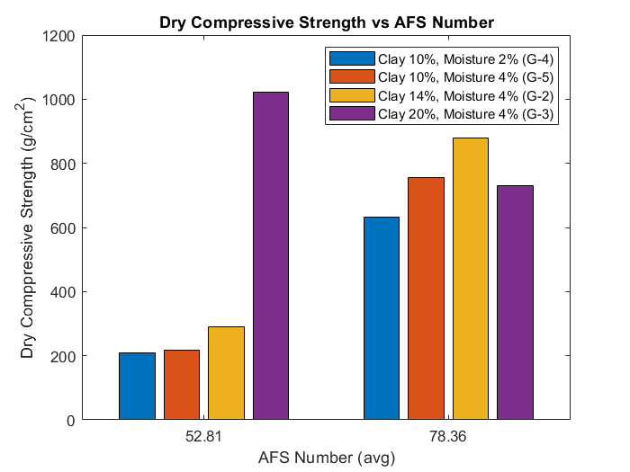

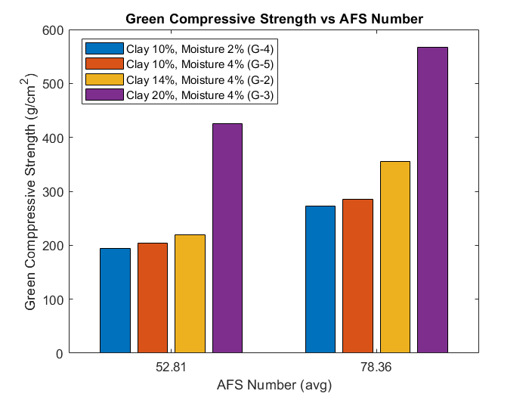

Figure 7

*Figure 8*

This graph shows relation between DCS, GCS value and AFS number. With increasing AFS number the sand becomes finer. The chart shows, significant improvement of DCS value when finer sand is taken.

Figure 8

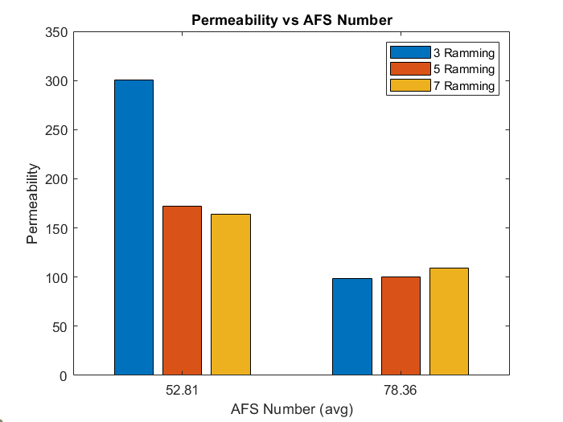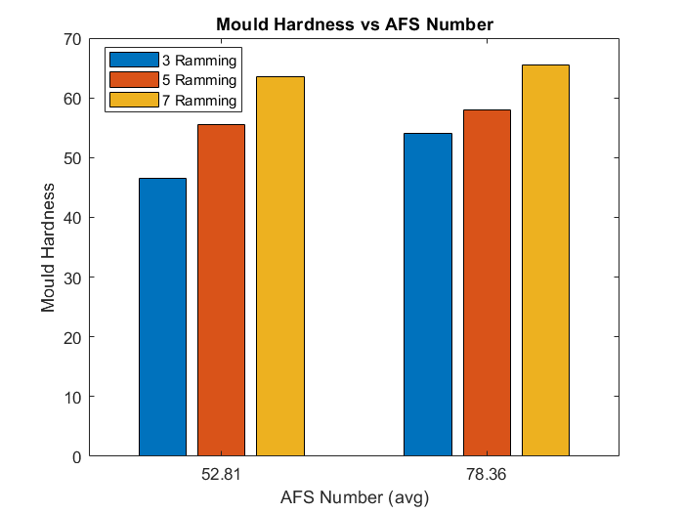

Figure 10

Figure 9

The above graphs show mould hardness increases for a fixed batch when number of ramming increases. The hardness is greater for finer sand, because in finer sand the binder content is higher which results in better packing and better bonding. The permeability is higher for the coarse batch-1 sand than the finer batch-2 sand. Because coarse particles have less contact point than finer particles and thus contains gaps between them.