Assignment 2 Worked Solutions
Part A analytical problems • Ungraded practice
These solutions cover Problems 1–3 in instructions2.md. The separate Part B gem5 exercise is omitted. All numerical results below are analytical calculations, not measurements or simulation results. Lecture citations use PDF page numbers, counted from 1.

Problem 1 Pipeline RAW hazards

Part A Without hardware forwarding
Answer: insert 3 NOPs before sub, then 0 additional NOPs before and and 0 before or. The total is 3 stalls. All three instructions read x1, but delaying sub also delays the later consumers; their stalls must not be counted independently and added again.
The add instruction produces its result at the end of EX in CC3 and writes x1 in the second half of WB in CC5. An ID read in the first half of CC5 still sees the old value. Therefore, sub must read x1 in CC6 or later. Its unstalled ID cycle would be CC3, so it must be delayed by three cycles.
$$Required delay = 6 - 3 = 3 cycles$$
A valid space-time schedule uses three explicit NOP instructions. A dash marks a cycle in which that instruction is absent. NOP rows are shown to make the inserted spacing explicit.
Instruction | 1 | 2 | 3 | 4 | 5 | 6 | 7 | 8 | 9 | 10 | 11
add | IF | ID | EX | MEM | WB | – | – | – | – | – | –
NOP 1 | – | IF | ID | EX | MEM | WB | – | – | – | – | –
NOP 2 | – | – | IF | ID | EX | MEM | WB | – | – | – | –
NOP 3 | – | – | – | IF | ID | EX | MEM | WB | – | – | –
sub | – | – | – | – | IF | ID | EX | MEM | WB | – | –
and | – | – | – | – | – | IF | ID | EX | MEM | WB | –
or | – | – | – | – | – | – | IF | ID | EX | MEM | WB

Equivalently, a hardware interlock can hold sub in ID until CC6 and inject bubbles into EX while freezing younger instructions. The final or completes WB in CC11: the usual 4 + 4 = 8 cycles for four instructions, plus 3 stalls.
Lecture reference: Lecture 12, pp. 4, 8–9. Its two-stall example does not establish the assignment’s explicitly reversed read/write half-cycle convention; the timing stated in the question controls this answer.

Problem 1 Forwarding pathways

Part B With hardware forwarding
The answer depends on whether “full hardware forwarding” also includes a WB-to-ID register-read bypass. With that bypass, the usual answer is 0 stalls. If Part A’s read-first/write-second timing remains in force and only the two expressly listed EX forwarding paths exist, the complete sequence requires 1 stall before or.
Consumer | EX cycle without stalls | Source supplying x1 | ALU input
sub x4, x1, x5 | CC4 | EX/MEM.ALUResult from add | A (rs1)
and x6, x1, x7 | CC5 | MEM/WB write-back value from add | A (rs1)
or x8, x1, x9 | CC6 | ID/EX.ReadData1, made correct by WB-to-ID bypass in CC5 | A (rs1)

The second ALU operand comes from ID/EX.ReadData2: x5 for sub, x7 for and, and x9 for or. No forwarding to ALU input B is needed because x1 is rs1 in every consumer. For add, the MEM/WB write-back value is its ALU result, rather than loaded memory data.

Why the third consumer needs a separate assumption
Without a stall, or reads x1 in ID during CC5. Under the stated half-cycle ordering, this read precedes add’s write. In CC6, when or reaches EX, EX/MEM belongs to and and MEM/WB belongs to sub. Neither register still contains add’s x1 result. Thus neither listed EX bypass can repair the stale x1 operand.
A WB-to-ID bypass routes the current WB value to the ID read-data output when register numbers match. Alternatively, writing in the first half and reading in the second half of the cycle would avoid the conflict, but that changes Part A’s timing assumption. With neither mechanism, hold or in ID one extra cycle so it reads x1 in CC6 and enters EX in CC7.
Instruction | IF | ID | EX | MEM | WB
add | 1 | 2 | 3 | 4 | 5
sub | 2 | 3 | 4 | 5 | 6
and | 3 | 4 | 5 | 6 | 7
or, WB-to-ID bypass | 4 | 5 | 6 | 7 | 8
or, only listed EX paths | 4 | 5–6 | 7 | 8 | 9

The two or rows are alternative schedules, not two instructions. In the last row, ID spans CC5–CC6; the useful read is in CC6. Forwarding control must check RegWrite, a matching source register, and rd ≠ x0; if both stages match, the younger EX/MEM result takes priority.
Lecture reference: Lecture 12, pp. 4, 8, 10–11. The slides show EX/MEM-to-EX and MEM/WB-to-EX bypasses. The WB-to-ID requirement here follows from the assignment’s half-cycle timing and its additional third consumer.

Problem 1 Load use hazard

Part C Replacing add with lw
Answer: the immediate lw-to-sub dependency requires 1 load-use stall. If “full forwarding” includes WB-to-ID bypass, that is the only stall in the sequence. If only the listed EX paths exist and the read-first/write-second register timing is retained, and needs a further WB-to-ID-related stall, giving 2 total stalls for the four-instruction sequence.
The load calculates its address in EX during CC3, then obtains the loaded x1 value only at the end of MEM in CC4. Without a stall, sub would need that value at the beginning of its own EX stage in CC4. Forwarding cannot deliver a value before it exists. EX/MEM at that point contains the load address, not the loaded data.
Holding sub for one cycle moves its EX stage to CC5. The loaded value is then available from MEM/WB’s selected memory-data write-back value and is forwarded to sub’s ALU input A. Its input B still supplies x5.

Schedule when WB to ID bypass is included
Instruction | IF | ID | EX | MEM | WB
lw x1, 0(x2) | 1 | 2 | 3 | 4 | 5
sub x4, x1, x5 | 2 | 3–4 | 5 | 6 | 7
and x6, x1, x7 | 3–4 | 5 | 6 | 7 | 8
or x8, x1, x9 | 5 | 6 | 7 | 8 | 9

Ranges denote a stage held by the interlock. An EX bubble appears in CC4. In CC5, and gets x1 through the WB-to-ID bypass; or reads the already updated register file in CC6. Final completion is CC9.

Schedule with only the two listed EX bypasses
Instruction | IF | ID | EX | MEM | WB
lw x1, 0(x2) | 1 | 2 | 3 | 4 | 5
sub x4, x1, x5 | 2 | 3–4 | 5 | 6 | 7
and x6, x1, x7 | 3–4 | 5–6 | 7 | 8 | 9
or x8, x1, x9 | 5–6 | 7 | 8 | 9 | 10

After the load-use stall, and reaches ID in CC5, before lw writes x1 late in that cycle. It must read again in CC6 and enter EX in CC7. There are two EX bubbles, in CC4 and CC6. Only the first is the intrinsic load-use delay; the second is caused by the missing WB-to-ID bypass.
Lecture reference: Lecture 12, pp. 4 and 8: load data appears at the end of MEM and an immediate dependent arithmetic instruction needs one bubble. Additional WB/ID analysis applies the assignment’s explicit timing convention.

Problem 2 Branch prediction and CPI
Assume the instruction count and clock period stay unchanged, correctly predicted branches have no penalty, every branch misprediction costs 2 cycles, and the stated hazard penalties add without overlap. The 2-cycle misprediction model is necessary to use the supplied overall prediction accuracy in Part B.

Part A Static predict not taken
The ideal CPI already includes normal execution of every instruction. Add only the expected stall cycles per committed instruction. Twenty percent of instructions are loads, and twenty percent of those loads cause one stall.
$$Load stall CPI = 0.20 × 0.20 × 1 = 0.04$$
With predict-not-taken, each taken conditional branch is mispredicted. The misprediction probability among branches is therefore 0.70.
$$Branch stall CPI = 0.20 × 0.70 × 2 = 0.28$$
$$CPI static = 1.00 + 0.04 + 0.28 = 1.32$$

Part B Dynamic two bit predictor
A 90% prediction accuracy gives a 10% misprediction rate among branches. Do not multiply that rate by the taken fraction again: the accuracy already covers all branch outcomes. The load contribution is unchanged.
$$Branch stall CPI = 0.20 × (1 - 0.90) × 2 = 0.04$$
$$CPI dynamic = 1.00 + 0.04 + 0.04 = 1.08$$

Part C Overall performance speedup
Execution time equals instruction count multiplied by CPI and clock period. With the same workload and clock period, those common factors cancel in the old-time/new-time ratio.
$$Speedup = CPI static / CPI dynamic = 1.32 / 1.08 = 1.2222…$$
The upgrade yields approximately 1.222× speedup, or 22.22% higher performance. Execution time falls by (1 − 1.08/1.32) × 100% = 18.18%; this is a different percentage from the performance increase.

Independent check using 100 instructions
Contribution | Static predictor | Dynamic predictor
Ideal execution | 100 cycles | 100 cycles
20 loads × 20% dependent × 1 cycle | 4 cycles | 4 cycles
20 branches × error rate × 2 cycles | 28 cycles | 4 cycles
Total expected cycles | 132 | 108
Cycles per instruction | 1.32 | 1.08

If correctly predicted taken branches still paid a fixed flush penalty, or if taken and not-taken mispredictions had different costs, overall 90% accuracy alone would not determine the dynamic CPI. The solution uses the standard misprediction-only penalty model.
Lecture reference: Lecture 12, pp. 8, 12, 17 for prediction and additive hazard CPI; Lectures 7–8, p. 22 for CPU time = IC × CPI / frequency.

Problem 3 Clock timing and stage imbalance

Part A Minimum period and maximum frequency
The slowest combinational stage determines the pipeline clock period. Add the specified 20 ps register overhead once per clock period, not once for every stage.
$$T clock = max(160, 120, 190, 200, 110) + 20 = 220 ps$$
$$f max = 1 / (220 × 10⁻¹² s) = 4.54545 × 10⁹ Hz ≈ 4.545 GHz$$
MEM is the limiting stage at 200 ps. The 220 ps clock accommodates its logic delay plus the register setup and clock-to-Q overhead.

Part B Ideal speedup over a single cycle implementation
$$T single = 160 + 120 + 190 + 200 + 110 = 780 ps$$
$$f single = 1 / (780 × 10⁻¹² s) ≈ 1.282 GHz$$
For a long instruction stream with ideal CPI = 1 in both designs, throughput is proportional to clock frequency. Using the question’s single-cycle period without adding extra overhead:
$$Speedup = 780 / 220 = 3.54545… ≈ 3.545×$$
This is a steady-state throughput speedup. It is not the latency speedup of one instruction: one pipelined instruction spans 5 × 220 = 1100 ps, versus 780 ps in the single-cycle implementation. For N independent instructions, including pipeline fill and drain, the time ratio is 780N / [220(N + 4)], approaching 3.545× as N becomes large.

Part C Why the speedup is below five times
Stage imbalance is the first source. Five perfectly balanced stages would each contain 780/5 = 156 ps of combinational logic. The actual MEM stage takes 200 ps, forcing faster stages to wait for the shared clock. Even with zero register overhead, the speedup would be only 780/200 = 3.90×.
Pipeline register overhead is the second source. Setup and clock-to-Q delay increase the limiting period from 200 to 220 ps, reducing the speedup from 3.90× to 3.545×. For comparison, perfectly balanced stages with the same 20 ps overhead would run at 176 ps and achieve 780/176 ≈ 4.432×, still below 5×.
Additional practical losses can come from forwarding-multiplexer and control delays, bypass-wire delay, and clock skew if not already included in stage timing. Data stalls, branch flushes, structural conflicts, and finite fill/drain time reduce realized performance further, but they do not explain the numerical ideal-CPI result above because that result excludes stalls and assumes steady state.

Part-B Hands-on experience Gem5 simulator

Step-1
Both commands have been executed successfully
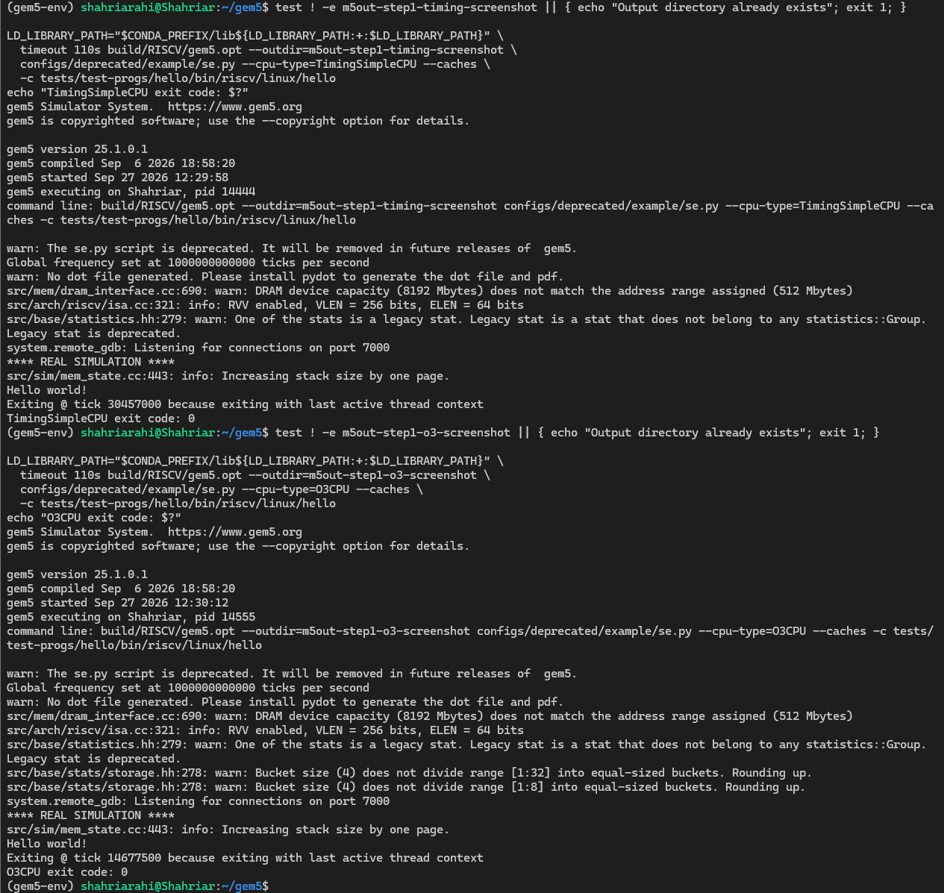

Step 2: Hardware Telemetry Extraction Table
Gem5 stat key | TimingSimpleCPU(In-order) | O3CPU(Out-of-Order)
sim_ticks | 30457000 | 14677500
System.cpu.numCycles | 60914 | 29357
System.cpu.ipc | 0.090587 | 0.187962
System.cpu.dcache.overall_misses | 135 | 524

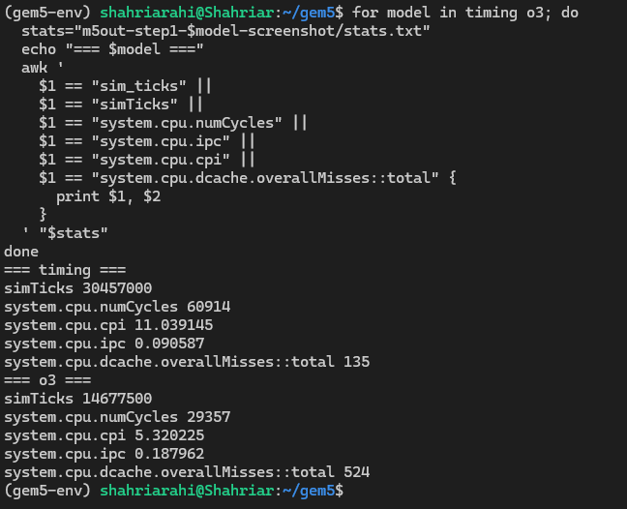

Step 3: Reflection
For the same RISC-V hello binary, O3CPU completed in 14,677,500 simulated ticks and 29,357 cycles (IPC 0.187962; CPI 5.320225), versus 30,457,000 ticks and 60,914 cycles (IPC 0.090587; CPI 11.039145) for TimingSimpleCPU. Out-of-order scheduling can run ready independent instructions while others wait, which plausibly contributes to the approximately 2.075× higher IPC, although these aggregate counters do not isolate that effect. O3CPU recorded more L1 data-cache misses (524 versus 135), so fewer data-cache misses do not explain its shorter simulated runtime.

