Evaluating LLC Way Partitioning as a Defense Against Simulated Cross-Core AES Cache Contention
Shahriar Ahmed, Khan Thamid Hasan, and Md Touhidul Islam
EEL 5764 Computer Architecture, Fall 2026 — Group 18
Abstract—This project evaluates way partitioning of a shared 16-way last-level cache as a defense against simulated cross-core cache contention. In gem5, core 0 runs a depth-matched Prime+Probe-style monitor and core 1 runs a deliberately leakage-prone educational T-table AES-128 workload. For monitor depths A=1...8, each A/(16-A) partitioned treatment is paired with an unpartitioned control using the same monitor footprint, binaries, schedule, and public plaintext seed. Three seeds produce 48 inferential processes; two excluded diagnostics bring the total to 50. Every matched control detected labelled AES activity, all physical-set mapping checks passed, and every partitioned treatment had disjoint way occupancy. Fisher combination across seeds followed by Holm correction across allocations classified all partitioned treatments as indistinguishable from their shuffled-label nulls. The first tested stable collapse point was 1/15. At that split, monitor IPC decreased by 0.7867%, AES IPC increased by 0.0016%, monitor LLC miss rate increased by 19.362274 percentage points, and AES cycles per encryption decreased by 0.0098%. These results support way partitioning for the tested data-way contention signal, but they do not establish equivalence or eliminate contention through other shared structures.
Index Terms—gem5, cache partitioning, Prime+Probe, T-table AES, last-level cache, hardware security.

I. INTRODUCTION
Shared last-level caches improve utilization but allow activity from one security domain to influence another domain's cache state. Prime+Probe exploits this interaction by filling selected cache sets and measuring the latency of later accesses [3]. Hardware way partitioning limits each domain to a disjoint subset of cache ways and can therefore remove cross-domain data evictions [4]. The architectural question is not only whether partitioning reduces a signal, but how much cache capacity must be assigned before a validated monitor can no longer distinguish a known activity pattern and what performance cost accompanies that allocation.
We study this question entirely inside gem5 v25.1.0.1. Core 0 measures only its own memory accesses, while core 1 executes educational T-table AES with a public key, public deterministic plaintexts, and public active/idle labels. No physical hardware or secret data is involved, and the analysis performs no key recovery.
The main methodological contribution is a matched-control design. A monitor assigned A ways primes and probes exactly A congruent lines per set. Its partitioned result is interpreted only when an unpartitioned run with the same depth and seed detects AES activity. This removes monitor self-thrashing as an alternative explanation for signal suppression.

II. BACKGROUND AND MOTIVATION
A conventional AES T-table implementation uses four 1 KiB lookup tables. Lookup-dependent memory traffic is a useful controlled source of cache activity, but a private cache can absorb most accesses before they reach the LLC. Our initial 16 KiB L1D control therefore failed to produce a detectable LLC signal. A later 4 KiB L1D pilot exposed activity but incorrectly walked 16 lines per set for every partition size. With fewer than 16 assigned ways, the monitor evicted its own lines and remained near miss latency during both active and idle intervals. That pilot could not answer the allocation-threshold question.
The corrected study retains the 4 KiB L1D stress configuration but matches the monitor footprint to its allocation. The configuration is intentionally favorable to exposing T-table traffic at the LLC and is not intended as a model of every commercial processor.

III. EXPERIMENTAL PLATFORM
Component | Configuration
Simulator | gem5 v25.1.0.1, commit c8222cc6
ISA and mode | RISC-V syscall emulation
Processors | 2 × TimingSimpleCPU, 2 GHz
Private caches | 16 KiB L1I; 4 KiB, 4-way L1D
Shared LLC | 256 KiB, 16-way, 64 B lines, 256 sets, LRU
Memory | DDR3-1600, 512 MiB
Intervals | 32 active + 32 idle, 2,000,000 cycles each
Stock RISC-V requests do not provide the core-specific partition identifiers required by gem5's way-partitioning policy. An out-of-tree RequestorPartitionManager maps cpu0 and cpu1 traffic to partitions 0 and 1. For split A/(16-A), ways [0,A) belong to the monitor and ways [A,16) belong to AES. Instrumentation records mapping consistency, address-partition conflicts, unmapped requests, and valid-block occupancy outside each mask.

IV. WORKLOADS AND METHOD
The monitor primes and probes A lines in every LLC set and records timestamp, interval, public label, logical set, and latency. Each process produces 16,384 measurements. Runtime physical-address lookup verifies that logical set indices differ from physical LLC sets only by a constant rotation; any mismatch invalidates the run.
The AES workload uses four conventional 1 KiB tables, the public key 000102030405060708090a0b0c0d0e0f, and plaintexts generated by public seeds 0x5764A5E5, 0x5764A5E6, and 0x5764A5E7. A FIPS-197 known-answer test runs before measurement. The workload reports total encryptions, allowing cycles per completed encryption to be calculated over the fixed active duration.
For each seed and A=1...8, one unpartitioned control and one partitioned treatment run as fresh gem5 processes. The 48 inferential runs are supplemented by two A=16 positive-control diagnostics excluded from inference. Every output directory preserves the command, configuration, binary hashes, simulator statistics, workload log, and derived analysis.

V. STATISTICAL ANALYSIS
For each set, SNR is the absolute difference between mean active and idle latency divided by their pooled sample standard deviation. The run statistic is the maximum SNR over 256 sets. Each of 10,000 balanced label permutations recomputes this maximum using analysis seed 5764; the empirical p-value is (1 + count(null ≥ observed))/10001. This construction corrects the within-run search over sets.
For each allocation, Fisher's method combines the three seed-specific p-values. Holm adjustment controls familywise error across the eight allocations at alpha=0.05, with controls and treatments treated as separate families. An allocation is interpretable only when all three individual controls distinguish activity and the combined control remains significant. A stable collapse point is the first non-significant treatment for which every larger tested monitor allocation is also non-significant.

VI. VALIDATION
Validation gate | Observed result
Planned/completed processes | 50 / 50; no failed directories
Probe records | 819,200
Statistics blocks | 100
AES self-tests | 50 PASS
Physical-set mapping | 50 PASS congruent; zero mismatches
Way isolation | 24 PASS disjoint; zero violations
Matched controls | 24/24 individually distinguishable
Binary consistency | One hash pair across all processes
These gates establish that suppression is not an artifact of the earlier fixed-depth monitor, an unverified virtual-to-physical mapping assumption, or overlapping way masks.

VII. RESULTS
Split | Control SNR | Partitioned SNR | Holm p | Decision
1/15 | 0.754±0.010 | 0.600±0.060 | 1.000 | Indist.
2/14 | 0.887±0.079 | 0.579±0.119 | 1.000 | Indist.
3/13 | 1.041±0.086 | 0.650±0.095 | 1.000 | Indist.
4/12 | 1.189±0.027 | 0.769±0.082 | 0.148 | Indist.
5/11 | 1.268±0.024 | 0.760±0.073 | 0.248 | Indist.
6/10 | 1.381±0.048 | 0.768±0.005 | 0.248 | Indist.
7/9 | 1.570±0.033 | 0.796±0.206 | 0.062 | Indist.
8/8 | 1.724±0.130 | 0.613±0.074 | 1.000 | Indist.
All eight partitioned treatments were non-significant after correction, so 1/15 is the first tested stable collapse point. The 7/9 result is closest to the boundary (Holm p=0.061546), and one of its three individual runs was significant. The conclusion therefore follows the predefined combined rule but remains sensitive to additional repetitions.
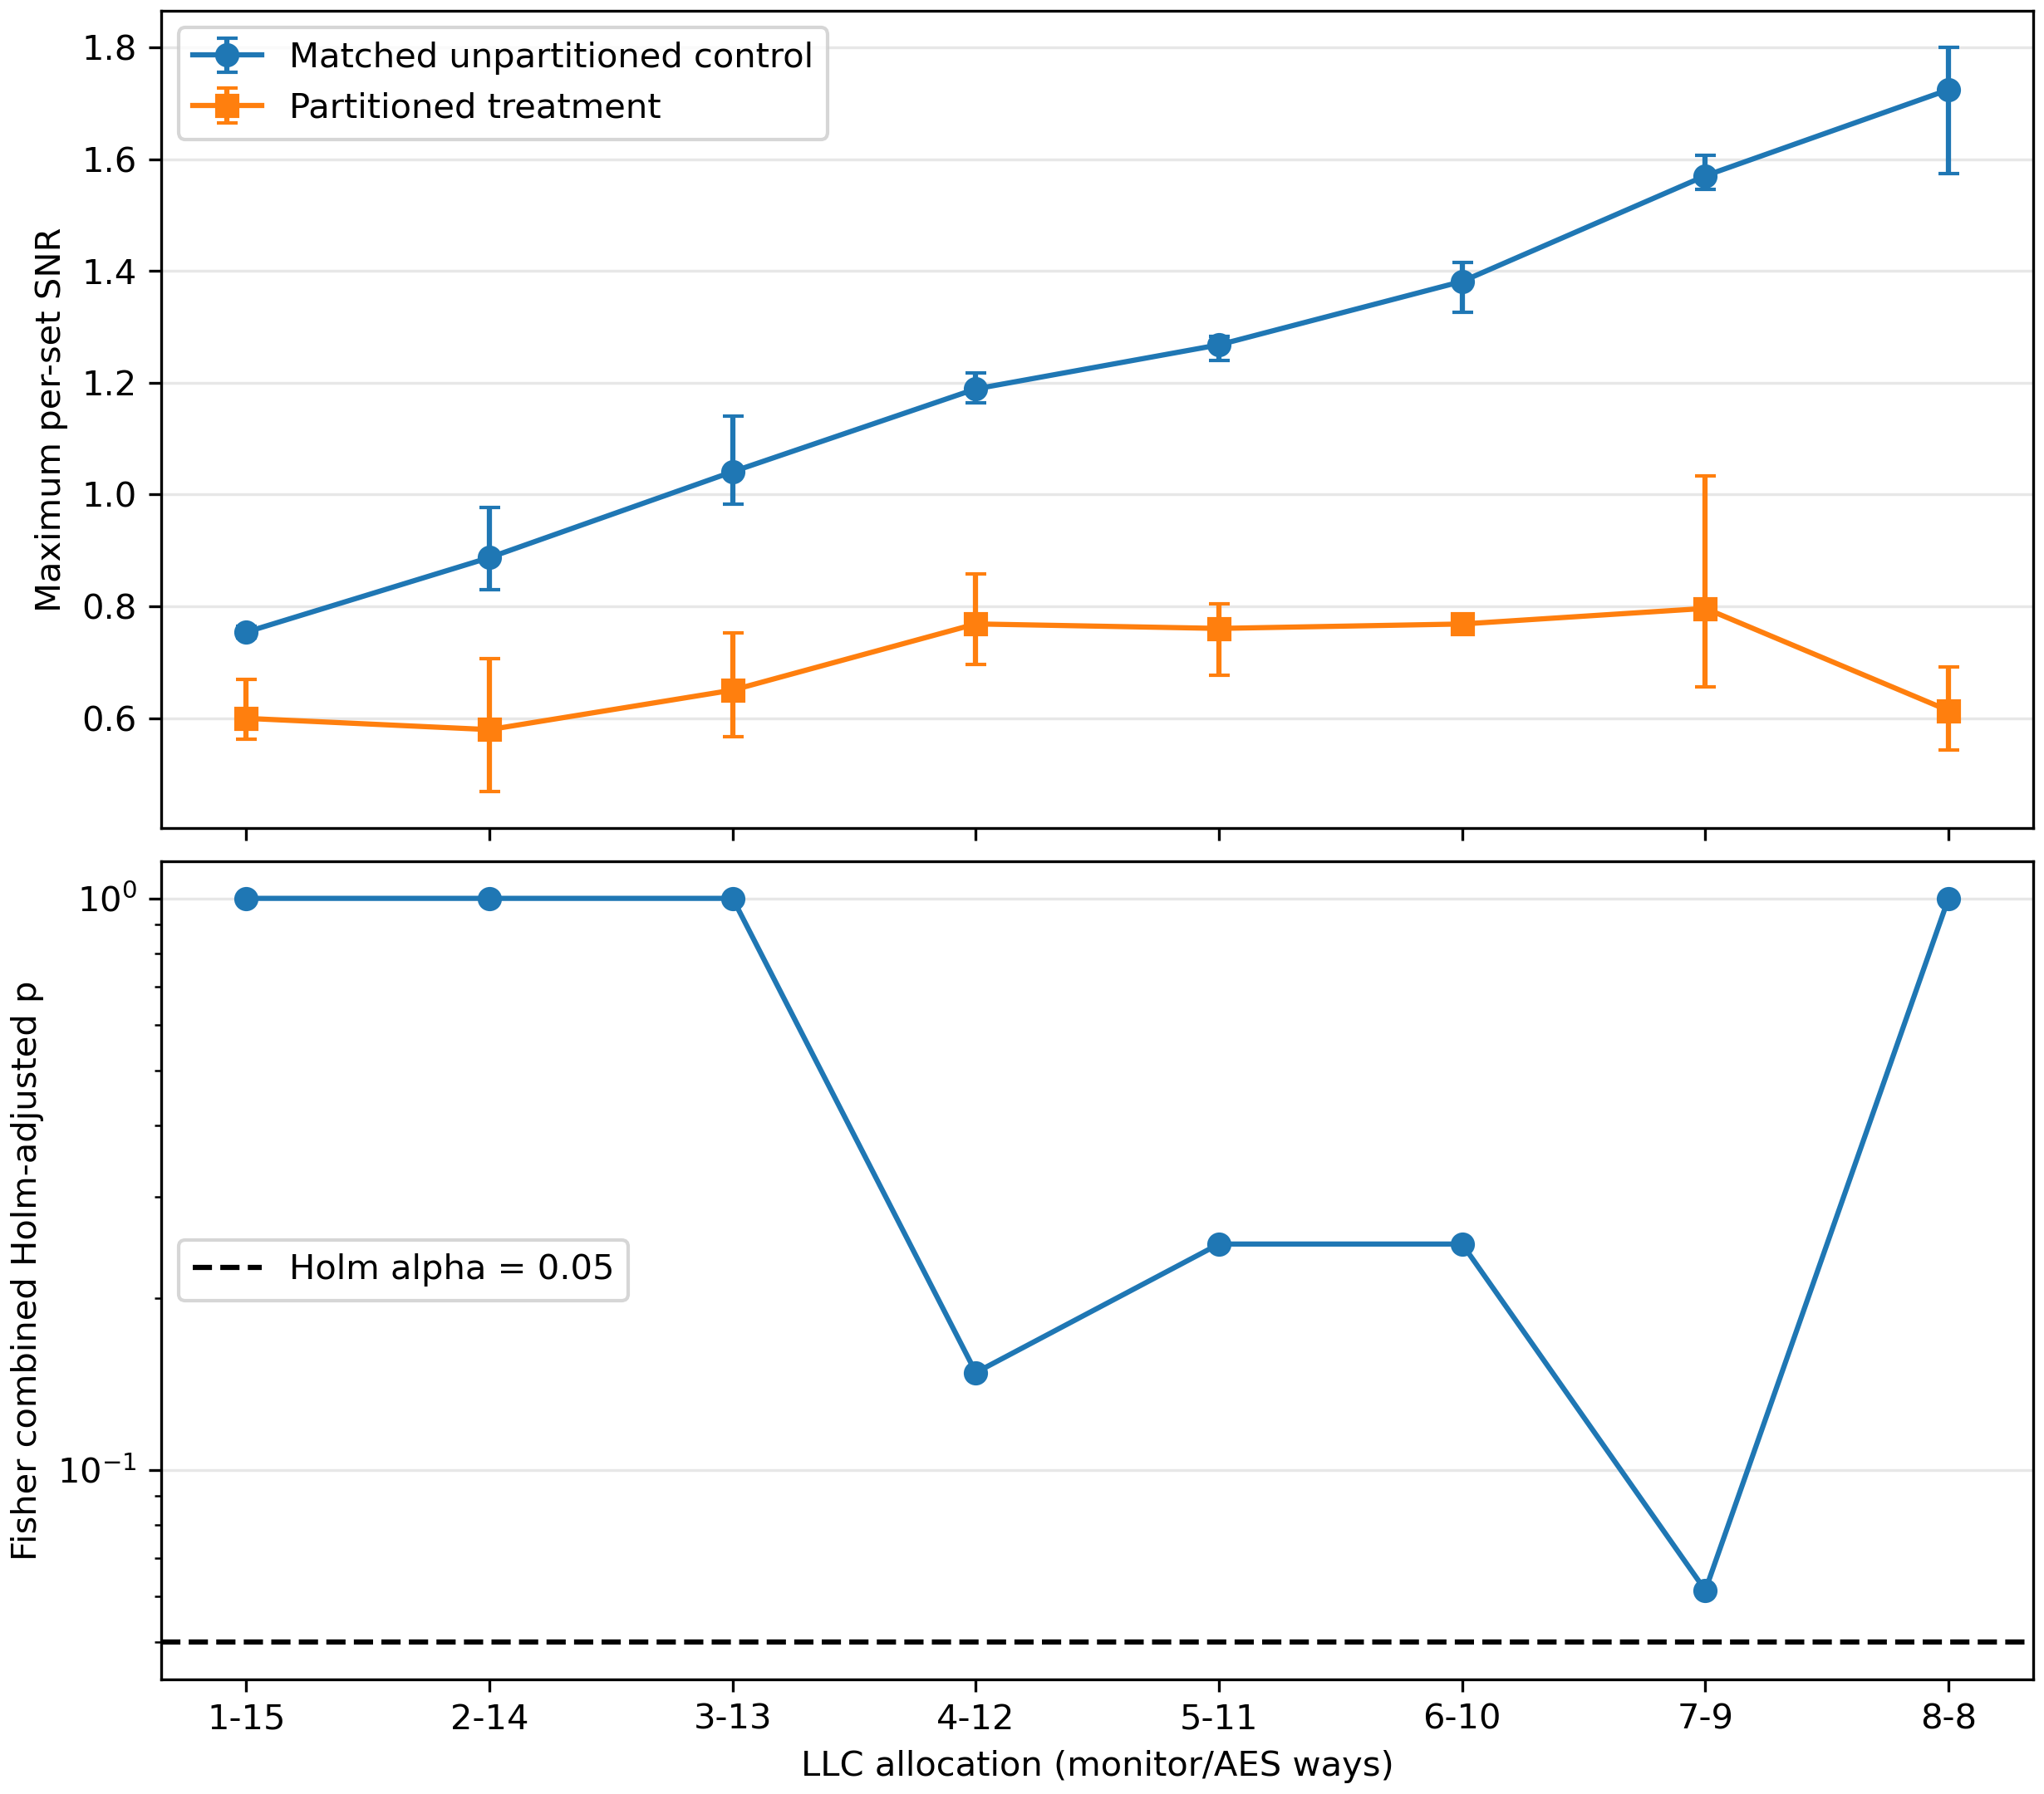
Fig. 1. Mean maximum per-set SNR and Holm-adjusted treatment p-values across three public seeds.

VIII. PERFORMANCE TRADEOFF
Metric at 1/15 | Matched change
Monitor IPC | −0.7867%
AES IPC | +0.0016%
Monitor LLC miss rate | +19.362274 percentage points
AES LLC miss rate | −0.000000047 percentage points
AES cycles/encryption | −0.0098%
The monitor pays a small IPC cost but a large miss-rate increase because its allowed capacity is restricted to one line per set. AES retains 15 ways and exhibits no measurable slowdown. The tiny AES IPC and cycles-per-encryption improvements should be interpreted as descriptive simulation variation, not as evidence that partitioning accelerates AES. Cycles per encryption is the clearer useful-work metric because both programs contain rdcycle busy-wait loops that contribute instructions to IPC.

IX. THREATS TO VALIDITY
The study uses gem5 timing rather than silicon measurements. The symmetric 4 KiB L1D caches deliberately expose T-table traffic and limit generalization to systems with larger private caches. Three consecutive deterministic seeds are repeated inputs, not a population of executions. Fisher combination assumes the seed-specific tests provide independent evidence, although the shared simulator structure may introduce dependence. Failure to reject is not a formal equivalence test, and the near-threshold 7/9 result could change with more seeds.
Way masks isolate LLC data capacity but not MSHRs, queues, ports, interconnects, coherence metadata, memory controllers, or DRAM. The observed latency therefore may include contention outside data-way eviction. The result applies only to this monitor, workload, cache hierarchy, run length, and decision rule.

X. CONCLUSION
This project demonstrates a complete, validated gem5 experiment for evaluating LLC way partitioning against labelled AES cache activity. Depth-matched positive controls detected activity in all 24 cases, physical-set mapping passed in all 50 processes, and all 24 partitioned treatments obeyed disjoint way masks. Under Fisher combination across three public seeds and Holm correction across eight allocations, the first tested stable collapse point was 1/15. At that allocation the monitor IPC cost was 0.7867%, while AES throughput was effectively unchanged. The defensible conclusion is that way partitioning removed distinguishability for this monitor under the tested configuration; it does not establish equivalence or eliminate every shared-resource channel.

REFERENCES
[1] gem5 Project, “gem5 v25.1.0.1 source,” 2026. [Online]. Available: https://github.com/gem5/gem5/tree/v25.1.0.1
[2] J. Lowe-Power et al., “The gem5 simulator: Version 20.0+,” arXiv:2007.03152, 2020.
[3] D. A. Osvik, A. Shamir, and E. Tromer, “Cache attacks and countermeasures: The case of AES,” in Proc. CT-RSA, 2006.
[4] F. Liu et al., “CATalyst: Defeating last-level cache side channel attacks in cloud computing,” in Proc. IEEE HPCA, 2016.

