Evaluating LLC Way Partitioning as a Defense Against Simulated Cross-Core AES Cache Contention
Shahriar Ahmed, Khan Thamid Hasan, and Md Touhidul Islam
EEL 5764 Computer Architecture, Fall 2026 — Group 18
Abstract—This project evaluates way partitioning of a shared 16-way last-level cache as a defense against simulated cross-core cache contention. In gem5, core 0 runs a depth-matched Prime+Probe-style monitor and core 1 runs a deliberately leakage-prone educational T-table AES-128 workload. For monitor depths A=1...8, each A/(16-A) partitioned treatment is paired with an unpartitioned control using the same monitor footprint, binaries, schedule, and public plaintext seed. Three seeds produce 48 inferential processes; two excluded diagnostics bring the total to 50. Every matched control detected labelled AES activity, all physical-set mapping checks passed, and every partitioned treatment had disjoint way occupancy. Fisher combination across seeds followed by Holm correction across allocations classified all partitioned treatments as indistinguishable from their shuffled-label nulls. The first tested stable collapse point was 1/15. At that split, monitor IPC decreased by 0.7867%, AES IPC increased by 0.0016%, monitor LLC miss rate increased by 19.362274 percentage points, and AES cycles per encryption decreased by 0.0098%. These results support way partitioning for the tested data-way contention signal, but they do not establish equivalence or eliminate contention through other shared structures.
Index Terms—gem5, cache partitioning, Prime+Probe, T-table AES, last-level cache, hardware security.

I. INTRODUCTION
Shared last-level caches improve utilization but allow activity from one security domain to influence another domain's cache state. Prime+Probe exploits this interaction by filling selected cache sets and measuring the latency of later accesses [3]. Hardware way partitioning limits each domain to a disjoint subset of cache ways and can therefore remove cross-domain data evictions [4]. The architectural question is not only whether partitioning reduces a signal, but how much cache capacity must be assigned before a validated monitor can no longer distinguish a known activity pattern and what performance cost accompanies that allocation.
We study this question entirely inside gem5 v25.1.0.1. Core 0 measures only its own memory accesses, while core 1 executes educational T-table AES with a public key, public deterministic plaintexts, and public active/idle labels. No physical hardware or secret data is involved, and the analysis performs no key recovery.
The main methodological contribution is a matched-control design. A monitor assigned A ways primes and probes exactly A congruent lines per set. Its partitioned result is interpreted only when an unpartitioned run with the same depth and seed detects AES activity. This removes monitor self-thrashing as an alternative explanation for signal suppression.

A. Research Contributions and Scope
This work makes three concrete contributions. First, it implements per-requestor LLC way partitioning for a two-core RISC-V gem5 system and validates enforcement using tag-array occupancy rather than inferring isolation from performance changes. Second, it develops a depth-aware activity monitor whose footprint always matches its assigned capacity, with a separate positive control for every tested footprint. Third, it uses a repeated statistical design that combines evidence across public inputs and controls false positives across the allocation sweep. Together, these choices turn a qualitative demonstration into a reproducible architecture experiment.
The security goal is deliberately narrow. The monitor decides only whether latency differs between public AES-active and AES-idle intervals. It does not identify table indices, classify plaintexts, recover key bytes, or interact with a cryptographic service. This boundary is important because the architectural defense can be evaluated without converting the coursework into an offensive key-recovery exercise. The study therefore reports detectability, isolation invariants, and performance cost as separate outcomes.

II. BACKGROUND AND MOTIVATION
A conventional AES T-table implementation uses four 1 KiB lookup tables. Lookup-dependent memory traffic is a useful controlled source of cache activity, but a private cache can absorb most accesses before they reach the LLC. Our initial 16 KiB L1D control therefore failed to produce a detectable LLC signal. A later 4 KiB L1D pilot exposed activity but incorrectly walked 16 lines per set for every partition size. With fewer than 16 assigned ways, the monitor evicted its own lines and remained near miss latency during both active and idle intervals. That pilot could not answer the allocation-threshold question.
The corrected study retains the 4 KiB L1D stress configuration but matches the monitor footprint to its allocation. The configuration is intentionally favorable to exposing T-table traffic at the LLC and is not intended as a model of every commercial processor.

A. Cache Contention and Set Associativity
A set-associative cache maps each physical address to one set and may place the corresponding block in any way within that set. With a 16-way LLC, as many as 16 blocks can reside in one set. In an unpartitioned design, blocks from both cores compete for all 16 positions. A monitor can exploit this competition by filling selected positions and measuring whether later accesses hit or miss. Longer probe latency during victim-active intervals indicates that the victim changed either cache residency or another shared timing resource.
Way partitioning changes the placement rule rather than the address-to-set mapping. Each request carries a partition identifier, and the replacement policy restricts insertion and victim selection to the ways assigned to that partition. A monitor assigned one way can retain at most one of its blocks per set, while AES assigned 15 ways can use the remaining positions. Correct enforcement should prevent a monitor block from appearing in an AES-only way and vice versa.

B. Why T-table AES Produces a Controlled Signal
T-table AES combines substitution and linear transformation operations into four lookup tables. The table index depends on intermediate data, so repeated encryption produces data-dependent memory references. In this project the dependence is not secret: the key and plaintext generator are public. The tables are useful because they create structured lookup activity with a compact 4 KiB footprint, allowing the experiment to ask whether activity reaches the shared LLC and perturbs another core's timing.
Private-cache capacity determines how visible this traffic is. With a 16 KiB L1D, the four tables can remain resident together with much of the working state, so only a few requests reach the LLC. The 4 KiB L1D stress profile forces the table footprint to compete with plaintext, round-key, stack, and program data. This increases LLC exposure without adding explicit flush instructions or artificial table eviction. The choice improves experimental observability but also narrows external validity.

III. EXPERIMENTAL PLATFORM
Component | Configuration
Simulator | gem5 v25.1.0.1, commit c8222cc6
ISA and mode | RISC-V syscall emulation
Processors | 2 × TimingSimpleCPU, 2 GHz
Private caches | 16 KiB L1I; 4 KiB, 4-way L1D
Shared LLC | 256 KiB, 16-way, 64 B lines, 256 sets, LRU
Memory | DDR3-1600, 512 MiB
Intervals | 32 active + 32 idle, 2,000,000 cycles each
Stock RISC-V requests do not provide the core-specific partition identifiers required by gem5's way-partitioning policy. An out-of-tree RequestorPartitionManager maps cpu0 and cpu1 traffic to partitions 0 and 1. For split A/(16-A), ways [0,A) belong to the monitor and ways [A,16) belong to AES. Instrumentation records mapping consistency, address-partition conflicts, unmapped requests, and valid-block occupancy outside each mask.

A. Request to Way-Mask Path
Each timing CPU receives a distinct gem5 requestor identity. The RequestorPartitionManager translates those identities to partition 0 for core 0 and partition 1 for core 1. The LLC tag store consults the selected partitioning policy when allocating or replacing a block. In split A/(16-A), partition 0 may use ways numbered 0 through A-1, while partition 1 may use ways A through 15. Off mode removes the restrictions so both requestors share all ways.
This mechanism isolates data capacity but does not duplicate the complete LLC pipeline. Requests still traverse shared crossbars and cache ports, use common miss-status holding registers and queues, and ultimately share the memory controller and DRAM. Consequently, a remaining latency signal would not automatically prove that way masking failed; it could arise in another shared structure. Conversely, disappearance of this monitor's signal cannot establish the absence of every microarchitectural channel.

B. Choice of RISC-V SE Mode
Syscall-emulation mode was selected because the experiment requires two deterministic user processes rather than a full operating-system stack. It reduces boot time and eliminates uncontrolled kernel scheduling and background services. RISC-V provides the rdcycle instruction needed for reproducible simulated timing. Freestanding static binaries avoid dependence on a guest C library and ensure that the same compiled workloads are used in every process.

IV. WORKLOADS AND METHOD
The monitor primes and probes A lines in every LLC set and records timestamp, interval, public label, logical set, and latency. Each process produces 16,384 measurements. Runtime physical-address lookup verifies that logical set indices differ from physical LLC sets only by a constant rotation; any mismatch invalidates the run.
The AES workload uses four conventional 1 KiB tables, the public key 000102030405060708090a0b0c0d0e0f, and plaintexts generated by public seeds 0x5764A5E5, 0x5764A5E6, and 0x5764A5E7. A FIPS-197 known-answer test runs before measurement. The workload reports total encryptions, allowing cycles per completed encryption to be calculated over the fixed active duration.
For each seed and A=1...8, one unpartitioned control and one partitioned treatment run as fresh gem5 processes. The 48 inferential runs are supplemented by two A=16 positive-control diagnostics excluded from inference. Every output directory preserves the command, configuration, binary hashes, simulator statistics, workload log, and derived analysis.

A. Interval Synchronization and Logging
The two workloads do not synchronize through shared memory. Both derive the current interval from the absolute rdcycle value and the same compiled schedule. Measurement starts after a fixed warm-up, and each two-million-cycle interval is labelled active or idle by a deterministic non-alternating sequence. A non-alternating schedule reduces the risk that a simple periodic drift is mistaken for activity. Thirty-two observations per class provide balanced input to the SNR calculation.
The monitor buffers all probe records in memory and writes them after measurement. This keeps write system calls out of the latency, IPC, and miss-rate windows. Gem5 resets statistics after warm-up and dumps a measurement-only block before post-measurement logging, so the reported IPC and cache metrics exclude most output overhead. Every run preserves both statistics blocks, but analysis explicitly selects the measurement block.

B. Why Matched Controls Are Required
Changing A changes the monitor itself. A one-line probe has a different instruction count, memory footprint, and expected SNR from an eight-line probe. Comparing every treatment with a single A=16 control would therefore mix the effect of partitioning with the effect of monitor depth. The matched design holds depth, seed, binary, interval schedule, and analysis constant. The only intended difference within a pair is whether the LLC way masks are enabled.
A partitioned run is considered interpretable only when its matched unpartitioned control detects activity. If the control fails, the treatment cannot demonstrate suppression because the monitor lacked sensitivity before the defense was applied. Requiring all three seed-specific controls to pass is deliberately conservative and prevents one strong repetition from hiding a nonfunctional control.

V. STATISTICAL ANALYSIS
For each set, SNR is the absolute difference between mean active and idle latency divided by their pooled sample standard deviation. The run statistic is the maximum SNR over 256 sets. Each of 10,000 balanced label permutations recomputes this maximum using analysis seed 5764; the empirical p-value is (1 + count(null ≥ observed))/10001. This construction corrects the within-run search over sets.
For each allocation, Fisher's method combines the three seed-specific p-values. Holm adjustment controls familywise error across the eight allocations at alpha=0.05, with controls and treatments treated as separate families. An allocation is interpretable only when all three individual controls distinguish activity and the combined control remains significant. A stable collapse point is the first non-significant treatment for which every larger tested monitor allocation is also non-significant.

A. From Per-set SNR to a Run-level Test
For one set, the SNR numerator measures the separation between active and idle mean probe latency. The pooled sample standard deviation normalizes this difference by within-class variability, allowing sets with different absolute latency scales to be compared. Zero-variance or malformed sets are excluded by explicit analysis checks. The maximum across eligible sets represents the strongest activity-dependent location available to the monitor.
Selecting the maximum creates a multiple-comparison problem: even random labels can produce an unusually large value when 256 sets are searched. The permutation procedure therefore repeats the complete maximum search after every shuffle. Comparing the observed maximum with this shuffled-maximum distribution controls selection within a run. The plus-one empirical p-value prevents a zero estimate when none of 10,000 permutations exceeds the observation.

B. Combining Repetitions and Allocations
Fisher's method combines the three seed-specific p-values by summing their negative log values. This gives a single allocation-level measure while retaining evidence from each public input sequence. The eight allocations are then a second family of simultaneous questions. Holm's step-down procedure adjusts their p-values while controlling the familywise error rate and is less conservative than multiplying every p-value by eight. Controls and treatments form separate families because they answer different questions.
The stable-collapse rule adds an ordering constraint. It prevents a low-A non-significant result from being reported as a threshold if detectability returns at a larger monitor allocation. This mattered in the earlier single-seed study, where classifications were non-monotonic. The three-seed corrected study applies the rule without changing it after observing the results.

VI. VALIDATION
Validation gate | Observed result
Planned/completed processes | 50 / 50; no failed directories
Probe records | 819,200
Statistics blocks | 100
AES self-tests | 50 PASS
Physical-set mapping | 50 PASS congruent; zero mismatches
Way isolation | 24 PASS disjoint; zero violations
Matched controls | 24/24 individually distinguishable
Binary consistency | One hash pair across all processes
These gates establish that suppression is not an artifact of the earlier fixed-depth monitor, an unverified virtual-to-physical mapping assumption, or overlapping way masks.

A. Physical-set Congruence
Virtual address bits within a page do not determine every LLC set bit. In syscall-emulation mode, assuming that the virtual set number equals the physical set number would leave higher index bits unverified. The monitor therefore records address translations and checks the physical LLC set selected by each probe line. A constant rotation is acceptable because it preserves one-to-one coverage; any missing translation or inconsistent mapping is a failure. All 50 processes passed this check.

B. Direct Way-occupancy Evidence
Performance changes alone cannot prove that way partitioning is enforced. At the end of each measured statistics interval, minimal instrumentation walks the valid LLC blocks, associates them with their originating partition, and verifies that each block resides in an allowed way. It also counts unmapped lookups and conflicts in which one address is associated with incompatible partitions. All 24 treatments reported disjoint occupancy, zero forbidden-way blocks, zero unmapped lookups, and zero address-partition conflicts.
The validation gates are independent of the security statistic. A treatment must pass mapping and occupancy checks even if its SNR is small, and a high-SNR result does not excuse an isolation violation. This separation is essential: the security measurement asks what the monitor observes, while the invariants ask what architectural policy the simulator enforced.

VII. RESULTS
Split | Control SNR | Partitioned SNR | Holm p | Decision
1/15 | 0.754±0.010 | 0.600±0.060 | 1.000 | Indist.
2/14 | 0.887±0.079 | 0.579±0.119 | 1.000 | Indist.
3/13 | 1.041±0.086 | 0.650±0.095 | 1.000 | Indist.
4/12 | 1.189±0.027 | 0.769±0.082 | 0.148 | Indist.
5/11 | 1.268±0.024 | 0.760±0.073 | 0.248 | Indist.
6/10 | 1.381±0.048 | 0.768±0.005 | 0.248 | Indist.
7/9 | 1.570±0.033 | 0.796±0.206 | 0.062 | Indist.
8/8 | 1.724±0.130 | 0.613±0.074 | 1.000 | Indist.
All eight partitioned treatments were non-significant after correction, so 1/15 is the first tested stable collapse point. The 7/9 result is closest to the boundary (Holm p=0.061546), and one of its three individual runs was significant. The conclusion therefore follows the predefined combined rule but remains sensitive to additional repetitions.
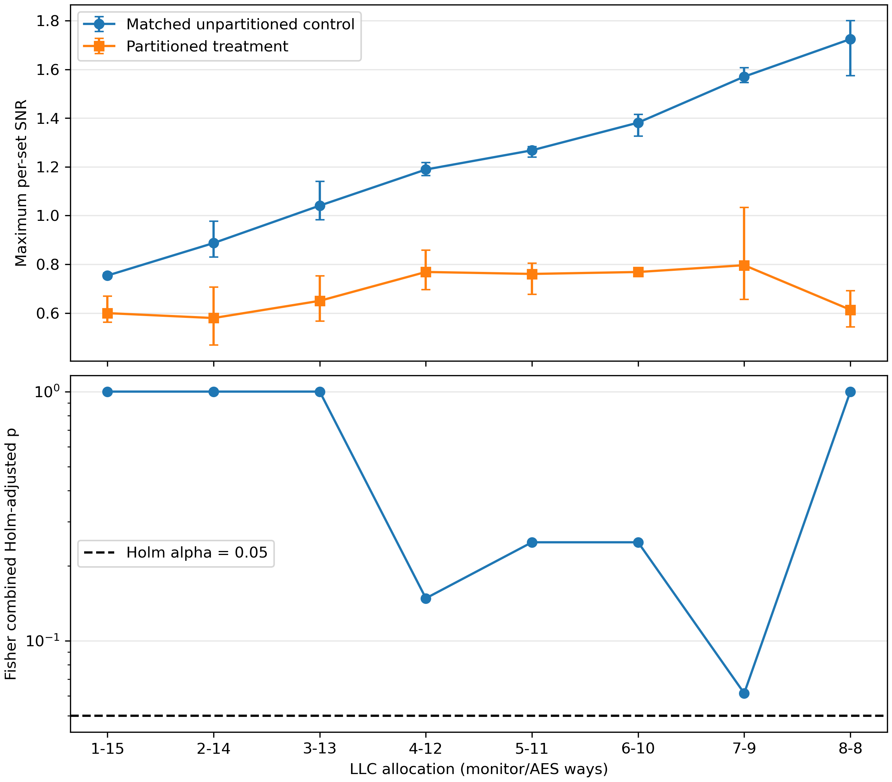
Fig. 1. Mean maximum per-set SNR and Holm-adjusted treatment p-values across three public seeds.

A. Interpretation Across Allocations
Control SNR rises with monitor depth, from a mean of 0.754 at A=1 to 1.724 at A=8. More lines provide more opportunity for interference and aggregate more latency, so this trend confirms why depth-matched controls are necessary. Partitioned SNR remains in a narrower band from 0.579 to 0.796 before dropping to 0.613 at 8/8. The treatment curve is not expected to decrease monotonically because residual timing noise, cache-state interactions, and the maximum-set selection remain present even when data ways are disjoint.
The 7/9 split deserves special attention. Its combined unadjusted Fisher p-value is 0.007693, but Holm correction raises it to 0.061546, just above alpha=0.05. One seed-specific treatment is individually significant. The predefined familywise rule classifies the allocation as indistinguishable, yet the small margin means the scientific conclusion is sensitive to additional repetitions. Reporting this boundary case is more informative than describing every treatment as equally strong evidence.

B. Meaning of the 1/15 Threshold
The threshold does not mean that one way is universally sufficient for a secure domain. It means that among the tested integer allocations, the A=1 treatment and all subsequent treatments failed to distinguish the labels under this monitor, sample size, and correction rule, while the corresponding controls remained functional. Because no allocation below one monitor way exists in this experiment, 1/15 is both the first tested allocation and the lower boundary of the sweep.

VIII. PERFORMANCE TRADEOFF
Metric at 1/15 | Matched change
Monitor IPC | −0.7867%
AES IPC | +0.0016%
Monitor LLC miss rate | +19.362274 percentage points
AES LLC miss rate | −0.000000047 percentage points
AES cycles/encryption | −0.0098%
The monitor pays a small IPC cost but a large miss-rate increase because its allowed capacity is restricted to one line per set. AES retains 15 ways and exhibits no measurable slowdown. The tiny AES IPC and cycles-per-encryption improvements should be interpreted as descriptive simulation variation, not as evidence that partitioning accelerates AES. Cycles per encryption is the clearer useful-work metric because both programs contain rdcycle busy-wait loops that contribute instructions to IPC.

A. Costs Beyond the Threshold
Monitor IPC cost increases gradually with A, from 0.7867% at 1/15 to 5.4186% at 8/8 relative to the corresponding controls. This does not imply that more monitor ways intrinsically reduce performance. Each comparison uses a different depth, and enabling the masks changes replacement opportunities and timing. The matched differences quantify the cost of partitioning for that particular footprint; they should not be compared as if they came from one fixed application.
The monitor LLC miss-rate increase remains near 18.5–19.4 percentage points across the sweep. AES receives between 15 and eight ways, yet its IPC and cycles-per-encryption differences remain below approximately 0.04% in magnitude. The workload's small LLC-resident state and active/idle duty cycle explain why capacity removal produces little AES cost. A larger AES working set or a multiprogram workload could show a different tradeoff.

IX. THREATS TO VALIDITY
The study uses gem5 timing rather than silicon measurements. The symmetric 4 KiB L1D caches deliberately expose T-table traffic and limit generalization to systems with larger private caches. Three consecutive deterministic seeds are repeated inputs, not a population of executions. Fisher combination assumes the seed-specific tests provide independent evidence, although the shared simulator structure may introduce dependence. Failure to reject is not a formal equivalence test, and the near-threshold 7/9 result could change with more seeds.
Way masks isolate LLC data capacity but not MSHRs, queues, ports, interconnects, coherence metadata, memory controllers, or DRAM. The observed latency therefore may include contention outside data-way eviction. The result applies only to this monitor, workload, cache hierarchy, run length, and decision rule.

A. Reproducibility and Traceability
Every quantitative claim can be traced from the report to summary_repeated.csv, from that table to the per-seed analysis files, and from each analysis file to simout.txt and stats.txt. run_plan.json fixes the seed, split, monitor depth, and inferential role of all 50 processes. Binary hashes show that every case used the same monitor and victim executables. The runner refuses to reuse an existing root unless resume mode is selected, and resume mode validates metadata and isolation fields before skipping a case.

B. Future Work
The most important extension is to add independent public seeds and repeat the full matched design, especially around 7/9. A formal equivalence or non-inferiority test with a predeclared smallest effect of interest would support a stronger statement than failure to reject. Longer intervals or more intervals would improve power but increase simulation cost. Repeating the study with larger and more realistic L1D sizes would test whether the activity signal survives without the current stress configuration.
Architecturally, future studies could isolate or instrument other shared resources. Separate MSHR quotas, request queues, or memory-controller scheduling would help determine whether any residual signal comes from data-way eviction or pipeline contention. Additional benign workloads could measure the performance cost of partitioning under capacity pressure. These extensions should retain the current safeguards: simulator-only execution, public inputs, activity detection rather than key inference, matched positive controls, and direct isolation evidence.

X. CONCLUSION
This project demonstrates a complete, validated gem5 experiment for evaluating LLC way partitioning against labelled AES cache activity. Depth-matched positive controls detected activity in all 24 cases, physical-set mapping passed in all 50 processes, and all 24 partitioned treatments obeyed disjoint way masks. Under Fisher combination across three public seeds and Holm correction across eight allocations, the first tested stable collapse point was 1/15. At that allocation the monitor IPC cost was 0.7867%, while AES throughput was effectively unchanged. The defensible conclusion is that way partitioning removed distinguishability for this monitor under the tested configuration; it does not establish equivalence or eliminate every shared-resource channel.

REFERENCES
[1] gem5 Project, “gem5 v25.1.0.1 source,” 2026. [Online]. Available: https://github.com/gem5/gem5/tree/v25.1.0.1
[2] J. Lowe-Power et al., “The gem5 simulator: Version 20.0+,” arXiv:2007.03152, 2020.
[3] D. A. Osvik, A. Shamir, and E. Tromer, “Cache attacks and countermeasures: The case of AES,” in Proc. CT-RSA, 2006.
[4] F. Liu et al., “CATalyst: Defeating last-level cache side channel attacks in cloud computing,” in Proc. IEEE HPCA, 2016.

