Evaluating LLC Way Partitioning as a Defense Against Simulated Cross-Core AES Cache Contention
Shahriar Ahmed, Khan Thamid Hasan, and Md Touhidul Islam
EEL 5764 Computer Architecture, Fall 2026 — Group 18
Abstract—This project evaluates way partitioning of a shared 16-way last-level cache as a defense against simulated cross-core cache contention. In gem5, core 0 runs a depth-matched Prime+Probe-style monitor and core 1 runs a deliberately leakage-prone educational T-table AES-128 workload. For monitor depths A=1...8, each A/(16-A) partitioned treatment is paired with an unpartitioned control using the same monitor footprint, binaries, schedule, and public plaintext seed; three seeds give 48 inferential processes plus two excluded diagnostics. An earlier version of this study concluded that one monitor way (1/15) already made AES activity undetectable. Validation showed that conclusion was an artifact: the monitor's own record buffer evicted 20–25% of its probe lines, but only in partitioned runs, hiding the signal. With a corrected record-free monitor and a predeclared self-eviction gate, all 24 matched pairs pass every validity check and all eight allocations remain distinguishable after Fisher combination and Holm correction. The partitioned monitor retains 70%–100% of its control's hit-latency signal; no allocation is equivalent to zero within ±0.02 cycles per probed line. Partitioning removes eviction-based contention but not the hit-timing channel through shared LLC resources, and it costs these workloads at most 0.029% in IPC or cycles per encryption.
Index Terms—gem5, cache partitioning, Prime+Probe, T-table AES, last-level cache, hardware security.

I. INTRODUCTION
Shared last-level caches improve utilization but allow activity from one security domain to influence another domain's cache state. Prime+Probe exploits this interaction by filling selected cache sets and measuring the latency of later accesses [3]. Hardware way partitioning limits each domain to a disjoint subset of cache ways and can therefore remove cross-domain data evictions [4]. The architectural question is not only whether partitioning reduces a signal, but how much cache capacity must be assigned before a validated monitor can no longer distinguish a known activity pattern and what performance cost accompanies that allocation.
We study this question entirely inside gem5 v25.1.0.1. Core 0 measures only its own memory accesses, while core 1 executes educational T-table AES with a public key, public deterministic plaintexts, and public active/idle labels. No physical hardware or secret data is involved, and the analysis performs no key recovery.
The methodological core is a matched-control design: a monitor assigned A ways primes and probes exactly A congruent lines per set, and its partitioned result is interpreted only when an unpartitioned run with the same depth and seed detects AES activity. This study shows that matched controls are necessary but not sufficient. Under strict way masks, every cache line the monitor touches competes with its own probe lines, so a monitor can lose its signal through self-eviction that occurs only in the partitioned arm. Our original analysis fell into exactly this trap and reported a false 1/15 threshold; this report presents the corrected study.

A. Research Contributions and Scope
This work makes four concrete contributions. First, it implements per-requestor LLC way partitioning for a two-core RISC-V gem5 system and validates enforcement using tag-array occupancy rather than inferring isolation from performance changes. Second, it develops a depth-aware activity monitor whose footprint matches its assigned capacity and whose measurement loop allocates no cache lines besides its probe lines. Third, it identifies and removes two self-eviction confounds, a 384 KiB record buffer and a single hot global variable, and adds a predeclared gate that detects such confounds. Fourth, it uses a repeated, preregistered statistical design that combines evidence across public inputs and controls false positives across the allocation sweep.
The security goal is deliberately narrow. The monitor decides only whether latency differs between public AES-active and AES-idle intervals. It does not identify table indices, classify plaintexts, recover key bytes, or interact with a cryptographic service. The study therefore reports detectability, isolation invariants, and performance cost as separate outcomes.

II. BACKGROUND AND MOTIVATION
A conventional AES T-table implementation uses four 1 KiB lookup tables. Lookup-dependent memory traffic is a useful controlled source of cache activity, but a private cache can absorb most accesses before they reach the LLC. Our initial 16 KiB L1D control therefore failed to produce a detectable LLC signal. A later 4 KiB L1D pilot exposed activity but walked 16 lines per set for every partition size, so with fewer than 16 assigned ways the monitor evicted its own lines. The first depth-matched study fixed that, yet its monitor still stored 16,384 measurement records in a 384 KiB array during measurement, which reintroduced self-eviction in a milder form.
The final study retains the 4 KiB L1D stress configuration, matches the monitor footprint to its allocation, and keeps every other monitor access out of the LLC during measurement. The configuration is intentionally favorable to exposing T-table traffic at the LLC and is not intended as a model of every commercial processor.

A. Cache Contention and Set Associativity
A set-associative cache maps each physical address to one set and may place the corresponding block in any way within that set. With a 16-way LLC, as many as 16 blocks can reside in one set. In an unpartitioned design, blocks from both cores compete for all 16 positions. A monitor can exploit this competition by filling selected positions and measuring whether later accesses hit or miss. Longer probe latency during victim-active intervals indicates that the victim changed either cache residency or another shared timing resource.
Way partitioning changes the placement rule rather than the address-to-set mapping. Each request carries a partition identifier, and the replacement policy restricts insertion and victim selection to the ways assigned to that partition. A monitor assigned one way can retain at most one of its blocks per set, while AES assigned 15 ways can use the remaining positions. The same restriction applies to the monitor's own non-probe data: any such line resident in the LLC occupies one of the monitor's few ways in its set.

B. Why T-table AES Produces a Controlled Signal
T-table AES combines substitution and linear transformation operations into four lookup tables. The table index depends on intermediate data, so repeated encryption produces data-dependent memory references. In this project the dependence is not secret: the key and plaintext generator are public. The tables create structured lookup activity with a compact 4 KiB footprint, allowing the experiment to ask whether activity reaches the shared LLC and perturbs another core's timing.
Private-cache capacity determines how visible this traffic is. With a 16 KiB L1D, the four tables can remain resident together with much of the working state, so only a few requests reach the LLC. The 4 KiB L1D stress profile forces the table footprint to compete with plaintext, round-key, stack, and program data. This increases LLC exposure without adding explicit flush instructions or artificial table eviction. The choice improves observability but also narrows external validity.

III. EXPERIMENTAL PLATFORM
Component | Configuration
Simulator | gem5 v25.1.0.1, commit c8222cc6
ISA and mode | RISC-V syscall emulation
Processors | 2 × TimingSimpleCPU, 2 GHz
Private caches | 16 KiB L1I; 4 KiB, 4-way L1D
Shared LLC | 256 KiB, 16-way, 64 B lines, 256 sets, LRU
Memory | DDR3-1600, 512 MiB
Intervals | 32 active + 32 idle, 2,000,000 cycles each
Stock RISC-V requests do not provide the core-specific partition identifiers required by gem5's way-partitioning policy. An out-of-tree RequestorPartitionManager maps cpu0 and cpu1 traffic to partitions 0 and 1. For split A/(16-A), ways [0,A) belong to the monitor and ways [A,16) belong to AES. Instrumentation records mapping consistency, address-partition conflicts, unmapped requests, and valid-block occupancy outside each mask.

A. Request to Way-Mask Path
Each timing CPU receives a distinct gem5 requestor identity. The RequestorPartitionManager translates those identities to partition 0 for core 0 and partition 1 for core 1. The LLC tag store consults the selected partitioning policy when allocating or replacing a block. In split A/(16-A), partition 0 may use ways 0 through A-1, while partition 1 may use ways A through 15. Off mode removes the restrictions.
This mechanism isolates data capacity but does not duplicate the complete LLC pipeline. Requests still traverse shared crossbars and cache ports, use common miss-status holding registers and queues, and share the memory controller and DRAM. A remaining latency signal therefore does not mean that way masking failed; it can arise in another shared structure. The results in Section VII show that this is what happens.

B. Choice of RISC-V SE Mode
Syscall-emulation mode was selected because the experiment requires two deterministic user processes rather than a full operating-system stack. It reduces boot time and eliminates uncontrolled kernel scheduling and background services. RISC-V provides the rdcycle instruction needed for reproducible simulated timing. Freestanding static binaries avoid dependence on a guest C library and ensure that the same compiled workloads are used in every process.

IV. WORKLOADS AND METHOD
The monitor primes and probes A lines in every LLC set and records, for each set and interval, a timestamp and the walk latency. It never writes a separate record array: each 16-byte record is stored in the spare bytes of the probe line it has just loaded, which is already resident in the L1D, and after every interval a single writev system call hands all 256 records to the simulator, which reads them functionally without changing cache state. The way count and file descriptor stay in registers throughout measurement, so the measurement loop loads only probe-chain pointers. Each process produces 16,384 measurements. Runtime physical-address lookup verifies that logical set indices differ from physical LLC sets only by a constant rotation; any mismatch invalidates the run.
The AES workload uses four conventional 1 KiB tables, the public key 000102030405060708090a0b0c0d0e0f, and plaintexts generated by public seeds 0x5764A5E5, 0x5764A5E6, and 0x5764A5E7. A FIPS-197 known-answer test runs before measurement. The workload reports total encryptions, allowing cycles per completed encryption to be calculated over the fixed active duration.
For each seed and A=1...8, one unpartitioned control and one partitioned treatment run as fresh gem5 processes. The 48 inferential runs are supplemented by two A=16 positive-control diagnostics excluded from inference. Every output directory preserves the command, configuration, binary hashes, simulator statistics, workload log, the raw probe file, and derived analysis.

A. Interval Synchronization and Logging
The two workloads do not synchronize through shared memory. Both derive the current interval from the absolute rdcycle value and the same compiled schedule. Measurement starts after a fixed warm-up, and each two-million-cycle interval is labelled active or idle by a deterministic non-alternating sequence. Thirty-two observations per class provide balanced input to the statistics.
Gem5 resets statistics after warm-up and dumps a measurement-only block before post-measurement logging, so the reported IPC and cache metrics exclude output overhead. The monitor flushes each interval's records after that interval's probe walk is complete, and prints its completion line one interval after measurement ends so that its output cannot interleave with the AES workload's.

B. Why Matched Controls Are Required
Changing A changes the monitor itself. A one-line probe has a different instruction count, memory footprint, and expected signal from an eight-line probe. Comparing every treatment with a single A=16 control would mix the effect of partitioning with the effect of monitor depth. The matched design holds depth, seed, binary, interval schedule, and analysis constant; the only intended difference within a pair is whether the LLC way masks are enabled.
A partitioned run is considered interpretable only when its matched control detects activity. If the control fails, the treatment cannot demonstrate suppression because the monitor lacked sensitivity before the defense was applied. Requiring all three seed-specific controls to pass is deliberately conservative.

C. Why Matched Controls Are Not Sufficient
A matched control does not detect a confound that exists only in the treatment. In the original study the monitor's record stores allocated 96 new LLC lines per interval; with 16 ways these displaced old record lines, but with A ways they displaced probe lines, so 20–25% of partitioned probe walks contained an LLC miss against almost none in the controls. Those label-independent misses added roughly 120-cycle outliers that hid a sub-cycle signal. A first corrected monitor removed the buffer; an LLC trace then showed that one remaining line, holding the global way count, was refetched from A=4 upward and occupied one monitor way in one set.
Each matched pair must therefore pass a self-eviction gate: the fraction of probe walks more than 100 cycles above the run's 1st-percentile walk time, which identifies an LLC miss, may differ between treatment and control by at most one percentage point in every seed pair. An allocation that fails the gate is uninterpretable rather than indistinguishable.

V. STATISTICAL ANALYSIS
For each set, SNR is the absolute difference between mean active and idle latency divided by their pooled sample standard deviation. The max-set statistic is the maximum SNR over 256 sets. Each of 10,000 balanced label permutations recomputes this maximum using analysis seed 5764; the empirical p-value is (1 + count(null ≥ observed))/10001. This construction corrects the within-run search over sets.
The co-primary hit-only statistic averages, per interval, all probe walks within 20 cycles of the run's 1st-percentile walk time and tests the active-minus-idle difference with the same 10,000 permutations. Its effect size, in cycles per probed line, has a 90% bootstrap confidence interval; an allocation is equivalent to no leak only if that interval lies inside ±0.02 cycles per line.
For each allocation, Fisher's method combines the three seed-specific p-values. Holm adjustment controls familywise error across 16 tests, eight allocations by two statistics, at alpha=0.05, separately for controls and treatments. An allocation is distinguishable if, under either statistic whose control is valid, the treatment is significant. A stable collapse point is the first indistinguishable allocation for which every larger allocation is also indistinguishable.

A. From Per-set SNR to a Run-level Test
For one set, the SNR numerator measures the separation between active and idle mean probe latency. The pooled sample standard deviation normalizes this difference by within-class variability. The maximum across eligible sets represents the strongest activity-dependent location available to the monitor.
Selecting the maximum creates a multiple-comparison problem: even random labels can produce an unusually large value when 256 sets are searched. The permutation procedure therefore repeats the complete maximum search after every shuffle. The plus-one empirical p-value prevents a zero estimate when none of 10,000 permutations exceeds the observation. The max-set statistic is, however, fragile to rare large outliers in any one set, which is why the hit-only statistic and the self-eviction gate were added.

B. Combining Repetitions and Allocations
Fisher's method combines the three seed-specific p-values by summing their negative log values. Holm's step-down procedure then adjusts the 16 allocation-by-statistic p-values while controlling the familywise error rate. Controls and treatments form separate families because they answer different questions.
The decision rule, thresholds, and file hashes were fixed in a preregistration before the corrected data existed. Three logged deviations followed: a fix to interleaved output (D1), the hot-variable fix and miss-based gate after the first corrected sweep (D2), and the full confirmatory sweep reported here (D3).

VI. VALIDATION
Validation gate | Observed result
Planned/completed processes | 50 / 50; no failed directories
Probe records | 819,200
Statistics blocks | 100
AES self-tests | 50 PASS
Physical-set mapping | 50 PASS congruent
Way isolation | 24 PASS disjoint; zero violations
Self-eviction gate | 24/24 pairs PASS
Matched controls (hit-only) | 24/24 individually distinguishable
Binary consistency | One hash pair across all processes
Treatment probe walks with an LLC miss averaged 0.006–0.018% against 0.006% in the controls. These gates establish that the result is not an artifact of monitor self-eviction, an unverified virtual-to-physical mapping assumption, or overlapping way masks.

A. Physical-set Congruence
Virtual address bits within a page do not determine every LLC set bit. The monitor therefore records address translations and checks the physical LLC set selected by each probe line. A constant rotation is acceptable because it preserves one-to-one coverage; any missing translation or inconsistent mapping is a failure. All 50 processes passed this check.

B. Direct Way-occupancy Evidence
Performance changes alone cannot prove that way partitioning is enforced. At the end of each measured statistics interval, instrumentation walks the valid LLC blocks, associates them with their originating partition, and verifies that each block resides in an allowed way. All 24 treatments reported disjoint occupancy, zero forbidden-way blocks, zero unmapped lookups, and zero address-partition conflicts.
The validation gates are independent of the security statistic. A treatment must pass mapping, occupancy, and self-eviction checks even if its signal is small, and a strong signal does not excuse a violation.

VII. RESULTS
Split | Control effect | Partitioned effect [90% CI] | Holm p (max-set / hit-only)
1/15 | 0.347 | 0.346 [0.335, 0.358] | 1.2e-05 / 6.6e-09
2/14 | 0.292 | 0.224 [0.216, 0.232] | 3.7e-07 / 6.6e-09
3/13 | 0.338 | 0.287 [0.279, 0.296] | 6.4e-08 / 6.6e-09
4/12 | 0.362 | 0.254 [0.248, 0.260] | 6.6e-09 / 6.6e-09
5/11 | 0.383 | 0.302 [0.297, 0.308] | 6.6e-09 / 6.6e-09
6/10 | 0.391 | 0.294 [0.288, 0.299] | 6.6e-09 / 6.6e-09
7/9 | 0.392 | 0.284 [0.278, 0.290] | 6.6e-09 / 6.6e-09
8/8 | 0.401 | 0.279 [0.275, 0.284] | 6.6e-09 / 6.6e-09
All eight partitioned treatments remained distinguishable after correction, so there is no stable collapse point and no equivalence point. Effects are active-minus-idle hit latency in cycles per probed line (active intervals slower), averaged over three seeds. The partitioned monitor retains 70%–100% of its matched control's signal, and every confidence interval lies far outside ±0.02 cycles per line. The hit-only control is valid at all eight allocations; the max-set control is valid at all eight, and the max-set treatment test alone is significant at all eight.
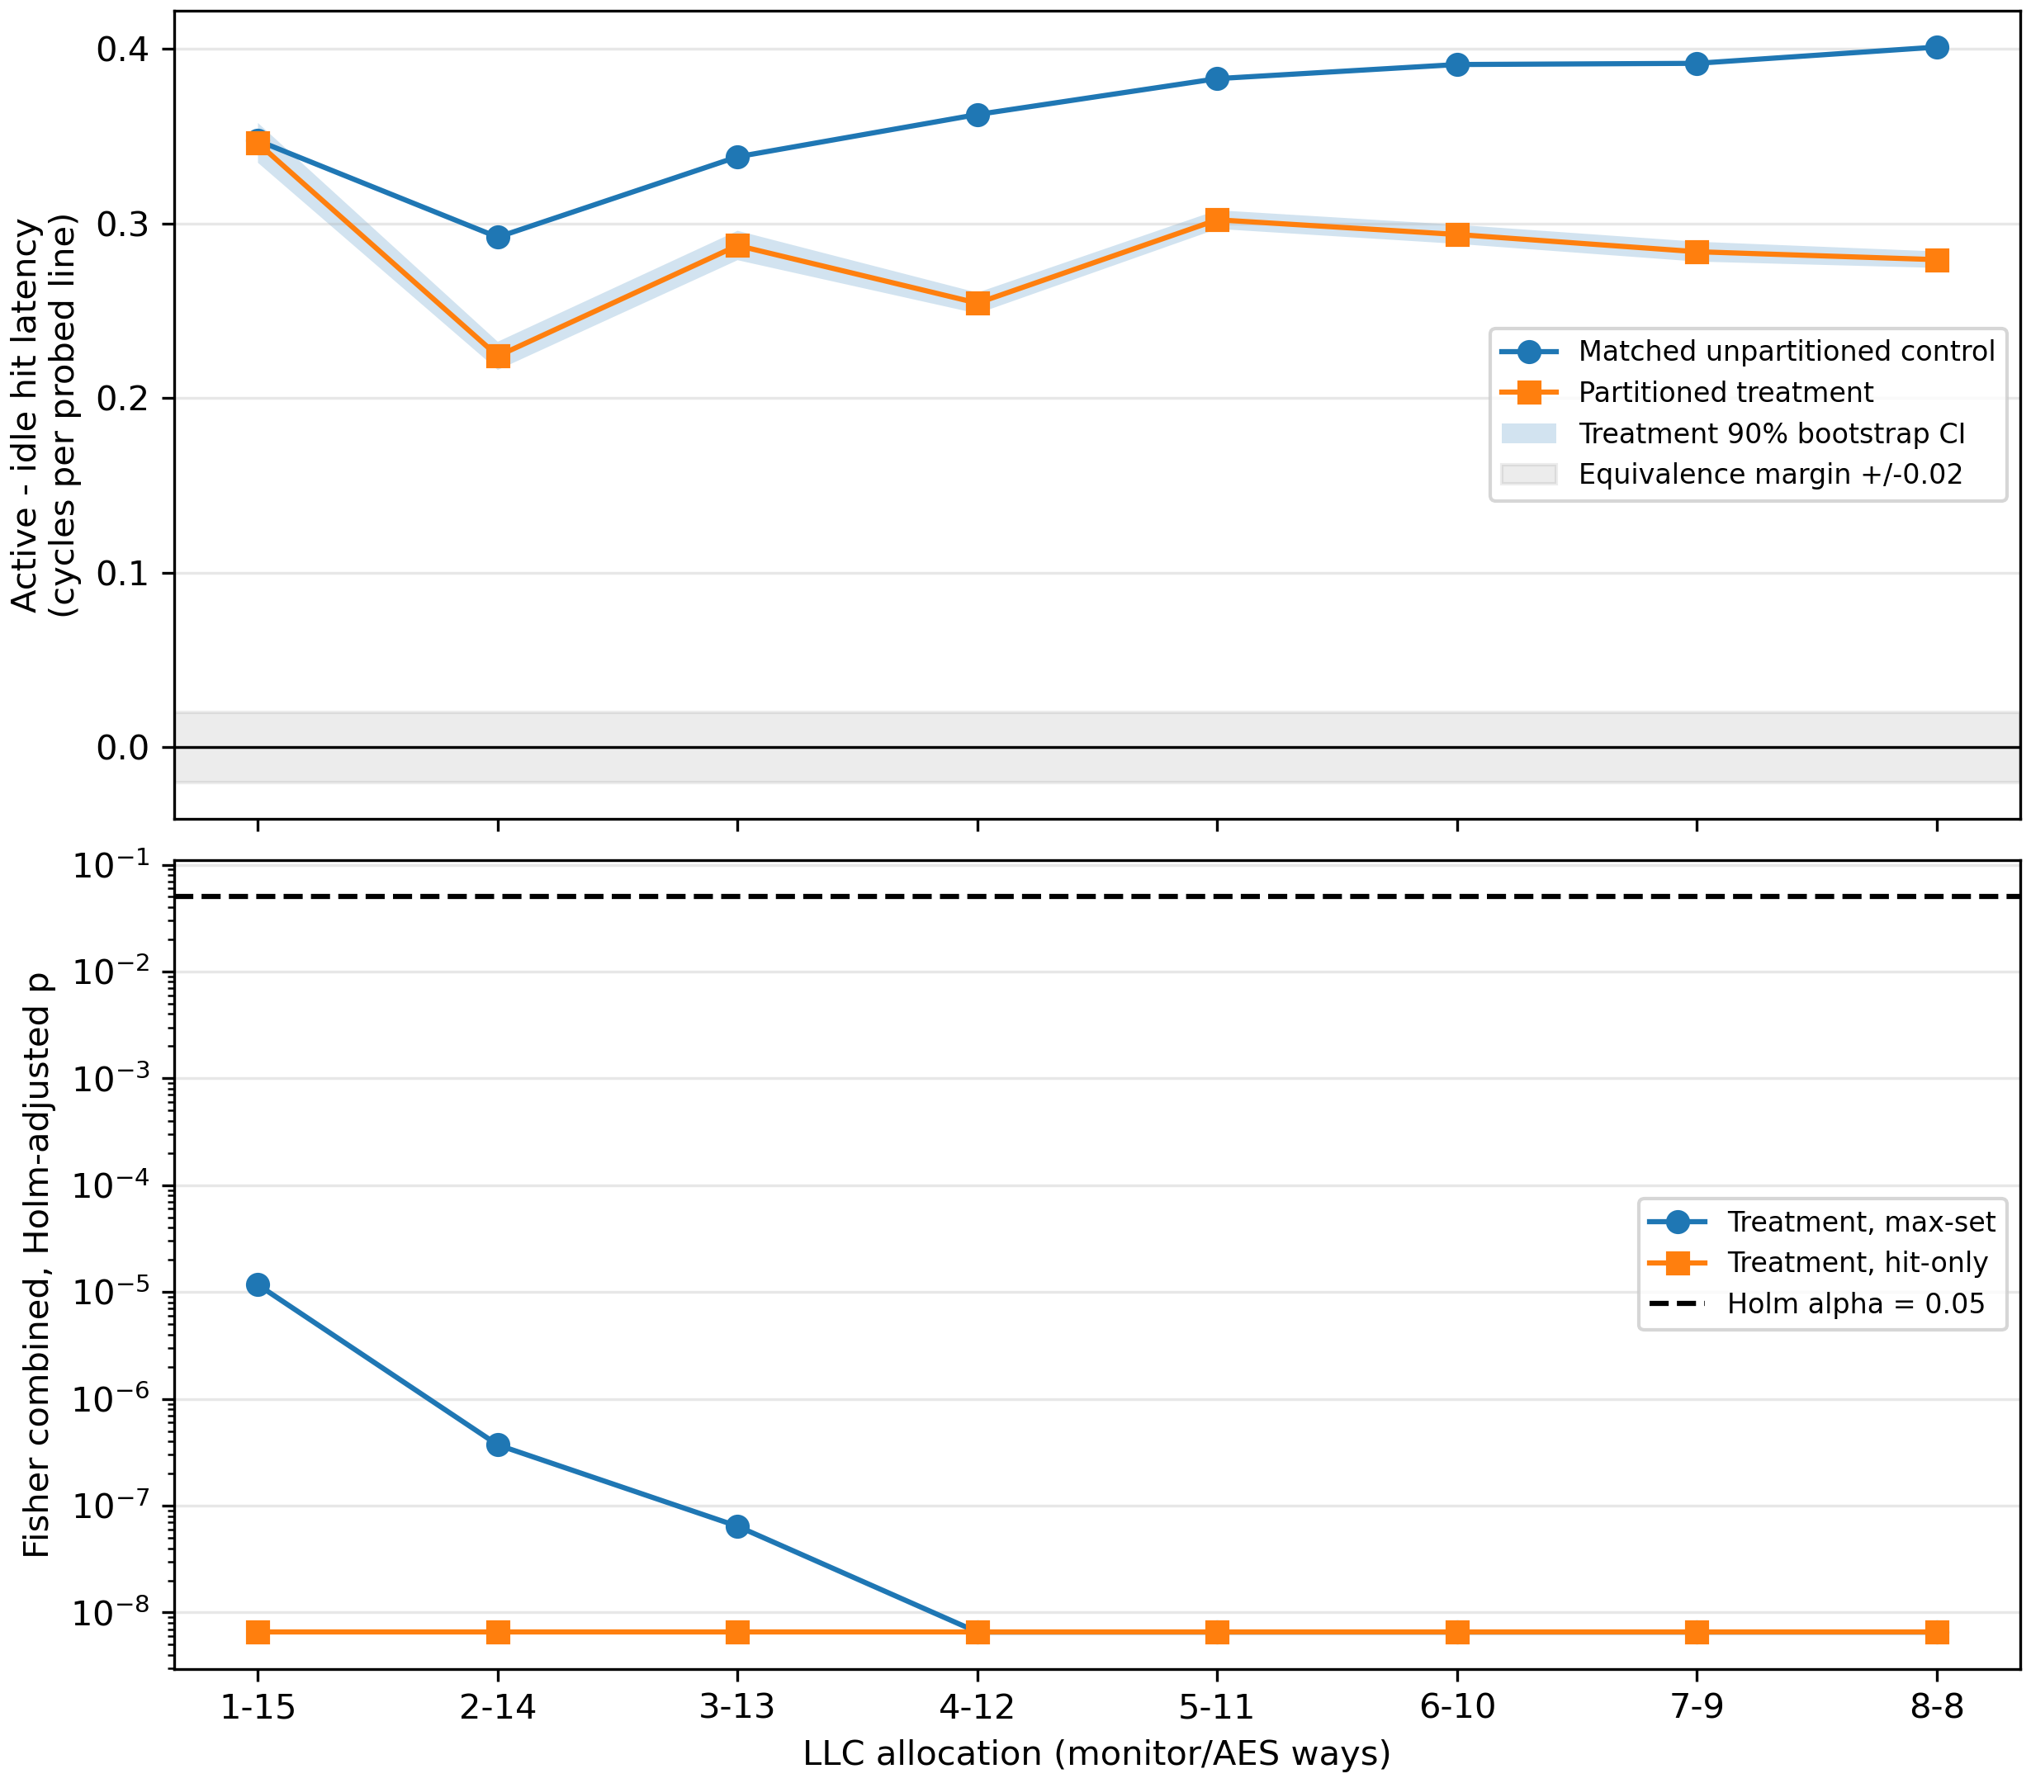
Fig. 1. Active-minus-idle hit latency per probed line for matched controls and partitioned treatments (top, with the treatment 90% bootstrap CI and the ±0.02 equivalence band) and Holm-adjusted treatment p-values for both statistics (bottom), three public seeds.

A. Interpretation Across Allocations
The control effect ranges from +0.292 to +0.401 cycles per line across allocations. Partitioning leaves 100% of it at 1/15 and 70%–85% at larger allocations. The signal is a latency shift on LLC hits of a few tenths of a cycle, not an eviction: control probes almost never miss. This is consistent with contention for the LLC's shared ports, crossbar, or queues, which way masks do not partition; the mechanism was inferred from latency data, not instrumented.
Way partitioning does remove an eviction component. In the original data, the number of missing control probes per interval depended on AES activity from A=5 upward, and the A=16 diagnostics show a very strong eviction signal when the monitor fills every way. With the corrected monitor, at most 0.018% of partitioned probe walks contain an LLC miss, so no eviction signal remains. Partitioning therefore closes the storage channel it was designed to close, while a smaller timing channel remains.

B. Why the Original Analysis Reported a 1/15 Threshold
Split | Treatment all-hit walks, original → final | Original decision | Final decision
1/15 | 80.1% → 99.98% | Indist. | Dist.
2/14 | 80.8% → 99.98% | Indist. | Dist.
3/13 | 80.2% → 99.98% | Indist. | Dist.
4/12 | 75.6% → 99.95% | Indist. | Dist.
5/11 | 75.6% → 99.87% | Indist. | Dist.
6/10 | 75.6% → 99.80% | Indist. | Dist.
7/9 | 75.6% → 99.62% | Indist. | Dist.
8/8 | 75.6% → 99.41% | Indist. | Dist.
The original study found every treatment indistinguishable (Holm p from 0.062 to 1.000) and reported 1/15 as a stable collapse point. The reason is monitor self-eviction: in the original monitor only 75.6–80.8% of partitioned probe walks were free of LLC misses, against 99.41–99.98% after the fix. The original 1/15 threshold was produced by the measurement artifact, not by the defense, and is withdrawn.

VIII. PERFORMANCE TRADEOFF
Metric at 1/15 | Matched change
Monitor IPC | -0.0085%
AES IPC | 0.0000%
Monitor LLC miss rate | +0.262 percentage points
AES LLC miss rate | 0.0000 percentage points
AES cycles/encryption | 0.0000%
Across all eight allocations, monitor IPC changes by at most 0.029% and AES cycles per encryption by at most 0.008%; the monitor's LLC miss rate rises by 0.26 percentage points, a one-time refill at the start of measurement (every probe walk with a miss falls in the first interval), not ongoing self-eviction. Both workloads fit easily in their allocations, so partitioning costs them essentially nothing. Cycles per encryption is the clearer useful-work metric because both programs contain rdcycle busy-wait loops that contribute instructions to IPC.

A. Costs in the Original Analysis
The original study reported a monitor IPC cost rising from 0.79% at 1/15 to 5.42% at 8/8 and a monitor miss-rate increase near 19 percentage points. Those costs came from the monitor evicting its own probe lines, not from partitioning, and disappear with the corrected monitor. A larger AES working set or a capacity-hungry co-runner could still show a real tradeoff.

IX. THREATS TO VALIDITY
The study uses gem5 timing rather than silicon measurements. The symmetric 4 KiB L1D caches deliberately expose T-table traffic and limit generalization. Three consecutive deterministic seeds are repeated inputs, not a population of executions: they share one activity schedule and one permutation sequence, so Fisher's independence assumption is optimistic. The conclusion does not rest on it, because each of the 24 partitioned runs is individually significant (Bonferroni over 24 runs, p ≤ 0.0024). The hit-only statistic was chosen after a post-hoc analysis of the original data and the gate was revised after the first corrected sweep; both were fixed before the final data existed, and the max-set statistic alone reaches the same conclusion at all eight allocations. The gate's one-point tolerance is loose; the stronger evidence against self-eviction is that no probe walk after the first interval contains an LLC miss.
Way masks isolate LLC data capacity but not MSHRs, queues, ports, interconnects, coherence metadata, memory controllers, or DRAM. The residual signal is attributed to these structures by elimination, not by direct measurement. The result applies only to this monitor, workload, cache hierarchy, run length, and decision rule.

A. Reproducibility and Traceability
Every quantitative claim traces from this report to results/updated run/sweep-v3/summary_v3.csv, from that table to the per-run analysis files, and from each analysis file to the raw probes.bin, simout.txt, and stats.txt. The preregistration fixes the decision rule and file hashes. The original study's results and code paths are preserved unchanged and verified by checksum, and an original case rerun with the current code reproduced it byte for byte.

B. Future Work
Architecturally, the next step is to instrument the shared LLC path, including ports, crossbar, and MSHR occupancy, to confirm the source of the residual hit-timing signal, and to test mitigations that partition bandwidth as well as capacity. More seeds, larger L1D sizes, and capacity-hungry co-runners would test generality and expose a real performance tradeoff. These extensions should retain the current safeguards: simulator-only execution, public inputs, activity detection rather than key inference, matched positive controls, direct isolation evidence, and a self-eviction gate.

X. CONCLUSION
This project evaluated LLC way partitioning against labelled AES cache activity in gem5 with matched controls, direct isolation evidence, and a preregistered statistical rule. After correcting a monitor self-eviction artifact that had produced a false 1/15 threshold in our original analysis, all eight allocations from 1/15 to 8/8 remain distinguishable, the partitioned monitor retains 70%–100% of the control signal, and no allocation is equivalent to zero. Way partitioning removes eviction-based contention at negligible cost, but it does not close the hit-timing channel through shared LLC resources. A complete defense must also isolate those resources, and any evaluation of such defenses must verify that the measuring monitor does not interfere with itself.

REFERENCES
[1] gem5 Project, “gem5 v25.1.0.1 source,” 2026. [Online]. Available: https://github.com/gem5/gem5/tree/v25.1.0.1
[2] J. Lowe-Power et al., “The gem5 simulator: Version 20.0+,” arXiv:2007.03152, 2020.
[3] D. A. Osvik, A. Shamir, and E. Tromer, “Cache attacks and countermeasures: The case of AES,” in Proc. CT-RSA, 2006.
[4] F. Liu et al., “CATalyst: Defeating last-level cache side channel attacks in cloud computing,” in Proc. IEEE HPCA, 2016.

