Evaluating LLC Way Partitioning as a Defense Against Simulated Cross-Core AES Cache Contention
Shahriar Ahmed, Khan Thamid Hasan, and Md Touhidul Islam
EEL 5764 Computer Architecture, Fall 2026 — Group 18
Abstract—This project evaluates way partitioning of a shared 16-way last-level cache as a defense against simulated cross-core cache contention. In gem5, core 0 runs a depth-matched Prime+Probe-style monitor and core 1 runs a deliberately leakage-prone educational T-table AES-128 workload. For monitor depths A=1...8, each A/(16-A) partitioned treatment is paired with an unpartitioned control using the same monitor footprint, binaries, schedule, and public plaintext seed; three seeds give 48 inferential processes plus two excluded diagnostics. An earlier version of this study concluded that one monitor way (1/15) already made AES activity undetectable. Validation showed that conclusion was an artifact: the monitor's own record buffer evicted 20–25% of its probe lines, but only in partitioned runs, hiding the signal. With a corrected record-free monitor and a predeclared self-eviction gate, all 24 matched pairs pass every validity check and all eight allocations remain distinguishable after Fisher combination and Holm correction. The partitioned monitor retains 70%–100% of its control's hit-latency signal; no allocation is equivalent to zero within ±0.02 cycles per probed line. Partitioning removes eviction-based contention but not the hit-timing channel through shared LLC resources, and it costs these workloads at most 0.029% in IPC or cycles per encryption.
Index Terms—gem5, cache partitioning, Prime+Probe, T-table AES, last-level cache, hardware security.

I. INTRODUCTION
Shared last-level caches improve utilization but allow activity from one security domain to influence another domain's cache state. Prime+Probe exploits this interaction by filling selected cache sets and measuring the latency of later accesses [3]. Hardware way partitioning limits each domain to a disjoint subset of cache ways and can therefore remove cross-domain data evictions [4]. The architectural question is not only whether partitioning reduces a signal, but how much cache capacity must be assigned before a validated monitor can no longer distinguish a known activity pattern and what performance cost accompanies that allocation.
We study this question entirely inside gem5 v25.1.0.1. Core 0 measures only its own memory accesses, while core 1 executes educational T-table AES with a public key, public deterministic plaintexts, and public active/idle labels. No physical hardware or secret data is involved, and the analysis performs no key recovery.
The methodological core is a matched-control design: a monitor assigned A ways primes and probes exactly A congruent lines per set, and its partitioned result is interpreted only when an unpartitioned run with the same depth and seed detects AES activity. This study shows that matched controls are necessary but not sufficient. Under strict way masks, every cache line the monitor touches competes with its own probe lines, so a monitor can lose its signal through self-eviction that occurs only in the partitioned arm. Our original analysis fell into exactly this trap and reported a false 1/15 threshold; this report presents the corrected study.

II. BACKGROUND AND MOTIVATION
A conventional AES T-table implementation uses four 1 KiB lookup tables. Lookup-dependent memory traffic is a useful controlled source of cache activity, but a private cache can absorb most accesses before they reach the LLC. Our initial 16 KiB L1D control therefore failed to produce a detectable LLC signal. A later 4 KiB L1D pilot exposed activity but walked 16 lines per set for every partition size, so with fewer than 16 assigned ways the monitor evicted its own lines. The first depth-matched study fixed that, yet its monitor still stored 16,384 measurement records in a 384 KiB array during measurement, which reintroduced self-eviction in a milder form.
The final study retains the 4 KiB L1D stress configuration, matches the monitor footprint to its allocation, and keeps every other monitor access out of the LLC during measurement. The configuration is intentionally favorable to exposing T-table traffic at the LLC and is not intended as a model of every commercial processor.

III. EXPERIMENTAL PLATFORM
Component | Configuration
Simulator | gem5 v25.1.0.1, commit c8222cc6
ISA and mode | RISC-V syscall emulation
Processors | 2 × TimingSimpleCPU, 2 GHz
Private caches | 16 KiB L1I; 4 KiB, 4-way L1D
Shared LLC | 256 KiB, 16-way, 64 B lines, 256 sets, LRU
Memory | DDR3-1600, 512 MiB
Intervals | 32 active + 32 idle, 2,000,000 cycles each
Stock RISC-V requests do not provide the core-specific partition identifiers required by gem5's way-partitioning policy. An out-of-tree RequestorPartitionManager maps cpu0 and cpu1 traffic to partitions 0 and 1. For split A/(16-A), ways [0,A) belong to the monitor and ways [A,16) belong to AES. Instrumentation records mapping consistency, address-partition conflicts, unmapped requests, and valid-block occupancy outside each mask.

IV. WORKLOADS AND METHOD
The monitor primes and probes A lines in every LLC set and records, for each set and interval, a timestamp and the walk latency. It never writes a separate record array: each 16-byte record is stored in the spare bytes of the probe line it has just loaded, which is already resident in the L1D, and after every interval a single writev system call hands all 256 records to the simulator, which reads them functionally without changing cache state. The way count and file descriptor stay in registers throughout measurement, so the measurement loop loads only probe-chain pointers. Each process produces 16,384 measurements. Runtime physical-address lookup verifies that logical set indices differ from physical LLC sets only by a constant rotation; any mismatch invalidates the run.
The AES workload uses four conventional 1 KiB tables, the public key 000102030405060708090a0b0c0d0e0f, and plaintexts generated by public seeds 0x5764A5E5, 0x5764A5E6, and 0x5764A5E7. A FIPS-197 known-answer test runs before measurement. The workload reports total encryptions, allowing cycles per completed encryption to be calculated over the fixed active duration.
For each seed and A=1...8, one unpartitioned control and one partitioned treatment run as fresh gem5 processes. The 48 inferential runs are supplemented by two A=16 positive-control diagnostics excluded from inference. Every output directory preserves the command, configuration, binary hashes, simulator statistics, workload log, the raw probe file, and derived analysis.
A matched control does not detect a confound that exists only in the treatment. In the original study the monitor's record stores allocated 96 new LLC lines per interval; with 16 ways these displaced old record lines, but with A ways they displaced probe lines, so 20–25% of partitioned probe walks contained an LLC miss against almost none in the controls. Those label-independent misses added roughly 120-cycle outliers that hid a sub-cycle signal. A first corrected monitor removed the buffer; an LLC trace then showed that one remaining line, holding the global way count, was refetched from A=4 upward and occupied one monitor way in one set.
Each matched pair must therefore pass a self-eviction gate: the fraction of probe walks more than 100 cycles above the run's 1st-percentile walk time, which identifies an LLC miss, may differ between treatment and control by at most one percentage point in every seed pair. An allocation that fails the gate is uninterpretable rather than indistinguishable.

V. STATISTICAL ANALYSIS
For each set, SNR is the absolute difference between mean active and idle latency divided by their pooled sample standard deviation. The max-set statistic is the maximum SNR over 256 sets. Each of 10,000 balanced label permutations recomputes this maximum using analysis seed 5764; the empirical p-value is (1 + count(null ≥ observed))/10001. This construction corrects the within-run search over sets.
The co-primary hit-only statistic averages, per interval, all probe walks within 20 cycles of the run's 1st-percentile walk time and tests the active-minus-idle difference with the same 10,000 permutations. Its effect size, in cycles per probed line, has a 90% bootstrap confidence interval; an allocation is equivalent to no leak only if that interval lies inside ±0.02 cycles per line.
For each allocation, Fisher's method combines the three seed-specific p-values. Holm adjustment controls familywise error across 16 tests, eight allocations by two statistics, at alpha=0.05, separately for controls and treatments. An allocation is distinguishable if, under either statistic whose control is valid, the treatment is significant. A stable collapse point is the first indistinguishable allocation for which every larger allocation is also indistinguishable.

VI. VALIDATION
Validation gate | Observed result
Planned/completed processes | 50 / 50; no failed directories
Probe records | 819,200
Statistics blocks | 100
AES self-tests | 50 PASS
Physical-set mapping | 50 PASS congruent
Way isolation | 24 PASS disjoint; zero violations
Self-eviction gate | 24/24 pairs PASS
Matched controls (hit-only) | 24/24 individually distinguishable
Binary consistency | One hash pair across all processes
Treatment probe walks with an LLC miss averaged 0.006–0.018% against 0.006% in the controls. These gates establish that the result is not an artifact of monitor self-eviction, an unverified virtual-to-physical mapping assumption, or overlapping way masks.

VII. RESULTS
Split | Control effect | Partitioned effect [90% CI] | Holm p (max-set / hit-only)
1/15 | 0.347 | 0.346 [0.335, 0.358] | 1.2e-05 / 6.6e-09
2/14 | 0.292 | 0.224 [0.216, 0.232] | 3.7e-07 / 6.6e-09
3/13 | 0.338 | 0.287 [0.279, 0.296] | 6.4e-08 / 6.6e-09
4/12 | 0.362 | 0.254 [0.248, 0.260] | 6.6e-09 / 6.6e-09
5/11 | 0.383 | 0.302 [0.297, 0.308] | 6.6e-09 / 6.6e-09
6/10 | 0.391 | 0.294 [0.288, 0.299] | 6.6e-09 / 6.6e-09
7/9 | 0.392 | 0.284 [0.278, 0.290] | 6.6e-09 / 6.6e-09
8/8 | 0.401 | 0.279 [0.275, 0.284] | 6.6e-09 / 6.6e-09
All eight partitioned treatments remained distinguishable after correction, so there is no stable collapse point and no equivalence point. Effects are active-minus-idle hit latency in cycles per probed line (active intervals slower), averaged over three seeds. The partitioned monitor retains 70%–100% of its matched control's signal, and every confidence interval lies far outside ±0.02 cycles per line. The hit-only control is valid at all eight allocations; the max-set control is valid at all eight, and the max-set treatment test alone is significant at all eight.
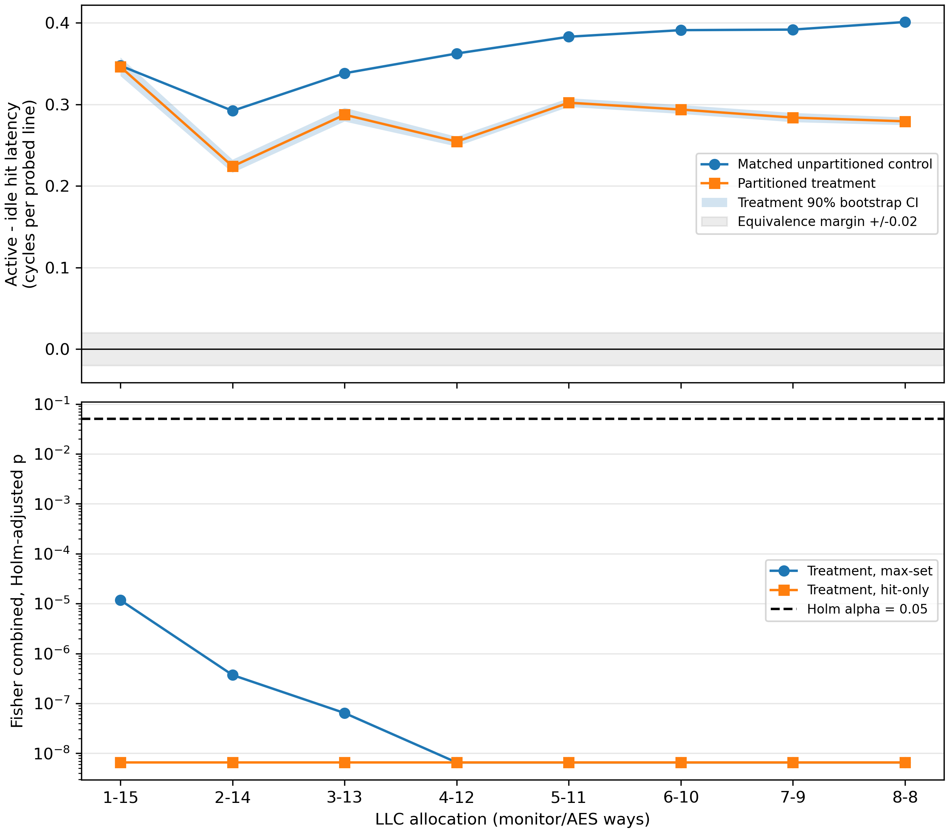
Fig. 1. Active-minus-idle hit latency per probed line for matched controls and partitioned treatments (top, with the treatment 90% bootstrap CI and the ±0.02 equivalence band) and Holm-adjusted treatment p-values for both statistics (bottom), three public seeds.
The control effect rises from +0.347 cycles per line at A=1 to +0.401 at A=8. Partitioning leaves 100% of it at 1/15 and 70%–85% at larger allocations. The signal is a latency shift on LLC hits of a few tenths of a cycle, not an eviction: control probes almost never miss. This is consistent with contention for the LLC's shared ports, crossbar, or queues, which way masks do not partition; the mechanism was inferred from latency data, not instrumented.
The original study found every treatment indistinguishable (Holm p from 0.062 to 1.000) and reported 1/15 as a stable collapse point. The reason is monitor self-eviction: in the original monitor only 75.6–80.8% of partitioned probe walks were free of LLC misses, against 99.41–99.98% after the fix. The original 1/15 threshold was produced by the measurement artifact, not by the defense, and is withdrawn.

VIII. PERFORMANCE TRADEOFF
Metric at 1/15 | Matched change
Monitor IPC | -0.0085%
AES IPC | 0.0000%
Monitor LLC miss rate | +0.262 percentage points
AES LLC miss rate | 0.0000 percentage points
AES cycles/encryption | 0.0000%
Across all eight allocations, monitor IPC changes by at most 0.029% and AES cycles per encryption by at most 0.008%; the monitor's LLC miss rate rises by 0.26 percentage points. Both workloads fit easily in their allocations, so partitioning costs them essentially nothing. Cycles per encryption is the clearer useful-work metric because both programs contain rdcycle busy-wait loops that contribute instructions to IPC.

IX. THREATS TO VALIDITY
The study uses gem5 timing rather than silicon measurements. The symmetric 4 KiB L1D caches deliberately expose T-table traffic and limit generalization. Three consecutive deterministic seeds are repeated inputs, not a population of executions, and Fisher combination assumes the seed-level tests are independent; most p-values already sit at the permutation floor. The hit-only statistic was chosen after a post-hoc analysis of the original data and the gate was revised after the first corrected sweep; both were fixed before the final data existed, and the max-set statistic alone reaches the same conclusion at all eight allocations.
Way masks isolate LLC data capacity but not MSHRs, queues, ports, interconnects, coherence metadata, memory controllers, or DRAM. The residual signal is attributed to these structures by elimination, not by direct measurement. The result applies only to this monitor, workload, cache hierarchy, run length, and decision rule.

X. CONCLUSION
This project evaluated LLC way partitioning against labelled AES cache activity in gem5 with matched controls, direct isolation evidence, and a preregistered statistical rule. After correcting a monitor self-eviction artifact that had produced a false 1/15 threshold in our original analysis, all eight allocations from 1/15 to 8/8 remain distinguishable, the partitioned monitor retains 70%–100% of the control signal, and no allocation is equivalent to zero. Way partitioning removes eviction-based contention at negligible cost, but it does not close the hit-timing channel through shared LLC resources. A complete defense must also isolate those resources, and any evaluation of such defenses must verify that the measuring monitor does not interfere with itself.

REFERENCES
[1] gem5 Project, “gem5 v25.1.0.1 source,” 2026. [Online]. Available: https://github.com/gem5/gem5/tree/v25.1.0.1
[2] J. Lowe-Power et al., “The gem5 simulator: Version 20.0+,” arXiv:2007.03152, 2020.
[3] D. A. Osvik, A. Shamir, and E. Tromer, “Cache attacks and countermeasures: The case of AES,” in Proc. CT-RSA, 2006.
[4] F. Liu et al., “CATalyst: Defeating last-level cache side channel attacks in cloud computing,” in Proc. IEEE HPCA, 2016.

