Problem-3: Part-C
The bottleneck is that 35% of the baseline execution time cannot be accelerated by the NPU. This could include data transfers, CPU control instructions, synchronization, or non-matrix computations. Even if NPU’s operations take zero time, the application must still complete the unenhanced portion’s work in the normal way. Therefore, acceleration alone cannot exceed the speedup ceiling.
This explains why architects prioritize “making the common case fast”: an optimization’s value depends on how much of the application’s total execution time it saves. A spectacular speedup of a rarely used operation can have very little effect on the whole program. For example, accelerating an operation that occupies only 1% of runtime yields only about a 1% overall performance improvement. A complex hardware unit may therefore consume substantial area, power, and design effort while delivering little practical benefit.

Part-B : Hands-On gem5 Simulation Exercise
Step-1: SCons Simulator Compilation
The SCon build has been conducted successfully.
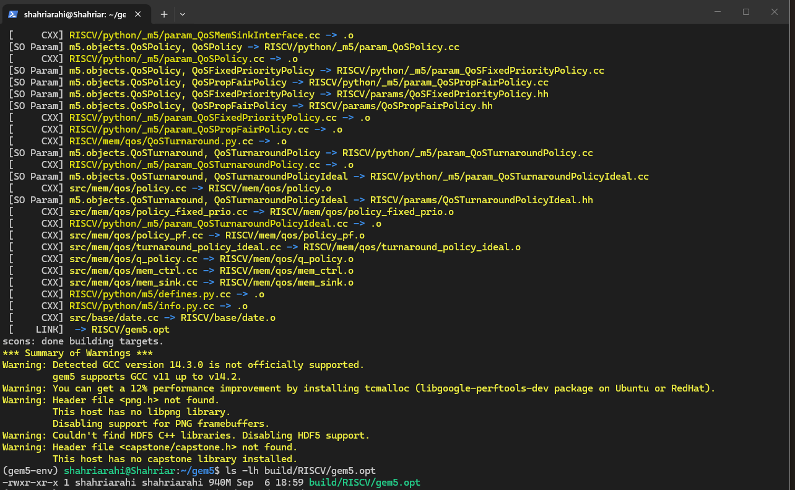

Step-2: Simple Executable Run in SE Mode
I have used the commands from the assignment and generated a “Hello World” line as shown below.
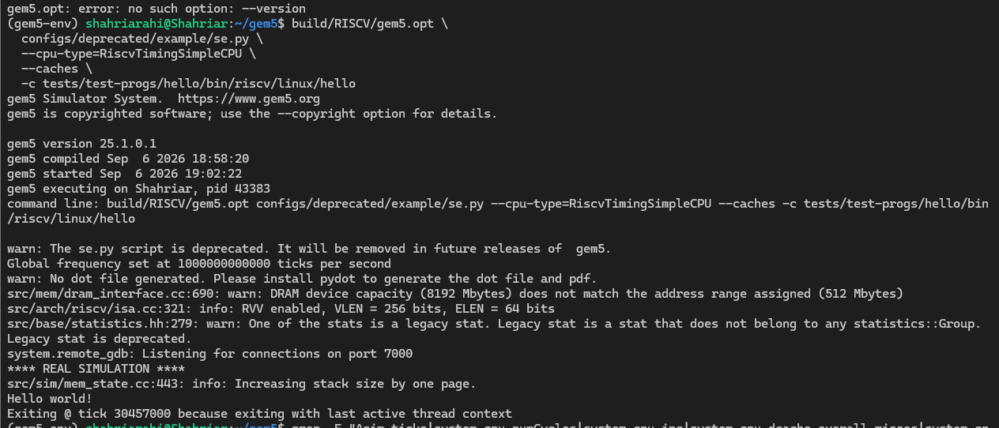

Step-3: Navigating Telemetry & Metric Extraction
Gem5 Stat Key | Physical Hardware Metric | Extracted Value
Sim_ticks | Total simulated benchmark runtime in picoseconds (ps). (Include your conversion to nanoseconds (ns)). | 30,457,000
System.cpu.numCycles | Total simulated processor clock cycles spent processing the dynamic instruction stream. | 60,914
System.cpu.ipc | Instructions executed per clock cycle. (Compute its reciprocal to find the effective Cycles Per Instruction, CPI). | 0.090587
System.cpu.dcache.overall_misses | Total cache lookup misses recorded on the L1 Data Cache interface during execution. | 135 misses
System.cpu.dcache.overall_miss_rate | The fraction of L1 Data Cache references that resulted in misses, causing memory hierarchy stalls. | 0.065217

Step-4: Reflection
Hello World took 60,914 cycles to retire its instruction stream, an IPC of 0.0906 (≈11 CPI). For a workload this small, that figure says more about startup cost than steady-state behavior: the instruction count is dominated by process setup and a single write syscall, so the pipeline has little opportunity to fill. The 135 L1 data cache misses (6.52%) are consistent with this — cold-start compulsory misses on a working set that is never revisited.

