Part B gem5 Local Simulation Results
RISC V hello benchmark 27 September 2026
TimingSimpleCPU and O3CPU both ran the same RISC-V hello binary under Syscall Emulation mode with caches enabled. Both local WSL runs printed “Hello world!” and exited with code 0. O3CPU completed in 14,677,500 simulated ticks versus 30,457,000 for TimingSimpleCPU, a 2.075× runtime improvement. These measurements are from host Shahriar; the assignment specifies the UF ECE server.

Step 1 Simulation launches

Run 1 In order TimingSimpleCPU
build/RISCV/gem5.opt --outdir=m5out-step1-timing-screenshot \
configs/deprecated/example/se.py --cpu-type=TimingSimpleCPU --caches \
-c tests/test-progs/hello/bin/riscv/linux/hello

Run 2 Out of order O3CPU
build/RISCV/gem5.opt --outdir=m5out-step1-o3-screenshot \
configs/deprecated/example/se.py --cpu-type=O3CPU --caches \
-c tests/test-progs/hello/bin/riscv/linux/hello
Local execution prefixed each command with a process-only LD_LIBRARY_PATH pointing to gem5-env/lib and used timeout 110s. Separate --outdir values preserved both stats.txt files. The companion ZIP contains reproducible scripts with distinct default output directories.

Step 2 Hardware telemetry
gem5 stat key | TimingSimpleCPU | O3CPU
sim_ticks | 30,457,000 | 14,677,500
system.cpu.numCycles | 60,914 | 29,357
system.cpu.ipc | 0.090587 | 0.187962
system.cpu.dcache.overall_misses | 135 | 524
All four rows were checked against m5out-step1-timing-screenshot/stats.txt and m5out-step1-o3-screenshot/stats.txt. This gem5 version labels the assignment’s sim_ticks as simTicks and overall_misses as system.cpu.dcache.overallMisses::total. At 10¹² ticks per second, the measured times are 30,457 ns and 14,677.5 ns.

Step 3 Reflection and submission bundle
For the same RISC-V hello binary, O3CPU completed in 14,677,500 simulated ticks and 29,357 cycles (IPC 0.187962; CPI 5.320225), versus 30,457,000 ticks and 60,914 cycles (IPC 0.090587; CPI 11.039145) for TimingSimpleCPU. Out-of-order scheduling can run ready independent instructions while others wait, which plausibly contributes to the approximately 2.075× higher IPC, although these aggregate counters do not isolate that effect. O3CPU recorded more L1 data-cache misses (524 versus 135), so fewer data-cache misses do not explain its shorter simulated runtime.

Step 1 Simulation launch screenshot
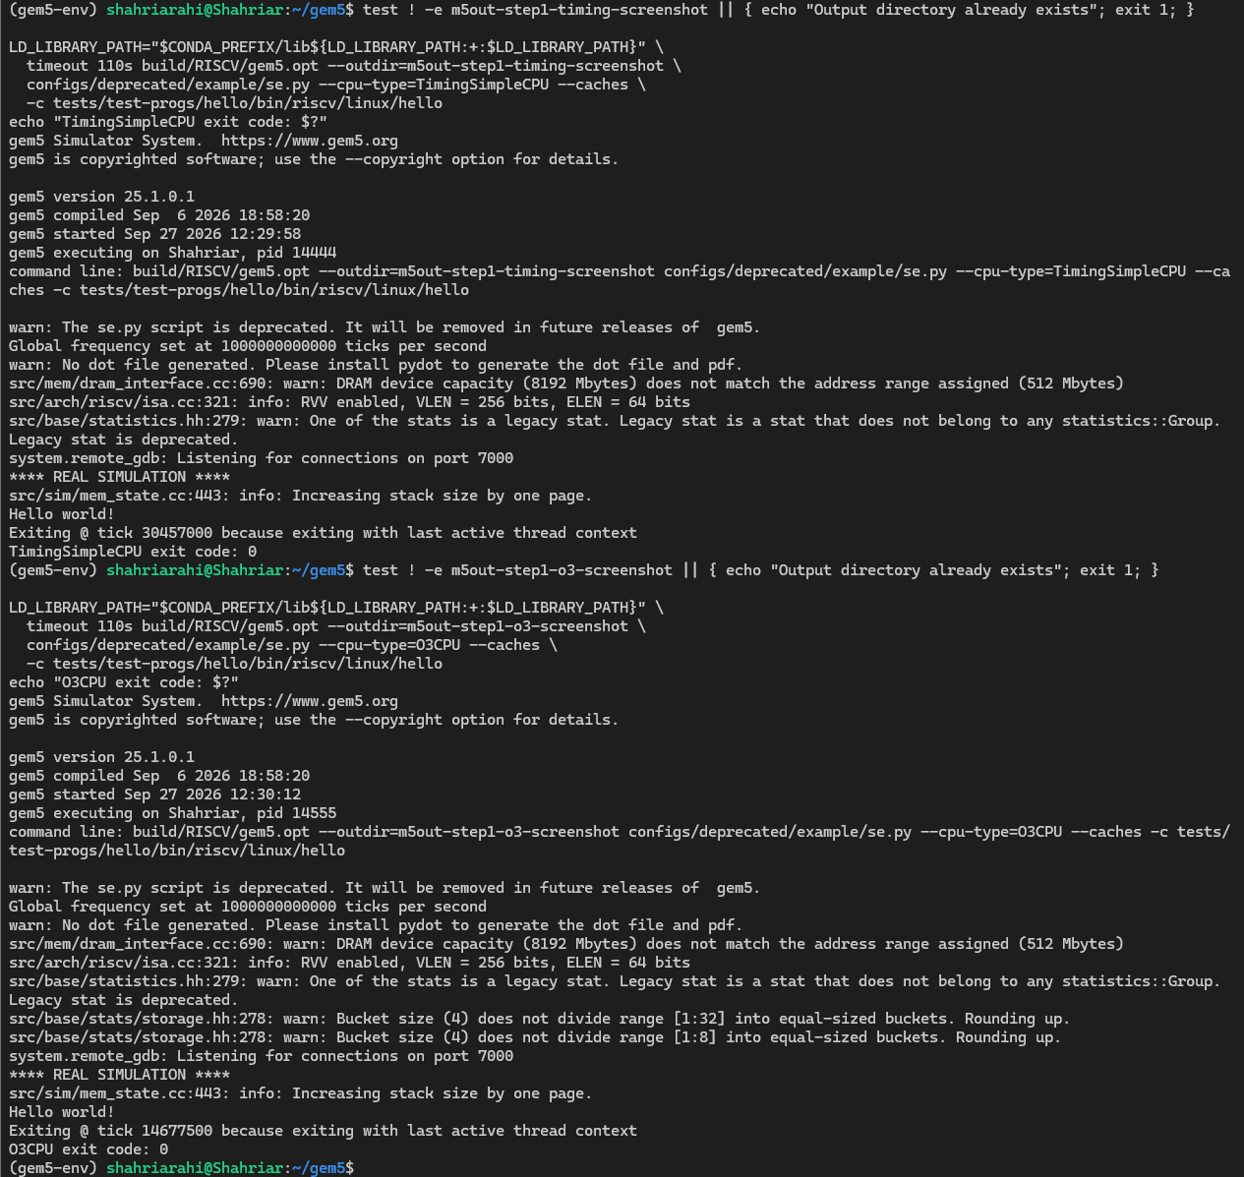

Step 2 Telemetry screenshot


