Evaluating LLC Way Partitioning as a Defense Against Simulated Cross-Core AES Cache Contention
Shahriar Ahmed, Khan Thamid Hasan, and Md Touhidul Islam
EEL 5764 Computer Architecture, Fall 2026 — Group 18
Abstract—This project evaluates way partitioning of a shared 16-way last-level cache as a defense against simulated cross-core cache contention. In gem5, core 0 runs a depth-matched Prime+Probe-style monitor and core 1 runs a deliberately leakage-prone educational T-table AES-128 workload. For monitor depths A=1...8, each A/(16-A) partitioned treatment is paired with an unpartitioned control using the same monitor footprint, binaries, schedule, and public plaintext seed; three seeds give 48 inferential processes plus two excluded diagnostics. An earlier version of this study concluded that one monitor way (1/15) already made AES activity undetectable. Validation showed that conclusion was an artifact: the monitor's own record buffer evicted 20–25% of its probe lines, but only in partitioned runs, hiding the signal. With a corrected record-free monitor and a predeclared self-eviction gate, all 24 matched pairs pass every validity check and all eight allocations remain distinguishable after Fisher combination and Holm correction. The partitioned monitor retains 70%–100% of its control's hit-latency signal; no allocation is equivalent to zero within ±0.02 cycles per probed line. Partitioning removes eviction-based contention but not the hit-timing channel through shared LLC resources, and it costs these workloads at most 0.029% in IPC or cycles per encryption. A preregistered ablation of the shared L1-to-LLC crossbar identifies the channel: its single request layer is busier in every AES-active interval, the leak shrinks in step with that layer's utilization, and a near-ideal crossbar removes 100% of the signal at 1/15 and 88% at 8/8. Two follow-up mechanisms close this channel: fixed request time slots at the crossbar and per-domain LLC response queues. With both added to way partitioning, every allocation becomes indistinguishable under the same preregistered rule, and the monitor's probe log is byte-identical whether the victim runs AES or stays idle in all 24 seed-allocation configurations, at about 6% AES cost.
Index Terms—gem5, cache partitioning, Prime+Probe, T-table AES, last-level cache, hardware security, on-chip interconnect, timing isolation.

I. INTRODUCTION
Shared last-level caches improve utilization but allow activity from one security domain to influence another domain's cache state. Prime+Probe exploits this interaction by filling selected cache sets and measuring the latency of later accesses [3]. Hardware way partitioning limits each domain to a disjoint subset of cache ways and can therefore remove cross-domain data evictions [4]. The architectural question is not only whether partitioning reduces a signal, but how much cache capacity must be assigned before a validated monitor can no longer distinguish a known activity pattern and what performance cost accompanies that allocation.
We study this question entirely inside gem5 v25.1.0.1. Core 0 measures only its own memory accesses, while core 1 executes educational T-table AES with a public key, public deterministic plaintexts, and public active/idle labels. No physical hardware or secret data is involved, and the analysis performs no key recovery.
The methodological core is a matched-control design: a monitor assigned A ways primes and probes exactly A congruent lines per set, and its partitioned result is interpreted only when an unpartitioned run with the same depth and seed detects AES activity. This study shows that matched controls are necessary but not sufficient. Under strict way masks, every cache line the monitor touches competes with its own probe lines, so a monitor can lose its signal through self-eviction that occurs only in the partitioned arm. Our original analysis fell into exactly this trap and reported a false 1/15 threshold; this report presents the corrected study.

A. Research Contributions and Scope
This work makes six concrete contributions. First, it implements per-requestor LLC way partitioning for a two-core RISC-V gem5 system and validates enforcement using tag-array occupancy rather than inferring isolation from performance changes. Second, it develops a depth-aware activity monitor whose footprint matches its assigned capacity and whose measurement loop allocates no cache lines besides its probe lines. Third, it identifies and removes two self-eviction confounds, a 384 KiB record buffer and a single hot global variable, and adds a predeclared gate that detects such confounds. Fourth, it uses a repeated, preregistered statistical design that combines evidence across public inputs and controls false positives across the allocation sweep. Fifth, a preregistered ablation of the shared L1-to-LLC crossbar identifies its request layer as the channel that partitioning leaves open. Sixth, it locates the remaining residual with request-level tracing and closes the channel with request time slots and per-domain LLC response queues, judged by the same preregistered rule.
The security goal is deliberately narrow. The monitor decides only whether latency differs between public AES-active and AES-idle intervals. It does not identify table indices, classify plaintexts, recover key bytes, or interact with a cryptographic service. The study therefore reports detectability, isolation invariants, and performance cost as separate outcomes.

II. BACKGROUND AND MOTIVATION
A conventional AES T-table implementation uses four 1 KiB lookup tables. Lookup-dependent memory traffic is a useful controlled source of cache activity, but a private cache can absorb most accesses before they reach the LLC. Our initial 16 KiB L1D control therefore failed to produce a detectable LLC signal. A later 4 KiB L1D pilot exposed activity but walked 16 lines per set for every partition size, so with fewer than 16 assigned ways the monitor evicted its own lines. The first depth-matched study fixed that, yet its monitor still stored 16,384 measurement records in a 384 KiB array during measurement, which reintroduced self-eviction in a milder form.
The final study retains the 4 KiB L1D stress configuration, matches the monitor footprint to its allocation, and keeps every other monitor access out of the LLC during measurement. The configuration is intentionally favorable to exposing T-table traffic at the LLC and is not intended as a model of every commercial processor.

A. Cache Contention and Set Associativity
A set-associative cache maps each physical address to one set and may place the corresponding block in any way within that set. With a 16-way LLC, as many as 16 blocks can reside in one set. In an unpartitioned design, blocks from both cores compete for all 16 positions. A monitor can exploit this competition by filling selected positions and measuring whether later accesses hit or miss. Longer probe latency during victim-active intervals indicates that the victim changed either cache residency or another shared timing resource.
Way partitioning changes the placement rule rather than the address-to-set mapping. Each request carries a partition identifier, and the replacement policy restricts insertion and victim selection to the ways assigned to that partition. A monitor assigned one way can retain at most one of its blocks per set, while AES assigned 15 ways can use the remaining positions. The same restriction applies to the monitor's own non-probe data: any such line resident in the LLC occupies one of the monitor's few ways in its set.

B. Why T-table AES Produces a Controlled Signal
T-table AES combines substitution and linear transformation operations into four lookup tables. The table index depends on intermediate data, so repeated encryption produces data-dependent memory references. In this project the dependence is not secret: the key and plaintext generator are public. The tables create structured lookup activity with a compact 4 KiB footprint, allowing the experiment to ask whether activity reaches the shared LLC and perturbs another core's timing.
Private-cache capacity determines how visible this traffic is. With a 16 KiB L1D, the four tables can remain resident together with much of the working state, so only a few requests reach the LLC. The 4 KiB L1D stress profile forces the table footprint to compete with plaintext, round-key, stack, and program data. This increases LLC exposure without adding explicit flush instructions or artificial table eviction. The choice improves observability but also narrows external validity.

III. EXPERIMENTAL PLATFORM
Component | Configuration
Simulator | gem5 v25.1.0.1, commit c8222cc6
ISA and mode | RISC-V syscall emulation
Processors | 2 × TimingSimpleCPU, 2 GHz
Private caches | 16 KiB L1I; 4 KiB, 4-way L1D
Shared LLC | 256 KiB, 16-way, 64 B lines, 256 sets, LRU
Memory | DDR3-1600, 512 MiB
Intervals | 32 active + 32 idle, 2,000,000 cycles each
Stock RISC-V requests do not provide the core-specific partition identifiers required by gem5's way-partitioning policy. An out-of-tree RequestorPartitionManager maps cpu0 and cpu1 traffic to partitions 0 and 1. For split A/(16-A), ways [0,A) belong to the monitor and ways [A,16) belong to AES. Instrumentation records mapping consistency, address-partition conflicts, unmapped requests, and valid-block occupancy outside each mask.

A. Request to Way-Mask Path
Each timing CPU receives a distinct gem5 requestor identity. The RequestorPartitionManager translates those identities to partition 0 for core 0 and partition 1 for core 1. The LLC tag store consults the selected partitioning policy when allocating or replacing a block. In split A/(16-A), partition 0 may use ways 0 through A-1, while partition 1 may use ways A through 15. Off mode removes the restrictions.
This mechanism isolates data capacity but does not duplicate the complete LLC pipeline. Requests still traverse shared crossbars and cache ports, use common miss-status holding registers and queues, and share the memory controller and DRAM. A remaining latency signal therefore does not mean that way masking failed; it can arise in another shared structure. The results in Section VII show that this is what happens.

B. Choice of RISC-V SE Mode
Syscall-emulation mode was selected because the experiment requires two deterministic user processes rather than a full operating-system stack. It reduces boot time and eliminates uncontrolled kernel scheduling and background services. RISC-V provides the rdcycle instruction needed for reproducible simulated timing. Freestanding static binaries avoid dependence on a guest C library and ensure that the same compiled workloads are used in every process.

IV. WORKLOADS AND METHOD
The monitor primes and probes A lines in every LLC set and records, for each set and interval, a timestamp and the walk latency. It never writes a separate record array: each 16-byte record is stored in the spare bytes of the probe line it has just loaded, which is already resident in the L1D, and after every interval a single writev system call hands all 256 records to the simulator, which reads them functionally without changing cache state. The way count and file descriptor stay in registers throughout measurement, so the measurement loop loads only probe-chain pointers. Each process produces 16,384 measurements. Runtime physical-address lookup verifies that logical set indices differ from physical LLC sets only by a constant rotation; any mismatch invalidates the run.
The AES workload uses four conventional 1 KiB tables, the public key 000102030405060708090a0b0c0d0e0f, and plaintexts generated by public seeds 0x5764A5E5, 0x5764A5E6, and 0x5764A5E7. A FIPS-197 known-answer test runs before measurement. The workload reports total encryptions, allowing cycles per completed encryption to be calculated over the fixed active duration.
For each seed and A=1...8, one unpartitioned control and one partitioned treatment run as fresh gem5 processes. The 48 inferential runs are supplemented by two A=16 positive-control diagnostics excluded from inference. Every output directory preserves the command, configuration, binary hashes, simulator statistics, workload log, the raw probe file, and derived analysis.

A. Interval Synchronization and Logging
The two workloads do not synchronize through shared memory. Both derive the current interval from the absolute rdcycle value and the same compiled schedule. Measurement starts after a fixed warm-up, and each two-million-cycle interval is labelled active or idle by a deterministic non-alternating sequence. Thirty-two observations per class provide balanced input to the statistics.
Gem5 resets statistics after warm-up and dumps a measurement-only block before post-measurement logging, so the reported IPC and cache metrics exclude output overhead. The monitor flushes each interval's records after that interval's probe walk is complete, and prints its completion line one interval after measurement ends so that its output cannot interleave with the AES workload's.

B. Why Matched Controls Are Required
Changing A changes the monitor itself. A one-line probe has a different instruction count, memory footprint, and expected signal from an eight-line probe. Comparing every treatment with a single A=16 control would mix the effect of partitioning with the effect of monitor depth. The matched design holds depth, seed, binary, interval schedule, and analysis constant; the only intended difference within a pair is whether the LLC way masks are enabled.
A partitioned run is considered interpretable only when its matched control detects activity. If the control fails, the treatment cannot demonstrate suppression because the monitor lacked sensitivity before the defense was applied. Requiring all three seed-specific controls to pass is deliberately conservative.

C. Why Matched Controls Are Not Sufficient
A matched control does not detect a confound that exists only in the treatment. In the original study the monitor's record stores allocated 96 new LLC lines per interval; with 16 ways these displaced old record lines, but with A ways they displaced probe lines, so 20–25% of partitioned probe walks contained an LLC miss against almost none in the controls. Those label-independent misses added roughly 120-cycle outliers that hid a sub-cycle signal. A first corrected monitor removed the buffer; an LLC trace then showed that one remaining line, holding the global way count, was refetched from A=4 upward and occupied one monitor way in one set.
Each matched pair must therefore pass a self-eviction gate: the fraction of probe walks more than 100 cycles above the run's 1st-percentile walk time, which identifies an LLC miss, may differ between treatment and control by at most one percentage point in every seed pair. An allocation that fails the gate is uninterpretable rather than indistinguishable.

V. STATISTICAL ANALYSIS
For each set, SNR is the absolute difference between mean active and idle latency divided by their pooled sample standard deviation. The max-set statistic is the maximum SNR over 256 sets. Each of 10,000 balanced label permutations recomputes this maximum using analysis seed 5764; the empirical p-value is (1 + count(null ≥ observed))/10001. This construction corrects the within-run search over sets.
The co-primary hit-only statistic averages, per interval, all probe walks within 20 cycles of the run's 1st-percentile walk time and tests the active-minus-idle difference with the same 10,000 permutations. Its effect size, in cycles per probed line, has a 90% bootstrap confidence interval; an allocation is equivalent to no leak only if that interval lies inside ±0.02 cycles per line.
For each allocation, Fisher's method combines the three seed-specific p-values. Holm adjustment controls familywise error across 16 tests, eight allocations by two statistics, at alpha=0.05, separately for controls and treatments. An allocation is distinguishable if, under either statistic whose control is valid, the treatment is significant. A stable collapse point is the first indistinguishable allocation for which every larger allocation is also indistinguishable.

A. From Per-set SNR to a Run-level Test
For one set, the SNR numerator measures the separation between active and idle mean probe latency. The pooled sample standard deviation normalizes this difference by within-class variability. The maximum across eligible sets represents the strongest activity-dependent location available to the monitor.
Selecting the maximum creates a multiple-comparison problem: even random labels can produce an unusually large value when 256 sets are searched. The permutation procedure therefore repeats the complete maximum search after every shuffle. The plus-one empirical p-value prevents a zero estimate when none of 10,000 permutations exceeds the observation. The max-set statistic is, however, fragile to rare large outliers in any one set, which is why the hit-only statistic and the self-eviction gate were added.

B. Combining Repetitions and Allocations
Fisher's method combines the three seed-specific p-values by summing their negative log values. Holm's step-down procedure then adjusts the 16 allocation-by-statistic p-values while controlling the familywise error rate. Controls and treatments form separate families because they answer different questions.
The decision rule, thresholds, and file hashes were fixed in a preregistration before the corrected data existed. Three logged deviations followed: a fix to interleaved output (D1), the hot-variable fix and miss-based gate after the first corrected sweep (D2), and the full confirmatory sweep reported here (D3).

C. Relation to the Accepted Proposal
The accepted proposal fixed the 50-process matched design, the three public seeds, the max-set statistic with 10,000 permutations, Fisher combination, and Holm correction across eight allocations. The study kept all of these and made four changes, each documented with its reason: the monitor stores its measurements without allocating LLC lines (Section IV); a hit-only statistic was added as a co-primary test, so Holm now covers 16 tests; every matched pair must pass a self-eviction gate; and a crossbar ablation was added to identify the mechanism (Section VIII).
Applying the proposal's exact criterion to the final data, the max-set statistic alone with Holm across the eight allocations, gives the same answer: every control is valid, every treatment is significant (largest adjusted p = 1.2e-05), and there is no stable collapse point. The proposal's hypothesis that disjoint ways reduce cross-domain evictions is confirmed; the expected loss of distinguishability did not occur.

VI. VALIDATION
Validation gate | Observed result
Planned/completed processes | 50 / 50; no failed directories
Probe records | 819,200
Statistics blocks | 100
AES self-tests | 50 PASS
Physical-set mapping | 50 PASS congruent
Way isolation | 24 PASS disjoint; zero violations
Self-eviction gate | 24/24 pairs PASS
Matched controls (hit-only) | 24/24 individually distinguishable
Binary consistency | One hash pair across all processes
Treatment probe walks with an LLC miss averaged 0.006–0.018% against 0.006% in the controls. These gates establish that the result is not an artifact of monitor self-eviction, an unverified virtual-to-physical mapping assumption, or overlapping way masks.

A. Physical-set Congruence
Virtual address bits within a page do not determine every LLC set bit. The monitor therefore records address translations and checks the physical LLC set selected by each probe line. A constant rotation is acceptable because it preserves one-to-one coverage; any missing translation or inconsistent mapping is a failure. All 50 processes passed this check.

B. Direct Way-occupancy Evidence
Performance changes alone cannot prove that way partitioning is enforced. At the end of each measured statistics interval, instrumentation walks the valid LLC blocks, associates them with their originating partition, and verifies that each block resides in an allowed way. All 24 treatments reported disjoint occupancy, zero forbidden-way blocks, zero unmapped lookups, and zero address-partition conflicts.
The validation gates are independent of the security statistic. A treatment must pass mapping, occupancy, and self-eviction checks even if its signal is small, and a strong signal does not excuse a violation.

VII. RESULTS
Split | Control effect | Partitioned effect [90% CI] | Holm p (max-set / hit-only)
1/15 | 0.347 | 0.346 [0.335, 0.358] | 1.2e-05 / 6.6e-09
2/14 | 0.292 | 0.224 [0.216, 0.232] | 3.7e-07 / 6.6e-09
3/13 | 0.338 | 0.287 [0.279, 0.296] | 6.4e-08 / 6.6e-09
4/12 | 0.362 | 0.254 [0.248, 0.260] | 6.6e-09 / 6.6e-09
5/11 | 0.383 | 0.302 [0.297, 0.308] | 6.6e-09 / 6.6e-09
6/10 | 0.391 | 0.294 [0.288, 0.299] | 6.6e-09 / 6.6e-09
7/9 | 0.392 | 0.284 [0.278, 0.290] | 6.6e-09 / 6.6e-09
8/8 | 0.401 | 0.279 [0.275, 0.284] | 6.6e-09 / 6.6e-09
All eight partitioned treatments remained distinguishable after correction, so there is no stable collapse point and no equivalence point. Effects are active-minus-idle hit latency in cycles per probed line (active intervals slower), averaged over three seeds. The partitioned monitor retains 70%–100% of its matched control's signal, and every confidence interval lies far outside ±0.02 cycles per line. The hit-only control is valid at all eight allocations; the max-set control is valid at all eight, and the max-set treatment test alone is significant at all eight.
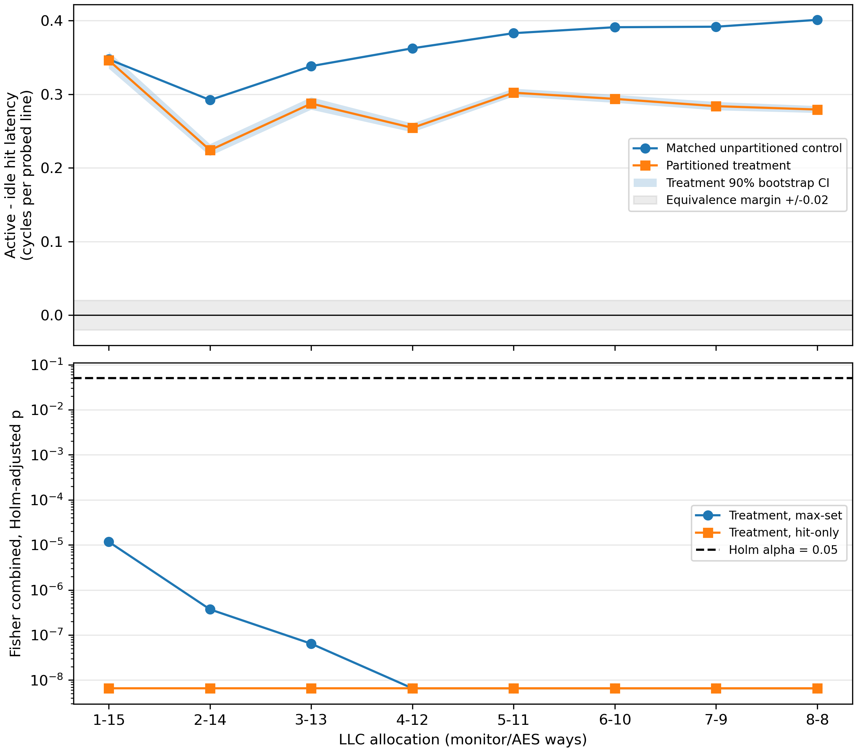
Fig. 1. Active-minus-idle hit latency per probed line for matched controls and partitioned treatments (top, with the treatment 90% bootstrap CI and the ±0.02 equivalence band) and Holm-adjusted treatment p-values for both statistics (bottom), three public seeds.

A. Interpretation Across Allocations
The control effect ranges from +0.292 to +0.401 cycles per line across allocations. Partitioning leaves 100% of it at 1/15 and 70%–85% at larger allocations. The signal is a latency shift on LLC hits of a few tenths of a cycle, not an eviction: control probes almost never miss. This is consistent with contention for the LLC's shared ports, crossbar, or queues, which way masks do not partition. Section VIII identifies the shared structure.
Way partitioning does remove an eviction component. In the original data, the number of missing control probes per interval depended on AES activity from A=5 upward, and the A=16 diagnostics show a very strong eviction signal when the monitor fills every way. With the corrected monitor, at most 0.018% of partitioned probe walks contain an LLC miss, so no eviction signal remains. Partitioning therefore closes the storage channel it was designed to close, while a smaller timing channel remains.

B. Why the Original Analysis Reported a 1/15 Threshold
Split | Treatment all-hit walks, original → final | Original decision | Final decision
1/15 | 80.1% → 99.98% | Indist. | Dist.
2/14 | 80.8% → 99.98% | Indist. | Dist.
3/13 | 80.2% → 99.98% | Indist. | Dist.
4/12 | 75.6% → 99.95% | Indist. | Dist.
5/11 | 75.6% → 99.87% | Indist. | Dist.
6/10 | 75.6% → 99.80% | Indist. | Dist.
7/9 | 75.6% → 99.62% | Indist. | Dist.
8/8 | 75.6% → 99.41% | Indist. | Dist.
The original study found every treatment indistinguishable (Holm p from 0.062 to 1.000) and reported 1/15 as a stable collapse point. The reason is monitor self-eviction: in the original monitor only 75.6–80.8% of partitioned probe walks were free of LLC misses, against 99.41–99.98% after the fix. The original 1/15 threshold was produced by the measurement artifact, not by the defense, and is withdrawn.

VIII. MECHANISM: THE SHARED CROSSBAR
Way masks partition where lines are stored, not how requests reach the LLC. Both cores' L1 caches send every LLC request through one request layer of the shared L2 crossbar, while the crossbar's response layers are private to each core, and the LLC was never blocked by MSHR exhaustion (zero blocked cycles in every run). We therefore preregistered one hypothesis: the hit-timing signal is queueing in that shared request layer. The test reran both allocation extremes, A=1 and A=8, as matched pairs for three seeds under four crossbar settings (48 fresh processes) with statistics dumped once per labelled interval. Faster settings shorten how long each packet holds the layer.
Crossbar | Util. 1/15 | Leak 1/15 | Util. 8/8 | Leak 8/8
Default (32 B, 1 GHz) | 5.5% | +0.346 | 6.9% | +0.279
Wider (128 B) | 4.4% | +0.211 | 5.6% | +0.245
2 GHz clock | 2.4% | +0.045 | 3.0% | +0.114
Near-ideal (512 B, header 0, 2 GHz) | 0.6% | +0.000 | 0.7% | +0.033
Leak is the partitioned treatment's active-minus-idle hit latency in cycles per probed line; utilization is the request layer's busy fraction. All three preregistered predictions were tested. First, the layer is busier in AES-active intervals in every default-crossbar cell (about +10.5 percentage points of utilization; Fisher p = 4.1e-10), and per-interval occupancy correlates with the monitor's hit-walk mean (r ≥ 0.96). Second, the leak falls monotonically as utilization falls, at both allocations (Spearman ρ = 1.0). Third, the near-ideal crossbar was predicted to remove the leak entirely: it does at 1/15, where the effect is +0.000 and equivalent to zero, but leaves +0.033 cycles per line at 8/8, a 88% reduction. The preregistered outcome is therefore partial.
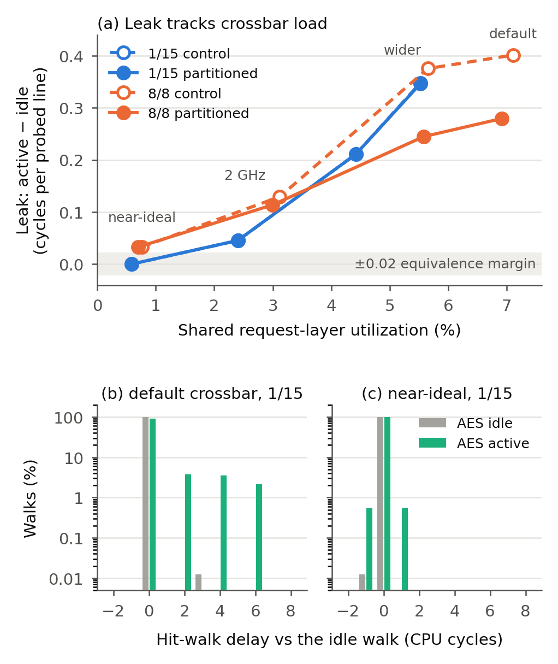
Fig. 2. (a) Leak versus shared request-layer utilization across four crossbar settings (1/15 control and partitioned curves coincide). (b, c) Distribution of 1/15 hit-walk delays relative to the idle walk for AES-idle and AES-active intervals, default and near-ideal crossbar, seed 0x5764A5E5.

A. What the Channel Looks Like
Fig. 2(b, c) shows the channel directly. With the default crossbar, 8,188 of 8,189 idle 1/15 hit walks take exactly the same time, while 9.4% of active walks are delayed by 2, 4, or 6 CPU cycles: one to three cycles of the 1 GHz crossbar, the time an AES packet holds the request layer. With the near-ideal crossbar no walk is delayed; only a symmetric one-cycle jitter remains.

B. Implication for Defenses
Partitioning does not change this channel: matched controls and partitioned treatments fall together as the crossbar speeds up, and at the near-ideal setting the 8/8 residual is identical in both arms (+0.033). That residual still arrives in two-cycle steps, one cycle of the LLC's own 1 GHz clock, and is attributed by elimination to the LLC's single request path. A defense that keeps way partitioning must therefore also partition or time-multiplex the interconnect into the LLC. Section IX does so.

IX. CLOSING THE CHANNEL
Sections VII and VIII show that way partitioning leaves a hit-timing channel through the shared path into and out of the LLC. We tested whether isolating that path closes it, adding two mechanisms to the A/(16-A) way partition while keeping the monitor, workloads, seeds, labels, and decision rule unchanged. Each step was preregistered and built in a separate gem5 tree whose disabled path reproduces the stored results byte for byte.

A. Request Time Slots
The first mechanism time-multiplexes the shared crossbar request layer, following static-turn arbitration for shared memory controllers [6]. Each core owns alternating 4 ns slots of an 8 ns frame; a core may launch one LLC request at the start of its own slot, an unused slot stays idle, and every transfer must finish before the next slot. Writebacks and page-table walks belong to the issuing core. At the allocation extremes this cut the hit-only leak from 0.346 to 0.040 cycles per line at 1/15 and from 0.279 to 0.004 at 8/8 (three-seed means). The hit-only test still detected activity at both allocations (Holm-adjusted p = 8.2e-10 and 2.8e-09), and the 1/15 interval [0.032, 0.048] fails the ±0.02 margin. AES completed 6.0% fewer encryptions than under way partitioning alone.

B. Locating the Residual
To find where the remaining difference enters, debug-only trace points follow each monitor request through crossbar admission, the LLC's scheduled response time, the LLC's CPU-side response queue, the crossbar's response forwarding, and delivery to the CPU, recording both the current tick and the tick at which each response was scheduled to be ready. Tracing left probe bytes and every simulated statistic unchanged. For LLC hits at seed 0x5764A5E5, LLC service time was identical in active and idle intervals at 1/15 and 8/8. The only difference was that a few responses left the shared response queue one tick (1 ps) after their scheduled time: 40 active versus 2 idle hits at 1/15 and 268 versus 1 at 8/8. gem5's packet queue sends a second packet that becomes ready on the same tick one tick later, so a victim response ready at the same moment delays the monitor's. The crossbar then aligns that response to its next 1 GHz clock edge, turning one tick into a full nanosecond, and in 14 and 15 of these cases the monitor's next request missed its time slot and waited a further 8 ns frame. Every delayed response showed all three signatures, and no other response did. The same-tick rule is a modelling convention of gem5's packet queue; whether hardware arbitration behaves the same way was not evaluated.

C. Per-Domain LLC Response Queues
The second mechanism gives the LLC one CPU-side response queue per security domain, so responses for different cores never serialize against each other inside the cache, as in MI6's per-domain response queues [5]. Each response is routed by its requester's core. An unmapped requester or a response retry stops the simulation rather than silently sharing a queue; neither occurred. The crossbar already keeps a separate response layer for each core and is unchanged.

D. Evaluation Under the Proposal's Criterion
We repeated the 48-case matched design with the full defense (way partitioning, request slots, and per-domain response queues) as the treatment and the stored unpartitioned controls, and judged it with the unmodified decision code of Section V; applied to copies of the original runs, that code reproduces the stored decision exactly. Every allocation is now indistinguishable (Fig. 3 and the following table, which gives leak in cycles per probed line): both co-primary statistics have Holm-adjusted p = 1 at every allocation, every self-eviction gate passes, the stable collapse point is 1/15, and every 90% interval lies within ±0.003 cycles per line.
Split | Partition only | Full defense | Defense Holm p (max-set / hit-only)
1/15 | +0.346 | -0.0016 | 1.000 / 1.000
2/14 | +0.224 | -0.0008 | 1.000 / 1.000
3/13 | +0.287 | -0.0005 | 1.000 / 1.000
4/12 | +0.254 | -0.0004 | 1.000 / 1.000
5/11 | +0.302 | -0.0003 | 1.000 / 1.000
6/10 | +0.294 | -0.0003 | 1.000 / 1.000
7/9 | +0.284 | -0.0002 | 1.000 / 1.000
8/8 | +0.279 | -0.0002 | 1.000 / 1.000
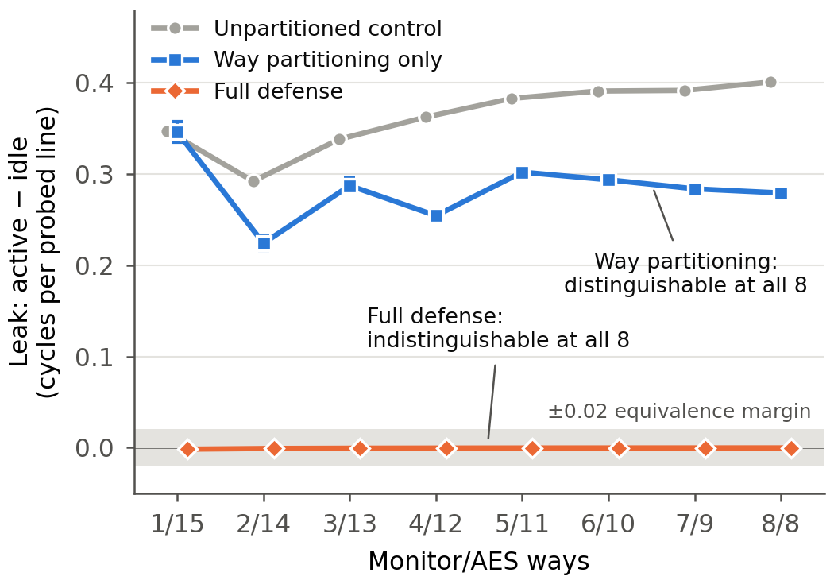
Fig. 3. Hit-only leak per allocation (mean over three seeds; bars: 90% bootstrap interval) for the unpartitioned control, way partitioning alone, and the full defense (way partitioning, request time slots, and per-domain LLC response queues). Shaded: ±0.02 equivalence margin.
A stronger, deterministic test agrees. Replacing AES with an idle victim leaves the monitor's entire probe log byte-identical in all 24 seed-allocation configurations; at seed 0x5764A5E5 the AES victim makes 694,708 LLC data accesses and the idle victim one. With request slots alone, the same comparison differs in 1,705 of 16,384 records at 1/15. For these inputs the monitor's observations carry no information about victim activity in this model.

E. Cost
The defense costs AES 6.3–6.4% in cycles per encryption relative to the matched controls and the monitor at most 0.18% in IPC; AES completes 5.95% fewer encryptions than under way partitioning alone. The cost comes from the request slots: at both allocation extremes, adding the per-domain response queues changed AES throughput by 0.00% relative to request slots alone.

X. PERFORMANCE TRADEOFF
Metric at 1/15 | Matched change
Monitor IPC | -0.0085%
AES IPC | 0.0000%
Monitor LLC miss rate | +0.262 percentage points
AES LLC miss rate | 0.0000 percentage points
AES cycles/encryption | 0.0000%
Across all eight allocations, monitor IPC changes by at most 0.029% and AES cycles per encryption by at most 0.008%; the monitor's LLC miss rate rises by 0.26 percentage points, a one-time refill at the start of measurement (every probe walk with a miss falls in the first interval), not ongoing self-eviction. Both workloads fit easily in their allocations, so partitioning costs them essentially nothing. Cycles per encryption is the clearer useful-work metric because both programs contain rdcycle busy-wait loops that contribute instructions to IPC.

A. Costs in the Original Analysis
The original study reported a monitor IPC cost rising from 0.79% at 1/15 to 5.42% at 8/8 and a monitor miss-rate increase near 19 percentage points. Those costs came from the monitor evicting its own probe lines, not from partitioning, and disappear with the corrected monitor. A larger AES working set or a capacity-hungry co-runner could still show a real tradeoff.

XI. THREATS TO VALIDITY
The study uses gem5 timing rather than silicon measurements. The symmetric 4 KiB L1D caches deliberately expose T-table traffic and limit generalization. Three consecutive deterministic seeds are repeated inputs, not a population of executions: they share one activity schedule and one permutation sequence, so Fisher's independence assumption is optimistic. The conclusion does not rest on it, because each of the 24 partitioned runs is individually significant (Bonferroni over 24 runs, p ≤ 0.0024). The hit-only statistic was chosen after a post-hoc analysis of the original data and the gate was revised after the first corrected sweep; both were fixed before the final data existed, and the max-set statistic alone reaches the same conclusion at all eight allocations. The gate's one-point tolerance is loose; the stronger evidence against self-eviction is that no probe walk after the first interval contains an LLC miss.
Way masks isolate LLC data capacity but not MSHRs, queues, ports, interconnects, coherence metadata, memory controllers, or DRAM. Section VIII measures the main channel directly, and Section IX traces the remaining residual to the LLC's shared response queue. The full defense also isolates request admission and LLC responses; MSHRs, the write buffer, DRAM, and response retries remain shared or unsupported, and the idle-victim comparison covers one key and one activity schedule. The result applies only to this monitor, workload, cache hierarchy, run length, and decision rule.

A. Reproducibility and Traceability
Every quantitative claim traces from this report to results/updated run/sweep-v3/summary_v3.csv, from that table to the per-run analysis files, and from each analysis file to the raw probes.bin, simout.txt, and stats.txt. The preregistration fixes the decision rule and file hashes; the mechanism study has its own preregistration and traces to results/updated run/mech-summary/summary_mechanism.csv. The Section IX experiments are on the experiment/tdma-prototype branch under experiments/tdma, experiments/causal-trace-20261016, and experiments/respq-defense-20261018; the defense decision table is results/updated run/tdma-rsv/summary_v3.csv. The original study's results and code paths are preserved unchanged and verified by checksum, and an original case rerun with the current code reproduced it byte for byte.

B. Future Work
Section IX closed the measured channel for this design. The next steps are to compare AES runs with different keys and independent activity schedules against each other, to isolate response retries rather than reject them, and to reduce the cost of the request slots. More seeds, larger L1D sizes, and capacity-hungry co-runners would test generality and expose a real performance tradeoff. These extensions should retain the current safeguards: simulator-only execution, public inputs, activity detection rather than key inference, matched positive controls, direct isolation evidence, and a self-eviction gate.

XII. CONCLUSION
This project evaluated LLC way partitioning against labelled AES cache activity in gem5 with matched controls, direct isolation evidence, and a preregistered statistical rule. After correcting a monitor self-eviction artifact that had produced a false 1/15 threshold in our original analysis, all eight allocations from 1/15 to 8/8 remain distinguishable, the partitioned monitor retains 70%–100% of the control signal, and no allocation is equivalent to zero. Way partitioning removes eviction-based contention at negligible cost, but it does not close the hit-timing channel. A preregistered crossbar ablation locates that channel in the shared L1-to-LLC crossbar's request layer, which carries 100% of the signal at 1/15 and 88% at 8/8. Adding fixed request time slots and per-domain LLC response queues closes it: every allocation becomes indistinguishable under the same rule, and the monitor's probe log matches an idle victim's byte for byte, at about 6% AES cost. Any evaluation of such defenses must also verify that the measuring monitor does not interfere with itself.

REFERENCES
[1] gem5 Project, “gem5 v25.1.0.1 source,” 2026. [Online]. Available: https://github.com/gem5/gem5/tree/v25.1.0.1
[2] J. Lowe-Power et al., “The gem5 simulator: Version 20.0+,” arXiv:2007.03152, 2020.
[3] D. A. Osvik, A. Shamir, and E. Tromer, “Cache attacks and countermeasures: The case of AES,” in Proc. CT-RSA, 2006.
[4] F. Liu et al., “CATalyst: Defeating last-level cache side channel attacks in cloud computing,” in Proc. IEEE HPCA, 2016.
[5] T. Bourgeat, I. Lebedev, A. Wright, S. Zhang, Arvind, and S. Devadas, “MI6: Secure enclaves in a speculative out-of-order processor,” in Proc. IEEE/ACM MICRO, 2019.
[6] Y. Wang, A. Ferraiuolo, and G. E. Suh, “Timing channel protection for a shared memory controller,” in Proc. IEEE HPCA, 2014.

