**Military Institute of Science and Technology  
Mirpur Cantonment, Dhaka**



**CSE Department,Course Code-302:**

**Final Project Report, Group-11:**

**Group members: 1. Nasif Shahriar Mohim(201914007)**

**2. Abedur Rahman Khan(201914011)**

**Project Name: Hospital Management System.**

**Introduction:**

Hospital management people have indicated that technology can substantially hospital activities and services. But it was found that the IS in the hospitals did not develop according to the needs and developments in the hospital organizations over the past decades.

This work is focused on the development of a computer aided Hospital Management System and specifically on hospital information systems (IS). An interesting question is how organisational, managerial and IT developments take place in hospitals, and how these developments influence each other, in terms of impact, alignment, and reinforcement. A more recent response of hospitals is to move into ‘network management’. A networked hospital tries to improve it’s ‘input-output’ or ‘market’ relations with primary care physicians.

Hospital management system is a web based software and can be used from anywhere of the world.From appointment to inventory management,billing,laboratory management everything is controlled by hospital management software.With this system,a health care organization can automate its several functions like Online appointment management system,doctor consultation management,billing and discharged summary and so on.

**Present System:**

* Present Scenario of the web-based Hospital management system is still not developed enough.  The current status of Hospital management system in Bangladesh, however, has not been assessed in every fields. The present status in the public and private sectors are facing challenges in managing hospital in Bangladesh. It remains somewhat problematic, the difficulties could be overcome.
* Based on the current scenario and challenges of hospital management, the scope of some fields requires further improvement. Patient doesn’t want to wait for much time to get appoint from doctors.Digital hospital management system can solve the problem.
* The administrator can’t handle all things in the manual way.

He needs to monitor all panel of hospital but present scenario is really hard for him to do that. Also billing system and nursing,cleaning sytem are time consuming which should be improved.

**Proposed system:**

Proposed system is a web based software and can overcome all the problems.It has user friendly interface and very easy to manage.

* **Conceptual design:**

**ER diagram:**

* 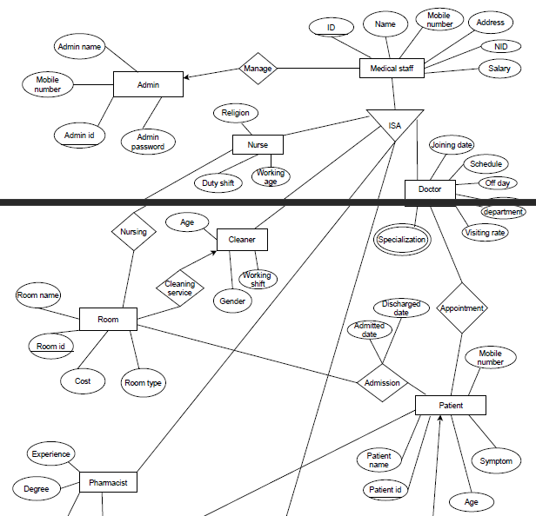

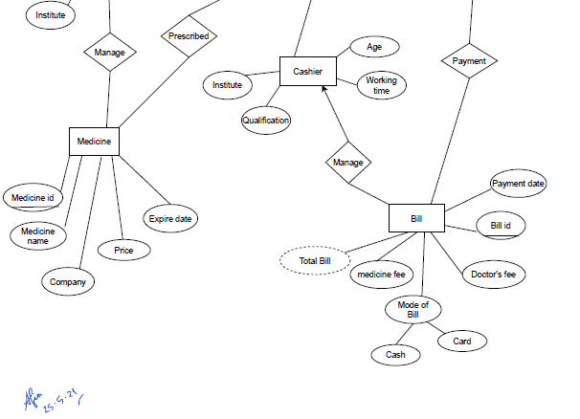

**Schema Diagram:**

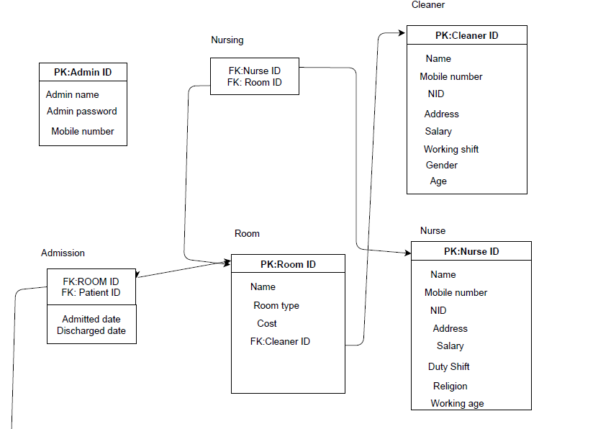

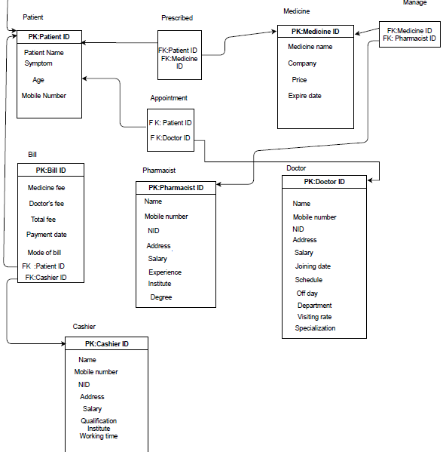

* **Development of the system:**

Features of the system includes an admin panel which monitores the full management process. Creating the accounts of other panels like cleaners, doctors, patients, pharmacist , appointing rooms ,bill create and approving request are the works of admin panel.

Fig: Admin Panel

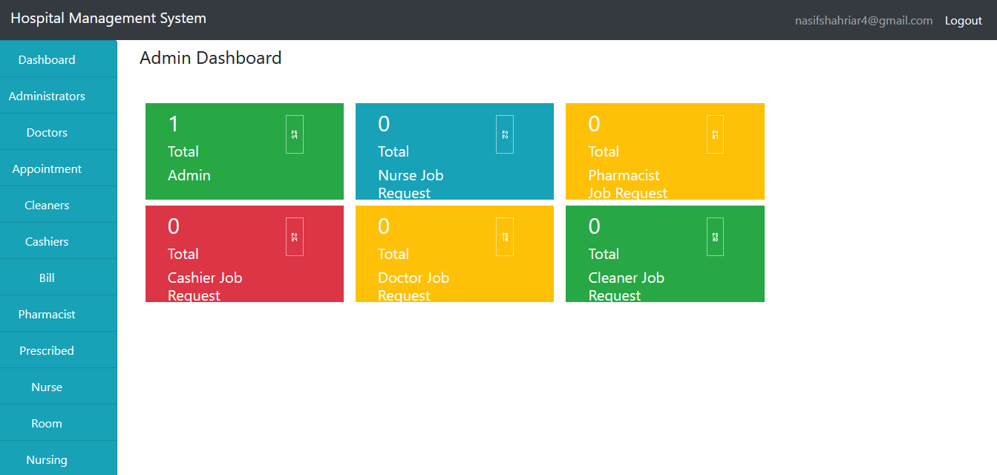

**Fig: Admin Dashboard.**

**Admin can approve or reject all doctors, patients, cashiers, cleaners, pharmacist and can see their list,nursing system,bill.**

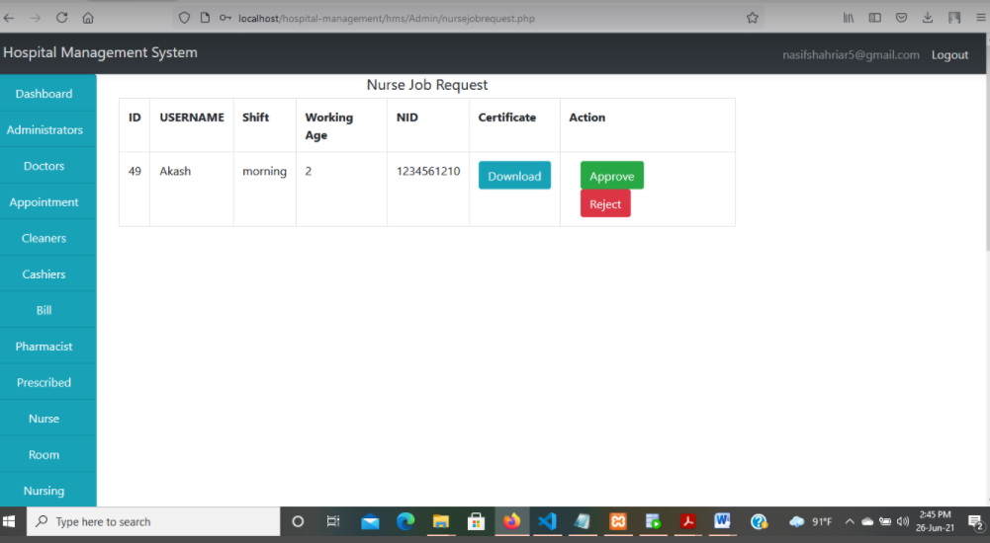

**Fig:Medical_Staff job request.**

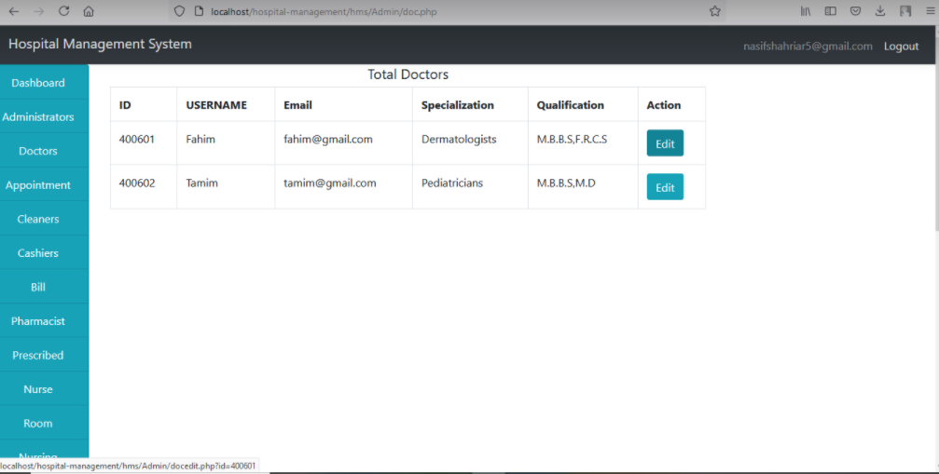

**Fig:Total doctors.**

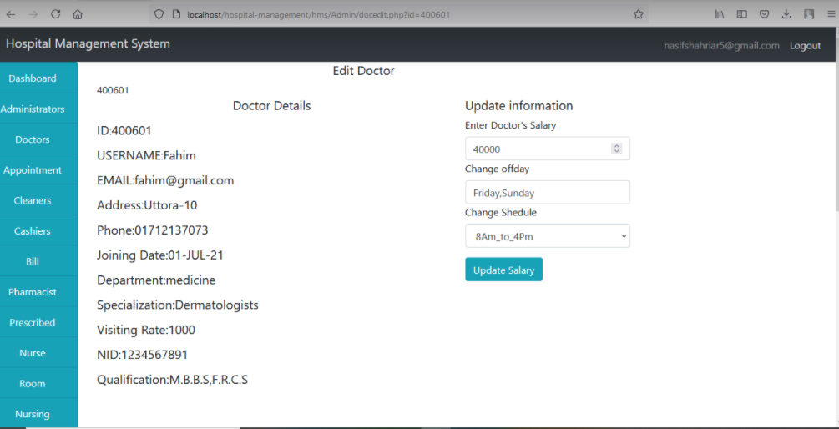**Fig: Edit doctors from admin panel**

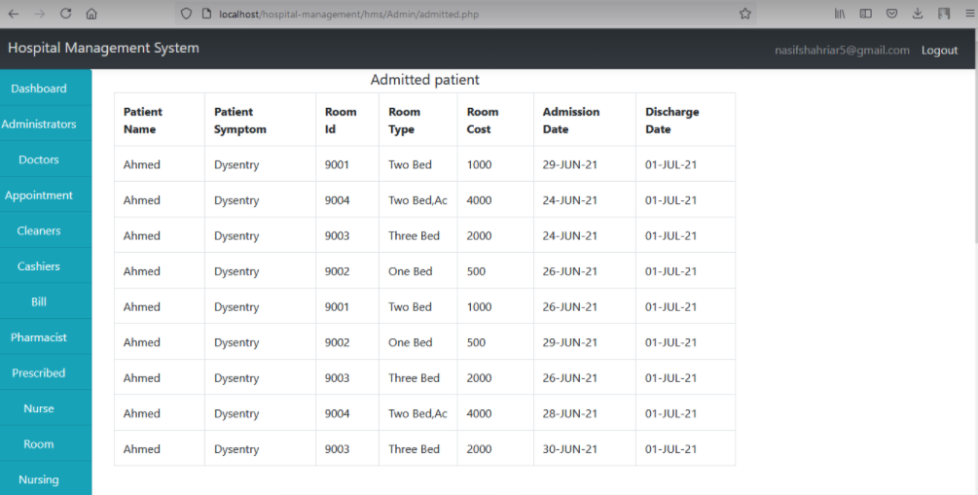

**Fig: Admitted patient.**

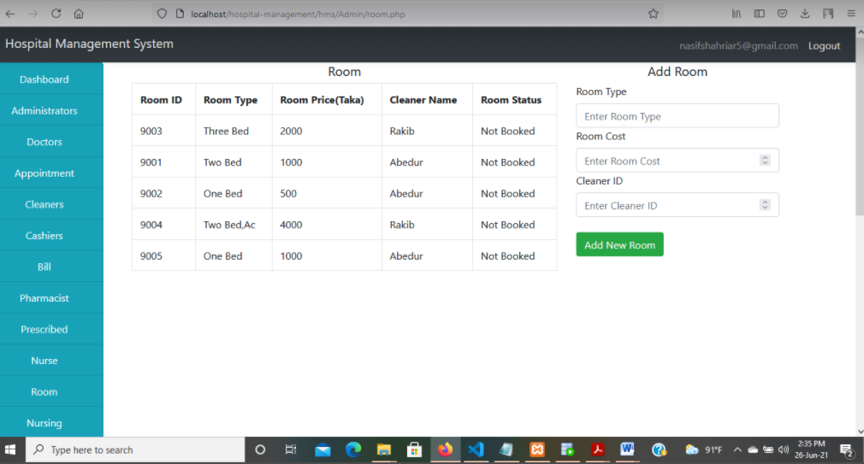

**Fig: Room from admin panel.**

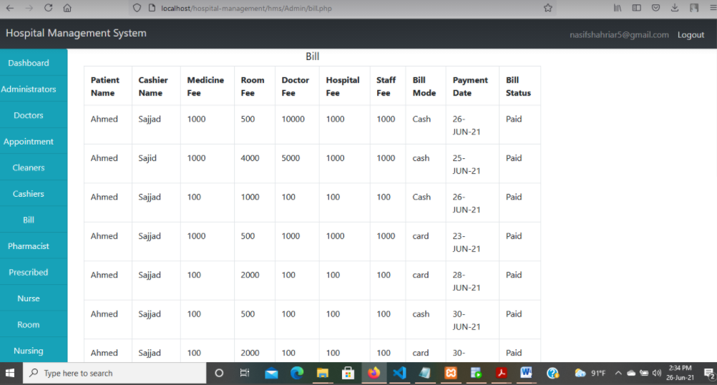

**Fig:Bill from admin panel.**

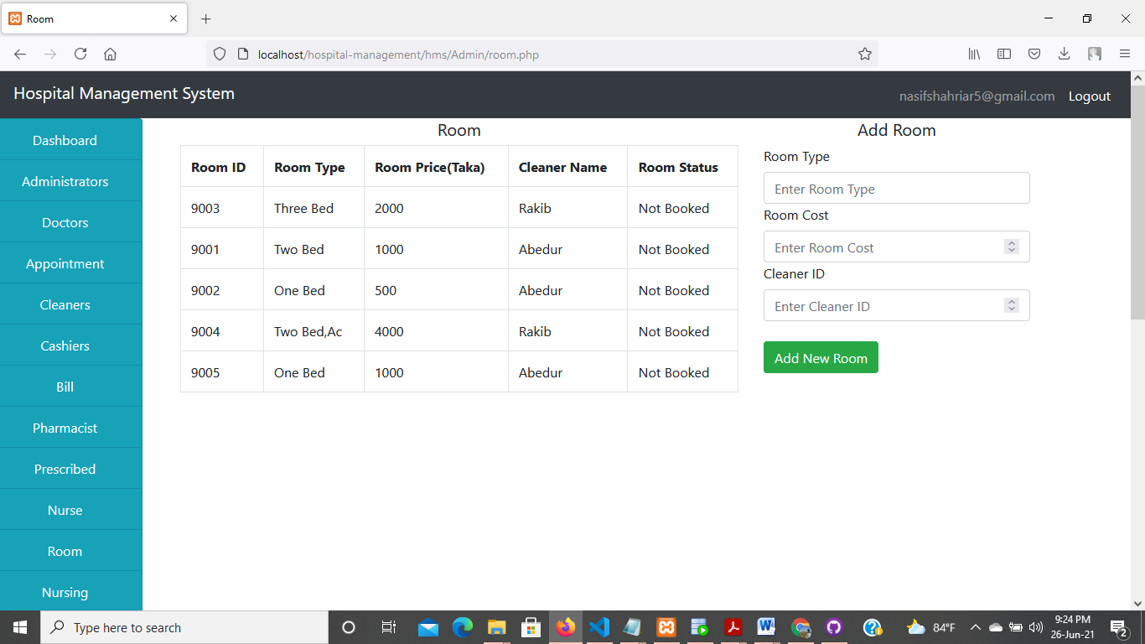

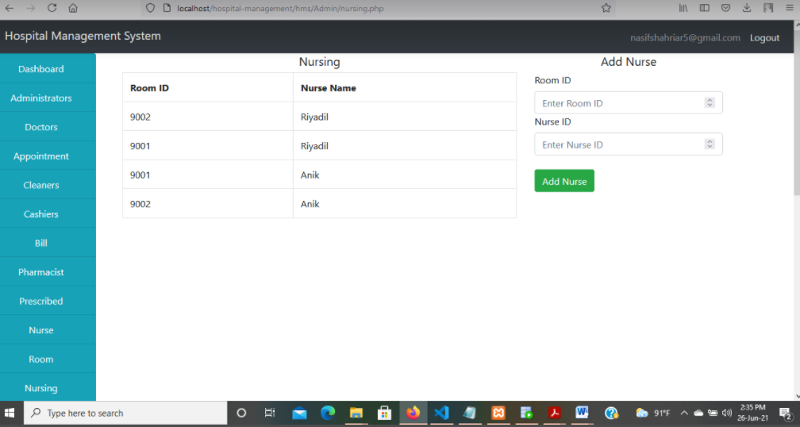

**Fig:Add Nurse in the Room.**

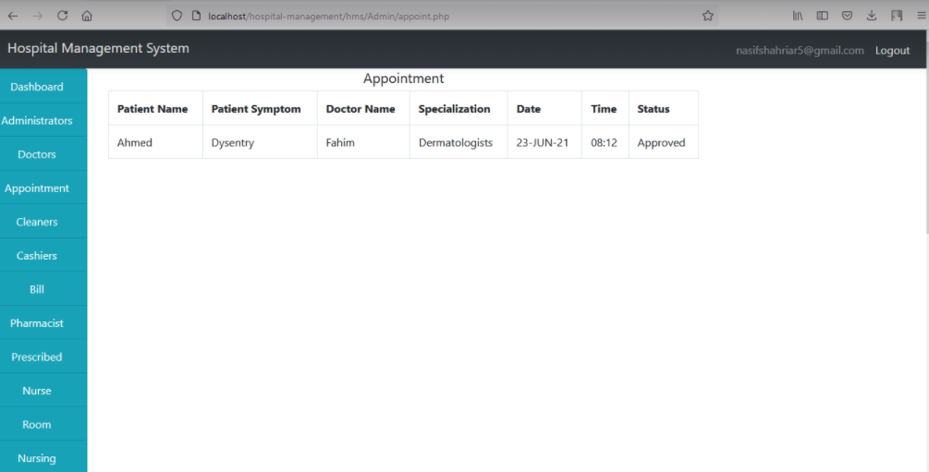

**Fig: Appointment table Viewed from Admin Panel.**

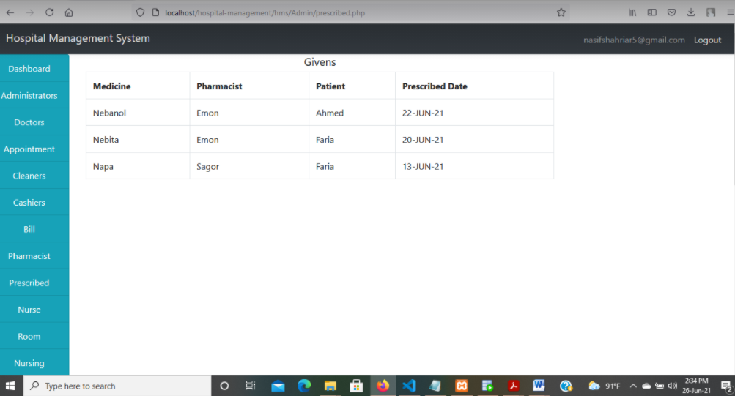

**Fig:Prescribed medicine.**

**Cleaners can see in which room he/she is assigned-**

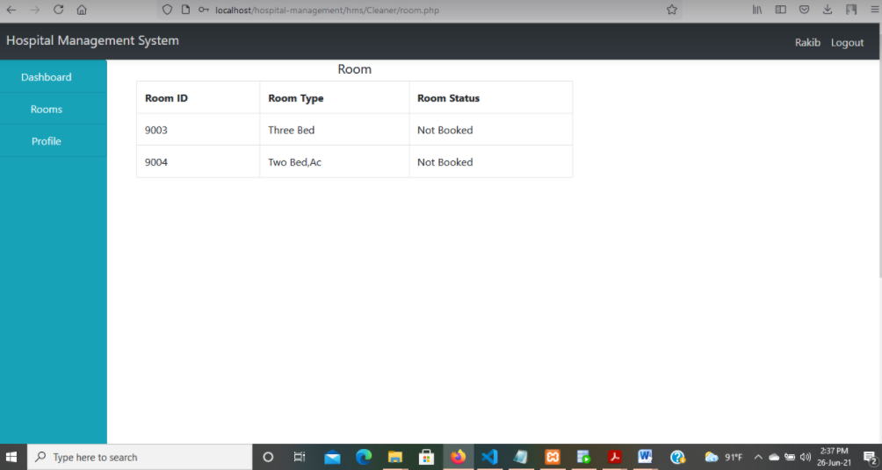

**Fig:Room from cleaner panel.**

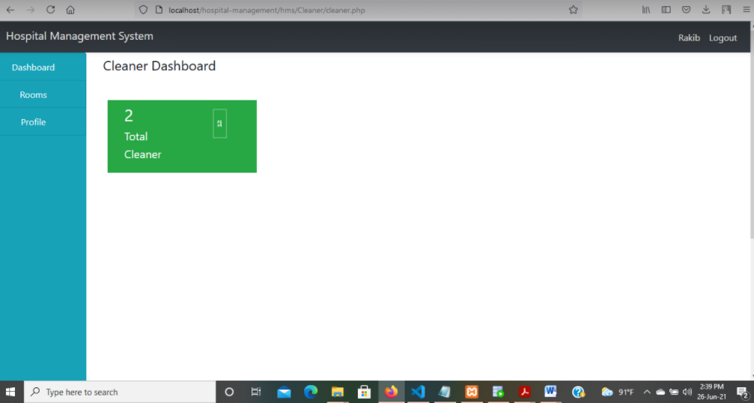

**Fig: Cleaner dashboard .**

**Fig: Patient panel**

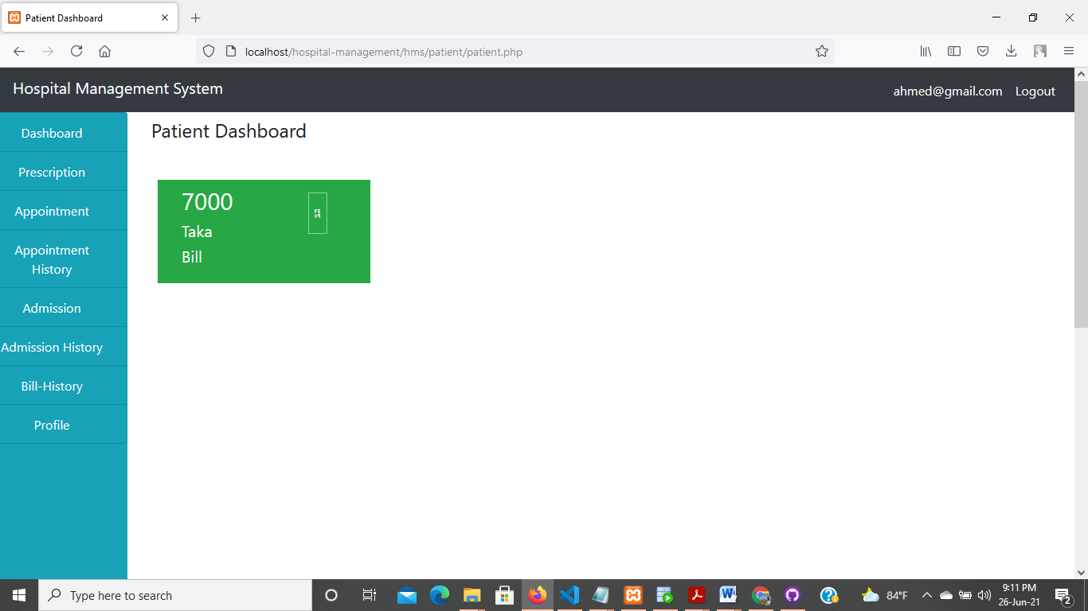

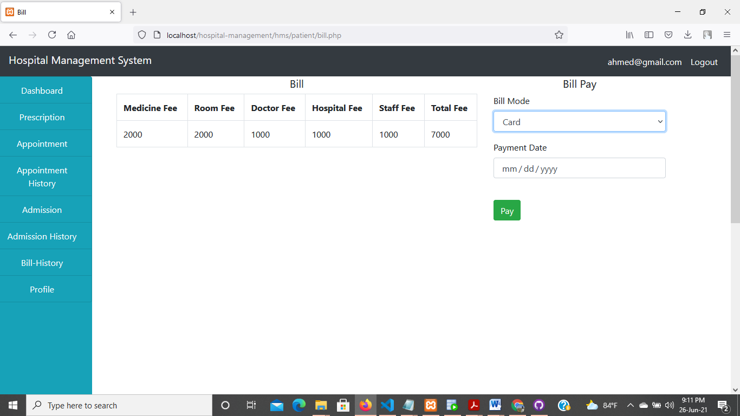

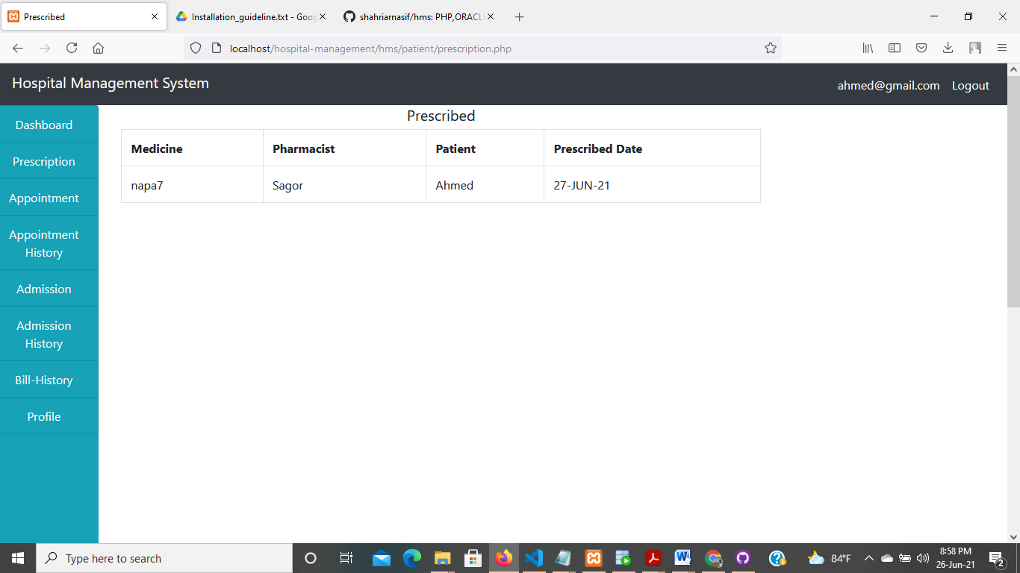

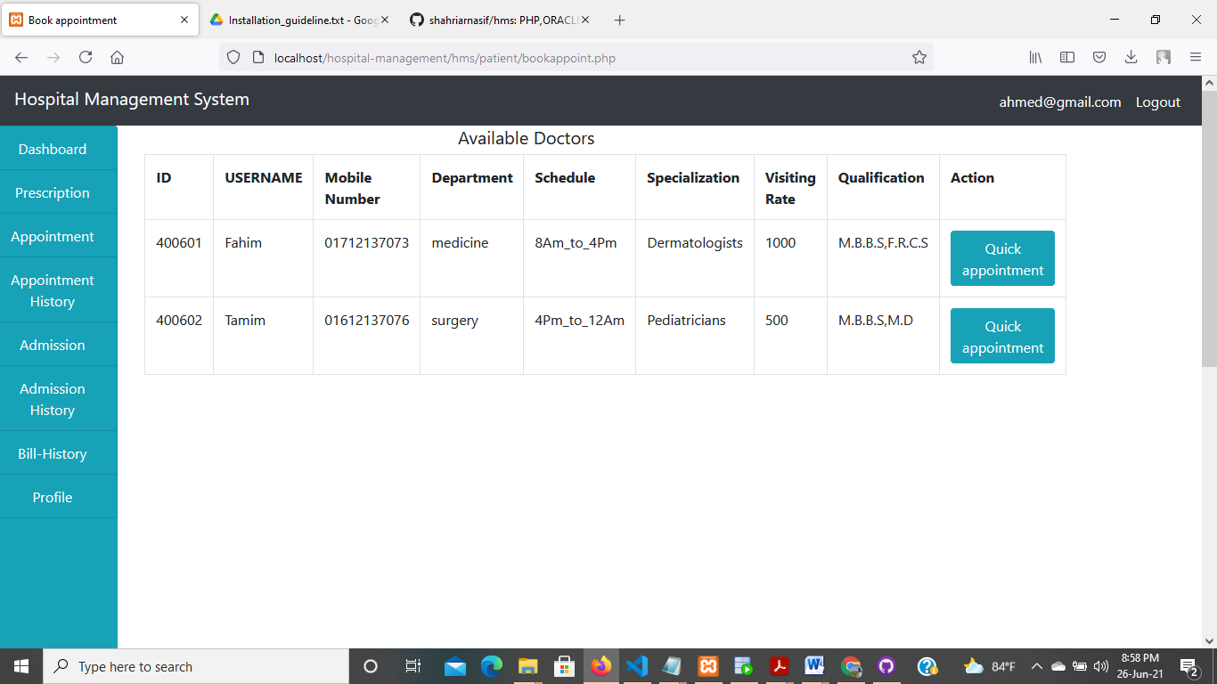

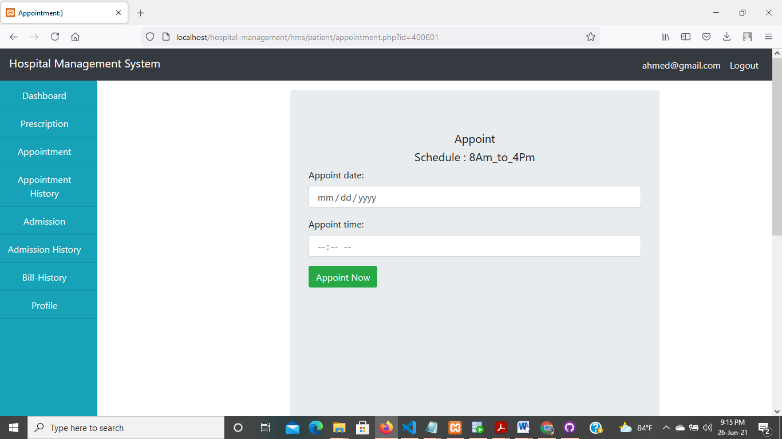

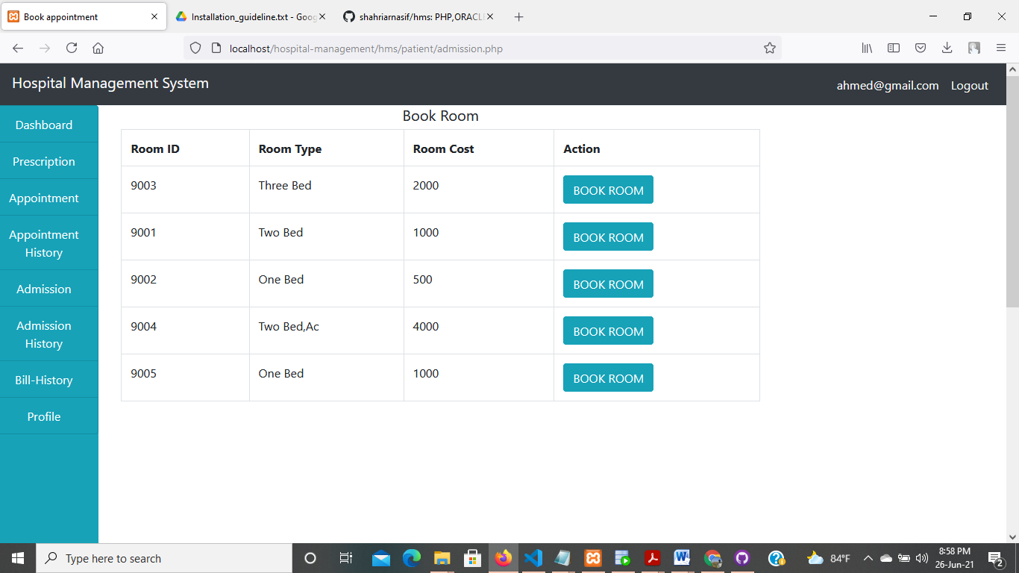

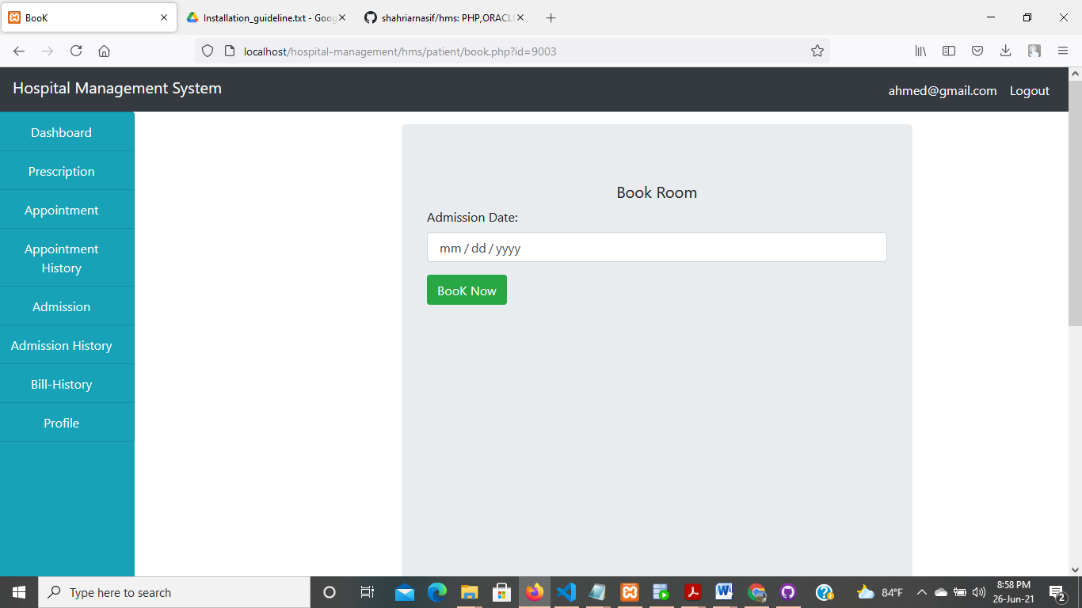

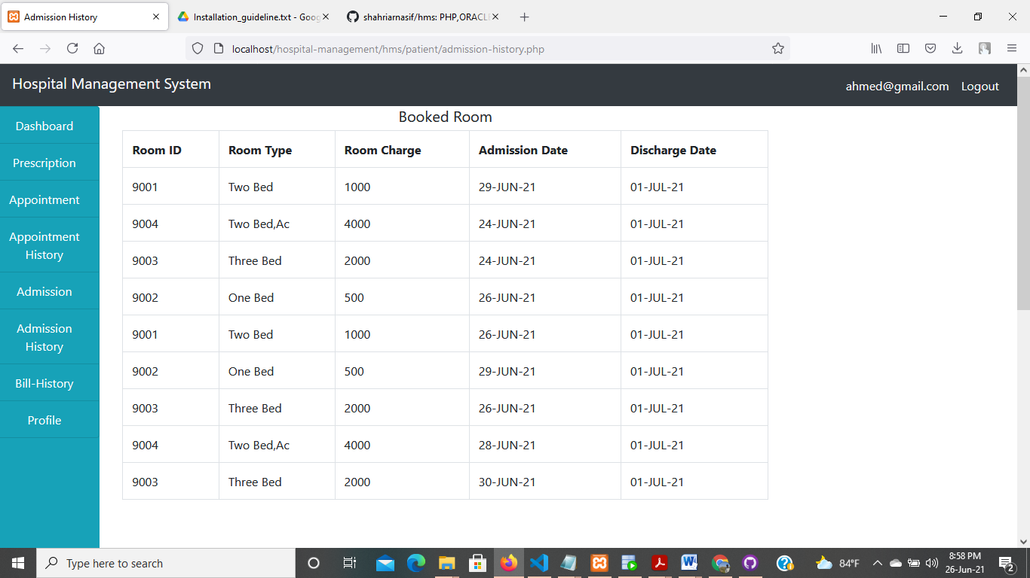

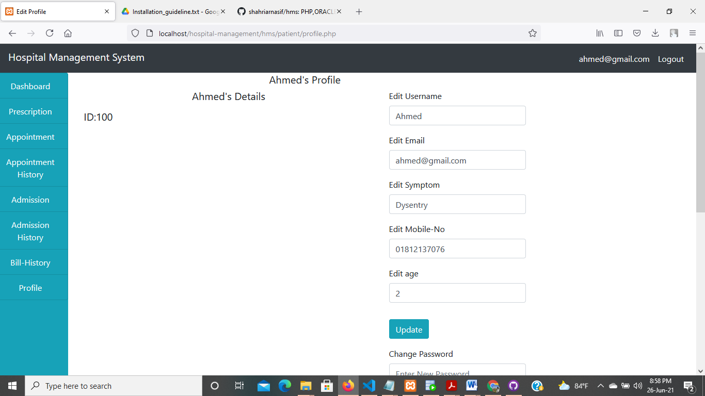

**Fig: Pharmacist Panel**

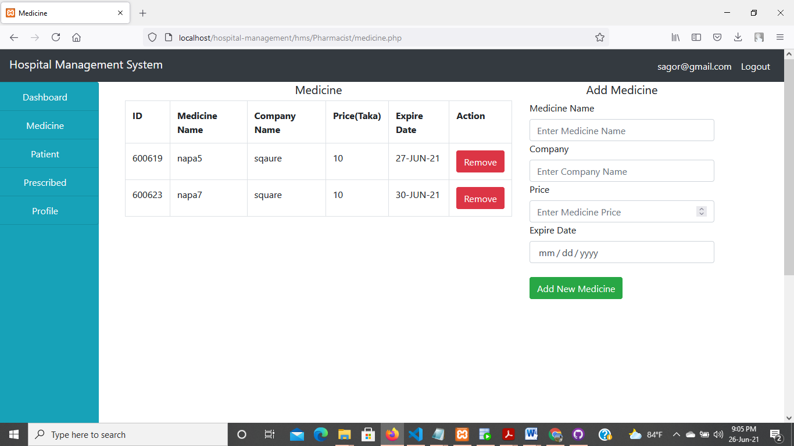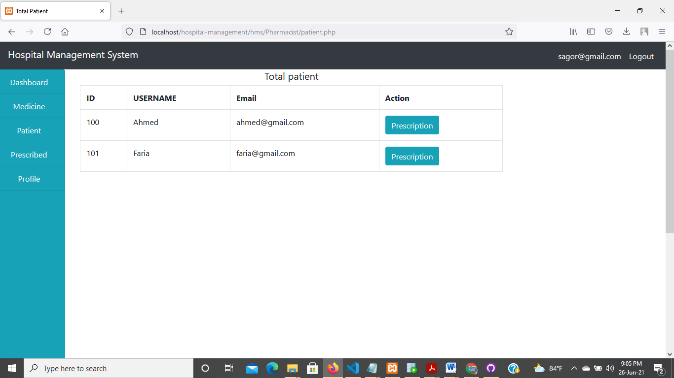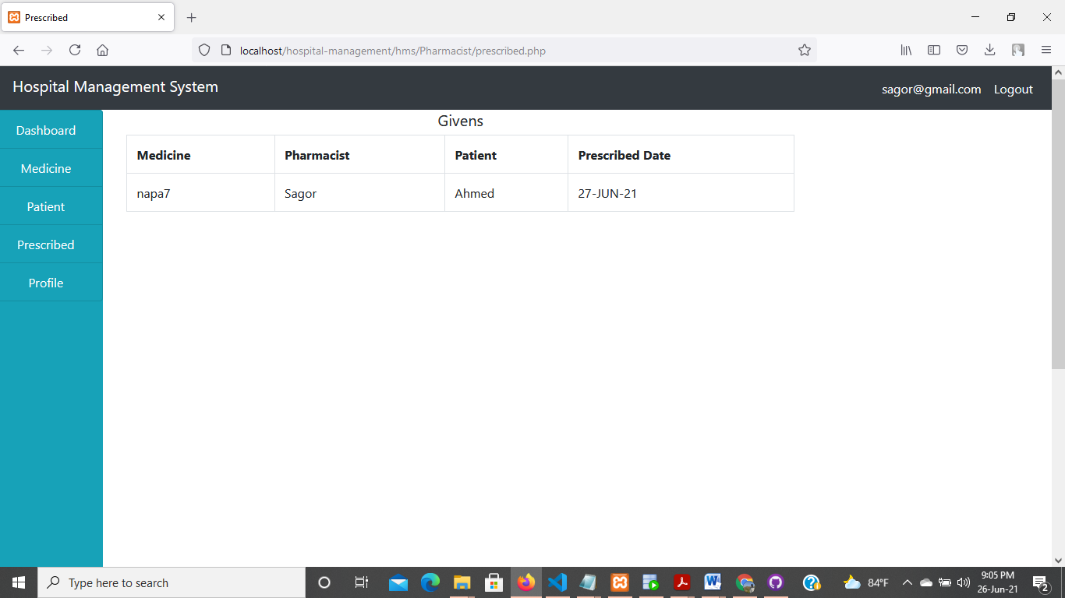

**Fig: Cashier panel**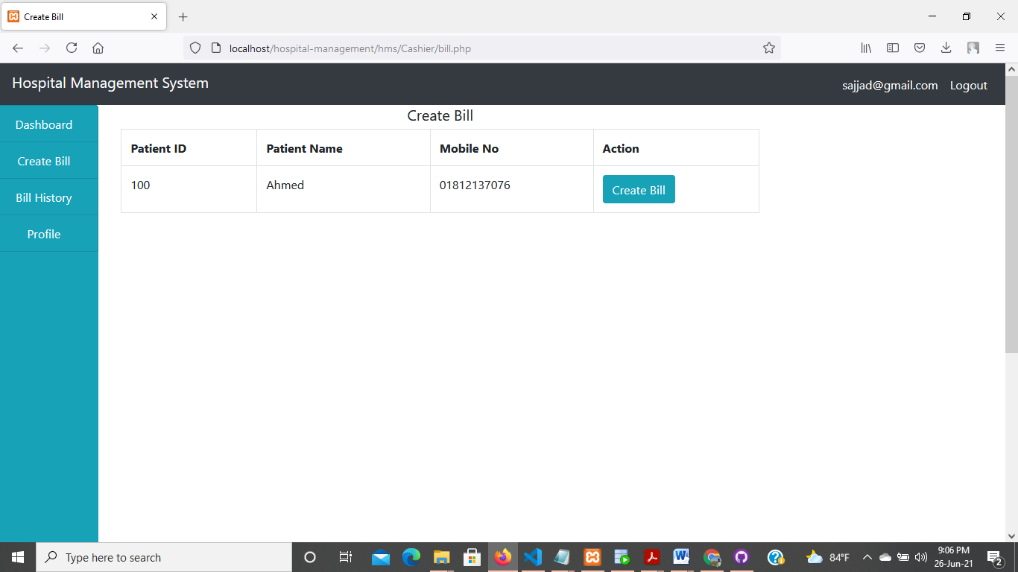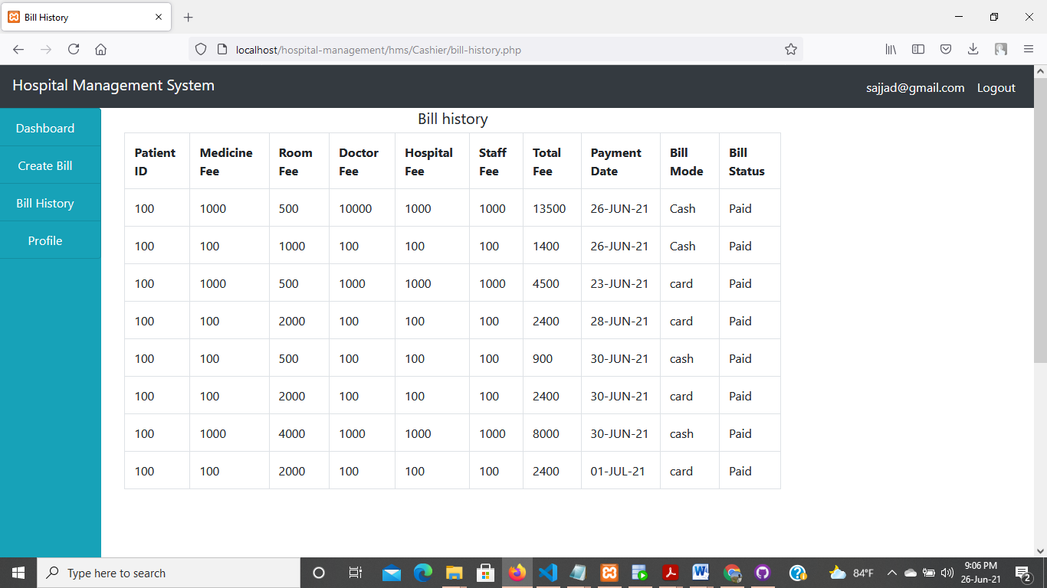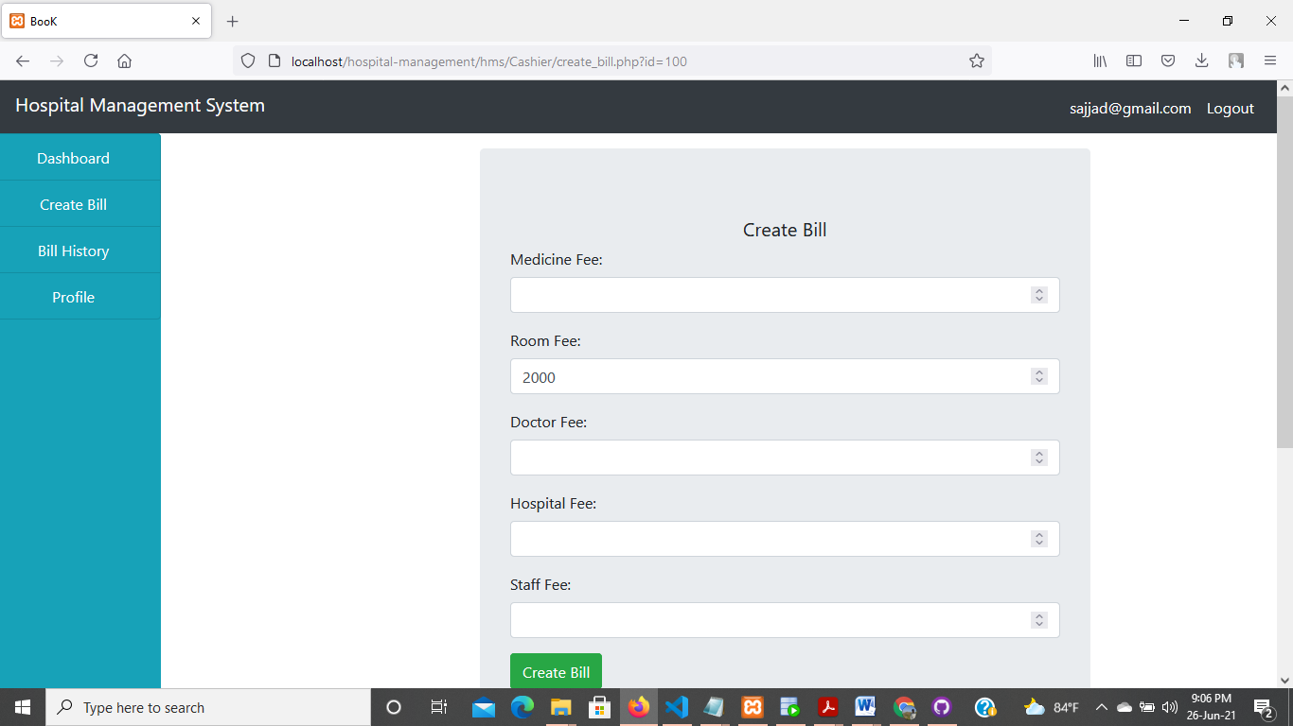

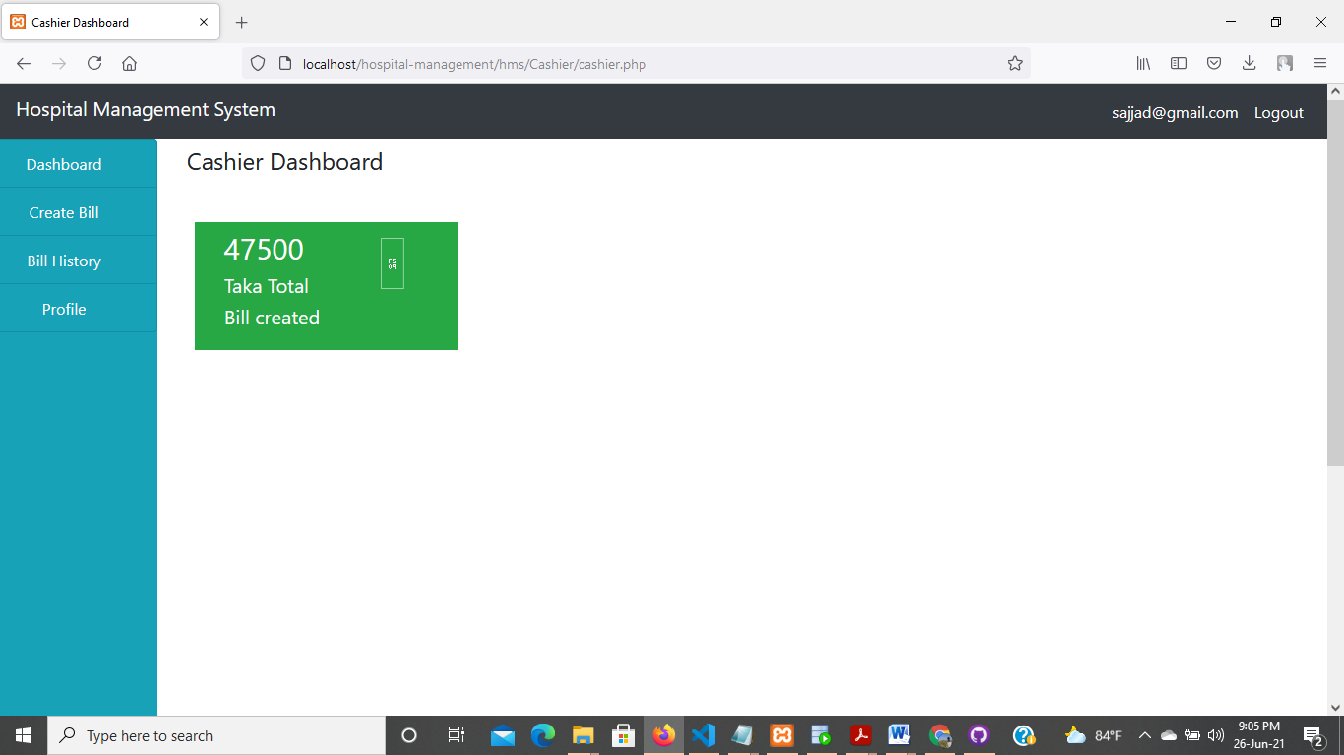

**Fig: Nurse Panel**

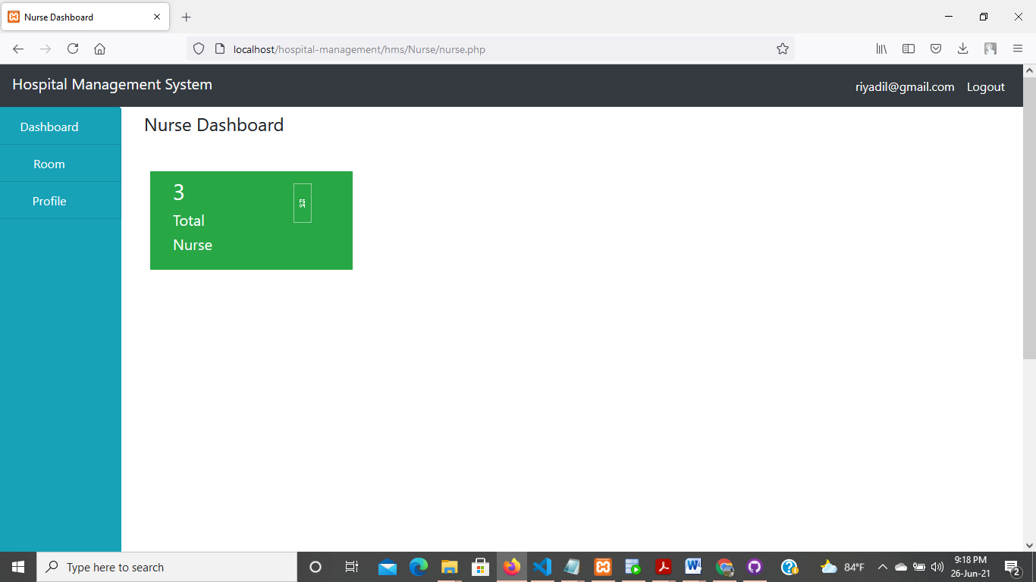

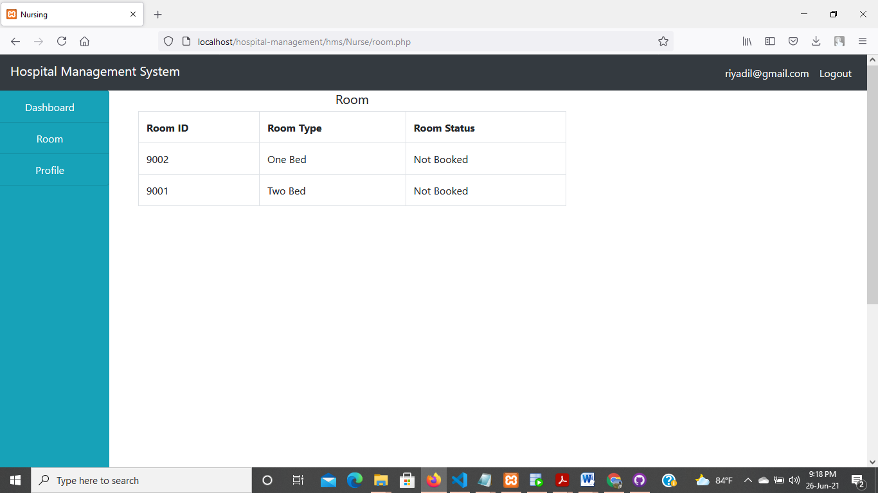

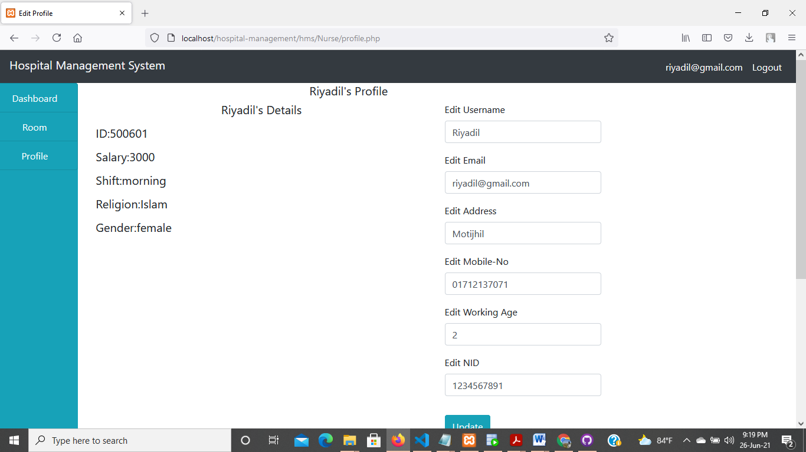

**System Requirements:**

**Tools Used: 1) VS Code (For Frontend)**

**2) Xampp Control Panel (For connecting frontend and backend)**

**3) Oracle SQL Developer (For Backend)**

**OS Version: Windows 10**

**Discussion:**

The system gives a quick access for all the doctors,patient,cleaners nurse and other panels to create their profile easily .Patient can make appointment easily without waiting in lines .Patients can book appointment with any doctor seeing the available doctors and time.

Cleaners and nurse can see the rooms where they need to work.they can update their profile and pharmacist can easily gives medicine to the patients. Creating bill and room book for patients are very quick process in this system and many problems will be solved.

**Limitation and Future expansion:**

This is a good management system to solve present problems in managing hospitals .But in this process, when multiple persons are applying together, then some persons may need to wait. Besides

All the countries don’t have good internet services whick will make them facing many problems uging these web based software. So

These problems should be solved working on this project widely in future. The interface can be created more attractive to seek attention of the users also.

**Conclusion:**

The Hospital management system includes services that integrate and simplify the work of healthcare professionals and their interaction with patients. Without a proper healthcare facility management system, a hospital system would not effectively keep good staff, care for patients, or make a good profit.

A hospital service manager is accountable for guaranteeing a social insurance office is running as it ought to regarding the financial plan, the objectives of the office's specialists, and the network's necessities. A member of the hospital management system can get healthcare facilities and oversees the operation day-by-day.

Patient can get appointments without going physically and can easily choose their favourite doctors.Cashier can easily creat bill for patients and doctors can easily maintains huge numbers of patients.The admin can oversees all the doctors,patients, cashiers,cleaners,nurse,pharmacist easily.