Database Management Project

**Final Report**

**Group**

| **Name:** | **ID:** |
| --- | --- |
|  |  |
|  |  |
|  |  |
|  |  |
|  |  |
|  |  |

Table of Contents

Ch 1: Introduction 3

a: Background of the Organization 3

b: Background of the Project 5

c: Objectives of the Project 6

d: Scope of the Project 7

Ch 2: Requirement Analysis 8

a: Rich Picture-Existing System 9

b: Six Elements Analysis- Existing System 10

c: Problem Analysis- Existing System **Error! Bookmark not defined.**

d: Rich Picture- Proposed System 13

e: Six Elements Analysis- Proposed System 14

Ch 3: Logical System Design 18

a: Business Rule 18

b: Entity Relationship Diagram 19

c: Entity Relationship Diagram to Relational Schema 20

d: Normalization 21

e: Data Dictionary 25

Ch 4: Physical System Design 34

a: Input Form 34

b: Output Form 36

Ch 5: Conclusion 52

a: Problem & Solution 52

Analysis phase 52

Design phase 52

Implementation phase 52

b: Additional Feature And Future Development: 53

References **Error! Bookmark not defined.**

Figures:

Figure 1: Rich Picture of Existing System 9

Figure 8: Rich Picture of proposed system 13

Figure 19: Entity Relationship Diagram 19

Figure 20: Entity Relationship Diagram to Schema 20

Figure 21: Normalization 20

# Ch 1: Introduction

The overall topics that we have covered in the following document is based on all Private Universities, however we assumed all the schools are similar for all universities and follow the same Business Policy as Independent University, Bangladesh (IUB):

* Business & Entrepreneurship
* Engineering, Technology & Sciences
* Environment and Life Sciences
* Liberal Arts & Social Sciences
* Pharmacy and Public Health.

## In today's fast-paced financial world, efficiency and accuracy are paramount. The management of customer forms is a critical aspect of any financial institution's operations. To address this challenge, we are proud to introduce a groundbreaking system developed using a powerful combination of HTML, CSS, and PHP, designed specifically to automate and streamline the customer form management process for LankaBangla Finance.

## LankaBangla Finance, a trusted name in the financial sector, is dedicated to providing superior services to its valued customers. With the ever-growing customer base and evolving regulatory requirements, managing customer forms can become a time-consuming and error-prone task. This is where our innovative solution comes into play.

## Our system leverages the latest web technologies to create a seamless and user-friendly experience for both customers and staff members. By automating the customer form management process, we aim to enhance operational efficiency, reduce errors, and improve overall customer satisfaction.

## a: Background of the Organization

LankaBangla Finance Limited is a prominent and reputable financial institution operating in Bangladesh. Established with a vision to provide comprehensive financial services to individuals and businesses, LankaBangla Finance has steadily grown to become one of the leading non-banking financial institutions in the country. Its history is characterized by innovation, commitment to excellence, and a strong focus on customer satisfaction.

LankaBangla Finance was founded in the early 2000s, marking the beginning of a journey towards financial excellence. The institution was established with the mission of bridging the financial gaps in Bangladesh, providing accessible and diversified financial products and services tailored to the needs of a rapidly evolving economy. Over the years, LankaBangla Finance has expanded its offerings to include a wide array of financial services, catering to both individual and corporate clients.

Retail Banking: Providing individuals with various financial solutions, including personal loans, home loans, credit cards, and savings accounts, to enhance their financial well-being.Corporate Finance: Offering customized financial solutions to businesses, such as working capital loans, project financing, and trade finance, to support their growth and development.

Investment and Capital Market Services: Assisting clients in wealth management, portfolio advisory, and facilitating investment in capital markets.

Leasing and SME Financing: Supporting small and medium-sized enterprises (SMEs) through leasing, term loans, and trade finance products to stimulate economic growth.

LankaBangla Finance's commitment to excellence has been demonstrated through its adherence to the highest standards of corporate governance, transparency, and ethical business practices. It has earned the trust and confidence of its customers, shareholders, and stakeholders through consistent delivery of quality financial services.

Recognizing the importance of staying at the forefront of the financial industry, LankaBangla Finance has embraced technology and innovation. It has continuously invested in cutting-edge systems and digital solutions to enhance operational efficiency and customer experience.

## b: Background of the Project

In an era marked by technological advancements and the increasing demand for efficiency in the financial sector, the project to automate customer form management for LankaBangla Finance emerges as a strategic response to contemporary challenges and opportunities. This initiative aims to revolutionize the way LankaBangla Finance handles and processes customer forms, enhancing its operational efficiency and customer satisfaction while ensuring compliance with regulatory requirements.

## c: Objectives of the Project

The primary objectives of this project are as follows:

**Automation:** Develop a robust and user-friendly online system that automates the customer form submission, processing, and tracking processes.

**Efficiency:** Streamline internal workflows to reduce processing time, errors, and operational costs.

**Security:** Implement state-of-the-art security measures to protect customer data and maintain regulatory compliance.

**Enhanced Customer Experience:** Create an intuitive and responsive interface for customers to submit forms effortlessly, promoting a positive experience.

**Real-time Monitoring:** Enable staff members to monitor the progress of form submissions in real-time for quicker response and decision-making.

**Customization:** Build a system that can be customized to adapt to LankaBangla Finance's unique business processes and evolving requirements.

## d: Scope of the Project

The scope of the project is defined by its objectives, deliverables, and the boundaries within which it will operate. It encompasses all the aspects related to the automation of customer form management for LankaBangla Finance and outlines what will be included and excluded from the project. Here's an overview of the project's scope:

The project scope includes the following components:

System Development: Design and develop the online platform using HTML, CSS, and PHP technologies.

User Interface (UI) Design: Create an intuitive and responsive UI for both customers and staff members.

Database Integration: Implement a secure database system to store and manage customer form data.

Automation Features: Include features for automated data entry, validation, and processing of customer forms.

Security Measures: Implement robust security measures to protect sensitive customer information and ensure compliance with data protection regulations.

Real-time Monitoring: Develop functionality for real-time tracking and monitoring of form submissions.

Customization: Build a system that can be customized to accommodate LankaBangla Finance's specific business processes and requirements.

Testing and Quality Assurance: Conduct thorough testing to ensure the system's functionality, security, and performance.

Training: Provide training to staff members to effectively use and manage the new system.

# Ch 2: Requirement Analysis

Requirement analysis is a process used to determine the needs and expectations of a new product. It involves frequent communication with the stakeholders and end-users of the product to define expectations, resolve conflicts, and document all the key requirements.

One of the greatest challenges anyone faces is to share the vision of the final product with the customers. Hence, a business requirements analysis involves a team effort of all the key stakeholders, software developers, end-users, and customer managers to achieve a shared understanding of what the product should do. This is always done in the early phase of any project to ensure that the final product conforms to all the requirements. [2]

We will use simple notations and symbols which will enable anyone to understand how a business process works and break it down the whole process flow. As we discuss further in this chapter, we will find out the cause of problems and how to overcome it and make the whole system more efficient.

## a: Rich Picture-Existing System

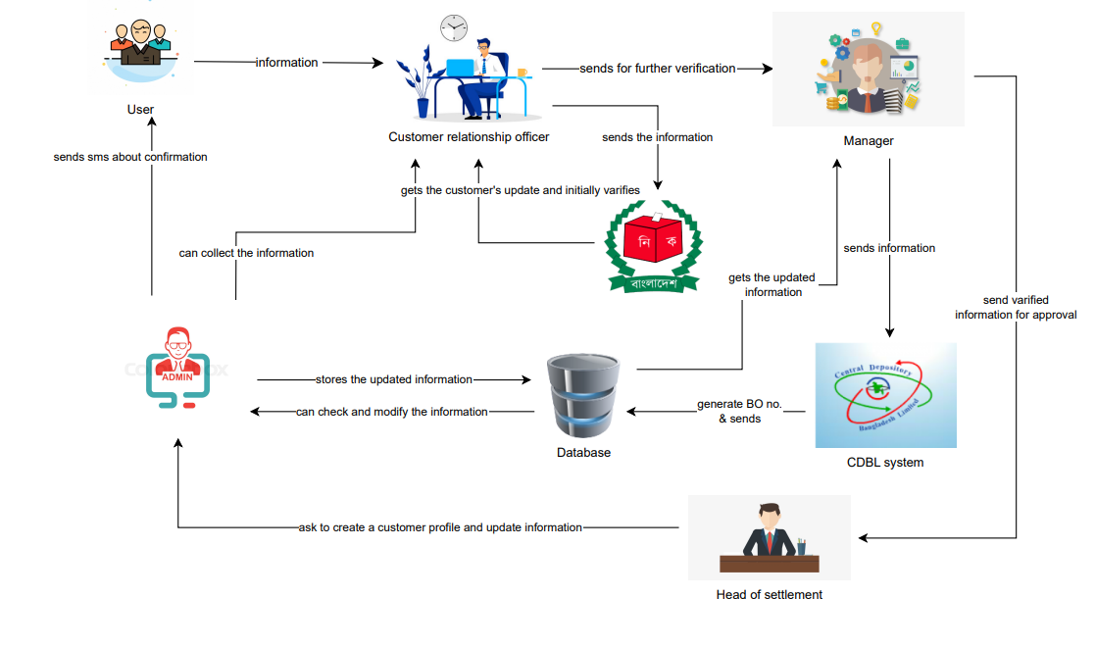



## b: Six Elements Analysis- Existing System

| **Process** | **System Roles** | | | | | |
| --- | --- | --- | --- | --- | --- | --- |
| Human | Non- Computing Hardware | Computing Hardware | Software | Database | Network and Communication |
| **User sends information to customer relationship officer** | **Customer relationship officer**   1. Takes the information from user for further process   b) Verifies NID and other documents.    **User**  a) Gives the needed information to Customer relationship officer | **Table and Chair**  a) To use for sitting arrangement and work purpose.    **Pen and Paper**  a) For filling up the given form for users.  **Room**  a) Lanka Bangla has office for their work. | **Computer** a) Used by customer relationship officer to save the collected data of new user in the Excel sheet.  b) Customer relationship officer uses it for NID verification and for entering to the website of Election commission.    **Mobile Phone** a) a) User gets OTP for phone number verification.    **Printer**  a) Used by customer relationship officer to print out all the documents which will be transferred hand to hand to the Manager.    **Networking devices (Router,**  **Switch,**  **Bridge, Hub** | **Microsoft**  **Office**  a) The software with which the customer relationship officer will collect some extra information.  **Operating**  **System**  a) Any OS used by the office stuffs  e.g. Windows,  Mac.    **Printing**  **Software**  a) Printing software used for printing the  documents.  **PDF viewer**  a) To view documents in PDF or send it in PDF.  2. To keep student assessment record throughout the semester. | **Microsoft Excel Database**  a) Customer relationship officer uses it for storing collected data. | **Internet**  a)  Used to access the Internet by the office stuffs. |
| **Manager verifies the collected data and sends it to CDBL for BO no. and also sends to the Head of settlement for approval** | **Manager**  a) Gets information of user from customer relationship manager.  b) Manager verifies it and send it to CDBL  **CDBL**  a) Generates a unique BO no. for the new user.  b) After generating the BO no. it sends to the Manager and he stores it to the database.  **Head of settlement**  a) gets the data for approval from the Manager.  b) Approves and send it to admin. | **Paper**  a) It is used to print the documents. | **Computer**  a) Used by the Manager to send data to CDBL.  **Printer**  a) Used by the Manager to print the documents.    **Networking devices (Route r, Internet Cable by ISP**  **Providers**  a) Used by Manager & Head of settlement to access the internet. | **Microsoft**  **Office**  a) Used to edit or update the documents.    **Gmail**  a) Used to send  mail to the  CDBL by Manager.    **Operating**  **System**  a) Any type of OS used by the office stuffs e.g.  Windows,  Linux.    **Adobe Acrobat** a) Used to view the PDF file.    **Printing**  **Software**  a) Used for printing the doc. | **Microsoft Excel Files**  a) Manager & Head of settlement access the data to edit or update the documents. | **Internet**  **Connection**  a) Used by Manager & Head of settlement to access the internet. |
| **Admin updates the data and stores it in database and sends SMS to new user** | **User**  a) Gets SMS from admin about conformation of the account.    **Admin**  a) Create a new user account and save it to database  b) Sends SMS to customer about confirmation. |  | **Computer**  a) Used to edit the Excel file.  b) Admin use it to create account.  c) Use it to send SMS to the customer about confirmation. | **Microsoft**  **Excel**  a) Admin use it to send SMS to the customer about confirmation.    **Web Browser**  a) To save the data in database. | **Microsoft**  **Excel File**  **System**  a) Contains the data.    **Hardcopy storage**  a) Contains the hardcopy version of the documents. | **Internet**  a) Used to send the emails and storing the data. |
| **User gets the final documentation from customer relationship officer** | **Customer Relationship Officer**  a) gets the final approved document b) send the final document to the customer and confirms the account.  **User**  a) gets the final document and confirmation from the customer relationship officer. | **Pen and Paper**  a) Used for signature of users. | **Computer**   1. Used by   Customer relationship officer to get the final data and print it.    **Printer**  a) Used to print the final documents. | **Microsoft**  **Office**  a) Admin stores  data in MS  Excel files.      **Operating**  **System**  a) Any OS used by the admins,  Windows, Mac.    **PDF viewer** a) To view document in PDF. | **Microsoft Excel**  **Database**  a) Used by Admin to update database. | **Internet**  Used by admins to access database. |



## D: Rich Picture- Proposed System



## E: Six Elements Analysis- Proposed System

| **Process** | **System Roles** | | | | | |
| --- | --- | --- | --- | --- | --- | --- |
| Human | Non- Computing Hardware | Computing Hardware | Software | Database | Network and Communication |
| **Users provides information to the webapp** | **Users**  a) Provides needed information to the webapp |  | **Computers/ Laptop**  a) User uses it for accessing webapp.  **Networking**  **Devices**  **(Router,**  **Switch, Bridge, Hub):**  a) Used to access webapp. | **Operating**  **Software**  a) Used by the users.  **Webapp**  a) Webapp of LankaBangla is used by users. | **Database**  a) webapp uses it to show data. | **Internet**  a) Used to access webapp. |
| **Manager gets data for verification** | **Manager**  a) gets data from webapp for verification.  b) Verifies and update it to webapp. |  | **Computer**  a) Is used by manager to get the data and verify it through webapp  **Mobile**  a) can be used as well for verification.    **Networking devices (Router,**  **Switch, Bridge, Hub)**  a) Used to access the Internet. | **Webapp**  a) Webapp of LankaBangla is used by manager for verification.    **Operating**  **System**  a) Any OS used by the Manager, Windows, Mac. | **Database**   1. For storing the data. | **Internet**  a) Used to access the Internet by manager. |
| **Election Commission gets the data for verification** |  |  | **Computer**  a) Used for verification by Election Commission    **Webapp**  a) Used by Election commission to access the data.  **Networking devices (Router)**  a) Used to access the internet | **Webapp**  a) used to access data and verification.    **Operating**  **System**  a) Any OS used by the Election Commission  Windows, Mac    **Printing**  **Software**  a) Printing software used for printing the docs.  **PDF viewer** a) To view docs in PDF. | **Database**  a) for storing data. | **Internet**  a) Used to access the internet |
| **Manager sends**  **data to CDBL** | **Manager**  a) Verifies & sends data to CDBL. |  | **Computer/ Laptop**  a) Used by the Manager.  b) CDBL uses it for generating BO no.  **Networking devices (Router,**  **Internet**  **Cable by ISP Providers)**  a) Used by  Manager to access the Internet.  b) Used by  CDBL to access the Internet. | **Webapp**  a) Used by Manager for getting data.    b) Used by CDBL for sending the generated BO no.  **Operating**  **System**  a) Any OS used by the Manager & CDBL,  e.g. Windows,  Mac. | **Database**  a) It is used to store the updated data through webapp. | **Internet**  **Connection**  a) Used by  Manager to access the Internet.  b) Used by  CDBL to access the Internet. |
| **Head of settlement gets the data for approval & update the approved data to Webapp** | **Head of settlement**  a) gets data from webapp for approval.  b) Update the data into webapp after approving. |  | **Computer/Ph one**  a) used by Head of settlement  **Printer**  a) Used to print the approved docs.    **Networking devices (Router,**  **Switch, Bridge, Hub):**  a) Used to access the Internet | **Webapp**  a) used to collect the data  **Operating**  **System**  a) Any OS used  by the Head of settlement,  Windows, Mac    **Printing**  **Software**  a) Printing software used for printing the docs.    **PDF viewer**  a) To view  docs in  PDF | **Database**  a) stores the updated data. | **Internet**  a) Used to access the Internet. |
| **Webapp creates a new account after approval & user can access the account** | **User**  a) can see the updated information in webapp.  b) gets the new account through webapp. |  | **Computer/Ph one**  a) Used to see data in webapp.    **Printer**  a) Print the docs from webapp.    **Networking devices (Router,**  **Switch, Bridge, Hub)**  a) Used to access the Internet. | **Webapp**  a) webapp will contain the  updated data.    **Operating**  **System**  a) Any OS used by the users,  e.g. Windows,  Mac.    **Printing**  **Software**  a) Printing software used for printing the docs.    **PDF viewer**  a) To view the curriculum report in PDF. | **Database**  a). stores the data. | **Internet**  a) Used to access the Internet. |

# Ch 3: Logical System Design

In this chapter, we will go through the processes of creating a data model of our proposed system for the data to be stored in a database. This data model is a conceptual representation of Data objects, the associations between different data objects, and the rules. Data modeling helps us in the visual representation of data and enforces business rules, regulatory compliances, and government policies on the data. Data Models ensure consistency in naming conventions, default values, semantics, security while ensuring quality of the data. We will be designing our proposed system for a better representation of all the data.

## a: Business Rule

Business rules help us to understand the operations, definitions and constraints that govern the data model. ERDs are made using regular English sentences so that a non-technical stakeholder can decipher information about the data model without notation knowledge.

The business rules that govern our data model are as follows:

1. A admin may create multiple customers. A admin include admin id, name, email, phone. And a customer is must create by on admin. A customer include customer id, name, email, phone, address etc.

2. A BO account Form is consist a nominee. BO account form contains bo id, gender, name, father name, mother name, address etc. And a nominee has BO account form. A nominee include nominee no, customer name, email, phone etc.

3. A BO Account Form has a POA form. Where the BO account form include bo id, name, email, phone. A POA form is a BO account form. The POA form include application no, name, email, mobile, address etc.

4. A BO Account Form has a Passport details. Where the BO account form include bo id, name, email, phone. A passport details is a BO account form. The passport details include passport no, issue place, issue date, expiry date.

5. A client information have bank details. A client information contain client code, date, account type, name, email, phone, present address, permanent address, BoD etc. A bank details is under fall a client information. A bank details include account no, bank name, branch name.

6. A client information has a joint account holder. If the client information being delete the joint account holder will not exist. Joint account holder include client code, name, date, account type, father name, mother name, email, phone, address

7. A client information has a authorized person. If the authorized person being delete the joint account holder will not exist. Authorized person include client code, name, date, account type, father name, mother name, email, phone, address

## b: Entity Relationship Diagram

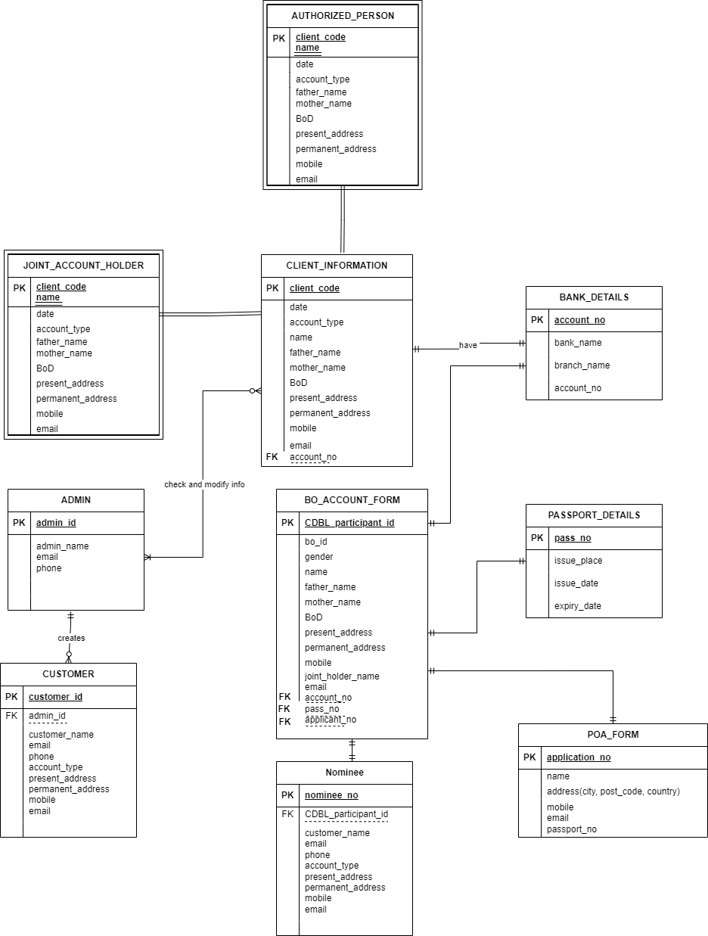

*Figure 3: Entity Relationship Diagram*

## c: Entity Relationship Diagram to Relational Schema

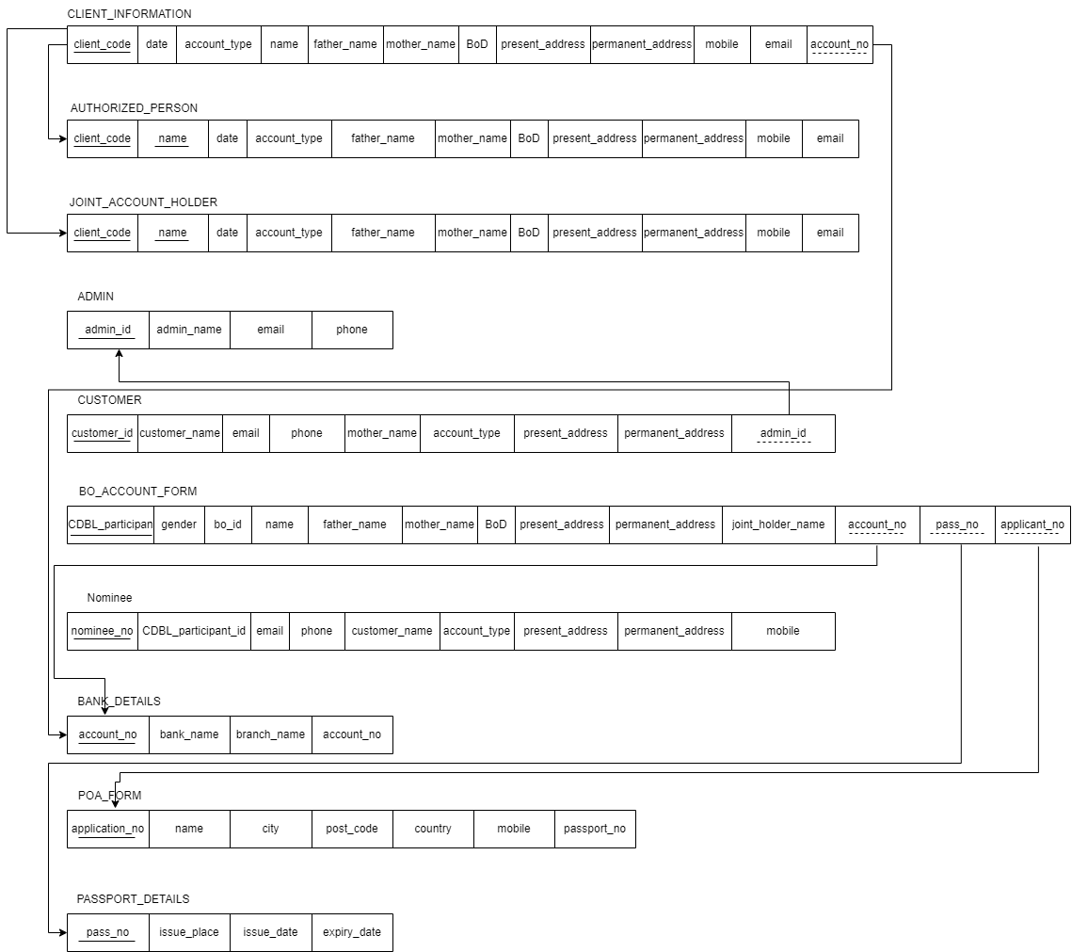

*Figure 4: Entity Relationship Diagram to Schema*

## d: Normalization

| Client Information | | Client_code | | C1 | | Join Account Holder | Client_code | J1 |
| --- | --- | --- | --- | --- | --- | --- | --- | --- |
| date | | C2 | | date | J2 |
| account_type | | C3 | | account_type | J2 |
| Name | | C4 | | Name | J4 |
| Father_name | | C5 | | Father_name | J5 |
| Mother_name | | C6 | | Mother_name | J6 |
| BoD | | C7 | | BoD | J7 |
| Present_address | | C8 | | Present_address | J8 |
| Permanent_address | | C9 | | Permanent_address | J9 |
| Mobile | | C10 | | Mobile | J10 |
| Email | | C11 | | Email | J11 |
| Account_no | | B1 | |  |  |
| Authorized Persion | | Client_code | | A1 | | Admin | Admin_id | Ad1 |
| name | | A2 | | Admin_name | Ad2 |
| email | Ad3 |
| phone | Ad4 |
| date | | A3 | | Bank Details | Account_no | B1 |
| Account_type | | A4 | | Bank_name | B2 |
| Father_name | | A5 | | Branch_name | B3 |
| Mother_name | | A6 | | Poa Form | Application_no | Pf1 |
| BoD | | A7 | | Name | Pf2 |
| Present_address | | A8 | | City | Pf3 |
| Post_code | Pf4 |
| country | Pf5 |
| mobile | Pf6 |
| Passport_no | P1 |
| Permanent_address | | A9 | | BO Account Form | CDBL_participent | Ba1 |
| Mobile | | A10 | |
| Email | | A11 | |
| Customer | | Customer_id | | Cs1 | | Gender | Ba2 |
| Customer_name | | Cs2 | | Bo_id | Ba3 |
| Email | | Cs3 | | name | Ba4 |
| phone | | Cs4 | | Father_name | Ba5 |
| Mother_name | | Cs5 | | Mother_name | Ba6 |
| Account_type | | Cs6 | | BoD | Ba7 |
| Present_address | | Cs7 | | Present_address | Ba8 |
| Permanent_address | | Cs8 | | Permanent_address | Ba9 |
| Admin_id | | Ad1 | | Join_holder_name | Ba10 |
| Nominee | | Nominee_no | | N1 | | Account_no | B1 |
| Cdbl_participent_id | | N2 | | Pass_no | P1 |
| email | | N3 | | Applicant_no | Pf1 |
| Phone | | N4 | |
| Customer_name | | N5 | |
| Account_type | | N6 | |
| Present_address | | N7 | |
| Permanent_address | | N8 | |
| mobile | | N9 | |
|  | Passport Details | | Passs_no | | P1 |  |  |  |
|  | Issue_pace | | P2 |  |  |
|  | Issue_date | | P3 |  |  |
|  | Expiry_date | | P4 |  |  |

| c1 | c2,c3,c4,c5,c6,c7,c8,c9,c10,c11,b1 | j1 | j2,j3,j4,j5,j6,j7,8,9,j10,j11 |
| --- | --- | --- | --- |
| a1 | a2,a3,a4,a5,a6,a7,a8,a9,a11 | ad1 | ad2,ad3,ad4 |
| cs1 | cs2,cs3,cs4,cs5,cs6,cs7,cs8,ad1 | pf1 | pf2,pf3,pf4,pf5,pf6,p1 |
| n1 | n2,n3,n4,n5,n6,n7,n8,n9 | ba1 | ba2,ba3,ba4,ba5,ba6,ba7,ba8,ba9,ba10,b1,p1,bf1 |
| b1 | b2,b3 | P1 | P2,p3,p4 |

1NF:

2NF:

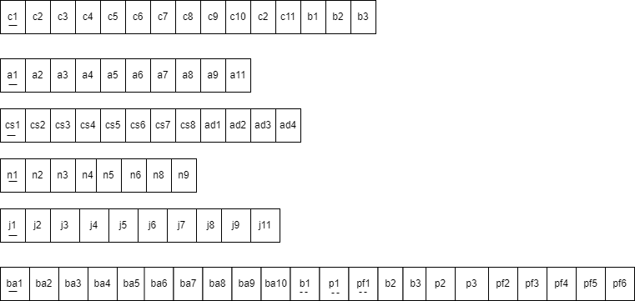

3NF:

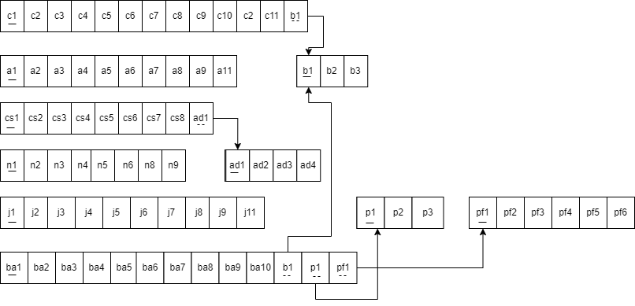

BCNF: All determinants are candidate keys. There is no determinant that is not unique

identifier. Here, all the relations already are in BCNF.

## e: Data Dictionary

Client Information

| Name | Data type | Size | Remarks |
| --- | --- | --- | --- |
| Client_code | INTEGER | 6 | This is the primary key representing the University table which is unique.  E.g.- 29689 |
| date | Date | 11 | It means the client joining date.  E.g.- 11/1/2023 |
| account_type | VARCHAR | 15 | This means the type of account.  E.g.- BO1 |
| Name | VARCHAR | 30 | This means the name of the client  E.g.- Rahul Paul |
| Father_name | VARCHAR | 30 | This means the client father name.  E.g.- Rahul Paul |
| Mother_name | VARCHAR | 30 | This means the client mother name.  E.g.- Smith |
| BoD | VARCHAR | 30 | This means the address of the university.  E.g.- Plot 16 Block B, Aftabuddin Ahmed Road  Bashundhara R/A, Dhaka. |
| Present_address | VARCHAR | 30 | This means the address of the client.  E.g.- Plot 16 Block B, Aftabuddin Ahmed Road  Bashundhara R/A, Dhaka. |
| Permanent_address | VARCHAR | 30 | This means the address of the client.  E.g.- Plot 16 Block B, Aftabuddin Ahmed Road  Bashundhara R/A, Dhaka. |
| Mobile | VARCHAR | 11 | This means the number of client.  E.g.- 0183648394 |
| Email | VARCHAR | 30 | This means the email of client.  E.g.- aaa@gmail.com |
| Account_no | INTEGER | 30 | This means the account number of client  E.g.- 124234433 |

Authorized Person

| Name | Data type | Size | Remarks |
| --- | --- | --- | --- |
| Client_code | INTEGER | 6 | This is the primary key representing the University table which is unique.  E.g.- 29689 |
| name | VARCHAR | 30 | It means the name of the person.  E.g.- Rahul Paul |
| date | Date | 30 | This means the date of joining  E.g.- 3/2/2023 |
| Account_type | VARCHAR | 15 | This means the type of account  E.g.- bo1 |
| Father_name | VARCHAR | 30 | This means the father name.  E.g.- Rahul Paul |
| Mother_name | VARCHAR | 30 | This means the mother name  E.g.- Smith |
| BoD | VARCHAR | 30 | This means the address of the university.  E.g.- Plot 16 Block B, Aftabuddin Ahmed Road  Bashundhara R/A, Dhaka. |
| Present_address | VARCHAR | 30 | This means the address of the university.  E.g.- Plot 16 Block B, Aftabuddin Ahmed Road  Bashundhara R/A, Dhaka. |
| Permanent_address | VARCHAR | 30 | This means the address of the university.  E.g.- Plot 16 Block B, Aftabuddin Ahmed Road  Bashundhara R/A, Dhaka. |
| Mobile | VARCHAR | 30 | This means the number of person  E.g.- 018364834 |
| Email | VARCHAR | 30 | This means the email of person  E.g.- aaa@gmail.com |

Customer

| Name | Data type | Size | Remarks |
| --- | --- | --- | --- |
| Customer_id | INTEGER | 6 | This is the primary key representing the University table which is unique.  E.g.- 29689 |
| Customer_name | VARCHAR | 30 | It means the name of the university.  E.g.- Independent University Bangladesh, North-South University and so on. |
| Email | VARCHAR | 30 | This means the address of the university.  E.g.- Plot 16 Block B, Aftabuddin Ahmed Road  Bashundhara R/A, Dhaka. |
| phone | VARCHAR | 30 | This means the address of the university.  E.g.- Plot 16 Block B, Aftabuddin Ahmed Road  Bashundhara R/A, Dhaka. |
| Mother_name | VARCHAR | 30 | This means the address of the university.  E.g.- Plot 16 Block B, Aftabuddin Ahmed Road  Bashundhara R/A, Dhaka. |
| Account_type | VARCHAR | 30 | This means the address of the university.  E.g.- Plot 16 Block B, Aftabuddin Ahmed Road  Bashundhara R/A, Dhaka. |
| Present_address | VARCHAR | 30 | This means the address of the university.  E.g.- Plot 16 Block B, Aftabuddin Ahmed Road  Bashundhara R/A, Dhaka. |
| Permanent_address | VARCHAR | 30 | This means the address of the university.  E.g.- Plot 16 Block B, Aftabuddin Ahmed Road  Bashundhara R/A, Dhaka. |
| Admin_id | INTEGER | 30 | This means the address of the university.  E.g.- Plot 16 Block B, Aftabuddin Ahmed Road  Bashundhara R/A, Dhaka. |

Nominee

| Name | Data type | Size | Remarks |
| --- | --- | --- | --- |
| Nominee_no | INTEGER | 6 | This is the primary key representing the University table which is unique.  E.g.- 29689 |
| Cdbl_participent_id | VARCHAR | 30 | It means the name of the university.  E.g.- Independent University Bangladesh, North-South University and so on. |
| email | VARCHAR | 30 | This means the address of the university.  E.g.- Plot 16 Block B, Aftabuddin Ahmed Road  Bashundhara R/A, Dhaka. |
| Phone | VARCHAR | 11 | This means the address of the university.  E.g.- Plot 16 Block B, Aftabuddin Ahmed Road  Bashundhara R/A, Dhaka. |
| Customer_name | VARCHAR | 30 | This means the address of the university.  E.g.- Plot 16 Block B, Aftabuddin Ahmed Road  Bashundhara R/A, Dhaka. |
| Account_type | VARCHAR | 15 | This means the address of the university.  E.g.- Plot 16 Block B, Aftabuddin Ahmed Road  Bashundhara R/A, Dhaka. |
| Present_address | VARCHAR | 30 | This means the address of the university.  E.g.- Plot 16 Block B, Aftabuddin Ahmed Road  Bashundhara R/A, Dhaka. |
| Permanent_address | VARCHAR | 30 | This means the address of the university.  E.g.- Plot 16 Block B, Aftabuddin Ahmed Road  Bashundhara R/A, Dhaka. |
| mobile | VARCHAR | 30 | This means the address of the university.  E.g.- Plot 16 Block B, Aftabuddin Ahmed Road  Bashundhara R/A, Dhaka. |

Passport Details

| Name | Data type | Size | Remarks |
| --- | --- | --- | --- |
| Passs_no | INTEGER | 6 | This is the primary key representing the University table which is unique.  E.g.- 29689 |
| Issue_place | VARCHAR | 30 | It means the name of the university.  E.g.- Independent University Bangladesh, North-South University and so on. |
| Issue_date | Date | 11 | This means the address of the university.  E.g.- Plot 16 Block B, Aftabuddin Ahmed Road  Bashundhara R/A, Dhaka. |
| Expiry_date | Date | 1 | This means the address of the university.  E.g.- Plot 16 Block B, Aftabuddin Ahmed Road  Bashundhara R/A, Dhaka. |

Join Account Holder

| Name | Data type | Size | Remarks |
| --- | --- | --- | --- |
| Client_code | INTEGER | 6 | This is the primary key representing the University table which is unique.  E.g.- 29689 |
| date | Date | 30 | It means the name of the university.  E.g.- Independent University Bangladesh, North-South University and so on. |
| account_type | VARCHAR | 30 | This means the address of the university.  E.g.- Plot 16 Block B, Aftabuddin Ahmed Road  Bashundhara R/A, Dhaka. |
| Name | VARCHAR | 30 | This means the address of the university.  E.g.- Plot 16 Block B, Aftabuddin Ahmed Road  Bashundhara R/A, Dhaka. |
| Father_name | VARCHAR | 30 | This means the address of the university.  E.g.- Plot 16 Block B, Aftabuddin Ahmed Road  Bashundhara R/A, Dhaka. |
| Mother_name | VARCHAR | 30 | This means the address of the university.  E.g.- Plot 16 Block B, Aftabuddin Ahmed Road  Bashundhara R/A, Dhaka. |
| BoD | VARCHAR | 30 | This means the address of the university.  E.g.- Plot 16 Block B, Aftabuddin Ahmed Road  Bashundhara R/A, Dhaka. |
| Present_address | VARCHAR | 30 | This means the address of the university.  E.g.- Plot 16 Block B, Aftabuddin Ahmed Road  Bashundhara R/A, Dhaka. |
| Permanent_address | VARCHAR | 30 | This means the address of the university.  E.g.- Plot 16 Block B, Aftabuddin Ahmed Road  Bashundhara R/A, Dhaka. |
| Mobile | VARCHAR | 11 | This means the address of the university.  E.g.- Plot 16 Block B, Aftabuddin Ahmed Road  Bashundhara R/A, Dhaka. |
| Email | VARCHAR | 30 | This means the address of the university.  E.g.- Plot 16 Block B, Aftabuddin Ahmed Road  Bashundhara R/A, Dhaka. |

Admin

| Name | Data type | Size | Remarks |
| --- | --- | --- | --- |
| Admin_id | INTEGER | 6 | This is the primary key representing the University table which is unique.  E.g.- 29689 |
| Admin_name | VARCHAR | 30 | It means the name of the university.  E.g.- Independent University Bangladesh, North-South University and so on. |
| email | VARCHAR | 30 | This means the address of the university.  E.g.- Plot 16 Block B, Aftabuddin Ahmed Road  Bashundhara R/A, Dhaka. |
| phone | VARCHAR | 30 | This means the address of the university.  E.g.- Plot 16 Block B, Aftabuddin Ahmed Road  Bashundhara R/A, Dhaka. |

Bank Details

| Name | Data type | Size | Remarks |
| --- | --- | --- | --- |
| Account_no | INTEGER | 6 | This is the primary key representing the University table which is unique.  E.g.- 29689 |
| Bank_name | VARCHAR | 30 | It means the name of the university.  E.g.- Independent University Bangladesh, North-South University and so on. |
| Branch_name | VARCHAR | 30 | This means the address of the university.  E.g.- Plot 16 Block B, Aftabuddin Ahmed Road  Bashundhara R/A, Dhaka. |

Poa Form

| Name | Data type | Size | Remarks |
| --- | --- | --- | --- |
| Application_no | INTEGER | 6 | This is the primary key representing the University table which is unique.  E.g.- 29689 |
| Name | VARCHAR | 30 | It means the name of the university.  E.g.- Independent University Bangladesh, North-South University and so on. |
| City | VARCHAR | 30 | This means the address of the university.  E.g.- Plot 16 Block B, Aftabuddin Ahmed Road  Bashundhara R/A, Dhaka. |
| Post_code | CHAR | 5 | This means the address of the university.  E.g.- Plot 16 Block B, Aftabuddin Ahmed Road  Bashundhara R/A, Dhaka. |
| mobile | VARCHAR | 11 | This means the address of the university.  E.g.- Plot 16 Block B, Aftabuddin Ahmed Road  Bashundhara R/A, Dhaka |

BO Account Form

| Name | Data type | Size | Remarks |
| --- | --- | --- | --- |
| CDBL_participent | INTEGER | 6 | This is the primary key representing the University table which is unique.  E.g.- 29689 |
| date | Date | 30 | It means the name of the university.  E.g.- Independent University Bangladesh, North-South University and so on. |
| account_type | VARCHAR | 30 | This means the address of the university.  E.g.- Plot 16 Block B, Aftabuddin Ahmed Road  Bashundhara R/A, Dhaka. |
| Gender | VARCHAR | 10 | This means the address of the university.  E.g.- Plot 16 Block B, Aftabuddin Ahmed Road  Bashundhara R/A, Dhaka. |
| Bo_id | INTEGER | 30 | This means the address of the university.  E.g.- Plot 16 Block B, Aftabuddin Ahmed Road  Bashundhara R/A, Dhaka. |
| name | VARCHAR | 30 | This means the address of the university.  E.g.- Plot 16 Block B, Aftabuddin Ahmed Road  Bashundhara R/A, Dhaka. |
| Father_name | VARCHAR | 30 | This means the address of the university.  E.g.- Plot 16 Block B, Aftabuddin Ahmed Road  Bashundhara R/A, Dhaka. |
| Mother_name | VARCHAR | 30 | This means the address of the university.  E.g.- Plot 16 Block B, Aftabuddin Ahmed Road  Bashundhara R/A, Dhaka. |
| BoD | VARCHAR | 30 | This means the address of the university.  E.g.- Plot 16 Block B, Aftabuddin Ahmed Road  Bashundhara R/A, Dhaka. |
| Present_address | VARCHAR | 30 | This means the address of the university.  E.g.- Plot 16 Block B, Aftabuddin Ahmed Road  Bashundhara R/A, Dhaka. |
| Permanent_address | VARCHAR | 30 | This means the address of the university.  E.g.- Plot 16 Block B, Aftabuddin Ahmed Road  Bashundhara R/A, Dhaka. |
| Join_holder_name | INTEGER | 30 | This means the address of the university.  E.g.- Plot 16 Block B, Aftabuddin Ahmed Road  Bashundhara R/A, Dhaka. |
| Account_no | VARCHAR | 30 | This means the address of the university.  E.g.- Plot 16 Block B, Aftabuddin Ahmed Road  Bashundhara R/A, Dhaka. |
| Pass_no | VARCHAR | 30 | This means the address of the university.  E.g.- Plot 16 Block B, Aftabuddin Ahmed Road  Bashundhara R/A, Dhaka. |

# Ch 4: Physical System Design

## Home Page:

## a: Input Form

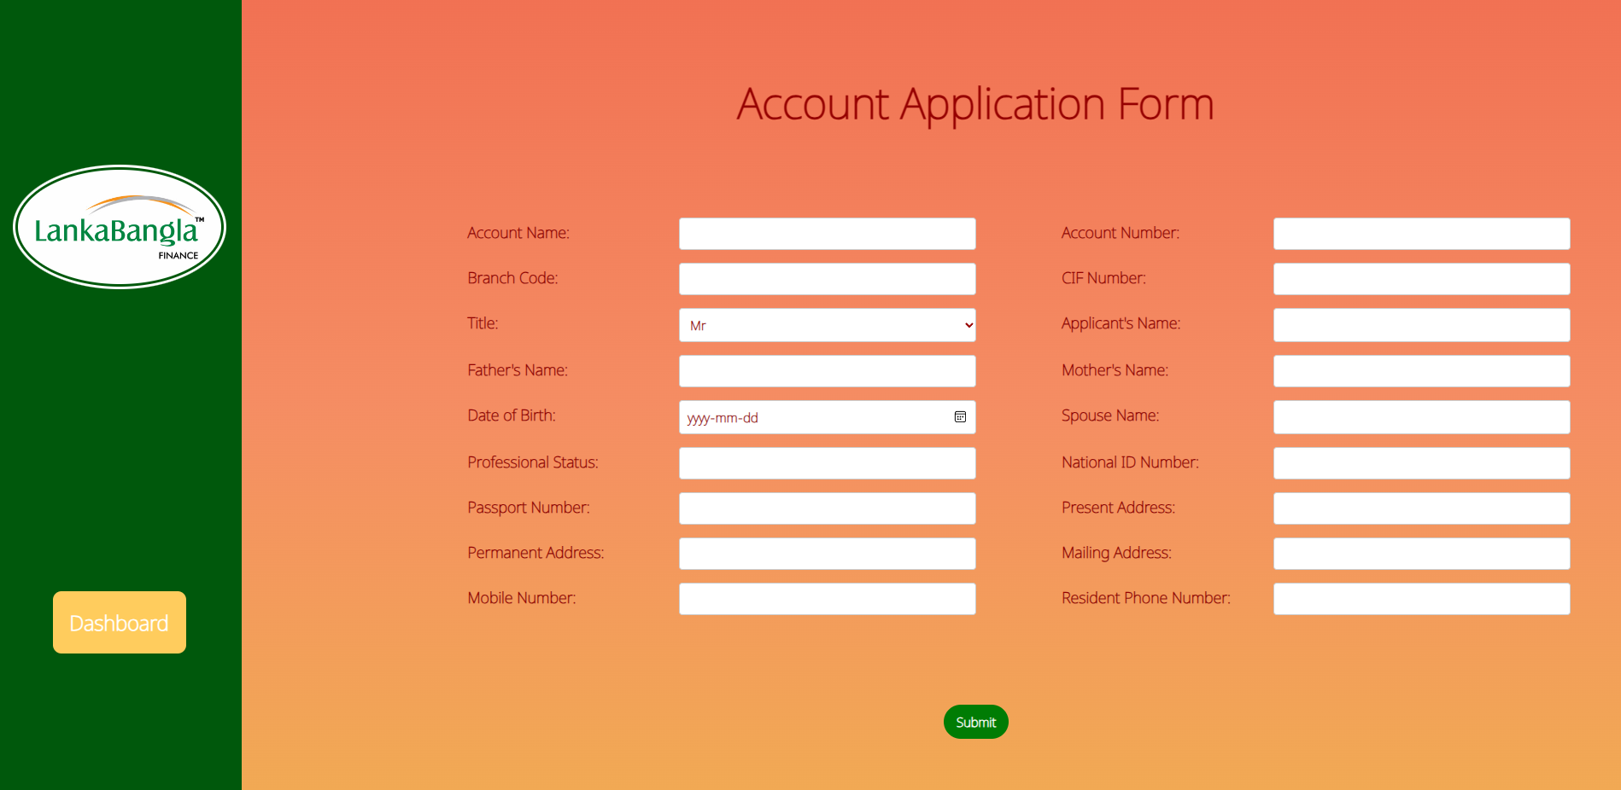

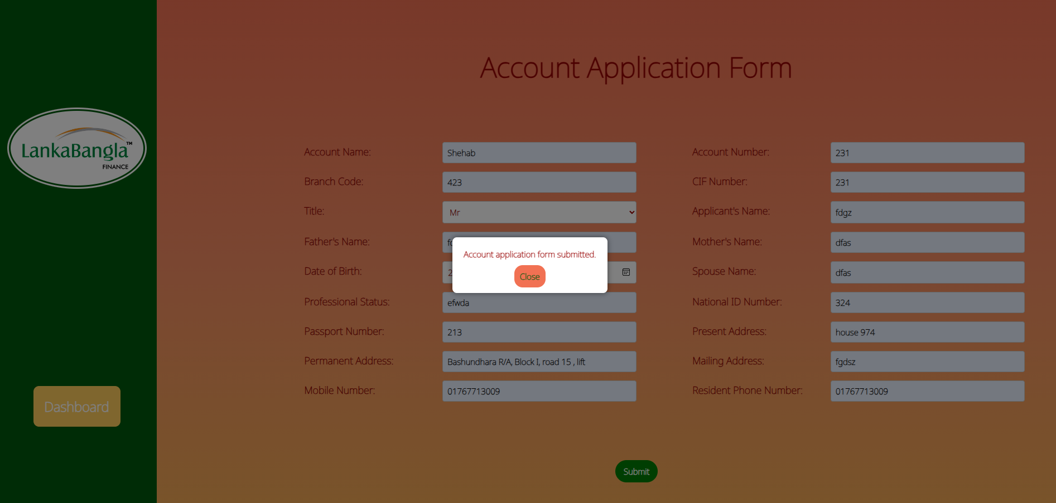

**Account Application Form php file.**

<?php

include 'connect.php';

if ($_SERVER["REQUEST_METHOD"] == "POST") {

$accountName = $_POST["accountName"];

$accountNumber = $_POST["accountNumber"];

$branchCode = $_POST["branchCode"];

$cifNumber = $_POST["cifNumber"];

$accountTitle = $_POST["accountTitle"];

$applicantName = $_POST["applicantName"];

$fatherName = $_POST["fatherName"];

$motherName = $_POST["motherName"];

$dateOfBirth = $_POST["dateOfBirth"];

$spouseName = $_POST["spouseName"];

$professionalStatus = $_POST["professionalStatus"];

$nationalID = $_POST["nationalID"];

$passportNumber = $_POST["passportNumber"];

$presentAddress = $_POST["presentAddress"];

$permanentAddress = $_POST["permanentAddress"];

$mailingAddress = $_POST["mailingAddress"];

$mobileNumber = $_POST["mobileNumber"];

$residentPhone = $_POST["residentPhone"];

$userInsertSQL = "INSERT INTO accounts (

accountName,

accountNumber,

branchCode,

cifNumber,

accountTitle,

applicantName,

fatherName,

motherName,

dateOfBirth,

spouseName,

professionalStatus,

nationalID,

passportNumber,

presentAddress,

permanentAddress,

mailingAddress,

mobileNumber,

residentPhone

) VALUES (

'$accountName',

'$accountNumber',

'$branchCode',

'$cifNumber',

'$accountTitle',

'$applicantName',

'$fatherName',

'$motherName',

'$dateOfBirth',

'$spouseName',

'$professionalStatus',

'$nationalID',

'$passportNumber',

'$presentAddress',

'$permanentAddress',

'$mailingAddress',

'$mobileNumber',

'$residentPhone'

)";

if ($conn->query($userInsertSQL) === TRUE) {

$response = array(

"success" => true,

"message" => "Account application form submitted."

);

} else {

$response = array(

"success" => false,

"message" => "Error: " . $userInsertSQL . "<br>" . $conn->error

);

}

$conn->close();

echo json_encode($response);

} else {

$response = array(

"success" => false,

"message" => "Invalid request."

);

echo json_encode($response);

}

?>

## b: Output Table From Accounts Table

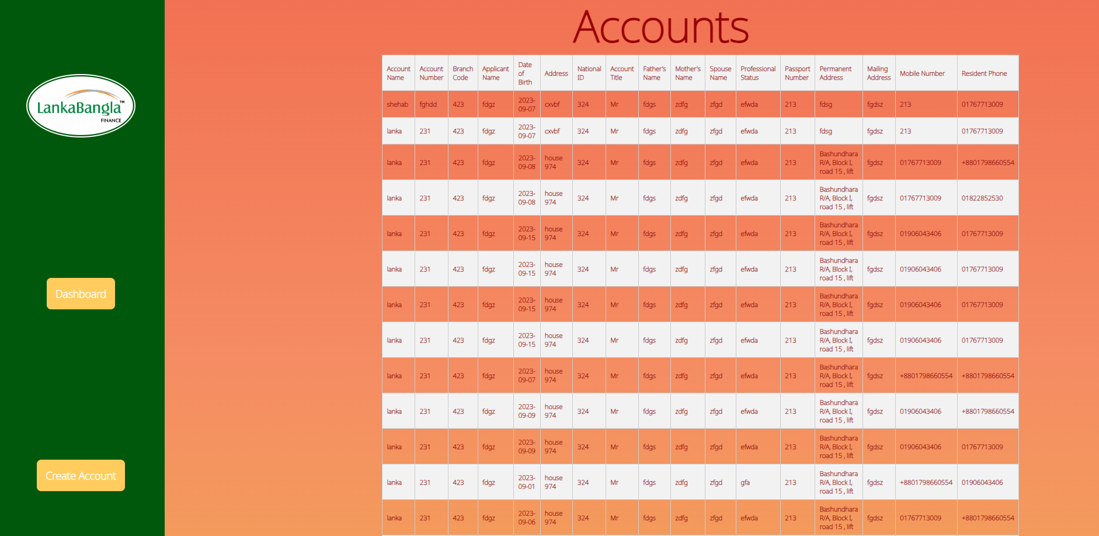

<?php

session_start();

require_once("connect.php");

$userQuery = "SELECT * FROM accounts";

$userResult = $conn->query($userQuery);

$conn->close();

?>

<!doctype html>

<html lang="en">

<head>

<style>

*{

color: black;

}

</style>

<meta charset="UTF-8">

<link rel="stylesheet" href="style2.css">

<link rel="stylesheet" href="bootstrap.min.css">

<link rel="preconnect" href="https://fonts.googleapis.com">

<link rel="preconnect" href="https://fonts.gstatic.com" crossorigin>

<link href="https://fonts.googleapis.com/css2?family=Noto+Sans:wght@100&family=Oxygen:wght@300;400;700&family=Rubik:ital,wght@0,300;0,400;0,500;0,600;0,700;0,800;0,900;1,300;1,400;1,500;1,600;1,700;1,800;1,900&display=swap" rel="stylesheet">

<title>Lanka Bangla Home</title>

</head>

<body style="

background: #F17153;

/* For browsers that do not support gradients */

background: -webkit-linear-gradient(#F17153, #F58D63, #f1ab53);

/* For Safari 5.1 to 6.0 */

background: -o-linear-gradient(#F17153, #F58D63, #f1ab53);

/* For Opera 11.1 to 12.0 */

background: -moz-linear-gradient(#F17153, #F58D63, #f1ab53);

/* For Firefox 3.6 to 15 */

background: linear-gradient(#F17153, #F58D63, #f1ab53);

/* Standard syntax */">

<div class="container-fluid">

<div class="row">

<div class="col-md-2 col-sm-4 sidebar1" style="height:100%;">

<div >

<a class="logo">

<img class="logo1" src="logo.jpg">

</a>

</div>

<a class="nav" href="dashboard.html">

Dashboard

</a>

<a class="nav" href="register.html">

Create Account

</a>

<a class="nav" href="home.html">

Logout

</a>

</div>

<div class="col-md-10" style="display: flex; flex-direction: column;">

<h1 style="font-size: 100px;">Accounts</h1>

<div >

<div class="table-wrapper" style="margin-left: 0px; ">

<!-- <h2 style="color: rgb(150, 0, 0);">User Table</h2> -->

<table>

<thead>

<tr>

<th>Account Name</th>

<th>Account Number</th>

<th>Branch Code</th>

<th>Applicant Name</th>

<th>Date of Birth</th>

<th>Address</th>

<th>National ID</th>

<th>Account Title</th>

<th>Father's Name</th>

<th>Mother's Name</th>

<th>Spouse Name</th>

<th>Professional Status</th>

<th>Passport Number</th>

<th>Permanent Address</th>

<th>Mailing Address</th>

<th>Mobile Number</th>

<th>Resident Phone</th>

</tr>

</thead>

<tbody>

<?php

while ($row = $userResult->fetch_assoc()) {

echo "<tr>";

echo "<td>" . $row["accountName"] . "</td>";

echo "<td>" . $row["accountNumber"] . "</td>";

echo "<td>" . $row["branchCode"] . "</td>";

echo "<td>" . $row["applicantName"] . "</td>";

echo "<td>" . $row["dateOfBirth"] . "</td>";

echo "<td>" . $row["presentAddress"] . "</td>";

echo "<td>" . $row["nationalID"] . "</td>";

echo "<td>" . $row["accountTitle"] . "</td>";

echo "<td>" . $row["fatherName"] . "</td>";

echo "<td>" . $row["motherName"] . "</td>";

echo "<td>" . $row["spouseName"] . "</td>";

echo "<td>" . $row["professionalStatus"] . "</td>";

echo "<td>" . $row["passportNumber"] . "</td>";

echo "<td>" . $row["permanentAddress"] . "</td>";

echo "<td>" . $row["mailingAddress"] . "</td>";

echo "<td>" . $row["mobileNumber"] . "</td>";

echo "<td>" . $row["residentPhone"] . "</td>";

echo "</tr>";

}

?>

</tbody>

</table>

</div>

</div>

</div>

</div>

</div>

</div>

</div>

</body>

<script src="bootstrap.min.js"></script>

</html>

# 

# Login Form:

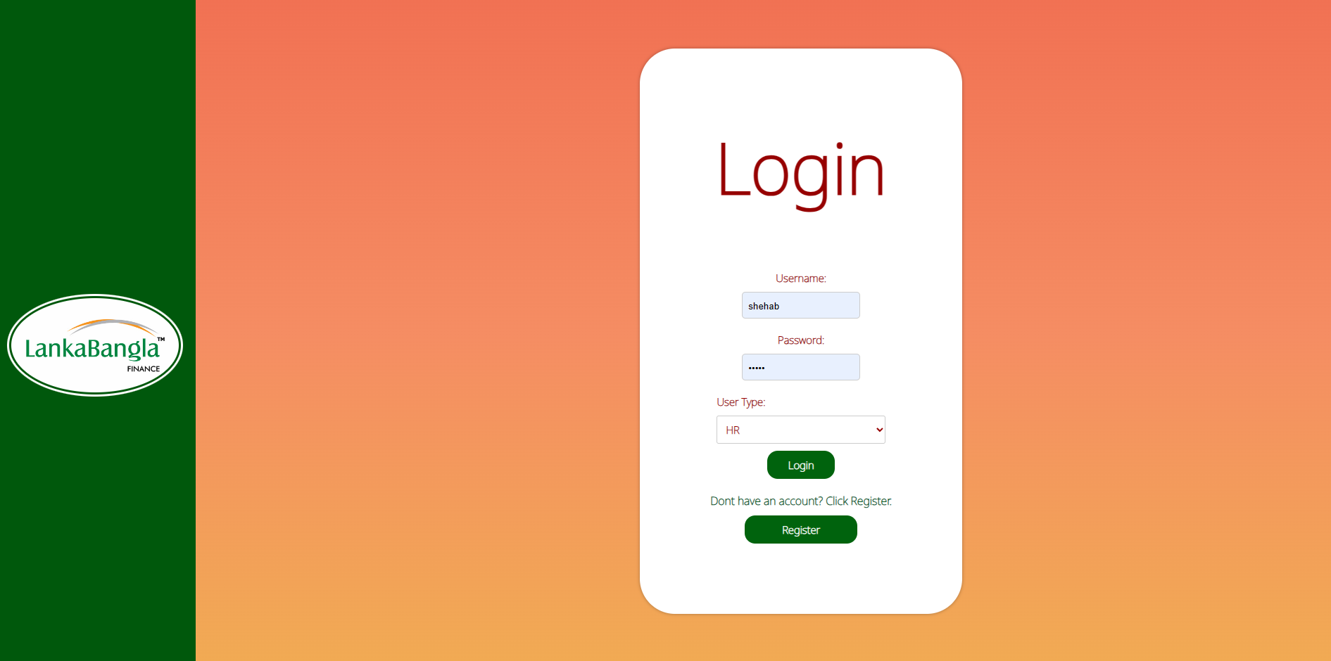

# 

# 

# User Registration Form:

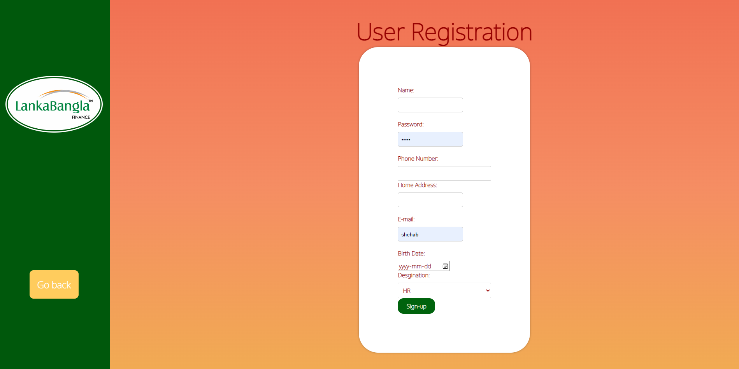

# Ch 5: Conclusion

## a: Problem & Solution

### Analysis phase

While working on the project, most of the work was based upon assumptions and queries were made while working on the rich picture and six element analysis of operations of the organization as there was no solid data present. For a better understanding about the whole scenario and to overcome from the confusions, respected faculty members /stake holder interviews were made.

### Design phase

By performing descriptive research, the entities that were created kept at their significant levels, which was also introduced in the Relational Schema schematic. Our course instructor’s feedback played an important and crucial role in this phase as well.

### Implementation phase

Almost all the System Requirement’s (SSR) are reached.

Front-End Developing tools: HTML, CSS, Bootstrap JavaScript, Chart Js.

Back-End Developing tools: PHP

Database: MySQL

## b: Additional Feature And Future Development:

* Compare their current result with the previous semester.
* Other features, which will be benefitted for the student in the academic level as they keep going forward.