

Department of Computing And Information System
Object Oriented Programming Lab Report-1
Lab Report Name: Java Basics
Course Name: Object Oriented Programming Lab
Course Code: CIS216L
Submitted By:
MD. Shahriar Sanjid Snikdho
Reg ID : 253-16-021
Semester: Fall 2026
Submitted To:
Mr. Md. Nasimul Kader
Assistant Professor
Department of Computing and Information System
Date of Submission: 26.09.2026

GitHub Repository Link: https://github.com/shahriarsnikdho/OOP_LAB_TASK

*Hello World*
public class HelloWorld {
public static void main(String[] args) {
System.out.println("Hello, World");
}
}
Output:
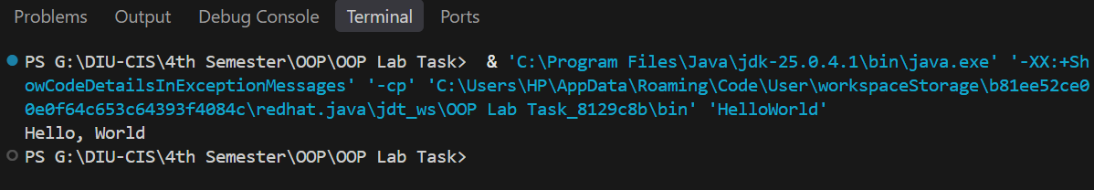
*Comments Example*
public class CommentsExample {
public static void main(String[] args) {
// This is a single-line comment
System.out.println("Hello, World"); // Comment at end of line

/*
* This is a multi-line comment
*/
int x = 10;
System.out.println("Value of x: " + x);
}
}
Output:
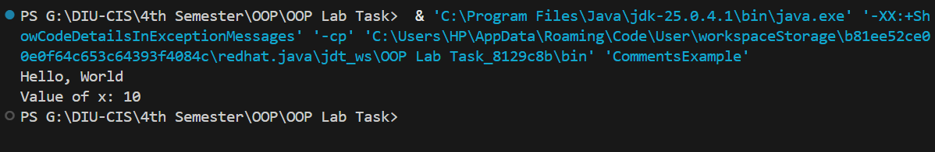
*Datatypes Demo*
public class DataTypesDemo {
public static void main(String[] args) {

// ------- Primitive Data Types -------
byte b = 100; // 1 byte
short s = 30000; // 2 bytes
int i = 100000; // 4 bytes
long l = 10000000000L; // 8 bytes

float f = 3.14f; // 4 bytes
double d = 3.14159265359; // 8 bytes

char c = 'A'; // 2 bytes (Unicode character)
boolean flag = true; // 1 bit

// ------- Non-Primitive Data Types -------
String str = "Hello, Java"; // String (class in Java)
int[] arr = {1, 2, 3, 4, 5}; // Array
Integer wrapperInt = Integer.valueOf(42); // Wrapper class
StringBuilder sb = new StringBuilder("Java"); // Class object

// ------- Output -------
System.out.println("byte: " + b);
System.out.println("short: " + s);
System.out.println("int: " + i);
System.out.println("long: " + l);
System.out.println("float: " + f);
System.out.println("double: " + d);
System.out.println("char: " + c);
System.out.println("boolean: " + flag);

System.out.println("String: " + str);
System.out.print("Array: ");
for (int num : arr) {
System.out.print(num + " ");
}
System.out.println();

System.out.println("Wrapper Integer: " + wrapperInt);
System.out.println("StringBuilder: " + sb);
}
}
Output:
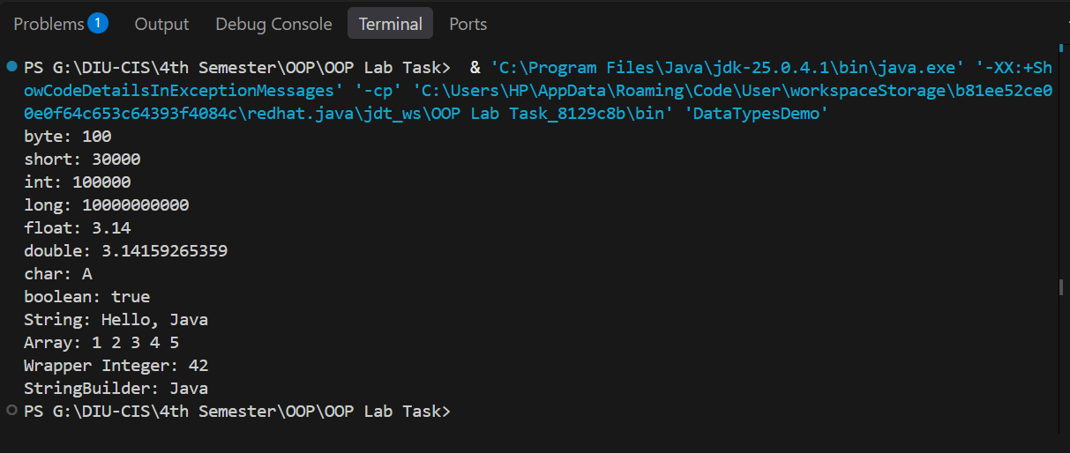
*Variables Demo*
public class VariablesDemo {

// Instance variable (belongs to each object)
int instanceVar = 10;

// Static variable (shared across all objects of the class)
static String staticVar = "I am static";

public void showVariables() {
// Local variable (declared inside a method)
int localVar = 5;

System.out.println("Instance Variable: " + instanceVar);
System.out.println("Static Variable: " + staticVar);
System.out.println("Local Variable: " + localVar);
}

public static void main(String[] args) {
// Creating object
VariablesDemo obj1 = new VariablesDemo();
obj1.showVariables();

// Accessing static variable directly using class name
System.out.println("Accessing Static Variable via class: " + VariablesDemo.staticVar);
}
}

Output:
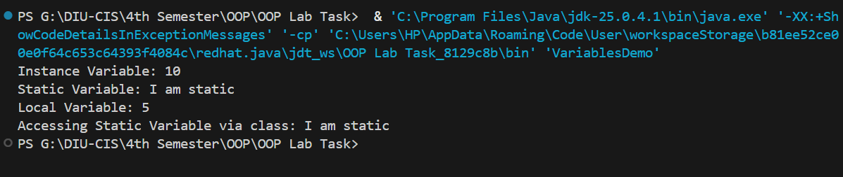
*Simple Operators Demo*
public class SimpleOperatorsDemo {
public static void main(String[] args) {
int a = 10, b = 3;

// Arithmetic Operators
System.out.println("a + b = " + (a + b)); // Addition
System.out.println("a - b = " + (a - b)); // Subtraction

// Relational Operator
System.out.println("a > b ? " + (a > b)); // Greater than

// Logical Operator
boolean x = true, y = false;
System.out.println("x && y = " + (x && y)); // Logical AND

// Assignment Operator
a += 5; // a = a + 5
System.out.println("a after += 5 : " + a);

// Ternary Operator
int max = (a > b) ? a : b;
System.out.println("Maximum = " + max);
}
}
Output:
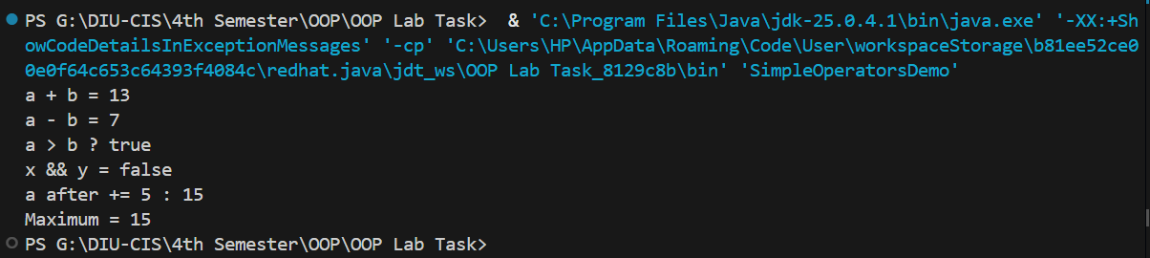
*Decision Making Demo*
public class DecisionMakingDemo {
public static void main(String[] args) {
int number = 10;

// if statement
if (number > 0) {
System.out.println("The number is positive.");
}

// if-else statement
if (number % 2 == 0) {
System.out.println("The number is even.");
} else {
System.out.println("The number is odd.");
}

// if-else-if ladder
if (number < 0) {
System.out.println("The number is negative.");
} else if (number == 0) {
System.out.println("The number is zero.");
} else {
System.out.println("The number is positive.");
}

// switch statement
int day = 3;
switch (day) {
case 1:
System.out.println("Monday");
break;
case 2:
System.out.println("Tuesday");
break;
case 3:
System.out.println("Wednesday");
break;
default:
System.out.println("Other day");
}
}
}

Output:
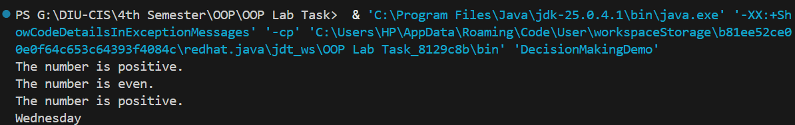
*Loops Demo*
public class LoopsDemo {
public static void main(String[] args) {

// 1. For loop
System.out.println("For Loop:");
for (int i = 1; i <= 5; i++) {
System.out.println("i = " + i);
}

// 2. While loop
System.out.println("\nWhile Loop:");
int j = 1;
while (j <= 5) {
System.out.println("j = " + j);
j++;
}

// 3. Do-While loop
System.out.println("\nDo-While Loop:");
int k = 1;
do {
System.out.println("k = " + k);
k++;
} while (k <= 5);

// 4. Enhanced For Loop (for-each loop)
System.out.println("\nEnhanced For Loop:");
int[] numbers = {10, 20, 30, 40, 50};
for (int num : numbers) {
System.out.println("num = " + num);
}
}
}

Output:
