**Software Design Specification**

**for**

Makeup Service Booking System

Version 1.0

Prepared by

Group Name: Domino

|  |  |  |
| --- | --- | --- |
| Dayang Nur Alisa Binti Abang Senawi | 77919 | 77919@siswa.unimas.my |
| Emma Farisyah Binti Kamalulil | 77959 | 77959@siswa.unimas.my |
| Ismairizz Bin Mohamad Rizal | 78063 | 78063@siswa.unimas.my |
| Mohamad Nasreen Bin Mohamad | 78166 | 78166@siswa.unimas.my |
| Shahril Aimar Bin Faizal | 78518 | 78518@siswa.unimas.my |
| Syamimi Binti Supian | 78553 | 78553@siswa.unimas.my |

|  |  |
| --- | --- |
| Instructor: | Ts. Nurfauza Jali |
| Course: | Software Engineering Lab |
| Lab Section: | Group 2 |
| Teaching Assistant: | Ts. Nurfauza Jali |
| Submission Date: | 12 January 2024 |

Contents

Revisions ii

1 Introduction 1

1.1 Purpose 1

1.2 System Overview 1

1.3 Definitions, Acronyms and Abbreviations 1

1.4 Supporting Materials 1

1.5 Document Overview 1

2 Architecture 2

2.1 Overview 2

2.2 Subsystem, or Component 1..n 2

3 High Level Design 3

3.1 View / Model Component 1..n 3

Appendix A – Group Log 4

Revisions

| Version | Primary Author(s) | Description of Version | Date Completed |
| --- | --- | --- | --- |
| Draft Type and Number | Full Name | Information about the revision. This table does not need to be filled in whenever a document is touched, only when the version is being upgraded. | 00/00/00 |

# Introduction

Domino will specify the software design requirements for the Makeup Service Booking System in this context. This document focuses heavily on the details of design requirements, building on the groundwork established by the Software Requirements Specification. In the pages that follow, we outline the goal of this work, give a brief description of the Makeup Service Booking System, and list the sources that helped form this extensive text.

## Purpose

The Makeup Service Booking System's organisational structure is outlined in this Software Design Specification (SDS) in order to meet the criteria. Since it serves as the main source of information for code development, it has all the information needed by a programmer to write code. It is carried out in two phases. The system architecture and data architecture are defined at the first stage, which is a preliminary design. For instance, more intricate data structures are defined and algorithms are created for the specified architecture in the second stage, which is known as the detailed design stage.

## System Overview

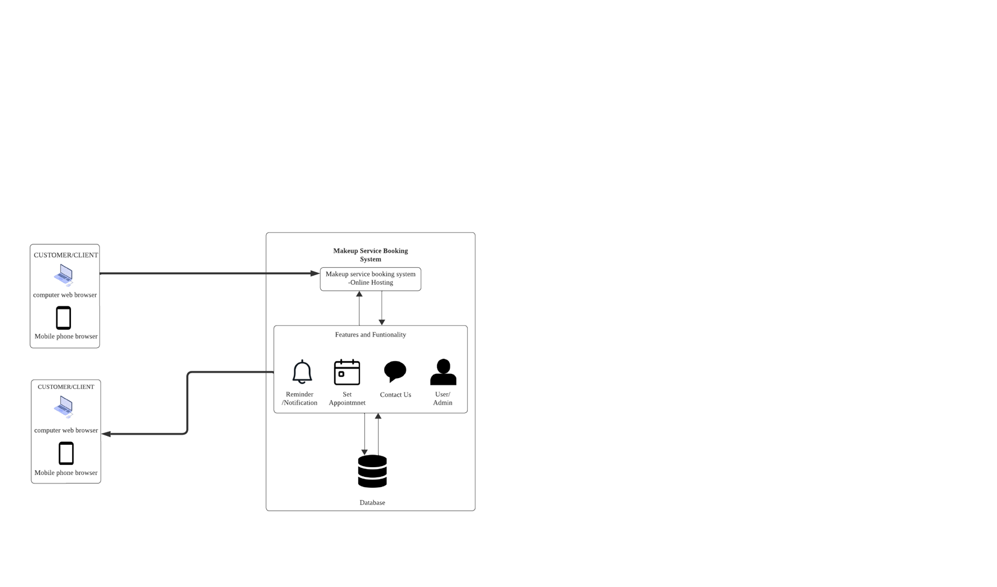

Figure 1: System Architecture of the Makeup Service Booking System

The system architecture of the Makeup Service Booking System that will be constructed is shown in Figure 1 above. Customers and administrators can use PCs, laptops, tablets, and even smartphones to use the web-based system for booking makeup services, but each user will have access to various features. It is a feature-rich online tool that streamlines communication between makeup artists and clients. Makeup artists may develop comprehensive profiles that highlight their abilities, offerings, and costs, and customers can easily peruse and schedule appointments. The technology facilitates clients' decision-making by providing straightforward access to artist profiles. Notifications and reminders are sent, and appointment scheduling is streamlined. In addition, an admin panel manages the platform, monitoring user engagement metrics, guaranteeing user pleasure, and settling disputes. All things considered, this system promotes confidence and openness in the makeup service sector by providing a practical, effective, and safe option for clients and makeup artists.

## Definitions, Acronyms and Abbreviations

Acronyms and Abbreviations;

1. CSS - Cascading Style Sheet
2. HTML - Hypertext Markup Language
3. IEEE – Institute of Electrical and Electronic Engineers
4. MySQL - Structured Query Language
5. PHP – Hypertext Preprocessor
6. SRS - Specific Requirement Specification
7. UI - User Interface
8. XAMPP - Cross-Platform (X), Apache (A), MariaDB (M), PHP (P), and Perl (P)

## Supporting Materials

The IEEE formatting specifications are applied to this text. The paper must meet the formatting specifications, which call for an Arial font in size 11, single spacing, and one inch margins on all sides. To make desired themes easier to read, the primary topic and any subtopic are indicated in bold characters. Every figure and diagram in this text has an assigned number, and when needed, a brief description is given.

## Document Overview

This SDS is a document created for the Makeup Service Booking System design process. The four sections of this SDS are the Appendix, Architecture, High Level Design, and Introduction. The Introduction will provide a quick description of this SDS as well as the first section. The system's general design is defined by the second part, architecture, which also acts as the basis for more in-depth design work. The themes discussed in the Architecture section are expanded upon in the High-Level Design section. This part will usually be broken up into distinct pieces for every aspect of design. Often, the Appendix section contains minutes from group meetings, activities, and other relevant data.

# Architecture

In this segment, we illustrate the conceptual model and the rationale underlying the Makeup Service Booking System. To clarify the relationships between components and the dependencies that are connected to each component, a component diagram is used. Three layers can be distinguished architecturally by classifying the Makeup Service Booking System:

1. Interface layer (User interface)

2. Application layer

3. Storage layer (Database)

Users can interact with the application or software using a graphical user interface that is provided by the interface layer. Web languages like PHP, CSS, and HTTP can be used as the framework for the interface layer. The application layer contains the directives and logic for managing data in the storage layer. This data can also be accessed, depending on what the system user needs. This layer supports parsers for handling the data files and enables administrative control over data file access.

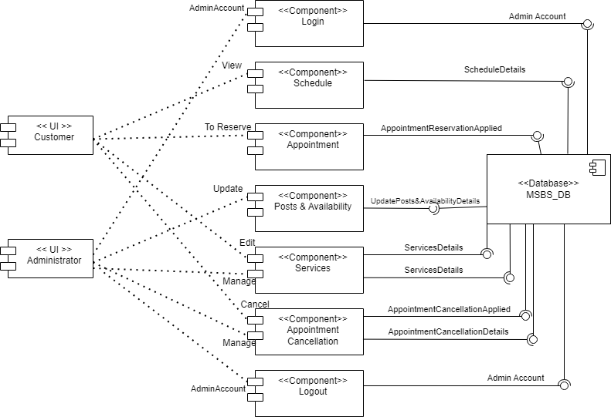

Figure 2: Component Diagram of Makeup Service Booking System

## Overview

Based on the figure 2, the components of the system are:

1. Customer
2. Administrator
3. Login
4. Booking
5. Schedule
6. Update Availability
7. Update Services
8. Appointment Cancellation
9. Database
10. Logout

## System Component

### 2.2.1 Customers

One element of a graphical interface that the end user can access is the customer user interface. The client's business background and services are disclosed to the customer through the website.

### 2.2.2 Administrator

The Administrator user interface is a component accessible to the end user (admin). Only the administrator has access to this graphical user interface, which lets him manage the page, booking dates, services, approval status, and his own availability.

### 2.2.3 Login

In order for the administrator to oversee the system's content and allow customers to monitor their availability and services, a login feature was developed. To access the administrative interface, the administrator must log in. Current clients can access their profile, services, availability, and reviews.

### 2.2.4 Appointment

The Appointment component is in charge of responding to consumer inquiries regarding makeup service scheduling. Customers will be able to choose services, examine available time slots, and make reservations using it.

### 2.2.5 Update Posts & Availability

Time slots and makeup artists' availability are managed by the Update Availability. In addition, it oversees the present schedule and modifies availability in response to new reservations or cancellations.

### 2.2.6 Update Services

Modifications to the makeup services provided are managed by the Update Services. It oversees the addition of new services, maintains the list of available services, and updates service details.

### 2.2.7 Appointment Cancellation

Customers can cancel their scheduled appointments using the Appointment Cancellation feature. Additionally, it responds to client requests for appointment cancellations and modifies availability as necessary.

### 2.2.8 Database

The database that houses all the information needed for the Makeup Service Booking System to function is known as MSBS_DB.

### 2.2.9 Logout

By using this feature, the administrator can log out of the system and end their session on the website.

# High Level Design

The High-Level Design (HLD) serves as an explanatory blueprint for the architecture intended for the development of a software product. It includes an architecture diagram that provides a high-level overview of the complete system, identifying the key parts designated for the product and outlining their interfaces. State charts are used to show how the Makeup Service Booking System behaves dynamically for both the Customer and Admin entities. The full Makeup Service Booking System is illustrated in Figures 3 and 4, showing it from the viewpoints of the administrator and customer, respectively. The public can access this system by using its assigned web address since it is installed on a live server that is reachable via the Internet.

Figure 3: Customer State Chart – Overall View of Makeup System Booking System

Upon successful entry into the Makeup Service Booking System (customer side), users can engage in several possible events:

1. Users have the option to explore the Home Page, where they can access the service page by clicking the "Book Now" button. Additionally, users can peruse the latest posts pertaining to the services.

2. Users can navigate to the "Book Now" Page to select their desired service for scheduling an appointment. This involves choosing a date and time for the booking, along with providing necessary booking information to facilitate the checkout process.

3. Users are also able to access company background and information for contact on the "Contact Us" Page and "About Us" Page.

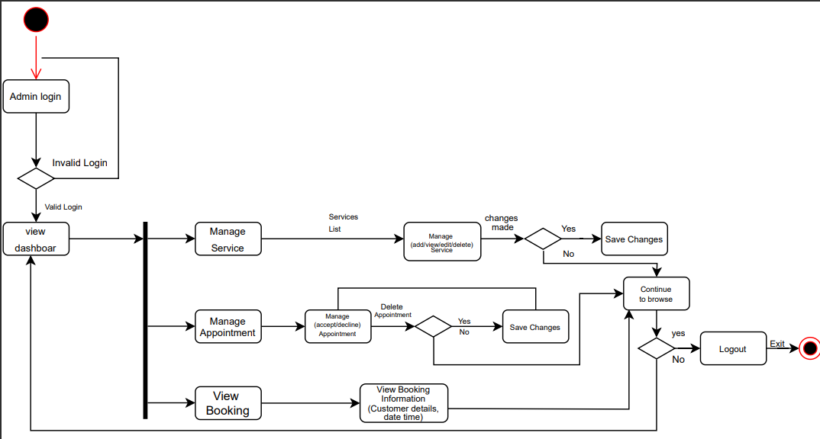

Figure 4 : Admin state chart – overall view of Makeup Service Booking system using state chart through the administrator link

The administrator must log in for verification before accessing the admin dashboard, when they have successfully landed on Makeup Service Booking System for admin page. Upon logging in successfully, the administrator will be taken to the dashboard. There are few events can be triggered:

1. Using CRUD operations which create, read, update and delete, the administrator can manage services that have appeared on the customer-side website.

2. Using CRUD operations, the administrator can manage service categories that have appeared on the customer-side website.

3. The administrator can view and remove a customer's appointment to manage their booking.

Any modifications made to events that make use of CRUD operations will be updated to the dashboard page and stored in the database. If the administrator logs from the admin page, the system will successfully terminate

## View / Model Component

Figure 5: Booking State Chart Model Component

Upon successfully accessing the Makeup Service Booking System from the customer's perspective, they have the option to select from a list of services. Several events may unfold during this process:

1. The customer can select a date and time available on the website to schedule an appointment.

2. The customer is required to complete a booking form, ensuring the successful confirmation of their appointment.

Figure 6: Service State Chart Model Component

If a user successfully navigates to the Makeup Service Booking System’s "Book Now" page (customer side), they can select and book services. Various events are available for them to access:

1. Customers can search for services.

On the other hand, when an administrator successfully accesses the Makeup Service Booking System admin page, they gain the ability to manage the products offered by Makeup Service Booking System. Several events can be accessed:

1. The administrator can add new services.

2. The administrator can edit and update information for existing services.

3. The administrator can delete existing services.

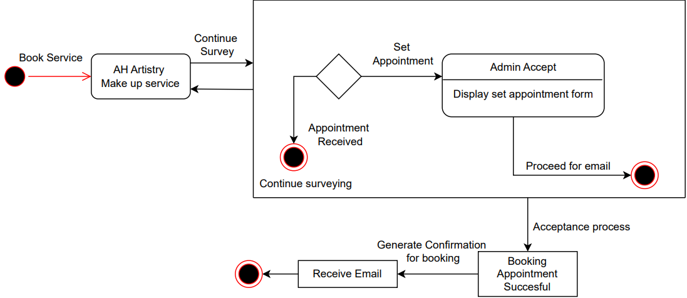

Figure 7: Reservation Checkout state chart model in Products components

On the event of a user successfully landed to the Makeup Service Booking System (customer side) then proceed to confirmation; customer can proceed to reservation. There are few events can be triggered:

1. "Booking Data Entry" event triggered when a customer enters their booking details.

2. "Admin Decline" event triggered when an administrator declines a booking request.

3. "Admin Accept" event triggered when an administrator accepts a booking request.

4. "Generate Confirmation for Booking" event triggered when a booking confirmation is generated.

5. "Receive Email" event triggered when the customer receives an email confirmation for their appointment.

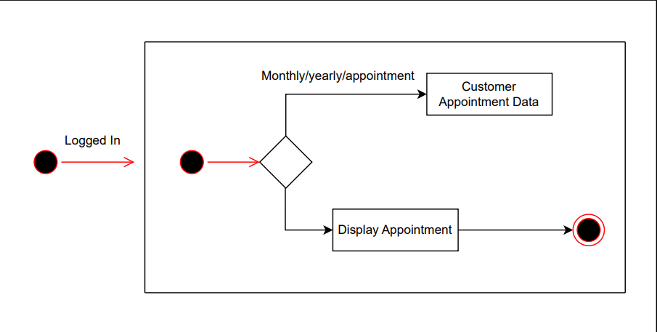

Figure 8: Dashboard State Chart Model Component

On the event of a user successfully landed to the Makeup Service Booking System (administrator view), administrator can view the dashboard. There are few events can be triggered:

1. Administrator can view customer information data.

2. Administrator can view booking order history

Appendix A – Group Log