Software Requirements Specification

for

Makeup Service Booking System

Version 1.0

Prepared by

Group Name: Domino

|  |  |  |
| --- | --- | --- |
| Dayang Nur Alisa Binti Abang Senawi | 77919 | 77919@siswa.unimas.my |
| Emma Farisyah Binti Kamalulil | 77959 | 77959@siswa.unimas.my |
| Ismairizz Bin Mohamad Rizal | 78063 | 78063@siswa.unimas.my |
| Mohamad Nasreen Bin Mohamad | 78166 | 78166@siswa.unimas.my |
| Shahril Aimar Bin Faizal | 78518 | 78518@siswa.unimas.my |
| Syamimi Binti Supian | 78553 | 78553@siswa.unimas.my |

|  |  |
| --- | --- |
| Instructor: | *Ts. Nurfauza Jali* |
| Course: | Software Engineering Lab |
| Lab Section: | *Group 2* |
| Teaching Assistant: | *Ts. Nurfauza Jali* |

|  |  |
| --- | --- |
| Date: | *08 December 2023* |

Contents

Contents 2

Revisions 2

1 Introduction 3

1.1 Document Purpose 3

1.2 Product Scope 3

1.3 Intended Audience and Document Overview 3

1.4 Definitions, Acronyms and Abbreviations 4

1.5 Document Conventions 5

1.6 References and Acknowledgments 5

1.7 Assumptions and Dependencies 5

2 Overall Description 6

2.1 Product Perspective 6

2.2 Product Functionality 7

2.3 Users and Characteristics 9

2.4 Operating Environment 10

2.5 Design and Implementation Constraints 10

2.6 User Documentation 11

2.7 Assumptions and Dependencies 11

3 Specific Requirements 13

3.1 External Interface Requirements 13

3.2 Functional Requirements 14

3.3 Behaviour Requirements 15

4 Other Non-functional Requirements 18

4.1 Performance Requirements 18

4.2 Safety and Security Requirements 18

4.3 Software Quality Attributes 19

5 Other Requirements 20

Appendix A – Data Dictionary 22

Appendix B - Group Log 23

Revisions

| Version | Primary Author(s) | Description of Version | Date Completed |
| --- | --- | --- | --- |
| Draft Type and Number | Full Name | Information about the revision. This table does not need to be filled in whenever a document is touched, only when the version is being upgraded. | 00/00/00 |

# Introduction

## Document Purpose

The purpose of this document is to outline the software requirements for the development of a web application with an integrated booking system for Aiman Hakim Abdul Latif, a successful makeup artist. The product in focus is the web application tailored to streamline and enhance the booking process for Aiman's makeup services. This document will detail the specific features and functionalities that the software should possess to meet Aiman's business needs.

The scope of this Software Requirements Specification (SRS) encompasses the entire web application, emphasizing the booking system as a crucial component. It aims to provide a comprehensive understanding of the system's requirements, ensuring that the development team can proceed with clarity and precision. Additionally, if there are any specific subsystems or modules within the web application, they will be clearly defined to avoid ambiguity in the development process. Ultimately, this document serves as a roadmap for crafting a tailored software solution that aligns seamlessly with Aiman Hakim Abdul Latif's vision for his makeup business.

## Product Scope

The software being specified is a comprehensive web application designed to serve as a robust booking system for Aiman Hakim Abdul Latif's makeup services. The primary purpose is to streamline and optimize the booking process, offering a user-friendly interface for both customer and the makeup artist. The application will facilitate the scheduling of makeup appointments, allowing customers to choose preferred dates, times, and specific services offered by Aiman.

The benefits associated with this product are multifaceted. Firstly, it enhances the overall customer experience by providing a convenient and efficient way to book Aiman's services. Customers can effortlessly browse through available time slots, select their desired makeup package, and confirm their appointments with ease. This not only saves time for both parties but also contributes to customer satisfaction.

From Aiman's perspective, the web application automates the booking management process, reducing administrative overhead. This allows him to focus more on his creative work and less on logistical tasks. Additionally, the system can generate reports and insights into booking trends, helping Aiman make informed decisions to further optimize his business operations. In essence, the web application aims to elevate Aiman Hakim Abdul Latif's makeup business by providing a technologically advanced and user-friendly platform for seamless appointment scheduling.

## Intended Audience and Document Overview

This document, referred to as the Software Requirement Specification (SRS), is crafted to be comprehensible for both our valued customer, Aiman Hakim Abdul Latif, and our respected instructor for the Software Engineering Laboratory course, Madam Nurfauza binti Jali.

For Aiman Hakim Abdul Latif, as the customer, this document provides a comprehensive understanding of the software requirements for the web application and booking system tailored to his makeup business. It outlines the functionalities, features, and benefits associated with the proposed solution. Aiman should focus on the Introduction for context, the Overall Description for a broad overview, and then delve into the Specific Requirements and Non-functional Requirements to gain insights into the technical aspects of the system.

Madam Nurfauza binti Jali, as the professor, would likely be interested in evaluating the completeness and coherence of the document. She can start with the Introduction for a brief overview, followed by the Overall Description to grasp the project's scope and goals. The Specific Requirements section provides detailed technical insights, while the Non-functional Requirements highlight the performance and quality aspects of the proposed solution.

The suggested sequence for reading the document is as follows:

1. Introduction
2. Overall Description
3. Specific Requirements
4. Non-functional Requirements

Following this sequence ensures a logical flow from general context to specific technical details, catering to the needs of both Aiman Hakim Abdul Latif and Madam Nurfauza binti Jali.

## Definitions, Acronyms and Abbreviations

The following are conventionally used.

|  |  |
| --- | --- |
| **Acronyms** | **Definitions** |
| BS | Booking System |
| ER | Entity Relationship |
| MMS | Makeup Management System |
| URS | User Requirements Specification |

## Document Conventions

|  |  |  |  |
| --- | --- | --- | --- |
| **Element** | **Font and Size** | **Spacing and Margins** | **Remark** |
| All text | Arial, Size 11 | Single - spaced |  |
| Section Titles | Arial Bold, Size 18 | Single - spaced |  |
| Subsection Titles | Arial Bold, Size 14 | Single - spaced |  |
| Document Margins |  | 1” |  |
| Yellow Highlights |  |  | Attention required |
| Red Highlights |  |  | Important (Risk involved may cause damage if take lightly) |

## References and Acknowledgments

1. “Guide to Writing a Software Requirements Specification (SRS) Document,” Incora - European software development company.

<https://incora.software/insights/how-to-write-srs-document> (accessed Nov. 11, 2023).

## Assumptions and Dependencies

The dependencies and assumptions regarding of the system is stated below:

* The system relies on the activeness of the admin interacting with the admin dashboard to updating the confirm reservation.
* The reservation is accepted with no changes towards the date of the services once it is updated on the website.
* The admin will receive request reservation through notification via e-mail.
* The admin receiving average of 15 per month or maximum of 30 per month.
* The system is very dependent on real time update on the website for updating the reserved scheduled table.

# Overall Description

## Product Perspective

The Makeup Service Booking System is a web-based platform designed to connect makeup artists which is our customer, Aiman Hakim Abdul Latif and his customers. This system is a recent addition, prompted by the absence of an effective booking system previously in use, indicating the need for a new and improved solution to better manage and facilitate booking procedures.

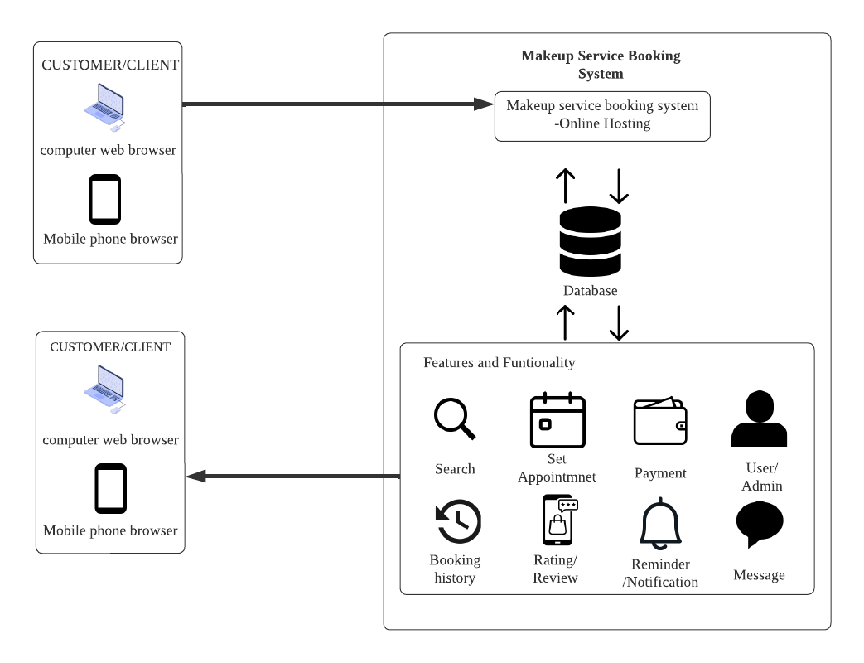

*Figure 1: System Architecture of the Makeup Service Booking System*

Figure 1 above depicts the system architecture of the Makeup Service Booking System to be built, admin and customers can access the web-based system via devices such as PC, laptops, tablets, or even smartphones, but each would have a different type of functionality as a different user in makeup service booking system. It is a comprehensive web application that simplifies the connection between makeup artists and customers. It enables makeup artists to create detailed profiles showcasing their skills, services, and pricing, while customers can effortlessly browse, book appointments, and make secure payments. The system offers transparent access to artist profiles, reviews, and ratings, enhancing decision-making for customers. It streamlines appointment scheduling, provides notifications and reminders, and facilitates direct communication between customers and artists through an in-app messaging system. Additionally, an admin panel oversees the platform, ensuring user satisfaction, resolving disputes, and tracking user engagement data. Overall, this system offers a convenient, efficient, and secure solution for makeup artists and customers, fostering trust and transparency in the makeup service industry.

## Product Functionality

**Makeup Service Booking System provides the following functionality to both end of the system's user:**

**Admin**User Registration and Profile Management:

* Allow users to create accounts and provide necessary information.
* Users should be able to manage their profiles, including contact details and preferences.

Makeup Artist profile:

* Display profiles of makeup artist, including experience, portfolio, and availability.

Service Selection:

* Display a catalog of available makeup services, including descriptions and pricing.
* Allow users to choose specific makeup services they are interested in.

Appointment Scheduling:

* Provide a calendar interface for users to select a date and time for their makeup appointment.
* Ensure that the selected time is available and provide confirmation to the user.

Payment Processing:

* Integrate a secure payment system for users to pay for the selected makeup services.
* Provide electronic receipts and confirmation of payment.

Cancellations and Rescheduling:

* Allow users to cancel or reschedule appointments within a reasonable time frame.
* Implement a cancellation policy, if applicable.

Security Measures:

* Implement secure authentication and authorization mechanisms to protect user data.
* Use encryption for sensitive information, such as payment details.

Accessibility and Responsiveness:

* Ensure the system is accessible to users with disabilities.
* Design the system to be responsive, allowing users to access it from various devices.

Administrator

Service Management:

* Add, edit, or remove makeup services from the catalog.
* Adjust pricing and descriptions as needed.

Appointment Management:

* View a comprehensive calendar of all scheduled makeup appointments.
* Edit or cancel appointments if necessary.
* Assign makeup artists to specific appointments.

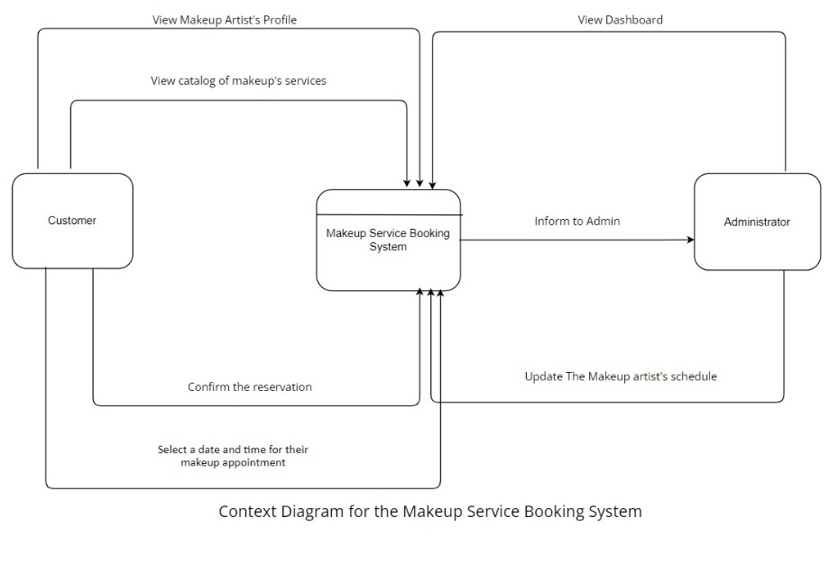

Figure 2: *Context Diagram for the Makeup Service Booking System*

## Users and Characteristics

Makeup Service Booking System caters to 2 types of users; Makeup Service & Booking’s customers and the admin which is the Makeup Artist. Taking into consideration that Makeup Service & Booking customers are from a wide age group, hence the customer's user interface must be user friendly and that customers will be able to use the system with ease. Intuitive design and easy navigation are essential for users with varying levels of technological proficiency. Thus, our group will be designing the customer's user interface based on Makeup Service & Booking’s requirements. As for the admin section, the system hopes to deliver the reservation information swiftly as soon as any new reservation has been placed and the ability to update the makeup artist availability and schedules to continuously improve the platform.

**The important features for the admin dashboard :**

1. Makeup Artist management:

- Simple tools to manage user and artist profiles.

1. Booking Control:

- Centralized system to handle bookings, cancellations, and rescheduling.

1. Calendar and Scheduling:

- User-friendly interface for managing artist availability and schedules.

**The important features for the user dashboard:**

1. User Registration:

- Create an account and set up a profile effortlessly.

1. Service Booking:

- Easily browse, choose, and book services with a simple interface.

1. Artist Profiles:

- Access clear artist profiles with portfolios and reviews.

1. Calendar and Notifications:

- Manage appointments with a user-friendly calendar and receive timely notifications.

1. Cancellation and Refunds:

- Understand clear policies for cancellations, rescheduling, and refunds.

## Operating Environment

Table 1 below shows the system environment for the Makeup Service Booking System. All the mentioned software, hardware and requirements should satisfy the need of the project team members throughout the development phase, and the deployment of both the user's end (Makeup Service Booking System Customer) and the customer's end (Admin).

Makeup Service Booking System is developed using the latest fundamental web development programming technologies. For the front-end side of the project, HTML, CSS, JavaScript will be used. On the back-end side of the project, PHP scripting language and MySQL will be used. These languages are suited towards web development especially in building a small reservation system like Makeup Service Booking System.

|  |  |  |  |
| --- | --- | --- | --- |
| Environment | Software | Hardware | System Requirements |
| Development | Operating system – macOS Mojave | Personal Computers – PCs (Desktop / Laptop / All-In-One PC)    Mobile Devices (Smartphones/Tablets) | Stable Internet Connection (4G/3G Access for those without Wi-Fi) |
| Operating system – Windows 10 |
| Source Code Editor – Visual Studio Code |
| Web Browser – Google Chrome |
| Web Hosting - 000webhost.com |
| Local Hosting  – XAMPP Apache Server |
| Delivered | Web Browser – Google Chrome |
| Email Application – Google Mail Application |
| Email Application – Microsoft Outlook |

## Design and Implementation Constraints

The system has the following constraints:

* Both sides of users (Makeup Service Booking System's customer or Makeup Artist) will need to have a stable internet connection in order to use the system.
* The system does not support multilingual language.
* The system will not be 100% responsive for all smartphones.
* The system does not support multiple currencies. All products and transaction are made in Ringgit Malaysia.
* The system needs to be compatible with various devices and browsers to ensure a seamless user experience for both customers and makeup artist.
* The system will be limited to Kuching and Samarahan only.

## User Documentation

A comprehensive set of user documentation components will be provided to ensure users can effectively understand, navigate, and utilize the system. The user documentation package will include user manuals, online help system and tutorials. A detailed user manual will be provided to guide users through the basic functionalities. It will offer step-by-step instructions with screenshots and examples to help users efficiently use the system. An online help system integrated into the system will provide context-sensitive assistance. Users can access relevant help topics directly within the application, offering guidance on specific features, error messages, and common user queries. This real-time support will enhance the user experience. A series of interactive tutorials will also be included to facilitate a hands-on learning experience for users. These tutorials will cover key workflows, advanced features, and best practices. Users can follow these tutorials at their own pace to deepen their understanding of the system's capabilities.

## Assumptions and Dependencies

Assumptions and dependencies of the system are stated below:

* **Availability of Internet Connectivity**

Assumption: Users will have consistent and reliable internet connectivity when using the makeup service booking system.

Implication: If users face connectivity issues, it may impact their ability to book appointments, receive notifications, and access real-time features.

* **Data Security Compliance**

Assumption: The external payment gateway complies with industry-standard security regulations.

Implication: If the payment gateway does not meet security standards, it could pose risks to sensitive user information, leading to security breaches.

* **Artist Portfolio Updates**

Assumption: Makeup artists will regularly update their portfolios with accurate and representative samples of their work.

Implication: If artists fail to update their portfolios, customers may make decisions based on outdated information, affecting the quality-of-service delivery.

# Specific Requirements

## External Interface Requirements

### User Interfaces

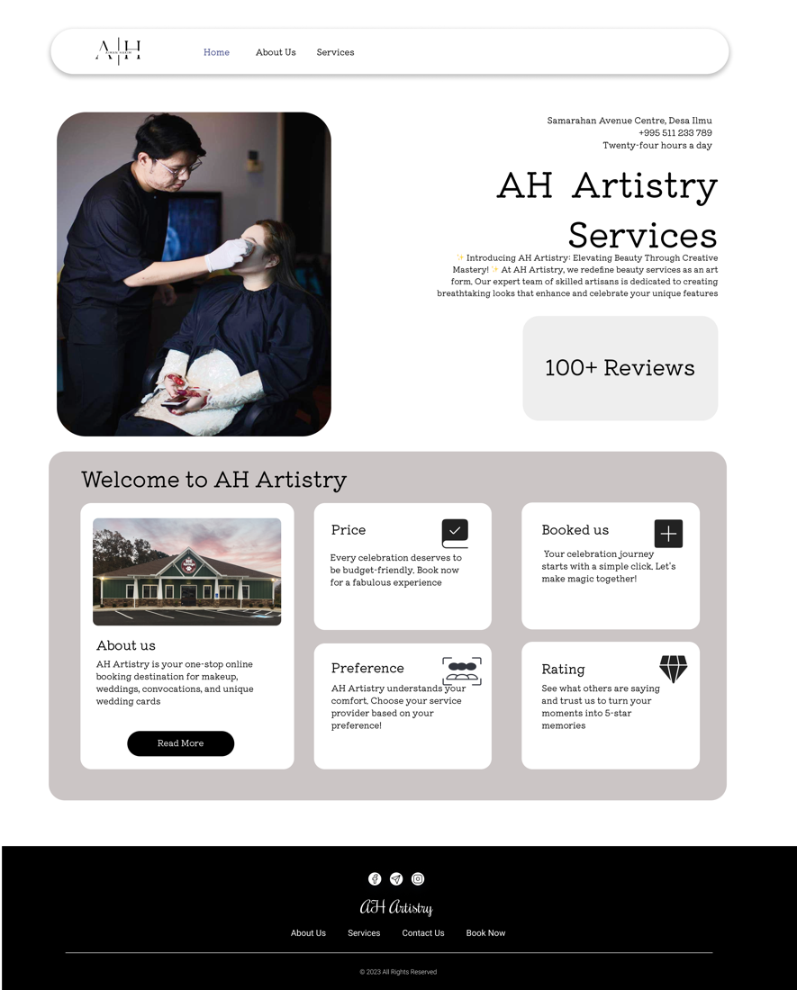

Figure 3: Homepage (Customer)

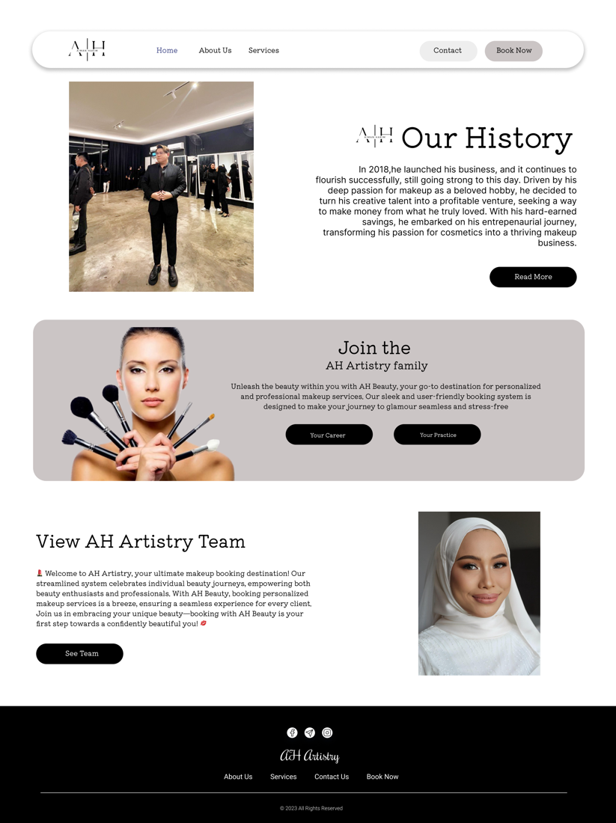

Figure 4: About Us (Customer)

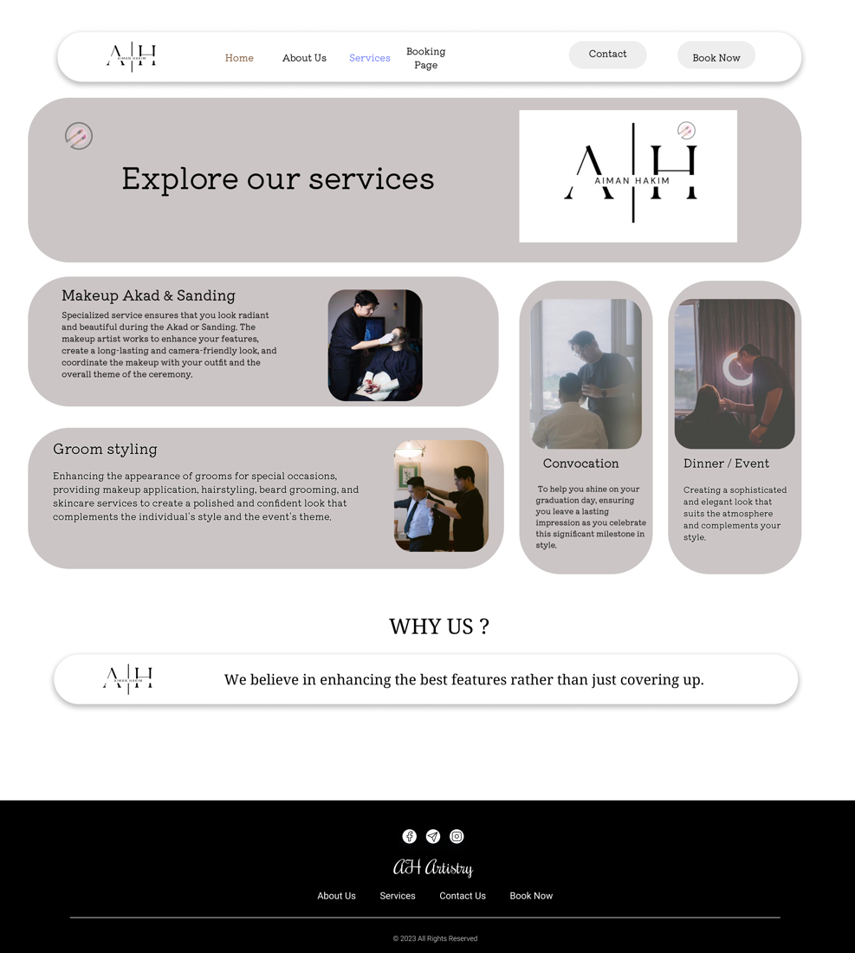

Figure 5: Services (Customer)

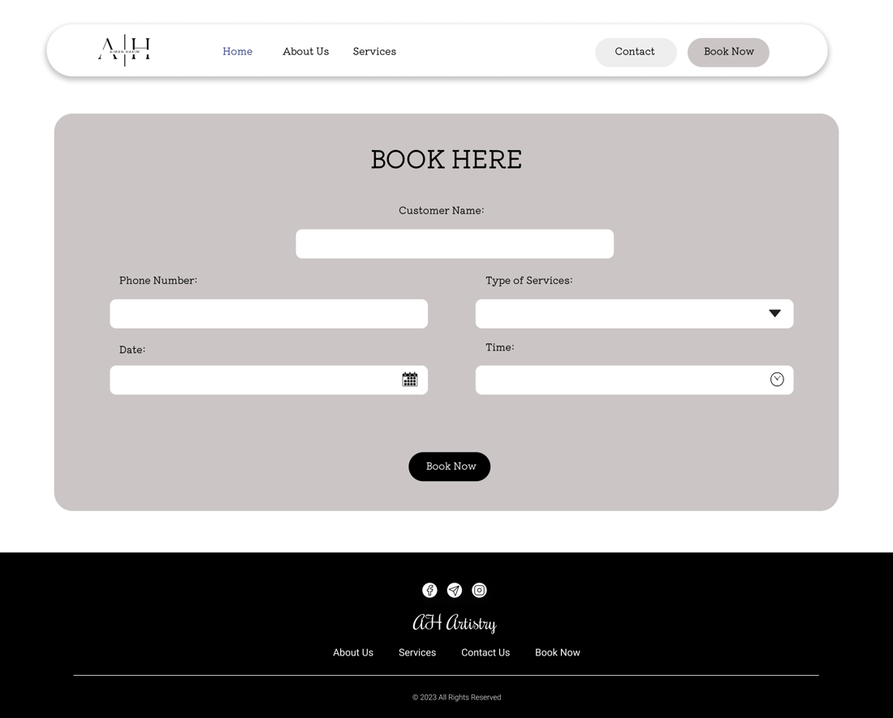

Figure 6: Booking Page (Customer)

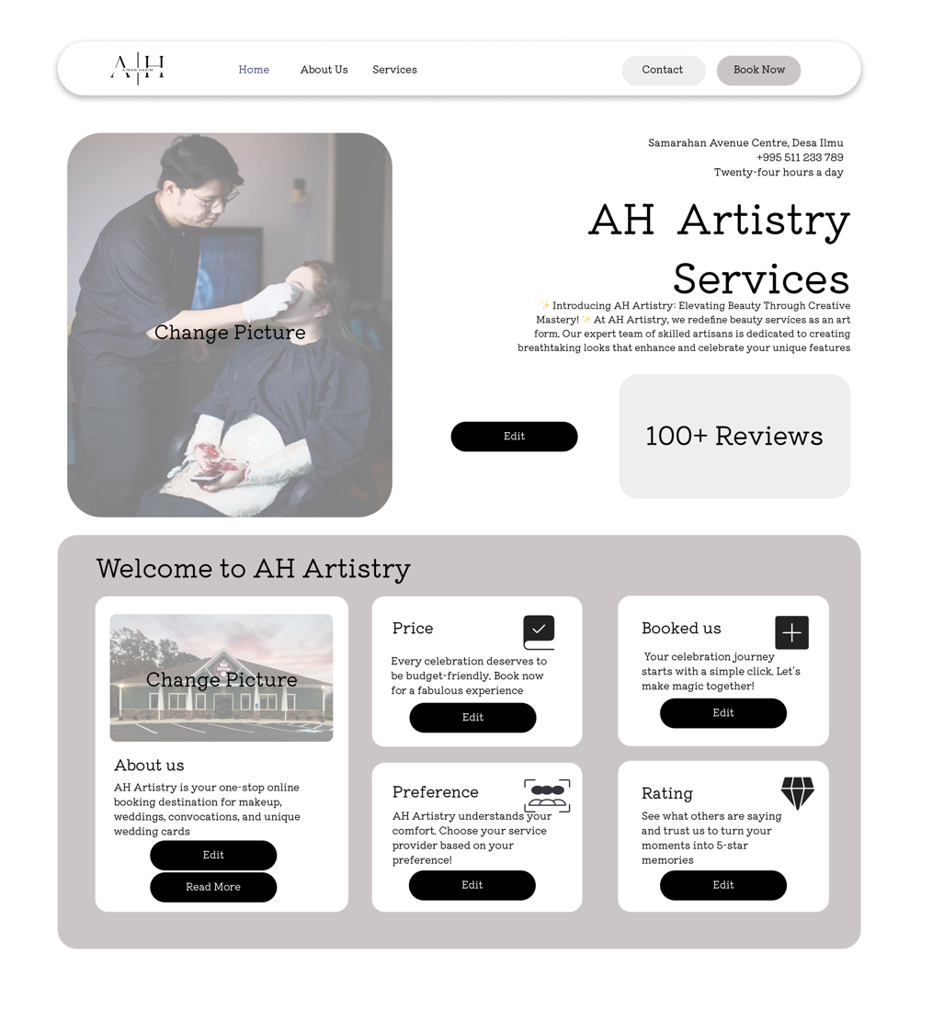

Figure 7: Homepage (Admin)

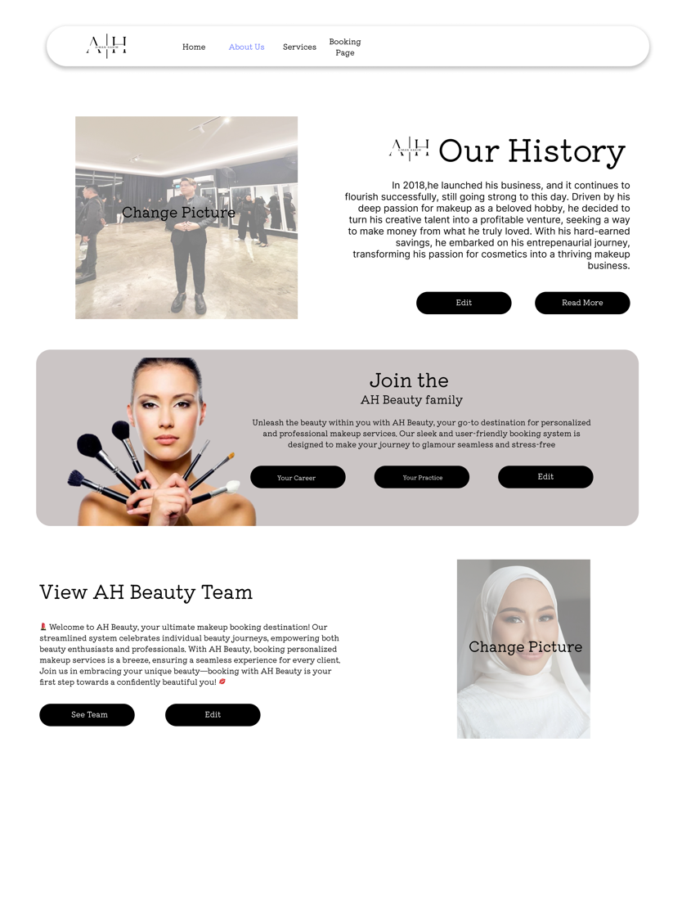

Figure 8: About Us (Admin)

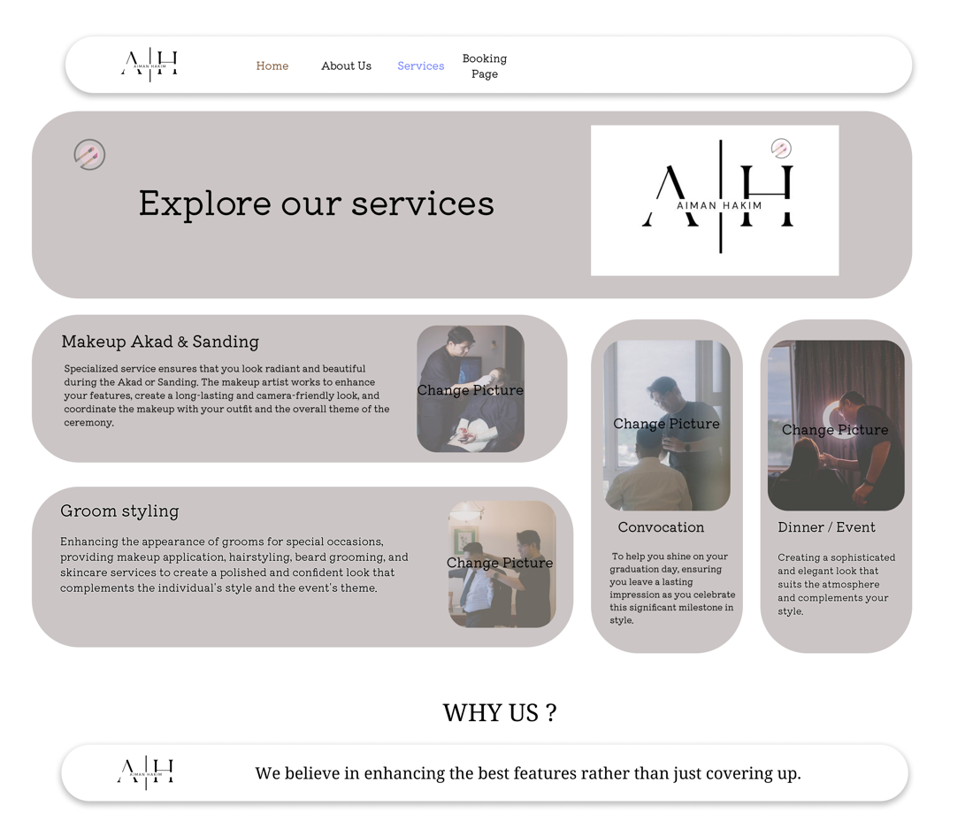

Figure 9: Services (Admin)

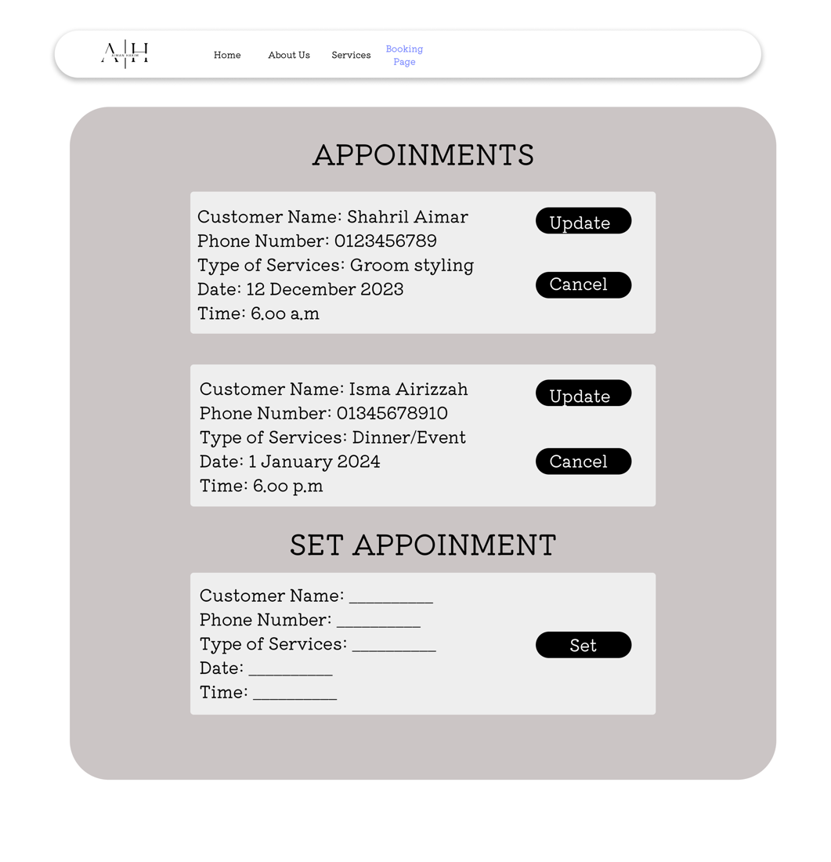

Figure 10: Booking (Admin)

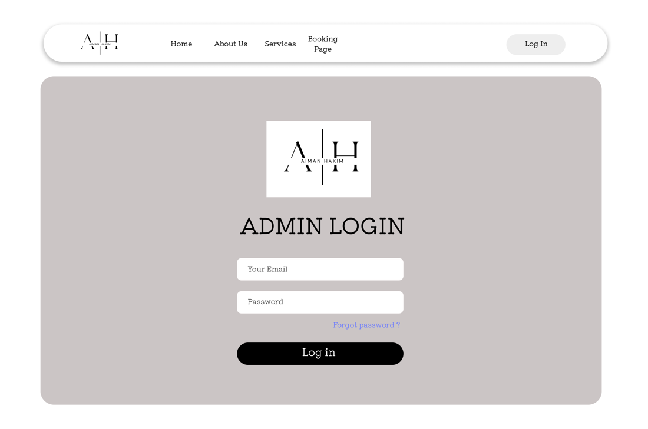

Figure 11: Login (Admin)

### Hardware Interfaces

The Makeup Service Booking System will be compatible to run on all web browsers such as Google Chrome, Internet Explorer or Safari that is installed on any device, be it PCs, Computers or smartphones. It is recommended to run the Makeup Service Booking System on a PC or desktop as the desktop version of the web application is scaled better. Running the Makeup Service Booking System such as interacting with the user interface of the system requires I/O hardware such as a display or a monitor, keyboard and a mouse or a touchscreen for mobile devices. In terms of compatibility, the Makeup Service Booking System will be able to run on all devices provided that the device has a web browser installed with a stable internet connection.

### Software Interfaces

Since the Makeup Service Booking System is a website system, it will be developed using web programming languages. For the front-end section of the web application, the system will be developed using HTML, CSS, JavaScript. For the back-end section of the web application, the system will be developed using the scripting language, PHP and MySQL for the database management system. This web programming languages and framework are used widely in current modern web development. The system must be able to run on all sorts of device if they have a compatible web browser pre-installed such as Google Chrome. The system also must be able to run on cross platforms such as MacOS, Windows OS, Android OS and iOS.

### Communications Interfaces

Devices equipped with a web browser and a stable internet connection will work hand in hand with the web server to communicate with the TCP/IP (Transmission Control Protocol/internet Protocol) as a customer-server system. For the storing, processing and displaying of data stored in the database to the end user, HTTP (Hypertext Transfer Protocol) is used. It works in a way that the customer. (a browser) sends an HTTP request to the Makeup Booking System. The Web system then receives the request, and the server runs an application to process the request. The server then returns and HTTP response (output) to the browser, and the customer receives the response.

For email purposes for both ends (customer and employee), SMTP (Simple Mail Transfer Protocol) will be used. PHPMailer will be integrated to send emails safely and easily via PHP code from the web browser.

For the contact section, a form will be displayed prompting customers to fill in necessary information and details. Once completed, customers will proceed to click the submit button and the information that has been filled by customers will be posted to the Makeup Booking system's official email address using PHPMailer as, PHPMailer integrates will with PHP codes in regard to SMTP.

## Functional Requirements

3.2.1 Customer can view services available

3.2.1.1 Stimulus/Response sequence

|  |  |
| --- | --- |
| Use Case | View Services |
| Short Description | Allowing customers to view Aiman Hakim Artisty’s services offered |
| Actor(s) | Customer |
| Pre-condition(s) | 1. A device that is equipped with a web browser with an active and stable internet connection. 2. Landed on the Aiman Hakim Artistry’s website page. |
| Post-condition(s) | Customer is able to view all of services offered with its detail. |
| Main Flow | 1. Customer clicks the “Services” button at the navigation bar 2. The customer is then directed to the Services page which displays all of the services offered. |
| Alternative Flow(s) | N/A |
| Exception Flow(s) | N/A |

3.2.1.2 Direct Functional Requirements

Table

|  |  |
| --- | --- |
| Requirement | Description |
| REQ-1 | the system must be able to automatically display all the Aiman Hakim Artistry services offered along with the availability. |
| REQ-2 | The system must allow the user to navigate using the navigation bar. |

3.2.2 Customer can book a make-up appointment

3.2.2.1 Stimulus/Response sequence

Table

|  |  |
| --- | --- |
| Use Case | Booking appointment |
| Short Description | Allowing customers book a make-up appointment |
| Actor(s) | Customer |
| Pre-condition(s) | A device that is equipped with a web browser with an active and stable internet connection. |
| Post-condition(s) | Customer will be able to place a booking appointment and the notification will be sent to the Aiman Hakim Artistry’s email. |
| Main Flow | 1. Customer clicks the “Book Now” button at the navigation bar. 2. The customer is then directed to the Booking page which displays the booking form. 3. Customer fills in the booking form. 4. Customer clicks the “Book Now” button at the bottom of the booking form to book. |
| Alternative Flow(s) | N/A |
| Exception Flow(s) | N/A |

3.2.2.2 Direct Functional Requirements

Table

|  |  |
| --- | --- |
| Requirement | Description |
| REQ-1 | the system must be able to allow customer to book the appointment through booking form. |
| REQ-2 | The system must be able to send the notification of the booking to the Aiman Hakim Artistry’s email as the booking form is submitted. |

3.2.3 Admin login

3.2.3.1 Stimulus/Response sequence

Table

|  |  |
| --- | --- |
| Use Case | Admin login |
| Short Description | Login function for admin |
| Actor(s) | Administrator |
| Pre-condition(s) | 1. A device that is equipped with a web browser with an active and stable internet connection. 2. The user has the access to the login page, the link for the login page will only be sent to the Aiman Hakim Artistry |
| Post-condition(s) | The logged in user has the access to all the admin page and features. |
| Main Flow | 1. The admin will be given a link to the login page. Admin enters a specific link to be directed to the login page. 2. [E1] The admin enters email and password. 3. Admin clicks the “Login” button 4. Admin will be logged into the system 5. Admin will be redirected to the admin dashboard page |
| Alternative Flow(s) | N/A |
| Exception Flow(s) | (E1) Admin forgot their email or password, hence need to contact the developer to retrieve the login details. |

3.2.3.2 Direct Functional Requirements

Table

|  |  |
| --- | --- |
| Requirement | Description |
| REQ-1 | The system must have a login page that shows the admin the information and credentials needed to log in. |

3.2.4 Admin can set the make-up appointment

3.2.4.1 Stimulus/Response sequence

Table

|  |  |
| --- | --- |
| Use Case | Set make-up appointment |
| Short Description | To allow the admin to set the make-up appointments, including the details such as name, date, service and price |
| Actor(s) | Administrator |
| Pre-condition(s) | The user must be logged in as admin |
| Post-condition(s) | 1. The appointment is set up and added into the appointment schedule 2. An email of notifying the customer’s that the appointment has been set up is sent to the customer’s email. |
| Main Flow | 1. Admin clicks “Booking Page” button at the navigation 2. In the Set Appointment Form, admin enters the details of the new appointment such as customer’s name, phone number, type of services, date, and time. [E1] 3. Admin clicks “Set” button. |
| Alternative Flow(s) | N/A |
| Exception Flow(s) | (E1) The date and time filled by the admin is clash with the other appointment in the appointment schedule. The Set Appointment form will prompt the error and prompt the admin to fill in the form again. |

3.2.4.2 Direct Functional Requirements

Table

|  |  |
| --- | --- |
| Requirement | Description |
| REQ-1 | the system must be able to allow admin to set up the make-up appointment through the Set-up appointment form |
| REQ-2 | The system must be able to send the notification of the appointment confirmation to the Aiman Hakim Artistry’s email as the Set Appointment form is submitted. |

3.2.5 Admin can update the make-up appointment

3.2.5.1 Stimulus/Response sequence

Table

|  |  |
| --- | --- |
| Use Case | Update make-up appointment details |
| Short Description | To allow the admin to update the details of the make-up appointments, including the details such as service price and appointment status. |
| Actor(s) | Administrator |
| Pre-condition(s) | 1. The user must be logged in as admin. 2. The appointment that will be updated is in the appointment schedule. |
| Post-condition(s) | 1. The appointment details are updated 2. An email of notifying the customer that the appointment details is updated is sent to the customer’s email. |
| Main Flow | 1. Admin clicks “Booking Page” button at the navigation 2. In the Set Appointment Form, admin edit the details of the new appointment including type of service, service price and appointment status. [E1] 3. Admin clicks “Set” button. |
| Alternative Flow(s) | N/A |
| Exception Flow(s) | N/A |

3.2.5.2 Direct Functional Requirements

Table

|  |  |
| --- | --- |
| Requirement | Description |
| REQ-1 | the system must be able to allow admin to set up the make-up appointment through the Update Appointment Details form |
| REQ-2 | The system must be able to send the notification to the customer’s email regarding the appointment details update |

3.2.6 Admin can cancel the appointment

3.2.6.1 Stimulus/Response Sequence

Table

|  |  |
| --- | --- |
| Use Case | Appointments cancellation |
| Short Description | To allow the admin to cancel and remove the make-up appointment from the appointments schedule. |
| Actor(s) | Administrator |
| Pre-condition(s) | 1. The user must be logged in as admin. 2. The appointment that will be cancelled is in the appointment schedule. |
| Post-condition(s) | 1. The appointment details are deleted 2. An email of notifying the customer that the appointment details has been cancelled and removed is sent to the customer’s email. |
| Main Flow | 1. On the appointment schedule, the admin clicks the ‘X’ icon on the specific appointment. 2. Confirmation popup will be prompted with “Confirm” and “Cancel” button. 3. [E1] The admin clicks “Confirm” button. |
| Alternative Flow(s) | N/A |
| Exception Flow(s) | (E1) The admin clicks “Cancel” button on the confirmation popup form. The specific appointment is not removed. |

3.2.6.2 Direct Functional Requirements

Table

|  |  |
| --- | --- |
| Requirement | Description |
| REQ-1 | the system must be able to allow admin to cancel and remove the make-up appointment details from the appointment schedule. |
| REQ-2 | The system must be able to send the notification to the Aiman Hakim Artistry’s email as the appointment is cancelled. |

3.2.7 Admin can create daily Posts

3.2.7.1 Stimulus/Response Sequence

Table

|  |  |
| --- | --- |
| Use Case | Create daily post |
| Short Description | To allow the admin to create a daily post. |
| Actor(s) | Administrator |
| Pre-condition(s) | The user must be logged in as admin. |
| Post-condition(s) | The post created is display on the admin and customer page |
| Main Flow | 1. On the admin homepage, admin clicks “Add Post” in the Post section. 2. Admin write the post and upload the picture of the post. 3. Admin clicks the “Post” button on the Create Post form. |
| Alternative Flow(s) | N/A |
| Exception Flow(s) | N/A |

3.2.7.2 Direct Functional Requirements

Table

|  |  |
| --- | --- |
| Requirement | Description |
| REQ-1 | the system must be able to allow admin to create daily posts |

3.2.8 Admin can edit the About Us page

3.2.8.1 Stimulus/Response Sequence

Table

|  |  |
| --- | --- |
| Use Case | Edit About Us page |
| Short Description | To allow the admin to edit the about us page |
| Actor(s) | Administrator |
| Pre-condition(s) | The user must be logged in as admin. |
| Post-condition(s) | The about us page is updated both in the admin and customer pages. |
| Main Flow | 1. Admin clicks the “About Us” button at the navigation bar. 2. Admin clicks the “Edit” button in the About Us Section. |
| Alternative Flow(s) | N/A |
| Exception Flow(s) | N/A |

3.2.8.2 Direct Functional Requirements

Table

|  |  |
| --- | --- |
| Requirement | Description |
| REQ-1 | the system must be able to allow the admin to edit the About Us page. |

## Behaviour Requirements

### Use Case View

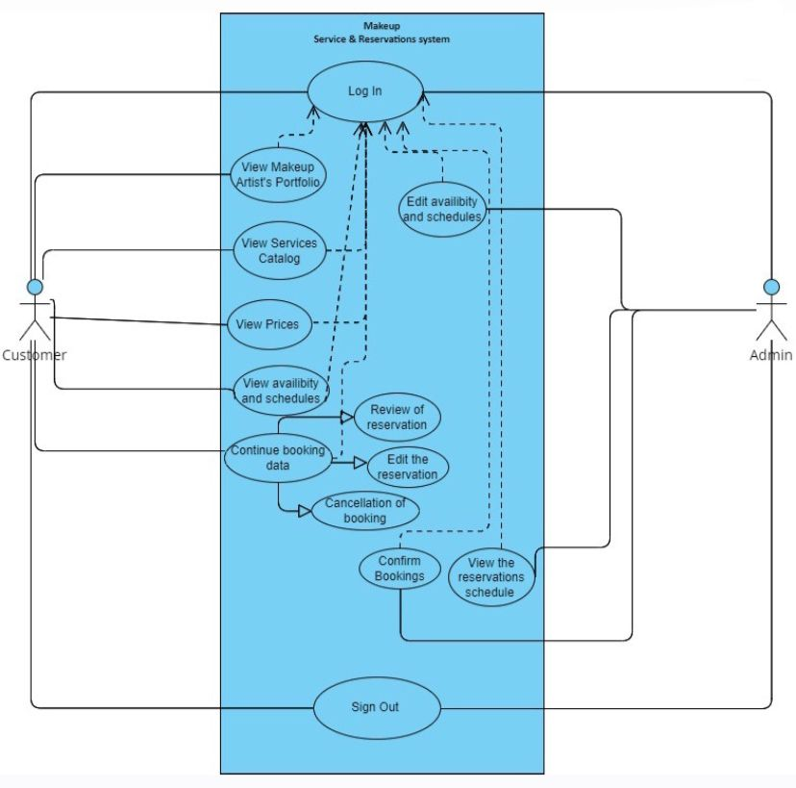

Figure 12: Use Case Diagram for Makeup Service Booking System

Makeup Service Booking System compromises of 2 actors involved, mainly the Makeup Service Booking System’s Customerand the Makeup Service Booking System’s Admin which is the Makeup Artist. The use case diagram consists of 13 use cases involving the mentioned actors respectively. Customer being the main user of the web application, have functionalities such as the user view the makeup artist’s portfolio, selects a specific service based on their preferences, such as occasion, price and style. The users are also able to view the calendar and select a suitable date and time for the appointment. For the administrator side, they are able to login to the system in order to edit availability and schedules. They are also able to manage customer's reservation and view reservation schedules.

Brief description of each use cases on the use case diagram are as below:

1. Login - To allow administrator and Customer to log into the system.
2. View Makeup Artist's Portfolio: Customers explore the portfolios of makeup artists, showcasing their previous work, styles, and expertise. This helps customers make informed decisions about the artist they want to book.
3. View Services Catalog: Customers browse through a catalog displaying the range of makeup services offered. Each service is accompanied by a brief description, allowing customers to understand what is included.
4. View Prices: Customers access a pricing section where they can view the cost of each makeup service. Transparent pricing helps customers make decisions based on their budget.
5. View Availability and Schedules: Customers check the availability and schedules of the makeup artist. The system displays available time slots, allowing customers to choose a convenient date and time for their appointment.
6. Continue Booking Data: Customers seamlessly proceed with the booking process, providing necessary information such as personal details, preferences, and any specific requests related to the makeup service.
7. Review of Reservation: After entering booking details, customers review the information for accuracy.
8. Edit Reservation: Customers can make changes to their existing reservations, such as adjusting the appointment time, selecting a different service, or updating personal preferences.
9. Cancellation of Booking: In case plans change, customers have the option to cancel their booking. The system guides them through the cancellation process, providing any relevant information about refund policies.
10. Edit Availability and Schedules: The admin accesses the system to modify the availability and schedules of makeup artist. This includes adding or removing time slots, updating working hours, and ensuring the system accurately reflects the availability of services.
11. View Reservation Schedules: The admin reviews the reservation schedules, gaining a comprehensive overview of upcoming appointments. This view includes details such as date, time, customer information, and booked services, facilitating efficient management of the makeup appointments.
12. Confirm Bookings : After reviewing the details of a makeup appointment, the admin confirms the booking. This action finalizes the reservation,and ensures the system accurately reflects the confirmed appointment.
13. Sign Out : The admin and Customer securely signs out of the admin and customer portal when their tasks are completed. This helps maintain the security of sensitive information and ensures that unauthorized access is prevented.

### Class Diagram

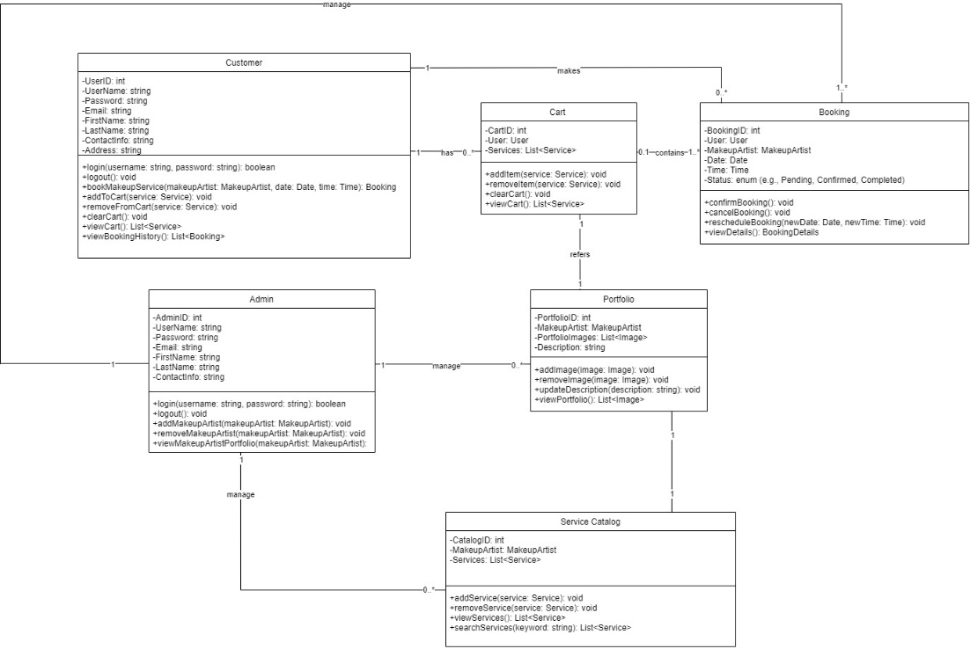

Figure 13: Class Diagram of Makeup Service Booking System

# Other Non-functional Requirements

## Performance Requirements

Five performance criteria have been established from our customer's requirement. The first is that the Makeup Service Booking System is designed to be available around the clock, 24 hours a day, 7 days a week. This ensures that customers can access the platform at their convenience to schedule or modify appointments. The uninterrupted availability is vital for the success of the system, preventing any missed bookings and offering a seamless experience for both customers and admin.

Another requirement for performance is that the Makeup Service Booking System Web Framework must be mobile optimised and prioritizes user experience by providing a user-friendly interface. The layout is designed to be intuitive, allowing customers to easily navigate the platform. Moreover, the system is optimized for mobile devices, acknowledging the trend of customers preferring to use their smartphones for appointment scheduling. This mobile optimization ensures accessibility on various devices and aligns with the familiarity of other service booking systems in the market.

Apart from that, the application must validate the system's performance under real-world conditions, comprehensive load testing should be conducted. This involves subjecting the Makeup Service Booking System to simulated high traffic scenarios to assess its scalability and responsiveness. The goal is to verify that the system can gracefully handle the expected volume of booking requests even during peak usage periods. Load testing will also ensure that response times remain acceptable under varying loads, providing confidence in the system's ability to deliver a consistent and reliable experience for users.

Next the system must be capable of managing heavy traffic, especially during peak hours or when there is a surge in appointment bookings. It should accommodate a high volume of users simultaneously without experiencing downtime. This scalability is crucial as the platform gains popularity and experiences increased usage over time.

The last criterion for success is that the the system operates in real-time, ensuring that customer and admin receive instant updates on appointment availability, confirmations, and any modifications. Real-time functionality is a key feature to facilitate efficient scheduling processes, preventing delays that might disrupt the makeup service workflow. Customers and admin can make timely decisions based on the most up-to-date information available through the platform

## Safety and Security Requirements

**4.2.1** Safety requirements for Makeup Booking System aim to protect user data and prevent unauthorized access, as well as ensure that the system is reliable and stable. Here are some safety requirements for a web log system:

1. Authentication and Access Control: The Makeup Booking System prioritizes user data protection through robust authentication measures. Users must authenticate themselves using secure login credentials, including strong password policies. Additionally, the system integrates multi-factor authentication options to add an extra layer of security. This ensures that only authorized individuals, such as customers and admin, can access the system, safeguarding sensitive booking information.

2. Authorization Mechanisms: The Makeup Booking System implements stringent authorization mechanisms to control user access. Properly defined roles and permissions are established to ensure that users can only access the data and features relevant to their roles. For instance, customers may have access to their own booking history, while admin have authorization to manage their schedules. This level of authorization adds an essential layer of security, preventing unauthorized users from tampering with or accessing confidential data.

3. Data Backup and Recovery: The Makeup Booking System prioritizes the safety and reliability of user data through regular backups and a comprehensive recovery plan. Scheduled backups of all system data are performed to secure customer information and appointment details. In the event of system failure or unexpected data loss, the recovery plan ensures a swift and effective restoration of data to minimize downtime. This commitment to data backup and recovery underscores the system's dedication to preserving the integrity and availability of critical information.

**4.2.2** Security Requirements

1. Authentication and Authorization: The web log system should require users to authenticate themselves before accessing the system, with strong password policies and multi-factor authentication options available. All the billing information given by the customer are stored in the database and protected to prevent any misuse or unauthorized actions that could harm the customer safety. Only certain staff of Makeup Booking System has access to administrator’s credentials as it is kept private for security measures.

## Software Quality Attributes

**Maintainability:** The system should be easily maintainable to accommodate changes and new requirements.

How to achieve: Include detailed documentation within the source code, providing explanations for each module and component. Organize files logically into folders, such as separating backend and frontend code. Adopt a modular design to facilitate easier updates or replacements of specific functionalities without affecting the entire system.

**Usability:** The system should be user-friendly and intuitive, requiring minimal reliance on external documentation.

How to achieve: Design the user interface following modern usability principles. Implement a clean and intuitive layout like popular booking applications. Ensure straightforward navigation with clear labels and minimal steps for users to book appointments. Maintain a standardized colour scheme for consistency and easy recognition of key elements.

**Portability:** The system should be accessible from any supported device, allowing users to make bookings anytime, anywhere.

How to achieve: Develop the system as a web application, ensuring compatibility with web browsers on various devices. Implement a responsive design to adapt to different screen sizes, enabling users to access the booking system seamlessly from desktops, tablets, and smartphones.

**Flexibility:** The system must be flexible enough to run on different web browsers across various devices.

How to achieve: Utilize standard web programming languages like HTML, CSS, JavaScript, and PHP. These languages are widely supported by different browsers and platforms. Test the application on multiple browsers to identify and resolve any compatibility issues, ensuring a consistent experience for users.

**Availability:** The system should be available 24/7 without downtime for users to book appointments.

How to achieve: Host the system on a reliable web hosting service with high uptime guarantees. Implement failover mechanisms to redirect users to a backup webpage with basic functionality in case of downtime. Regularly monitor the system's performance and address any issues promptly to maintain continuous availability.

**Design for Change:** The system architecture should support easy adaptation to accommodate future changes and enhancements.

How to achieve: Employ a modular and scalable architecture, such as a microservices or component-based design. Use design patterns that facilitate flexibility, such as Dependency Injection. Implement version control for the source code to track changes and roll back if necessary. Encourage the use of APIs for integrations, making it easier to extend functionality or add new features without disrupting existing components.

# Other Requirements

<This section is **Optional.** Define any other requirements not covered elsewhere in the SRS. This might include database requirements, internationalization requirements, legal requirements, reuse objectives for the project, and so on. Add any new sections that are pertinent to the project.>

Appendix A – Data Dictionary

***1. Request Reservation Detail***

|  |  |  |  |  |
| --- | --- | --- | --- | --- |
| ***Field Name*** | ***Data Type*** | ***Size*** | ***Description*** | ***Example*** |
| *Request ID* | *Integer* | *10* | *Unique ID for every reservation request that is in the database* | *1* |
| *Customer Name* | *Text* | *80* | *Customer’s Name* | *Fadhulah Binti Hasnah* |
| *Customer Age* | *int* | *2* | *Customer’s Age* | *23* |
| *Customer Email* | *email* | *10* | *Customer’s Email* | *Airds3Id@gmail.com* |
| *Request Reservation Date* | *date* | *20* | *Date of service the customer wanted to reserve* | *14 January 2023* |
| *Request Reservation Time* | *time* | *20* | *Time of the service the customer wanted to have service on.* | *13:20* |
| *Request Reservation Address* | *Text* | *256* | *The address or location of the services the customer wants to have at.* | *326, Jalan Pinang Jawa, Kampung Pinang Jawa, 93050, Kuching* |

**2. Scheduled Reservation**

|  |  |  |  |  |
| --- | --- | --- | --- | --- |
| ***Field Name*** | ***Data Type*** | ***Size*** | ***Description*** | ***Example*** |
| *Reservation ID* | *Integer* | *10* | *Unique ID for every reservation confirmed that is in the database* | *3* |
| *Reservation Name* | *Text* | *80* | *Customer’s Name* | *Kumar bin Kamarudin* |
| *Reservation Date* | *date* | *20* | *Date of service* | *14 January 2023* |
| *Reservation Time* | *time* | *20* | *Time of the service* | *13:20* |

**3.Admin**

|  |  |  |  |  |
| --- | --- | --- | --- | --- |
| ***Field Name*** | ***Data Type*** | ***Size*** | ***Description*** | ***Example*** |
| *Admin Username* | *string* | *10* | *Admin’s username* | *UWAH* |
| *Admin Password* | *string* | *10* | *Admin’s passrword* | *uWa23H* |

Appendix B - Group Log

**TSP Student Information Sheet: Form Info**

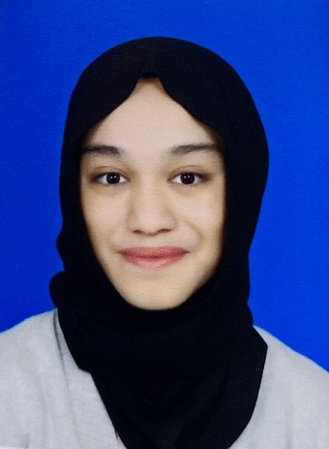

Name: Dayang Nur Alisa Binti Abang Senawi Instructor: Ts Nurfauza Jali

Date: 6th November 2023 Number of College Credits: 51

Major: Software Engineering Expected Graduation Date: 2025

**Briefly describe your relevant experience and interests:**

In Year 2 Semester 1, I have taken a course named Database Analysis and Design, I learned some of the skills that are related to this course which is about Knowledge of the relational model, entity-relationship diagrams, and normalization procedures which are also required and Knowledge of database engines such as MySQL. Besides, when I worked on a project for a course named Web Based System programming project that required both back-end and front-end programming. I enjoy front-end programming because I am interested in providing a positive user experience through the execution of both visual design and code.

**Briefly describe your work on other team projects:**

During my Human Computer Interaction team projects, I work as a creator of a scenario for each of the sample tasks that explains what a user would have to accomplish and what he or she would see step by step when performing a task using a specific system which is for Instagram Page. I created it using a Figma interface design tool.

**Briefly describe any leadership or management positions you have held (at work or in clubs/ organization):**

During my foundation, I was a leader in the mathematics group during online learning, where my responsibilities included supervising the project's proposal, organizing online meetings with the lecturer and team members, assigning duties to team members, and managing the project's progress.

**State your team preferences, if any:**

It is essential that I respect my team members. This entails being aware of their work habits, communication preferences, and personal preferences. It can establish a healthy and productive working atmosphere where everyone feels appreciated and encouraged by showing my respect to my team members.

|  |  |  |  |  |  |  |  |
| --- | --- | --- | --- | --- | --- | --- | --- |
| **List your class schedule and other times when you have scheduled activities such as work, clubs, sports teams, etc.** | | | | | | | |
| Time | Mon | Tues | Wed | Thurs | Fri | Sat | Sun |
| 0800-0900 |  | TMF3113 |  |  |  |  |  |
| 0900-1000 |  |  |  |  | TMF3123 |  |  |
| 1000-1100 | PBM2072 |  |  |  |  |  |  |
| 1100-1200 | PBM2072 | TMF3113 | STU2063 |  |  |  |  |
| 1200-1300 |  | TMF3113 | STU2063 | TMA3083 |  |  |  |
| 1300-1400 |  | TMF3123 | STU2063 | TMA3083 |  |  |  |
| 1400-1500 |  | TMF3123 |  | TMA3083 |  |  |  |
| 1600-1700 |  |  |  |  |  |  |  |
| 1700-1800 |  |  |  | TMF3963 |  |  |  |
| 1800-1900 |  |  |  | TMF3963 |  |  |  |
|  |  |  |  |  |  |  |  |
|  |  |  |  |  |  |  |  |

|  |
| --- |
| Rank from 1 (least) to 5 (most) your preferences for serving in the following team roles: |
| Team Leader 1 2 3 4 5 |
| Development Manager 1 2 3 4 5 |
| Planning Manager 1 2 3 4 5 |
| Quality/Process Manager 1 2 3 4 5 |
| Support Manager 1 2 3 4 5 |

**TSP Student Information Sheet: Form Info**



**Name** **:** Emma Farisyah binti Kamalulil Instructor : Ts. Nurfauza bt Jali

**Date**  **:** 06/11/2023 No. of College Credits : -

**Major** **:** Software Engineering Exp. Graduation Date : 2025

**Briefly describe your relevant experience and interests:**

I've studied the particulars of many different programming languages, learning about their unique features and syntactic structures. I've investigated the varied world of coding, from the logical grace of Python to the precision of C++. Software engineering is my passion because it allows me to use these languages to write creative solutions and use the power of code to make ideas come to life. I'm always fascinated by the world of software development, whether it's creating user-friendly interfaces or designing effective algorithms.

**Briefly describe your work on other team projects:**

In various team projects, I have taken on the role of a leader, guiding the team through collaborative efforts. I excel in organizing tasks, efficiently dividing responsibilities based on team members' strengths, and ensuring a cohesive workflow. Beyond contributing my skills to the project, I take the extra step of proofreading all assignments meticulously to guarantee quality and coherence. My commitment to meeting deadlines is unwavering, as I understand the importance of timely submission in a collaborative environment. Through effective leadership and attention to detail, I strive to foster a productive and successful team dynamic.

**Briefly describe any leadership or management positions you have held (at work or in clubs/ organization):**

I've had the privilege of serving as the head of the entrepreneurship subcommittee within the college's executive committee (exco). In this leadership role, I took charge of guiding and coordinating the team's efforts in fostering entrepreneurial initiatives within the college community. From organizing events to encouraging innovative projects, I aimed to create an environment that nurtured entrepreneurial spirit among students. Balancing strategic planning with hands-on involvement, I worked to ensure the committee's initiatives aligned with our overarching goals, fostering a collaborative and innovative atmosphere within the college.

**State your team preferences, if any:**

I'm ready for anything! Whether it's a solo mission or a team adventure, I'm up for the challenge.

|  |  |  |  |  |  |  |  |
| --- | --- | --- | --- | --- | --- | --- | --- |
| **List your class schedule and other times when you have scheduled activities such as work ,clubs, sports teams, etc.** | | | | | | | |
| Time | Mon | Tues | Wed | Thurs | Fri | Sat | Sun |
| 800-900 |  | Project Management | Introduction to Social Interaction |  |  |  |  |
| 915-1015 |  |  |  | Software Economics |  |  |
| 1030-1130 |  | Project Management |  |  |  |  |
| 1145-1245 |  |  | Software Engineering Laboratory |  |  |  |
| 1300-1400 |  | Software Economics |  |  |  |  |
| 1415-1515 |  |  |  |  |  |
| 1530-1630 |  |  |  |  | Weekly Meeting JPK Dahlia |  |  |
| 1645-1745 | Ethics and Professionalism | Ethics and Professionalism |  | Malay Language |  |  |

|  |
| --- |
| Rank from 1 (least) to 5 (most) your preferences for serving in the following team roles: |
| Team Leader 1 2 3 **4** 5 |
| Development Manager 1 2 3 **4** 5 |
| Planning Manager 1 2 3 **4** 5 |
| Quality/Process Manager 1 2 3 4 **5** |
| Support Manager 1 2 3 4 **5** |

**TSP Student Information Sheet: Form Info**

Name: ISMAIRIZZ BIN MUHAMMAD RIZAL Instructor: Ts Nurfauza Jali

Date: 6/11/2023 Number of College Credits: -

Major:SOFTWARE ENGINEERING Expected Graduation Date: 2025

**Briefly describe your relevant experience and interests:**

I have had the opportunity to lead teams in various settings, such as competitions, events, and projects of different sizes. I have been fortunate to have the opportunity to assume leadership roles within various distinctive teams, composed of members possessing a wide array of exceptional skillsets, often entrusted with such responsibilities by my peers or willingly taking on the role when the situation demanded. My passion lies in tackling diverse challenges, no matter how intricate or demanding they may be. These endeavors typically necessitate the collaboration of a team or an organization for successful execution.

**Briefly describe your work on other team projects:**

Despite my role as leading team members, I often play a support role in providing help to other departments and team members that are struggling or lacking during the team projects. Due to my experience in tackling diverse challenges previously, I often support all members in every department to reduce the team’s pressure in handling the project within the time limit.

**Briefly describe any leadership or management positions you have held (at work or in clubs/ organization):**

Pemimbing Rakan Sebaya (PRS): Chairman  
Silat Seni Cekak: Chairman  
F1 in School (High school): Team Leader  
G6 Dance Event Management (Team Multimedia): Team Leader

**State your team preferences, if any:**

Enthusiastic and passionate teammate.

|  |  |  |  |  |  |  |  |
| --- | --- | --- | --- | --- | --- | --- | --- |
| **List your class schedule and other times when you have scheduled activities such as work ,clubs, sports teams, etc.** | | | | | | | |
| Time | Mon | Tues | Wed | Thurs | Fri | Sat | Sun |
| 800-900 |  | CLASS |  |  |  |  |  |
| 915-1015 |  |  |  |  | CLASS |  |  |
| 1030-1130 |  | CLASS | CLASS |  |  |  |  |
| 1145-1245 |  | CLASS | CLASS | CLASS |  |  |  |
| 1300-1400 |  | CLASS | CLASS | CLASS |  |  |  |
| 1415-1515 |  | CLASS |  | CLASS | SILAT HELANG PUTIH |  |  |
| 1530-1630 |  |  |  |  | SILAT HELANG PUTIH |  |  |
| 1700 -1800 |  |  | SILAT  HELANG PUTIH | CLASS | SILAT HELANG PUTIH |  |  |
| 1800-1900 |  | CLASS | SILAT HELANG PUTIH | CLASS |  |  |  |
| 2000-2100 |  |  | SILAT GAYONG | SILAT  GAYONG |  |  |  |
| 2100-2200 |  |  | SILAT GAYONG | SILAT GAYONG |  |  |  |

|  |
| --- |
| Rank from 1 (least) to 5 (most) your preferences for serving in the following team roles: |
| Team Leader 1 2 3 4 5 |
| Development Manager 1 2 3 4 5 |
| Planning Manager 1 2 3 4 5 |
| Quality/Process Manager 1 2 3 4 5 |
| Support Manager 1 2 3 4 5 |

TSP Student Information Sheet: Form Info

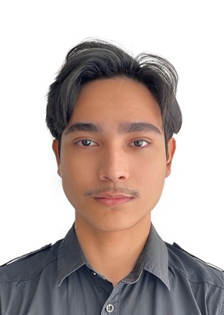

**Name :** Mohamad Nasreen bin Mohamad Razuan **Instructor :** Ts. Nurfauza bt Jali

**Date :** 6/11/2023 **Number of College Credits :** -

**Major :** Software Engineering **Expected Graduation Date :** 2025

Briefly describe your relevant experience and interests:

My interests in software engineering lie in creating elegant and efficient solutions to complex problems. I'm passionate about staying up to date with the latest industry trends and technologies, and I'm particularly excited about machine learning and artificial intelligence. I enjoy collaborating with cross-functional teams and take a proactive approach to problem-solving. My experience and enthusiasm make me an asset to any software engineering project.

Briefly describe your work on other team projects:

In one project, I worked on developing a web-based e-commerce platform, where I collaborated with my team to design the database schema, implement front-end components, and integrate payment gateways. In another project, I took on a leadership role, organizing sprint planning and ensuring our team adhered to agile development practices.

Briefly describe any leadership or management positions you have held (at work or in clubs/ organization):

I am currently serving as the JawatanKuasa Perwakilan Kolej Allamanda, holding the position of leader for the exco sahsian dan kerohanian, and I also serve as the pengerusi Unit pengurusan for Kolej Allamanda's Club. During my tenure, I have acquired numerous skills, including managing students in my club and organization, organizing programs within my college, and fostering a spirit of collaboration among members.

State your team preferences, if any:

I'm ready for anything! Whether it's a solo mission or a team adventure, I'm up for the challenge.

|  |  |  |  |  |  |  |  |
| --- | --- | --- | --- | --- | --- | --- | --- |
| **List your class schedule and other times when you have scheduled activities such as work, clubs, sports teams, etc.** | | | | | | | |
| Time | Mon | Tues | Wed | Thurs | Fri | Sat | Sun |
| 800-900 |  | Project Management | Introduction to Social Interaction |  |  |  |  |
| 915-1015 |  |  |  | Software Economics |  |  |
| 1030-1130 |  | Project Management |  |  |  |  |
| 1145-1245 |  |  | Software Engineering Laboratory |  |  |  |
| 1300-1400 |  | Software Economics |  |  |  |  |
| 1415-1515 |  |  |  |  |  |
| 1530-1630 |  |  |  |  | Weekly Meeting JPK Allamanda |  |  |
| 1645-1745 | Ethics and Professionalism | Ethics and Professionalism | Kayak practise | Malay Language |  |  |

|  |
| --- |
| Rank from 1 (least) to 5 (most) your preferences for serving in the following team roles: |
| Team Leader 1 2 3 4 5 |
| Development Manager 1 2 3 4 5 |
| Planning Manager 1 2 3 4 5 |
| Quality/Process Manager 1 2 3 4 5 |
| Support Manager 1 2 3 4 5 |

**TSP Student Information Sheet: Form Info**



Name : SHAHRIl AIMAR BIN FAIZAL Instructor: Ts. Nurfauza Jali

Date : 06 JANUARY 2023 Number of College Credits: -

Major: SOFTWARE ENGINEERING Expected Graduation Date: 2025

Briefly describe your relevant experience and interests:

I have created an inventory management website as my coursework for computer science subject in form 4 and form 5. I have participated and led my group in Young Innovator Challenge 2018 (YIC 2018). We used Arduino and coding to make a prototype of automatic car tyre inflator for the YIC 2018. In 2022, I have joined a Website Development Program conducted at TEGAS Digital Village and I have worked under company GoBarber and developed a Minimum Viable Product of a website called Rapid Barber. Currently, I am developing IDCTKPT website which is a program held under UNIMAS Entrepreneurship Centre (UEC).

Briefly describe your work on other team projects:

I have always taking a leadership role on multimedia projects in my foundation. One of it is the Keris Sihir UNIMAS multimedia team in 2020. I have participated and won 1st place in music video competition in my foundation as a singer and I have led my team alongside my team member Eric Leon Geom which was the videographer.

Briefly describe any leadership or management positions you have held (at work or in clubs/ organization):

I have led my team in Young Innovator Challenge 2018 (YIC 2018) where we apply our Arduino and programming knowledge into developing an innovation. Besides that, I have led my team alongside Eric Leon Geom in Music Video Competition in our Foundation in 2020. I have taken leadership roles in software engineering course projects and assignments. One of the heavy project that I have led in this course is web based system development.

State your team preferences, if any:

Passionate in working, have a good understanding in a team, being transparent in work where it can be easier to handle and to lead.

|  |  |  |  |  |  |  |  |
| --- | --- | --- | --- | --- | --- | --- | --- |
| **List your class schedule and other times when you have scheduled activities such as work ,clubs, sports teams, etc.** | | | | | | | |
| Time | Mon | Tues | Wed | Thurs | Fri | Sat | Sun |
| 0800-0900 |  | TMF3113 |  |  |  |  |  |
| 0900-1000 |  |  |  |  | TMF3123 |  |  |
| 1000-1100 | PBM2072 |  |  |  |  |  |  |
| 1100-1200 | PBM2072 | TMF3113 | STU2063 |  |  |  |  |
| 1200-1300 |  | TMF3113 | STU2063 | TMA3083 |  |  |  |
| 1300-1400 |  | TMF3123 | STU2063 | TMA3083 |  |  |  |
| 1400-1500 |  | TMF3123 | MUSICAL BAND PRACTICE | TMA3083 | MUSICAL BAND PRACTICE |  |  |
| 1600-1700 |  |  | MUSICAL BAND PRACTICE |  | MUSICAL BAND PRACTICE |  |  |
| 1700-1800 |  |  | MUSICAL BAND PRACTICE | TMF3963 |  |  |  |
| 1800-1900 |  | MUSICAL BAND PRACTICE |  | TMF3963 |  |  |  |
| 1900-2000 |  | MUSICAL BAND PRACTICE |  | MUSICAL BAND PRACTICE |  |  |  |
| 2000-2100 |  | MUSICAL BAND PRACTICE |  | MUSICAL BAND PRACTICE |  |  |  |
| 2100-2200 | MUSICAL BAND PRACTICE |  |  | MUSICAL BAND PRACTICE |  |  |  |
| 2200-2300 | MUSICAL BAND PRACTICE |  |  |  |  |  |  |

|  |
| --- |
| Rank from 1 (least) to 5 (most) your preferences for serving in the following team roles: |
| Team Leader 1 2 3 4 5 |
| Development Manager 1 2 3 4 5 |
| Planning Manager 1 2 3 4 5 |
| Quality/Process Manager 1 2 3 4 5 |
| Support Manager 1 2 3 4 5 |

TSP Student Information Sheet: Form Info



**Name:** Syamimi Binti Supian **Instructor**: Ts Nurfauza Jali

**Date:** 12th December 2023 **Number of College Credits**: -

**Major:** Software Engineering **Expected Graduation Date:** 2025

**Briefly describe your relevant experience and interests:**

When I was in Year 2 Semester 1, I had experience using back end and front-end development in Web Based System Development project. I prefer front-end development because I have an interest in ensuring a good user experience by executing both visual design and code.

**Briefly describe your work on other team projects:**

I work as a graphical user interface designer within a Java development team, where I focus on creating visually appealing and user-friendly interfaces for our software applications.

**Briefly describe any leadership or management positions you have held (at work or in clubs/ organization):**

During my foundation, I served as a leader in the mathematics group, where my responsibilities encompassed supervising the project's proposal, organizing meetings with the lecturer and team members, delegating tasks to team members, and handling survey data management for the project.

**State your team preferences, if any:**

I prefer being part of a team that motivates one another and gives their best effort until the very end.

|  |  |  |  |  |  |
| --- | --- | --- | --- | --- | --- |
| **List your class schedule and other times when you have scheduled activities such as work, clubs, sports teams, etc.** | | | | | |
| Time | Mon | Tues | Wed | Thurs | Fri |
| 0800-0900 |  | TMF3113 |  |  |  |
| 0900-1000 |  |  |  |  |  |
| 1000-1100 | PBM2072 |  |  |  | TMF3123 |
| 1100-1200 | TMF3113 | STU2063 |  |  |
| 1200-1300 | TMF3123 | TMA3083 |  |
| 1300-1400 |  |  |
| 1400-1500 |  |  |  |  |
| 1500-1600 |  |  |  |  |  |
| 1600-1700 |  |  |  |  |  |
| 1700-1800 |  |  |  | TMF3963 |  |
| 1800-1900 |  |  |  |  |

|  |
| --- |
| Rank from 1 (least) to 5 (most) your preferences for serving in the following team roles |
| Team Leader 1 2 3 4 5 |
| Development Manager 1 2 3 4 5 |
| Planning Manager 1 2 3 4 5 |
| Quality/Process Manager 1 2 3 4 5 |
| Support Manager 1 2 3 4 5 |

**Domino Group**

Meeting Minutes

**Location**: Google Meet

**Date**: 27 November 2023

**Attendees**: Dayang Nur Alisa Binti Abang Senawi , Emma Farisyah Binti Kamalulil ,Ismairizz Bin Mohamad Rizal, Mohamad Nasreen Bin Mohamad, Shahril Aimar Bin Faizal, Syamimi Binti Supian

**Absent with apologies**: N/A

**Meeting Objective**: To monitor the progress of Software Requirements Specifications (SRS).

|  |  |
| --- | --- |
| Agenda Item | |
| Discussion: | Ismairizz started the meeting by highlighting the major topics that needs to be done for the Software Requirements Specification documentation. |
| Ismairizz mentioned that he will do the Figma.  Ismairizz also mentioned that he will be doing data dictionary section of the SRS. |
| Alisa mentioned that she will be designing the use case diagram and taking the overall description of the SRS. |
| Emma mentioned that she will be doing the group log and the first half of the non-functional requirements section of the SRS. |
| Nasreen mentioned that he will be taking the other half of the non-functional requirements and will be designing the first half of the sequence diagram of the SRS. |
| Syamimi mentioned that she will do the introduction and half of the specific requirements. |
| Shahril mentioned that he will be taking the other half of designing the Sequence Diagram and half of the specific requirements. |
| Everyone agreed to do their parts responsibly, efficiently and to deliver the SRS on the given time. |
| Decision: | Task distribution for the SRS documentation has been decided. |
| Meeting adjournment | Meeting adjourned at 3:30 PM. |

**Domino Group**

Meeting Minutes

**Location**: Google Meet

**Date**: 5th December 2023

**Attendees**: Dayang Nur Alisa Binti Abang Senawi , Emma Farisyah Binti Kamalulil ,Ismairizz Bin Mohamad Rizal, Mohamad Nasreen Bin Mohamad, Shahril Aimar Bin Faizal, Syamimi Binti Supian

**Absent with apologies**: N/A

**Meeting Objective**: To update the progress on the Software Requirements Specifications (SRS) documentation.

|  |  |
| --- | --- |
| Agenda Item | |
| Discussion: | Ismairizz started the meeting by highlighting his progress update on the SRS. Ismairizz mentioned that he had completed the data dictionary and designing the Figma. |
| Emma mentioned that she is 80% completed on the group log and the first half of the nonfunctional requirements of the SRS. |
| Alisa mentioned that she had finish drafting the use case diagram for the system and, she had finished the overall description section of the SRS. |
| Nasreen mentioned that he had finish drafting the sequence diagram for the system. He mentioned that he is almost done with the other half of the non-functional requirements. |
| Syamimi mentioned that she had completed both Introduction and half of the specific Requirements. |
| Shahril mentioned that he is 70% completed on designing the other half of the sequence diagram and completed the other half of the specific Requirements. |
| All team members agreed that the SRS is at 85% to completion and that the SRS must be completed on 8th December 2023. |
| Decision: | SRS is at 85% to completion and will be completed on 8th December 2023. |
| Meeting adjournment | Meeting adjourned at 5:30 pm. |