Artificial Intelligence Lab Project Report

Medical Student Data-set

Group no : 19

Group Member info -

Name : Sudiptha Roy
ID : 23101044

Name : Shahrin Tabassum
ID : 22299127

Table of Contents

1. Introduction
2.Dataset Description
- Dataset Overview
- Number of Features and Data Points
- Problem Type (Classification or Regression)
- Feature Types (Quantitative / Categorical
- Encoding of Categorical Variables (Need and Justification)
- Correlation Analysis (Heatmap)
- Imbalanced Dataset Analysis

3. Dataset Pre-processing
- Null / Missing Values
- Categorical Values
- Feature Scaling
- Handling Missing Values
- Encoding Categorical Variables
- Scaling Methods

4. Dataset Splitting
- Train-Test Split (70%–30%)
- Stratified Splitting

5. Model Training (Supervised Learning)
- Decision Tree Classifier
- Logistic Regression
- Neural Network (MLP Classifier)
6.Model Testing
- Precision and Recall Comparison
- Confusion Matrix Analysis
- F1 Score Analysis
- AUC Score and ROC Curve
7.Apply Unsupervised Learning
8.Conclusion

Introduction:
This project aims to predict whether a medical student has diabetes based on their health records and lifestyle attributes. The problem is a binary classification problem where the target variable is diabetes. To learn and compare machine learning models to predict the case is the key motivation.

Dataset description :
The name of our dataset is Medical Student Data-set.
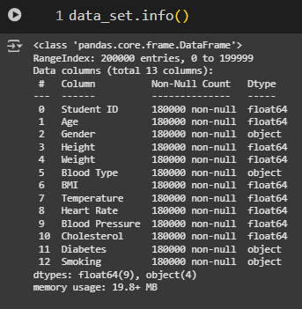

Here are a total of 200,000
data points and 13 columns,
where Diabetes is my target column, so the remaining 12 columns are features.

We will perform classification.
problem in this data-set as our
Target value is categorical ((Yes/No).
not continuous.

Yes, I need to encode categorical
variables because models like
KNN, Logistic Regression, and
Neural Network are sensitive and
only accept numerical values. So,
we have to encode categorical values
into numerical discrete values.
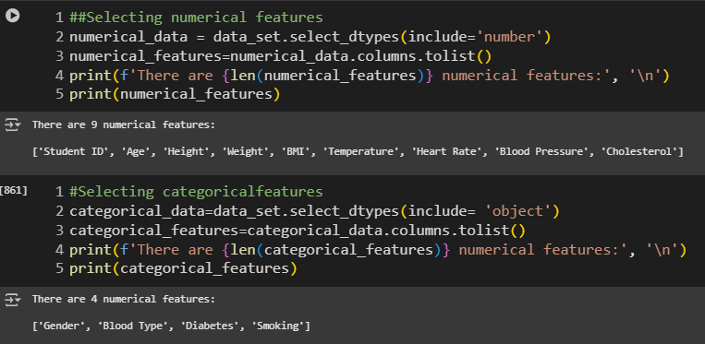

There are 9 numerical features:
['Student ID', 'Age', 'Height', 'Weight', 'BMI', 'Temperature', 'Heart Rate', 'Blood Pressure', 'Cholesterol']
There are 4 categorical features:
['Gender', 'Blood Type', 'Diabetes', 'Smoking']
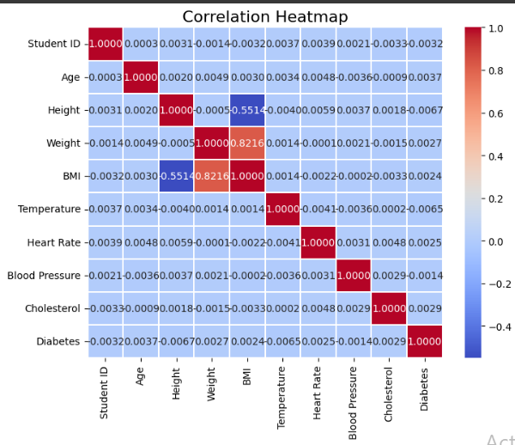

6.thttttttt

There are some strong co-relation between Height , Weight and BMI and rest of all have weak co-relation

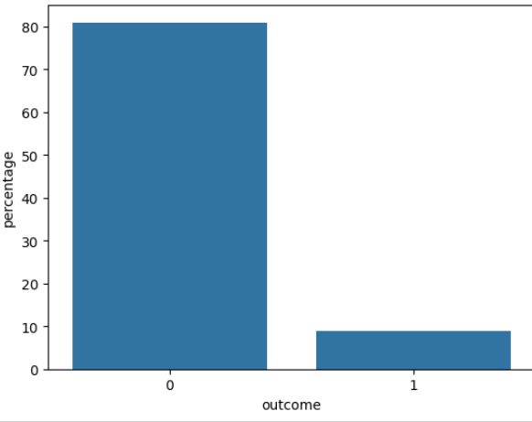

Imbalanced :
The target feature, diabetes, is imbalanced.
- Class 0 (No diabetes) has more data points than Class 1 (Diabetes).
- Represented with a bar chart showing class distribution.

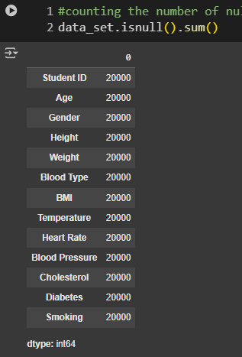
Dataset pre-processing :

There are null values in almost every
group, with about 20,000 null values in each
group, which is problematic as our model
does not work if null values exist. So, we
have to fix this by either setting a fixed
value for nulls or by replacing them with
the mean value of each group.

For this reason we drop a column named
BML as it has the lowest correlation between
out desire target . as a result now out feature
became 11 .

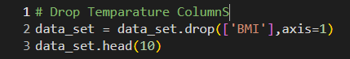

As we know, machine learning model like KNN , logistic regression and neural network cannot handle NAN value so we also have to drop some Null value .
Here we drop a specific class NAN value .and the class is diabetes .Moreover in some cases the label is numerical value label then we handle the missing value but mean value . -SimpleImputer(strategy="mean")

Encoding is very important part of preprocessing as it make the data set useable for machine learning model in simple it convert categorical data into numerical data
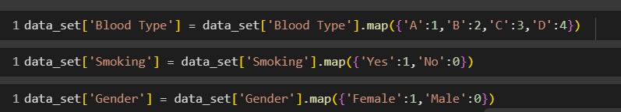

Scaling :
We use scaling instead of raw data because Without scaling, models like KNN,
Logistic Regression, and Neural Networks give more importance to larger numbers just because of their range, not because they are more important . Scaled data ensures all features contribute equally, improving performance and accuracy.
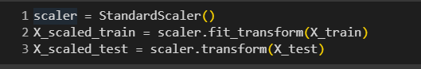

Here we use standardbscaler method

Dataset splitting
For feeding our model, we need data, and we split the data from our main dataset into train data and test data in a 70% - 30% ratio.
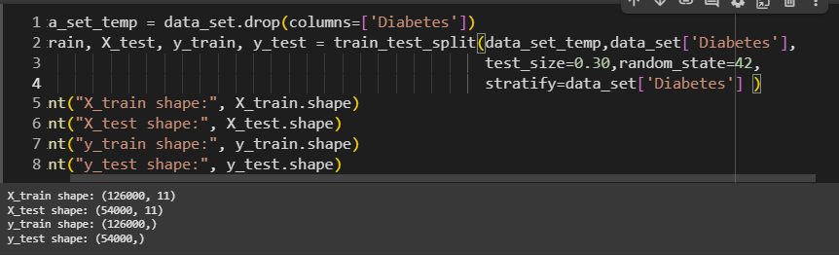

Model training & testing (Supervised)
Logistic Regression is a classification algorithm that predicts the probability of a data point belonging to a certain class ( 0/1). Instead of giving a continuous value like Linear Regression, it uses the sigmoid function to output probabilities between 0 and 1. Finally, it assigns the class based on a thresh
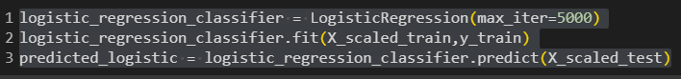
old (usually 0.5).

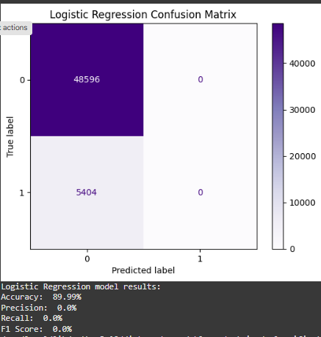

Here in this model, we faced a serious issue because we got precision and recall as zero. So, it is not a useful model. This indicates that the model failed to correctly identify the positive class (Diabetes).the main reason behind ir .Imbalanced dataset

  - 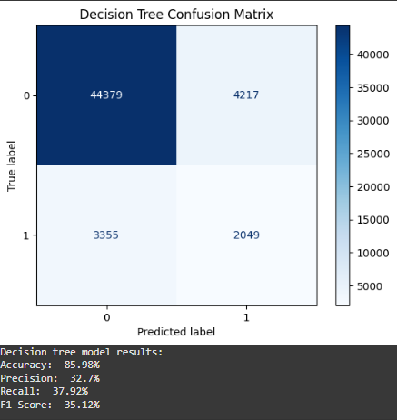
What is a Decision Tree:
A Decision Tree is a supervised machine learning algorithm used for classification and regression.It works like a flowchart:

Accuracy (85.98%)
The model classified almost 86% of students correctly overall. At first glance, this looks like a good performance. However, accuracy can be misleading in medical problems because the dataset may be imbalanced (more "No" than "Yes" for diabetes).
Precision (32.7%)
Out of all the students predicted as diabetic by the model, only 32.7% were actually diabetic. This is quite low, meaning the model produced many false positives (healthy students predicted as diabetic).
Recall (37.92%)
Out of all actual diabetic students, the model was able to correctly identify only 37.92%. This is also very low, meaning the model missed many diabetic students (false negatives). In medical prediction, low recall is a serious problem because failing to detect diabetic cases can have harmful consequences.
F1 Score (35.12%)
The F1 Score is the balance between precision and recall. At 35.12%, it confirms that the model did not achieve a good balance and struggled to properly classify diabetic cases.

Neural Network :
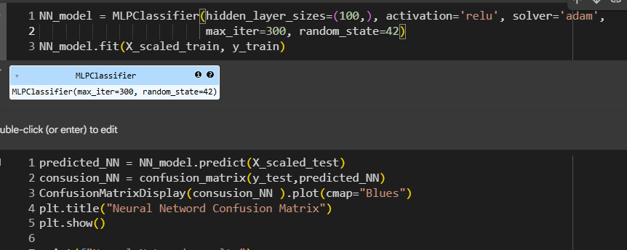

A Neural Network is a machine learning model inspired by the human brain.
It is designed to learn patterns from data by adjusting connections

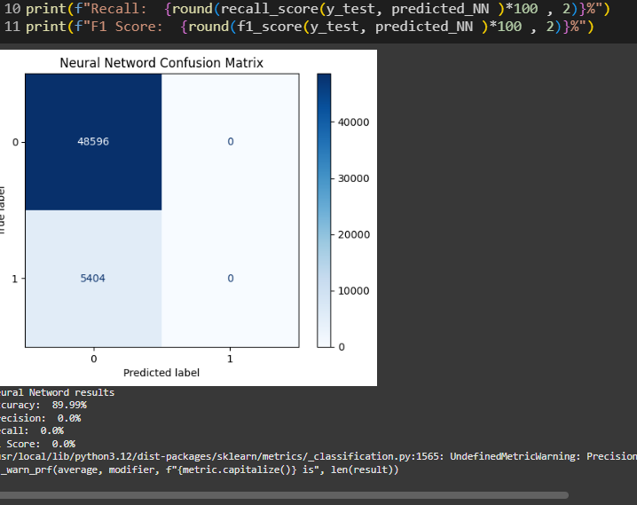
Accuracy (89.99%)
- The model correctly predicted ~90% of students overall.
- Misleading due to class imbalance: the majority class (non-diabetic) dominates predictions.
Precision (0.0%)
- The model predicted zero students as diabetic, so it has no true positives.
- Indicates all positive predictions are missing.
Recall (0.0%)

- Out of all actual diabetic students, the model identified 0%.
- This is critical in medical prediction since failing to detect diabetes is dangerous.

F1 Score (0.0%)
- With both precision and recall at 0, the F1 Score is 0, confirming that the model fails entirely for the diabetic class.

Now by AUD:
AUD represent how much the model is capable of distinguishing between classes.
AUD = 1 then the model iod perfect
If AUD > 5 then the model has some flaw
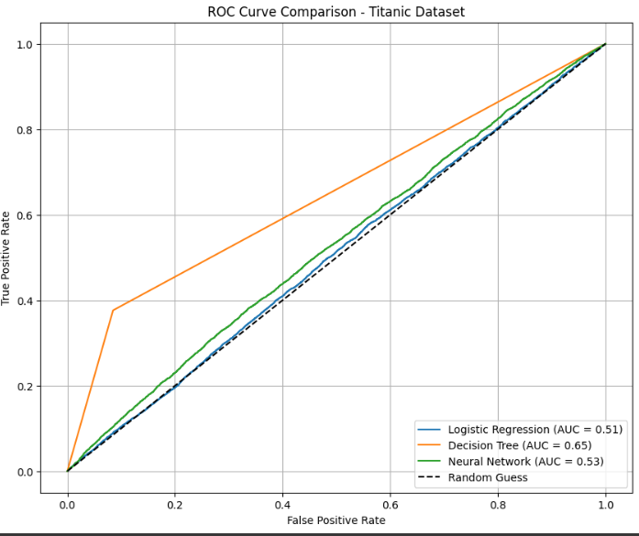

Here Logistic Regression AUD is 0.51 which is not good at all on the other hand
Decision tree model perform better the previous one again Neural network model also fail here . and all happened because of imbalance of data set

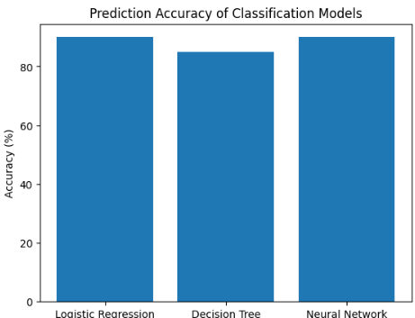

Here we see among this 3 model logistic regression and Nural network accuracy is good but it misleading due to imbalance od data-set so decision accuracy is but beeter then those 2 model

Apply Kmean Clustaring :
Here we cluster our all datapoint into 3 group and set random seed = 42 . and it is a seed which control randomness .
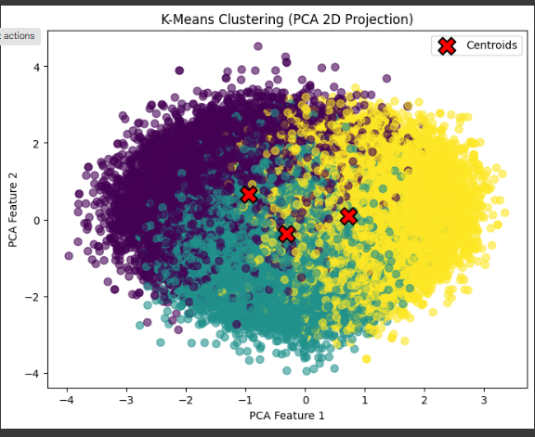

Conclusion :
Logistic Regression and Neural Network achieved high accuracy (~89.99%) but precision, recall, and F1 score = 0%.This means they predicted almost all students as Non-Diabetic .Decision Tree gave lower accuracy (~85.98%), but better precision (32.7%) and recall (37.9%), meaning it can detect some diabetic students, although not very well.
Due to Severe Class Imbalance: If 90% students are “No” and only 10% are “Yes,” models predict “No” to get high accuracy but fail to catch the minority clas
Challenges -
- Imbalanced dataset: Models ignore the minority class.
- Every Group has 20000 missing value to handle this amount missing value almost 10 percent od dataset is difficult . Moreover make the null value to mean is not also better option .
- Logistic Regression and Neural Network are sensitive to imbalance.

