Lab 1: Working with Java and Eclipse IDE

Goals

Learn and understand the process of:

➢ Setting environment variables

➢ Creating a simple Java Project using Eclipse 3.0 or above

Time

45 minutes

1.1: Setting environment variables from CommandLineSolution:

Step 1: Set JAVA_HOME to Jdk1.8 using the following command:

• Set JAVA_HOME=C:\Program Files\Java\jdk1.8.0_25

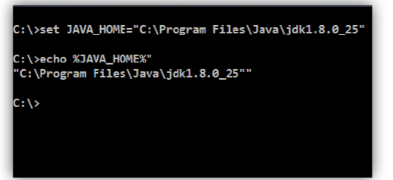

Figure 1: Java program

Step 2: Set PATH environment variable:

• Set PATH=%PATH%;%JAVA_HOME%\bin;

Step 3: Set your current working directory and set classpath.

• Set CLASSPATH=.

Note: Classpath searches for the classes required to execute the command. Hence it must be set to the directory containing the class files or the names of the jars delimited by ;

For example: C:\Test\myproject\Class;ant.jar

Alternatively follow the following steps for setting the environment variables

Alternate approach:

Step 1: Right click My Computers, and select Properties→Environment Variables.

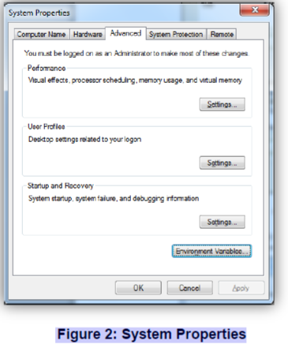

Step 2: Click Environment Variables. The Environment Variables window will be displayed.

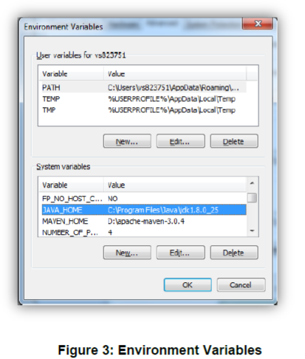

Step 3: Click JAVA_HOME System Variable if it already exists, or create a new one and set the path of JDK1.8 as shown in the figure.

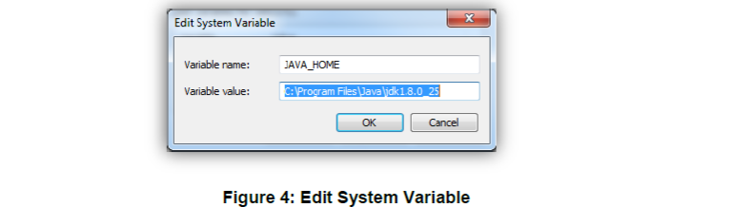

Step 4: Click PATH System Variable and set it as %PATH%;%JAVA_HOME%\bin.

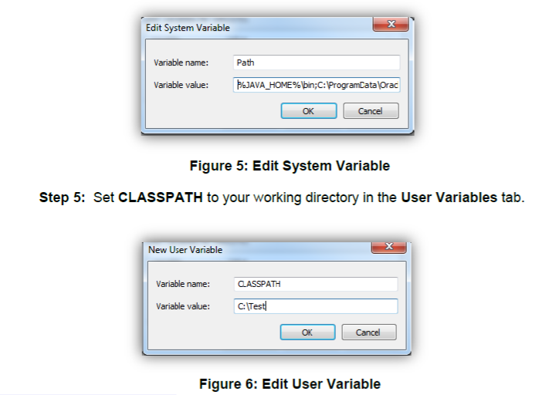

1.2: Create Java Project

Create a simple java project named ‘MyProject’.

Solution:

Step 1: Open eclipse 4.4(or above)

Step 2: Select File→New→Project →Java project.

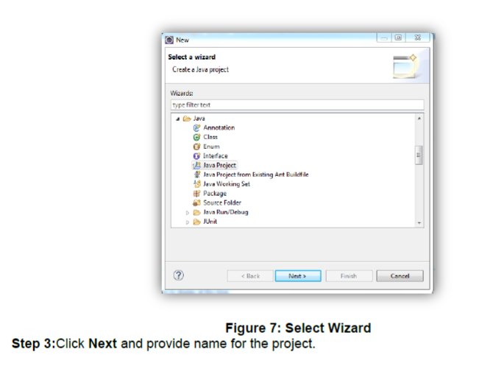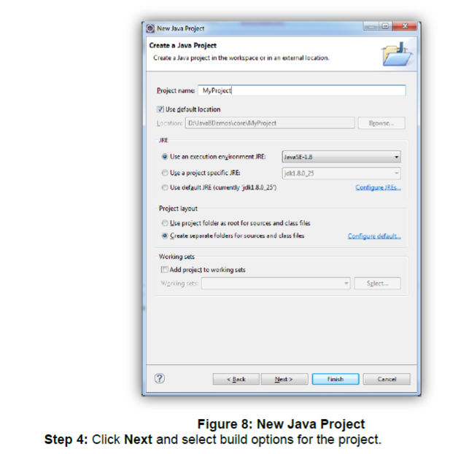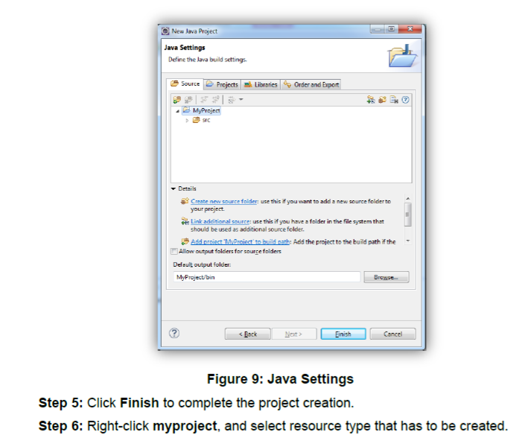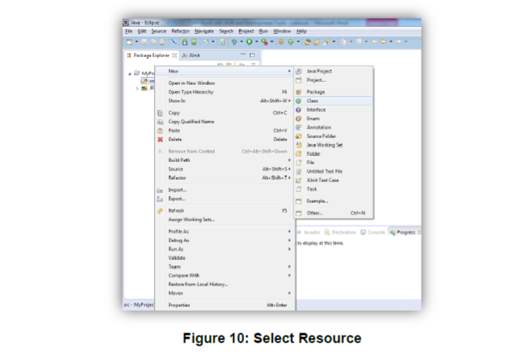

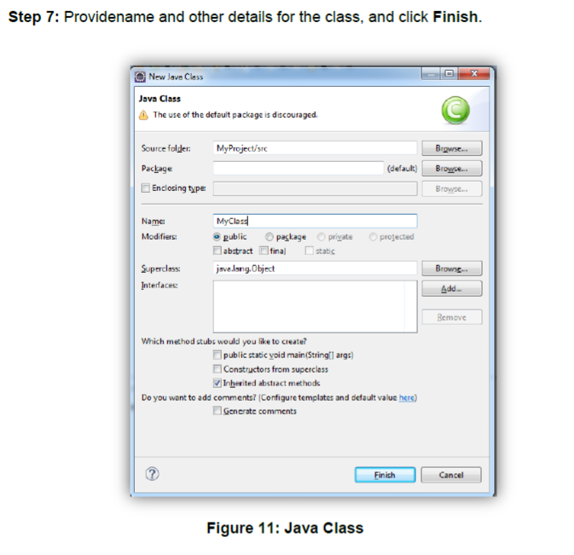

This will open MyClass.java in the editor, with ready skeleton for the class, default constructor, main() method, and necessary javadoc comments.

To run this class, select Run from toolbar, or select Run As →Java application. Alternatively, you can select Run..and you will be guided through a wizard, for the selection of class containing main() method.

Console window will show the output.

1.3: Using offline Javadoc API in Eclipse

Step 1: Open eclipse 4.4(or above)

Step2:From eclipse Window → Preferences →Java → "Installed JREs" select available JRE (jdk1.8.0_25 for instance) and click Edit.

