Generate overloaded constructor in eclipse

Rt click on code area-> Source-> Generate constructor using fields

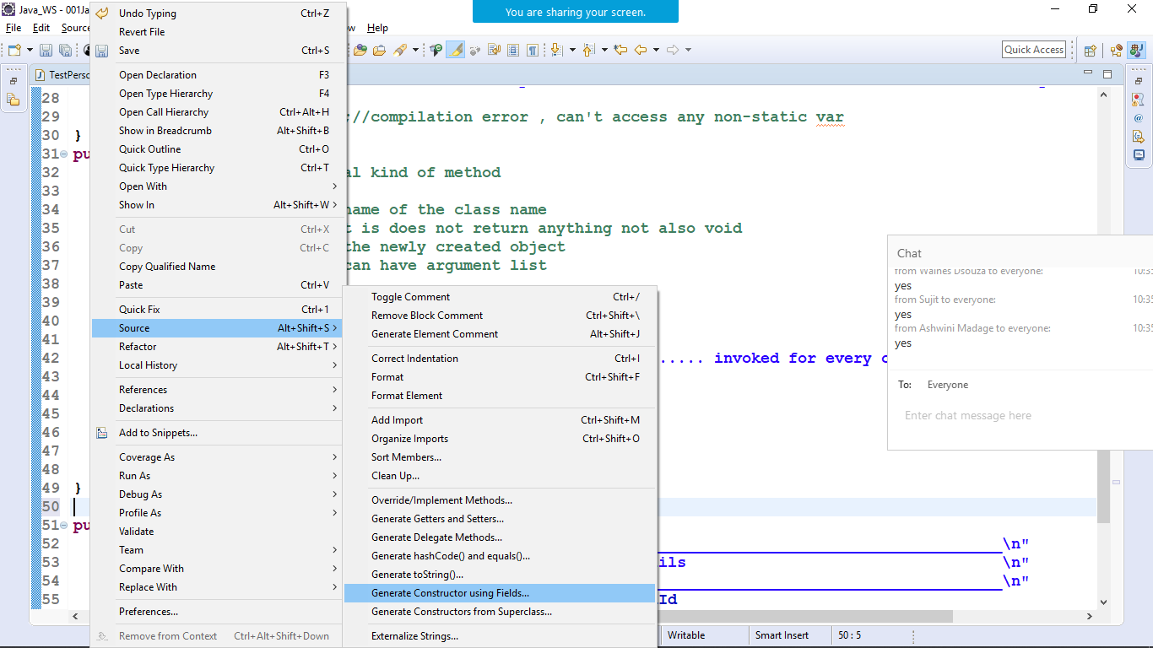

Select all the field

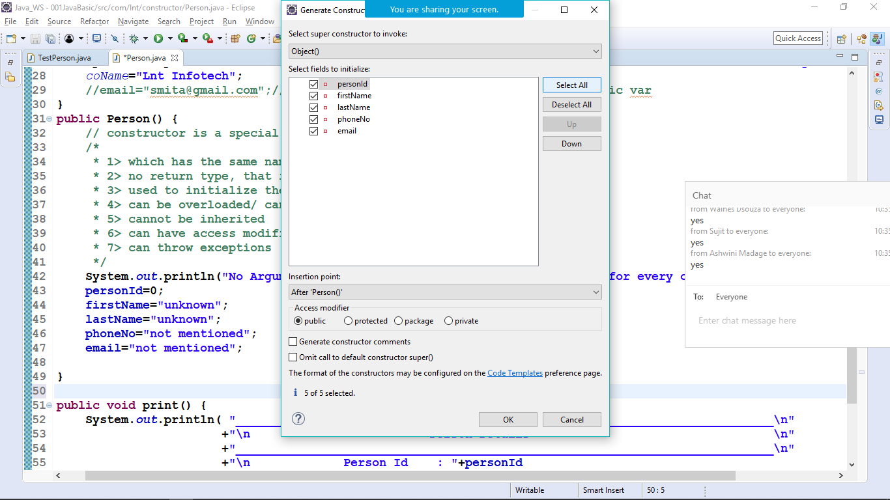

Hit ok

Then the overloaded constructor will be generated

**//local variable -passed through arg list or defined within the method**

**//local var name and instance var name are same**

**//in such case we use explicitly this keyword to refer to instance var**

**public Person(int personId, String firstName, String lastName, String phoneNo, String email) {**

**super();//Inheritance**

**this.personId = personId;//this is a keyword which refers to current object in java**

**this.firstName = firstName;**

**this.lastName = lastName;**

**this.phoneNo = phoneNo;**

**this.email = email;**

**}**

//Inorder to access private instance var lets generate getters and setters

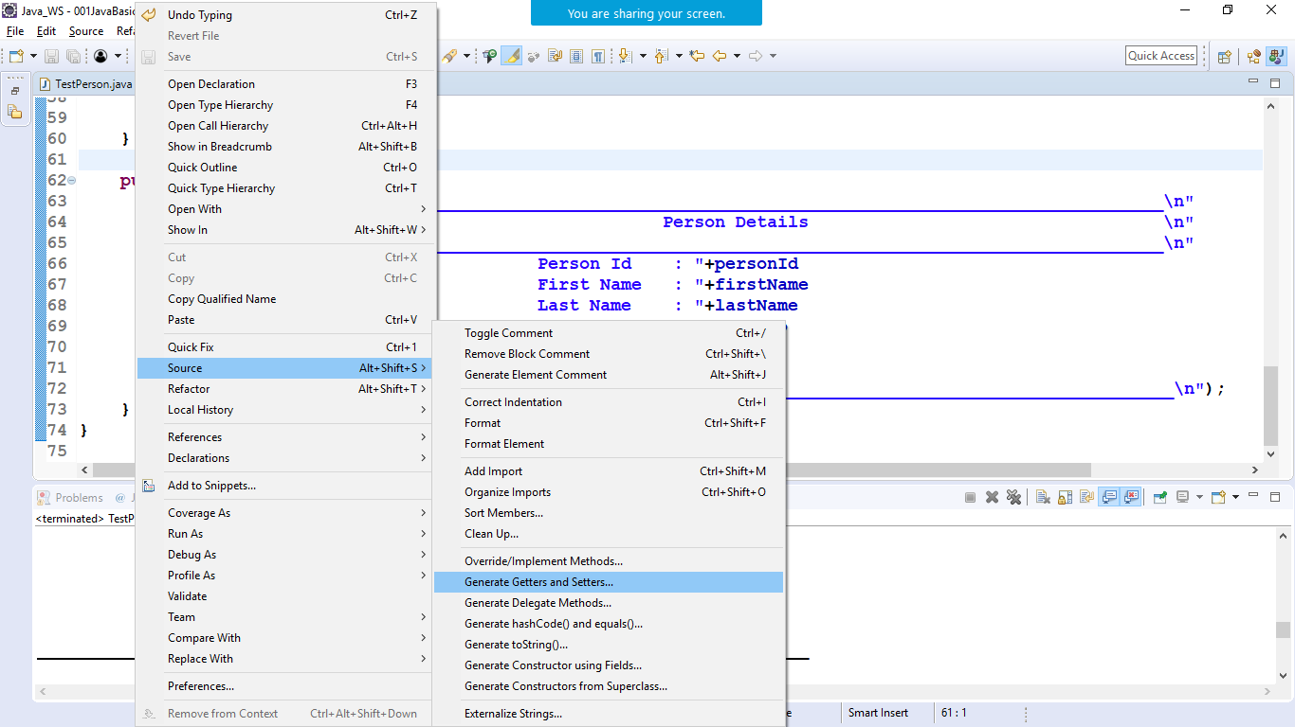–

Select all and hit ok.

//private cannot be accessed outside the class

//in certain scenarios when we want to provide access to private var outside the class

//we have a concept of accessor and mutator also known as getters and setters method