Lets handle the exception by try-catch-block

Select the the code->rt-click -> Surround With -> Try/catch Block

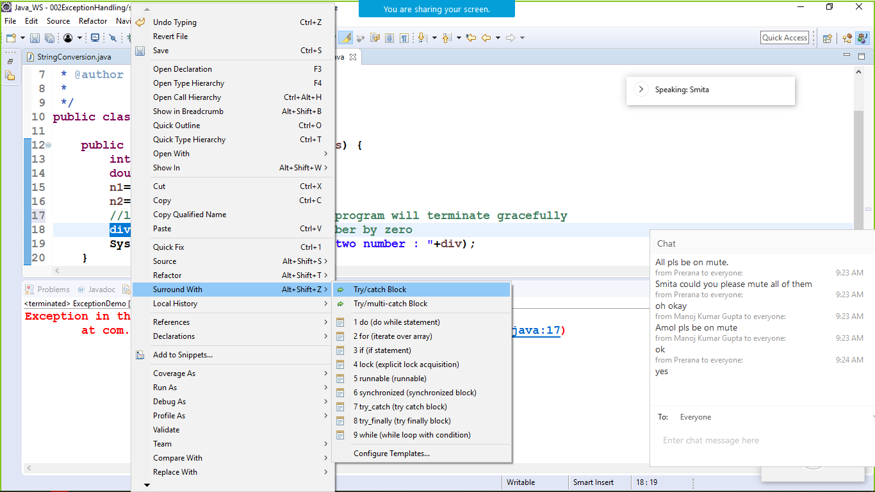

Creating user defined exception, create a class LowBalanceException and extends from Exception

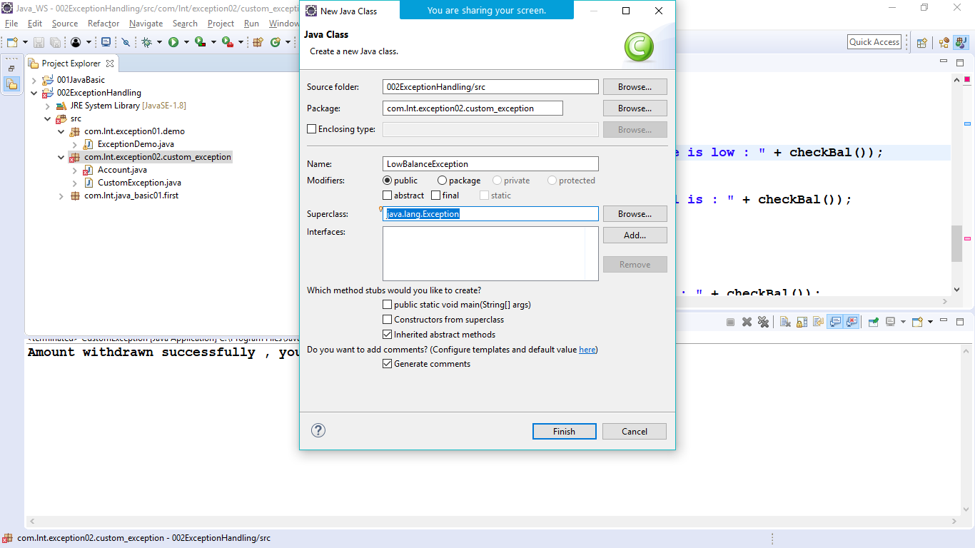

//generated constructors from super class

Rt click -> generate constructors from superclass

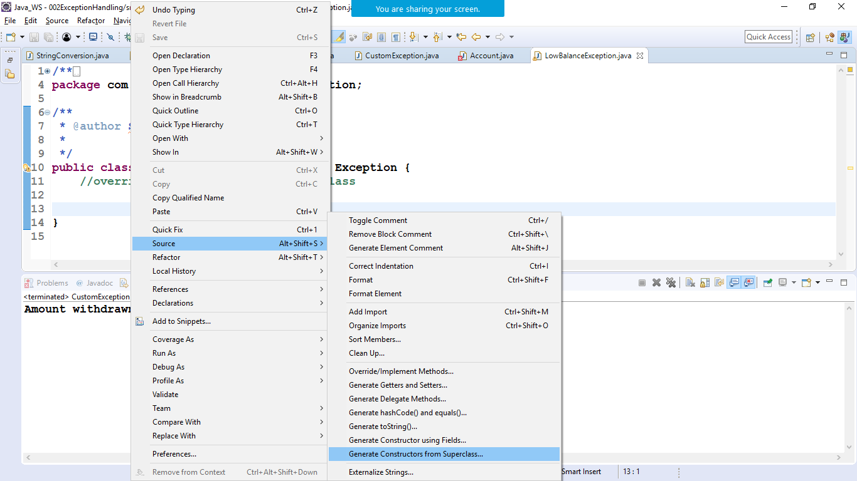

We will select two constructors 1> no_arg constructor

2> constructor with string parameter

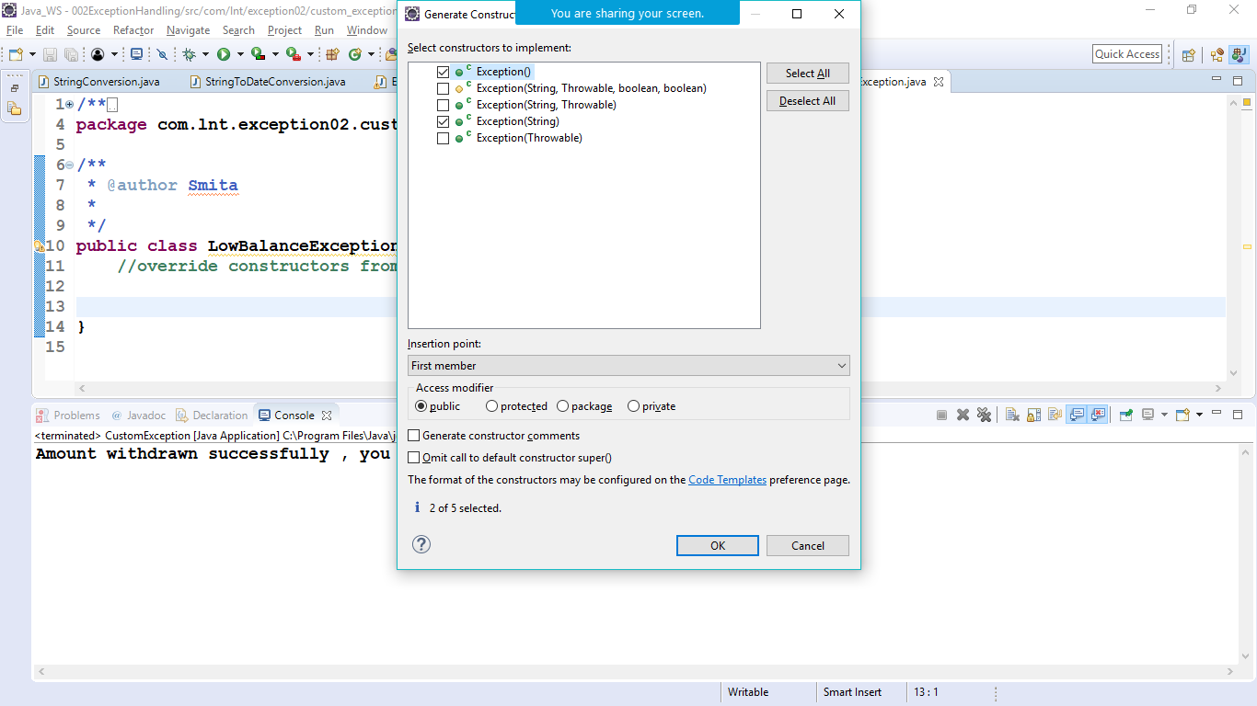

package com.lnt.exception02.custom_exception; /** * @author Smita* */

public class Account {

private int accNo;

private String accHolderName;

private double balance;

// constructors

public Account() {

}

// overloaded constructor

public Account(int accNo, String accHolderName, double balance) {

super();

this.accNo = accNo;

this.accHolderName = accHolderName;

this.balance = balance;

}

// getters and setters

public int getAccNo() {

return accNo;

}

public void setAccNo(int accNo) {

this.accNo = accNo;

}

public String getAccHolderName() {

return accHolderName;

}

public void setAccHolderName(String accHolderName) {

this.accHolderName = accHolderName;

}

public double getBalance() {

return balance;

}

public void setBalance(double balance) {

this.balance = balance;

}

// toString() method - which return the object value in string format

@Override

public String toString() {

return "Account [accNo=" + accNo + ", accHolderName=" + accHolderName + ", balance=" + balance + "]";

}

public void withdraw(double amount)throws LowBalanceException {

if (balance <= amount) {

//delegating the execution to the user defined exception class,

//the the method must be informed that the particular exception class will be handling the exception

//using throws or try-catch block

throw new LowBalanceException("Amount can't be withdrawn as balance is low : " + checkBal());

} else {

balance -= amount;

System.out.println("Amount withdrawn successfully , you current bal is : " + checkBal());

}

}

public void deposit(double amount) {

balance += amount;

System.out.println("Amount deposited successfully , you current bal is : " + checkBal());

}

public double checkBal() {

return balance;

}

}

/********************/

**package** com.lnt.exception02.custom_exception;

/**

* **@author** Smita

*

*/

**public** **class** LowBalanceException **extends** Exception {

//generated constructors from super class

**public** LowBalanceException() {

**super**();

// **TODO** Auto-generated constructor stub

}

**public** LowBalanceException(String message) {

**super**(message);

// **TODO** Auto-generated constructor stub

}

}

/****************/

**package** com.lnt.exception02.custom_exception;

/**

* **@author** Smita

*

*/

**public** **class** CustomException {

**public** **static** **void** main(String[] args) {

Account acc1= **new** Account(101,"Zara",1000);

**try** {

acc1.withdraw(1200);

} **catch** (LowBalanceException e) {

System.***out***.println(e.getMessage());

}//withdraw method is handling exception but main method has not been informed

//so the main method need to be informed

//either with throws or try-catch block

}

}