<https://www.rishabhsoft.com/blog/reactjs-vs-angularjs>

https://www.codementor.io/chrisharrington/react-vs-angularjs-how-the-two-compare-8t6f1ioan

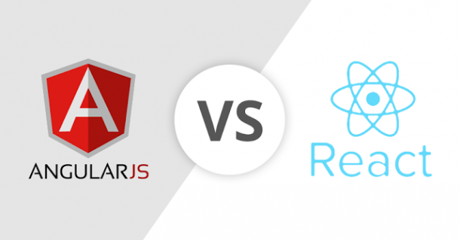

AngularJS vs ReactJS: Framework Against Library

Some might argue that comparing the two is like comparing apples to oranges because while React is a library that deals with views, Angular is a legit framework. In fact, Angular is one of the top JavaScript frameworks and much like other software suits it has multiple out-of-the-box solutions and designs. However most React developers will add a few libraries to React to work it like a regular framework. Of course the resultant workflow of this stack is much different from Angular so comparison is moot.

|  |  |  |  |
| --- | --- | --- | --- |
| **Technology** | **React JS** | **Angular JS** | **Angular 2** |
| **Author** | Facebook Community | Google | Google |
| **Type** | Open Source JS library | Fully-featured MVC framework | Fully-featured MVC framework |
| **Tool Chain** | High | Low | High |
| **Language** | JSX | JavaScript, HTML | TypeScript |
| **Learning Curve** | Low | High | Medium |
| **Packaging** | Strong | Weak | Medium |
| **Rendering** | Server Side | Client Side | Server Side |
| **App Architecture** | None, combined with Flux | MVC | Component-Based |
| **Data Binding** | Uni-Directional | Bi-Directional | Bi-Directional |
| **DOM** | Virtual DOM | Regular DOM | Regular DOM |
| **Latest Version** | 15.4.0 (November 2016) | 1.6.0 | 2.2.0 (November 2016) |