

American International University-Bangladesh (AIUB)  
**Department of Computer Science  
Faculty of Science &Technology (FST)  
Summer 22 23**

**ERP System Development for Hospital**

Software Requirement Engineering

Sec: **A**

Project submitted

By

*Sanjida Alam (20-43188-1)*

*Sumi Akther (20-43154-1)*

*Nurshad Jahan Urmi (20-43153-1)*

*A.K.M Shahriyar Rahman (19-40787-2)*

**Checked By Industry Personnel**

Name:

Designation:

Company:

Sign:

Date:

**Table of Contents**

1. PROBLEM DOMAIN 3-4.

1.1 Background to the Problem 3

1.2 Solution to the Problem 3-4**.**

2. SOLUTION DESCRIPTION 4-8

2.1 System Features 4-5

2.2 Uml Diagrams 6-8

3. SOCIAL IMPACT 9

4. DEVELOPMENT PLAN WITH PROJECT SCHEDULE 9-11

5. MARKETING PLAN 12-13

6. COST AND PROFIT ANALYSIS 13-14.

7. REFERENCES 14.

1. **PROBLEM DOMAIN**
   1. **Background to the Problem**

* Hospitals are the essential part of our lives, providing the best medical facilities to people suffering from various ailments, which may be due to change in climatic conditions, increased workload, emotional trauma stress, etc. The hospitals must keep track of their day-to-day activities & records of their administrators, patients, doctors, nurses, ward boys, and other staff personals that keep the hospital running smoothly & successfully. So, here comes the concept of the hospital ERP system, which is an integrated ERP system that handles different directions of clinic workflows. It manages the smooth healthcare performance along with administrative, medical, legal, and financial control.
* The recent population growth as well as new diseases has created a multitude of acute challenges for hospitals, including inadequate capacity, supply shortages, the need for care redesign, and financial loss. Health care providers are struggling to meet two goals:
* Quality Patient Care
* Substantial Cost reduction

To this end, healthcare institutions are continually investing in updating their ERP systems to make patient care more available and better. Furthermore, reducing clinical errors and increasing efficiency for health care providers are primary reasons for implementing **ERP software** for the healthcare industry.

* 1. **Solution to the Problem**
* I am going to propose the **ERP software in hospitals** to deal with the problem.

Healthcare Facilities should use ERP software because it can:

* Improve operational performance
* Control costs
* Improve clinical results
* Improve patient health
* Enhance collaboration
* Optimize patient management
* Provide information on patient visits, budgeting, procurement, and other topics by tracking key indicators, or KPIs
* Calculate and assess the operational efficiency of a healthcare facility
* Locate gaps and bottlenecks

Yes, the ERP software solution is **feasible** to the meet the business objective. The biggest advantage of a feasibility study is that it allows your company to make an informed decision. Rather than make assumptions, your business can prove the value of an ERP solution through an organized methodology and realize what it takes to successfully execute the implementation. Through the process of conducting an **ERP feasibility study**, your business can develop a shared understanding about the software investment and how it could improve your business performance.

* Significant reasons for introducing ERP software in hospitals are clinical and administrative – **cost control**, operational performance, patient health improvement, and better clinical results. ERP platform helps healthcare providers with remote access to **Key resources and reports for patients**. ERP software for healthcare will result in process efficiencies as part of the IT automation program. ERP carries different tasks, such as payroll, accounting, human resources, and puts them into a shared database. By facilitating communication between physicians and patients, ERP program helps healthcare providers to improve patient safety. When you run a hospital, implementing an ERP program can provide better business knowledge to help you make better decisions. This software can calculate and assess the operational efficiency of a hospital. It offers information on budgeting, requisitions, and patient visitation.
* **Implementing ERP software** solution is available to solve the problem. Implementing ERP software for the healthcare industry helps put healthcare professionals, insurance companies, and patients under one umbrella and centralizes all of the main information. User-friendly and innovative ERP solutions from diverse providers help healthcare professionals concentrate on their core concerns like quality patient care and safety.

1. **SOLUTION DESCRIPTION**
   1. **System Features**

**Requirements**

In our project we need Users. We breakdown the Users Category into four types.

They are:

1. System Administrator
2. Doctors
3. Patients
4. Staffs

**System Features List**

Every user has different role and our system have some advance features.

The features are:

* System Administrator

*– Role: Manage Everything in Whole System*

* + - Login
    - Create A Users
    - Delete A Users
    - Modify & Update A Users.
    - Monitor and Visit Everything in Database.
* Doctors

*– Role:* *Relation Between Patients & Nurses*

* + - Login
    - Request for Visiting Time
    - Schedule
    - Visit Patients Profile
    - Visit Nurse Profile
    - Cabin & Room Allocation
* Patients

*– Role:* *Relation Between Doctors*

* + - Login
    - Request for Appointment
    - Cancel Appointment
    - Visit Doctor Profile
    - Schedule
    - Medicine List
    - Cabin & Room Allocation
* Staffs

*– Role:* *Relation Between Rooms*

* Login
* Schedule
* Cabin & Room Allocation
  1. **UML Diagrams**
* **Class Diagram:**

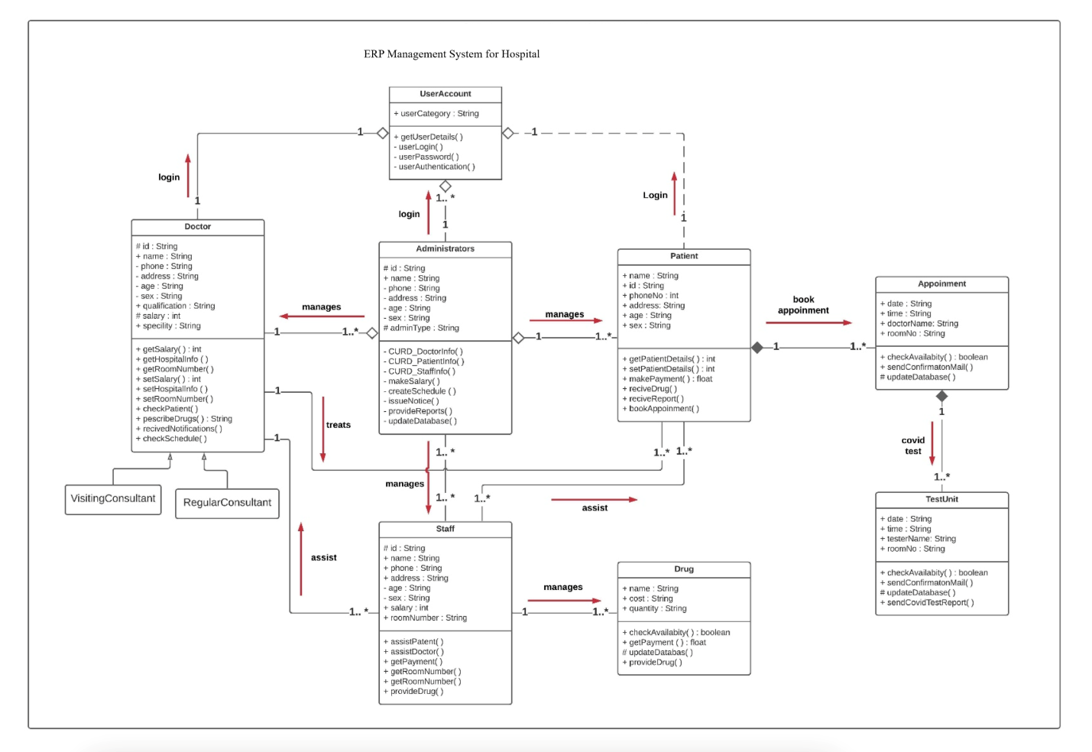

Figure 2.2.1: Class diagram

[Class diagram defines the structure of a system by showing the system’s classes, attributes and methods, and the relationships between different classes. It is a static structure diagram. It is used in software engineering to describe the structure of a system. In the design of a system, a number of classes are identified and grouped together in a class diagram that helps to determine the static relations between them. In detailed modeling, the classes of the conceptual design are often split into subclasses.]

* **Use Case Diagram:**

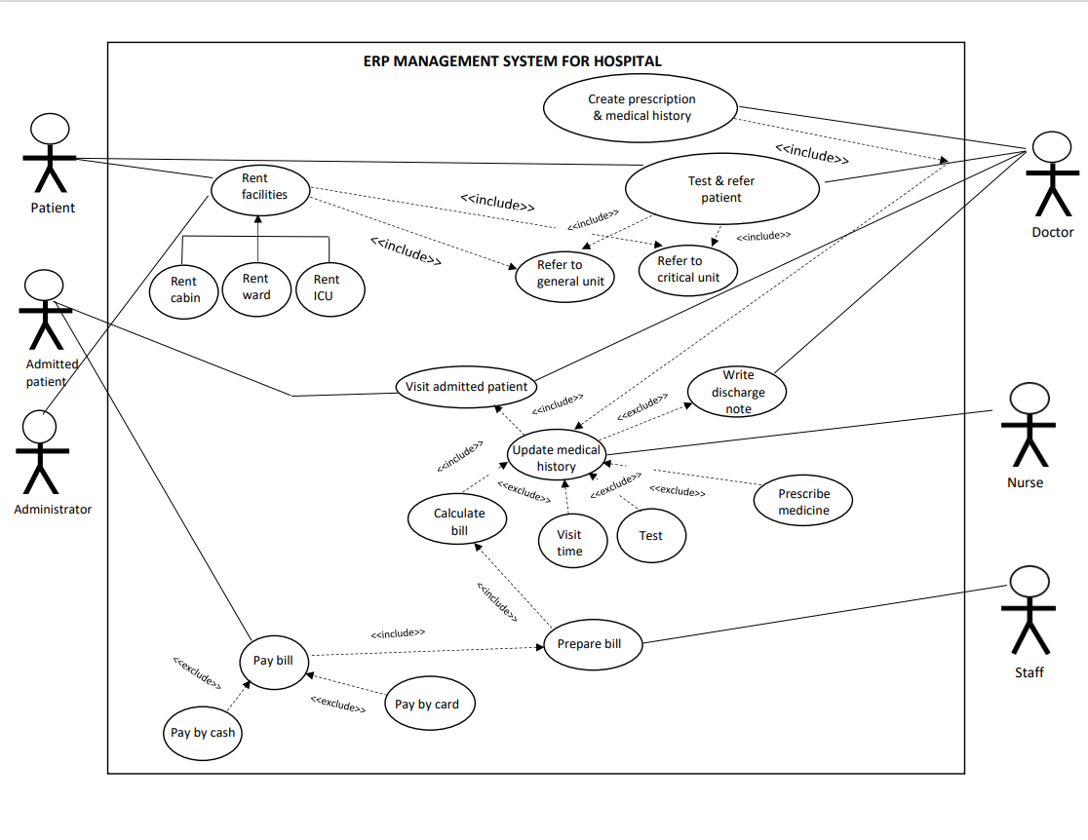

Figure 2.2.2: Use case diagram

[Use-case diagrams describe a system's high-level functions and scope. These diagrams also show how the system, and its actors interact with one another. In use-case diagrams, the use cases and actors describe what the system does and how the actors interact with it, but not how the system operates internally.]

* **Activity Diagram:**

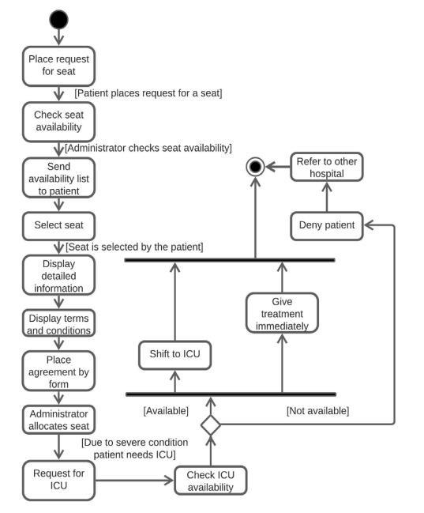

Figure 2.2.3: Activity diagram

[Activity Diagrams explain how activities are coordinated to provide a service at various levels of abstraction. Typically, an event must be accomplished by some operations, particularly when the operation is intended to accomplish a number of different things that necessitate coordination, or how the events in a single use case relate to one another, particularly in use cases where activities may overlap and necessitate coordination.]

1. **Social Impact**

The social impact of an ERP System for Hospital might be a platform that provides high-quality, universal health care. The ERP is an excellent solution for hospitals that want to minimize the expenses of administrative and clinical transactions while also providing better service to their customers. It assists hospital administrators by greatly enhancing operational control and streamlining processes. Because it automates the process of gathering, aggregating, and retrieving patient information, it provides an improved response to patient care demands. The system's clinical pathways improve diagnostics and treatments. It provides doctors and medical personnel with a decision-support system that is like worldwide standards for patient care. By providing an automatic and intelligent flow of patient data. The ERP enables hospitals and clinicians to better serve their patients by facilitating an automated and intelligent flow of patient information. Furthermore, the ERP provides a slew of direct benefits, such as easier patient record management, reduced paperwork, faster information flow between departments, greater organizational flexibility, reliable and timely information, minimal inventory levels, reduced waste, reduced patient wait time at the counters, and reduced patient registration time. The hospital's image would improve, and the hospital's competitive edge would increase. The system not only allows the hospital to improve patient care, but it also has the potential to increase the organization's profitability.

1. **Development Plan with Project Schedule**
2. Planning:
   1. Develop project budget.
   2. Resource estimation
   3. Scheduling
   4. Identifying Product champions
   5. Identifying stakeholders
   6. Develop work plan.
3. Requirement Development:
   1. Requirement elicitation
   2. Requirement analysis
   3. Requirement specification
   4. Requirement validation
4. Requirement Management:
   1. Vision control
   2. Change control
   3. Requirement status tracking
   4. Requirement tracking
5. Develop Project Control Plan:
   1. Develop communication plan.
   2. Develop quality management plan.
6. Design:
   1. UML diagram design
   2. Interface design
   3. Database Design
   4. Design content Formats
7. Development
   1. Front-end development
   2. Back-end development
8. Testing
   1. Unit Testing
   2. Quality analysis
   3. Data flow testing
   4. Control flow testing
   5. Domain testing
9. Deployment & Implementation
   1. Move tool to production environment
   2. Review the product
   3. Release The product
10. Maintenance
    1. Proper functionality of software
    2. Ensure best methodologies are implemented
    3. Check for bugs
11. Close Project

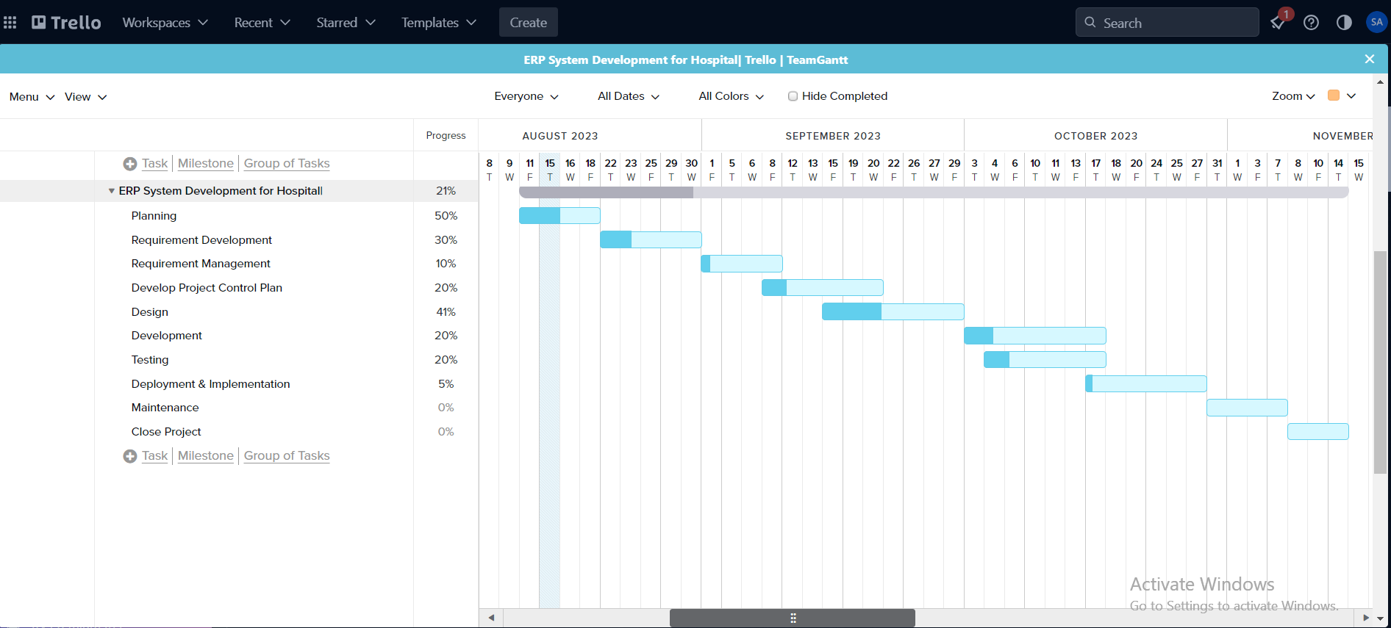

Fig 4.1: Gantt Chart

[Team Gantt Chart, which is widely used in Trello project management, is one of the most popular and useful apps for displaying activities (tasks or events) against time. The chart has a list of activities on the left and a time scale along the top. Each activity is represented by a bar, with the position and length of the bar reflecting the activity's start, duration, and end dates]

**5. Marketing Plan**

Our goal is to Keep our patients satisfaction and happiness. providing the patients long-term services. Enhance loyalty among current and new patients. Be known as a high-end adventure leader. Each year, the growth rate remains consistent. Using disciplined growth to reduce fixed costs. Reduce the variable costs related to different production methods. For those we will be focusing on marketing structure below.

* **Social Media:**

The primary objectives of our advertising strategy are to boost brand awareness and services. The plan is to offer the quality full services, boost sales conversion rates, attract new consumers using social media, expand the target demographic, and maintain engagement with existing customers. A social media celebrity, for instance, might potentially impact the purchasing decisions of thousands of their followers just by promoting our product on Facebook, Twitter or Instagram. In addition, most social networking sites include advertising campaigns that cost money to operate. The project may benefit greatly from this possibility.

* **Campaigning:**

Advertising campaigns spread the word about items via a variety of media, including print, radio, television, and online platforms. How much marketing is required and which media are most effective for reaching a certain consumer category are often determined by the campaign's goals. Healthcare marketing is a process of strategic communications and outreach intended to draw in consumers, assist them in their healthcare journeys, and maintain their interest in the healthcare system.

* **Google Ads:**

The Google Ads program enables to develop online advertisements to target audiences who are interested in the goods and services you provide. The extensive reach of Google, the ability to target in a variety of ways, harness purpose, keep constant complete control over the campaigns, regardless of the available funds, In Google Ads, results are presented in an understandable style. Obtain speedier outcomes compared to SEO, increase brand recognition

* **Billboard and Poster:**

Billboard posters are a terrific technique to let people know you're open for business if you're trying to reach a large audience. These little yet mighty billboards are easy to produce on short notice and can help you enhance brand recognition. With just one kind of advertising, businesses can use billboards to connect with a wide range of consumers. A billboard enables you to reach a sizable portion of the diverse general public without having to invest additional time and resources in identifying and researching particular target consumer groups.

* **Promotion:**

our advertising approach will focus on creating brand recognition as a means of promoting our service. But we also need to shape our approach such that it attracts attention to the quality. We also need to get our intended users involved with the quality and service in some way. We may either convince them with a great service on our site, emails, ads, and social media pages.

## 6. Cost and Profit Analysis

|  |  |  |  |
| --- | --- | --- | --- |
| **Employee Cost Estimate** | **NO. Of Employee** | **Salary** | **Total Salary (BDT)** |
| Junior Developer | 5 | 20,000 | 100,000 |
| Senior Developer | 2 | 50,000 | 100,000 |
| Marketing | 4 | 10,000 | 40,000 |
| UI/UX Designer | 2 | 15,000 | 30,000 |
| Total Employee Cost |  |  | 270,000 |

This system initially has 4-month contract. Salary of 4 month will be:

= (270,000*4) BDT

= 1,080,000 BDT

So, employee cost estimation for the project will be **1,080,000 BDT**

**Total Cost Estimate:**

|  |  |
| --- | --- |
| **Cost List** | **Cost (BDT)** |
| Development Cost | 500,000 |
| Maintenance Cost | 250,000 |
| Hardware | 350,000 |
| Database Services | 150,000 |
| Connectivity | 120,000 |
| Training | 70,000 |
| Utility | 150,000 |
| Total Cost | 1,590,000 |

So total cost estimation for the project will be **1,590,000 BDT**.

## Benefit Estimate

* If everything goes according to plan, we anticipate a 40% increase in revenue, or about 600,000 BDT in revenue gains, for the hospital management system within a year.
* The additional hiring cost is estimated to be 25,000 BDT, hardware and software needed will cost about 20,000 BDT in total and worker salary will reach 270,000 BDT.

So,

Total benefit from the project = 600,000 BDT

Total Cost = (Salary of employees + Cost of hiring + Cost of additional hardware and software)

Total Cost = (270,000 + 25,000 + 20,000) BDT

= 315,000 BDT

Cost-Benefit Ratio = (600,000 / 315,000)

= 1.90

As a result, the system has a about 40% profitable return on investment over the following three years, and the profit comes close to covering the development cost in the first year, according to the cost profit analysis estimates provided below. In the second year, the true profit could be computed.

1. **References**
2. Tsui, Frank, Orlando Karam and Barbara Bernal (2013) *Essentials of Software Engineering*, Jones & Bartlett Learning, Sudbury, MA.
3. Eko Handoyo, R Rizal Isnantoa, “SRS Document Proposal Analysis on the Design of Management

Information Systems According to IEEE” STD 830-1998, Procedia - Social and Behavioral Sciences, Volume 67, 2012, Pages 123-134, ISSN 1877-0428.

Links:

* + <https://datixinc.com./>
  + <https://netsuite.com./>
  + <https://controlerp.com./>