Developer Assessment

# Introduction

Candidate is required to complete CRUD of backend and frontend functions for the accompanying solution.

The solution consists of,

1. .NET Core project
   1. Stored in the /api folder
2. Angular 8 project
   1. Stored in the /web folder
3. SQLite Database
   1. Stored at /api/DB/data.db

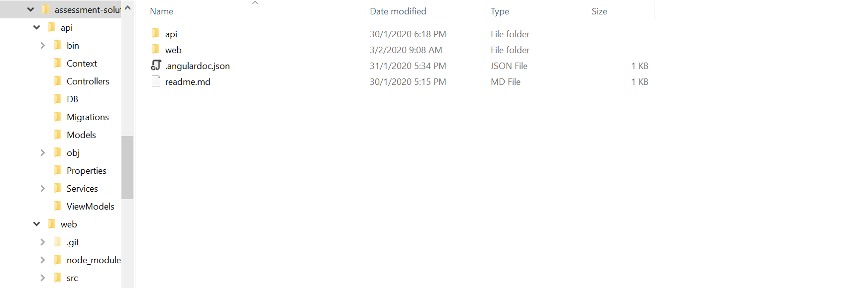

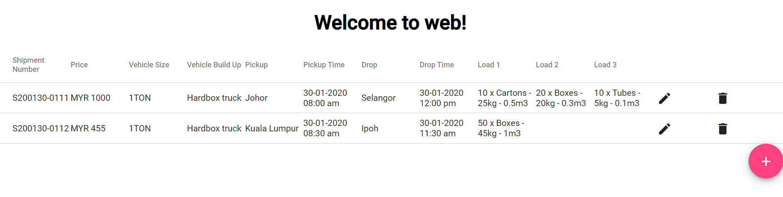

At the end of the assessment, the entire solution including any and all changes should be zipped and returned to Ezyhaul for grading.

Note1: Please verify that the solution works before sending it back to Ezyhaul for grading.  
  
Note2: Development time for this assessment is not expected to exceed **4 hours** if the candidate is familiar with .Net and Angular. For candidates who are unfamiliar they should spend some time to become familiar with the technology before attempting the test.  
  
Note3: Please fill in and return the assessment feedback so that we can improve our candidate assessment methodology. Thank you.

Note4: If there are any questions about this assessment, please feel free to contact us as below.  
- Edmund Lee ([e.lee@ezyhaul.com](mailto:e.lee@ezyhaul.com)) – Technical Lead

# Requirements

* Develop forms to create, edit and delete new offers
  + Delete offer should prompt for confirmation before deleting
* All forms should have the appropriate form UI and validation
  + Columns marked as Required should be required on form
  + Remarks will contain additional validation information if any
* Data should be saved into the provided SQLite database
* Database design should not be changed

# Skills

* Angular
* .Net Core
* Entity Framework Core

# Database design

|  |  |  |  |
| --- | --- | --- | --- |
| Column | Data type | Required | Remarks |
| Id | GUID | Yes | Unique ID |
| ShipmentNumber | String | Yes | Should follow the format as below  S{YYMMDD}-{running number}  YY – 2 digit year  MM – 2 digit month  DD – 2 digit day |
| Price | Decimal | Yes | 2 decimal places |
| Currency | String | Yes | Default value to MYR |
| VehicleSize | String | Yes | Only allow the following values  1TON, 3TON, 5TON, 10TON |
| VehicleBuildUp | String | Yes | Only allow the following values  Hardbox truck  Canvas truck  Open truck |
| PickupLocationName | String | Yes | Only allow states in Peninsula Malaysia |
| PickupDateTime | Long | Yes | Pickup date time should be earlier than delivery date time  Unixtimestamp in milliseconds  Save in DB as number but render on web as DateTime (use moment.js) |
| DeliveryLocationName | String | Yes | Only allow states in Peninsula Malaysia |
| DeliveryDateTime | Long | Yes | Delivery date time should be later than pickup date time  Unixtimestamp in milliseconds  Save in DB as number but render on web as DateTime (use moment.js) |
| LoadDetail1 | String | No | Free entry textarea |
| LoadDetail2 | String | No | Free entry textarea |
| LoadDetail3 | String | No | Free entry textarea |

# Validation

1. Pickup Date Time must be earlier than Delivery Date Time
2. Pickup Date Time cannot be equal to Delivery Date Time

# Running the project

## Prerequisites

* Install [Node JS](https://nodejs.org/en/download/) – LTS version
* Install [.Net Core SDK](https://dotnet.microsoft.com/download/visual-studio-sdks) – 3.1
* Install [Angular CLI](https://cli.angular.io/) – Node JS
* Install [VS Code](https://code.visualstudio.com/) - *optional*

## Running the API project

1. Using Visual Studio Code, open the folder containing the solution

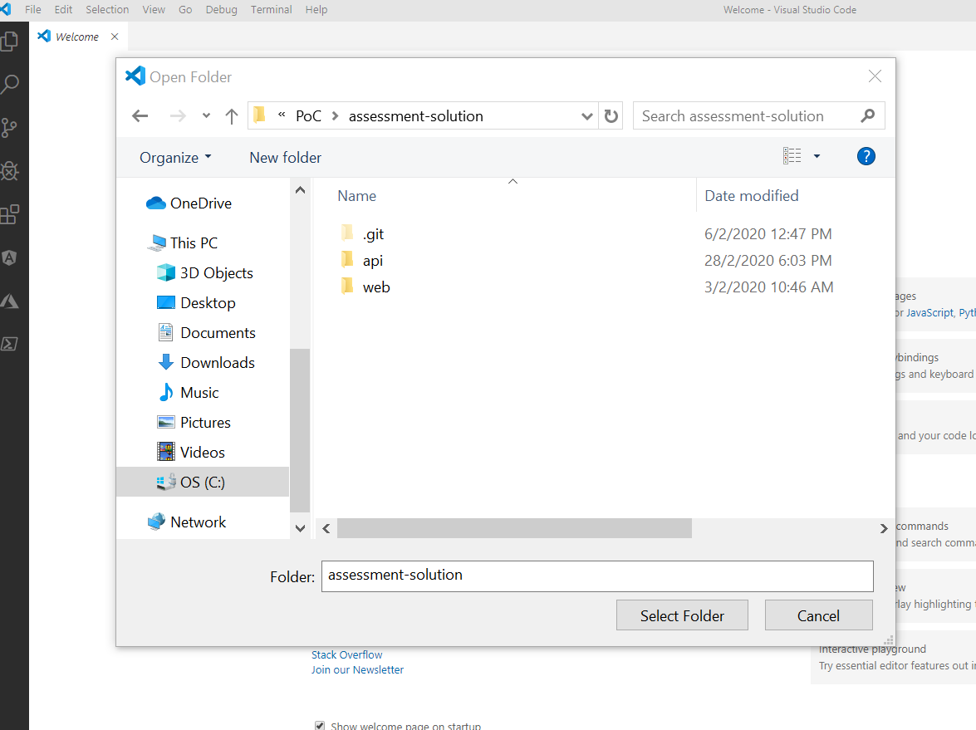

1. Open New Terminal

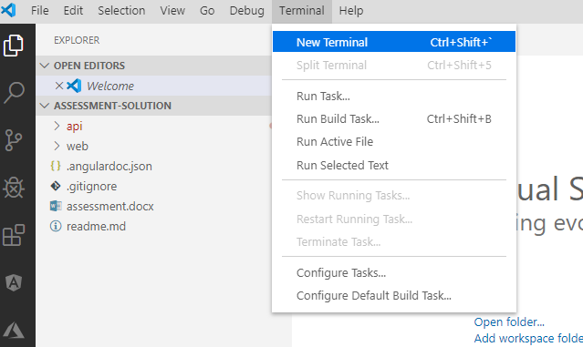

1. Using the terminal window, run the following commands in the folder
   1. cd api
   2. dotnet restore
   3. dotnet build
   4. dotnet run

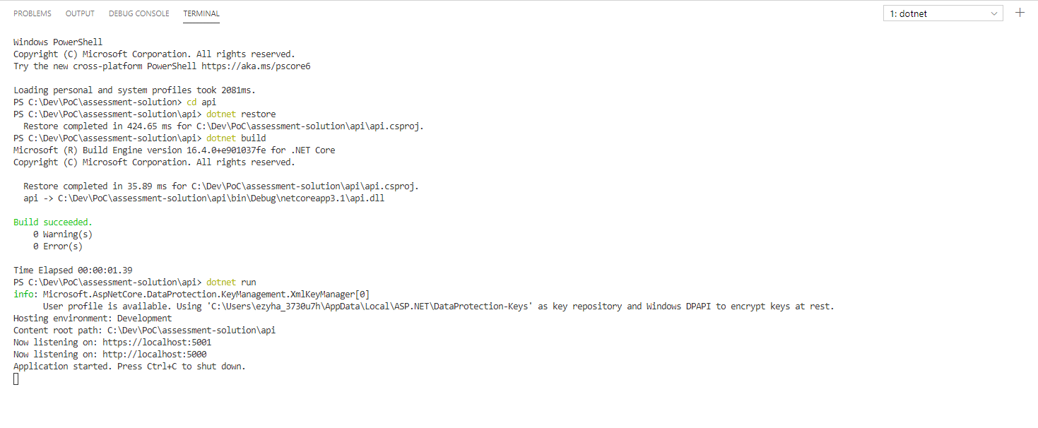

1. The api project should be running now. To verify this, navigate to the site at, <https://localhost:5001/swagger>
   1. Bypass browser prompt on insecure certification if necessary

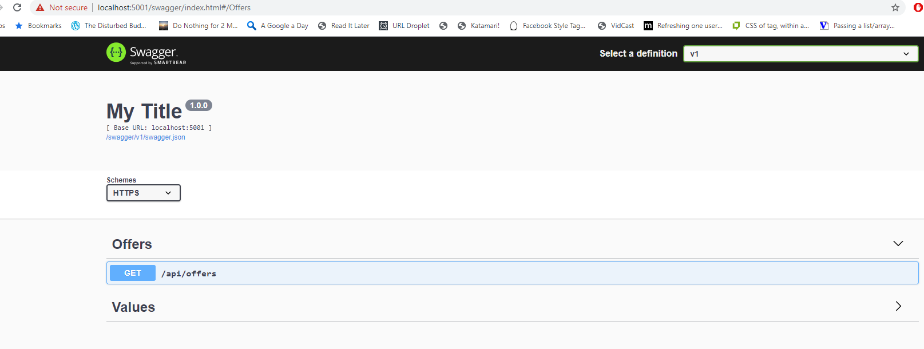

1. Expand the Offers section and expand the section “/api/offers”. Click “Try it out” and followed by “Execute”. This will make a call to the api and the response will be displayed below.

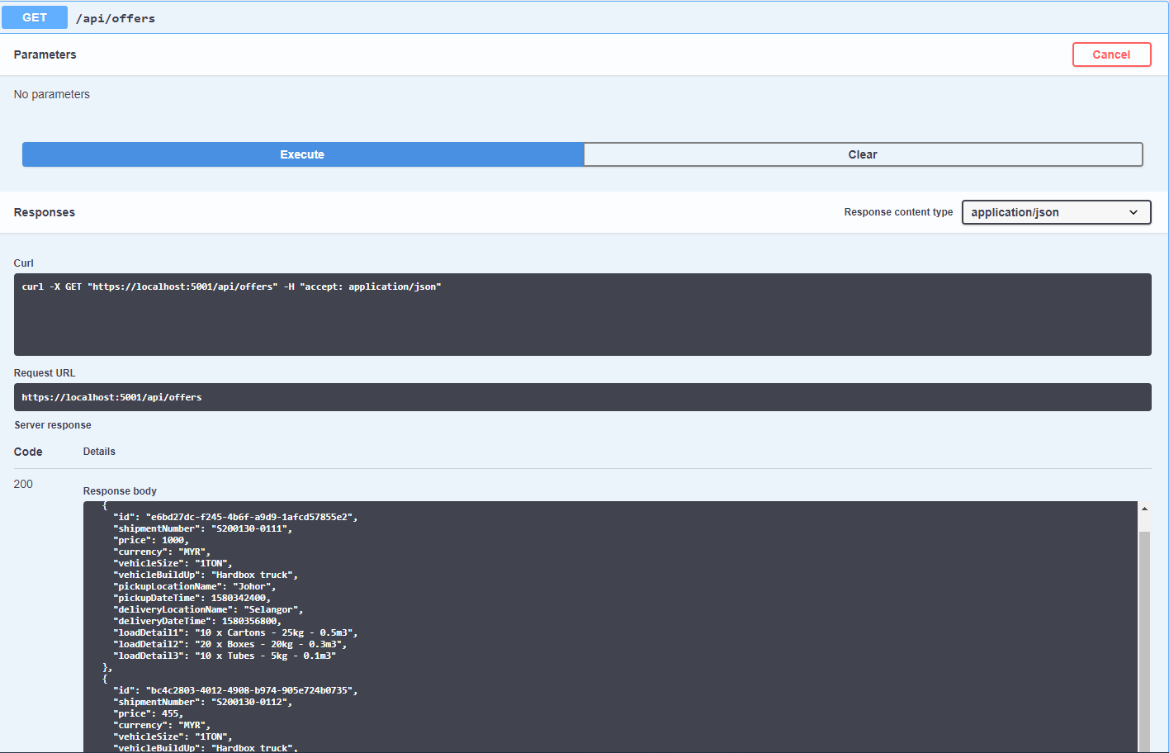

## Running the Web project

1. Open a new terminal window

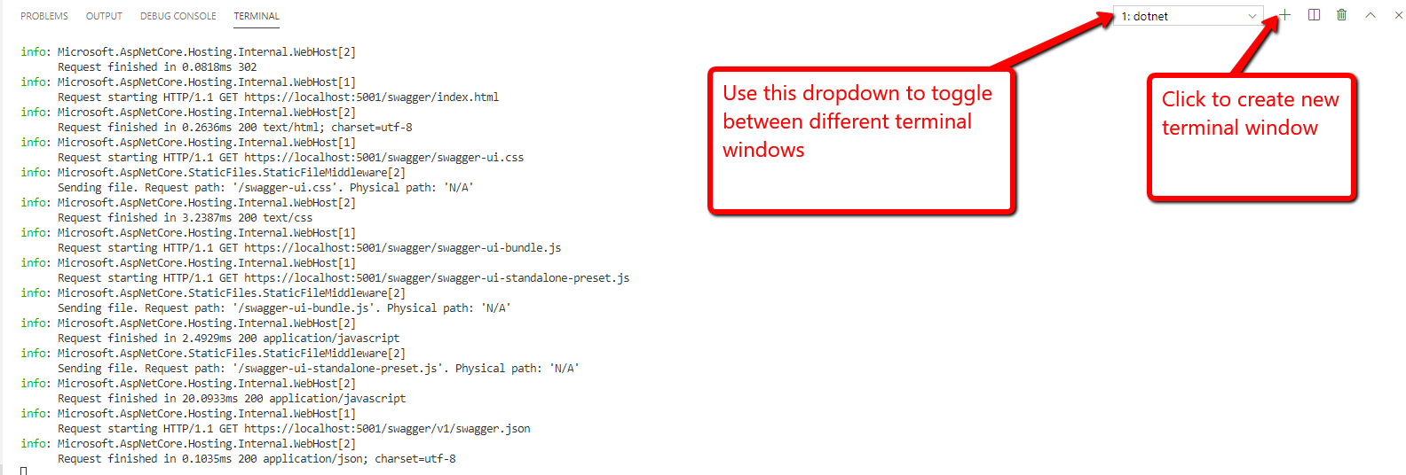

1. In the new terminal window, run the following commands
   1. cd web
   2. npm install
   3. npm start

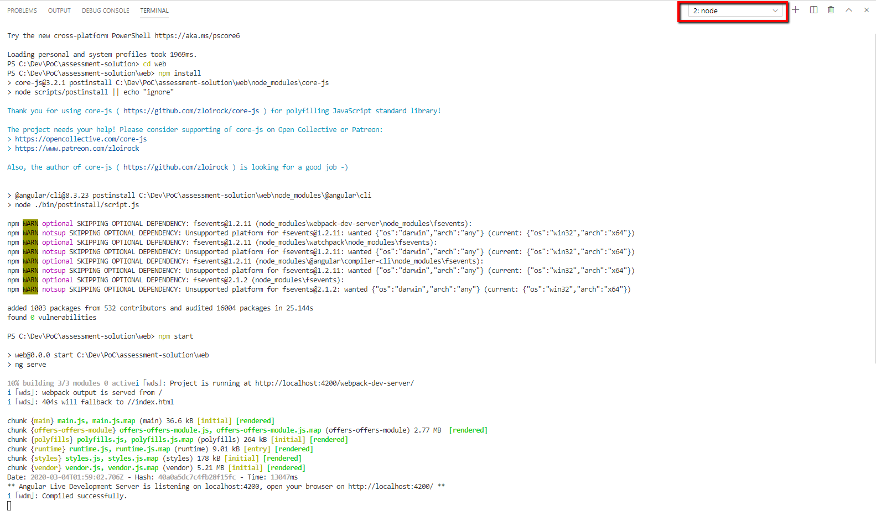

1. The web project should be running now. To verify this, navigate to the site at <http://localhost:4200>

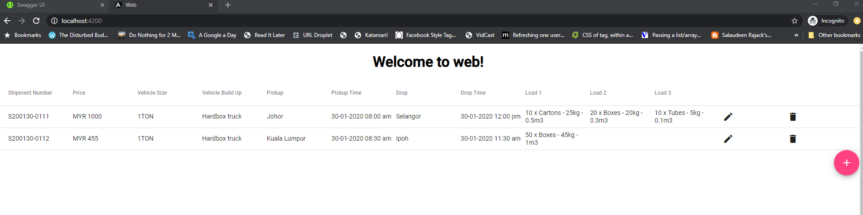

# Development Notes

* The Angular project implements **live reload** so changes to the project will cause the project to auto rebuild and the web to auto refresh
* The .Net Core project on the other hand does not implement live reload so you will need to stop and restart the project manually
* The resources list in the next section contains links that are related or will be useful for development of this assessment project.

# Resources

* Angular Docs Introduction - <https://angular.io/docs>
* Angular Environment Setup - <https://angular.io/guide/setup-local>
* Visual Studio Code - <https://code.visualstudio.com/>
* Moment JS - <https://momentjs.com/>
* Angular Material - <https://material.angular.io/components/categories>
* Angular Flex Layout - <https://github.com/angular/flex-layout>
* Material Icons - <https://material.io/resources/icons/?style=baseline>
* Angular Reactive Forms - <https://angular.io/guide/reactive-forms>
* Angular Form Validation - <https://angular.io/guide/form-validation>
* Angular CLI Wiki - <https://github.com/angular/angular-cli/wiki/1-x-home>
* SQLite DB Browser - <https://sqlitebrowser.org/>
* Angular 8 RxJS tutorial - <https://www.djamware.com/post/5da31946ae418d042e1aef1d/angular-8-tutorial-observable-and-rxjs-examples>