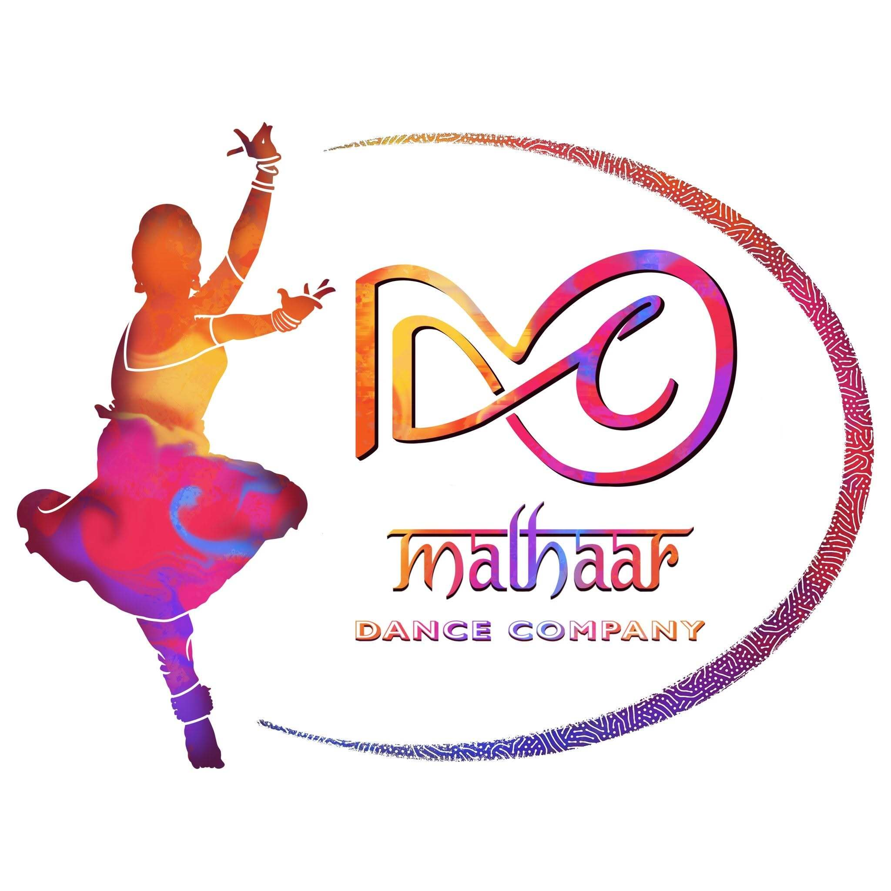 | Website Design Questions  Malhaar Dance Company · Website redesign · 3 October 2026
Your answers to these 37 questions will let us design the new website the way you picture it. Short answers are fine, and you can type in the box under each question or reply by message.
Design
1. Colors and fonts. Should the site's colors and fonts be drawn from the new logo, or do you have a separate palette and fonts you want used?

2. Mood. Should the site feel dark and dramatic (stage, spotlight) or light and airy (cream, gold, lots of white space)?

3. Reference sites. What specifically do you like on each of the four reference sites (layout, photos, menu, colors)? Is there anything on them you dislike?

4. Tagline. Keep "Dance Better. Live Better." from the old site, use a new one, or none?

5. Home banner. One strong image, rotating images, or a short video? Which 3–5 photos best represent Malhaar?

6. Photography. How many professional photos do you have for each section? Are any sections short of images (About, Training, Instructors)?

7. Old site photos. We saved the 16 photos from the old website. Only about six are sharp enough to use large. Do you want any of them reused, or will all imagery be new?

8. Student photos. Are you comfortable showing student group photos on the public site, and do the families' consents cover that?

9. Festival look. Does Ananta have its own logo and colors, and should its page look distinct from the rest of the site or match it?

10. Motion. Do you want subtle animation (fades, slow image movement), or a completely still, classic look?

Flow
11. Main action. What is the one thing you most want a visitor to do: inquire about classes, buy festival tickets, or contact you?

12. Joining a class. When someone clicks "Class Inquiry", should they get the short inquiry form only, with the full registration form sent privately later? Or should the registration form be reachable from the site?

13. Inquiry form. One form for everything with an "Interested In" dropdown, or separate short forms for classes, sponsorship, and press?

14. After submitting. What should the visitor see and receive (a thank-you message, a confirmation email, an expected reply time)?

15. Training page. One page showing all three dance forms, or a separate page for each?

16. Semi Classical. The old site lists it but the new brief does not. Is it dropped, or part of Bollywood/Cinematic?

17. Instructors. Only the two founders, or other teachers as well? Short cards that open a full biography, or full biographies on one page?

18. Performances. Shown as a photo grid, a timeline by year, or grouped by type (productions, collaborations, student performances)? Does each performance need its own page with a gallery and video?

19. Press & Media. Do items open the original article in a new tab, or show a screenshot on your site? Should videos sit here, under Performances, or both?

20. Festival tickets. Does "Buy Tickets" send visitors to an outside ticketing page? Which one?

21. Festival artists. Does "Meet the Artists" scroll to a section on the festival page, or open a separate page for each artist?

22. Past festivals. Once 2027 is announced, should the Ananta tab open the newest edition by default with earlier years in a switcher?

23. Sponsorship. Does "Become a Sponsor" open the inquiry form, or first show sponsorship levels and benefits?

24. Support page. Are Sponsorship, Partnerships, Collaborations and Volunteering four separate blocks with their own buttons, or one page with one contact button?

25. Contact details. Email only, or also a phone or WhatsApp button? Should a map of the Wood Dale and Elgin areas appear, without street addresses?

26. Social media. Do you want a live Instagram feed on the site, or a few hand-picked posts and videos?

27. Self-editing. Which sections will you update most often, and who will do it? This decides how simple each editing screen needs to be.

Photos and materials for each page
28. Home. Which photos or video clip should be used for the main banner, and which one photo should represent each of Training, Instructors, Performances, Ananta, and Press?

29. About. Which photos can you share of the two founders together, of Malhaar's early years, and of classes or rehearsals to go with the story and vision?

30. Training. Can you share one strong photo for each dance form (Bharatanatyam, Mohiniyattam, Bollywood/Cinematic), plus any class or rehearsal photos?

31. Instructors. Can you share a professional portrait of each instructor, and any performance photos of them to go beside their biography?

32. Performances. For each performance to be listed, can you share its name, year, venue or event, a few photos, and a video link if there is one?

33. Ananta Festival. Can you share the festival logo, the poster or flyer, a photo and biography of each featured artist, the musicians' names, the ticket link and prices, and the sponsors' logos?

34. Press & Media. Can you share the link or a screenshot of each article or interview, the name or logo of the publication, the date, and any video links?

35. Support. Which photos should go with sponsorship and community support, and do you have current sponsor or partner logos and a sponsorship brochure to include?

36. Contact. Which photo should appear on the contact page, and what are the links to your social media accounts?

37. Sending files. How would you prefer to send the photos and videos (a shared Google Drive or Dropbox folder, or WhatsApp)? Original full-size files give the best result.

