Circuit Analysis (Lab11)

Experiment 10: Verification of Norton’s Theorems

Name: Shahroz Ahmed Registration No: 2025-CE-B-115 Date: 18-05-2026 Grade and Signature: ……………………
CLO2 CLO3 | Use with identification the circuit components, breadboards, multimeter, power supplies, signal generators, and oscilloscopes. Make measurements in their own constructed electric circuits.
Psychomotor/Affective | Level1  (1) | Level2 (2-3) | Level3 (4-5) | Level4 (6-7)
Report Marks (3)
 | Total marks (10)

Objective
The objective of this lab is verify Nortan’s theorem and to find the full load current.

Apparatus Required
Sr. no | Apparatus | Range | Quantity
1 | Regulated Power Supply | Standard | 1
2 | Signal Generator | Standard | 1
3 | Oscilloscope | Standard | 1
4 | Digital Multimeter | Standard | 1
5 | Breadboard & Wires | Standard | As Required
6 | Resistors | 1k, 330 ohms | 1,3
7 | Potentiometer | Standard | 1

Description
Statement:

Any linear circuit can be simplified to an equivalent circuit consisting of a single current source and parallel resistance that is connected to a load.
Precautions:
- Voltage control knob of RPS should be kept at minimum position.
- Current control knob of RPS should be kept at maximum position

Procedure for Norton’s Theorem:
- Connections are given as per circuit diagram.
- Set a particular value in RPS and note down the ammeter readings in the original circuit.

To Find I_{N}:
- Remove the load resistance and short circuit the terminals.
- For the same RPS voltage note down the ammeter readings.

To Find R_{N}:
- Remove RPS and short circuit the terminal and remove the load and note down the resistance across the two terminals.

Equivalent Circuit:
- Set IN and RN and note down the ammeter readings.
- Verify Norton’s theorem.

To find load current in circuit 1:
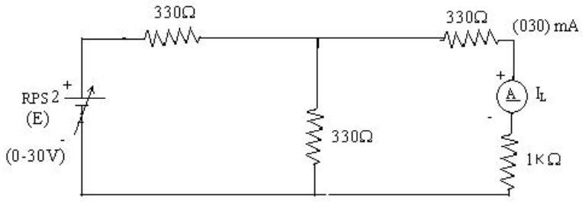

To find I_{N}
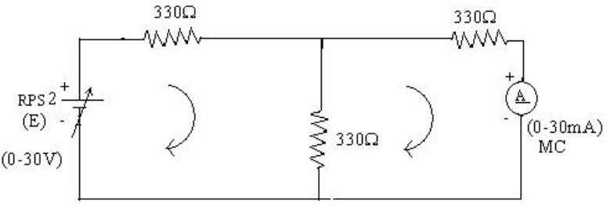

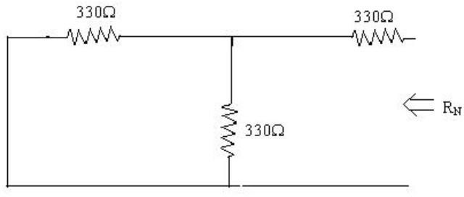
To find R_{N}

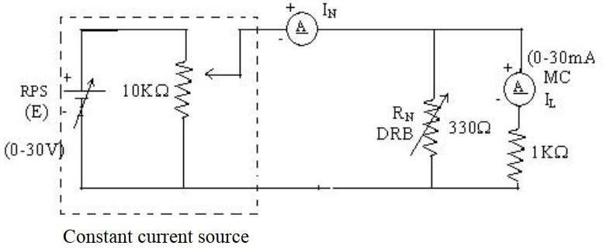
Norton’s equivalent circuit

Norton’s Practical Values
 | E (volts) | IN (mA) | Rn  (ohms) | IL (mA)
 |  |  |  | Circuit - I | Equivalent Circuit
Practical Values | 30V 30.3mA |  | 495 | 10.03mA | 10.03mA

Post Lab Questions
- What is Nortan’s Theorem?
2
Norton’s theorem states that any linear electrical circuit can be replaced by an equivalent circuit consisting of a current source in parallel with a resistance .

What are the applications of Nortan’s Theorem?

To simplify complex electrical circuits

To find load current and load voltage easily

Used in circuit analysis and network design

Helpful when the load resistance changes frequently
- Used in electronic and power system calculations

What are the theoretical and practical limitations of Nortan’s Theorem?

Theoretical Limitations

Applicable only to linear and bilateral circuits

Not suitable for nonlinear elements like diodes and transistors

Cannot be directly used for time-varying or unstable circuits

Practical Limitations

Difficult to calculate Norton current in complex circuits

Measuring short-circuit current may damage components
- Equivalent circuit may not represent internal circuit behavior completely

