Circuit Analysis (Lab10)

Experiment 9: Verification of Thevenin’s Theorem

Name: Shahroz Ahmed Registration No: 2025-CE-115

Date: 8/5/2026 Grade and Signature: ……………………

CLO2  CLO3 | Use with identification the circuit components, breadboards, multimeter, power supplies, signal generators, and oscilloscopes.  Make measurements in their own constructed electric circuits.
Psychomotor/Affective | Level1  (1) | Level2 (2-3) | Level3 (4-5) | Level4 (6-7)
Report Marks (3)
Total marks
(10)

Objective
The objective of this lab is verify Thevenin’s theorem and to find the full load current.

Apparatus Required
Sr. no | Apparatus | Range | Quantity
1 | Regulated Power Supply | Standard | 1
2 | Signal Generator | Standard | 1
3 | Oscilloscope | Standard | 1
4 | Digital Multimeter | Standard | 1
5 | Breadboard & Wires | Standard | As Required
6 | Resistors | 1k, 330 ohms | 1,3
7 | Potentiometer | Standard | 1

Description
Statement:
Any linear bilateral, active two terminal network can be replaced by an equivalent voltage source
(VTH). Thevenin’s voltage or V OC in series with looking pack resistance RTH.

Precautions:
- Voltage control knob of RPS should be kept at minimum position.
- Current control knob of RPS should be kept at maximum position

Procedure:
- Connections are given as per the circuit diagram.
- Set a particular value of voltage using RPS and note down the corresponding ammeter readings. To find VTH 3. Remove the load resistance and measure the open circuit voltage using multimeter (VTH). To find RTH
- To find the Thevenin’s resistance, remove the RPS and short circuit it and find the RTH using multimeter.
- Give the connections for equivalent circuit and set VTH and RTH and note the corresponding ammeter reading. 6. Verify Thevenins theorem.
Circuit - 1: To find load current
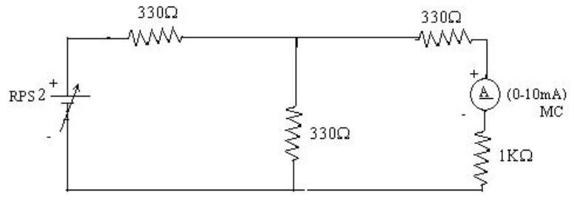

To find VTH
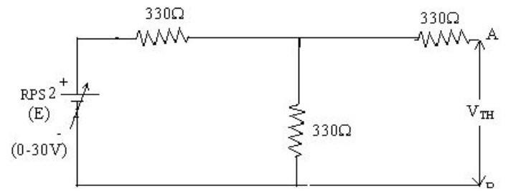

To find RTH
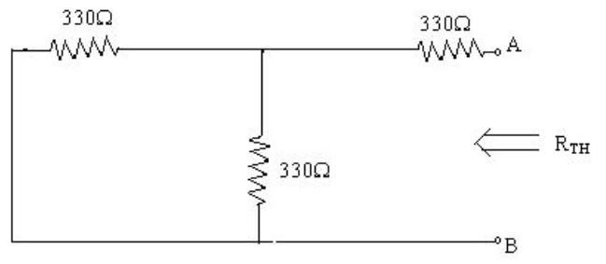

Thevenin’s Equivalent circuit:
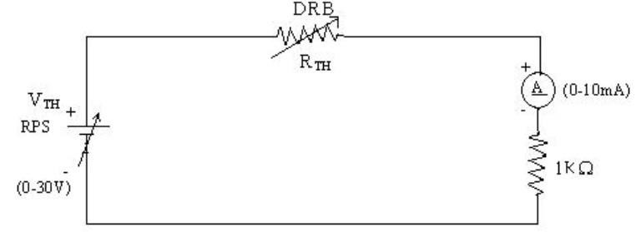

Thevenin Practical Values

 | E(V) | VTH(V) | RTH(ohms) | I_{L} (mA)
 |  |  |  | Circuit - I | Equivalent Circuit
Values | 10V | 5V | 4.95Ω | 3.34mA | 6.69mA

Post Lab Questions
  - What is Thevenin’s Theorem?
Thevenin’s Theorem states that any linear, bilateral electrical network containing voltage sources, current sources, and resistances can be replaced by an equivalent circuit consisting of a single voltage source called Thevenin voltage, Vth in series with a single resistance (called Thevenin resistance, Rth as seen from the load terminals.
This simplification makes complex circuits easier to analyze, especially when studying the effect of varying loads.

  - What are the applications of Thevenin’s Theorem?
Applications of Thevenin’s Theorem:
- It is used to simplify complex circuits into a single voltage source and series resistance.
- It helps in analyzing circuits with varying load resistance without re-solving the entire circuit.
- It is widely used in power system analysis and electronic circuit design.
- It is useful for maximum power transfer analysis.
- It assists in troubleshooting and understanding circuit behavior easily.

  - What are the theoretical and practical limitations of Thevenin’s Theorem?
Theoretical and Practical Limitations of Thevenin’s Theorem:
Theoretical Limitations:
- Applicable only to linear circuits (does not work with non-linear elements like diodes or transistors in non-linear regions).
- Valid only for bilateral networks (elements should behave the same in both directions).
- Cannot be directly applied to circuits with time-varying or dynamic components without modifications.

Practical Limitations:
- Determining Thevenin equivalent can be time-consuming for large and complex circuits.
- In practical circuits, internal resistances and losses may reduce accuracy.
- Not suitable for circuits with dependent sources unless handled carefully.
- Measurement errors in real experiments can lead to incorrect equivalent values.

