Circuit Analysis (Lab # 6)

Experiment 6: VERIFICATION OF KIRCHHOFFS LAWS

Name: Shahroz Ahmad Registration No: 2025-CE-B-115 Date: 22-04-2026 Grade and Signature: ………………………
CLO2  CLO3 | Use with identification the circuit components, breadboards,  multimeters, power supplies, signal generators, and oscilloscopes. Make measurements in their own constructed electric circuits.
Psychomotor/Affective | Level1 (1) | Level2 (2-3) | Level3 (4-5) | Level4 (6-7)
Report Marks (3) |  |  | Total marks (10)

Objective
To verify Kirchhoff’s current law and Kirchhoff’s voltage law for the given Circuit.

Apparatus Required
Sr. no | Apparatus | Range | Quantity
1 | Regulated Power Supply | Standard | 1
2 | Signal Generator | Standard | 1
3 | Oscilloscope | Standard | 1
4 | Digital Multimeter | Standard | 1
5 | Breadboard & Wires | Standard | As Required
6 | Resistors | 330ohm, 220ohm 1kohm | 3
Description
KCL: The algebraic sum of the currents meeting at a node is equal to zero.
KVL: In any closed path / mesh, the algebraic sum of all the voltages is zero.
Precautions:
- Voltage control knob should be kept at minimum position.
- Current control knob of RPS should be kept at maximum position.

Procedure for KCL:
- Give the connections as per the circuit diagram.

- Set a value in RPS.

- Note down the corresponding readings using multimeter

- Repeat the same for different voltages

Circuit - KCL
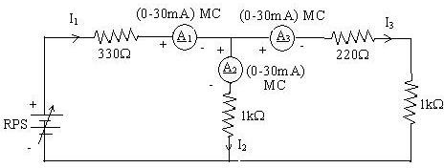
KCL - Practical Values:

Sl. No. | Voltage E | Current |  |  | I1 = I2 + I3
 |  | I1 | I2 | I3
 | Volts | mA | mA | mA | mA
1 | 5 | 5.68 | 3.12 | 2.56 | 5.68
2 | 15 | 17.05 | 9.37 | 7.68 | 17.05
3 | 25 | 28.42 | 15.62 | 12.08 | 28.42

Procedure for KVL:

- Give the connections as per the circuit diagram.

- Set a value in RPS.

- Note all the voltage reading

- Repeat the same for different voltages

Circuit - KVL
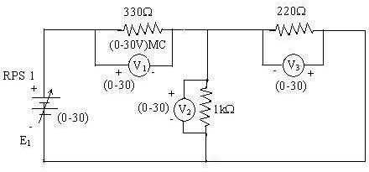

KVL - Practical Values

Sl. No. | RPS | Voltage |  |  | E1 = V1 + V2
 | E1 | V1 | V2 | V3
 | V | V | V | V | V
1 | 5 | 3.23 | 1.77 | 1.77 | 5
2 | 10 | 6.47 | 3.53 | 3.53 | 10
3 | 15 | 9.70 | 5.30 | 5.30 | 15

Result:
Thus, Kirchhoff’s voltage law and Kirchhoff’s current law are verified practically by performing this experiment.

Post Lab Questions

- Define Kirchhoff’s current law.

Kirchhoff’s Current Law states that the total current entering a junction (node) is equal to the total current leaving the junction.

- Define Kirchhoff’s voltage law.

Kirchhoff’s Voltage Law states that the sum of all voltages around any closed loop in a circuit is equal to zero.

- What are the applications of regulated power supply?

A regulated power supply provides a constant and stable voltage, so it is used in:
- Electronic circuits (like amplifiers, microcontrollers)
- Computers and laptops
- Telecommunication equipment
- Laboratory instruments and testing devices
- Medical equipment
- Battery charging systems

- What are the limitations of KCL?

• Not accurate at very high frequencies – effects like capacitance and inductance can cause errors.
• Ignores charge storage – KCL assumes no charge accumulates at a node (not true in some cases like capacitors).
• Not suitable for distributed systems – in transmission lines, current may vary along the length.
• Fails in non-lumped circuits – where circuit elements are not ideal or concentrated.

