Circuit Analysis (Lab 7)
Experiment 7: Analysis of Operational Amplifiers Operations

Name: Shahroz Ahmed Registration No: 2025-CE-B-115

Date: 2-5-2026 Grade and Signature: …………………

CLO4 | Construct amplifiers with operational amplifiers.
Psychomotor/ Affective | Level1  (1) | Level2  (2-3) | Level3  (4-5) | Level4  (6-7)
Report Marks (3) |  |  | Total marks (10)

Objective
The objective of this lab is to investigate the input to output relationship for inverting and non- inverting amplifiers.

Apparatus Required

Sr. No. | Apparatus | Range | Quantity
1 | Regulated Power Supply | Standard | 1
2 | Signal Generator | Standard | 1
3 | Oscilloscope | Standard | 1
4 | Digital Multimeter | Standard | 1
5 | Breadboard & Wires | Standard | As Required
6 | Resistors | 1k Ω, 2k Ω ,3k Ω | 3
Description
Operational amplifiers can be used in two basic configurations to create amplifier circuits. One is the inverting amplifier where the output is the inverse or 180° out of phase with the input, and the other is the non-inverting amplifier where the output is in the same sense or in phase with the input.
Both operational amplifier circuits are widely used and they find applications in different areas. When an operational amplifier or op-amp is used as a non-inverting amplifier it only requires a few additional components to create a working amplifier circuit.
Pin configuration of IC 741 op amp is shown below

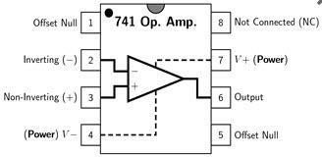
- Pin 1 is offset null.
- Pin 2 is inverting input terminal.
- Pin 3 is a non-inverting input terminal.
- Pin 4 is negative voltage supply (VCC)
- Pin 5 is offset null.
- Pin 6 is the output voltage.
- Pin 7 is positive voltage supply (+VCC)
- Pin 8 has no connection.

Precautions:
- Voltage control knob should be kept at minimum position.
- Current control knob of RPS should be kept at maximum position.
- Carefully utilize the oscilloscope channels and function generator.

Procedure for Inverting Amplifier:
- Wire up the circuit as shown in the figure below on the breadboard.
- Give the input to the inverting terminal of the op-amp and simultaneously display the input and output on the oscilloscope.
- Draw the input & output waveforms at the end of the lab.
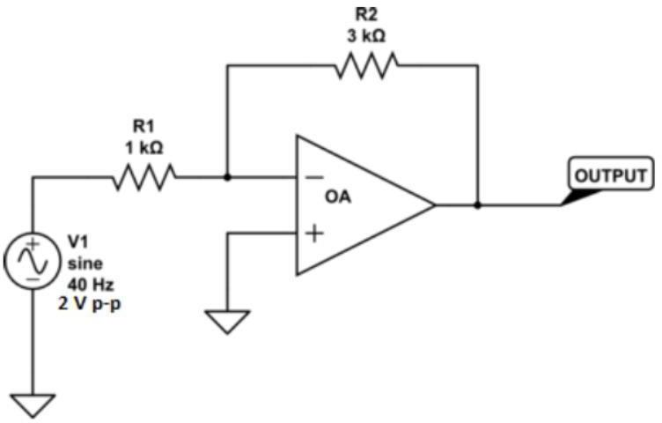

Procedure for Non-Inverting Amplifier:
- Wire up the circuit as shown in the figure below on the breadboard.
- Give the input to the non-inverting terminal of the op-amp and simultaneously display the input and output on the oscilloscope.
- Draw the input & output waveform at the end of the lab.

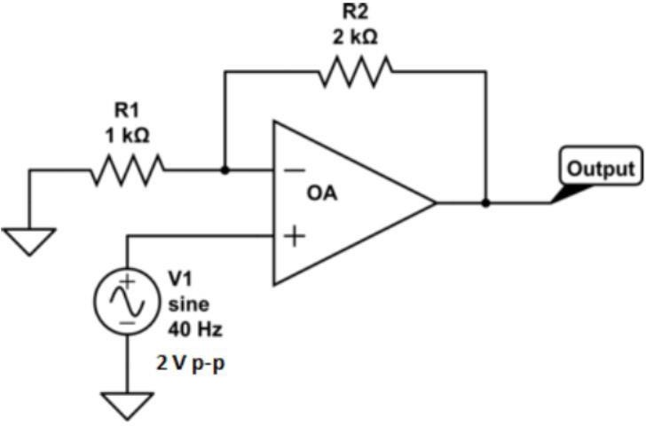



Result:

One horizontal box = 10ms One horizontal box = 10ms

One vertical box = 0.5V One vertical box = 0.5V

Input Voltage = 5V Input Voltage = 5V

Figure 7: Input Voltage Signal Figure 8: Inverted Output



One horizontal box = 10ms

One vertical box = 0.5V

Input Voltage = 5V
Figure 9: Non-Inverting Output

Post Lab Questions
- Define inverting amplifier.
An inverting amplifier is a type of operational amplifier (op-amp) circuit in which the input signal is applied to the inverting (−) terminal, while the non-inverting (+) terminal is usually connected to ground.
1.

3.

- Define Non-inverting amplifier.
A non-inverting amplifier is a type of operational amplifier (op-amp) circuit in which the input signal is applied to the non-inverting (+) terminal, while the inverting (−) terminal is connected to ground through a resistor network.
4.

5.

6.

- What are the applications of inverting amplifiers?
Inverting amplifiers are used for signal inversion, amplification, summing circuits, integration, differentiation, filtering, and current-to-voltage conversion.
7.

8.

9.

- What are the applications of non-inverting amplifiers?
Non-inverting amplifiers are used for amplification without phase change, buffering, impedance matching, filtering, and sensor signal conditioning.
10.

11.

12.

- What is gain of an amplifier?
Gain of an amplifier is the measure of how much an amplifier increases the strength (amplitude) of an input signal.
13.

14.

15.

- How do you calculate the gains for inverting and non-inverting amplifiers?
Gain of an amplifier is the measure of how much an amplifier increases the strength (amplitude) of an input signal, defined as the ratio of output to input.
16.

17.

18.

