# RTA Smart Bus Application.

# Brief Description:

This document entails the technical specification of the RTA Smart Bus project structure. It entails mainly the data objects and how they are passed from one operation to the next.

It also encompasses the libraries used in the development with the reason as to why they were used at a certain point.

## Technologies used:

The project vast range of libraries as seen in the project.gradle file. In this section I will introduce the most essential ones:

# Application Structure:

At application level the structure takes the into account the functionalities below with the service.

* Pay For Fines
* Vehicle Services
* Driver Services
* Certificates

Language Selection:

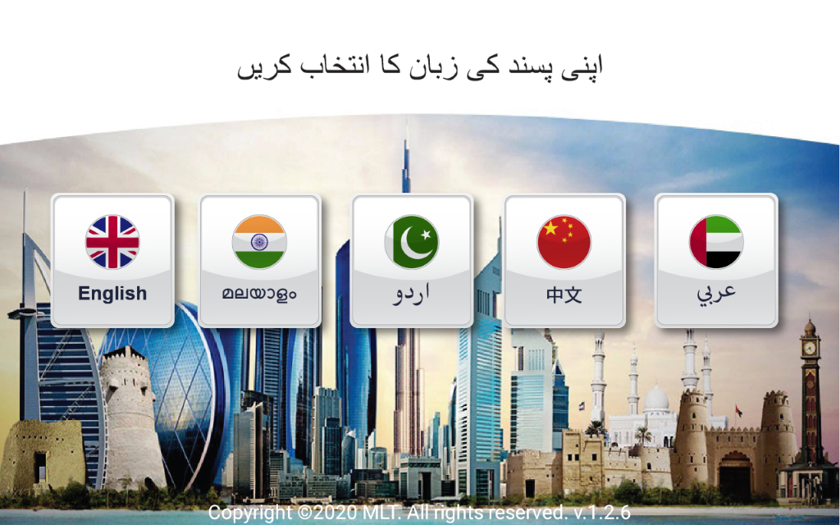

**Pay For Fines,**

Pay for fines have 4 services

1.TRAFFIC FILE NUMBER

2.DRIVING LICENSE

3.VEHICLE PLATE NUMBER

4.FINE NUMBER

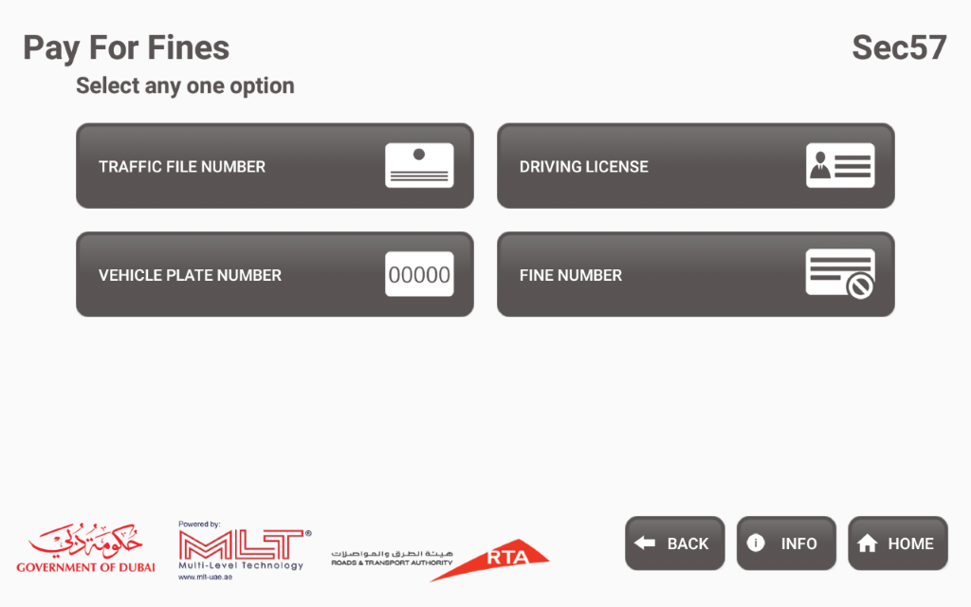

**1.Traffic File Number**

Fragment for enter traffic file number and birth year.

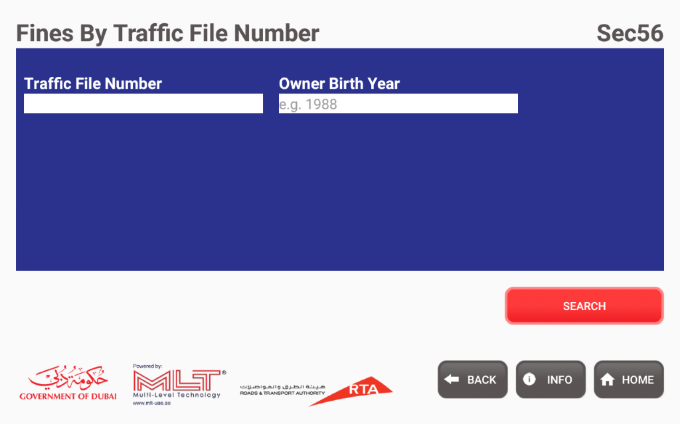

**Fine Details of Traffic file numbe**r

Once you search the file number and birth year,we will get the details of each date of fines and total amount.

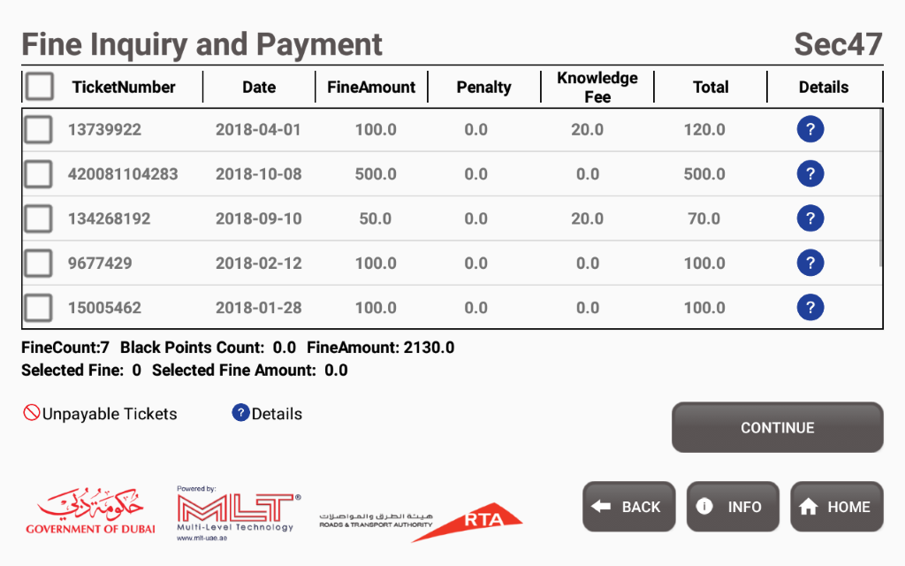

**Enter Contact Details**

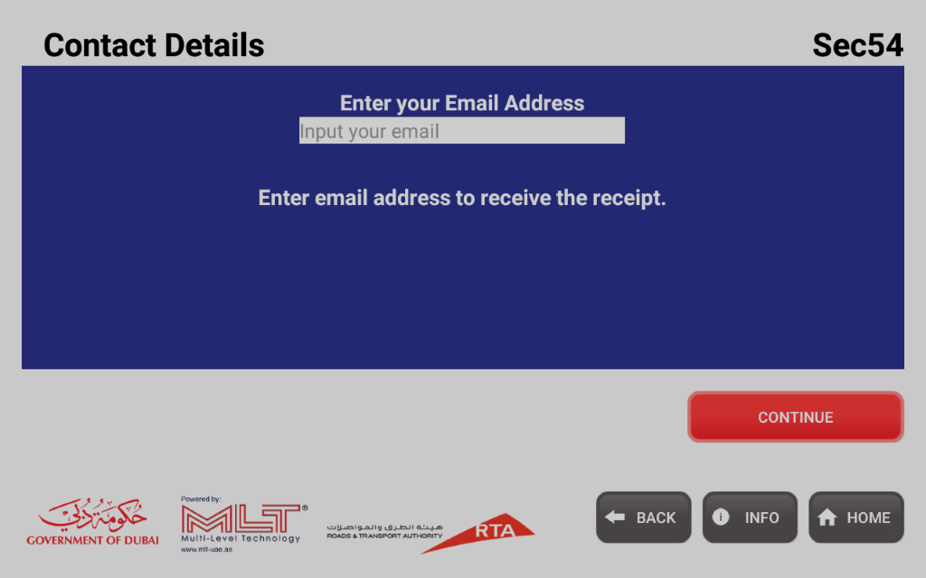

**Total Amount of Fine**

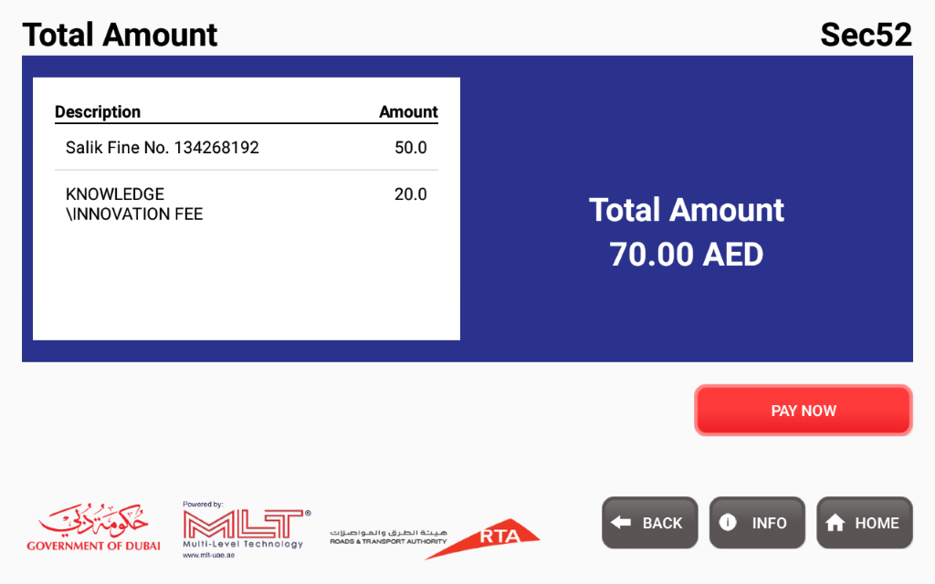

**Payment Part**

**Payment Confirmation**

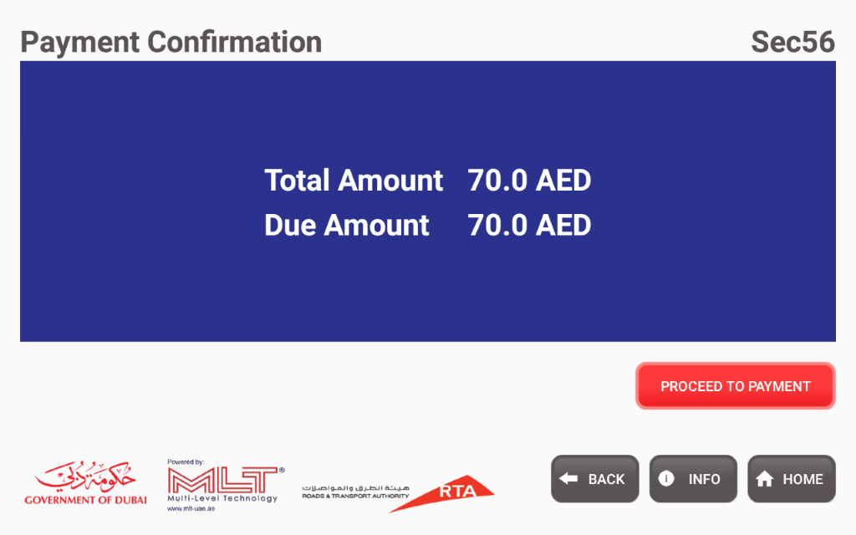

**Card Swipe**

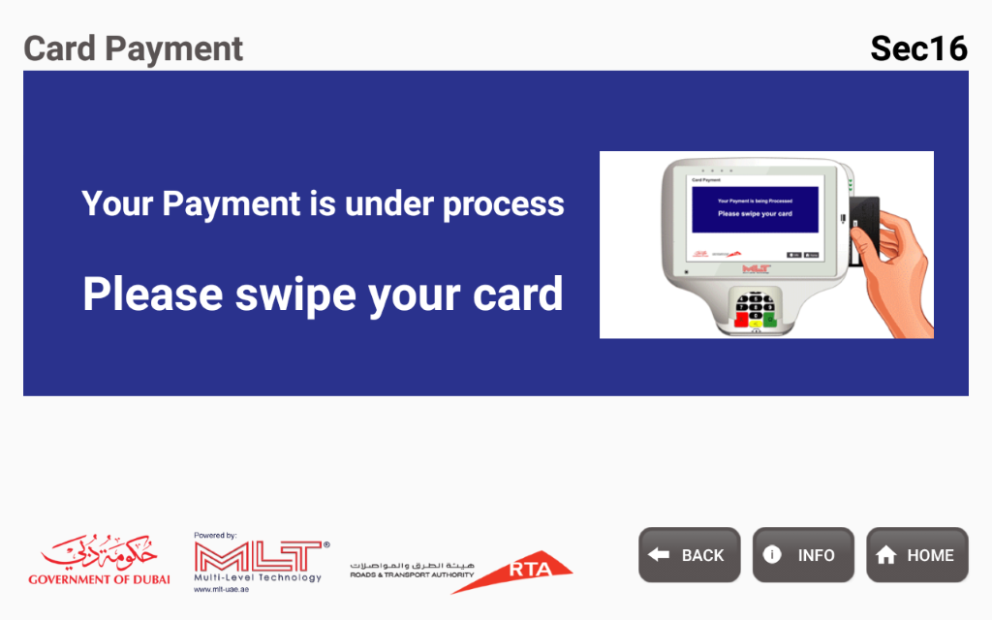

**Enter CVV**

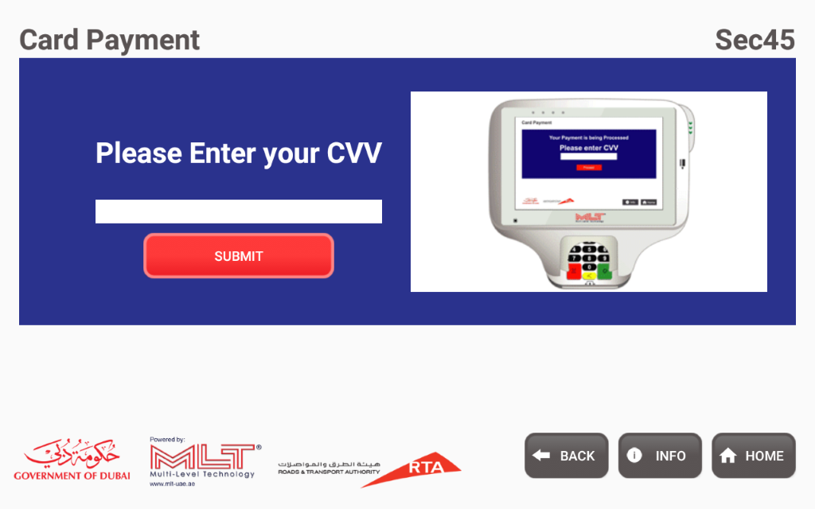

**Payment Process**

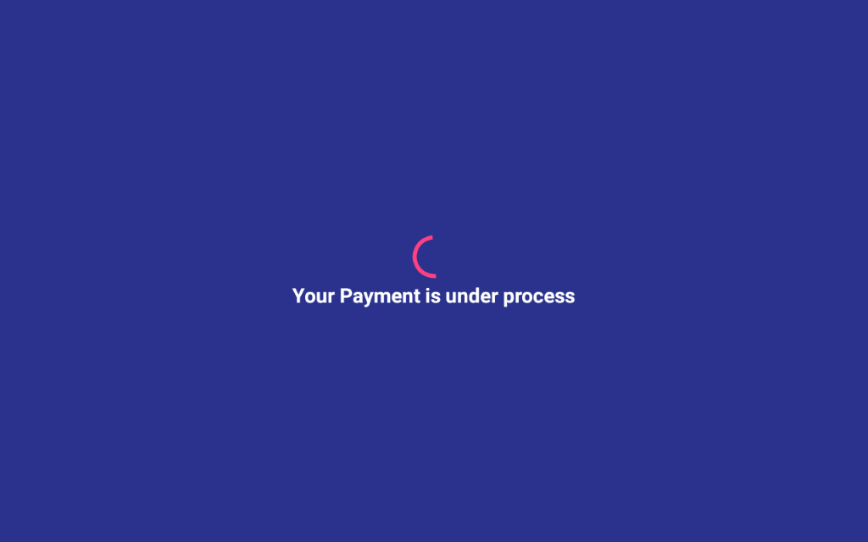

**OTP Screen**

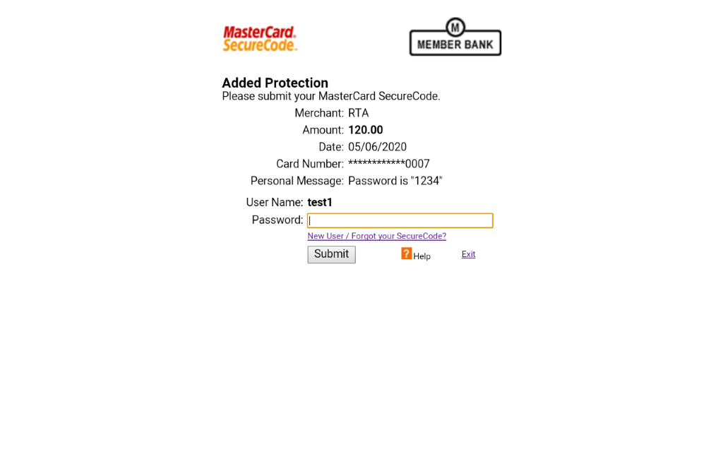

**Payment Successful**

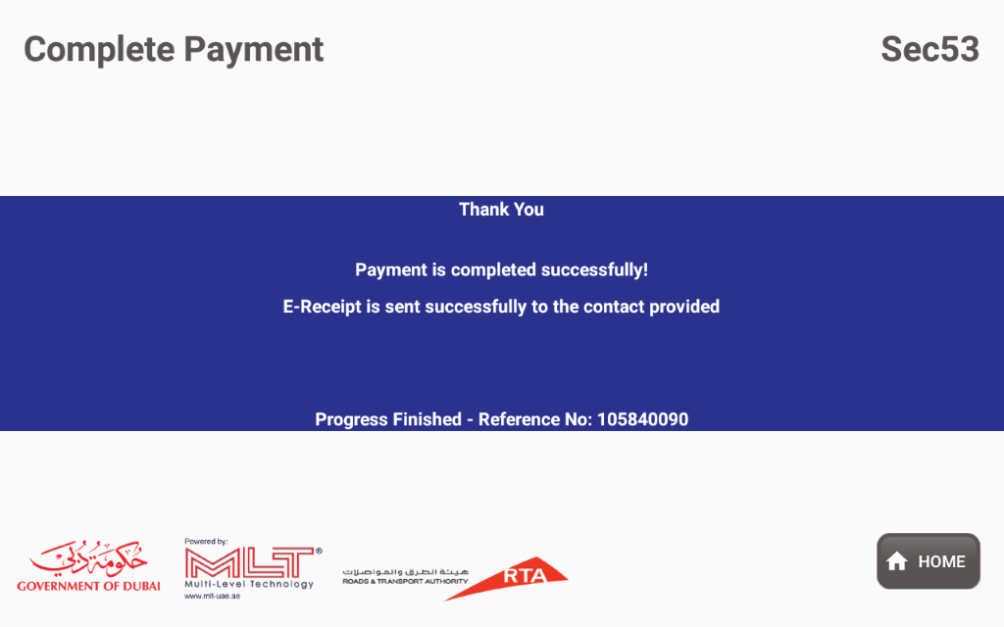

**2.DRIVING LICENSE**

User can enter the license number,birth year,license source.

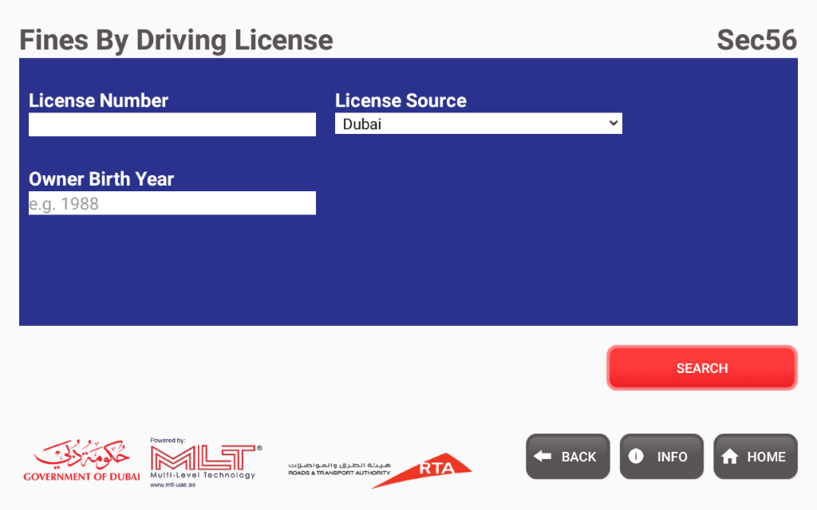

**3.VEHICLE PLATE NUMBER**

User can enter the plate number,birthyear.spinner selecting the plate code,license

Source,plate category.

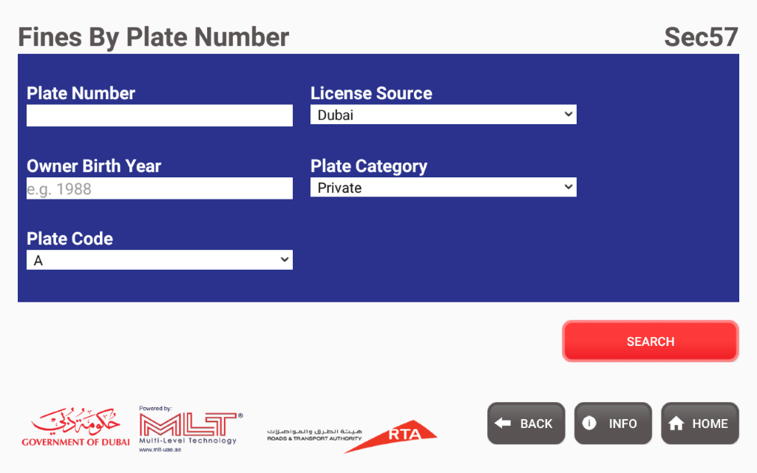

**Fine Details of Vehicle plate numb**er

Once you search the plate number,birth year,platecode,license source,late category,we will get the details of each date of fines and total amount.

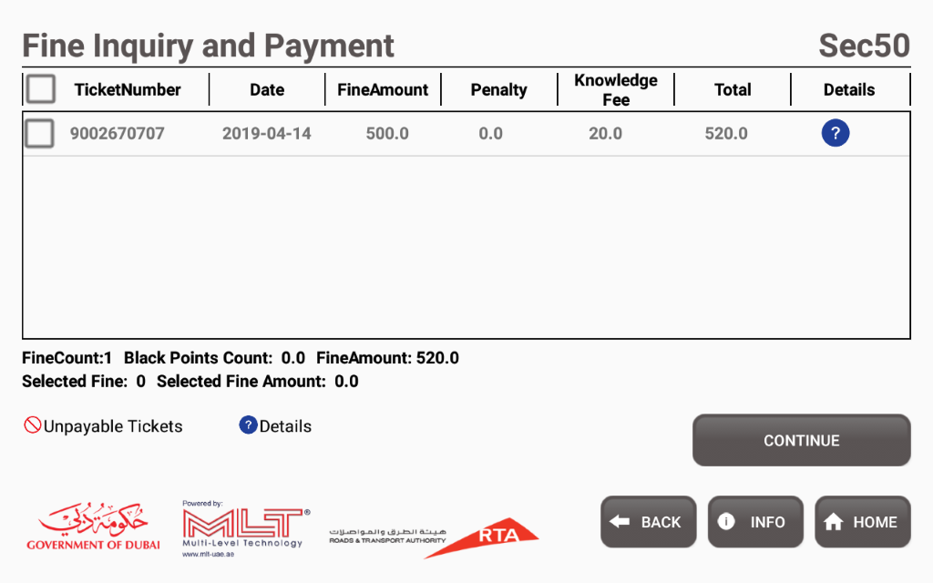

**4.FINE NUMBER**

User can enter the fine number,ticket year and select beneficiary code.

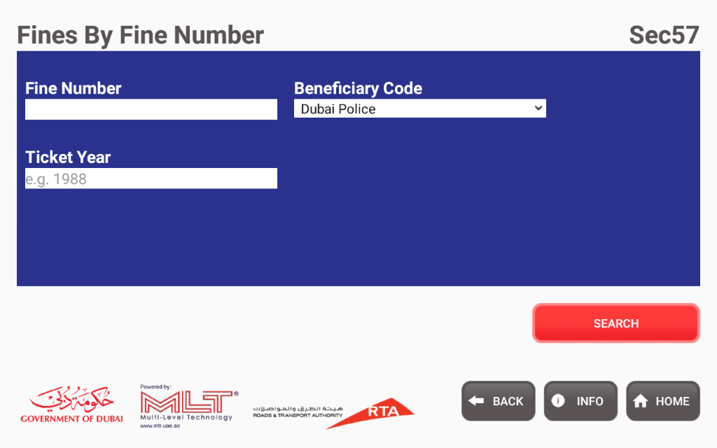

**Vehicle Services,**

Vehicle Services s have 2 services

1.APPLY FOR RENEWING A VEHICLE REGISTRATION CARD

2.APPLY FOR REPLACING A LOST/DAMAGED VEHICLE REGISTARTION CARD

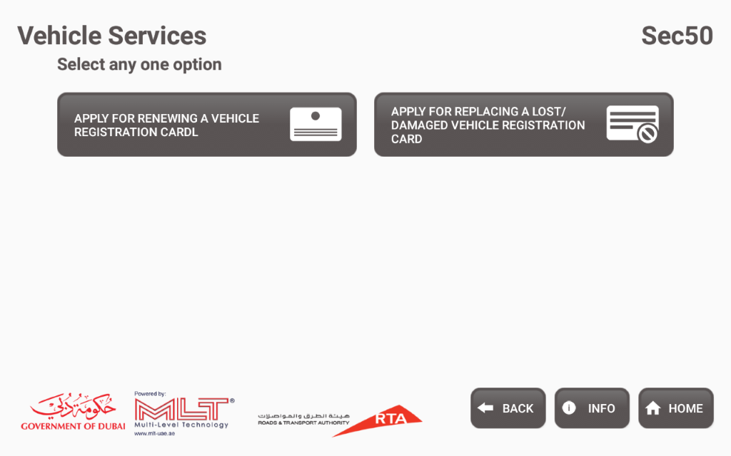

**1.APPLY FOR RENEWING A VEHICLE REGISTRATION CARD**

Renewing for vehicle registration card.user can enter plate number,birthyear,selecting the license source,plate category,plate code.

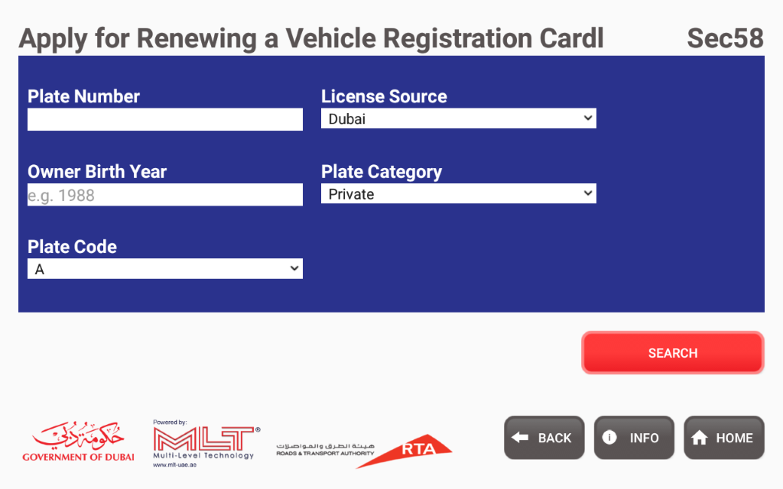

**Vehicle Registration Renewal Details**

Once you searched these parameter we will get the details of Vehicle renewal.

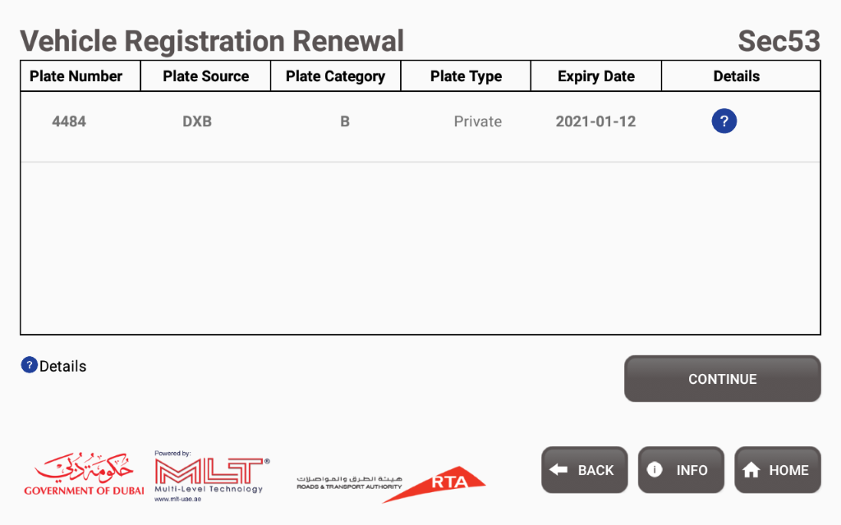

**2.APPLY FOR REPLACING A LOST/DAMAGED VEHICLE REGISTARTION CARD**

User can enter the plate number, birth year and select plate code, plate source, plate category, replacement reason.

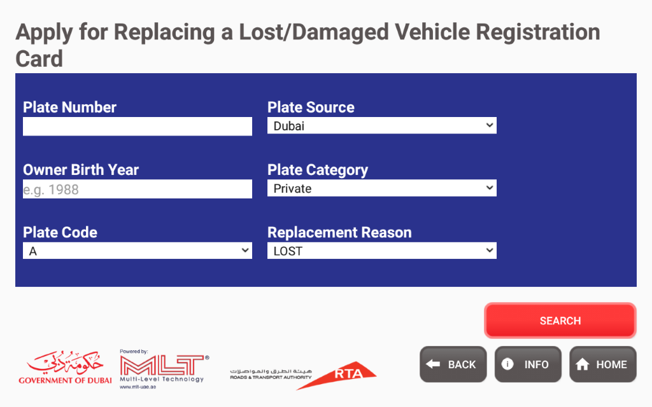

**Vehicle Registration Card Loss/Damage Details**

Once you search these paramters we will get the details of vehicle registration card loss/damage card.

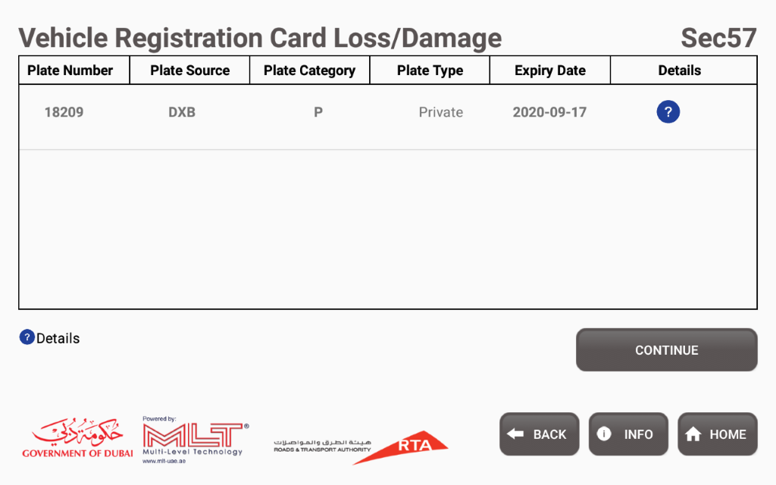

**Driver Services**

Driver Services have 2 services

1.APPLY FOR RENEWING A DRIVING LICENSE

2.APPLY FOR REPLACING A LOST/DAMAGED DRIVING LICENSE

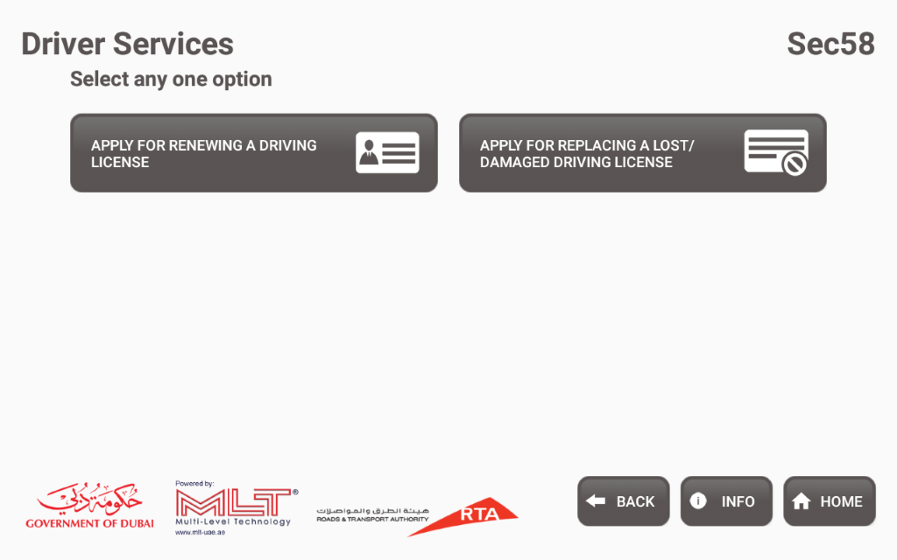

**1. APPLY FOR RENEWING A DRIVING LICENSE**

Renewing driving license user can enter the license number,birth year and select the licence source.

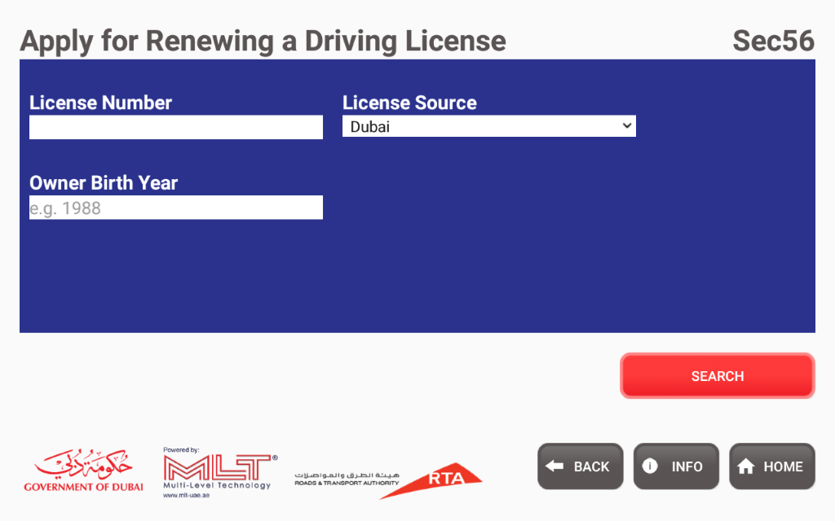

**Driving License Renewal Details**

One you search these parameters we will get the expiry details.

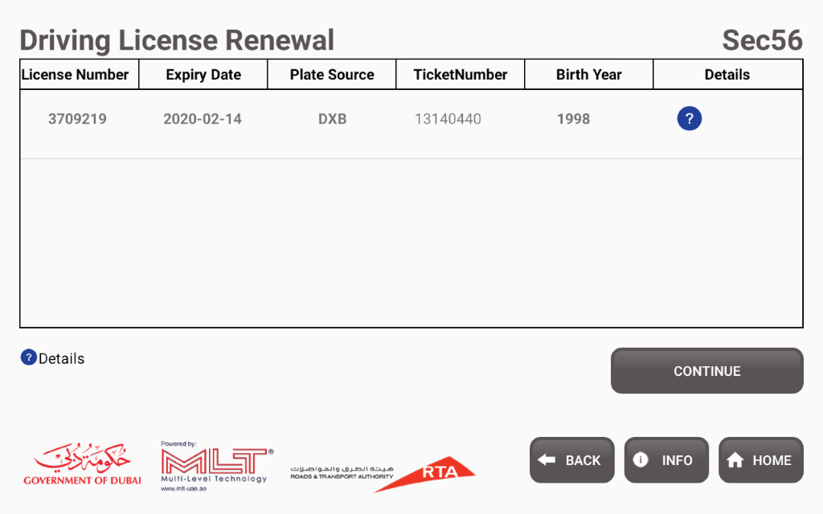

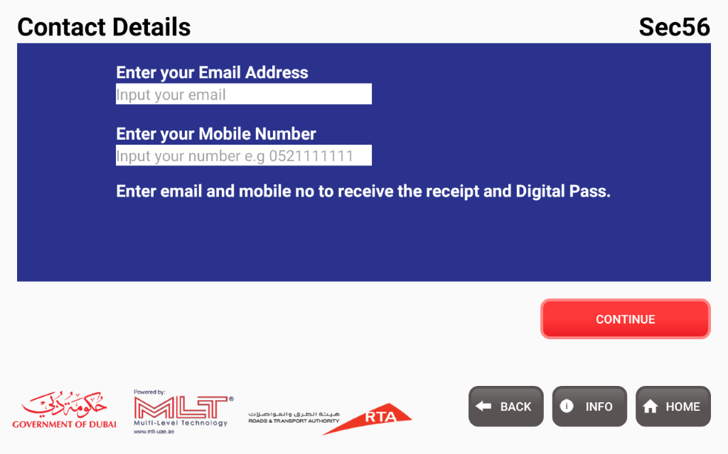

**2.APPLY FOR REPLACING A LOST/DAMAGED DRIVING LICENSE**

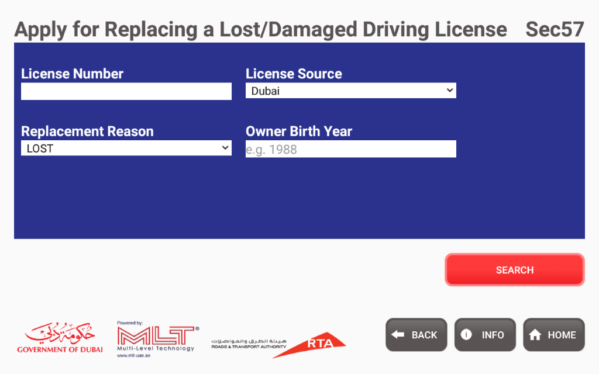

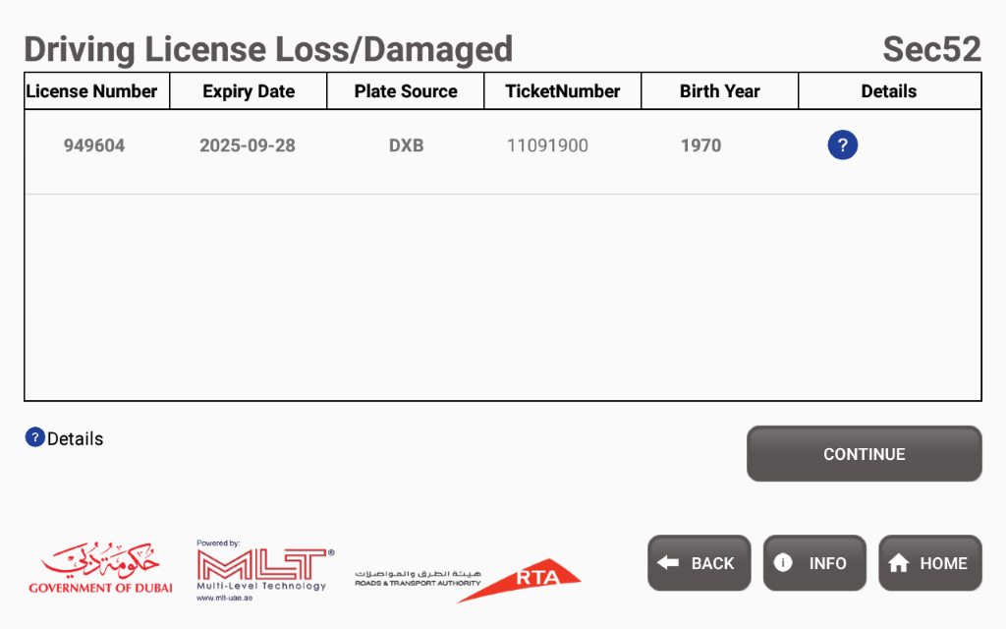

**Certificates,**

Certificates have 5 services

1.APPLY FOR VEHICLE OWNERSHIP CERTIFICATE

2.APPLY FOR VEHICLE NON-OWNERSHIP CERTIFICATE

3.APPLY FOR INSURANCE REFUND CERTIFICATE

4.APPLY FOR VEHICLE CLEARENCE CERTIFICATE

5.APPLY FOR DRIVING EXPERIENCE CERTIFICATE

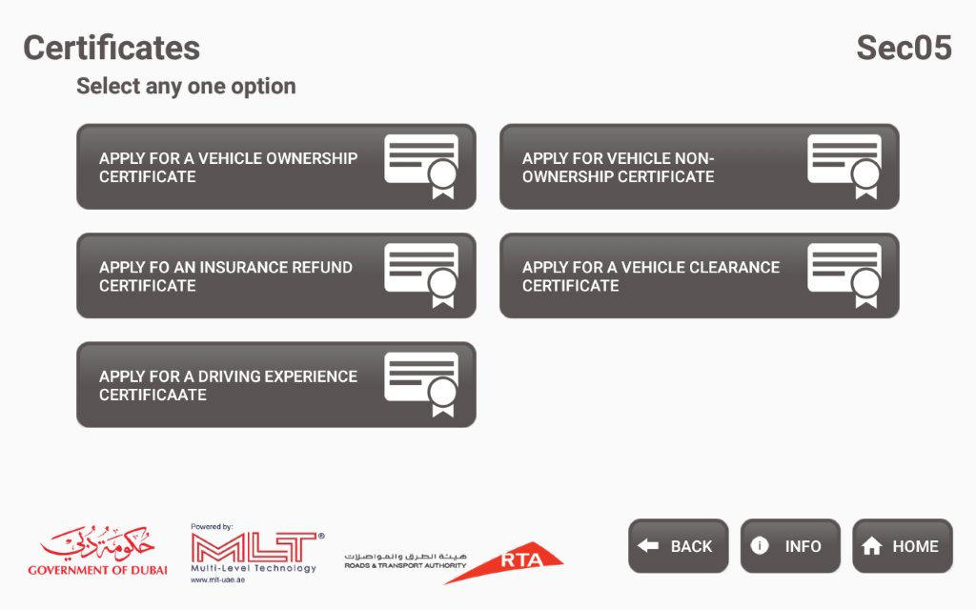

**1.APPLY FOR VEHICLE OWNERSHIP CERTIFICATE**

User can enter the plate number, birth year and select the license source, plate category, plate code, addressed department.

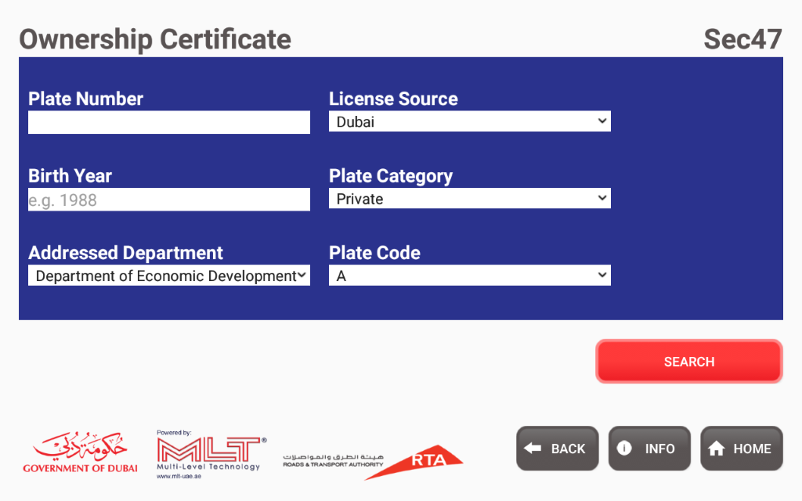

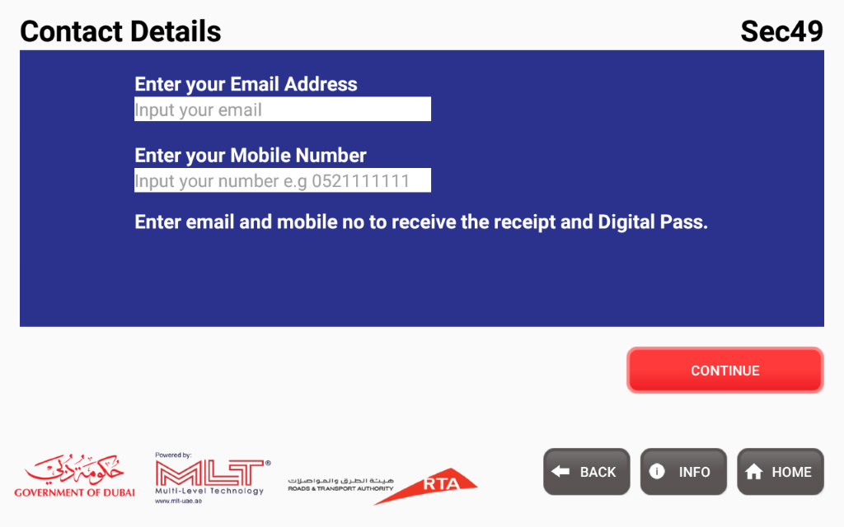

**2.APPLY FOR VEHICLE NON-OWNERSHIP CERTIFICATE**

User can enter the traffic file number, birth year and select the addressed department.

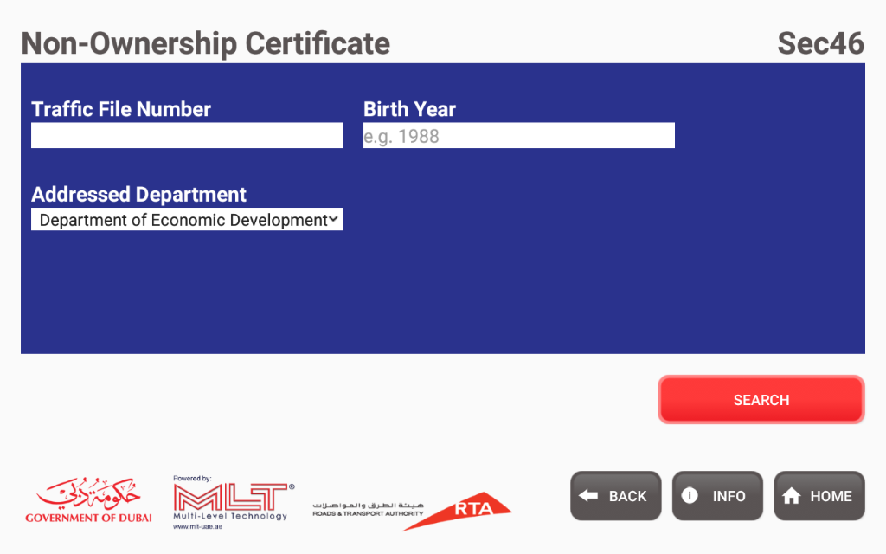

**3.APPLY FOR INSURANCE REFUND CERTIFICATE**

User can enter the plate number,birth year and select the license source,plate category,plate code,insurance company.

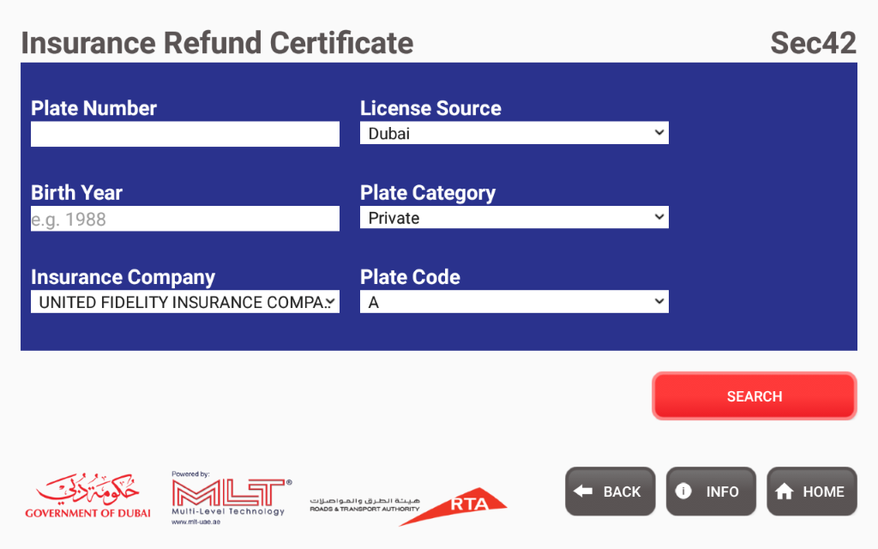

**4.APPLY FOR VEHICLE CLEARENCE CERTIFICATE**

User can enter the plate number,birth year and select the plate code,license source,plate category.

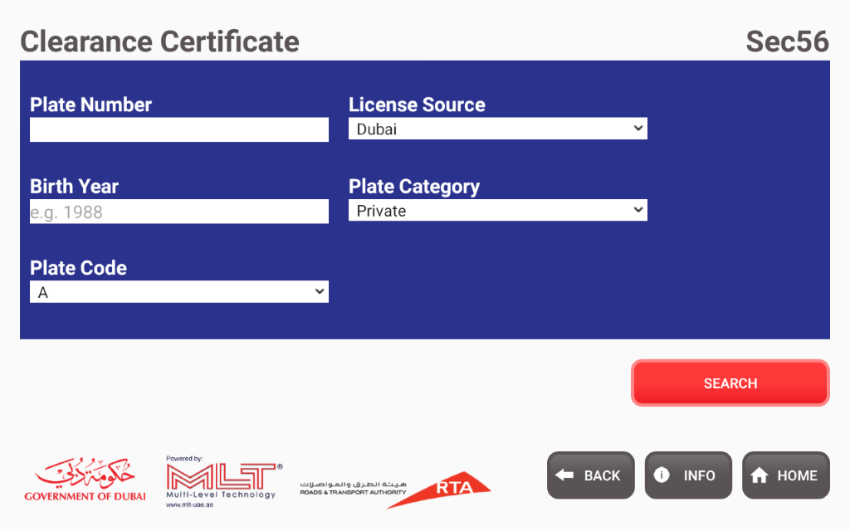

**5.APPLY FOR DRIVING EXPERIENCE CERTIFICATE**

User can enter the licence number,birth year and select the license source

