

PROJECT

DEEP LEARNING CLASS

PROFESSOR RICARDO CALIX

APPLYING CONVOLUTION NEURAL NETWORK ON COLOUR IMAGES DATASET.

DATA SOURCE: KAGGLE DATASETS

**DATA SET:**

**CLASSIFICATION OF SCENERY IMAGES:**

**Objective:**

***To classify scenery images that consist of 4 classes that are sea , mountain , forest and buildings.***

***SAMPLE IMAGES :***

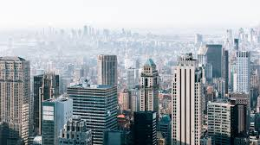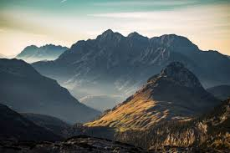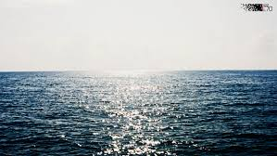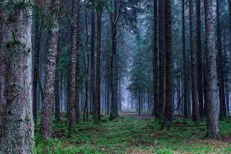

CONVOLUTION NEURAL NETWORK CODE:

##!/usr/bin/env python

## Deep Learning code

##Professor Ricardo Calix

## simple example of a convolutional neural network for RGB data

###################################################################

import sklearn

import tensorflow as tf

import numpy as np

from numpy import genfromtxt

from sklearn import datasets

#from sklearn.cross_validation import train_test_split

from sklearn.model_selection import train_test_split

from sklearn.metrics import accuracy_score

from sklearn.metrics import confusion_matrix

from sklearn.metrics import precision_score

from sklearn.metrics import recall_score, f1_score

import pandas as pd

import matplotlib.pyplot as plt

###########################################################

## set parameters

import warnings

warnings.filterwarnings("ignore")

np.set_printoptions(threshold=np.inf) #print all values in numpy array

###########################################################

#parameters for the main loop

learning_rate = 0.001

n_epochs = 6000 ##27000

batch_size = 150

display_step = 10

# Parameters for the network

n_input = 7500 # 50x50x3

n_classes = 4 # (0-3 classes)

dropout = 0.75 # Dropout, probability to keep units

###############################################################################################

## this will create your own data set (i.e. your_mnist)

## put your images in testA (I used pngs)

from PIL import Image

#import cv2

import glob

import numpy as np

train = []

labels = []

################################################################################################

files = glob.glob ("scenery/forest/*.jpg") # your images path

for myFile in files:

my_im = Image.open(myFile).convert('RGB') ## .convert('LA') ## is for greyscale

#my_im.show()

resized_my_im = my_im.resize((50,50)) ## resize from 150x150x3 to 50x50x3

#resized_my_im.show()

image = np.array(resized_my_im)

#image = np.array(my_im)

print(image.shape)

new_image = image.reshape(image.shape[0]*image.shape[1]*image.shape[2])

print(new_image.shape)

#input_string = input("???")

train.append(new_image)

labels.append(0)

##################################################################################################

files = glob.glob ("scenery/buildings/*.jpg") # your images path

for myFile in files:

my_im = Image.open(myFile).convert('RGB') ## .convert('LA') ## is for greyscale

#my_im.show()

resized_my_im = my_im.resize((50,50)) ## resize from 150x150x3 to 50x50x3

#resized_my_im.show()

image = np.array(resized_my_im)

#image = np.array(my_im)

print(image.shape)

new_image = image.reshape(image.shape[0]*image.shape[1]*image.shape[2])

print(new_image.shape)

#input_string = input("???")

train.append(new_image)

labels.append(1)

########################################################################################################

files = glob.glob ("scenery/mountain/*.jpg") # your images path

for myFile in files:

my_im = Image.open(myFile).convert('RGB') ## .convert('LA') ## is for greyscale

#my_im.show()

resized_my_im = my_im.resize((50,50)) ## resize from 150x150x3 to 50x50x3

#resized_my_im.show()

image = np.array(resized_my_im)

#image = np.array(my_im)

print(image.shape)

new_image = image.reshape(image.shape[0]*image.shape[1]*image.shape[2])

print(new_image.shape)

#input_string = input("???")

train.append(new_image)

labels.append(2)

##################################################################################################

files = glob.glob ("scenery/sea/*.jpg") # your images path

for myFile in files:

my_im = Image.open(myFile).convert('RGB') ## .convert('LA') ## is for greyscale

#my_im.show()

resized_my_im = my_im.resize((50,50)) ## resize from 150x150x3 to 50x50x3

#resized_my_im.show()

image = np.array(resized_my_im)

#image = np.array(my_im)

print(image.shape)

new_image = image.reshape(image.shape[0]*image.shape[1]*image.shape[2])

print(new_image.shape)

#input_string = input("???")

train.append(new_image)

labels.append(3)

###############################################################################################################

#############################################################################################################

train = np.array(train,dtype='float32')

labels = np.array(labels, dtype='float32')

# convert (number of images x height x width x number of channels) to (number of images x (height * width *3))

# for example (120 * 40 * 40 * 3)-> (120 * 4800)

#train = np.reshape(train,[train.shape[0],train.shape[1]*train.shape[2]*train.shape[3]])

#train = np.reshape(train,[train.shape[0],train.shape[1]*train.shape[2]])

print(train.shape)

print(labels.shape)

#print(train.shape[1])

#input_string = input("train size is")

##############################################################################################################

# save numpy array as .npy formats

np.save('train',train)

your_mnist = train

################################################################################################################

## normalization is very important

x=your_mnist

xmax, xmin = x.max(), x.min()

x = (x - xmin)/(xmax - xmin)

your_mnist = x

############################################################################################################

x_all = your_mnist

labels_all = labels

x_train, x_test, y_train, y_test = train_test_split(x_all, labels_all, test_size=0.30, random_state=42)

################################################################################################################

## print stats

precision_scores_list = []

accuracy_scores_list = []

def print_stats_metrics(y_test, y_pred):

print('Accuracy: %.2f' % accuracy_score(y_test, y_pred) )

#Accuracy: 0.84

accuracy_scores_list.append(accuracy_score(y_test, y_pred) )

confmat = confusion_matrix(y_true=y_test, y_pred=y_pred)

print "confusion matrix"

print(confmat)

print pd.crosstab(y_test, y_pred, rownames=['True'], colnames=['Predicted'], margins=True)

precision_scores_list.append(precision_score(y_true=y_test, y_pred=y_pred, average='weighted'))

print('Precision: %.3f' % precision_score(y_true=y_test, y_pred=y_pred, average='weighted'))

print('Recall: %.3f' % recall_score(y_true=y_test, y_pred=y_pred, average='weighted'))

print('F1-measure: %.3f' % f1_score(y_true=y_test, y_pred=y_pred, average='weighted'))

#####################################################################

########################################################################

def conv2d(x, W, b, strides=1):

# Conv2D function, with bias and relu activation

x = tf.nn.conv2d(x, W, strides=[1, strides, strides, 1], padding='SAME')

x = tf.nn.bias_add(x, b)

return tf.nn.relu(x) ## relu removes negative values

##########################################################################

def maxpool2d(x, k=2):

# MaxPool2D function

# padding='SAME' is very useful for uneven images. If maxpooling

# image 25x25 -> 12.5 x 12.5 then it is rounded up to 13x13

return tf.nn.max_pool(x, ksize=[1, k, k, 1], strides=[1, k, k, 1],

padding='SAME')

################################################################

def layer(input, weight_shape, bias_shape):

W = tf.Variable(tf.random_normal(weight_shape))

b = tf.Variable(tf.random_normal(bias_shape))

mapping = tf.matmul(input, W)

result = tf.add( mapping , b )

return result

################################################################

def conv_layer(input, weight_shape, bias_shape):

##rr =raw_input()

W = tf.Variable(tf.random_normal(weight_shape))

b = tf.Variable(tf.random_normal(bias_shape))

conv = conv2d(input, W, b)

# Max Pooling (down-sampling)

conv_max = maxpool2d(conv, k=2)

return conv_max

################################################################

def fully_connected_layer(conv_input, fc_weight_shape, fc_bias_shape, dropout):

new_shape = [-1, tf.Variable(tf.random_normal(fc_weight_shape)).get_shape().as_list()[0]]

fc = tf.reshape(conv_input, new_shape)

w_fc = tf.Variable( tf.random_normal( fc_weight_shape ) )

mapping = tf.matmul( fc , w_fc ) # y = w * x

fc = tf.add( mapping, tf.Variable(tf.random_normal( fc_bias_shape )) )

fc = tf.nn.relu(fc)

# Apply Dropout

fc = tf.nn.dropout(fc, dropout)

return fc

###########################################################

## define the architecture here

def inference_conv_net_3_convolutions(x, dropout):

# Reshape input picture

# shape = [-1, size_image_x, size_image_y, 3 channels (e.g. rgb)]

# the imge for rgb and batches of 150 would be [150, 7500] because

# there are 128 samples per batch and images are 50x50x3 = 7500

# this has to be re-shaped bacause Convolutional layers only take 4 dimensional tensors as input

# the -1 infers the number of batches and then we make the 7500 into 50x50x3

x = tf.reshape(x, shape=[-1, 50, 50, 3])

# Convolution Layer 1, filter 5x5 conv, 3 inputs or 3 channels, 16 outputs

# max pool will reduce image from 50x50 to 25x25

conv1 = conv_layer(x, [5, 5, 3, 16], [16] )

# Convolution Layer 2, filter 5x5 conv, 16 inputs, 36 outputs

# max pool will reduce image from 25x25 to 13x13

conv2 = conv_layer(conv1, [5, 5, 16, 36], [36] )

# Convolution Layer 2, filter 5x5 conv, 36 inputs, 64 outputs

# max pool will reduce image from 13x13 to 7x7

conv3 = conv_layer(conv2, [5, 5, 36, 64], [64] )

# Fully connected layer, 7*7*64 inputs, 1024 outputs

# Reshape conv2 output to fit fully connected layer input

# maxpool function padding=same rounds up 6.5 to 7

fc1 = fully_connected_layer(conv3, [7*7*64, 1024], [1024] , dropout)

# Output, 128 inputs, 10 outputs (class prediction)

output = layer(fc1 ,[1024, n_classes], [n_classes] )

return output

###########################################################

def loss_deep_conv_net(output, y_tf):

xentropy = tf.nn.softmax_cross_entropy_with_logits(logits=output, labels=y_tf)

loss = tf.reduce_mean(xentropy)

return loss

###########################################################

def training(cost):

optimizer = tf.train.AdamOptimizer(learning_rate=learning_rate)

train_op = optimizer.minimize(cost)

return train_op

###########################################################

def evaluate(output, y_tf):

correct_prediction = tf.equal(tf.argmax(output,1), tf.argmax(y_tf,1))

accuracy = tf.reduce_mean(tf.cast(correct_prediction, "float"))

return accuracy

###########################################################

x_tf = tf.placeholder(tf.float32, [None, n_input]) ## 50x50x3

y_tf = tf.placeholder(tf.float32, [None, n_classes])

keep_prob = tf.placeholder(tf.float32) #dropout (keep probability)

###############################################################

output = inference_conv_net_3_convolutions(x_tf, keep_prob)

#output = inference_conv_net2(x_tf, keep_prob)

#output = inference_conv_net(x_tf, keep_prob)

cost = loss_deep_conv_net(output, y_tf)

train_op = training(cost)

eval_op = evaluate(output, y_tf)

##################################################################

## for metrics

y_p_metrics = tf.argmax(output, 1)

##################################################################

# Initialize and run

#init = tf.global_variables_initializer()

init = tf.initialize_all_variables()

sess = tf.Session()

sess.run(init)

############################################################

# one-hot encoding

depth = 4

y_train_onehot = sess.run(tf.one_hot(y_train, depth))

y_test_onehot = sess.run(tf.one_hot(y_test, depth))

##########################################################

## batch parameters

num_samples_train = len(y_train)

print num_samples_train

num_batches = int(num_samples_train/batch_size)

###########################################################################################

dropout2 = 1.0

############################################################

# MAIN_LOOP()

for i in range(n_epochs):

for batch_n in range(num_batches):

sta= batch_n*batch_size

end= sta + batch_size

sess.run( train_op , feed_dict={x_tf: x_train[sta:end,:] , y_tf: y_train_onehot[sta:end, :], keep_prob: dropout })

loss, acc = sess.run([cost, eval_op], feed_dict={x_tf: x_train[sta:end,:] , y_tf: y_train_onehot[sta:end, :], keep_prob: dropout2})

result = sess.run(eval_op, feed_dict={x_tf: x_test, y_tf: y_test_onehot, keep_prob: dropout2})

result2, y_pred = sess.run([eval_op, y_p_metrics], feed_dict={x_tf: x_test, y_tf: y_test_onehot, keep_prob: dropout2})

print "test1 {},{}".format(i,result)

print "test2 {},{}".format(i,result2)

y_true = np.argmax(y_test_onehot, 1)

print y_pred

print y_true

print_stats_metrics(y_true, y_pred)

print "**********************************************************************************************************"

##########################################################################################

print "<<<<<<<<<<<<<<<<<<DONE>>>>>>>>>>>>>>>>>>>>>>>"

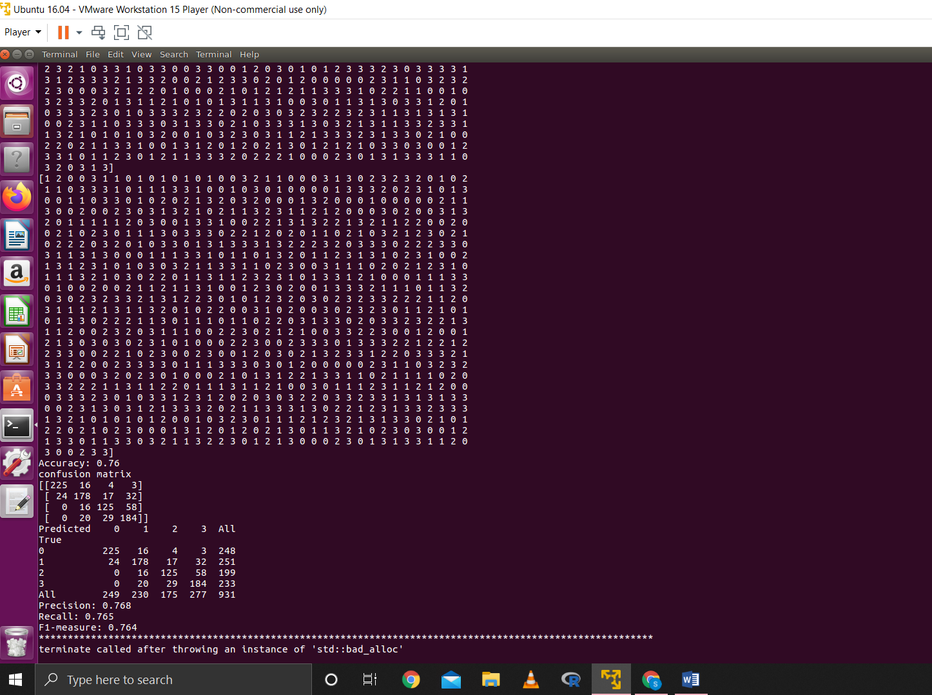

**Output:**

RESULTS:

|  |  |  |  |  |
| --- | --- | --- | --- | --- |
|  | **PRECISION** | **RECALL** | **ACCURACY** | **F- MEASURE** |
| **COVOLUTION**  **NEURAL NETWORK** | 0.768 | 0.764 | 0.76 | 0.764 |