DEEP LEARNING HOMEWORK 3

*PROF:RICARDOCALIX*

# LOGISTIC REGREESION CODE WITH MNIST DATA AND OUTPUT.

## logistic regression algorithm

## supervised learning classifier

#############################################################

import tensorflow as tf

import numpy as np

from numpy import genfromtxt

import sklearn

from sklearn.preprocessing import StandardScaler

#############################################################

number_epochs = 90

learning_rate = 0.01

batch_size = 1000

#############################################################

#training_data = genfromtxt('cs-training.csv', delimiter=',')

#testing_data = genfromtxt('cs-testing.csv', delimiter=',')

#############################################################

x_train = genfromtxt('mnist_train.csv', delimiter=',', usecols=(i for i in range(1,785)) , skip_header=1)

y_train = genfromtxt('mnist_train.csv', delimiter=',', usecols=(0))

x_test = genfromtxt('mnist_test.csv', delimiter=',', usecols=(i for i in range(1,785)) , skip_header=1)

y_test = genfromtxt('mnist_test.csv', delimiter=',', usecols=(0))

############################################################

## normalizing

sc = StandardScaler()

sc.fit(x_train)

x_train_normalized = sc.transform(x_train)

x_test_normalized = sc.transform(x_test)

############################################################

# one-hot encoding

depth = 10

y_train_onehot = tf.one_hot(y_train, depth)

y_test_onehot = tf.one_hot(y_test, depth)

#############################################################

# features (A)

A = len(x_train[0])

print A # number of features

#############################################################

# classes (B)

B = 10 #len(sess.run(y_train_onehot[0]))

print "number of classes ", B

############################################################

def inference(x, A, B):

W = tf.Variable( tf.zeros([A, B]) )

b = tf.Variable(tf.zeros( [B]) )

output = tf.nn.softmax( tf.matmul(x, W) + b )

return output

############################################################

def loss(output, y):

output = tf.clip_by_value(output, 1e-10, 1.0)

dot_product = y * tf.log(output)

xentropy = -tf.reduce_sum( dot_product )

loss = tf.reduce_mean( xentropy )

return loss

#############################################################

def training(cost):

optimizer = tf.train.GradientDescentOptimizer(learning_rate)

train_op = optimizer.minimize(cost)

return train_op

#############################################################

def evaluate(output, y):

correct_prediction = tf.equal( tf.argmax(output,1) , tf.argmax(y,1) )

accuracy = tf.reduce_mean( tf.cast(correct_prediction, "float") )

return accuracy

#############################################################

x = tf.placeholder("float", [None, A])

y = tf.placeholder("float", [None, B])

#############################################################

## call the core functions

output = inference(x, A, B)

cost = loss(output, y)

train_op = training(cost)

eval_op = evaluate(output, y)

############################################################

init = tf.global_variables_initializer()

sess = tf.Session()

sess.run(init)

###########################################################

## batch parameters

num_samples_train = len(y_train)

print num_samples_train

num_batches = int(num_samples_train/batch_size)

############################################################

# MAIN_LOOP()

print "running..."

for i in range(number_epochs):

for batch_n in range(num_batches):

sta= batch_n*batch_size

end= sta + batch_size

y_temp = sess.run(y_train_onehot)

sess.run( train_op , feed_dict={x: x_train_normalized[sta:end,:] , y: y_temp[sta:end, :]})

y_test_temp = sess.run(y_test_onehot)

print "accuracy ..."

accuracy_score = sess.run(eval_op, feed_dict={x: x_test_normalized, y: y_test_temp})

print "run {}, {}".format(i, accuracy_score)

#############################################################

print "<<<<<<<<DONE>>>>>>>>>"

**SCREEN SHOT OF THE OUTPUT OF LOGISTIC REGRESSION:**

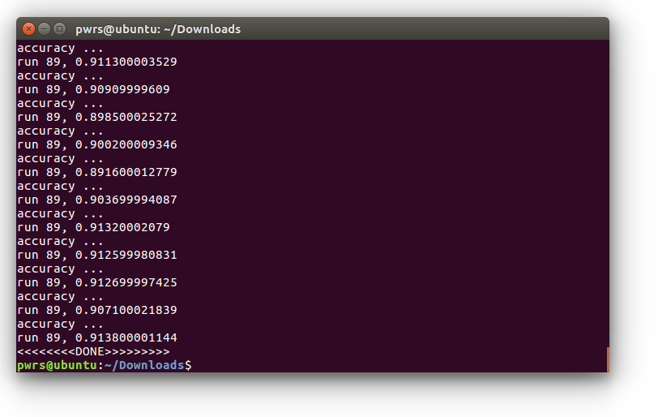

# **NEURAL NETWORK WITH MINIST DATA SET.**

## log reg, nn, deep neural net algorithm

## supervised learning classifier

#############################################################

import tensorflow as tf

import numpy as np

from numpy import genfromtxt

import sklearn

from sklearn.preprocessing import StandardScaler

from sklearn.metrics import accuracy_score

from sklearn.metrics import confusion_matrix

from sklearn.metrics import precision_score

from sklearn.metrics import recall_score, f1_score

import pandas as pd

import matplotlib.pyplot as plt

#############################################################

## remove if not using a mac

#import os

#os.environ['KMP_DUPLICATE_LIB_OK']='True'

#############################################################

number_epochs = 50

learning_rate = 0.1

batch_size = 1000

#############################################################

x_train = genfromtxt('mnist_train.csv', delimiter=',', usecols=(i for i in range(1,785)) , skip_header=1)

y_train = genfromtxt('mnist_train.csv', delimiter=',', usecols=(0))

x_test = genfromtxt('mnist_test.csv', delimiter=',', usecols=(i for i in range(1,785)) , skip_header=1)

y_test = genfromtxt('mnist_test.csv', delimiter=',', usecols=(0))

############################################################

## normalizing

sc = StandardScaler()

sc.fit(x_train)

x_train_normalized = sc.transform(x_train)

x_test_normalized = sc.transform(x_test)

###########################################################

# Convert to one hot data

def convertOneHot_data2(data):

y=np.array([int(i) for i in data])

#print y[:20]

rows = len(y)

columns = y.max() + 1

a = np.zeros(shape=(rows,columns))

#print a[:20,:]

print rows

print columns

#rr = raw_input()

#y_onehot=[0]*len(y)

for i,j in enumerate(y):

#y_onehot[i]=np.array([0]*(y.max() + 1) )

#y_onehot[i][j]=1

a[i][j]=1

return (a)

############################################################

# one-hot encoding

depth = 10

#y_train_onehot = tf.one_hot(y_train, depth)

#y_test_onehot = tf.one_hot(y_test, depth)

y_train_onehot = convertOneHot_data2(y_train)

y_test_onehot = convertOneHot_data2(y_test)

#############################################################

# features (A)

A = len(x_train[0])

print A # number of features

#############################################################

# classes (B)

B = 10 #len(sess.run(y_train_onehot[0]))

print "number of classes ", B

############################################################

## print stats

precision_scores_list = []

accuracy_scores_list = []

def print_stats_metrics(y_test, y_pred):

print('Accuracy: %.2f' % accuracy_score(y_test, y_pred) )

#Accuracy: 0.84

accuracy_scores_list.append(accuracy_score(y_test, y_pred) )

confmat = confusion_matrix(y_true=y_test, y_pred=y_pred)

print "confusion matrix"

print(confmat)

print pd.crosstab(y_test, y_pred, rownames=['True'], colnames=['Predicted'], margins=True)

precision_scores_list.append(precision_score(y_true=y_test, y_pred=y_pred, average='weighted'))

print('Precision: %.3f' % precision_score(y_true=y_test, y_pred=y_pred, average='weighted'))

print('Recall: %.3f' % recall_score(y_true=y_test, y_pred=y_pred, average='weighted'))

print('F1-measure: %.3f' % f1_score(y_true=y_test, y_pred=y_pred, average='weighted'))

##############################################################

def plot_metric_per_epoch():

x_epochs = []

y_epochs = []

for i, val in enumerate(precision_scores_list):

x_epochs.append(i)

y_epochs.append(val)

plt.scatter(x_epochs, y_epochs,s=50,c='lightgreen', marker='s', label='score')

plt.xlabel('epoch')

plt.ylabel('score')

plt.title('Score per epoch')

plt.legend()

plt.grid()

plt.show()

############################################################

def layer(input, weight_shape, bias_shape):

bias_init = tf.constant_initializer(value=0)

weight_stddev = (2.0/weight_shape[0])**0.5

w_init = tf.random_normal_initializer(stddev=weight_stddev)

W = tf.get_variable("W", weight_shape, initializer=w_init)

b = tf.get_variable("b", bias_shape, initializer=bias_init)

return tf.nn.relu( tf.matmul(input, W) + b )

############################################################

## a neural network

def inference_nn(x, A, B):

with tf.variable_scope("hidden_1"):

hidden_1 = layer(x, [A, 128], [128] )

with tf.variable_scope("output"):

output = layer(hidden_1, [128,B], [B])

return output

############################################################

## deep neural network 3 hidden layers

#def inference_deep_3layers(x, A, B):

with tf.variable_scope("hidden_1"):

hidden_1 = layer(x, [A,300], [300])

with tf.variable_scope("hidden_2"):

hidden_2 = layer(hidden_1, [300,200], [200])

with tf.variable_scope("hidden_3"):

hidden_3 = layer(hidden_2, [200,100], [100])

with tf.variable_scope("output"):

output = layer(hidden_3, [100, B], [B])

return output

############################################################

## logistic regression

#def inference(x, A, B):

W = tf.Variable( tf.zeros([A, B]) )

b = tf.Variable(tf.zeros( [B]) )

output = tf.nn.softmax( tf.matmul(x, W) + b )

return output

############################################################

def loss_deep(output, y):

xentropy = tf.nn.softmax_cross_entropy_with_logits(logits=output, labels=y)

loss = tf.reduce_mean(xentropy)

return loss

############################################################

#def loss(output, y):

output = tf.clip_by_value(output, 1e-10, 1.0)

dot_product = y * tf.log(output)

xentropy = -tf.reduce_sum( dot_product )

loss = tf.reduce_mean( xentropy )

return loss

#############################################################

def training(cost):

optimizer = tf.train.GradientDescentOptimizer(learning_rate)

train_op = optimizer.minimize(cost)

return train_op

#############################################################

def evaluate(output, y):

correct_prediction = tf.equal( tf.argmax(output,1) , tf.argmax(y,1) )

accuracy = tf.reduce_mean( tf.cast(correct_prediction, "float") )

return accuracy

#############################################################

x = tf.placeholder("float", [None, A])

y = tf.placeholder("float", [None, B])

#############################################################

## call the core functions

#output = inference(x, A, B) ###log reg

#cost = loss(output, y) ###log reg

#output = inference_deep_3layers(x, A, B) ## deep nn

#cost = loss_deep(output, y) ## deep nn

output = inference_nn(x, A, B) ## nn

cost = loss_deep(output, y) ## nn

train_op = training(cost)

eval_op = evaluate(output, y)

############################################################

y_pred_metrics = tf.argmax(output,1)

############################################################

init = tf.global_variables_initializer()

sess = tf.Session()

sess.run(init)

###########################################################

## batch parameters

num_samples_train = len(y_train)

print num_samples_train

num_batches = int(num_samples_train/batch_size)

############################################################

# MAIN_LOOP()

#y_test_temp = sess.run(y_test_onehot)

#y_train_temp = sess.run(y_train_onehot)

y_test_temp = y_test_onehot

y_train_temp = y_train_onehot

print "running..."

for i in range(number_epochs):

for batch_n in range(num_batches):

sta= batch_n*batch_size

end= sta + batch_size

sess.run( train_op , feed_dict={x: x_train_normalized[sta:end,:] , y: y_train_temp[sta:end, :]})

print "accuracy ..."

accuracy_value, y_pred = sess.run([eval_op, y_pred_metrics], feed_dict={x: x_test_normalized, y: y_test_temp})

print "run {}, {}".format(i, accuracy_value)

y_true = np.argmax(y_test_temp, 1)

print y_true

print y_pred

print_stats_metrics(y_true, y_pred)

print '#####################################################################################'

#############################################################

print "<<<<<<<<DONE>>>>>>>>>"

**SCREENSHOT OF THE OUTPUT OF NEURAL NETWORK:**

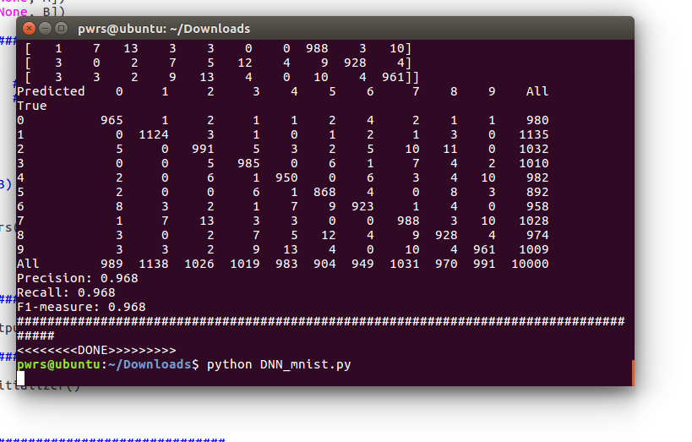

# **DEEP NEURAL NETWORK WITH MNIST DATA:**

## log reg, nn, deep neural net algorithm

## supervised learning classifier

#############################################################

import tensorflow as tf

import numpy as np

from numpy import genfromtxt

import sklearn

from sklearn.preprocessing import StandardScaler

from sklearn.metrics import accuracy_score

from sklearn.metrics import confusion_matrix

from sklearn.metrics import precision_score

from sklearn.metrics import recall_score, f1_score

import pandas as pd

import matplotlib.pyplot as plt

#############################################################

## remove if not using a mac

#import os

#os.environ['KMP_DUPLICATE_LIB_OK']='True'

#############################################################

number_epochs = 80

learning_rate = 0.1

batch_size = 1000

#############################################################

x_train = genfromtxt('mnist_train.csv', delimiter=',', usecols=(i for i in range(1,785)) , skip_header=1)

y_train = genfromtxt('mnist_train.csv', delimiter=',', usecols=(0))

x_test = genfromtxt('mnist_test.csv', delimiter=',', usecols=(i for i in range(1,785)) , skip_header=1)

y_test = genfromtxt('mnist_test.csv', delimiter=',', usecols=(0))

############################################################

## normalizing

sc = StandardScaler()

sc.fit(x_train)

x_train_normalized = sc.transform(x_train)

x_test_normalized = sc.transform(x_test)

###########################################################

# Convert to one hot data

def convertOneHot_data2(data):

y=np.array([int(i) for i in data])

#print y[:20]

rows = len(y)

columns = y.max() + 1

a = np.zeros(shape=(rows,columns))

#print a[:20,:]

print rows

print columns

#rr = raw_input()

#y_onehot=[0]*len(y)

for i,j in enumerate(y):

#y_onehot[i]=np.array([0]*(y.max() + 1) )

#y_onehot[i][j]=1

a[i][j]=1

return (a)

############################################################

# one-hot encoding

depth = 10

#y_train_onehot = tf.one_hot(y_train, depth)

#y_test_onehot = tf.one_hot(y_test, depth)

y_train_onehot = convertOneHot_data2(y_train)

y_test_onehot = convertOneHot_data2(y_test)

#############################################################

# features (A)

A = len(x_train[0])

print A # number of features

#############################################################

# classes (B)

B = 10 #len(sess.run(y_train_onehot[0]))

print "number of classes ", B

############################################################

## print stats

precision_scores_list = []

accuracy_scores_list = []

def print_stats_metrics(y_test, y_pred):

print('Accuracy: %.2f' % accuracy_score(y_test, y_pred) )

#Accuracy: 0.84

accuracy_scores_list.append(accuracy_score(y_test, y_pred) )

confmat = confusion_matrix(y_true=y_test, y_pred=y_pred)

print "confusion matrix"

print(confmat)

print pd.crosstab(y_test, y_pred, rownames=['True'], colnames=['Predicted'], margins=True)

precision_scores_list.append(precision_score(y_true=y_test, y_pred=y_pred, average='weighted'))

print('Precision: %.3f' % precision_score(y_true=y_test, y_pred=y_pred, average='weighted'))

print('Recall: %.3f' % recall_score(y_true=y_test, y_pred=y_pred, average='weighted'))

print('F1-measure: %.3f' % f1_score(y_true=y_test, y_pred=y_pred, average='weighted'))

##############################################################

def plot_metric_per_epoch():

x_epochs = []

y_epochs = []

for i, val in enumerate(precision_scores_list):

x_epochs.append(i)

y_epochs.append(val)

plt.scatter(x_epochs, y_epochs,s=50,c='lightgreen', marker='s', label='score')

plt.xlabel('epoch')

plt.ylabel('score')

plt.title('Score per epoch')

plt.legend()

plt.grid()

plt.show()

############################################################

def layer(input, weight_shape, bias_shape):

bias_init = tf.constant_initializer(value=0)

weight_stddev = (2.0/weight_shape[0])**0.5

w_init = tf.random_normal_initializer(stddev=weight_stddev)

W = tf.get_variable("W", weight_shape, initializer=w_init)

b = tf.get_variable("b", bias_shape, initializer=bias_init)

return tf.nn.relu( tf.matmul(input, W) + b )

############################################################

## a neural network

#def inference_nn(x, A, B):

with tf.variable_scope("hidden_1"):

hidden_1 = layer(x, [A, 128], [128] )

with tf.variable_scope("output"):

output = layer(hidden_1, [128,B], [B])

return output

############################################################

## deep neural network 3 hidden layers

def inference_deep_3layers(x, A, B):

with tf.variable_scope("hidden_1"):

hidden_1 = layer(x, [A,300], [300])

with tf.variable_scope("hidden_2"):

hidden_2 = layer(hidden_1, [300,200], [200])

with tf.variable_scope("hidden_3"):

hidden_3 = layer(hidden_2, [200,100], [100])

with tf.variable_scope("output"):

output = layer(hidden_3, [100, B], [B])

return output

############################################################

## logistic regression

#def inference(x, A, B):

W = tf.Variable( tf.zeros([A, B]) )

b = tf.Variable(tf.zeros( [B]) )

output = tf.nn.softmax( tf.matmul(x, W) + b )

return output

############################################################

def loss_deep(output, y):

xentropy = tf.nn.softmax_cross_entropy_with_logits(logits=output, labels=y)

loss = tf.reduce_mean(xentropy)

return loss

############################################################

#def loss(output, y):

output = tf.clip_by_value(output, 1e-10, 1.0)

dot_product = y * tf.log(output)

xentropy = -tf.reduce_sum( dot_product )

loss = tf.reduce_mean( xentropy )

return loss

#############################################################

def training(cost):

optimizer = tf.train.GradientDescentOptimizer(learning_rate)

train_op = optimizer.minimize(cost)

return train_op

#############################################################

def evaluate(output, y):

correct_prediction = tf.equal( tf.argmax(output,1) , tf.argmax(y,1) )

accuracy = tf.reduce_mean( tf.cast(correct_prediction, "float") )

return accuracy

#############################################################

x = tf.placeholder("float", [None, A])

y = tf.placeholder("float", [None, B])

#############################################################

## call the core functions

#output = inference(x, A, B) ###log reg

#cost = loss(output, y) ###log reg

#output = inference_nn(x, A, B) ## nn

#cost = loss_deep(output, y) ## nn

output = inference_deep_3layers(x, A, B) ## deep nn

cost = loss_deep(output, y) ## deep nn

train_op = training(cost)

eval_op = evaluate(output, y)

############################################################

y_pred_metrics = tf.argmax(output,1)

############################################################

init = tf.global_variables_initializer()

sess = tf.Session()

sess.run(init)

###########################################################

## batch parameters

num_samples_train = len(y_train)

print num_samples_train

num_batches = int(num_samples_train/batch_size)

############################################################

# MAIN_LOOP()

#y_test_temp = sess.run(y_test_onehot)

#y_train_temp = sess.run(y_train_onehot)

y_test_temp = y_test_onehot

y_train_temp = y_train_onehot

print "running..."

for i in range(number_epochs):

for batch_n in range(num_batches):

sta= batch_n*batch_size

end= sta + batch_size

sess.run( train_op , feed_dict={x: x_train_normalized[sta:end,:] , y: y_train_temp[sta:end, :]})

print "accuracy ..."

accuracy_value, y_pred = sess.run([eval_op, y_pred_metrics], feed_dict={x: x_test_normalized, y: y_test_temp})

print "run {}, {}".format(i, accuracy_value)

y_true = np.argmax(y_test_temp, 1)

print y_true

print y_pred

print_stats_metrics(y_true, y_pred)

print '#####################################################################################'

if i == 50:

plot_metric_per_epoch()

#############################################################

print "<<<<<<<<DONE>>>>>>>>>"

**SCREENSHOT OF THE OUTPUT OF DEEP NEURAL NETWORK:**

