# Marking Justification

###### Criteria: Weekly Progress [HD]

* The changelog.txt contains details of all the tasks complete and still working on.
* The tasks in each week are logically divided based on milestones.

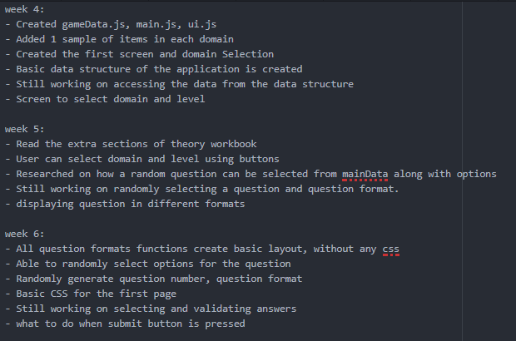

###### Criteria: Code quality [HD]

* The code has perfect indentations with comments provided for each function.
* Each function has an explanation of how it works along with who calls it and what it returns. Each function contains an example of calling and data returned.

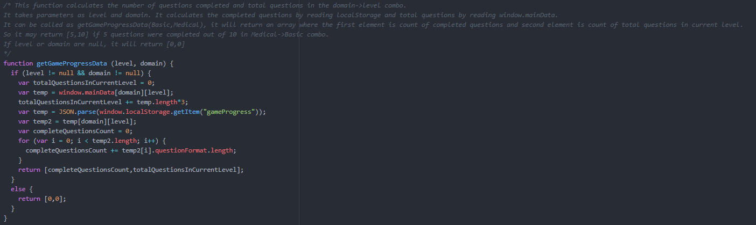

###### Criteria: Legal [HD]

* The project contains licenses.txt with links to sources.
* Application also contains an about page with link to the licenses page.
* All the images are licensed CC0 and public domain no attribution required.

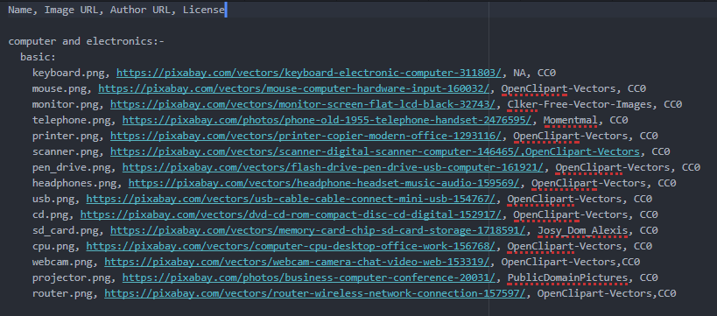

###### Criteria: Playable Scenes [HD]

* The application contains 3 domains and 3 levels in each domain.
* Other screens include selecting domain and level and answer result screen.
* Users can reset the progress of the game or a level.

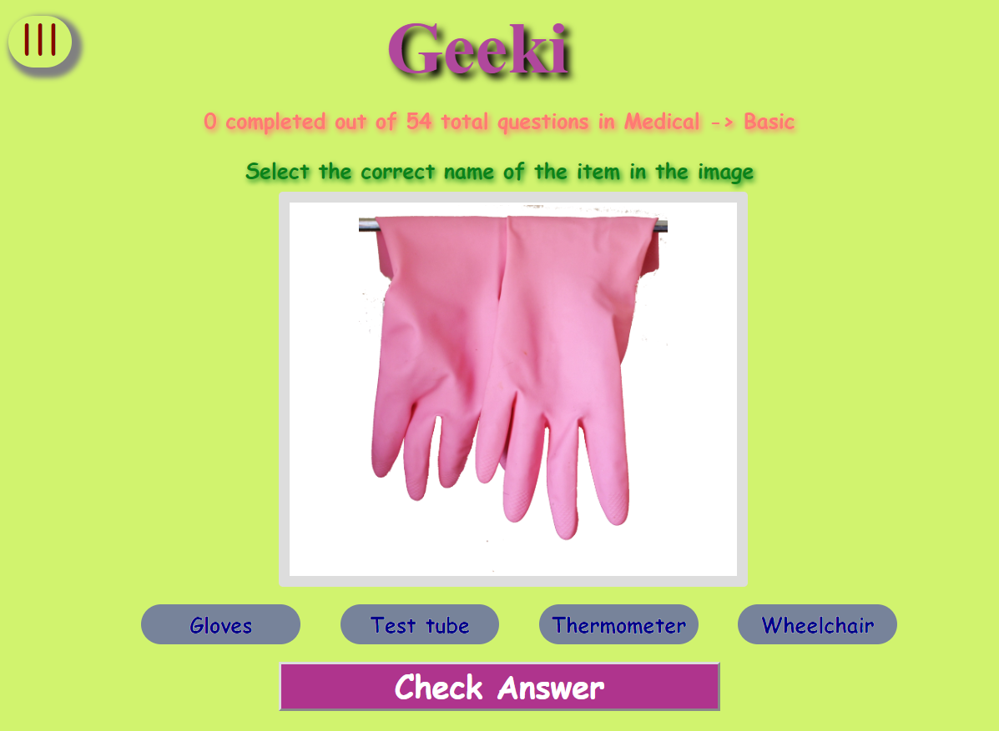

###### Criteria: Playability [HD]

* The application has 402 questions to be answered across 3 different domains and levels. Basic questions will be answered quickly while intermediate and advanced questions take time to get right.
* Question is only marked complete when the answer is correct.
* Users can also reset the level or full game.

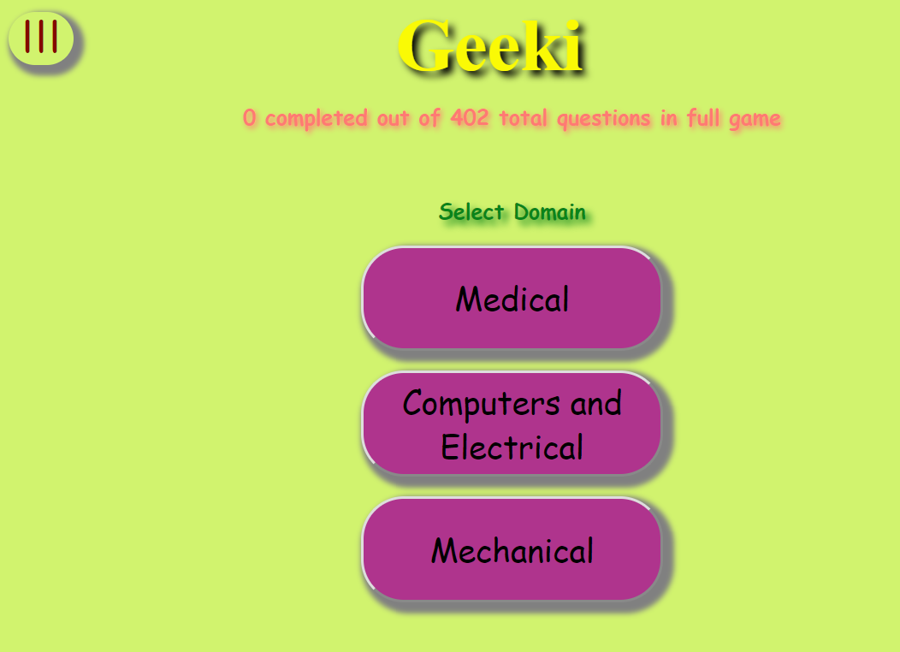

###### Criteria: UI Design [HD]

* The design of the game is fun and engaging.
* It also contains animating objects in the background and also animations based on user actions.

###### Criteria: UI Layout [HD]

* The application adjusts its layout and element sizes based on the orientation and size of the devices.

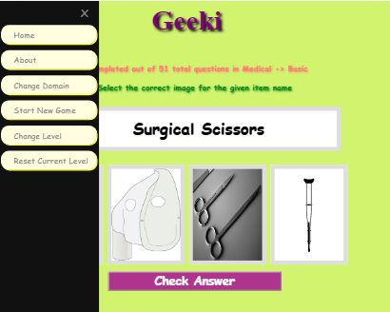

###### Criteria: Code Structure [HD]

* The code is divided in different js files based on their function.
* There are many reusable UI elements like 3 question format screens, description modal, answer result screen and menu screen.

###### Criteria: Data Structure [HD]

* JSON is used to store the data in the localStorage.
* Complex data structures like nested arrays and complex objects are used to make game data and perform various operations like calculating game progress and displaying question with different options and question formats.

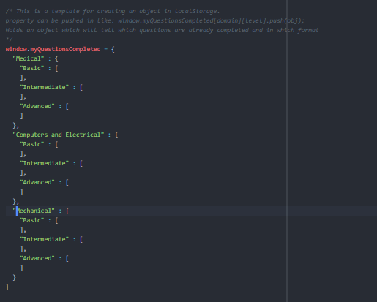

###### Criteria: Bugs [HD]

* Various validating conditions are added to keep the application running.
* Feedbacks are added if the user performs a wrong action.
* The try catch blocks are used to ensure error handling.

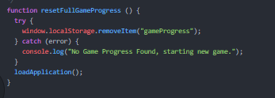

###### Criteria: Readme.txt [HD]

* Contains an overview of the application.
* Contains a list of major functions along with details of how to use and what they return.

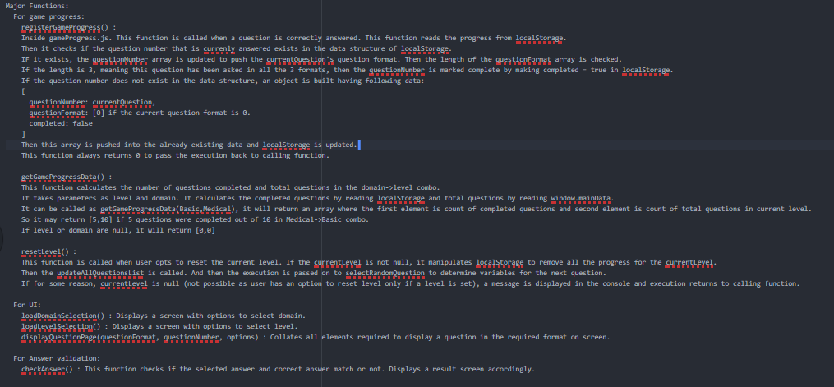

###### Criteria: Demonstration video [HD]

* Contains a demo of the application along with display of major features and where the code resides for these features.