**BIKE_BUYER** ([*Dataset*](https://github.com/AlexTheAnalyst/Excel-Tutorial/blob/main/Excel%20Project%20Dataset.xlsx)*)*

*A data frame comprises columns about Marital Status, Gender, Income, Children, Education, Occupation, Home Owner, Car, Commute Distance, Region, Age and Purchased Bike.*

· **Steps**

1) Created new sheets named as working sheet, dashboard, and pivot table while the raw data remained on the sheet named as raw data.

2) Copy all the raw data and paste into the working sheet. As all the tasks related to data transformation were done in the working sheet.

3) Used Remove Duplicate to clean duplicated entries.

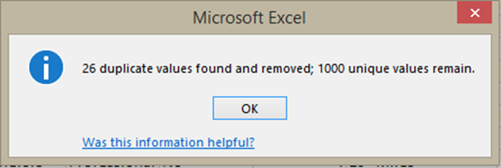

4) Changed the format of the columns as per ease of read.

Like M and F in the Gender column has been changed into Male and Female.

5) Created a column of Age Bracket to Convert Age into Age Range. Also used IF condition : =IF(L2>54,"Old",IF(L2>=31,"Middle Age”, IF(L2<31,"Adolescent","Invalid")))

(Could not use IFS condition, as the working tool was MS Excel 2013).

to form ranges that are 0-30(Adolescent), 31-54(Middle Age), and above 54(Old).

6) Inserted different pivot tables by selecting all the data from the previous sheet. Also, inserted a chart to show finding as visualization in pivot table sheet. This step was done in a pivot table sheet.

***FIRST***

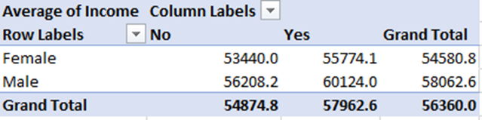

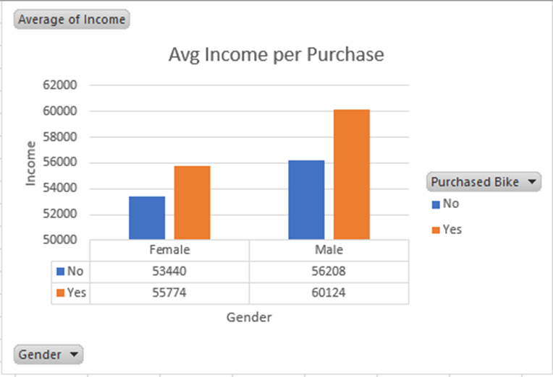

***SECOND***

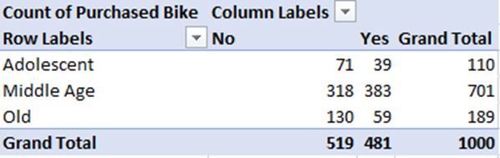

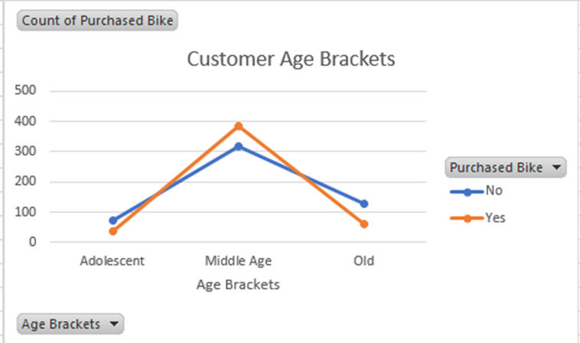

***THIRD***

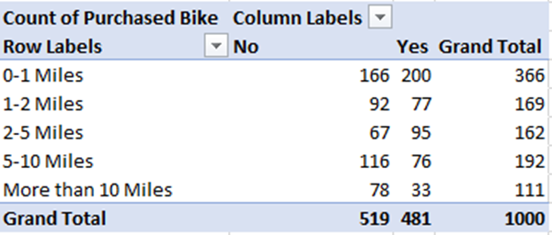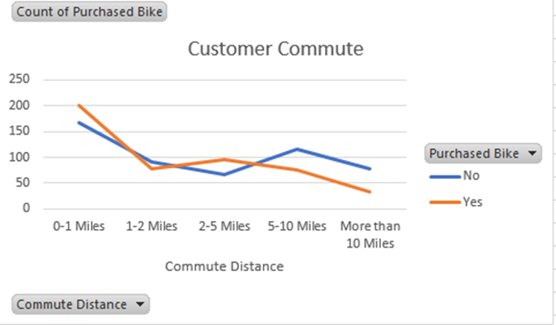

7) 7)

7) Copy all the visualizations from pivot table sheet and paste it into dashboard sheet.

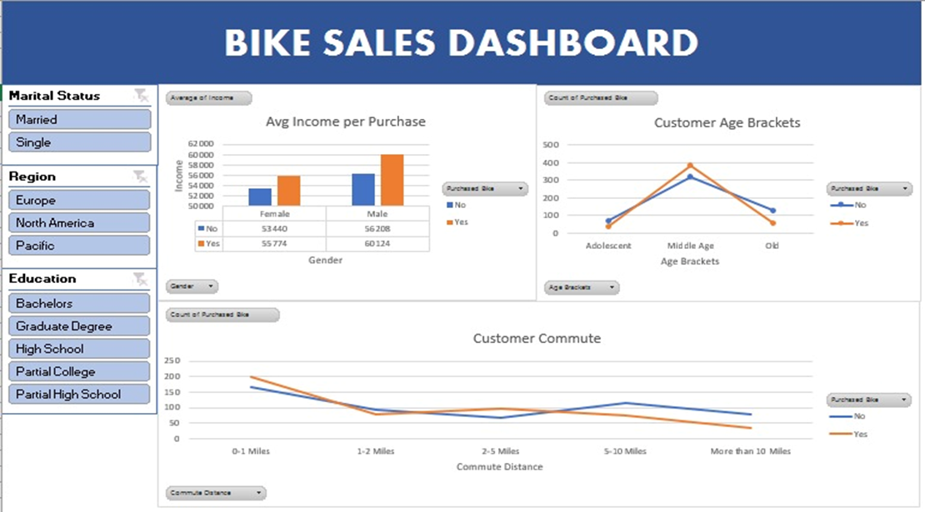

8) Inserted slicers (Marital Status, Region, and Education) and linked to the charts so through that we can get filtered visualization as per our need.

· **Trend**

1) Man whose income is $60,124 bought a bike, while a woman whose income is $55,740 bought a bike.

2) Middle age bracket (31-54) is the age group who bought bikes the most.

3) The single men are the one who bought bikes the most.

4) Most people prefer to travel on their bought bike when their commute is between (0-2 miles).

5) People are discouraged from traveling by bike when their commute is more than 5 miles.

· **Recommendation**

1) Easy loan scheme to single women to buy bikes.

2) Work on comfort of a bike and adverse how does a 2-5 miles distance on a bike is better option

3) Focus on middle age as they bought bikes the most but also the most who refuse to buy it. That means the target audience is middle aged.