**Quiz Management System**

My project is quiz management system in which I have basically 3 type of characters Student, Teacher and Admin. First You have to Login in Admin Panel.

The Concepts Used in this Quiz Management System are:

* Flask
* Flask API
* Bootstrap in Flask
* Sessions
* Flask Alchemy
* JSON
* SQLAlchemy
* Flask Models
* SQLite Database
* One to One, One to many relationship
* Redirect/url_for/render_template
* Ajax Request
* Bootstrap Modal
* Jquery Datatable (Client Site)
* RestAPI

You have run this to install flask-sqlalchemy

pip install flask-sqlalchemy

you need to import SQLAlchemy class from this module

from flask_sqlalchemy import SQLAlchemy

Now create a Flask application object and set URI for the database to be used

app = Flask(__name__)

app.config['SQLALCHEMY_DATABASE_URI'] = 'sqlite:///quiz.db'

you also have to install

flask-session

flask-MySQL

flask-mysql-db

1. **Login As Admin:**

Admin login will be performed using username/password and the username is ‘admin’ and password is also ‘admin’. You have to enter ‘admin’ as username and ‘admin’ as password and select the radio button ‘Admin’ and then press enter to login to the website. I used sessions for the login system and you can logout from your panel by click on the red button named as ‘logout’.

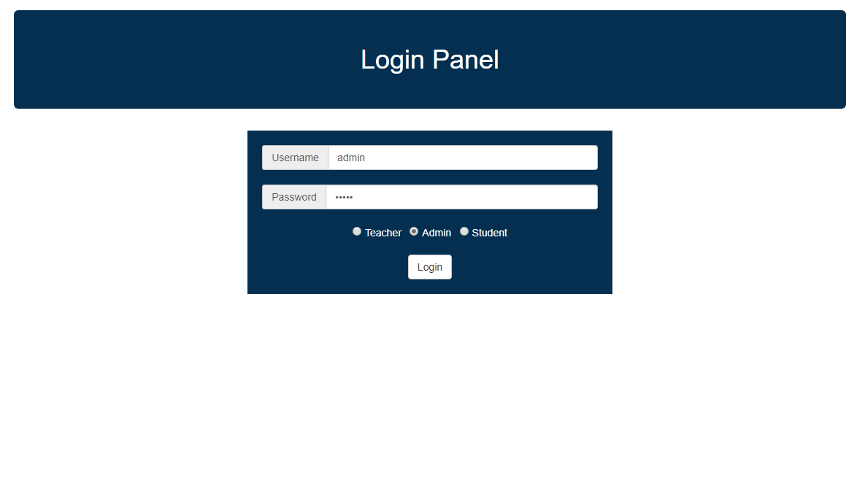

**After Login:**

After login you will see a page which have two pills bar one is for student and other is for the teacher. You can go to any of the pills bar and add student/teacher by just entering their password and username on every bottom I used client side jquery datatables which is used to display the data by which we can divide data into pagination, we can sort or search by any column like given in the screenshot:

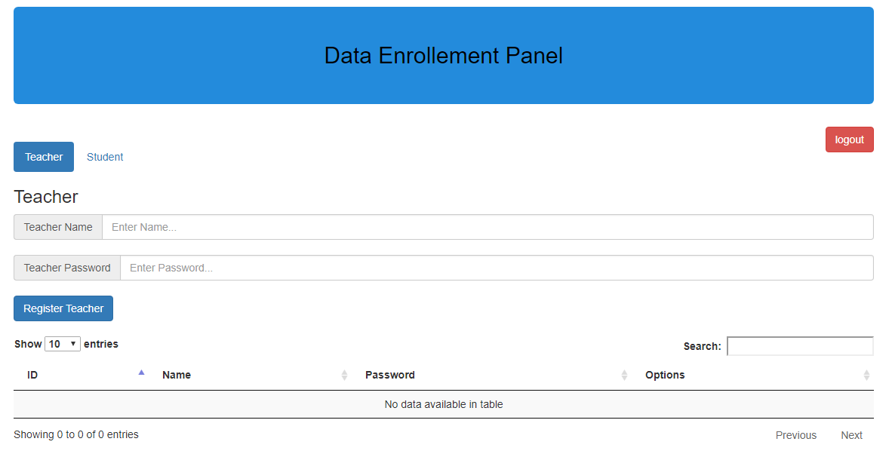

**Add Teacher:**

You can add teacher by adding name and password and then press ‘Register Teacher’ Button.

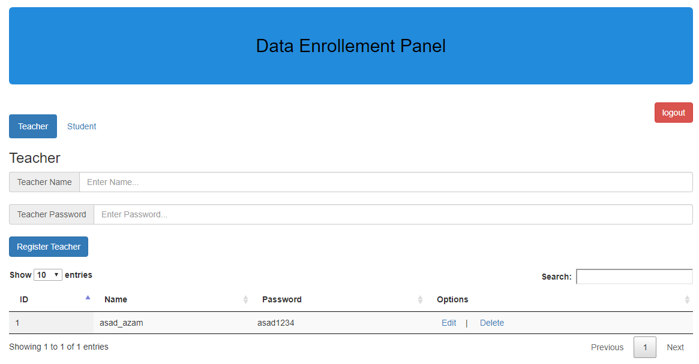

**Delete Teacher:**

you can delete any teacher by a Action Link Name ‘Delete’ against every entry of Teacher   
e.g when you click the delete in the row of ‘asad__azam’ then asad_azam will delete from teachers record.  
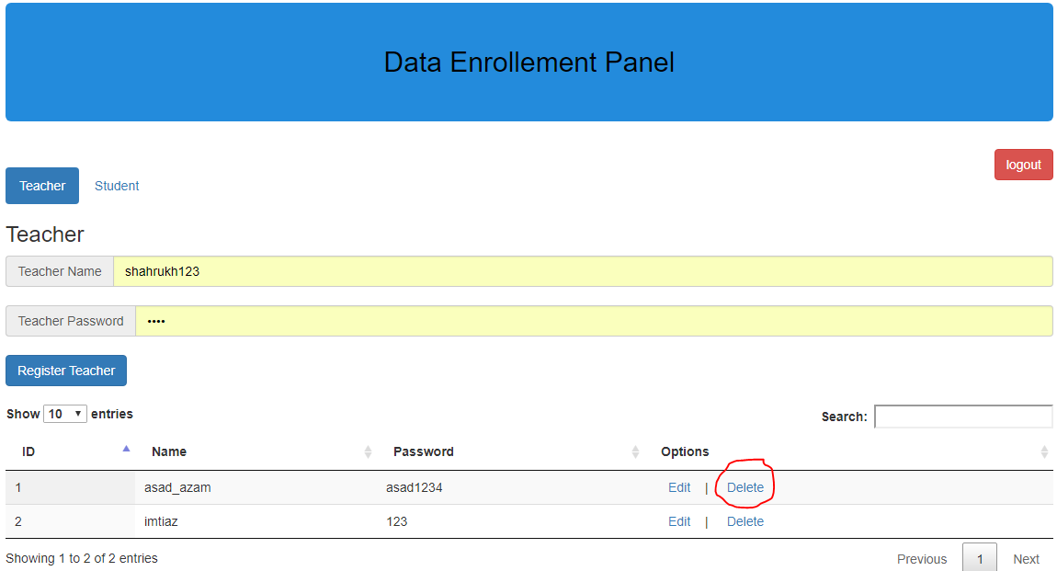

**Updated Teacher:**

You can update teacher data by click ‘Edit’ in front of every teacher. Fill the updated data you want to update and then click on update Teacher and update will done.

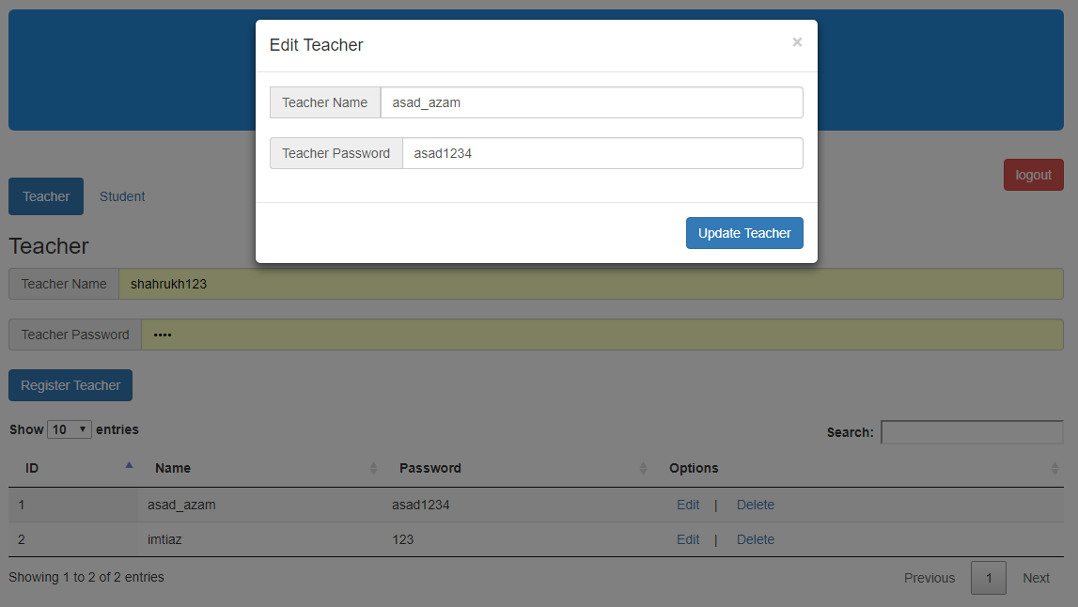

**Add/Update/Delete Student:**

Totally same procedure will repeat for the CRUD operations of student in Admin Panel.

**Logout From Admin Panel:**

Logout from the panel by using red button named as ‘Logout’.

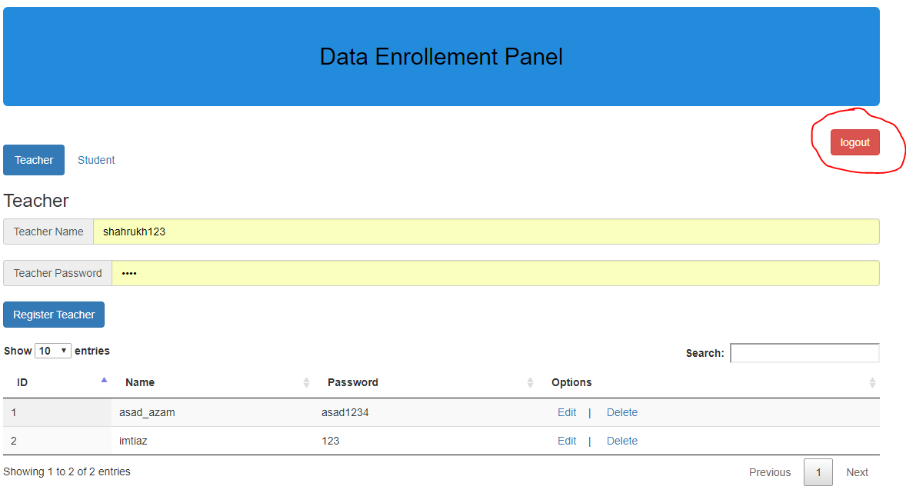

1. **Login As Teacher:**

You can login by just entering username and password, select the Radio button as Teacher and press button ‘login’.

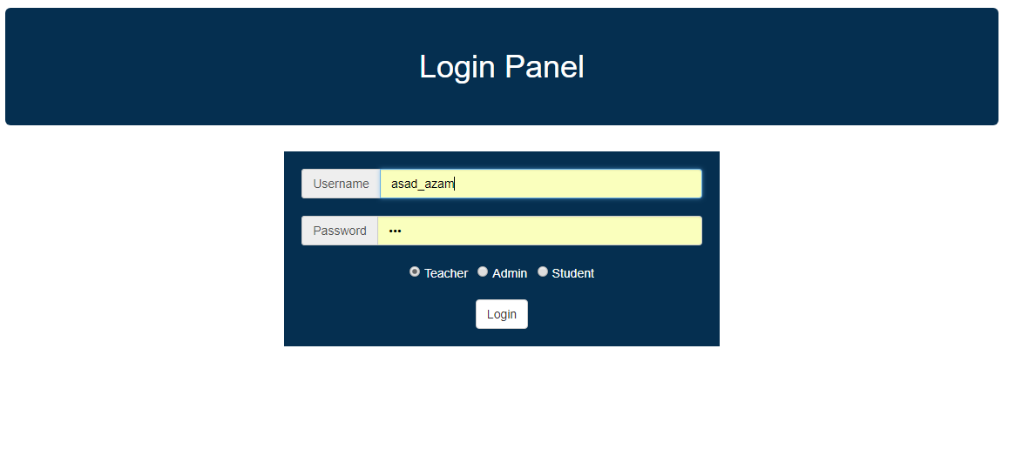

**After Login:**

After successfully login you will find this page given below:

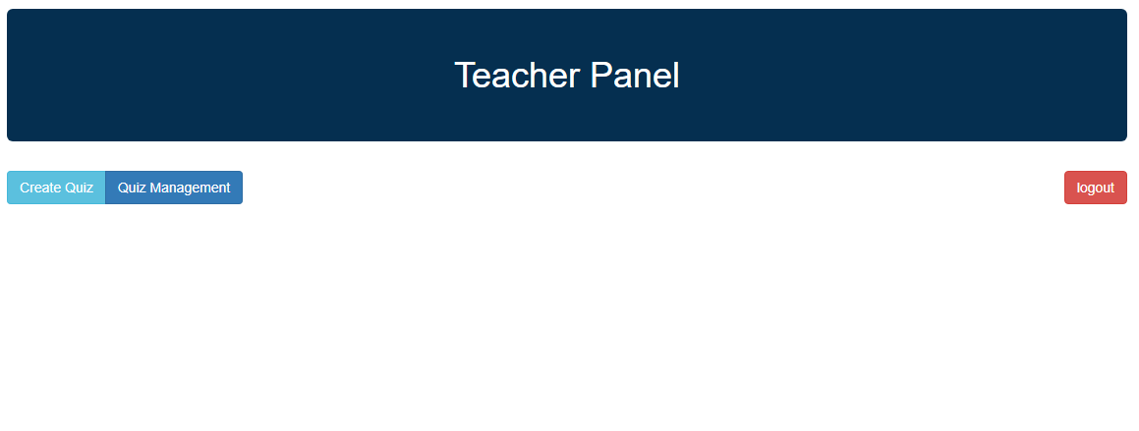

**Create Quiz:**

You have to enter the quiz name and number of questions you want in your quiz and press button ‘Next’ to continue the quiz creation.

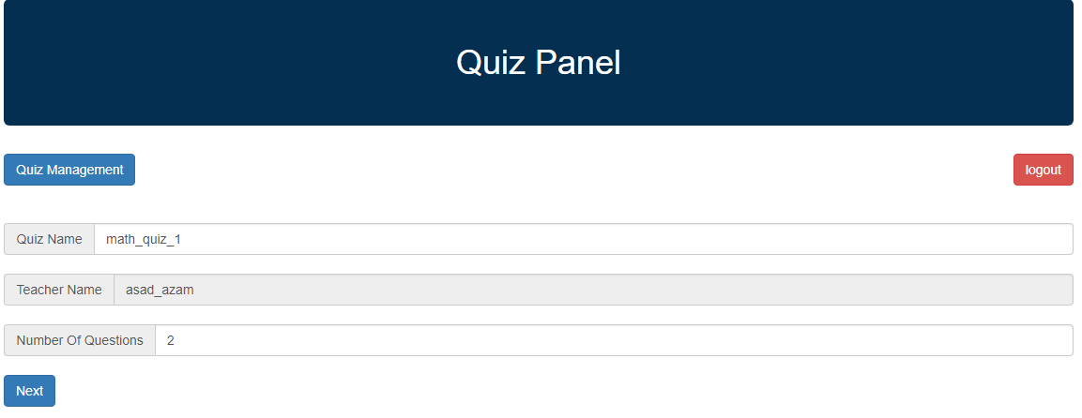

**Quiz Making:**

You have to enter the question statement and also enter the option and select the correct information from radio button and press button save to create the quiz.

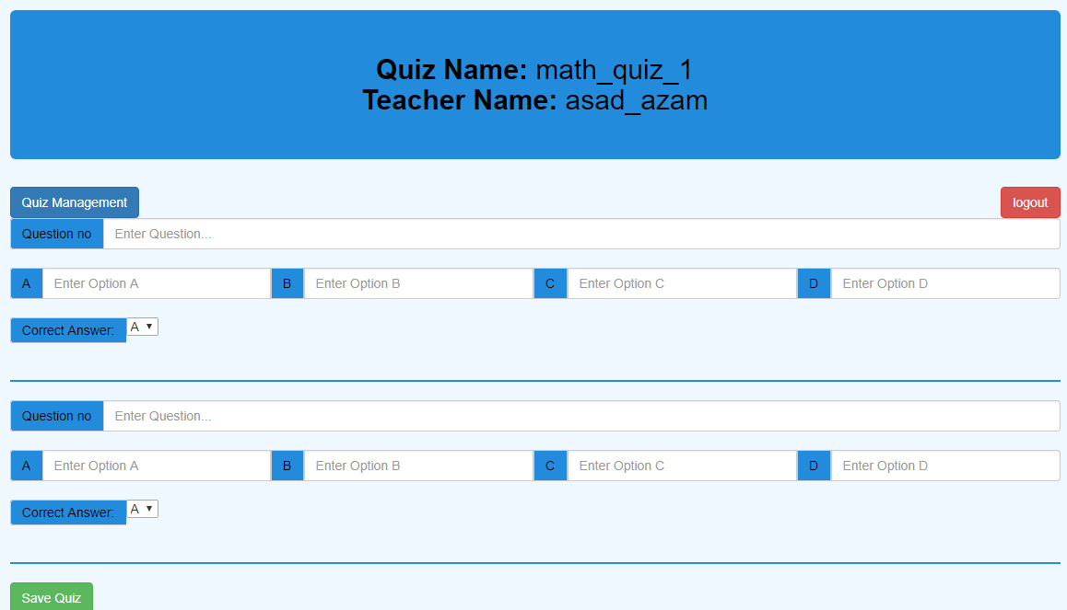

**Example of creating quiz:**

you have to add question statement and option and click save button as given below:

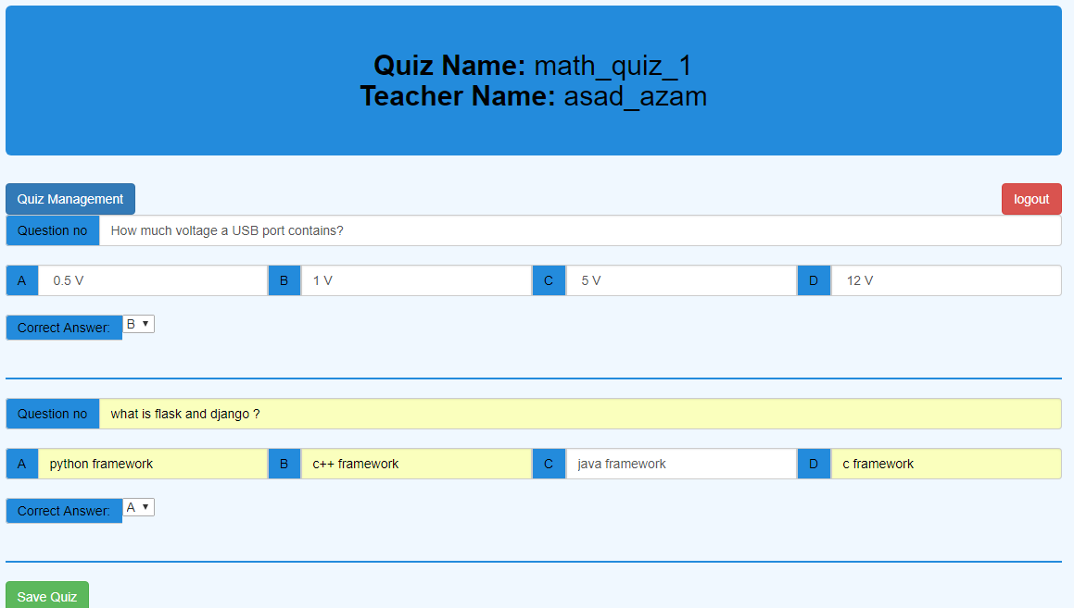

**Quiz Management:**

By pressing Quiz management system you can edit or delete any quiz and jquery datatable to reduce the complexity if we have many quizzes at the same time.

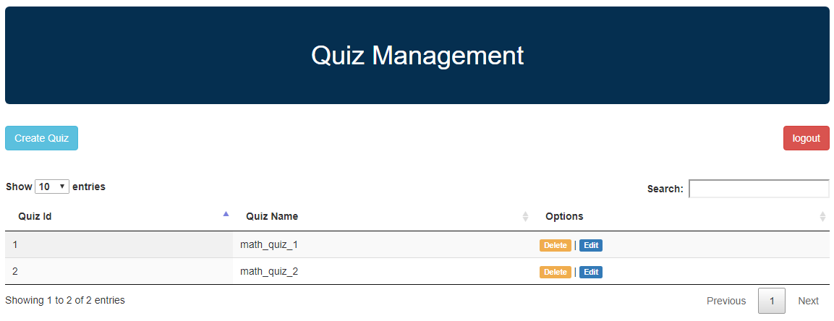

If you want to edit or delete any quiz just click that edit/delete in front of each quiz. When you press delete then quiz will immediately deleted and when you press edit button then you will see all the question of that quiz you can edit or delete any of the question. Same as above delete will immediately delete that question and edit will open a modal with editable option and statement of that question

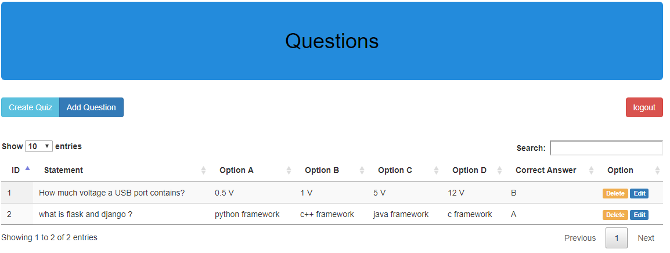

Same as above delete will immediately delete that question and edit will open a modal with editable option and statement of that question

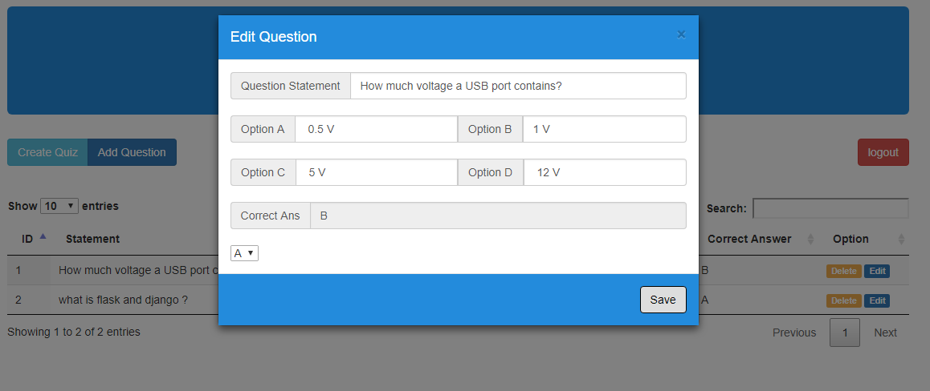

You can update anything of your question and then click ‘Save’ button to save that question and update.

You can also add new question by just click on the top nav button ‘Add question’:

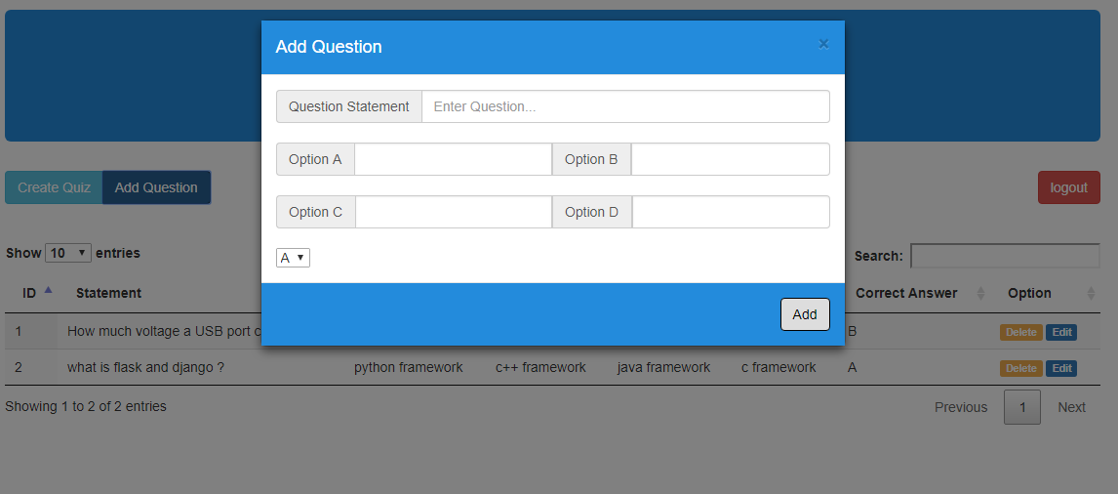

After fill all the text field press ‘Add’ button to add that quiz in that particular quiz. You can search on base of anything by using the jquery datatable search bar and paginate them if you have more than 10 questions or as per your choice.

**Logout:**

You can logout from the teacher by just clicking the red button on the top-right.

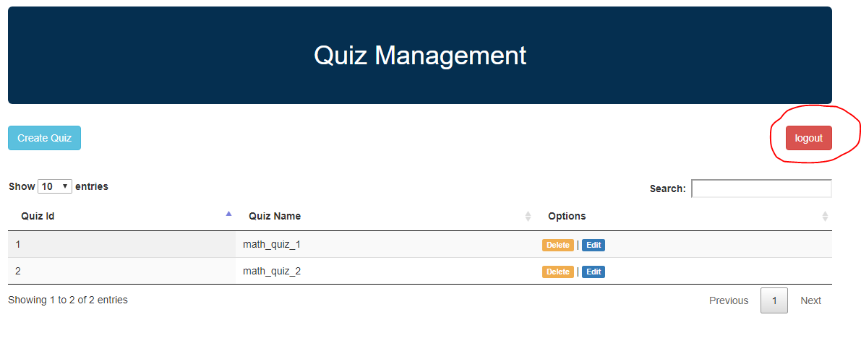

1. **Student Login:**

you can just login by entering username, password and selecting login type as student and press login button as given below:

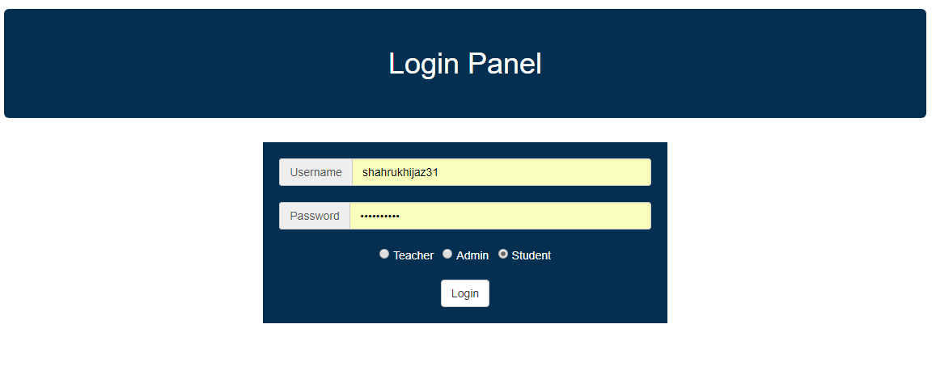

**After Login:**

After successfully login you will enter the student panel. In the student panel you will find two tabs one ‘Quiz Attempted’ and other is ‘Quiz Available’.

**Quiz Attempted:**

In quiz attempted, you will find all the quizzes you attempted

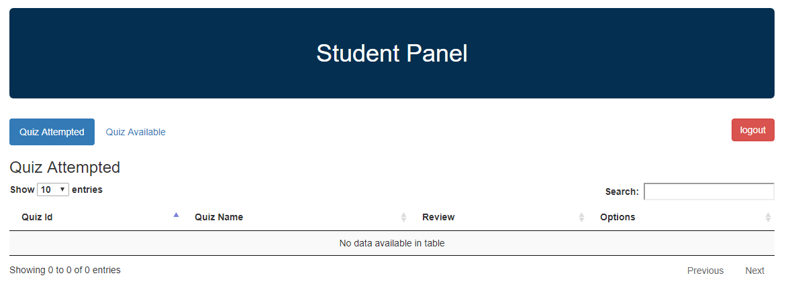

**Quiz Available:**

In this tab you will find all the quizzes which are not still attempted.

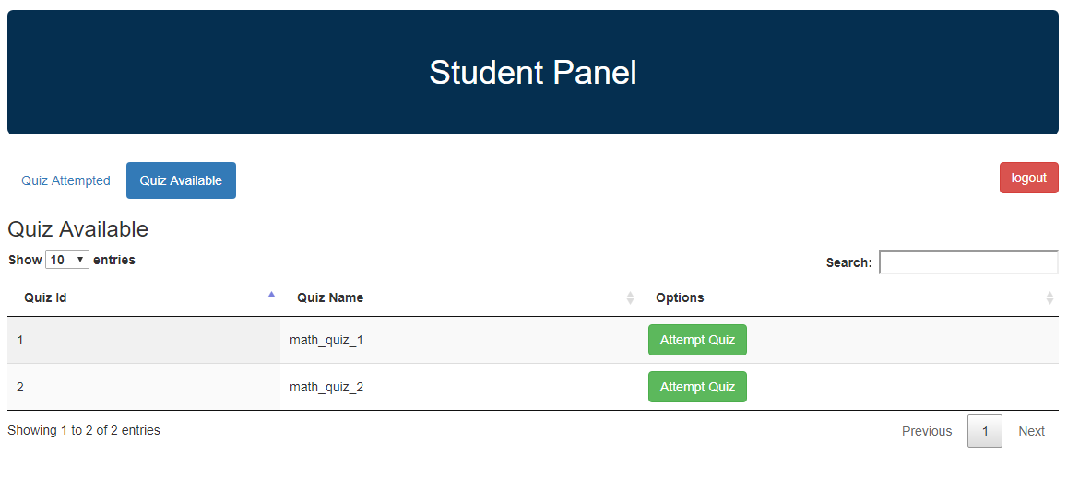

**Attempt Quiz:**

You can click on the attempt button in front of each questions and quiz will be shown like below:

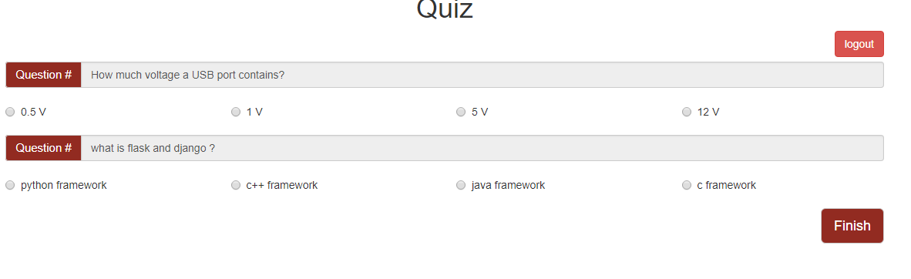

Answer the all questions by choosing the option you think right and click on the ‘Finish’ button to generate the result.  
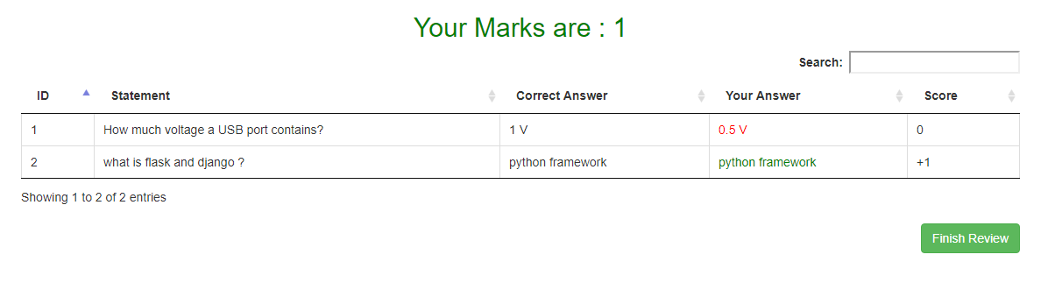  
Here are the result of each question if your answer is correct you will get +1 otherwise 0 click on the finish button if you are satisfying with your result review.

**Updated Attempt Quizzes:**

In this you will see that the quiz you attempted now view in the tab ‘Quiz Attempted’ and in front of that it is written that ‘quiz attempted’.

**­­­**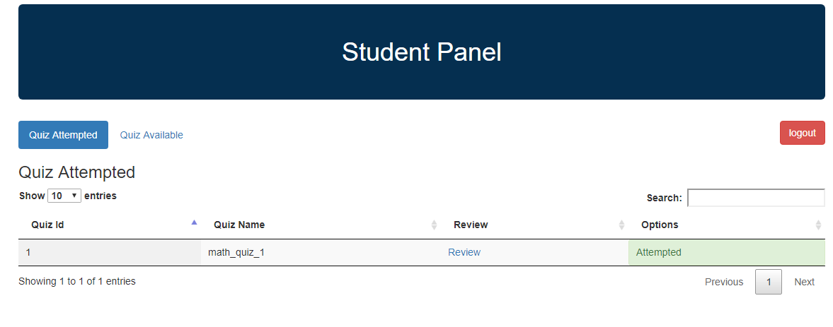

**Exceptional Case:**

If you delete all questions of a quiz and any student want to attempt the quiz then he/she will find a message like below:

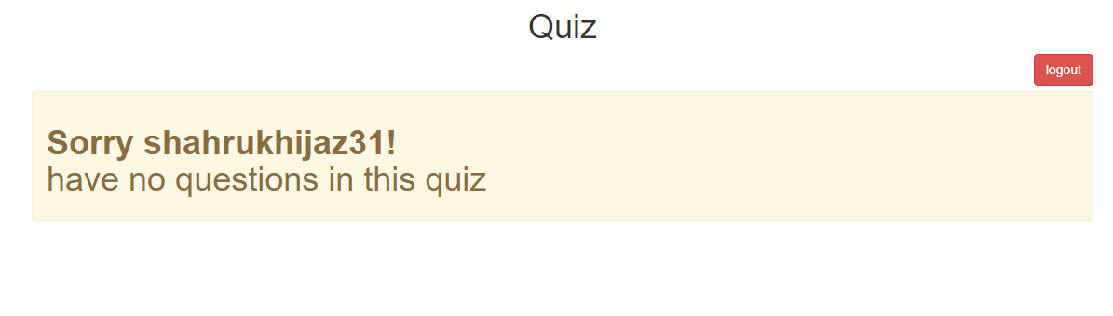

**Quiz Marks Check:**

You can check your marks of that quizzes which are attempted by just go to ‘Quiz Attempted’ tab and click on the review link and a popup will display which tell you your marks sample is given below:

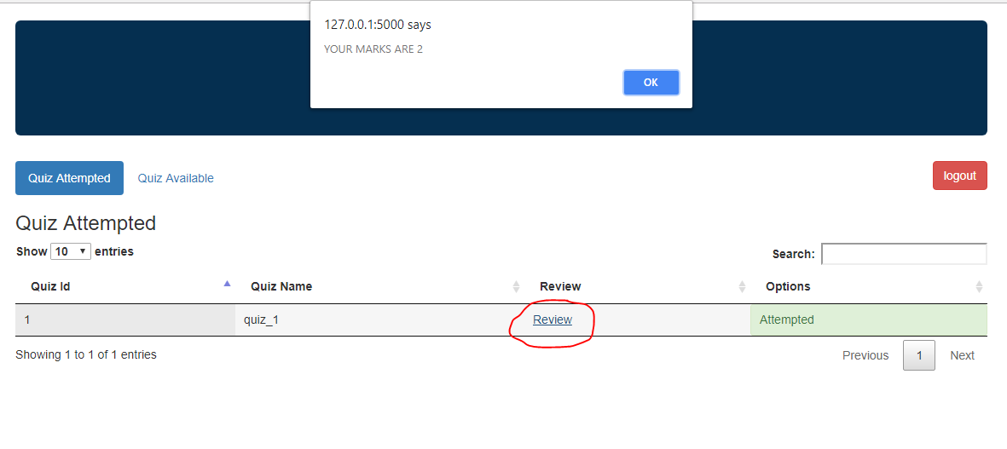

**RestAPI Details:**

My API file name is **quiz_api.py**. In this I have all functions which get the data of student, teacher, quizzes, marks etc. I have basically these functionalities:

* **Teacher Data**

You can get this by username or id by calling like:

**/api/teacher/id/1**

**/api/teacher/username/asad_azam**

* **Quiz Detail**

**/api/quiz/id/1**

**/api/quiz/name/quiz_1**

* **Student Score**

**/api/marks/id/1**

**/api/marks/username/shahrukh**

* **Student Data**

You can get this by username or id by calling like:

**/api/student/id/1**

**/api/ student /username/shahrukh**