SOFE 3980U

Software Quality Final Project README

*How to Use Automation Tool Created:*

Using our tool is really easy. Here are the steps for running the test automation tool:

1. Open up the code using any Java Compatible IDE. Open any of test class, so either TestOwner or Test Review class to run the junit.
2. 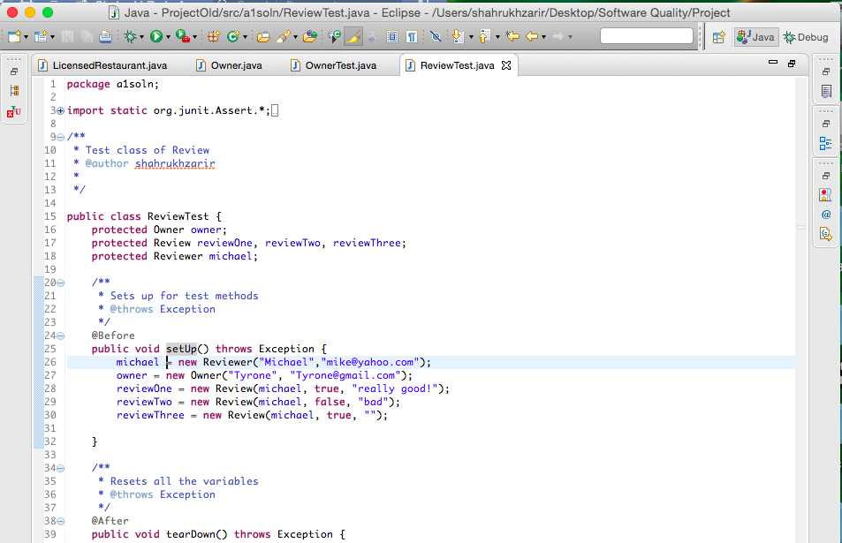
3. Click Run

.../../Screen%20Shot%202017-04-05%20at%2012.31.37%20AM.png

1. Look at the bar to see what the results are from running the test case. In our case all the tests pass!

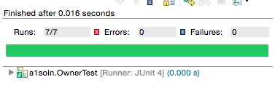

Or they could fail

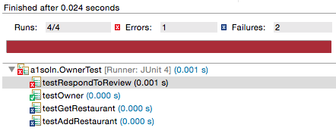

*Sample Test Runs :*

*assertEquals*("Tyrone", owner.getUsername());

*assertEquals*("Tyrone@gmail.com", owner.getEmail());