RUSHABH SHAH
SECTION: G
Lab 6 Report
Summary:
In this lab, we learn and implement few of the virtual memory's page replacement algorithms. Namely, we implement optimal solution, least recently used solution, first in first out solution and a custom algorithm that is more efficient than the LRU on locality of reference. All of these algorithms are tested on multiple inputs. Including, random access, sequential access, and LR workload access.
As learned in class, the implementation of LRU involves comparing the access time of the page. Then we remove the one, whose access time is the smallest. (i.e.) the one that was accessed furthest in history. For the optimal solution, we look at the occurrences of pages, starting from current_access up to num_accesses. As soon as loop hits the first access of that page, time at which the page is accessed is stored. Then we compare the access time of each page in page frame among others and remove one with largest access time.

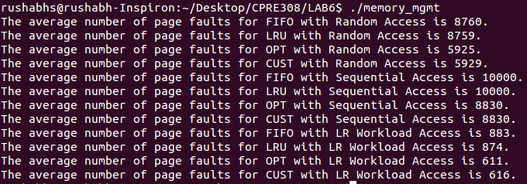
Program Output:

