Name: RUSHABH SHAH
Section: C
University ID: 728236509
Lab 7_8 Report
Summary:

In this lab 7 and 8, I explored FAT file-system and how to parse different attributes of file from boot sector. In lab7, We mainly implemented two function. The first one is the endianSwap. This function is utilized while interpreting various content of sector. The second function is decodeBootsector(). As the name suggests, it decodes the boot sector considering the appropriate offset and length for every content. I also made use of bitwise operators to achieve, where applicable, to achieve the goal.

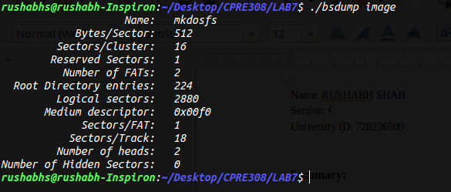
Lab 7 output:Lab 8 focused on implementation of 'ls' command using lab 7's functions. To implement 'ls' command, we look at various attributes of each file, such as name, date, time, and size. Then to output the correct value, we swap bytes, shift bits, when necessary and combine them to return the appropriate value.
