COMMUTRICS

2022 ANNUAL COMMUTING SURVEY

COMMUTING DATA ANALYSIS

# Introduction

The Downtown Denver Partnership (DDP) is committed to promoting sustainable and efficient transportation options for commuters in downtown Denver. To achieve this goal, DDP conducted a travel survey to gather data on the commuting patterns and preferences of downtown Denver employees. The survey was designed to provide insights into the factors that influence commuting behavior and to identify opportunities for promoting sustainable transportation options. This report presents the results of the data analysis of the commuter travel survey conducted by DDP. The analysis includes a descriptive summary of the survey data, as well as a statistical analysis of the relationships between commuting behavior and various demographic and behavioral factors. The findings of this report provide valuable insights into the commuting patterns and preferences of downtown Denver employees and can be used to inform transportation policy and planning decisions.

# Survey

The survey consisted of 47 questions that aimed to collect information on various aspects of commuters' transportation behavior and attitudes. Respondents were asked to provide demographic information such as their home location, work location, employer name, age, gender, and race, as well as their annual gross income and job type. In addition to demographic information, the survey collected data on respondents' commuting behaviors, including the frequency of their use of different transportation modes, including telecommuting, walking, transit, driving alone, carpooling, bike or e-bike, scooter or bike share, and ride-sharing services like Lyft or Uber. Respondents were also asked about their use of transportation programs such as carpool or vanpool programs, free transit passes, and secure bike parking, as well as their access to various transportation benefits offered by their employer. Finally, respondents were also asked to rank influential factors including time, cost, safety, flexibility, and etc., on their commute mode choice, as well as top three reasons of using drive. Overall, the survey aimed to collect comprehensive data on the commuting behaviors and attitudes of individuals in the Downtown Denver area, with a particular focus on sustainable transportation options and the availability and use of transportation programs and benefits.

The survey received a total of 3,668 responses from commuters in the Downtown Denver area. Of these respondents, 3,133 (85.4%) provided complete answers to all survey questions. Gender breakdown of the respondents reveals that 1,193 (38.1%) identified as male and 1,940 (61.9%) identified as female. The majority of respondents who completed the survey were female, with women accounting for nearly two-thirds of the total number of respondents.

These statistics provide insight into the representativeness of the survey sample and can be used to inform the analysis of the survey data. It is important to note that the sample may not be entirely representative of the broader population of commuters in the Downtown Denver area, and caution should be taken when generalizing the findings to the wider population. However, the large number of responses and the high completion rate suggest that the survey provides a valuable source of information on the commuting behaviors and attitudes of individuals in the Downtown Denver area.

# Analysis and Results

## Data Processing and Feature Engineering

Data processing and cleaning are essential steps in the data analysis process. Data processing involves transforming raw data into a usable format for analysis. This may include tasks such as merging datasets, aggregating data, creating new variables, and reformatting data. Data cleaning involves identifying and correcting errors and inconsistencies in the data. This may include tasks such as removing duplicate entries, correcting missing or invalid values, and identifying outliers. Data processing and cleaning are important because they ensure that the data used in the analysis is accurate, consistent, and complete. Inaccurate or incomplete data can lead to incorrect results and conclusions, while inconsistent data can introduce bias into the analysis. Data processing and cleaning are often iterative processes, and may involve multiple rounds of review and refinement. In addition to ensuring the accuracy and consistency of the data, it is also important to document the data processing and cleaning procedures for future reference and to ensure transparency in the analysis.

## Feature Engineering

Feature engineering is the process of selecting, creating, and transforming variables or features in a dataset to improve the performance of a machine learning model. It involves selecting the most relevant variables, creating new variables that capture important patterns or relationships, and transforming variables to make them more useful for the model. Feature engineering is important because the performance of machine learning models is highly dependent on the quality of the features used to train them. Good features should be informative, discriminative, and independent, and should capture the important patterns and relationships in the data. Common techniques used in feature engineering include:

* Feature selection: selecting a subset of the most informative features in the dataset.
* Feature extraction: creating new features from existing ones, such as calculating ratios, averages, or differences.
* Feature scaling: transforming features to have a similar scale, such as standardizing or normalizing them.
* Feature encoding: transforming categorical variables into numerical variables, such as one-hot encoding or label encoding.
* Feature imputation: filling in missing values in the dataset, such as using mean, median, or mode imputation.

## Logistic Regression

Logit regression, also known as logistic regression, is a statistical modeling technique used to analyze binary outcomes, such as yes/no responses or binary classification problems. In the context of transportation research, logit regression can be used to predict the likelihood of choosing a particular mode of transportation, such as bike mode choice, given a set of predictor variables. The logit regression model estimates the probability of choosing a particular mode of transportation based on the values of the predictor variables. The model outputs the estimated odds ratio, which represents the change in the odds of choosing the mode of transportation for a one-unit increase in the predictor variable, while holding all other variables constant. Logit regression models are useful for understanding the relative importance of different factors in predicting bike mode choice, such as demographic variables (age, gender, income), behavioral variables (car ownership, commute distance), and the availability of bike infrastructure. In a logit regression model, the dependent variable is binary (0 or 1) and represents the presence or absence of the outcome of interest, such as bike mode choice. The independent variables, or predictor variables, are continuous or categorical variables that may influence the dependent variable.

# Results

## Data Processing

|  |  |
| --- | --- |
| **age** | **ordinal category** |
| Under 25 | 1 |
| 25 to 29 | 2 |
| 30 to 34 | 3 |
| 35 to 39 | 4 |
| 40 to 44 | 5 |
| 45 to 49 | 6 |
| 50 to 54 | 7 |
| 55 to 59 | 8 |
| 60 to 64 | 9 |
| 65 or older | 10 |

|  |  |
| --- | --- |
| **income** | **ordinal category** |
| Less than $24,999 | 1 |
| $25,000 to 49,999 | 2 |
| $50,000 to 74,999 | 3 |
| $75,000 to 99,999 | 4 |
| $100,000 to 149,999 | 5 |
| Over $150,000 | 6 |

|  |  |
| --- | --- |
| GENDER | nominal category |
| Female | 0 |
| Male | 1 |

|  |  |
| --- | --- |
| YEARS OF COMMUTING BY BIKE | ordinal category |
| Less than 1 year | 0 |
| 1 to 2 years | 1 |
| 2 to 4 years | 2 |
| More than 4 years | 3 |

|  |  |
| --- | --- |
| REMOTE WORK POLICY | ordinal category |
| Must be in the workplace every day | 0 |
| Can work from home 1-2 days a week | 1 |
| Can work from home 3-4 days a week | 2 |
| Totally flexible: can work from home every day | 3 |

|  |  |
| --- | --- |
| INTERSTOP | ordinal category |
| Never | 0 |
| Sometimes | 1 |
| About half the time | 2 |
| Most of the time | 3 |
| Always | 4 |

|  |  |
| --- | --- |
| BIKE MODE CHOICE | binary category |
| No biking | 0 |
| Once a week | 1 |
| twice a week | 1 |
| three times a week | 1 |
| Four times a week | 1 |
| Five times a week | 1 |

## Data Analysis

Figure 1 presents the modal share of transportation modes for businesses with more than 50 survey respondents. The data shows the percentage of respondents who reported using each mode of transportation to commute to work, including driving alone, telecommute, carpooling, walking, biking, public transit, and others. The figure reveals that driving alone is the most popular mode of transportation among commuters, with 70% of respondents reporting this as their primary mode of commuting. Carpooling is the second most popular mode of transportation, with 14% of respondents reporting carpooling as their primary mode of commuting. Walking and biking are relatively fewer common modes of transportation, with 6% and 4% of respondents respectively reporting these modes as their primary means of commuting. Public transit and other modes of transportation, such as telecommuting, accounted for the remaining modal shares. Overall, this figure provides a snapshot of the current modal share for businesses with more than 50 survey respondents, highlighting the dominance of driving alone as the primary mode of commuting. These findings can be used to inform DDP's efforts to promote sustainable transportation options and reduce reliance on single-occupancy vehicles.

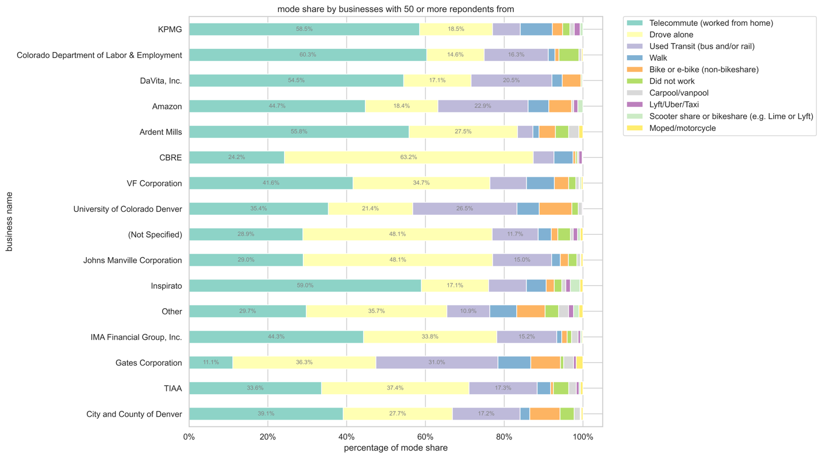

Figure 1. Modal Share for Businesses with More than 50 Respondents

Figure 2 shows the percentage of survey respondents who reported having access to various transportation programs offered by their employers. The data reveals the percentage of respondents who reported having access to each program, including free transit passes, secure bike parking, flexible work schedules, free or subsidized parking, subsidized transit fares or passes, and other programs. The table below provides a detailed breakdown of the data, showing the number of respondents and the percentage of respondents who reported having access to each program. The data shows that the most commonly reported transportation program was the free transit pass (EcoPass), with 48% of respondents reporting having access to this program. Secure bike parking was the second most commonly reported program, with 45% of respondents reporting having access. Flexible work schedules and free or subsidized parking were also popular programs, with 43% and 27% of respondents respectively reporting having access. Other programs, such as bike commuting stipends and carshare memberships, were reported by fewer respondents. Overall, this figure and table provide insight into the range of transportation programs offered by employers and the percentage of employees who have access to them. The findings can be used to inform DDP's efforts to promote sustainable transportation options and encourage employers to offer programs that support sustainable commuting.

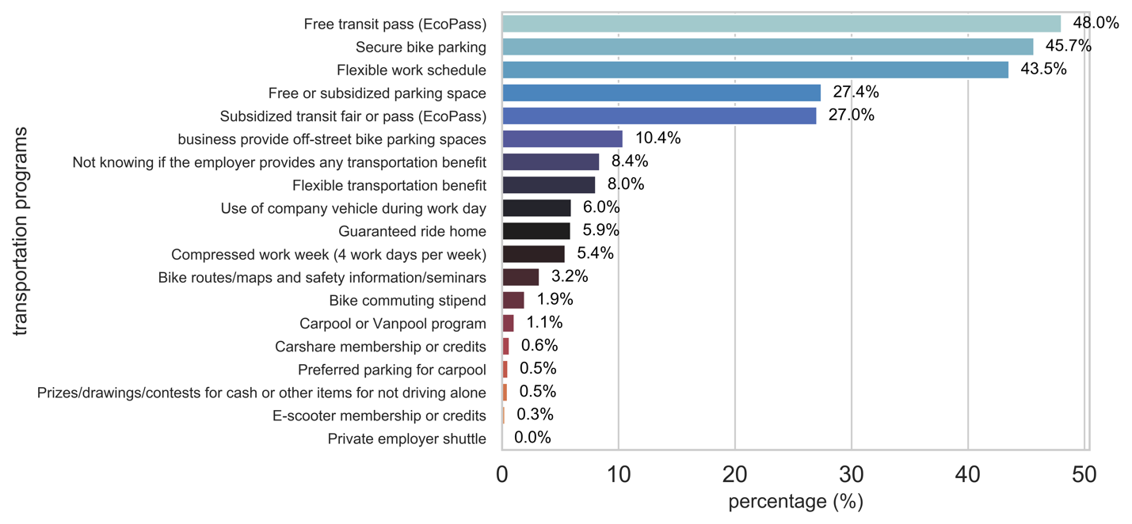

Figure 2. percentage of respondents for transportation programs

|  |  |  |
| --- | --- | --- |
| TRANSPORTATION PROGRAMS | NUMBER OF RESPONDENTS | PERCENTAGE (%) |
| Free transit pass (EcoPass) | 1505 | 48.00% |
| Secure bike parking | 1431 | 45.68% |
| Flexible work schedule | 1364 | 43.54% |
| Free or subsidized parking space | 859 | 27.42% |
| Subsidized transit fair or pass (EcoPass) | 847 | 27.03% |
| business provide off-street bike parking spaces | 326 | 10.41% |
| Not knowing if the employer provides any trans... | 263 | 8.39% |
| Flexible transportation benefit | 252 | 8.04% |
| Use of company vehicle during workday | 187 | 5.97% |
| Guaranteed ride home | 185 | 5.90% |
| Compressed work week (4 workdays per week) | 170 | 5.43% |
| Bike routes/maps and safety information/seminars | 101 | 3.22% |
| Bike commuting stipend | 61 | 1.95% |
| Carpool or Vanpool program | 33 | 1.05% |
| Carshare membership or credits | 20 | 0.64% |
| Preferred parking for carpool | 16 | 0.51% |
| Prizes/drawings/contests for cash | 15 | 0.48% |
| E-scooter membership or credits | 8 | 0.26% |
| Private employer shuttle | 1 | 0.03% |

Figure 3 presents a heatmap that shows the correlation of various features with the frequency of biking mode among survey respondents. The heatmap uses a color scale to represent the strength and direction of the correlation between each pair of features. The features included in the heatmap are demographic and behavioral factors such as age, gender, income, car ownership, commute distance, and the availability of bike infrastructure. Each feature is represented by a row and a column in the heatmap, and the correlation coefficient between each pair of features is displayed as a colored cell. The heatmap reveals several interesting findings. For example, there is a strong negative correlation between car ownership and the frequency of biking mode, indicating that respondents who own cars tend to bike less frequently than those who do not own cars. Similarly, there is a strong positive correlation between the availability of bike infrastructure and the frequency of biking mode, suggesting that respondents who have access to bike lanes, trails, and other bike-friendly infrastructure tend to bike more frequently. Other notable correlations include a negative correlation between age and the frequency of biking mode, and a positive correlation between income and the frequency of biking mode. These findings can be used to inform DDP's efforts to promote biking as a sustainable transportation option and to design targeted interventions to encourage biking among specific demographic groups. Overall, this heatmap provides a visual representation of the correlation of various features with the frequency of biking mode, highlighting the factors that are most strongly associated with biking behavior among survey respondents.

Figure 3. Correlation of Features for Frequency of Biking Mode

## Mode Choice Analysis

### Bike Mode Choice

Figure 4 shows the Spearman correlation coefficients between various factors and bike mode choice, as well as the corresponding p-values. The correlation coefficients indicate the strength and direction of the relationship between each factor and bike mode choice, with values ranging from -1 to 1. The factors included in the analysis are demographic and behavioral factors such as age, gender, income, car ownership, commute distance, and the availability of bike infrastructure. Each factor is represented by a row and a column in the correlation matrix, and the color of the cell represents the strength of the correlation coefficient, with darker colors indicating stronger correlations.

The p-values displayed in the matrix indicate the level of statistical significance of the correlation coefficients, with values less than 0.05 considered statistically significant. A significant p-value indicates that the observed correlation coefficient is unlikely to have occurred by chance and suggests a real relationship between the two variables.

The correlation matrix reveals several interesting findings. For example, there is a significant positive correlation between bike mode choice and commute distance, as well as a significant negative correlation between bike mode choice and car ownership. Additionally, there is a significant positive correlation between bike mode choice and the availability of bike infrastructure. Overall, this figure provides a visual representation of the correlation between various factors and bike mode choice, with p-values indicating the level of statistical significance of each relationship. These findings can be used to inform targeted interventions to encourage biking among specific demographic groups and to promote biking as a sustainable transportation option in the Downtown Denver area.

Figure 4. Spearman Correlation of Factors on Bike Mode Choice

Figure 5 displays the percentage change in odds ratios for bike mode choice when specific factors are introduced into the model. Odds ratios represent the likelihood of choosing bike mode over other modes of transportation, given a certain set of factors, and are commonly used in statistical modeling to estimate the effect of different factors on a binary outcome variable. The figure shows the baseline odds ratio for bike mode choice (represented by a horizontal line at 1.0) and the percentage change in the odds ratio when specific factors are added to the model. Factors included in the analysis may include demographic factors such as age, gender, and income, as well as behavioral factors such as car ownership and commute distance. Each factor is represented by a bar in the figure, with the height of the bar indicating the percentage change in the odds ratio when the factor is introduced into the model. Bars that extend above the horizontal line at 1.0 indicate a positive effect on the odds ratio for bike mode choice, while bars that extend below the line indicate a negative effect.

The figure provides insights into the relative importance of different factors in predicting bike mode choice and can be used to identify key target areas for interventions to promote biking as a sustainable transportation option in the Downtown Denver area. For example, if the introduction of bike infrastructure into the model results in a significant increase in the odds ratio for bike mode choice, this suggests that investment in bike infrastructure may be an effective way to promote biking among commuters. Overall, this figure provides a visual representation of the percentage change in odds ratios for bike mode choice when specific factors are introduced into the model, allowing for a quick comparison of the relative importance of different factors in predicting bike mode choice.

Figure 5. Percentage Change of Odds Ratios for Bike Mode Choice

Secure bike parking: an odds ratio of 7.64 means that commuters provided with secure bike parking are 7.64 times more likely to use bike. In other words, providing secure bike parking increases the likelihood of commuters to use bike by 664%. Gender (male) an odds ratio of 3.11 means that males are 3.11 times more likely to use bike compared to female. In other words, males are 211% more likely to commute by bike.