Shalin Shah

Professor Shoarinejad

29 October 2020

Week 3 Lab Report

1. What did you plan to do last week?
   1. Continue along with project and try to answer some of the questions posed in the previous section
   2. Continue to figure out good way of doing workflow
   3. Review and clean up tutorial responses
   4. Final Draft for the Proposal
2. What did you end up doing last week?
   1. Finished Task 4.4 for tutorial 0 that I hadn’t realized wasn’t done (took like 30 minutes tops)
      1. Here are the screenshots requested in the spec:
      2. 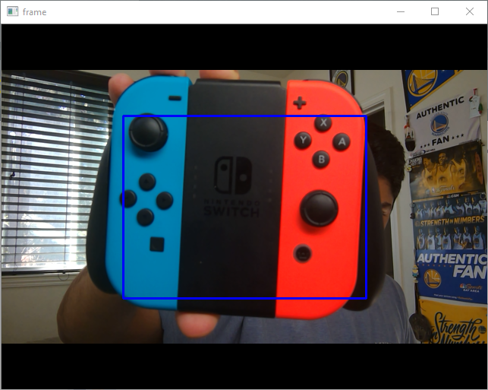
      3. 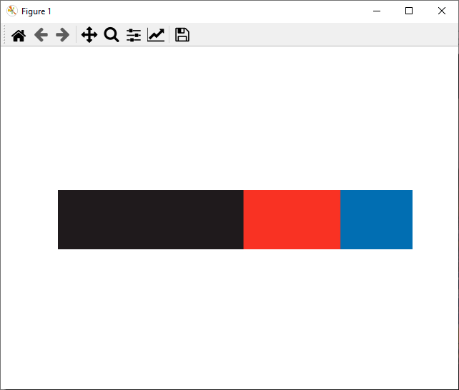
      4. As can be seen, the histogram is red, blue and black, which are the dominant colors for the bounding box (where the Switch Controller resides)
   2. Pushed Tutorial 1 image where I show that I connected to Pi over SSH and that Git and Python have properly been installed. To follow up on the questions in the Report section, I didn’t face any big problems as I have a static IP address that I use for the Pi.
3. This next week: