Shalin Shah

Professor Shoarinejad

12 November 2020

Week 5 Lab Report

1. What did you plan to do last week?
   1. Before the presentation, get the final project proposal and midterm presentation slides done
   2. Prepare for the midterm presentation
   3. Do Tutorial 3 (IMU tutorial)
   4. Continue with project and get contour + object detection done
2. What did you end up doing last week?
   1. Finalized the project proposal and slides and prepared for the presentation on Friday
   2. Did Tutorial 3 work:
      1. 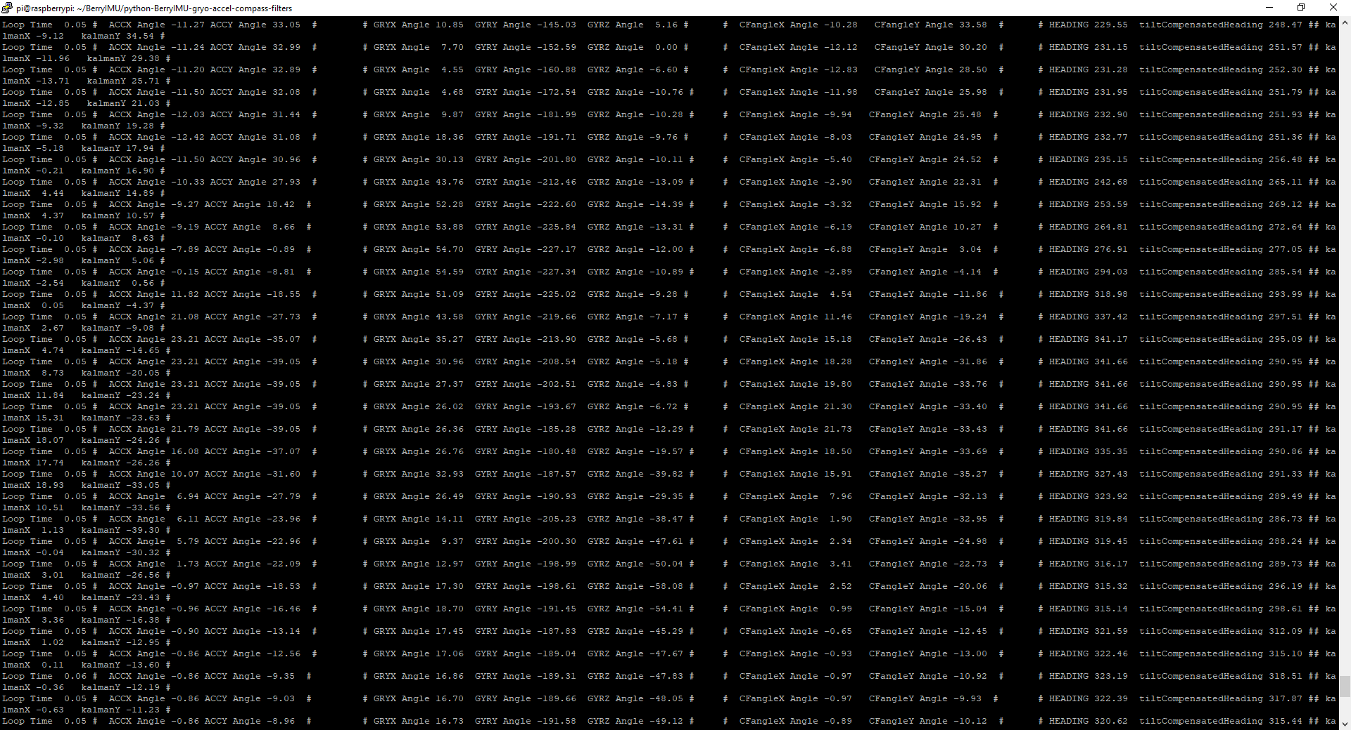Task 4.1: Here is a screenshot of the constant stream of data from the IMU on my RaspberryPi:
      2. 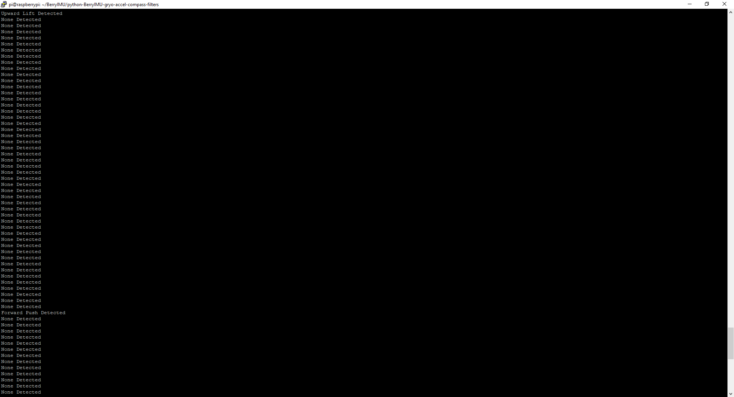Task 4.2: My classifier built on top of the berryIMU.py code that was obtained from the github repository we were linked to. I did some small code changes to the existing code. This is the output of my work:

Through this, we’re able to see that if the acceleration in the x-direction passes a threshold, that we’ve done a “push” and if the acceleration in the y-direction passes a threshold, that we’ve done a “lift”. The threshold is 0, going from negative acceleration to positive in either direction. I pushed my code to the repository.

* + 1. Task 4.4: for this task, I built my code on top of built on top of <https://github.com/Uberi/speech_recognition>. The library did most of the work, but I extended it so that the user could input the word they want to be understood. My program tells the user whether or not their speech was transcribed the way that they wanted based on the command line argument they inputted.

1. This next week: