SHAH MD REZAUL KARIM  Software Quality Assurance (SQA) Engineer  Address: 69/2/A Kodomtola, Basabo, Sabujbagh, Dhaka South 1214  Phone: +8801884711107 | Email: shah.shible12@gmail.com  LinkedIn: linkedin.com/in/shah-md-rezaul-karim-sqa | GitHub: github.com/shahshible/ | 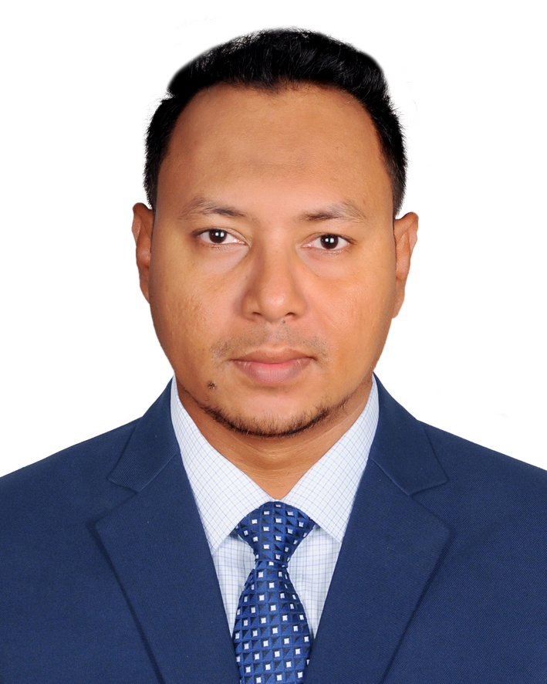

PROFESSIONAL SUMMARY
ISTQB Certified Software Quality Assurance (SQA) Engineer with 4 years of real-world experience delivering high-quality Web, SaaS, OTA, API, and Mobile applications. Proven expertise in transforming manual testing workflows into robust automated pipelines, successfully cutting regression cycles by up to 70%. Adept at architecting maintainable automation frameworks from the ground up using Playwright, Selenium, and Rest Assured. An early adopter of AI and emerging QA paradigms, skilled in leveraging Generative AI tools, Copilot, Prompt Engineering, and building AI/ML-driven testing solutions alongside autonomous AI Agent testing. A strong advocate for shift-left testing within Agile/Scrum environments, deeply experienced in mitigating security risks via OWASP Top 10 validation, optimizing performance with JMeter, and embedding automated quality gates directly into CI/CD pipelines.
TECHNICAL SKILLS
- Programming Languages: Java, JavaScript, TypeScript, Python
- AI & Emerging Technologies: Prompt Engineering, Generative AI tools and Copilot, AI and ML based QA Testing, AI Agent Testing
- Automation Testing: Playwright (JavaScript/TypeScript), Selenium WebDriver (TestNG, Cucumber), Rest Assured (API), Appium (Mobile)
- Manual & API Testing: Postman, Swagger, Functional, Regression, Integration, Exploratory Testing
- Performance & Security: Apache JMeter, OWASP Top 10 Testing, Input Validation Testing
- DevOps & CI/CD: Jenkins, Azure DevOps Pipelines, Docker, Git, GitHub
- Build Tools & Frameworks: Maven, TestNG, Cucumber, Page Object Model (POM)
- Management & Methodologies: Jira, Agile/Scrum, Waterfall, Defect Lifecycle Management
CERTIFICATION
ISTQB Certified Tester Foundation Level (CTFL)
Global Software Testing Board | License No: Available upon request | January 2023
PROFESSIONAL EXPERIENCE
SQA Engineer | Akashbari Holidays, Banani, Dhaka January 2025 – Present
- Formulate comprehensive test plans, test scenarios, and matrix-backed test cases for high-traffic SaaS and Online Travel Agency (OTA) applications.
- Execute rigorous functional, regression, API, and exploratory testing to ensure zero-defect leakage into production environments.
- Integrate Generative AI tools and Prompt Engineering techniques to accelerate test case generation and test data preparation workflows.
- Collaborate closely with cross-functional development and product teams within an Agile/Scrum framework to resolve critical blockers.
- Own and maintain end-to-end QA documentation, summary reports, and bug-tracking workflows.
SQA Engineer | South Maguri Solution, Banani, Dhaka January 2024 – January 2025
- Boosted regression testing efficiency by 70% by designing and maintaining robust automated test suites using Selenium WebDriver, TestNG, and Maven.
- Engineered and executed automated API test scripts via Rest Assured and validated backend workflows with Postman.
- Designed and scheduled automated test runs within CI/CD pipelines (Jenkins/Azure DevOps) for continuous quality feedback.
- Conducted performance and load testing using Apache JMeter to identify bottlenecks and ensure system stability.
- Managed the end-to-end defect lifecycle using Jira, ensuring precise reporting, prioritization, and verification.
PROJECTS
Automation & Emerging Tech Portfolios
- OrangeHRM & BlazeDemo Automation Frameworks: Built scalable, maintainable Page Object Model (POM) automation architectures utilizing Playwright (TS) and Selenium (Java) to validate end-to-end user journeys.
- AI-Accelerated Testing Suites (OpenCart & AutomationPractice): Developed data-driven automated suites handling complex web elements, dynamic synchronization, and augmented test scripts using GitHub Copilot for rapid development.
- API Automation Hub: Created a Rest Assured and Postman framework to validate RESTful endpoints, payload assertions, and response times.
Core Manual Portfolios
Akashbari Holidays SaaS & OTA Platforms: Conducted extensive end-to-end business logic testing, booking engine validations, and payment gateway verifications.
EDUCATION
Master of Arts in Islamic Studies Passing Year: 2018
University of Dhaka
REFERENCES
Md Rashed Karim
CTFL Working Group Member, ISTQB
Former Lecturer, Albukhary International University Malaysia
Former Trainer, Daffodil Institute of IT
ISTQB Board and SEIP Authorized Trainer
NSDA Resource Person
Phone: +880 1711-605286


___________________________
Shah Md Rezaul Karim

