# Lab Session Report

**Work done in Lab Session:**

1. **Flutter Overview**

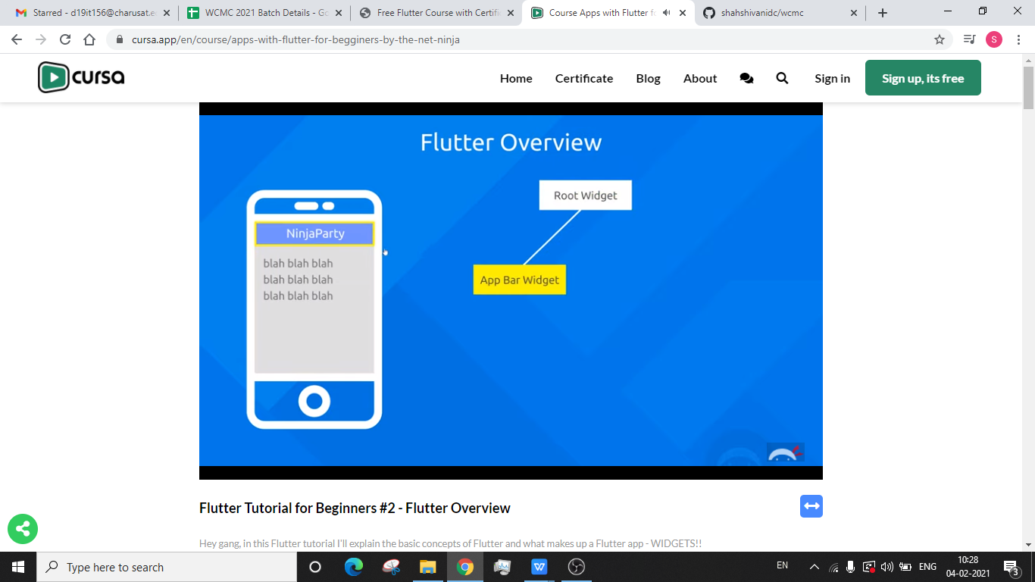

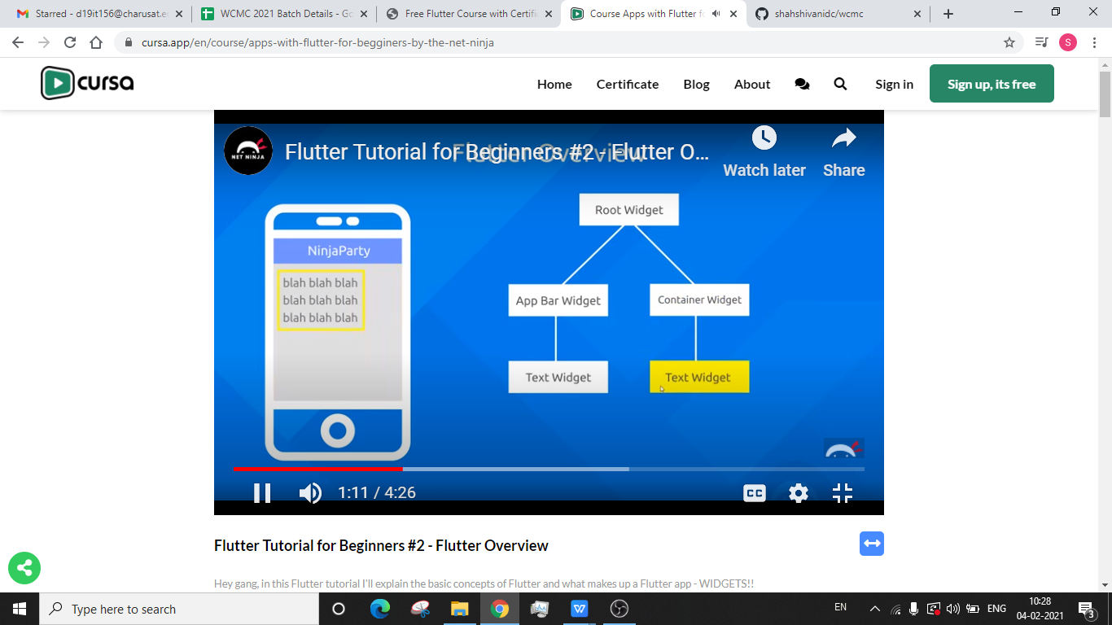

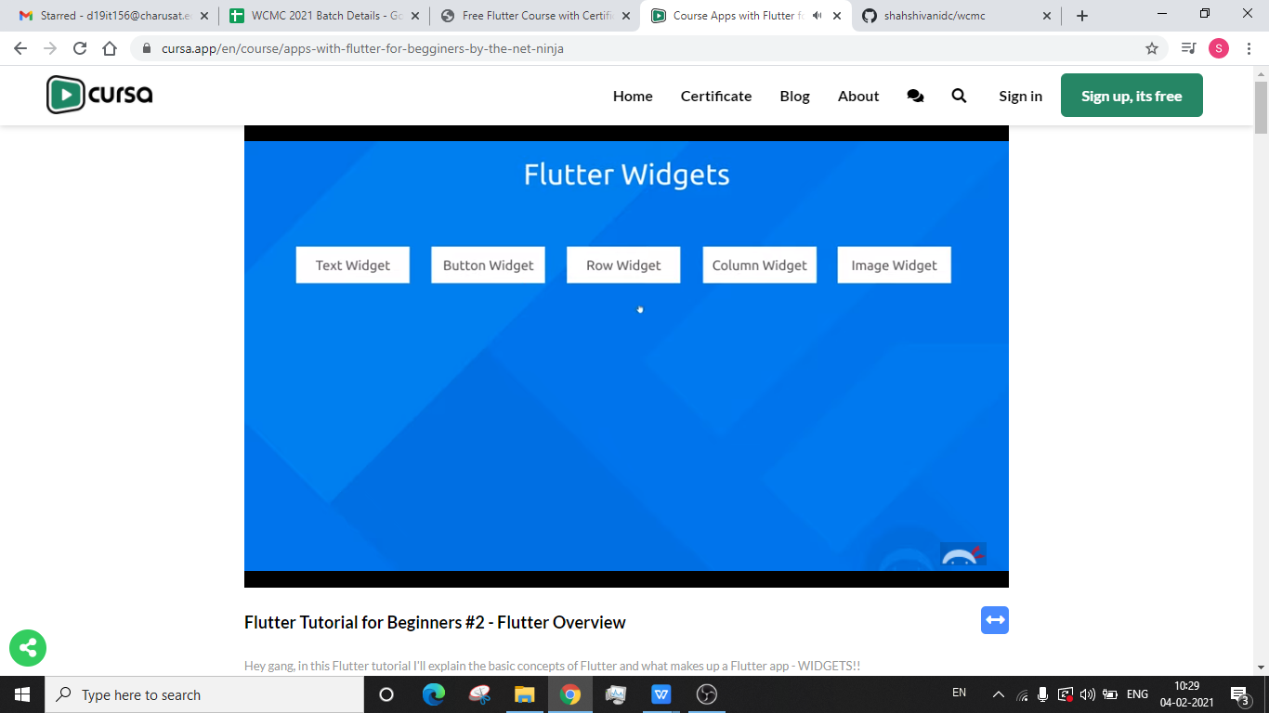

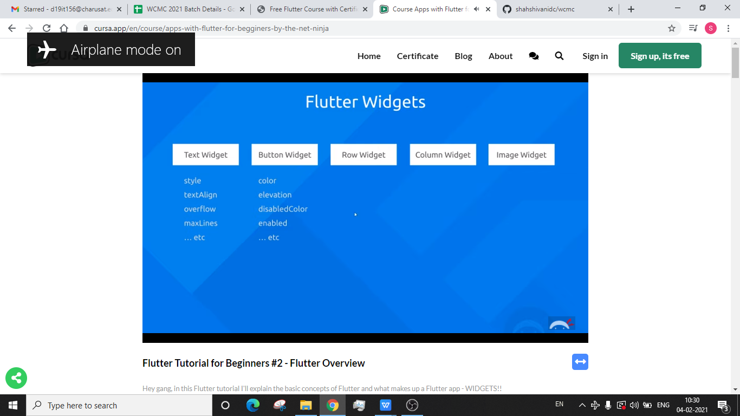

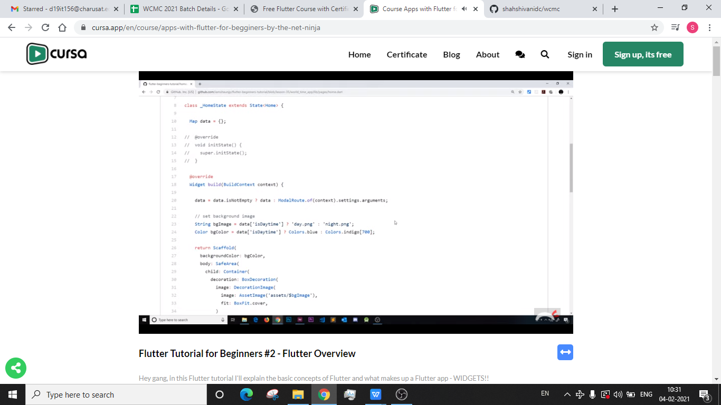

**Plans for next week:**

1. Dart Primer

## Git Repository Links:

Link: https://github.com/shahshivanidc/wcmc/upload/main

Git Username: shivanishahdc