**Tkinter – Hotel Management**

**What is Project?**

This application manages the records of visitors in hotel .You can add, edit/update, delete, search or view all the records of the people staying at hotel.

This project is made using Tkinter and sqlite3.

**Getting Started**

Setting up project is simple.

1. Clone this repo
2. cd into the root folder
3. run command ‘python front.py’ to start the project.

**Demo**

Here's a demo of what Project looks like once it's set up.

***Demo video file is uploaded as Demo.mp4.***

***Please check it.***

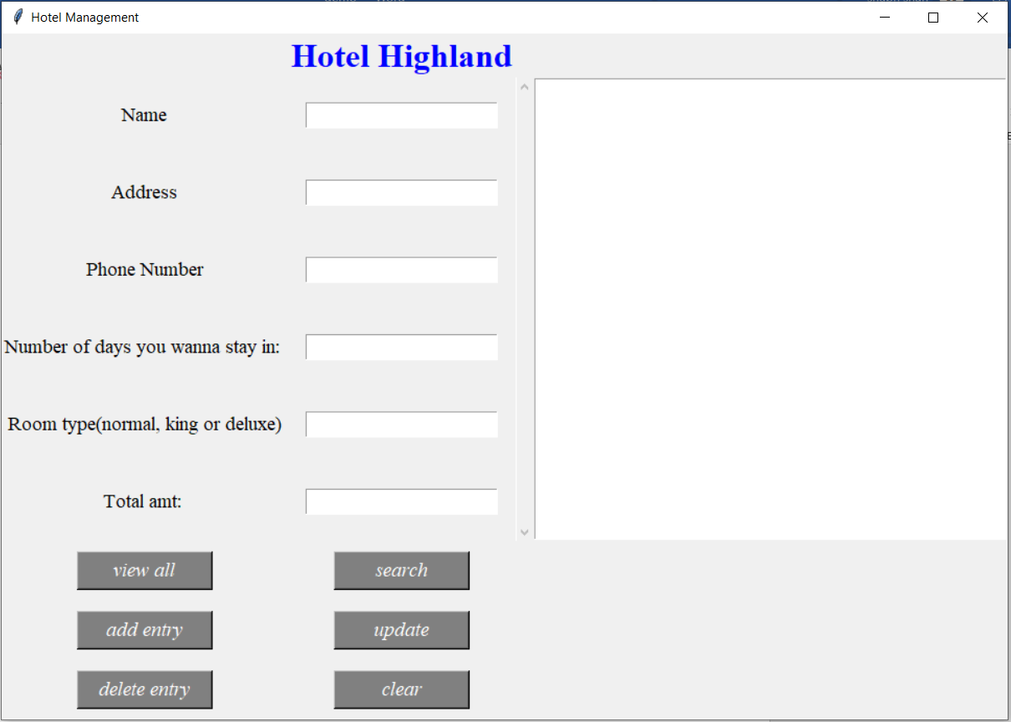

**More Information**

Check out the [build/api/overview](API Documentation) for more information.